EECE 419 - Pod 1

Hotel Bookings Requirements Specification
November 6, 2009
Sean Clark | 36538056
Yang Gao | 52588050
Shen Li | 65962060
Neil Gentleman | 62973029
Arash Malekzadeh | 33685058
Michael Tando | 79529061
Wei-Chen Wang | 64341043

1.0 Introduction 1
1.1 Purpose 1
1.2 System Overview 1
1.3 Project Scope 1
2.0 Assumptions 2
3.0 System Features 3
4.0 Non-Functional Requirements 5
4.1 Usability 5
4.2 Scalability 5
4.3 Security 5
4.4 Portability 6
4.5 Performance 6
4.6 Reliability 6
4.7 Robustness 6
4.8 Efficiency 6
4.9 Adaptability 7
5.0 Key Constraints 8
6.0 Functional Requirements 9
6.1 Class Diagram 9
6.2 Test Diagram 10
6.3 Controller Diagram 1
6.4 Repository Diagram 1
6.5 Use Cases 2
Create an account 3
Make a reservation 4
Cancel a reservation 5
Edit a reservation 6
Create new room 7
Edit room 8
Delete room 9
Create new room type 10
Edit room type 11
Delete toom type 12
Add chargeable item(s) [elided: edit chargeable item, delete chargeable item] 13
Charge chargeable item(s) 14
Check-in 15
Check-out 16
Check Dirty Room 17
Mark Clean Room 18
View Statistic Report 19
Appendix A: User Interface Mockups 20

Table of Figures
Figure 1: Class Diagram 4
Figure 2: Use Case Diagram 5
Figure 3: Create an Account (Sequence Diagram) 6
Figure 4: Make a Reservation (Sequence Diagram) 7
Figure 5: Cancel a Reservation (Sequence Diagram) 8
Figure 6: Edit a Reservation (Sequence Diagram) 9
Figure 7: Create Rooms (Sequence Diagram) 10
Figure 8: Edit Room (Sequence Diagram) 11
Figure 9: Delete Rooms (Sequence Diagram) 12
Figure 10: Create Room Type (Sequence Diagram) 13
Figure 11: Edit Room Type (Sequence Diagram) 14
Figure 12: Delete Room Type (Sequence Diagram) 15
Figure 13: Add Chargeable Items (Sequence Diagram) 16
Figure 14: Charge Chargeable Item (Sequence Diagram) 17
Figure 15: Check-in (Sequence Diagram) 18
Figure 16: Check-out (Sequence Diagram) 19
Figure 17: Check Dirty Room (Sequence Diagram) 20
Figure 18: Mark Clean Room (Sequence Diagram) 21
Figure 19: View Statistic Report 22
Figure 20: UC1 Mockup - Create Account 23
Figure 21: UC2 Mockup - Make a Reservation (Step 1) 24
Figure 22: UC2 Mockup - Make a Reservation (Step 2) 25
Figure 23: UC2 Mockup - Make a Reservation (Step 3) 26
Figure 24: UC2 Mockup - Make a Reservation (Step 4) 27
Figure 25: UC2 Mockup - Make a Reservation (Step 5) 28

1.0 Introduction

1.1 Purpose
The purpose of this document is to explain different aspects of software requirements regarding a hotel reservation software. The scope of this document is limited to the main functional and non-functional requirements of the system. These functions are defined as those required to have a stable and usable hotel reservation system. Extra features designed for different hotels will not be mentioned in this document.

1.2 System Overview
X-Reserve is a hotel reservation system that allows hotels to provide guests with a web-based reservation interface. There are a number of features available to both clients and the hotel management or staff. A client can create an account and use it to view available rooms for different dates. The room search function provides users the ability to find a room based on the price, date, room layout, capacity and other options. As for the management side, there are features designed for managers, staff and maids. Hotel managers can view reports and graphs on reservation trends, and be able to maximize their profits. They can add customized room layouts to the database and have automatic seasonal price changes. The hotel staff can make reservations for guests, add chargeable items to rooms, set special prices rates and have notes associates with each guest's account. Rooms will automatically be marked so that maids can keep track of which room is to be occupied and needs cleaning.

1.3 Project Scope
X-Reserve is to be designed as a web-based application which will only operate with one specific database. This software can be deployed for different hotels, and It will allow users around the world to make reservations. The goal of this software is to provide a reliable and fully customizable reservation system for any type of hotel within Canada and United States.

2.0 Assumptions
In order to simplify development and testing, we have decided to only support Firefox version 3.5 and up. Users of our software should be familliar with the navigation of websites and simple web applications, such as Google Maps or Gmail. Our interface will be designed around the current UI norms and should be intuitive enough to use without any instruction. Installation of X-Reserve is too technical for normal users, but we will provide enough documentation to make the process easy for people familiar with installing server-side software. To ease installation, our software will useable without any external database or servlet container. It will also be able to take advantage of pre-installed servlet containers and database servers, such as Apache Tomcat and MySQL, to enhance scalability. We will do our best to minimize resource usage of X-Reserve, and it will be usable on limited hardware with a small number of users.

3.0 System Features

3.1 Account Management and Security (Access Control)

X-Reserve is designed to enable role-based access control to organize privileges. It provides authentication and authorization of multiple customizable roles such as administrator role, staff role, and user role. This provides a secure and effective way to manage access to different information and resources.

3.2 AJAX Usability Enhancement

X-Reserve is further enhanced using AJAX approach. Using this approach, X-Reserve is able to provide improved user-experience by presenting web content dynamically without the need of page refresh. This decreases the bandwidth consumption and user delay, thus significantly improves the efficiency of workflow and overall productivity of the users.

3.3 Reservation Management

X-Reserve allows certain roles such as administrator and staff to manage customer reservations efficiently. The administrator and staff can easily view current reservations, modify or delete reservations. They can also manage customer check-in and check-out.

3.4 Business Report and Analysis

X-Reserve allows the administrator to generate business report easily and quickly. The administrator can analyze reports and graphs on reservation trends, and be able to maximize their profits. For example, the administrator can generate a room type statistic report that presents most recent data on room type preferences from latest customer reservations.

3.5 Easy Hotel Facility Management

X-Reserve provides hotel administrators an easy way to manage hotel facilities. They can add customized room types with different room layouts and attributes, such as number of beds, to the database. The hotel staff can make reservations for guests, add chargeable items to rooms, and adjust room rates depending on the season.

3.6 Web-based, No Installation Required

X-Reserve is designed as a web-based application. No installation is required in order to run X-Reserve; however, internet connection is required. X-Reserve can be up and running 24/7, providing services to customer and hotel management staffs.

3.7 Advanced Search with Attributes

Using X-Reserve, customers will be able to easily search room facilities according to their preferences. Customers can quickly search for rooms by specifying the type of room, the price range, and start/end date of their stay. Furthermore, with the advanced search, customers can, for example, specify the number of beds, number of bathrooms, smoking/non smoking, and etc. The advanced search will provide the customer with utmost satisfaction.

4.0 Non-Functional Requirements

The following section will describe our non-functional requirements in detail. They are broken down into five sections -- usabillity, scalability, security, portability and performance. Our key constraints are usability, security and performance.

4.1 Usability
The target clients of the software are hotel managers, receptionists, maids, and hotel customers. Most of the clients may know little about computers and software systems. As a result, the software interface takes a very important role. The software has to provide flexible and easy-to-use interfaces so that our clients can achieve reasonable success with little training. The software is a web-based application running on Mozilla Firefox 3.5, and the interface will be designed and constructed following the Nielsen's Ten Usability Heuristics. The software will expose different functionality depending on different roles of users. For example, if the login user is identified as manager, the manager will be seeing an interface with the viewing report option. The details of these interfaces will be discussed further in the functional requirements. Moreover, all these different interfaces will be consistent and will follow the same standards. The goal of these interfaces is to minimize user confusion and increase the usability of our software. Certain reports, like the maid's room occupancy view, are likely to be used in printed form, so all views will have a print-friendly mode.

4.2 Scalability
X-Reserve is only intended to manage one hotel, not a chain, so our ultimate scalability goals are limited. The system will, however scale to the largest of single hotels, with hundreds of of rooms. In this process, customer volumes are expected to scale to several thousands customers. The objective for this requirement is to cater for future growth in the business. The system also needs to provide access for a number of terminals that can be used by the hotel personnel. Eventually, there could be over twenty terminals in a hotel and thus the system should be able to handle over twenty simultaneous requests. This requirement is to allow the system to be used across the whole hotel by the hotel personnel at any time. The potential for database sharding or application server clustering will not be explored.

4.3 Security
Since our software will be storing sensitive personal information, like credit card information and addresses, security is essential. We are building on top of the Spring framework, which provides a secure base to work from. It provides authentication that will be used throughout the software to hide information from the wrong users. We will also be actively looking for bugs that could cause a security hole or information leak.

4.4 Portability
To ease installation and broaden our customer base, our software will be portable across a variety of operating systems, including Linux, OS X, and Windows. To simplify development, we will only be testing on Linux and Windows; however, our software should run without problems on any system with Java installed.

4.5 Performance
Performence is an important requirement for X-Reserve, especially due to its scalability. A system with our minimum requirements (1Ghz processor, 1GB of RAM) will be able to support up to 10 simultaneous users. The actual performance varies depending on a number of factors, including network latency and the capabilities of our user's computers. On an internal network, with relatively new computers (at least 600MHz with 256MB of RAM), X-Reserve will perform quite well. Normal operations and page refreshes will complete inside of 1 second, and more complicated operations (like statistical reports) will take at most 5 seconds.

4.6 Reliability
Since our software will be operating 24 hours a day and 7 days a week, reliability is a very important requirement to our system. All our system’s data will be stored into a database to prevent data corruption or data loss due to computer failure. In addition, to increase reliability of our system, we will perform a lot of testing on the software. We will perform testing on each of the system features with both valid inputs and invalid inputs. During all the testing phases, software bugs will be discovered, corrected, and re-tested. As a result of this huge amount of testing, our system is aiming to a very small failure rate or even a zero failure rate.

4.7 Robustness
Users’ inputs are always unpredictable and uncontrollable. They may enter invalid inputs to our system. As a result, our software has to validate all inputs to prevent system failure from unexpected inputs. That is, our software will provide robustness. All the input fields will be validated and if an unexpected input is encountered, a warning message will be displayed.

4.8 Efficiency
Our software will be very efficiency in term of utilization of resource. Our system uses the Jetty web server, which is a very light weighted web server. It is much smaller and more efficient than other web servers such as Tomcat. In addition, we choose Spring as our framework for developing, which is also a light weighted framework. It is very easy for programmers to develop. Since this software is a web based application, as a user, everything he/she needs is a browser and he/she can run the application immediately.

4.9 Adaptability
Our software is implemented in Java and can be run on all the Operation Systems. Also, our software is developed with Spring framework. One of its advantages is dependency injection, which is the ability of providing an external dependency to the software. It provides flexibility and adaptability to our software because it can create alternative services via a configuration file instead of changing our software.

5.0 Key Constraints

X-Reserve is developed as a reliable and fully customizable reservation system; however, there are some key constraints that must be followed. In order to run this software, users require the following applications: java 1.6 and FireFox 3.5.5. Since this software is a web-based application, it requires users to have internet access. X-Reserve is our first prototype; it has not been modified to handle large load; in other words, it cannot be clustered. In term of security, even though we do provide a secure on top of Spring framework base to work from, we are unable to prevent any brutal force attack.

6.0 Functional Requirements
This section contains descriptions and diagrams of our man functional requirements. There are also detailed use cases and sequence diagrams, which describe our user interactions and the sequence of messages needed to complete them.

6.1 Class Diagram
The class diagram, shown in Figure 1, shows the relationship between all of the classes we will be using to implement our software.
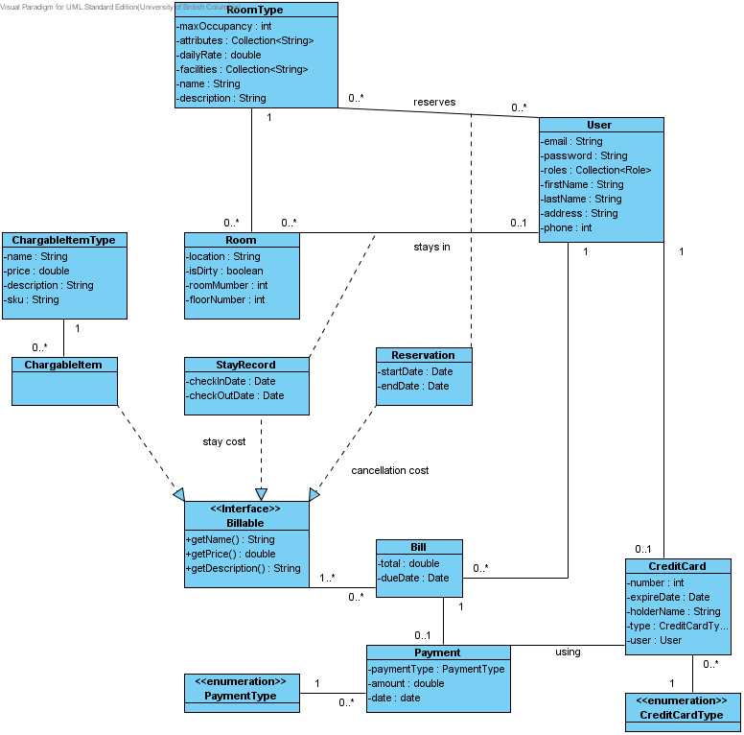Figure 1: Class Diagram

6.2 Test Diagram
The test diagram, shown in Figure 2, illustrates the relationships between Mock objects and our test controllers.

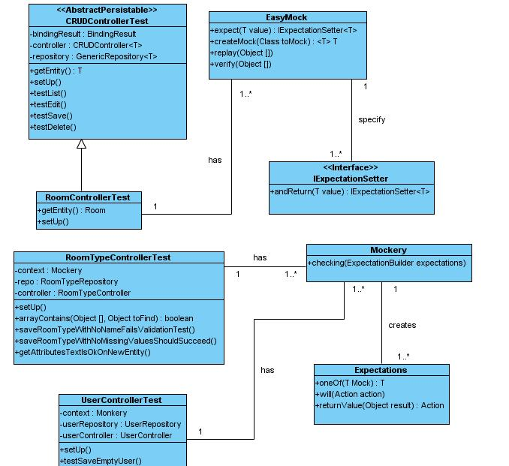
Figure 2: Test Diagram

6.3 Controller Diagram
The controller diagram shown in Figure 3, shows t
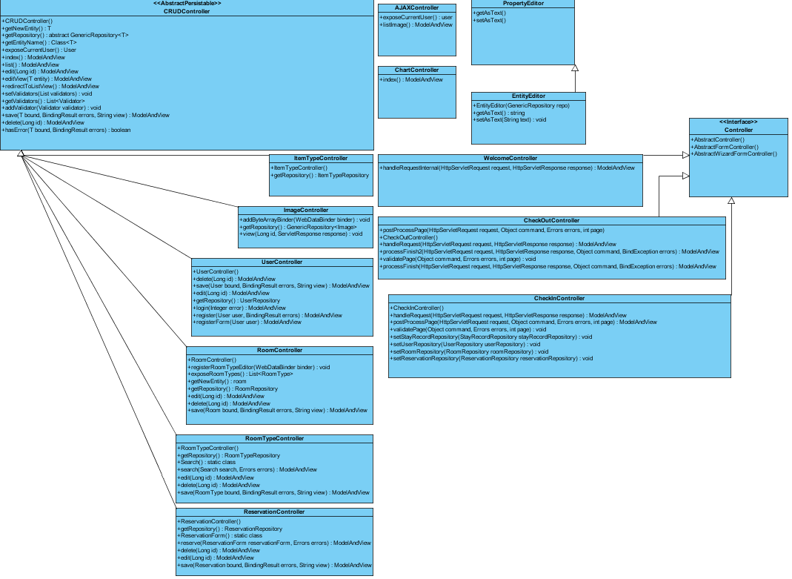
Figure 3 : Controller Class Diagram

6.4 Repository Diagram

This section provides an overview of a GenericDao class that implements GenericRepository. The extended GenericDao class forms a JDBC-abstraction layer that removes the need to do tedious JDBC coding and parsing of database-vendor specific error codes. Figure 4 below illustrates the functions associated with the GenericDao class and its subclasses.

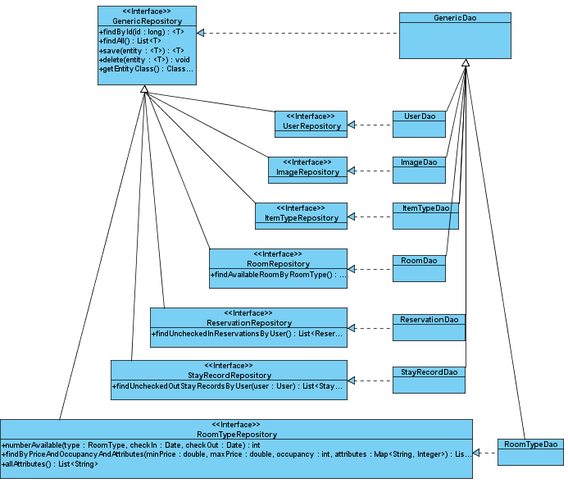
Figure 4: Repository Class Diagram

6.5 Use Cases

This section describes the use cases for our project. The use case diagram in Figure 1 shows the use cases and their relation to the different types of users of our project. The rest of this section explains the use cases in detail, with sequence diagrams explaining the flow of messages.

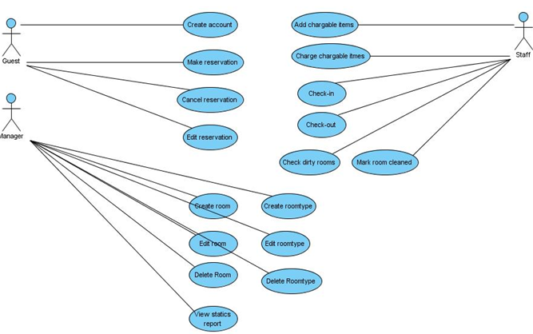
Figure 5: Use Case Diagram

Create an account
Use case number: UC1
- Guest enters his email address, password, credit card information and other relevant information
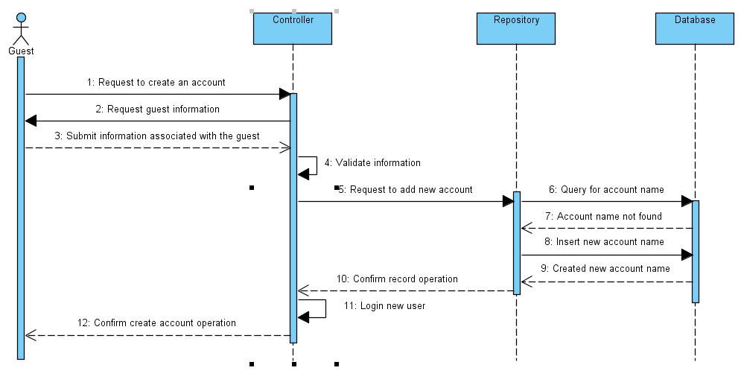Figure 6: Create an Account (Sequence Diagram)
- System validates all the information is correct
- System records all the information and logins the guest

Make a reservation
Use case Number: UC2
Figure 7: Make a Reservation (Sequence Diagram)
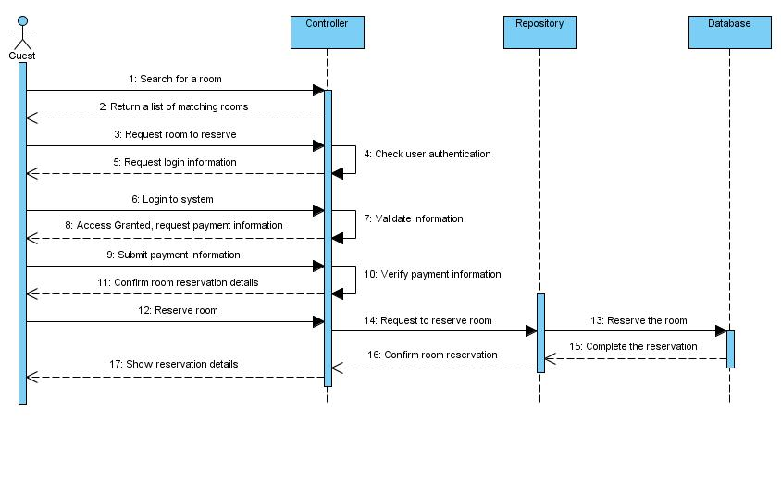Figure 7: Make a Reservation (Sequence Diagram)

- Guest or Staff enters the check-in and check-out dates, room capacity, and price range to the system.
- The system will return a list of rooms.
- User selects a room from this list to reserve.
- If guest, guest logs on to retrieve her already stored customer information.
  - If guest does not have an user account, include UC1
- User selects the payment type (Visa or MasterCard)
- User confirms the reservation
- The system generates a confirmation number and a reservation summary

Cancel a reservation
Use case Number: UC3
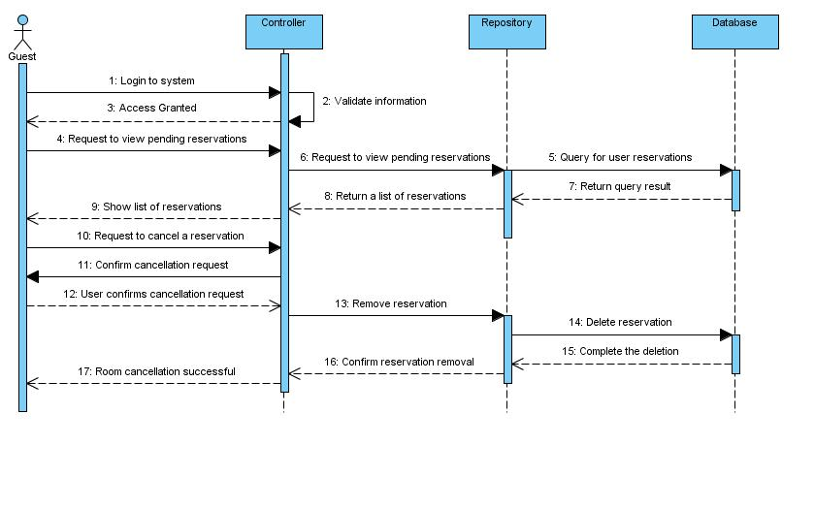Figure 8: Cancel a Reservation (Sequence Diagram)
Figure 8: Cancel a Reservation (Sequence Diagram)

- Guest logins to his account
- Guest requests to view all the reservations
- System responds with a list of reservations
- Guest requests to cancel one of listed reservation
- System validates that reservation can be cancelled
  - System will display an error if the reservation cannot be cancelled
- System displays any cancellation fees to the guest
- Guest confirms to proceed with the cancellation
- System confirms the reservation has been cancelled

Edit a reservation
Use case Number: UC4

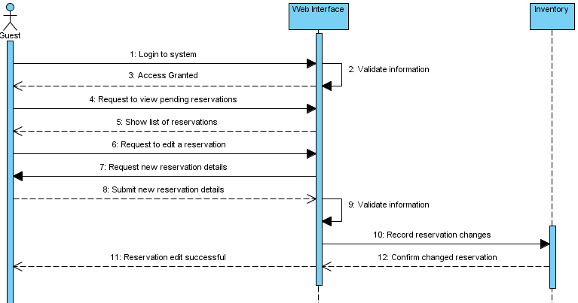
Figure 9: Edit a Reservation (Sequence Diagram)

- Guest logins to his account
- Guest requests to view all the reservations
- System responds with a list of reservations
- Guest requests to edit one of listed reservations
- System prompts the user to enter new reservation details
- Guests enter new reservation details
- System validates the new input
- System validates that changes can be accomidated
  - System displays an error if a matching room cannot be found
- The system generates a confirmation number and a reservation summary

Create new room
Use case Number: UC5
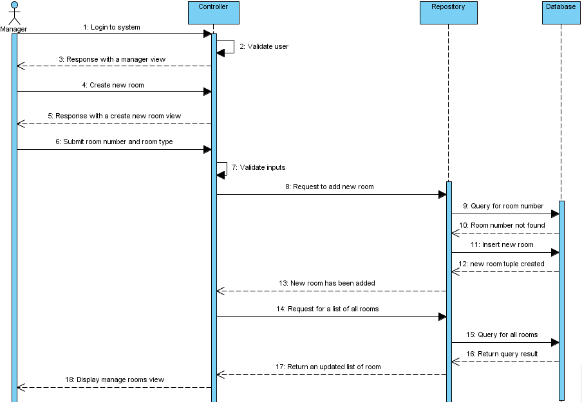
Figure 10: Create New Room (Sequence Diagram)

- Manager logs into the system using his or her account
- Manager requests to create a new room
- Manager specifies a room number and room type for the new room
- System validates all the information entered is correct
  - System displays an error message if the information is incorrect
- System adds the new room to the database

Edit room
Use case Number: UC6

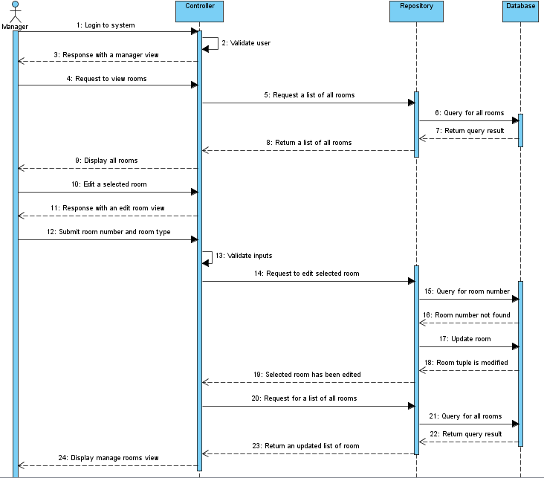
Figure 11: Edit Room (Sequence Diagram)
- Manager logs into the system using his or her account
- System displays list of all existing rooms
- Manager selects a room to edit from the list of all existing rooms
- Manager can change room type, room number and any information that should overwrite the defaults
- System validates all the information entered is correct
  - System displays an error message if the information is incorrect
- System saves the changes to the room in the database

Delete room
Use case Number: UC7

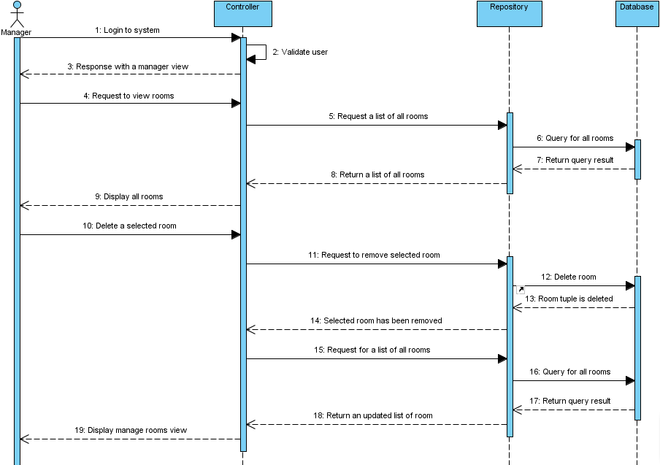
Figure 12: Delete Room (Sequence Diagram)

- Manager logs into the system using his or her account
- System displays list of all existing rooms
- Manager selects a room to delete from the list of all existing rooms
- System removes selected room from database

Create new room type
Use case Number: UC8

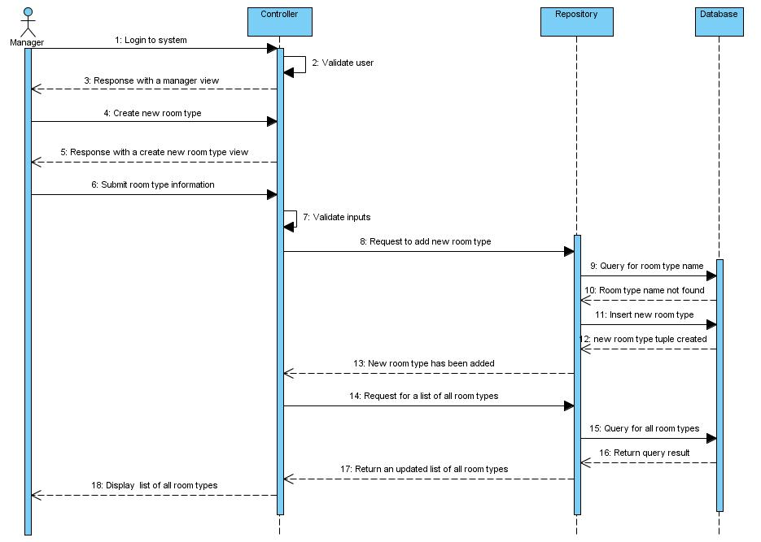
Figure 13: Create New Room Type (Sequence Diagram)

- Manager logs into the system using his or her account
- Manager selects to create a new room type
- Manager inputs name of type, beds, kitchenette, etc
- System validates all the information entered is correct
  - System displays an error message if the information is incorrect
- System adds the new room type to the database

Edit room type
Use case Number: UC9

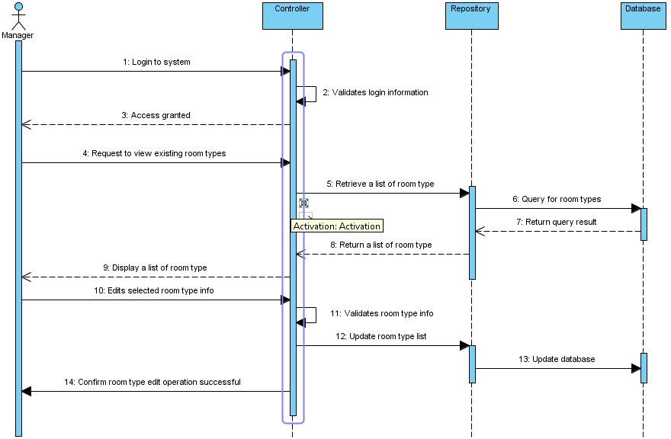
Figure 14: Edit Room Type (Sequence Diagram)

- Manager logs into the system using his or her account
- Manager requests to view existing room types
- After viewing a list of room type, Manager selects a room to edit
- Manager enters new room type information (room type name, price rate, etc. )
- System validates all the information entered is correct
  - System displays an error message if the information is incorrect
- System confirms the room type edit operation is completed

Delete toom type
Use case Number: UC10
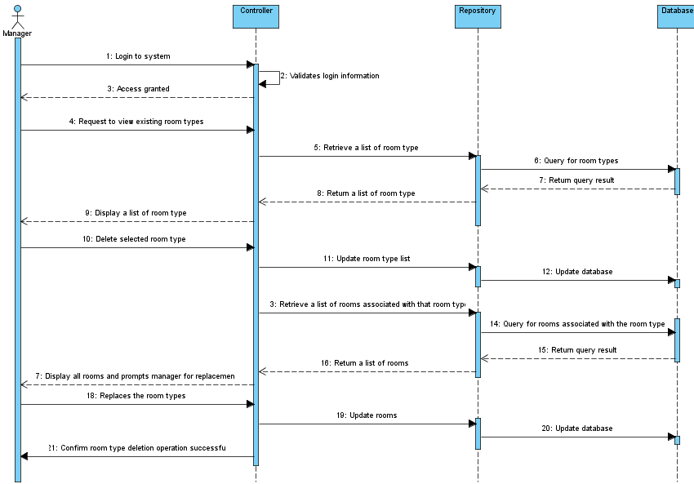
Figure 15: Delete Room Type (Sequence Diagram)

- Manager logs into the system using his or her account
- Manager requests to view existing room types
- After viewing a list of room type, manager selects a room type to delete
- System checks that no rooms use that type
  - If rooms use this type, system prompts for a type to replace this type with
- System confirms the room type deletion operation is completed

Add chargeable item(s) [elided: edit chargeable item, delete chargeable item]
Use case Number: UC11
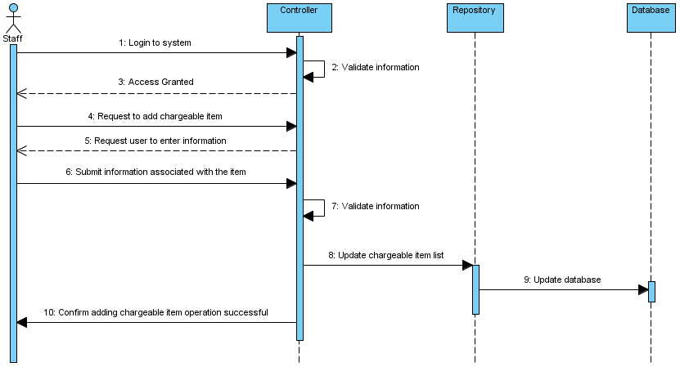
Figure 16: Add Chargeable Item(s) (Sequence Diagram)

- Hotel staff logs into the system using their account
- Staff requests to add chargeable item
- Staff enters all the information about the new item such as name and price
- System validates all the information entered is correct
  - System displays an error message if the information is incorrect
- System confirms a new item is added

Charge chargeable item(s)
Use case Number: UC12
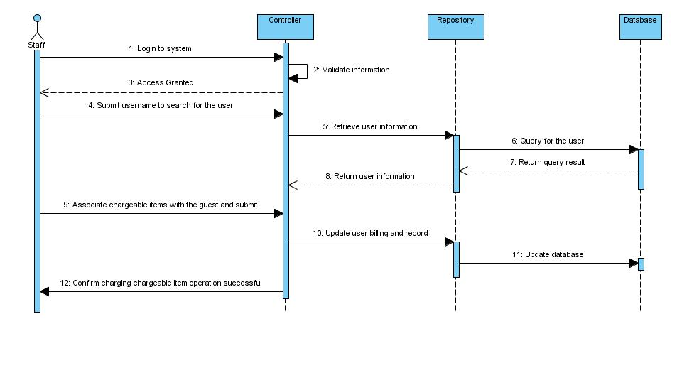Figure 17: Charge Chargeable Item (Sequence Diagram)
Figure 17: Charge Chargeable Item(s) (Sequence Diagram)

- Hotel staff logs into the system using their account
- Staff selects (by customer name) guest to bill
- Staff selects chargeable items and quantity
- System validates all the information entered is correct
  - System displays an error message if the information is incorrect
- System confirms the association between the chargeable item and the guest is established

Check-in
Use Case Number: UC13
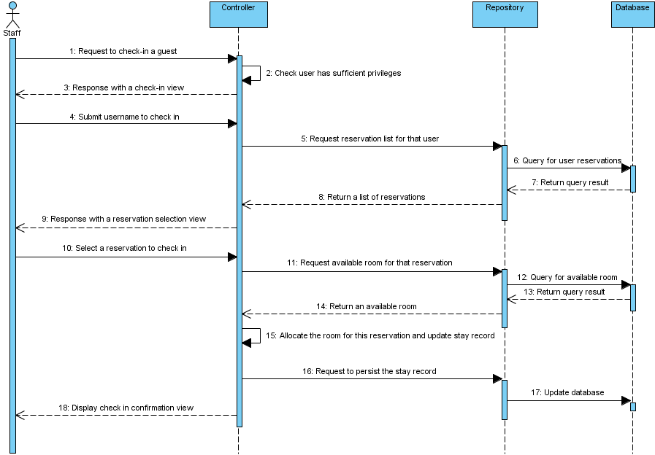
Figure 18: Guest Check-In (Sequence Diagram)

- Hotel staff logs into his or her account
- Hotel staff requests check-in
- Receptionist enters corresponding information (customer name, ID number) to retrieve customer data
  - System displays an error message if the corresponding customer is not found
- System displays a detail customer information summary including customer name, ID number, telephone number, address, room type, room number and stay duration
- Guest or receptionist validates the correctness of the summary
- System confirms check-in

Check-out
Use Case Number: UC14
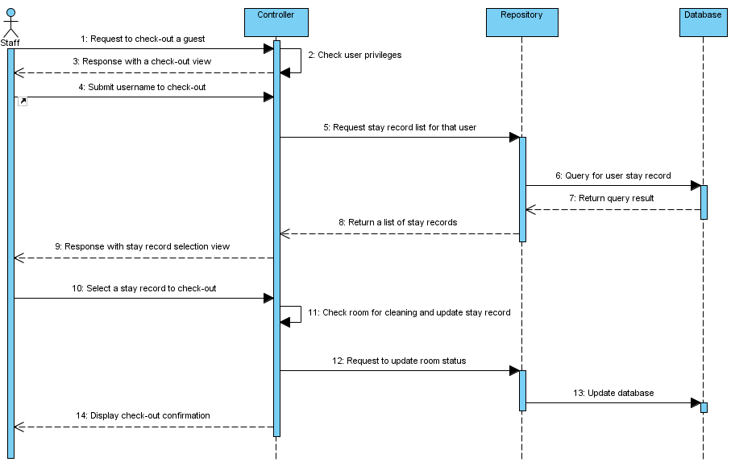
Figure 19: Guest Check-Out (Sequence Diagram)

- Hotel Staff logs into to his or her account
- Hotel Staff enters corresponding information (customer name, ID number) to retrieve customer data
  - System displays an error message if the corresponding customer is not found
- System displays a detail customer information summary including customer name, ID number, telephone number, address, room type, room number and stay duration
- System displays a summary of the stay and a detailed bill
- Guest and hotel staff validate the correctness of the summary and bill
- System charges the guest's credit card
- System confirms check-out

Check Dirty Room
Use Case Number: UC15
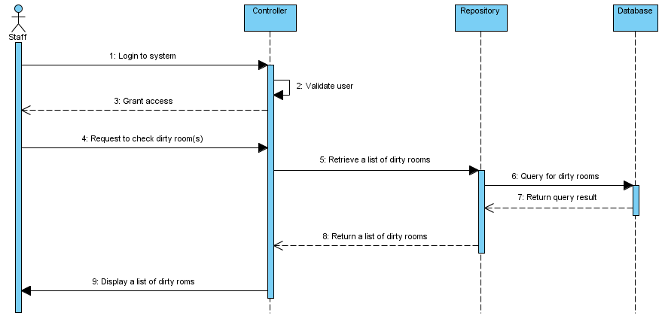
Figure 20: Check Dirty Room (Sequence Diagram)

- Hotel staff logs into his or her account
- Hotel requests to check dirty rooms
- System displays a list of rooms that is dirty

Mark Clean Room
Use Case Number: UC16
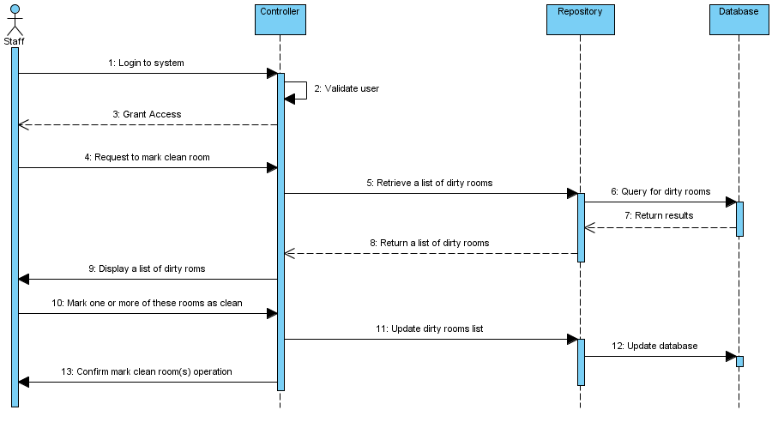
Figure 21: Mark Clean Room (Sequence Diagram)

- Hotel staff logs into his or her account
- Hotel staff requests to mark a room clean
- System displays a list of rooms that are dirty
- Hotel marks one or more of these rooms
- System confirms the rooms being marked are indicated as “clean”

View Statistic Report
Use Case Number: UC17
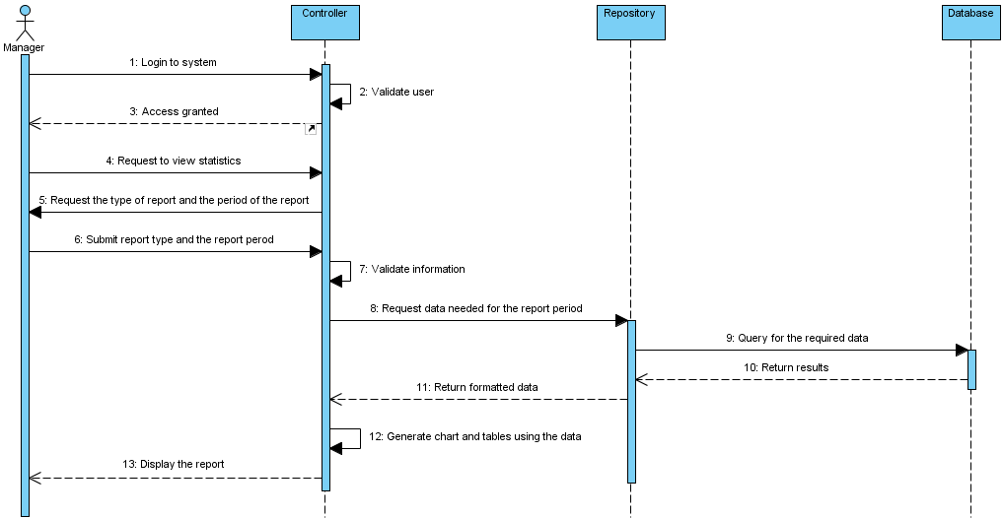
Figure 22: View Statistic Report (Sequence Diagram)

- Manager logins his account
- Manager requests to view reports
- Manager enters the type of report (statistical analysis room occupancy, most popular type of room reservation, real-time view of occupied/free status) and the period of the report
- System displays the corresponding report

Appendix A: User Interface Mockups
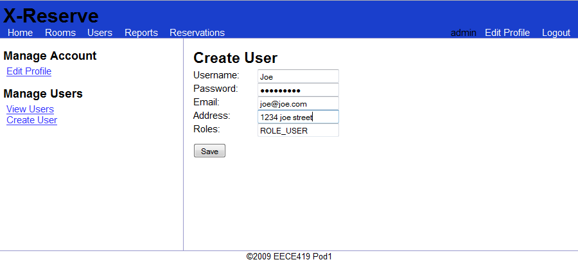
Figure 20: UC1 Mockup - Create Account
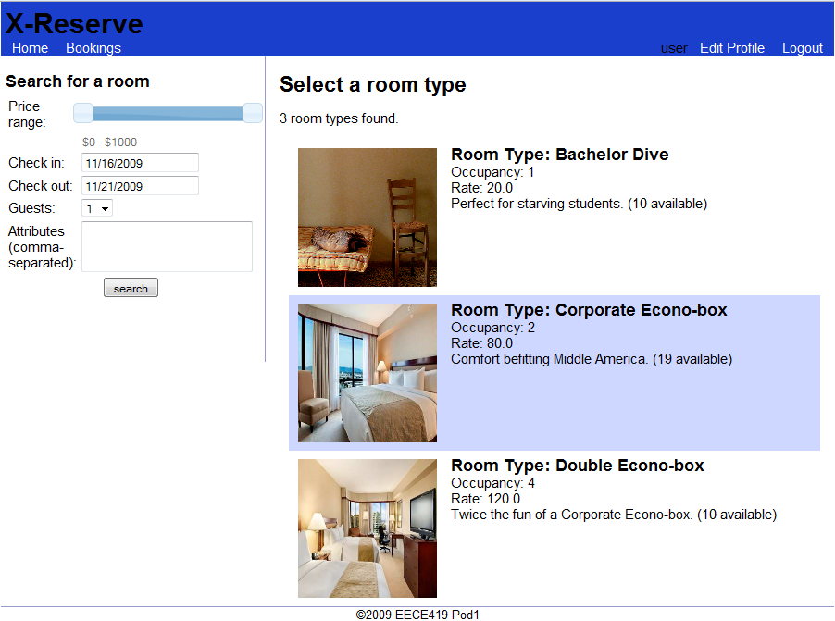
Figure 21: UC2 Mockup - Make a Reservation (Step 1)

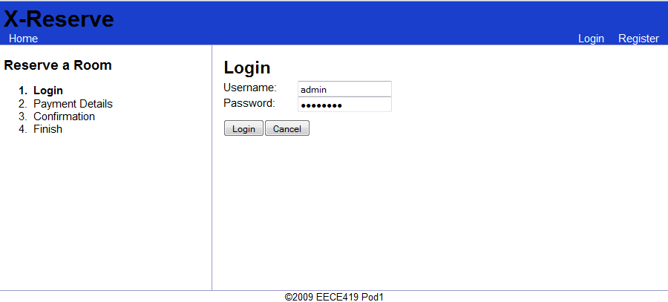
Figure 22: UC2 Mockup - Make a Reservation (Step 2)
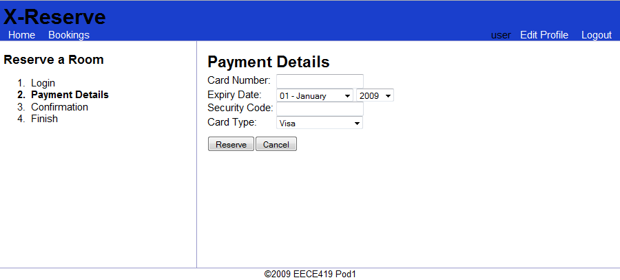
Figure 23: UC2 Mockup - Make a Reservation (Step 3)
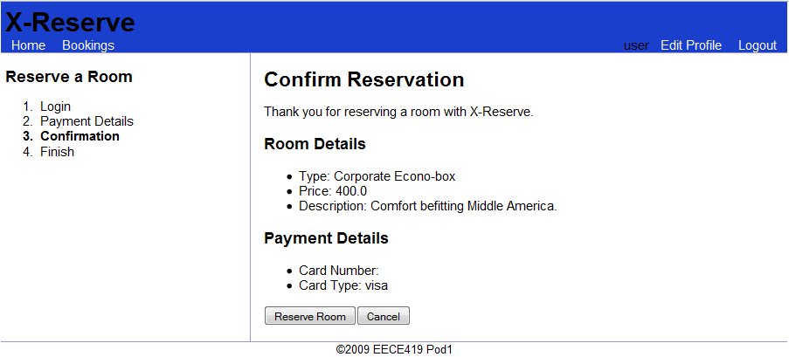
Figure 24: UC2 Mockup - Make a Reservation (Step 4)
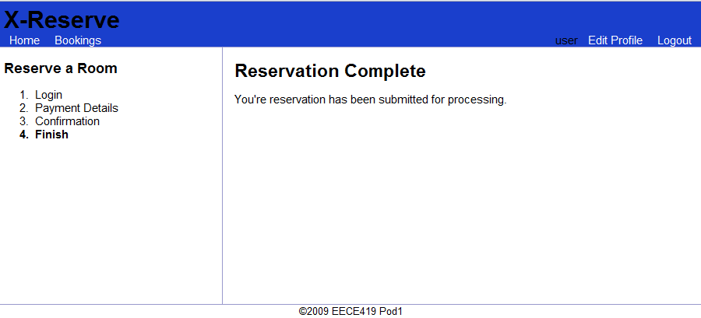
Figure 25: UC2 Mockup - Make a Reservation (Step 5)

