**Steps to Run Project**

1. Download the code from git hub Repo using path:

<https://github.com/rahulrex90/ExportDemoApp.git>

1. Open the project in visual studio 2017/20 and run project using Ctrl+F5 or you can directly run ConsoleApp1.exe from bin folder after publish project or using dotnet run Command.
2. Once you double click on exe file or run project using Ctrl+F5 , it will open a console window as you can see in below picture

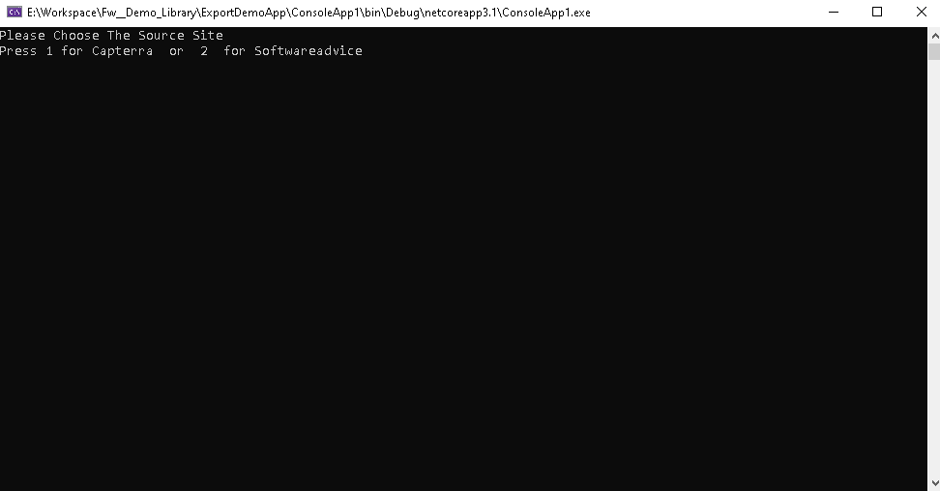

1. After opening it will ask to choose the source . Press 1 if you want to export data from Captera or Press 2 if you want to export the data from Software Advice.
2. After entering source type, enter the path where source file exists with extension yaml or json.

Sample Output for Captera for file with .yaml extension.

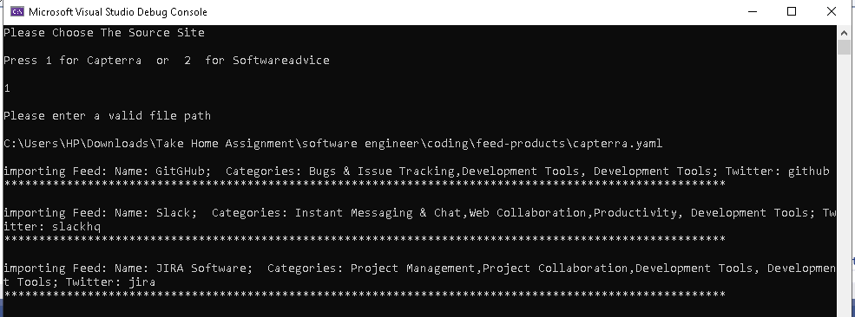

Sample Output for Captera for file with .json extension.

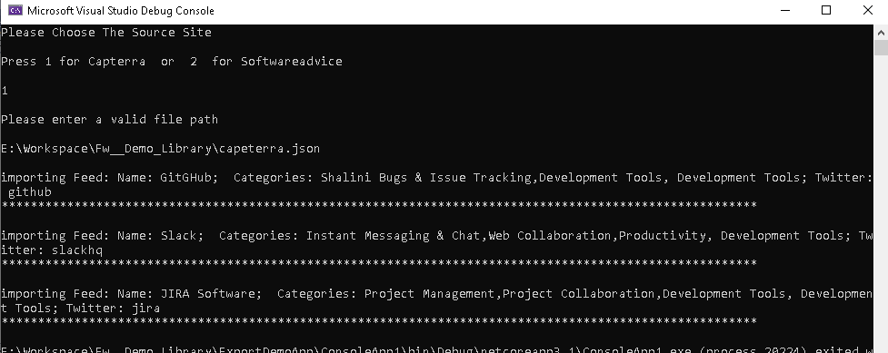

Sample Output for Software Advice source for file with .json extension.

ct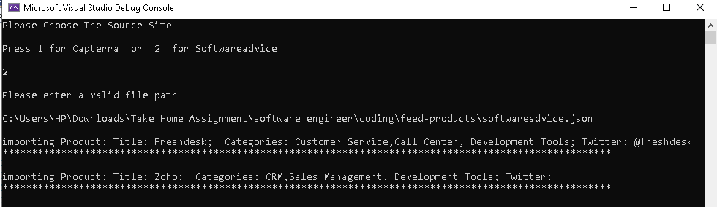

1. To Run Test Project: right click on ExportDemo_TestProject and select Run tests option

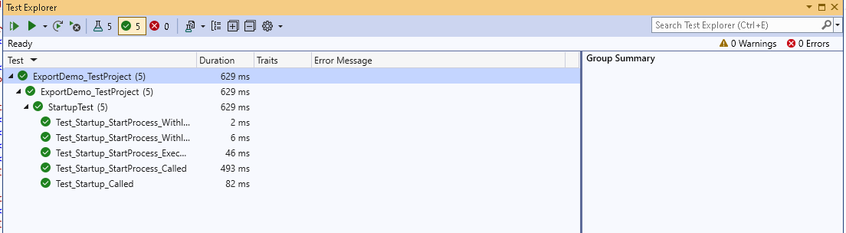

Or we can use dotnet test Command to run test

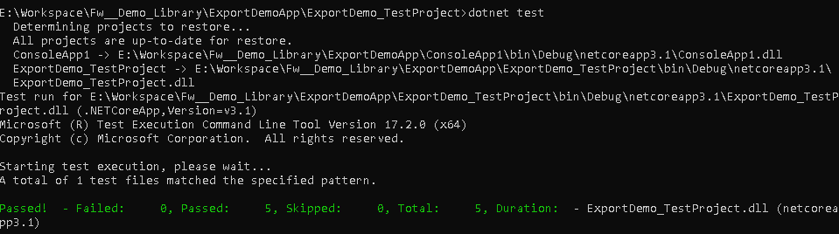

**Framework Used: .Net Core 3.1**

**Visual Studio: 2022**