Install Docker in Windows 10

## **Step 1 – Download Docker**

<https://download.docker.com/win/stable/Docker%20for%20Windows%20Installer.exe>

## **Step 2 – Run the installer**

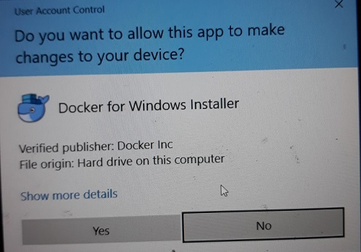

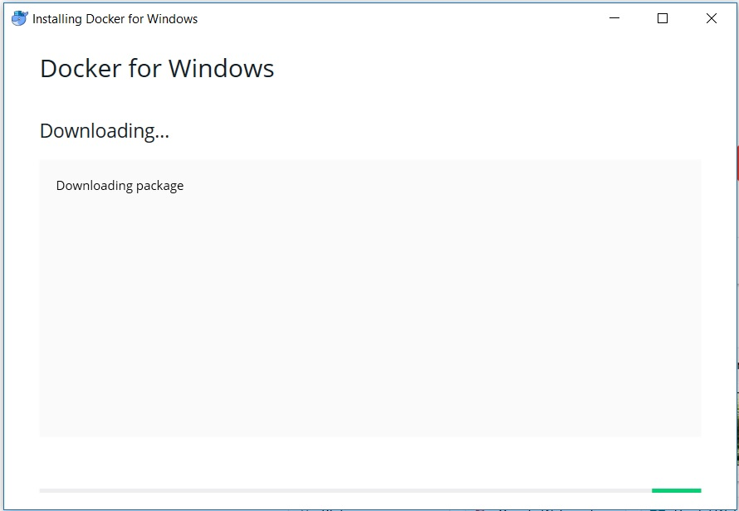

## **Step 3 – Configuration Settings**

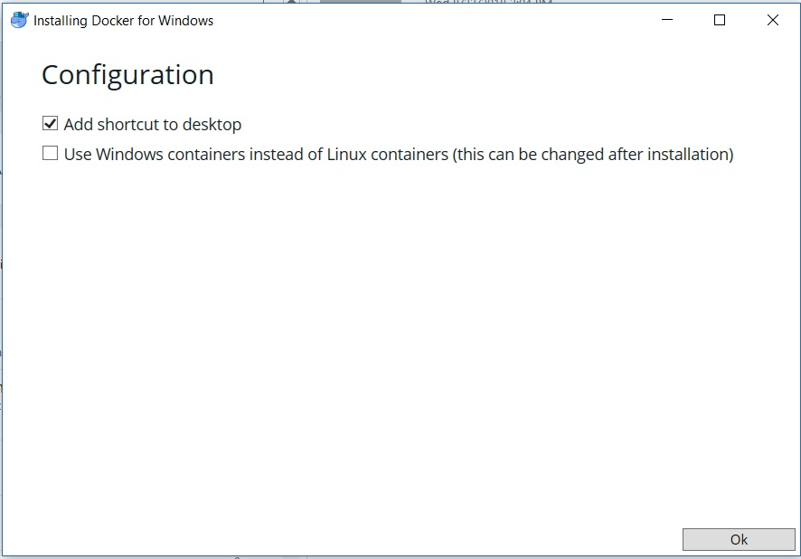

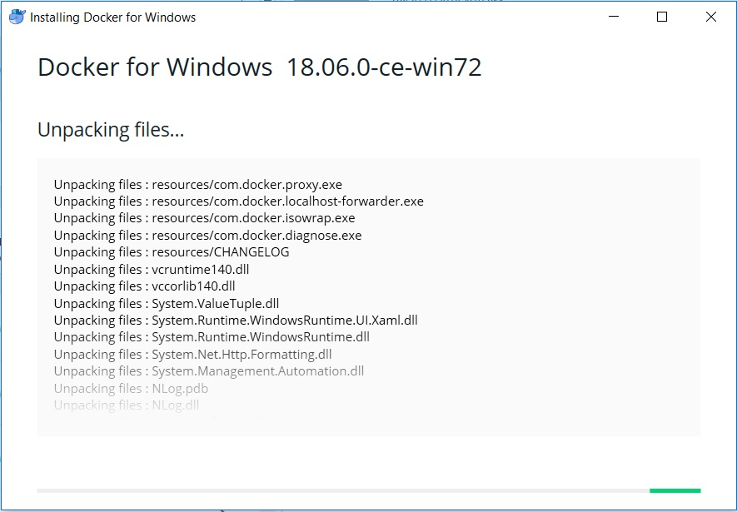

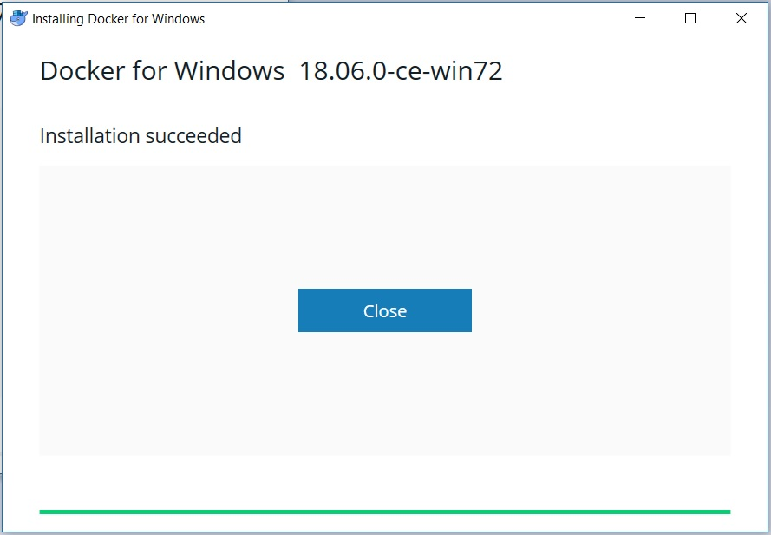

## **Step 4 – Run Docker**

## **Step 5 – Check the version of Docker Installed**

