**DOCUMENTATION**

**MADE BY: - Rahul Joshi**

**USN :- 2GI19CS106**

**BATCH:- 05**

**Project Name:**-SBI ONLINE TRANSACTION SYSTEM

**Language** **:**- Python

**IDE**:- Spyder

**Default User-name: –** Rahul

**Default password: -** rahul7

1. Run the main.py in the folder

2. On opening you will see this window on your screen

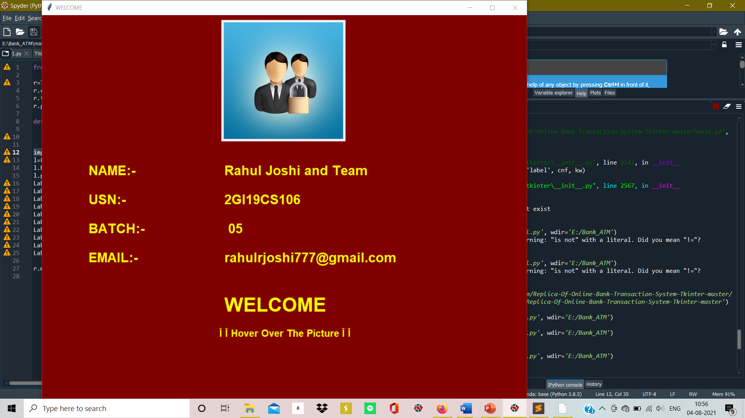

This window contains all information about me. This window will

disappear in when you hover on the Photo.

3. After the above window disappears a new window will open i.e. the Main Window.

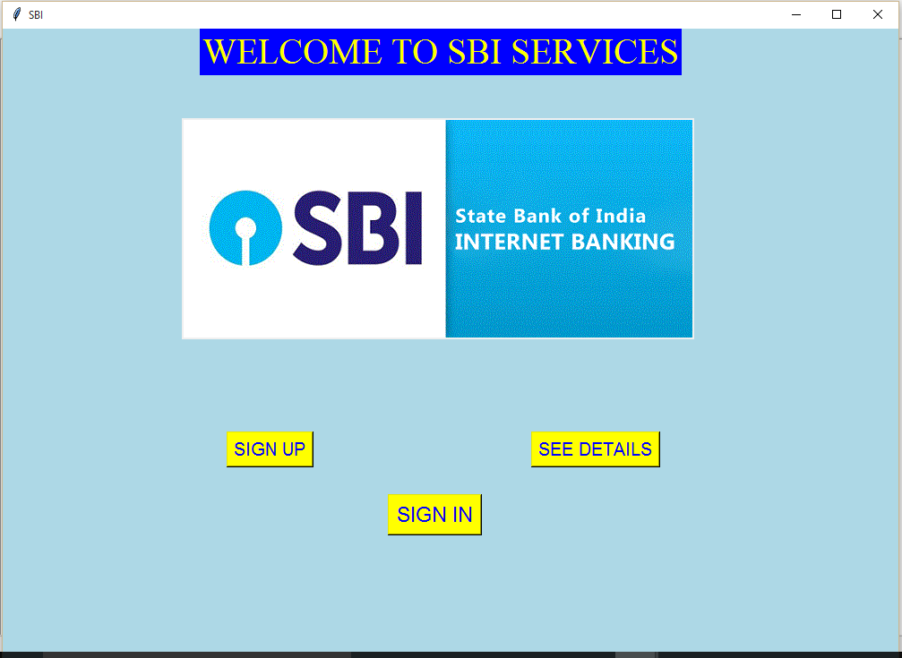

4. If you click the SIGN IN button the following screen appears

The default Username is:- Rahul

Password is:- rahul7

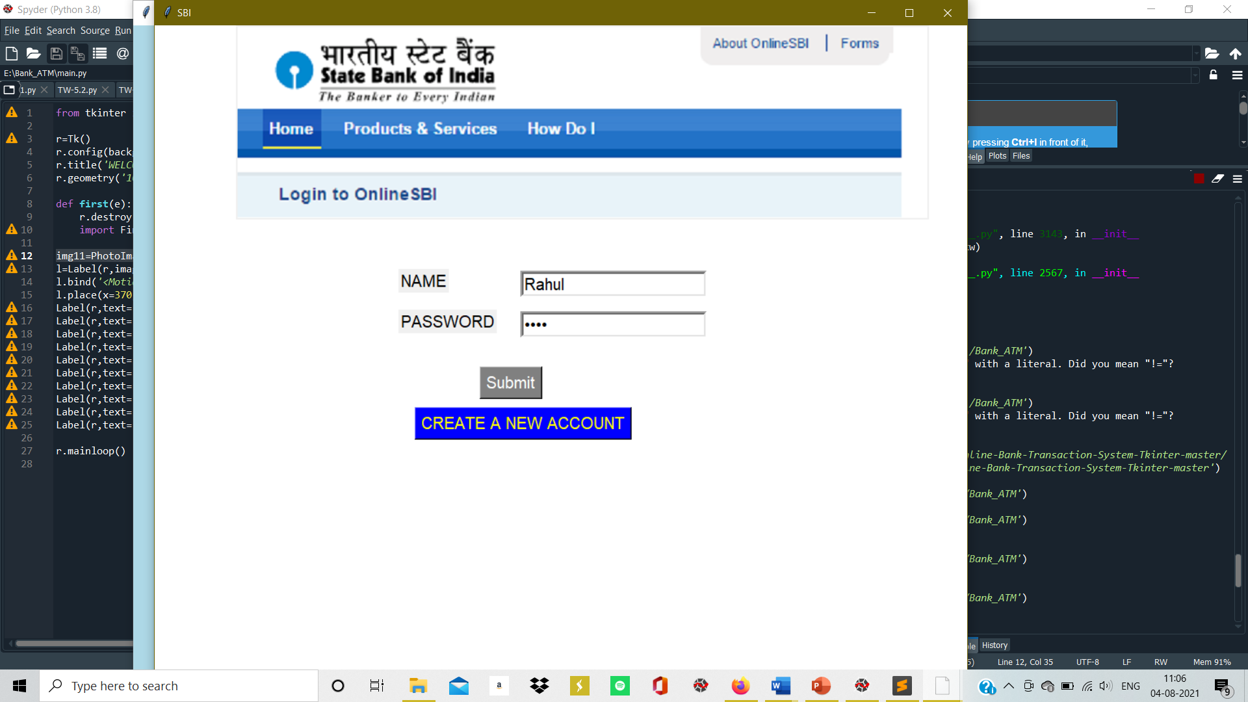

5. If you enter the password wrong then the following messagebox appears

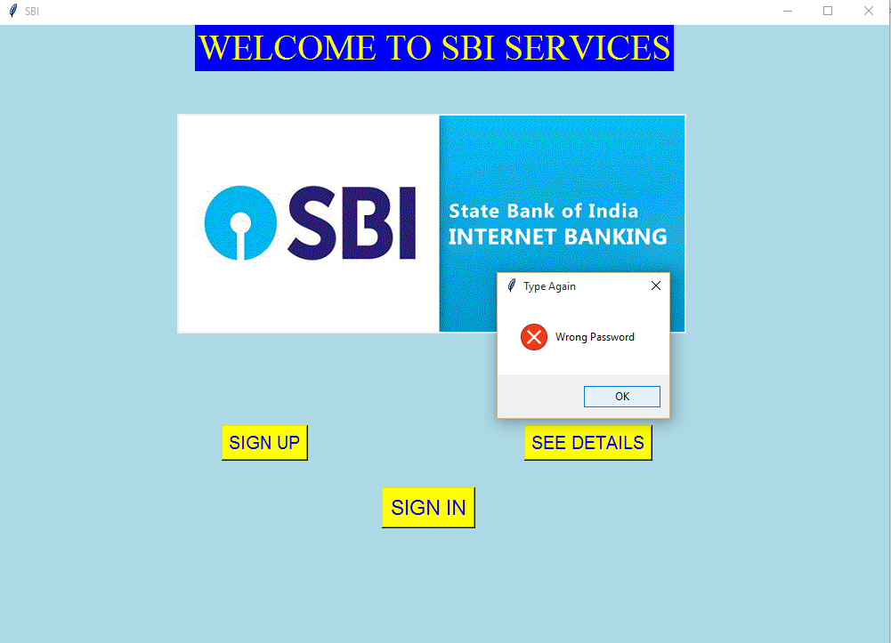

6. If you enter the username wrong or leave the entries empty the following screen appears

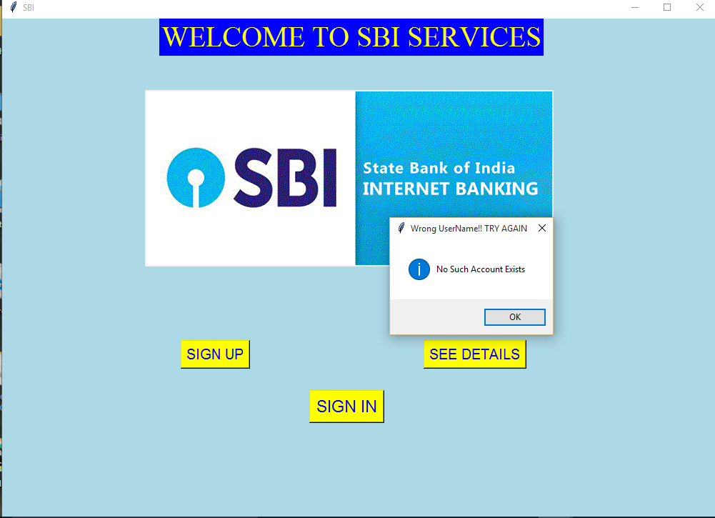

On clicking OK

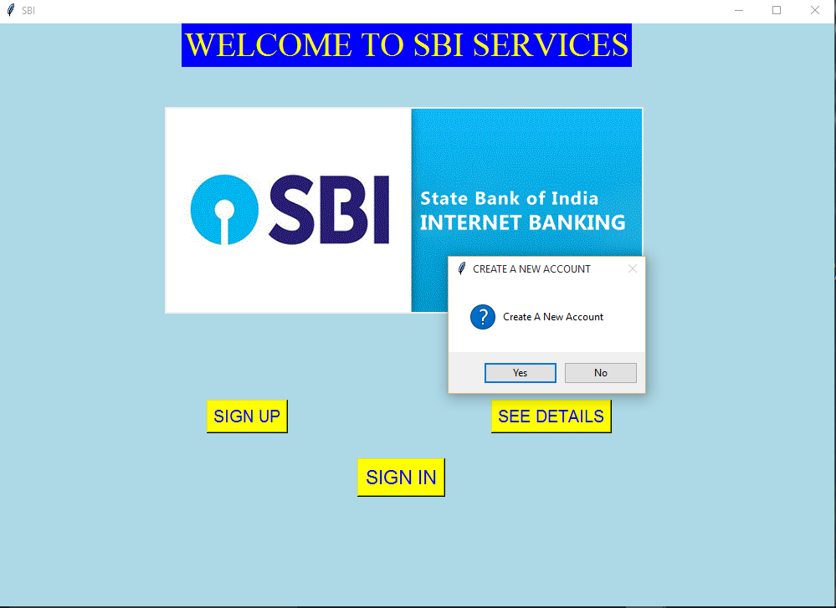

7. If we click Yes then the SIGN UP screen appears which can also appear on clicking on the SIGN UP button on the main screen

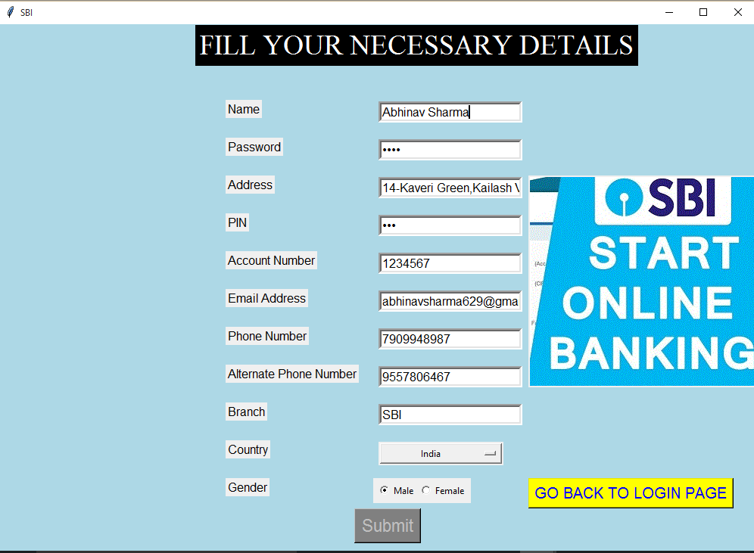

8. If we leave any entry empty then the following message box will appear

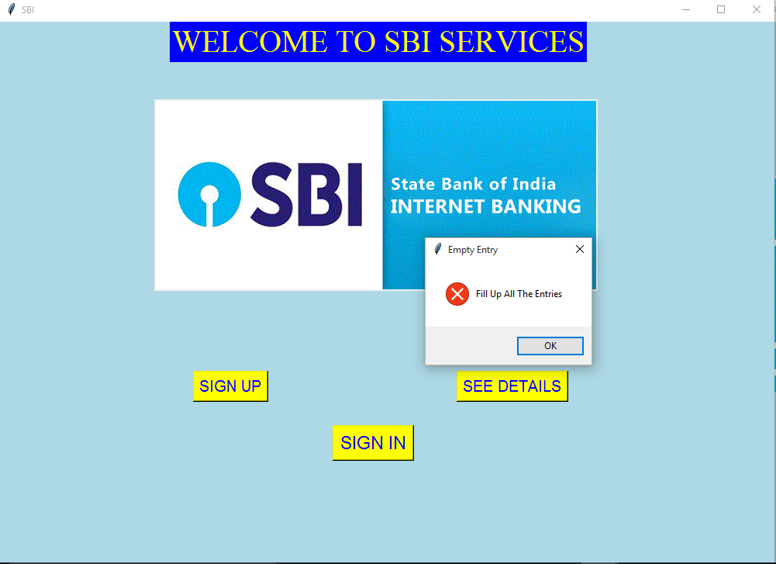

And the SIGN UP screen appears again.

If the user clicks the GO BACK TO LOGIN PAGE then it redirects to the login page that we have earlier also



9. Else if the username and password is filled correct then the message box appears

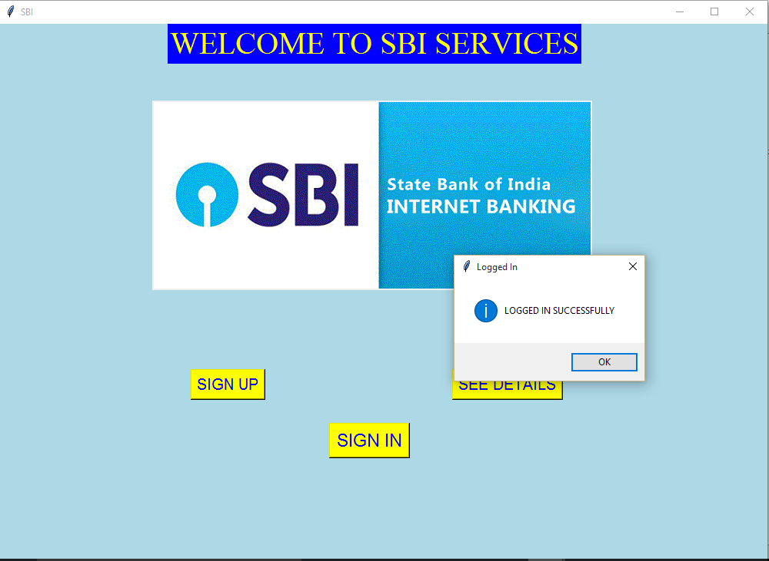

On clicking OK the following screen appears

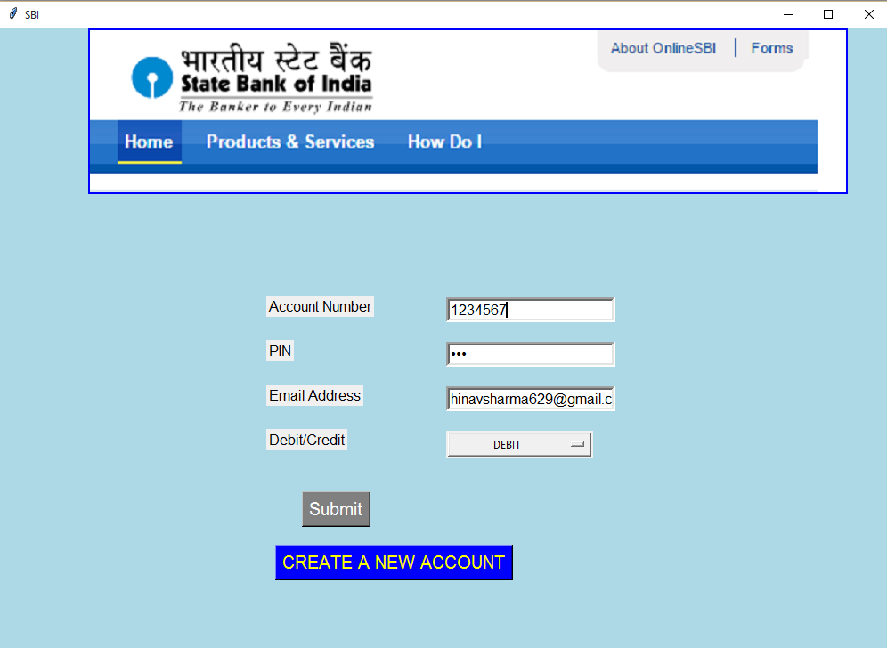

10. The default details are:-

Account Number:- 11140

Pin: -5577

Email Address:- rahul@gmail.com

If wrong details filled i.e. if the Account number in the database doesnot match with your Pin or Email Address the the following screen appears

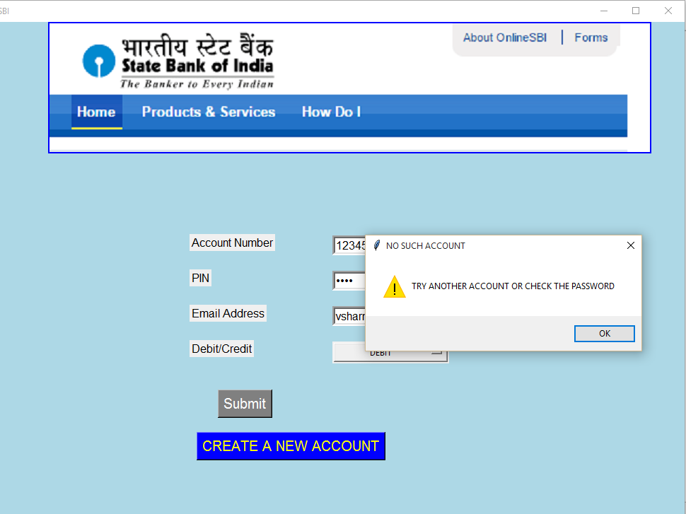

Else if the details are correct and we choose to DEBIT the amount and click Submit then the following screen appears

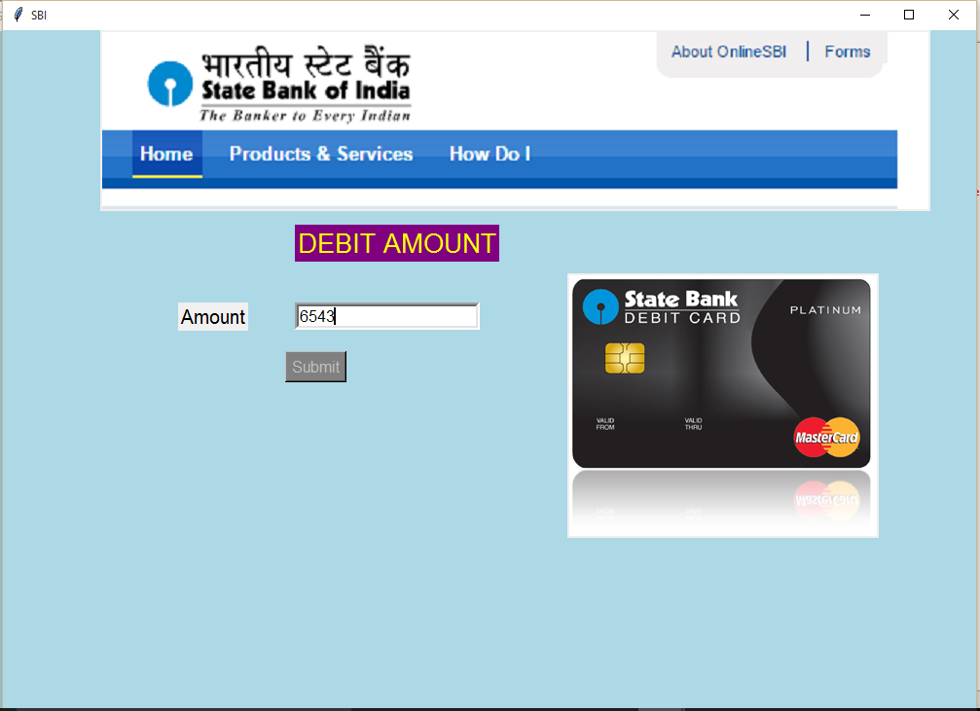

11. Here we have to enter the amount we want to debit and once we click Submit then an EMAIL is sent to the registered mail address of the user which I have commented out for the moment as it contains my password of Gmail.

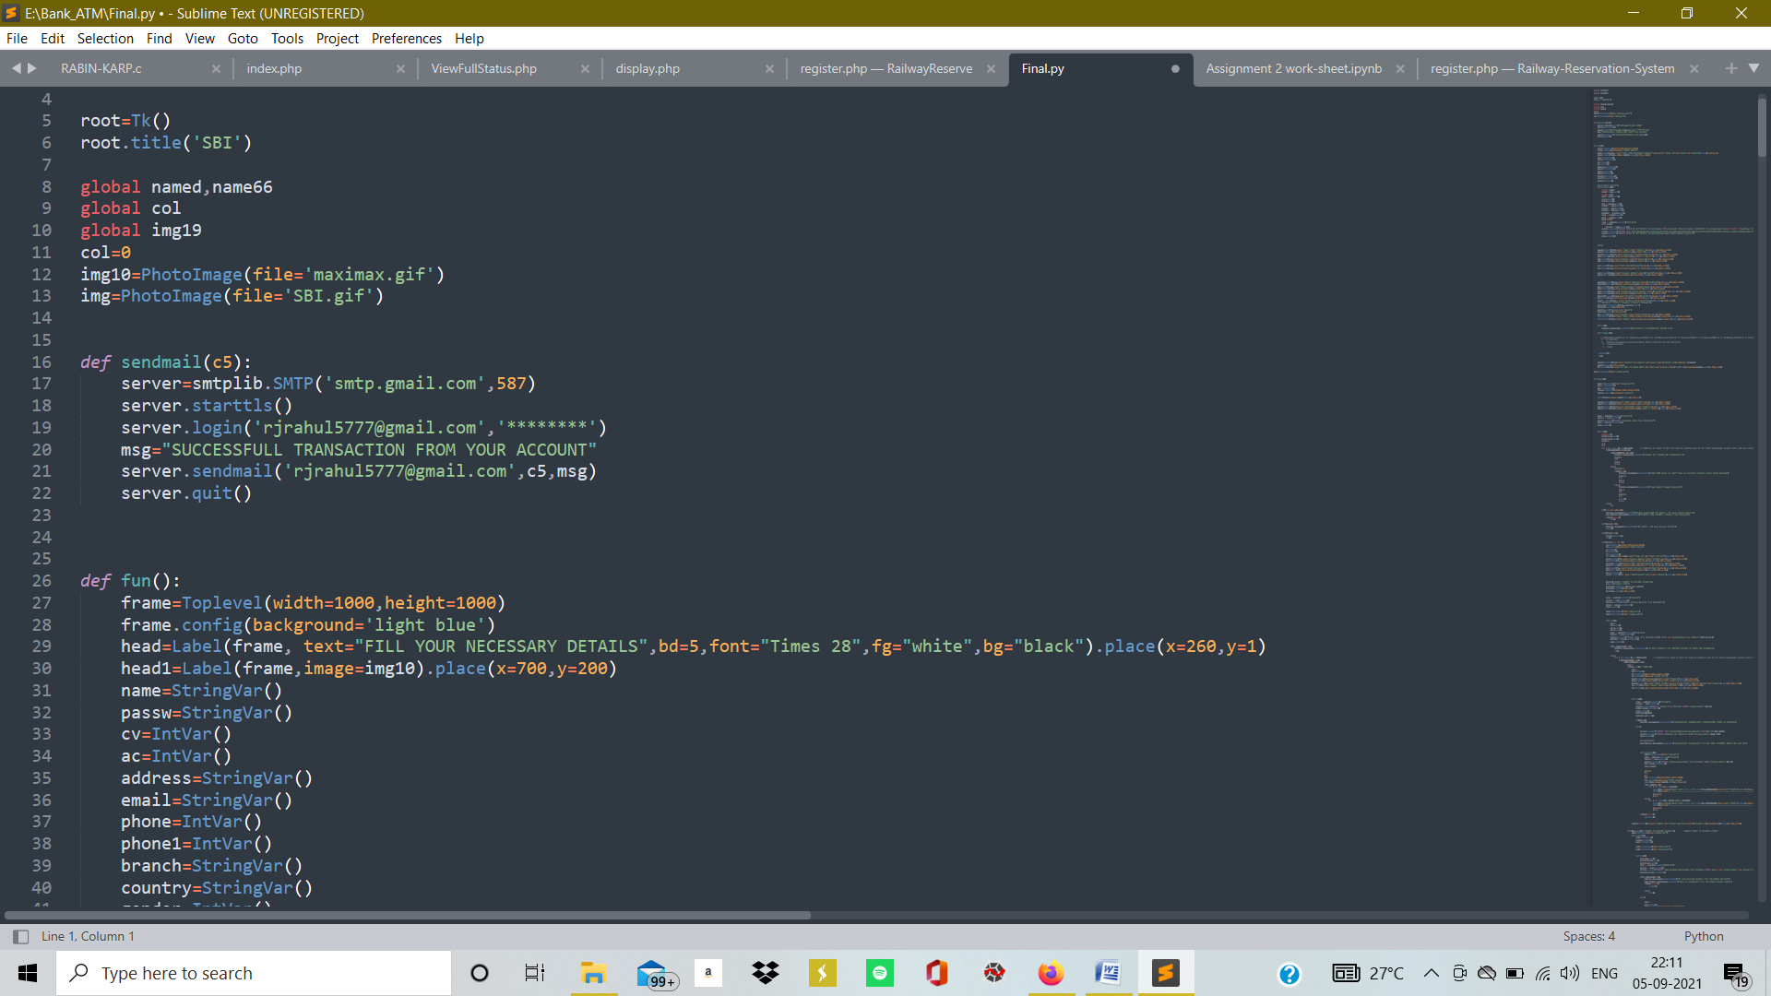

This is the snippet of the code.

It checks the bank balance and if the bank balance is insufficient then the following screen appears and the without giving the user another chance the program terminates to the main screen.

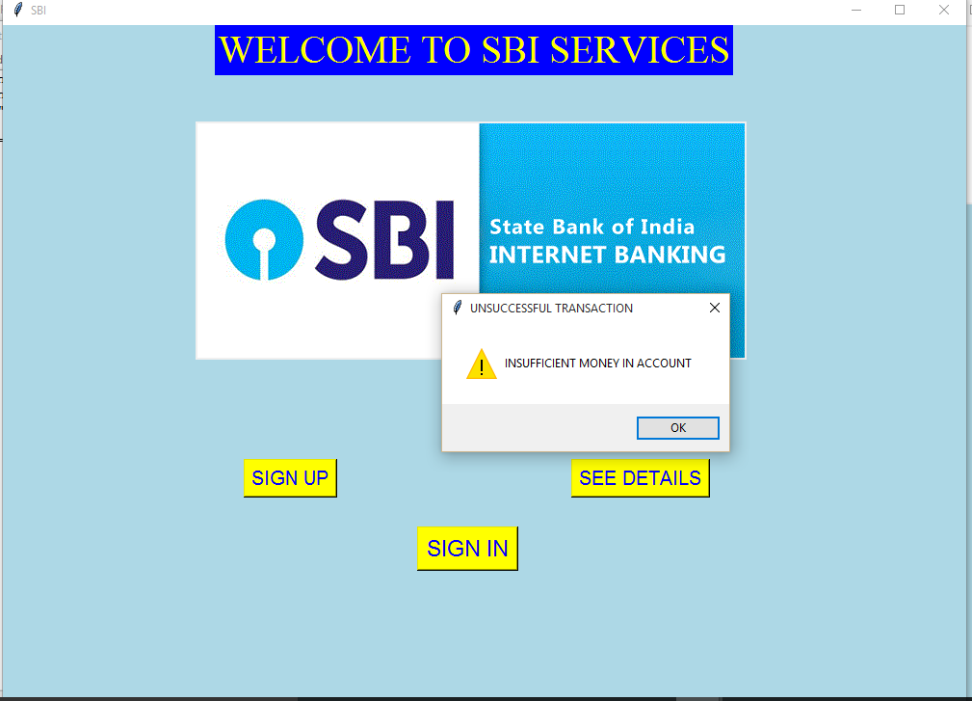

If there is sufficient then the amount gets deducted from the account and the following prompt appears

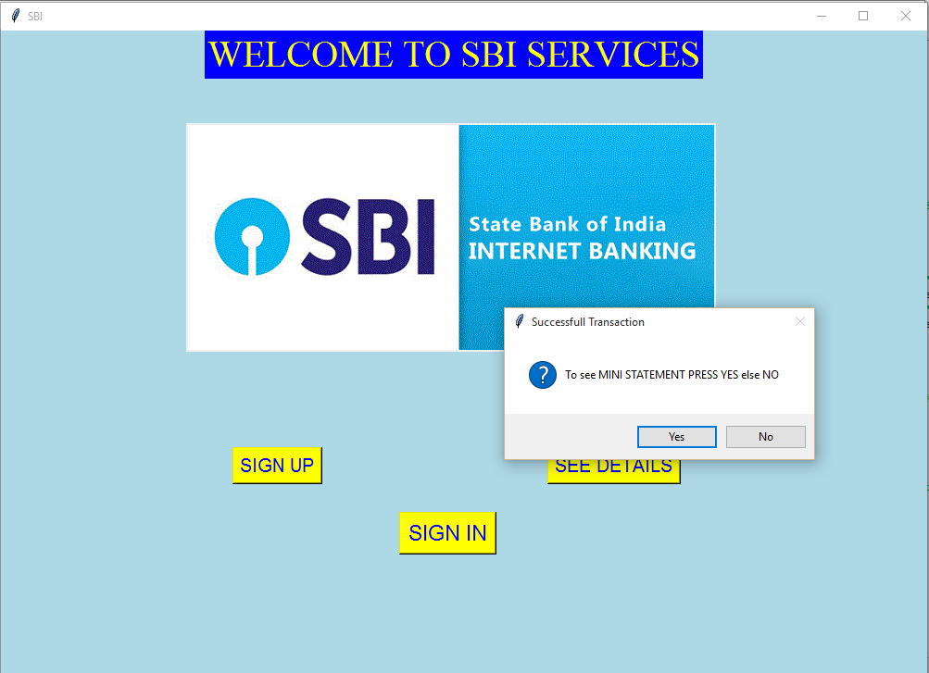

If we click YES then it shows up the mini statement linked with your account upto last 10 transactions

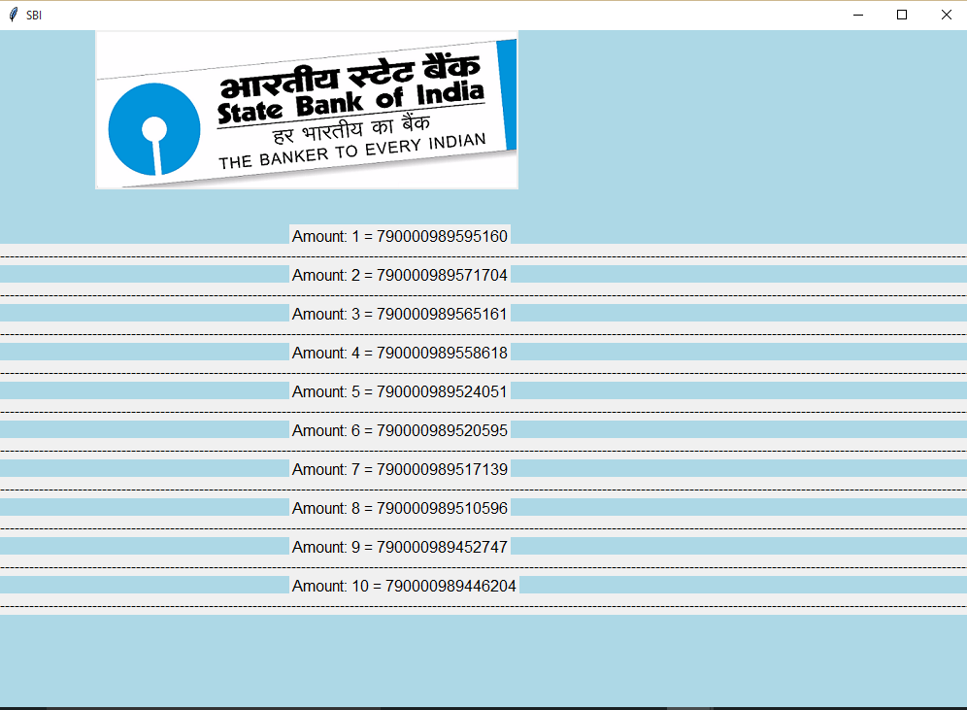

Else the program exists

12. Else if we would have chose the other option that is the CREDIT INTO ANOTHER ACCOUNT instead of DEBIT then the following screen appears

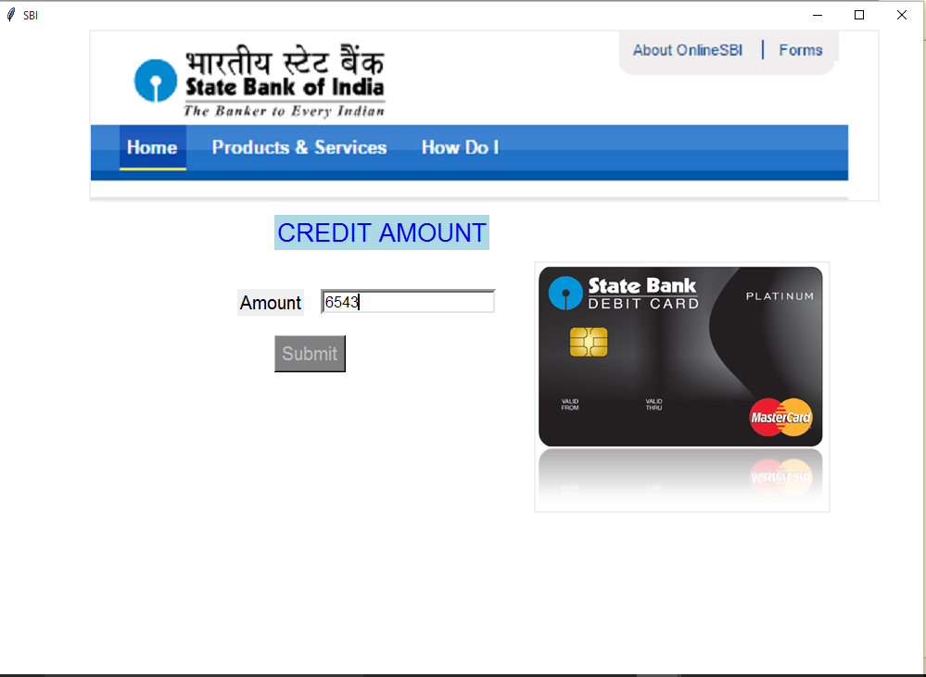

Once we enter the amount and click on the submit button the following screen appears

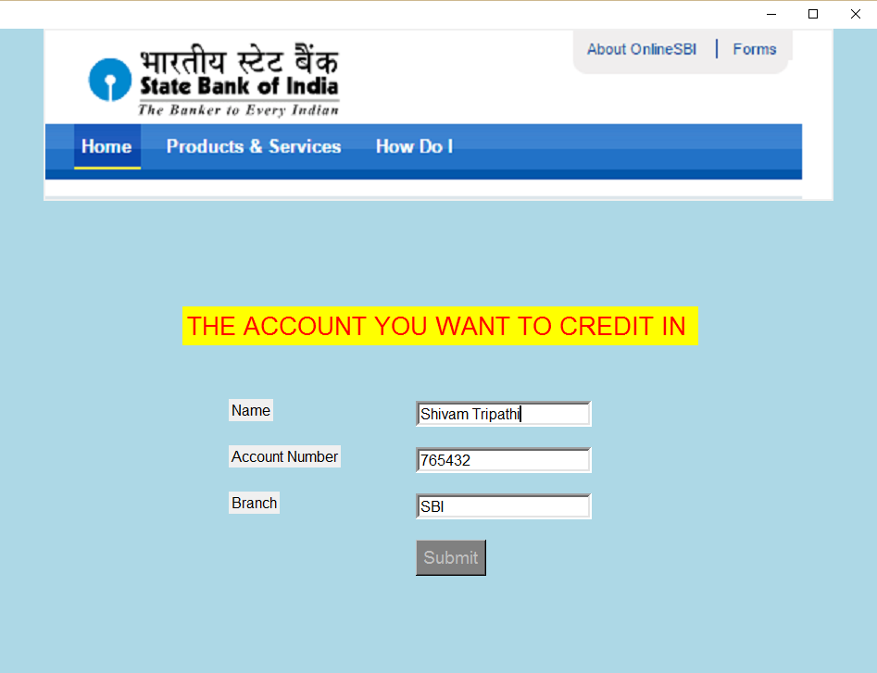

13. Here we need to enter the details of the person’s account to whose account we want to debit the money to.

The default details are:-

**Name:-**ShivamTripathi

**Account Number:-** 7654321

**Branch:-** SBI

If the details don’t match the details in the database or if the user doesn’t exist then the following message appears

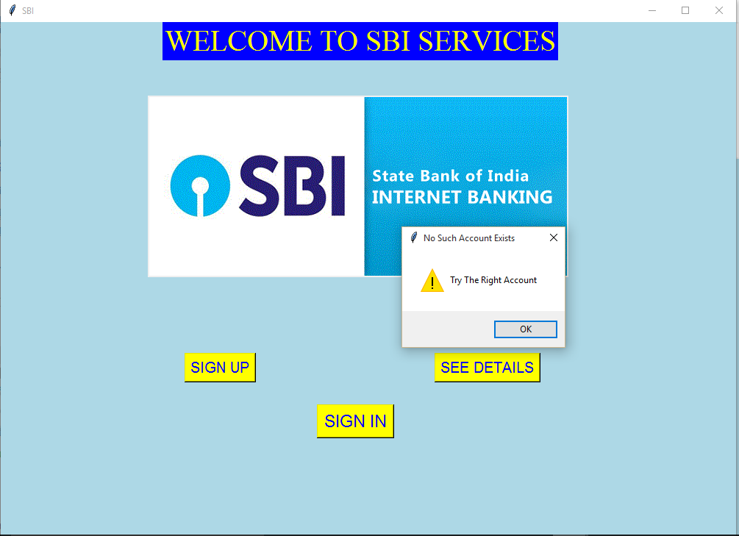

If we click YES then

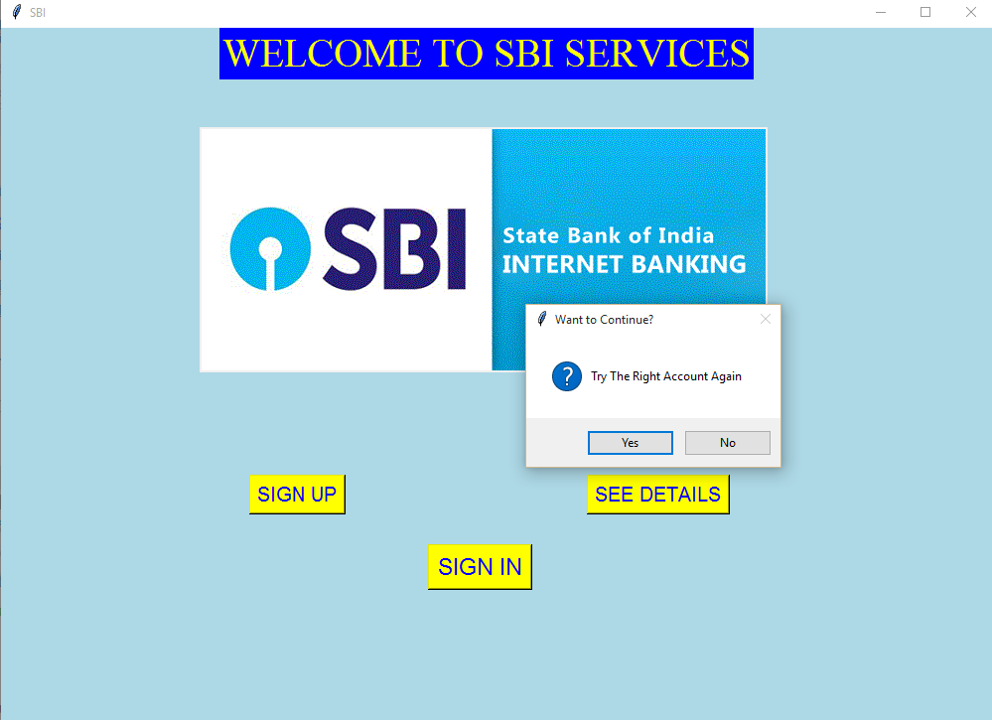

If we click YES then the credit to window appears again.

Else if we enter the correct details then the amount gets debited from your account and gets debited in the following users account and an EMAIL is sent to the registered mail address of the user which I have commented out for the moment as it contains my password of Gmail.



The snippet of the code.

Then the mini statement prompt box appears



If you click YES then the mini statement screen appears



15. If the user clicks on the SEE DETAILS button on the main screen then the details on the bank appears

