**CO1 PYTHON PROGRAMS**

2. Display future leap years from current year to a final year entered by user.

**Program**

s=int(input("Enter the start year: "))

e=int(input("Enter the end year:"))

if(s<e):

print("Leap years are:",end=" ")

for i in range(s,e):

if i%4==0 and i%100!=0:

print(i,end=" ")

**Output**

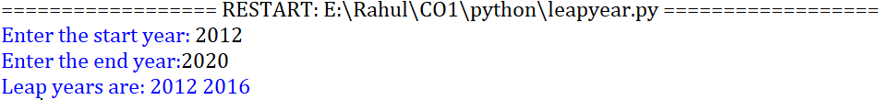

**3.** **List comprehensions:**

i. Generate positive list of numbers from a given list of integers.

**Program**

list=[-2,10,-22,31,54]

re=[num for num in list if num>=0]

print(re)

**Output**



ii. Square of n numbers.

**Program**

n=int(input("Enter the limit: "))

square=[i**2 for i in range(1,n+1)]

print("Square of the numbers: ",square)

**Output**



iii. Form a list of vowels selected from the given word.

**Program**

word=str(input("Enter the word: "))

print("The original string is: ",word)

print("The vowels are: ",end="")

for i in word:

if i in 'aeiouAEIOU':

print([i],end="")

**Output**

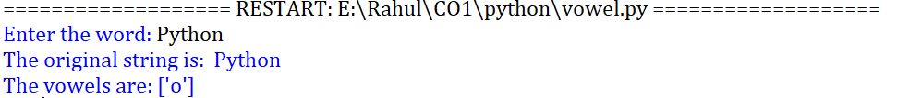

iv. List ordinal value of each element of a word (Hint: use ord() to get ordinal values)

**Program**

w=input("Enter a word:")

print("Ordinal values corresponding to each element is:")

for i in w:

print(i,end=":")

print(ord(i),end=" ")

**Output**

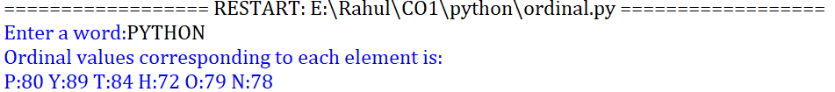

4. Count the occurrences of each word in a line of text.

**Program**

str1 = input("Enter a string : ")

wordlist = str1.split()

count= []

for w in wordlist: count.append(wordlist.count(w))

print("count of the occurrence:" + str(list(zip(wordlist, count))))

**Output**



5. Prompt the user for a list of integers. For all values greater than 100, store ‘over’ instead

**Program**

n=[]

s=int(input("Enter a limit:"))

print("Enter {s} values")

for i in range(0,s):

n.append(int(input()))

print("\nThe list after assinging:\n")

for i in range(0,len(n)):

if n[i]>=100:print("over")

else:

print(n[i])

**Output**

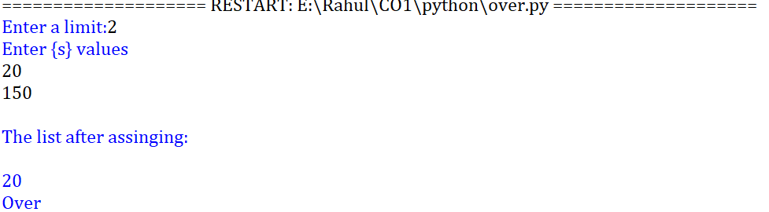

6. Store a list of first names. Count the occurrences of ‘a’ within the list

**Program**

a_list = ["a", "Rahul", "b"]

occ = a_list.count("a")

print("count of occurrences of a :",occ)

**Output**



7. Enter 2 lists of integers. Check (a) Whether list are of same length (b) whether list sums to same value (c) whether any value occur in both.

**Program**

lst=[1,3,5,7,9,11,34]

lst1=[5,13,45,7,20,65,1]

s=int(0)

c=int(0)

if len(lst)==len(lst1):

print("Lists are of same length")

else:

print("Lists have different length")

for i in range(0,len(lst) and len(lst1)):

s=s+lst[i]

c=c+lst1[i]

if(s==c):

print("equal sum")

else:

print("not same sum")

print("Elements that matched are:")

l=[]

for i in range(0,len(lst)):

for j in range(0,len(lst1)):

if lst[i]==lst1[j]:

l.append(lst[i] and lst1[j])

else:

continue

print(l)

**Output**

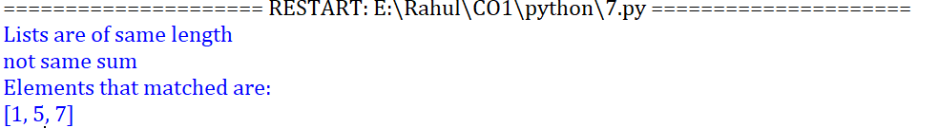

8. Get a string from an input string where all occurrences of first character replaced with ‘$’, except first character. [eg: onion -> oni$n]

**Program**

str1="malayalam"

char = str1[0]

str1=str1.replace(char, '$')

str1=char + str1[1:]

print(str1)

**Output**



9. Create a string from given string where first and last characters exchanged. [eg: python -> nythop]

**Program**

str1=input("Enter a string: ") str2=str1[-1:]+str1[1:-1]+str1[:1]

print("New string: ",str2)

**Output**



10. Accept the radius from user and find area of circle.

**Program**

pi=3.14 r=float(input("Enter the radius of the circle:"))

area=3.14*r*r

print("The area of the circle is: ",area)

**Output**



11. Find biggest of 3 numbers entered.

**Program**

x = int(input("Enter 1st number: "))

y = int(input("Enter 2nd number: "))

z = int(input("Enter 3rd number: "))

if (x > y) and (x > z):

largest = x

elif (y > x) and (y > z):

largest = y

else:

largest = z

print("The largest number is",largest)

**Output**

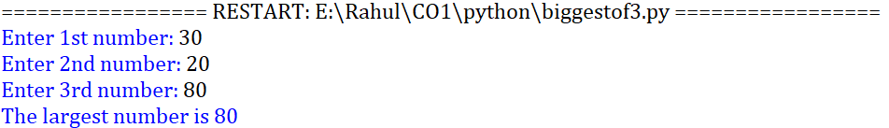

12. Accept a file name from user and print extension of that.

**Program**

file= input("Enter filename : ")

f=file.split(".")

print("Extension of the file is : " + f[-1])

**Output**



13. Create a list of colors from comma-separated color names entered by user.Display first and last colors.

**Program**

a=[]

for i in range(3):

b=input("enter the color:")

a.append(b)

print(a)

print(a[0])

print(a[2])

**Output**

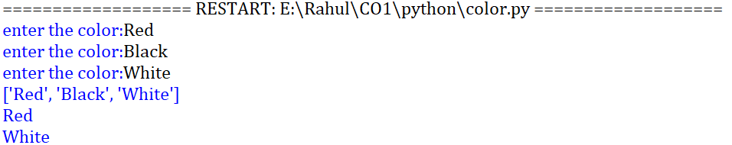

14. Accept an integer n and compute n+nn+nnn

**Program**

n =int(input("Enter a number : "))

x = int( "%s" % n )

y = int( "%s%s" % (n,n) )

z = int( "%s%s%s" % (n,n,n) )

print("n + nn + nnn :",x+y+z)

**Output**



15. Print out all colors from color-list1 not contained in color-list2.

**Program**

color-list1=set(["Yellow","White","Red","Gold","Black"])

color-list2=set(["Yellow"])

print(color-list1.difference(color-list2))

**Output**



16. Create a single string separated with space from two strings by swapping the character at position 1.

**Program**

a="Madrid"

b="Barcelona"

p1=a[0]

p2=b[0]

c=b[0]+a[1:]+" "+a[0]+b[1:]

print(c)

**Output**



19. Find GCD of 2 numbers.

**Program**

x= int(input("Enter 1st number: "))

y= int(input("Enter 2nd number: "))

i = 1

while(i <= x and i <= y):

if(x % i == 0 and y% i == 0):

gcd = i

i = i + 1

print("GCD :", gcd)

**Output**

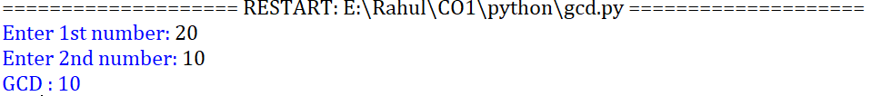

20. From a list of integers, create a list removing even numbers.

**Program**

num = [7,8, 120, 25, 44, 20, 27]

print( "Original list:",num)

num = [x for x in num if x%2!=0]

print("list after removing even numbers:",num)

**Output**

