Amazon Redshift: Architecture and Performance Optimization Guide
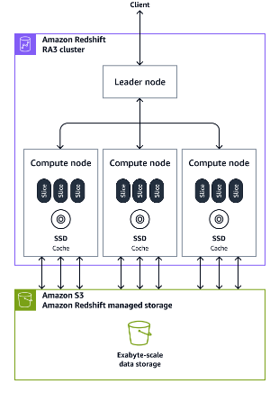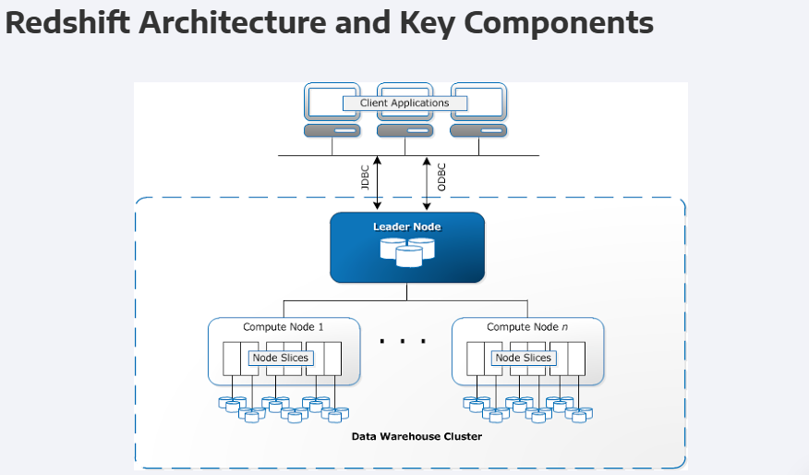

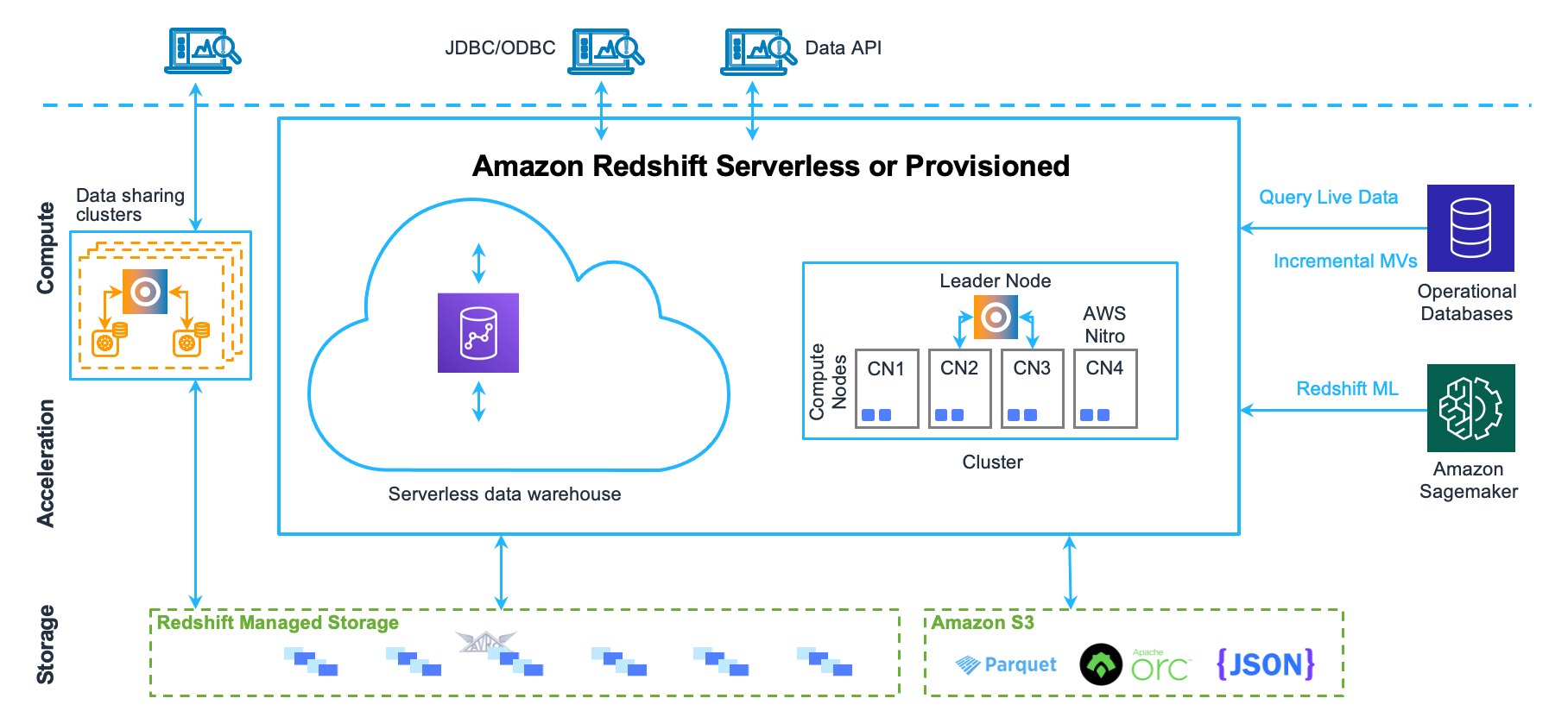

I. Introduction to Amazon Redshift
Amazon Redshift is a fully managed, petabyte-scale data warehouse service in the cloud, designed for high-performance analytics on large datasets. It uses a Massively Parallel Processing (MPP) architecture to distribute data and query workloads across multiple nodes, enabling fast query execution for datasets ranging from gigabytes to petabytes. Redshift is optimized for complex analytical queries and integrates with AWS services like Amazon S3 for scalable storage and Redshift Spectrum for querying external data.

II. Redshift Architecture
Redshift’s architecture is built around a cluster model with distinct roles for processing and storage:
- Leader Node:
  - Manages client connections via JDBC/ODBC.
  - Parses queries, optimizes them, and creates query execution plans.
  - Coordinates work distribution to Compute Nodes and aggregates results.
  - Stores metadata, not user data.
- Compute Nodes:
  - Execute queries in parallel, processing data stored in Redshift Managed Storage (RMS).
  - Divided into Node Slices, logical units with dedicated CPU, memory, and SSD storage.
  - Slice count varies by instance type (e.g., dc2.large has 2 slices, ra3.16xlarge has 16).
- Redshift Managed Storage (RMS):
  - A scalable storage layer separate from compute.
  - Stores data in columnar format using 1 MB data blocks.
  - Caches hot data in SSDs and offloads cold data to Amazon S3.
  - Uses Zone Maps to track min/max values per block for efficient query pruning.
- Amazon S3 Integration:
  - Supports backups, data unloading, and external queries via Redshift Spectrum.
  - RMS moves cold data to S3 transparently for cost-effective scaling.

III. Data Loading and Storage

Data Loading Process
- Ingestion:
  - Data is loaded from sources like Amazon S3 or DynamoDB using the COPY command.
  - Example: COPY sales FROM 's3://mybucket/sales_data' IAM_ROLE 'arn:aws:iam::123:role/MyRole';
- Leader Node Coordination:
  - Parses the command and assigns tasks to Compute Nodes based on the Distribution Style.
- Compute Node Processing:
  - Applies the Distribution Style to assign data to slices.
  - Sorts data if a Sort Key is defined.
  - Stores data in RMS in columnar format.

Storage in RMS
- Columnar Storage: Stores data by column, reducing I/O for analytical queries.
- Data Blocks: Each column is split into 1 MB blocks with Zone Maps and compression metadata.
- Hot vs. Cold Data: RMS caches hot data in SSDs and offloads cold data to S3.

IV. Distribution Styles

Distribution Styles determine how data is spread across Compute Nodes and slices, affecting query performance and data movement.
Types of Distribution Styles
Style | Description | Best Use Case | Data Duplication
EVEN | Distributes rows randomly across slices | General-purpose tables, no specific joins | ❌ No
KEY | Distributes rows based on a Distribution Key | Large tables joined on a specific column | ❌ No
ALL | Duplicates the table across all nodes | Small dimension tables for joins | ✅ Yes
- Default: EVEN for provisioned clusters; AUTO for serverless/RA3 clusters (Redshift chooses based on workload).

Choosing a Distribution Style
- EVEN: Balances workloads but may require data movement during joins.
- KEY: Optimizes joins by colocating rows; risks data skew if the key is unevenly distributed.
- ALL: Eliminates data movement for small tables but increases storage.

V. Sort Keys
Sort Keys define the physical order of data within slices, improving query performance via Zone Maps.
Types of Sort Keys

Type | Description | Best Use Case
Compound | Sorts by the first column, then others | Queries filtering on a primary column
Interleaved | Equal weight to all columns | Queries filtering on multiple columns

Impact of No Sort Key
- Data is stored in insertion order, reducing Zone Map efficiency and slowing queries.

VI. Query Execution and Optimization

Query Execution Flow
- Client Submission: Query sent via JDBC/ODBC.
- Leader Node: Parses, optimizes, and distributes tasks to Compute Nodes.
- Compute Nodes: Fetch and process data blocks in parallel from RMS.
- Result Aggregation: Leader Node aggregates and returns results.

Optimization Techniques
- Zone Maps: Enable block pruning to skip irrelevant data.
- Sort Keys: Order data for faster filtering.
- Distribution Styles: Reduce data movement during joins.

VII. Data Movement in Joins
Joins may trigger data movement if tables aren’t optimally distributed:
Join Type | Description | Data Movement | Performance
Co-located | Same Distribution Key on both tables | ❌ None | 🚀 Fastest
Broadcast | Small table copied to all nodes | ✅ Small table | 👍 Good
Redistribution | Data shuffled across nodes | ✅ Large movement | 🐢 Slowest
Minimizing Data Movement
- Use KEY Distribution with a common join key.
- Apply ALL Distribution for small dimension tables.

VIII. Metadata and System Tables
System tables provide insights into data distribution:
Table | Purpose | Example Query
STV_BLOCKLIST | Tracks block distribution across slices | SELECT node, slice, COUNT(*) FROM STV_BLOCKLIST GROUP BY node, slice;
SVV_TABLE_INFO | Shows distribution and sort key details | SELECT "table", diststyle, sortkey1 FROM SVV_TABLE_INFO;

IX. Best Practices for Performance Optimization
- Distribution Styles: Use KEY for joins, ALL for small tables, EVEN for balance.
- Sort Keys: Apply Compound for primary filters, Interleaved for multi-column queries.
- Query Optimization: Leverage Zone Maps and minimize data movement.

Confusion Summary: Key Areas of Misunderstanding
- Data Storage and Compute Node Roles
  - Confusion: Compute nodes store data persistently.
  - Clarification: Data resides in RMS; compute nodes use SSDs for temporary processing.
- Distribution Styles
  - Confusion: Distribution styles only affect queries, not storage.
  - Clarification: They are applied at load time, impacting storage and performance.
- Sort Keys
  - Confusion: Sort keys are applied during queries.
  - Clarification: They are applied at load time, ordering data in slices.
- Data Movement in Joins
  - Confusion: Unclear when data movement happens.
  - Clarification: Minimized with co-located joins; otherwise, broadcast or redistribution occurs.
- Slices and Data Assignment
  - Confusion: How slices and data assignment work.
  - Clarification: Leader Node assigns slices at load time; compute nodes use metadata to fetch data.

Redshift Spectrum
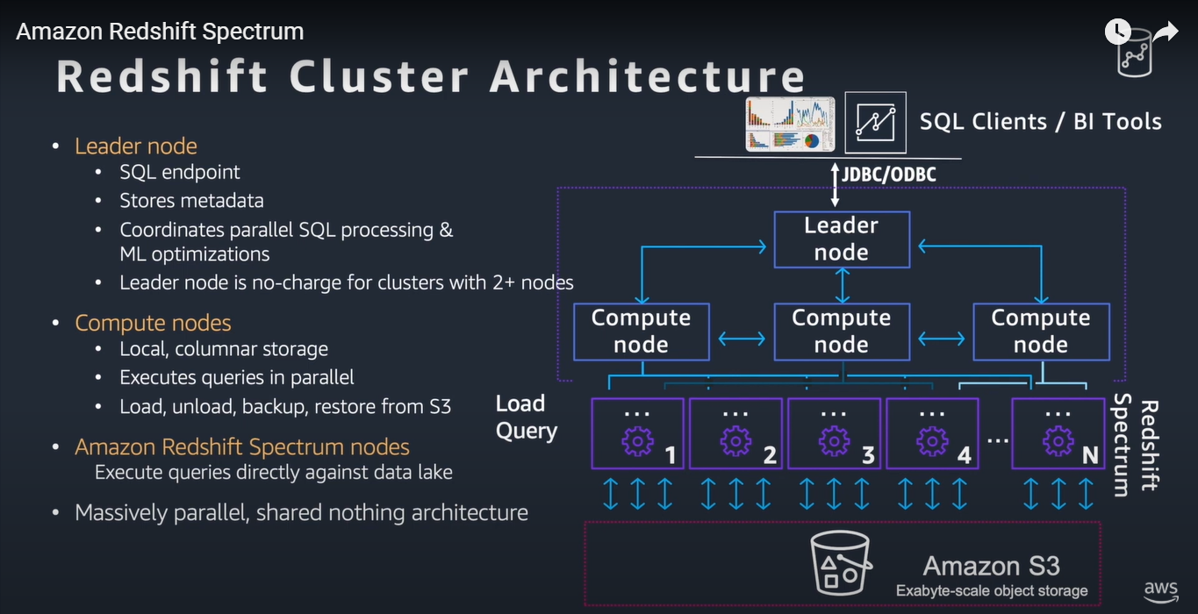
- Redshift Spectrum is the engine that handles queries for external data in S3.
- Leader Node creates the query execution plan, and Redshift Spectrum is responsible for scanning the external data in S3.
- Distribution Styles and Sort Keys only affect Redshift's internal data (in RMS). For external data, Redshift Spectrum handles data retrieval from S3, but distribution styles and sort keys are not applied to external data directly.
- If your query involves both internal and external data, distribution styles and sort keys apply to the internal Redshift data to improve query performance and minimize data shuffling.

