01.Basic Concepts in Machine Learning
Machine Learning is continuously growing in the IT world and gaining strength in different business sectors. Although Machine Learning is in the developing phase, it is popular among all technologies. It is a field of study that makes computers capable of automatically learning and improving from experience. Hence, Machine Learning focuses on the strength of computer programs with the help of collecting data from various observations. In this article, ''Concepts in Machine Learning'', we will discuss a few basic concepts used in Machine Learning such as what is Machine Learning, technologies and algorithms used in Machine Learning, Applications and example of Machine Learning, and much more. So, let's start with a quick introduction to machine learning.

What is Machine Learning?
Machine Learning is defined as a technology that is used to train machines to perform various actions such as predictions, recommendations, estimations, etc., based on historical data or past experience.
Machine Learning enables computers to behave like human beings by training them with the help of past experience and predicted data.
There are three key aspects of Machine Learning, which are as follows:
- Task: A task is defined as the main problem in which we are interested. This task/problem can be related to the predictions and recommendations and estimations, etc.
- Experience: It is defined as learning from historical or past data and used to estimate and resolve future tasks.
- Performance: It is defined as the capacity of any machine to resolve any machine learning task or problem and provide the best outcome for the same. However, performance is dependent on the type of machine learning problems.
- Machine Learning techniques are divided mainly into the following 4 categories:

1. Supervised Learning
Supervised learning is applicable when a machine has sample data, i.e., input as well as output data with correct labels. Correct labels are used to check the correctness of the model using some labels and tags. Supervised learning technique helps us to predict future events with the help of past experience and labeled examples. Initially, it analyses the known training dataset, and later it introduces an inferred function that makes predictions about output values. Further, it also predicts errors during this entire learning process and also corrects those errors through algorithms.

2. Unsupervised Learning
In unsupervised learning, a machine is trained with some input samples or labels only, while output is not known. The training information is neither classified nor labeled; hence, a machine may not always provide correct output compared to supervised learning.

3. Reinforcement Learning
Reinforcement Learning is a feedback-based machine learning technique. In such type of learning, agents (computer programs) need to explore the environment, perform actions, and on the basis of their actions, they get rewards as feedback. For each good action, they get a positive reward, and for each bad action, they get a negative reward. The goal of a Reinforcement learning agent is to maximize the positive rewards. Since there is no labeled data, the agent is bound to learn by its experience only

4. Semi-supervised Learning
Semi-supervised Learning is an intermediate technique of both supervised and unsupervised learning. It performs actions on datasets having few labels as well as unlabeled data. However, it generally contains unlabeled data. Hence, it also reduces the cost of the machine learning model as labels are costly, but for corporate purposes, it may have few labels. Further, it also increases the accuracy and performance of the machine learning model.

02. Interpreting the results of Linear Regression using OLS Summary

This article is to tell you the whole interpretation of the regression summary table. There are many statistical softwares that are used for regression analysis like Matlab, Minitab, spss, R etc. but this article uses python. The Interpretation is the same for other tools as well. This article needs the basics of statistics including basic knowledge of regression, degrees of freedom, standard deviation, Residual Sum Of Squares(RSS), ESS, t statistics etc.
In regression there are two types of variables i.e. dependent variable (also called explained variable) and independent variable (explanatory variable).
The regression line used here is,

The summary table of the regression is given below.
OLS Regression Results
==============================================================================
Dep. Variable: y R-squared: 0.669
Model: OLS Adj. R-squared: 0.667
Method: Least Squares F-statistic: 299.2
Date: Mon, 01 Mar 2021 Prob (F-statistic): 2.33e-37
Time: 16:19:34 Log-Likelihood: -88.686
No. Observations: 150 AIC: 181.4
Df Residuals: 148 BIC: 187.4
Df Model: 1
Covariance Type: nonrobust
==============================================================================
coef std err t P>|t| [0.025 0.975]
------------------------------------------------------------------------------
const -3.2002 0.257 -12.458 0.000 -3.708 -2.693
x1 0.7529 0.044 17.296 0.000 0.667 0.839
==============================================================================
Omnibus: 3.538 Durbin-Watson: 1.279
Prob(Omnibus): 0.171 Jarque-Bera (JB): 3.589
Skew: 0.357 Prob(JB): 0.166
Kurtosis: 2.744 Cond. No. 43.4

Dependent variable: Dependent variable is one that is going to depend on other variables. In this regression analysis Y is our dependent variable because we want to analyse the effect of X on Y.
Model: The method of Ordinary Least Squares(OLS) is most widely used model due to its efficiency. This model gives best approximate of true population regression line. The principle of OLS is to minimize the square of errors ( ∑e_{i}² ).
Number of observations: The number of observation is the size of our sample, i.e. N = 150.

Degree of freedom(df) of residuals:
Degree of freedom is the number of independent observations on the basis of which the sum of squares is calculated.
D.f Residuals = 150 – (1+1) = 148
Degree of freedom(D.f) is calculated as,
Degrees of freedom, D . f = N – K
Where, N = sample size(no. of observations) and K = number of variables + 1

Df of model:
Df of model = K – 1 = 2 – 1 = 1 ,
Where, K = number of variables + 1
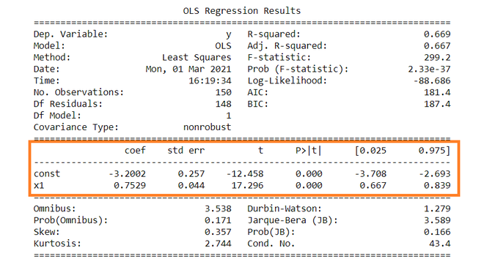

Constant term: The constant terms is the intercept of the regression line. From regression line (eq…1) the intercept is -3.002. In regression we omits some independent variables that do not have much impact on the dependent variable, the intercept tells the average value of these omitted variables and noise present in model.
Coefficient term: The coefficient term tells the change in Y for a unit change in X i.e if X rises by 1 unit then Y rises by 0.7529. If you are familiar with derivatives then you can relate it as the rate of change of Y with respect to X .
Standard error of parameters: Standard error is also called the standard deviation. Standard error shows the sampling variability of these parameters. Standard error is calculated by as –
Standard error of intercept term (b1):

Standard error of coefficient term(b2):

Here, σ² is the Standard error of regression (SER) . And σ² is equal to RSS( Residual Sum Of Square i.e ∑e_{i}² ).

t – statistics:
In theory, we assume that error term follows the normal distribution and because of this the parameters b₁ and b₂ also have normal distributions with variance calculated in above section.
That is ,
- b₁ ∼ N(B₁, σ_{b1}²)
- b₂ ∼ N(B_{2 ,} σ_{b2}²)
Here B₁ and B₂ are true means of b1 and b2.
t – statistics are calculated by assuming following hypothesis –
- H₀ : B₂ = 0 ( variable X has no influence on Y)
- H_{a} : B₂ ≠ 0 (X has significant impact on Y)
Calculations for t – statistics :
t = ( b₁ – B₁ ) / s.e (b₁)
From summary table , b₁ = -3.2002 and se(b₁) = 0.257, So,
t = (-3.2002 – 0) / 0.257 = -12.458
Similarly, b₂ = 0.7529 , se(b₂) = 0.044
t = (0.7529 – 0) / 0.044 = 17.296

p – values:
In theory, we read that p-value is the probability of obtaining the t statistics at least as contradictory to H₀ as calculated from assuming that the null hypothesis is true. In the summary table, we can see that P-value for both parameters is equal to 0. This is not exactly 0, but since we have very larger statistics (-12.458 and 17.296) p-value will be approximately 0.
If you know about significance levels then you can see that we can reject the null hypothesis at almost every significance level.

Confidence intervals:
There are many approaches to test the hypothesis, including the p-value approach mentioned above. The confidence interval approach is one of them. 5% is the standard significance level (∝) at which C.I’s are made.
C.I for B₁ is ( b₁ – t_{∝/2} s.e(b₁) , b₁ + t_{∝/2} s.e(b₁) )
Since ∝ = 5 %, b₁ = -3.2002, s.e(b₁) =0.257 , from t table , t_{0.025,148} = 1.655,
After putting values the C.I for B₁ is approx. ( -3.708 , -2.693 ). Same can be done for b₂ as well.
While calculating p values we rejected the null hypothesis we can see same in C.I as well. Since 0 does not lie in any of the intervals so we will reject the null hypothesis.
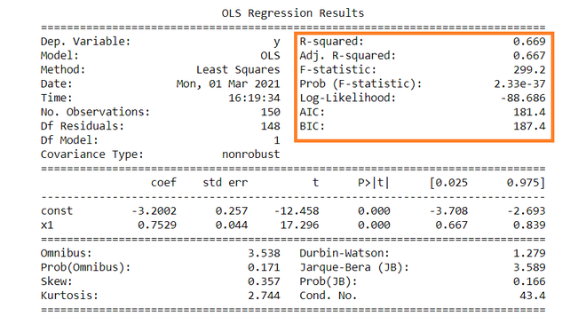

R – squared value:
R² is the coefficient of determination that tells us that how much percentage variation independent variable can be explained by independent variable. Here, 66.9 % variation in Y can be explained by X. The maximum possible value of R² can be 1, means the larger the R² value better the regression.

F – statistic:
F test tells the goodness of fit of a regression. The test is similar to the t-test or other tests we do for the hypothesis. The F – statistic is calculated as below –

Inserting the values of R², n and k, F = (0.669/1) / (0.331/148) = 229.12.
You can calculate the probability of F >229.1 for 1 and 148 df, which comes to approx. 0. From this, we again reject the null hypothesis stated above.
The remaining terms are not often used. Terms like Skewness and Kurtosis tells about the distribution of data. Skewness and kurtosis for the normal distribution are 0 and 3 respectively. Jarque-Bera test is used for checking whether an error has normal distribution or not.

03. Accuracy metrics regression
Regression refers to predictive modeling problems that involve predicting a numeric value.
It is different from classification that involves predicting a class label. Unlike classification, you cannot use classification accuracy to evaluate the predictions made by a regression model.
Instead, you must use error metrics specifically designed for evaluating predictions made on regression problems.
In this tutorial, you will discover how to calculate error metrics for regression predictive modeling projects.
After completing this tutorial, you will know:
- Regression predictive modeling are those problems that involve predicting a numeric value.
- Metrics for regression involve calculating an error score to summarize the predictive skill of a model.
- How to calculate and report mean squared error, root mean squared error, and mean absolute error.

Regression Metrics for Machine Learning
by Jason Brownlee on January 20, 2021 in Python Machine Learning
Tweet Tweet Share Share
Last Updated on February 16, 2021
Regression refers to predictive modeling problems that involve predicting a numeric value.
It is different from classification that involves predicting a class label. Unlike classification, you cannot use classification accuracy to evaluate the predictions made by a regression model.
Instead, you must use error metrics specifically designed for evaluating predictions made on regression problems.
In this tutorial, you will discover how to calculate error metrics for regression predictive modeling projects.
After completing this tutorial, you will know:
- Regression predictive modeling are those problems that involve predicting a numeric value.
- Metrics for regression involve calculating an error score to summarize the predictive skill of a model.
- How to calculate and report mean squared error, root mean squared error, and mean absolute error.
Let’s get started.

Tutorial Overview
This tutorial is divided into three parts; they are:
- Regression Predictive Modeling
- Evaluating Regression Models
- Metrics for Regression
  - Mean Squared Error
  - Root Mean Squared Error
  - Mean Absolute Error

Regression Predictive Modeling
Predictive modeling is the problem of developing a model using historical data to make a prediction on new data where we do not have the answer.
Predictive modeling can be described as the mathematical problem of approximating a mapping function (f) from input variables (X) to output variables (y). This is called the problem of function approximation.
The job of the modeling algorithm is to find the best mapping function we can given the time and resources available.
For more on approximating functions in applied machine learning, see the post:
- How Machine Learning Algorithms Work
Regression predictive modeling is the task of approximating a mapping function (f) from input variables (X) to a continuous output variable (y).
Regression is different from classification, which involves predicting a category or class label.
For more on the difference between classification and regression, see the tutorial:
- Difference Between Classification and Regression in Machine Learning
A continuous output variable is a real-value, such as an integer or floating point value. These are often quantities, such as amounts and sizes.
For example, a house may be predicted to sell for a specific dollar value, perhaps in the range of 100,000��200,000.
- A regression problem requires the prediction of a quantity.
- A regression can have real-valued or discrete input variables.
- A problem with multiple input variables is often called a multivariate regression problem.
- A regression problem where input variables are ordered by time is called a time series forecasting problem.

