TELECOM CUSTOMER CHURN ANALYSIS

Insights & Recommendations Report

Prepared using an end-to-end analytics pipeline:

Python (Data Cleaning & EDA) → MySQL (Star-Schema Data Model) → Power BI (Executive Dashboard)

Dataset: | 7,043 telecom customers
Report Date: | September 2026
Prepared For: | Client Stakeholder Review

1. Executive Summary
This report analyzes customer churn for a telecommunications provider based on a cleaned dataset of 7,043 customers. The objective is to quantify overall churn, identify the customer segments and service attributes most strongly associated with churn, and translate those findings into concrete retention actions.
Overall, 26.5% of customers in the dataset have churned. Churn is heavily concentrated among a specific customer profile: new, month-to-month customers on fiber-optic internet who pay by electronic check and have not subscribed to Tech Support or Online Security add-ons. These patterns are consistent and stack — customers meeting several of these criteria together show much higher churn risk than any single factor alone.
26.5%  Overall churn rate | 42.7%  Month-to-month churn rate | 47.4%  Churn in first 12 months

Top drivers of churn identified
- Contract type — month-to-month customers churn at more than 15x the rate of two-year contract customers.
- Tenure — churn is highest in the first year and falls sharply the longer a customer stays.
- Internet service — fiber-optic customers churn at more than double the rate of DSL customers.
- Payment method — electronic check payers churn at roughly 3x the rate of automatic payment methods.
- Support add-ons — customers without Tech Support or Online Security churn at roughly 2.8x the rate of those with these services.
- Pricing — churned customers pay meaningfully higher average monthly charges than retained customers.

2. Project Methodology
The analysis followed a three-stage analytics pipeline, moving raw data through cleaning, modeling, and visualization:
Stage | Tool | What was done
Data Cleaning & EDA | Python (Pandas, Matplotlib) | Removed duplicates, resolved missing values, standardized categories, and explored churn patterns across customer segments.
Data Modeling | MySQL | Built a star schema (one fact table and four dimension tables) to support fast, reliable business-question querying.
Reporting & Dashboard | Power BI | Connected to the modeled data to deliver an interactive executive dashboard for ongoing monitoring.

Data quality steps
- Removed 5 exact duplicate customer records (7,048 → 7,043 rows).
- Investigated and resolved missing Total Charges values by imputing them from Monthly Charges (affected customers had zero tenure, i.e., brand-new accounts).
- Converted Monthly Charges and Total Charges from text to numeric types, removing currency symbols.
- Standardized inconsistent category labels (e.g., unifying 'month to month' and 'Month-to-month').
- Engineered a Tenure Group feature (0–12, 13–24, 25–48, 49+ months) to support segment-level analysis.
Star-schema data model
The cleaned data was loaded into MySQL and organized into a star schema for efficient, reusable analysis:
Table | Type | Purpose
fact_churn | Fact | One row per customer: charges, churn outcome, and foreign keys to all dimensions.
dim_customer | Dimension | Demographics and tenure (gender, senior citizen, partner, dependents, tenure group).
dim_contract | Dimension | Contract type and paperless billing status.
dim_service | Dimension | The full service bundle a customer subscribes to (internet, phone, security, support, streaming).
dim_payment | Dimension | Payment method.
This structure was validated end-to-end (row counts, referential integrity, and orphan-key checks all passed) and used to answer the ten business questions detailed in Section 4.

3. Key Findings

3.1 Overall Churn
Of 7,043 customers, 1,869 have churned and 5,174 remain active — an overall churn rate of 26.5%. This is the baseline against which every segment below is compared.
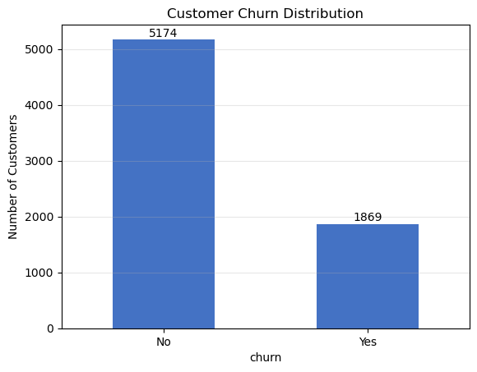
Figure 1. Customer churn distribution (No vs. Yes).

3.2 Contract Type Is the Single Strongest Predictor
Churn rate falls sharply as contract commitment increases. Month-to-month customers are far more likely to leave than customers on fixed-term contracts.
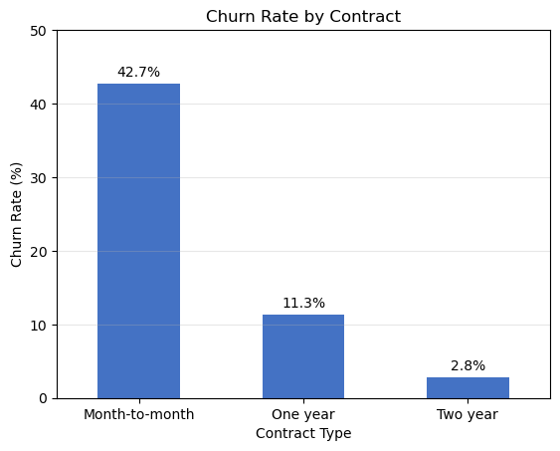
Figure 2. Churn rate by contract type.
Contract Type | Churn Rate
Month-to-month | 42.7%
One year | 11.3%
Two year | 2.8%

3.3 New Customers Churn at a Much Higher Rate
Average tenure for retained customers is 37.6 months versus just 18.0 months for churned customers. Risk is concentrated in a customer's first year and declines steadily the longer they stay.
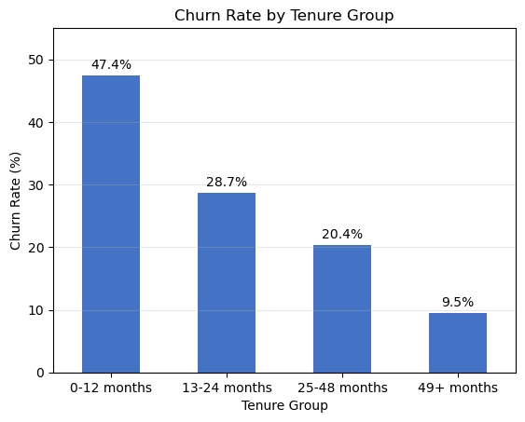
Figure 3. Churn rate by tenure group.
Tenure Group | Churn Rate
0–12 months | 47.4%
13–24 months | 28.7%
25–48 months | 20.4%
49+ months | 9.5%

3.4 Fiber-Optic Customers Churn Most Among Internet Services
Fiber-optic subscribers churn at 41.9%, more than double the DSL rate and nearly 6x the rate of customers with no internet service. This points to a service-quality, pricing, or expectations gap specific to the fiber product, rather than internet access itself.
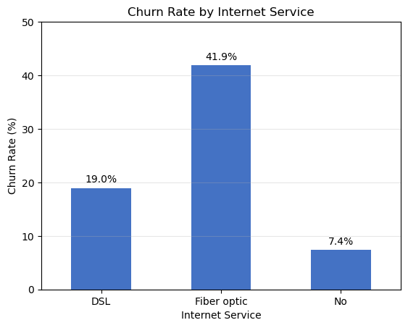
Figure 4. Churn rate by internet service type.
Internet Service | Churn Rate
Fiber optic | 41.9%
DSL | 19.0%
No internet service | 7.4%

3.5 Electronic Check Payers Churn Most
Customers paying by electronic check churn at 45.3% — roughly three times the rate of customers on automatic bank transfer or credit card payment. Manual, recurring-effort payment methods are strongly associated with disengagement and churn.
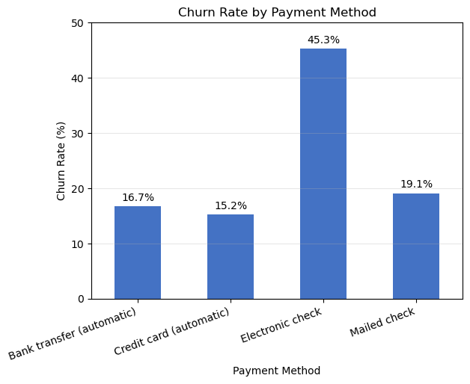
Figure 5. Churn rate by payment method.
Payment Method | Churn Rate
Electronic check | 45.3%
Mailed check | 19.1%
Bank transfer (automatic) | 16.7%
Credit card (automatic) | 15.2%

3.6 Support Add-ons Are Associated With Lower Churn
Customers without Tech Support churn at 41.6%, compared to 15.2% for those with it — a difference of more than 2.7x. Online Security shows an almost identical pattern (41.8% vs. 14.6%). These services appear to meaningfully increase customer stickiness, whether through the practical value delivered or the added switching friction they create.
Service | Without Service | With Service
Tech Support | 41.6% | 15.2%
Online Security | 41.8% | 14.6%

3.7 Household Structure Correlates With Loyalty
Customers with a partner churn at 19.7% versus 33.0% for those without one. Customers with dependents churn at 15.5% versus 31.3% for those without. Single customers with no dependents represent a higher-risk demographic segment.
Household Attribute | Without | With
Partner | 33.0% | 19.7%
Dependents | 31.3% | 15.5%

3.8 Senior Citizens Churn at a Notably Higher Rate
Senior citizens churn at 41.7%, compared with 23.6% for non-seniors — nearly double. This is one of the largest gaps in the dataset by any single demographic attribute and suggests the senior segment may need a distinct retention approach (e.g. simplified plans, dedicated support).
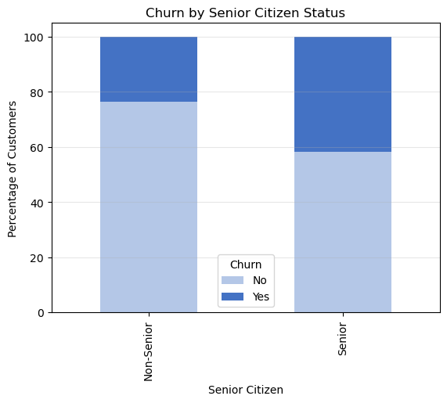
Figure 6. Churn distribution by senior citizen status.

3.9 Pricing: Churned Customers Pay More Per Month
Customers who churned paid an average of $74.42/month, versus $61.27/month for retained customers. However, average lifetime (total) charges are lower for churned customers ($1,532 vs. $2,550) — a direct consequence of their shorter tenure rather than lower spend intensity. In other words, churned customers were often higher-value on a monthly basis but left before that value could compound.
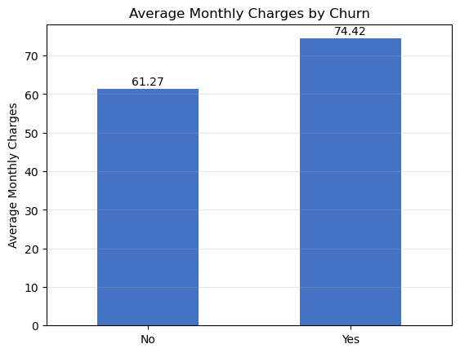
Figure 7. Average monthly charges by churn status.

3.10 Highest-Risk Segment
Combining the strongest individual drivers identifies the single highest-risk customer profile in the dataset: month-to-month contract, fiber-optic internet, tenure under 12 months. This segment should be the primary target for proactive retention investment, as it concentrates the largest share of preventable churn.

4. Business Questions Answered (SQL Analysis)
The star-schema data model in MySQL was used to directly answer ten business questions posed at the start of the project. A condensed summary is provided below; full queries are available in the accompanying SQL file.
# | Business Question | Answer
1 | What is the overall churn rate? | 26.54% (1,869 of 7,043 customers)
2 | Which contract type has the highest churn? | Month-to-month, at 42.7%
3 | Are new customers more likely to churn? | Yes — 47.4% churn in the first 12 months vs. 9.5% after 49+ months
4 | Which internet service has the highest churn? | Fiber optic, at 41.9%
5 | Which payment method has the highest churn? | Electronic check, at 45.3%
6 | Does Tech Support reduce churn? | Yes — 41.6% without vs. 15.2% with Tech Support
7 | Does Online Security relate to lower churn? | Yes — 41.8% without vs. 14.6% with Online Security
8 | Do higher monthly charges relate to higher churn? | Yes — churned customers average $74.42/mo vs. $61.27/mo
9 | Which customer segments are most at risk? | Month-to-month + fiber-optic + low tenure segments
10 | What actions can reduce churn? | See Section 5 — Recommendations

5. Recommendations
The following actions are prioritized by expected impact on churn reduction, based on the segment sizes and churn-rate gaps identified above.

1 | Target new, month-to-month fiber customers first  This is the highest-risk segment in the dataset. Launch a proactive retention program — onboarding check-ins, satisfaction surveys, and early-tenure incentives — during customers' first 12 months on fiber, month-to-month plans.

2 | Migrate month-to-month customers to term contracts  Offer discounts, bundled perks, or loyalty pricing to convert month-to-month customers to one- or two-year contracts, where churn drops to 11.3% and 2.8% respectively.

3 | Investigate the fiber-optic customer experience  Fiber churn (41.9%) is more than double DSL churn (19.0%). Review pricing relative to perceived value, service reliability, and competitive alternatives specifically for fiber subscribers.

4 | Promote Tech Support and Online Security add-ons  Both services are associated with roughly a 2.7x reduction in churn. Bundle them into onboarding by default or offer a free trial period to at-risk segments.

5 | Address the electronic-check payment experience  Electronic check payers churn at 45.3%, nearly 3x the rate of automatic-payment customers. Incentivize migration to autopay (bank transfer or credit card) with a small recurring discount or friction-free enrollment.

6 | Build a dedicated senior-citizen retention track  Seniors churn at nearly double the rate of non-seniors (41.7% vs. 23.6%). Consider simplified plans, proactive outreach, and accessible support channels for this segment.

7 | Prioritize high-value, high-risk customers for retention spend  Churned customers had higher average monthly charges ($74.42) than retained ones ($61.27). Weight retention investment toward high-monthly-value customers in the risk segments above to protect revenue, not just customer count.

6. Project Deliverables
This analysis was delivered as an integrated set of technical and business artifacts:
Deliverable | Description
Customer_Churn_EDA_Analysis.ipynb | Python notebook covering data cleaning, validation, and exploratory analysis with visualizations.
Customer_Churn_Analysis_SQL_file.sql | MySQL script building the star-schema data model and answering all business questions.
star_schema.mwb | MySQL Workbench model file documenting the database design.
Customer_churn.pbix | Interactive Power BI dashboard for ongoing, self-serve monitoring of churn KPIs.
This report | Executive-level summary of insights and recommendations for stakeholder review.

For ongoing monitoring, the Power BI dashboard should be refreshed on a regular cadence (e.g. monthly) as new customer and billing data becomes available, allowing the retention team to track whether the recommended interventions are moving the churn rate in the desired direction.

