Docker

**Aim: -** To install, configure and manage docker in the azure portal

Docker Installation on azure portal:

Create VM for docker installation by using the azure cloud.

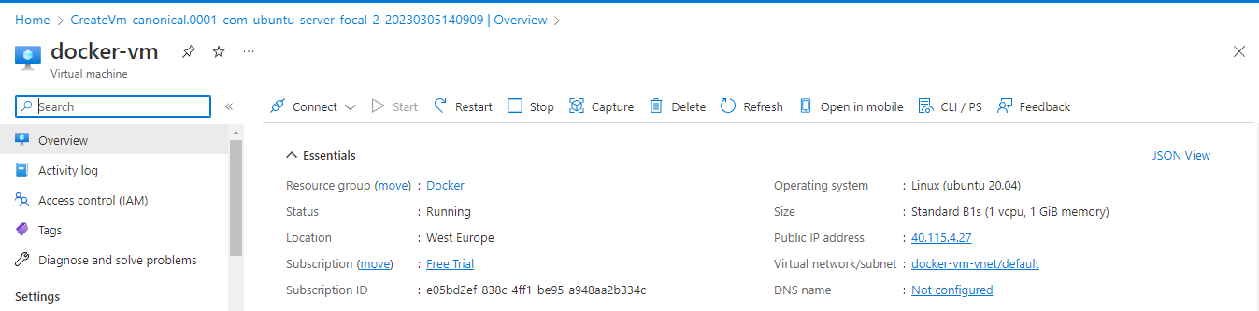

Steps for Installing Docker:

Connect to Docker-vm and Open the terminal on Ubuntu.

Check if the system is up-to-date using the following command:

#apt-get update

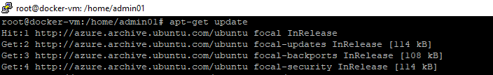

Install Docker using the following command:

#apt install docker.io

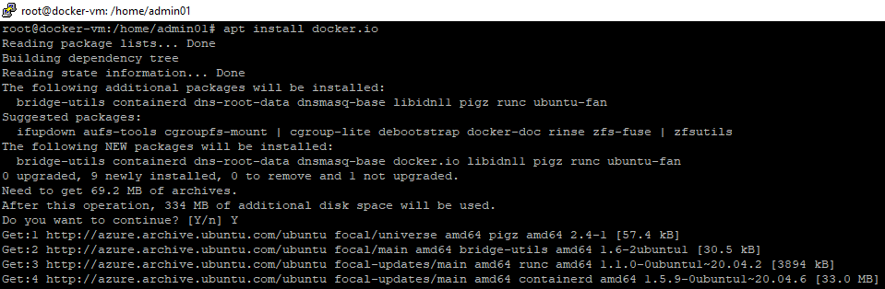

Install all the dependency packages using the following:

#snap install docker

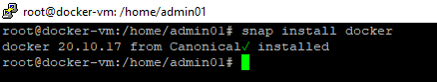

To check the docker version installed and docker info using the following command:

#docker –version

#docker info

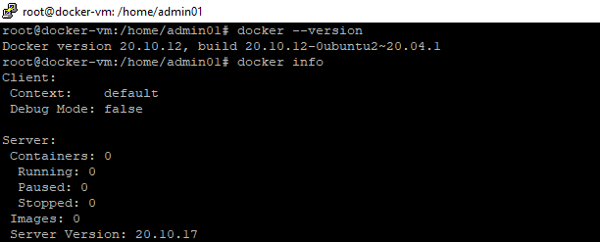

Pull an image from the Docker hub using the following command:

#docker pull nginx

# docker pull jboss/wildfly

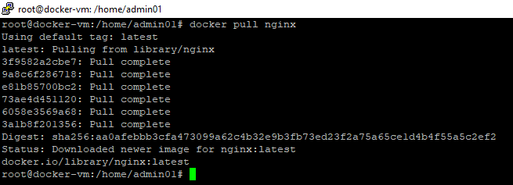

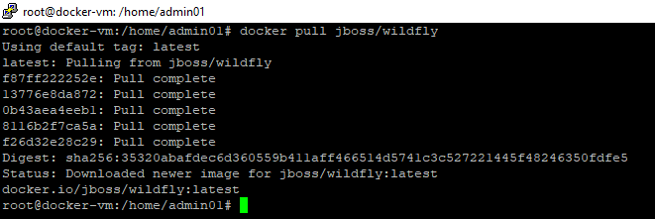

Here, nginx and jboss/wildfly are the docker images present on the Docker hub.

Check if the docker image has been pulled and is present in your system using the following command:

#docker images

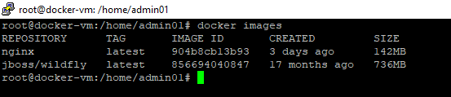

To run the docker images, use the following commands:

#docker run –d nginx

#docker run –d jboss/wildfly

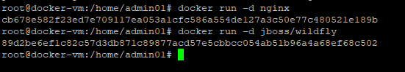

To display all the containers pulled, use the following command:

#docker ps –a

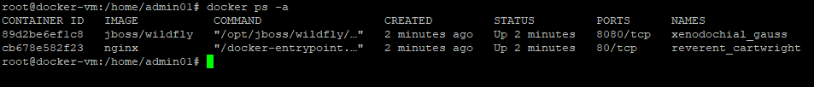

To check for containers in a running state, use the following command:

#docker ps

