Docker

# **Aim: -** To create docker hub account, new Dockerfile, docker image and push docker image in docker hub.

**Create a docker account in docker hub using following command:**

Signup docker account in to**:** [**https://hub.docker.com/signup**](https://hub.docker.com/signup)

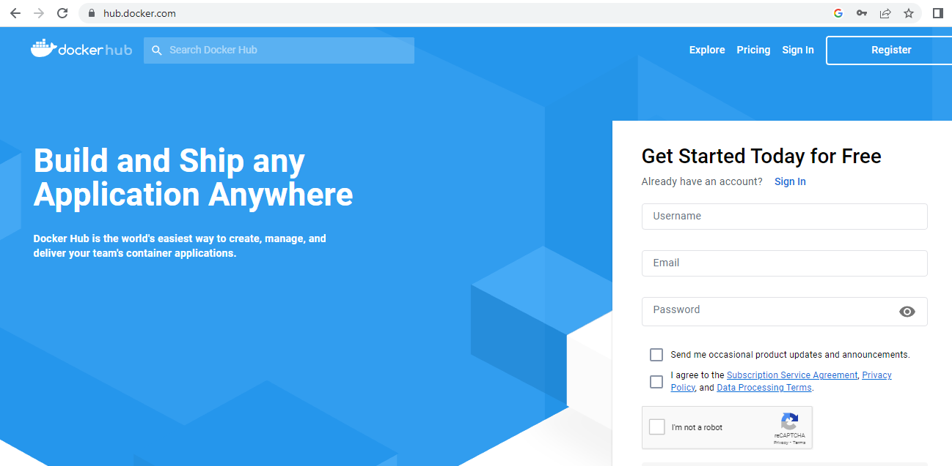

**To create new Dockerfile using the following command:**

Create a directory using the following the command:

#mkdir ram

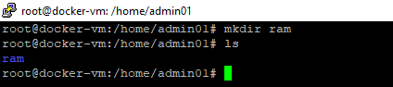

Create an index.html file using following command:

#cd ram

#vi index.html

#cat index.html





Create a Dockerfile in /home/rahul/ram directory, using the following command:

#vi Dockerfile



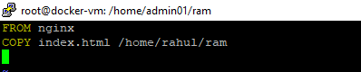

**Build Docker Image & run it, using following command:**

#docker build –t myfirstdocimage .

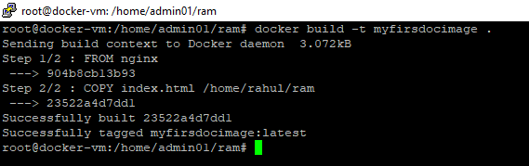

Check if the docker image has been pulled and is present in your system using the following command:

#docker images

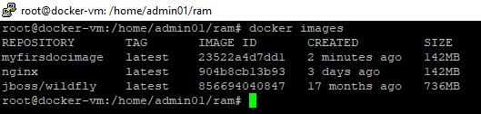

Create container from the above image, using the following command:

#docker run –d myfirstdocimage



To display all the containers pulled, use the following command:

#docker ps –a

To check for containers in a running state, use the following command:

#docker ps

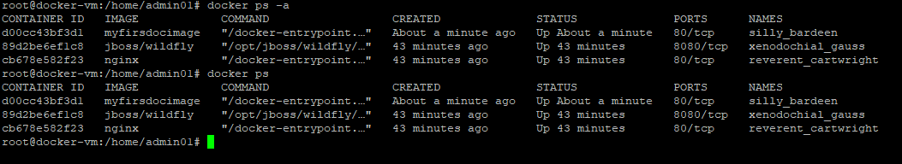

**Tag & push the Docker image and push into the docker hub:**

To login docker hub account in docker-vm, using the following command:

#docker login

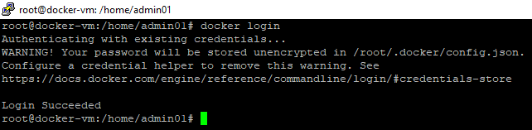

# To tag the repositories using the following command:

#docker tag myfirstdocimage:latest rahulsharan/myfirstdocimage

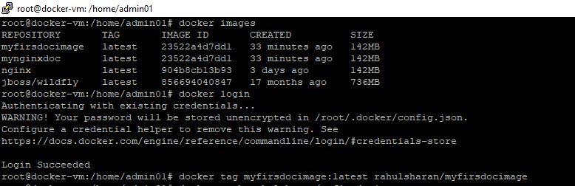

# To push image into docker hub using the following command:

# #docker push rahulsharan/myfirstdocimage

# 

**To verify the same on docker hub:**

Using docker hub account**: https://hub.docker.com/**

