Docker

# **Aim: -** To create a wildfly Docerfile and build a WildFly application server image from jboss/wildfly.

**To create a Wildfly Dockerfile using the following command:**

Create a directory using the following the command:

#vi Dockerfile

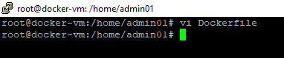

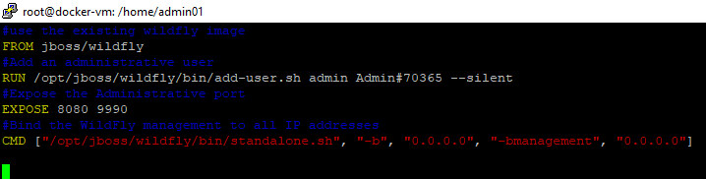

**Build Docker Image & run it, using following command:**

#docker build –t wildflyapp .

# 

Check if the docker image has been pulled and is present in your system using the following command:

#docker images

# 

Create container from the above image, using the following command:

#docker run –d wildflyapp

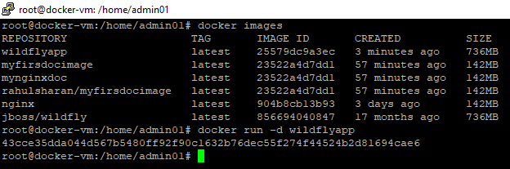

To display all the containers pulled, use the following command:

#docker ps –a



**Tag & push the Docker image and push into the docker hub:**

To login docker hub account in docker-vm, using the following command:

#docker login

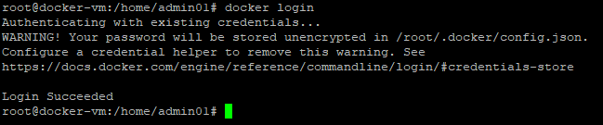

# To tag the repositories using the following command:

#docker tag wildflyapp:latest rahulsharan/wildflyapp

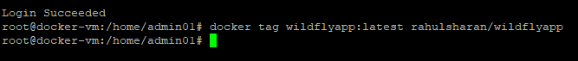

# To push image into docker hub using the following command:

# #docker push rahulsharan/wildflyapp

# 

**To verify the same on docker hub:**

Using docker hub account**: https://hub.docker.com/**

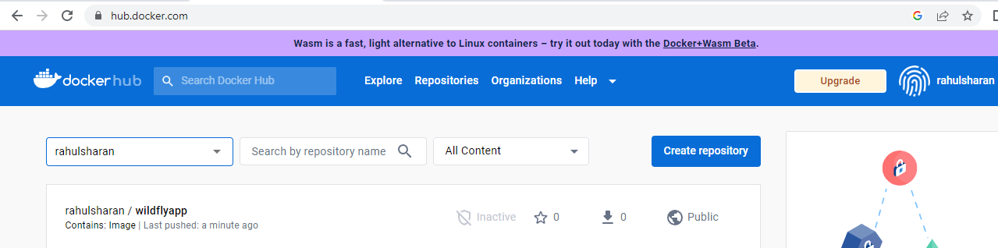

# **Create Dockerfile and dangling image using the following the command:**

Create a directory using the following the command:

#vi Dockerfile

# 

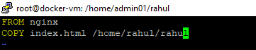

**Build Docker Image & run it, using following command:**

#docker build .

Check if the docker image has been pulled and is present in your system using the following command:

#docker images

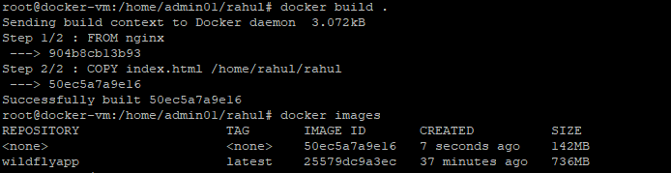

To check the dangling image in your system using the following the command:

#docker images -f dangling=true

