Docker

# **Aim: -** To create Docerfile and dangling image and build an nginx application server image.

# **Create Dockerfile and dangling image using the following the command:**

Create a directory using the following the command:

#vi Dockerfile

# 

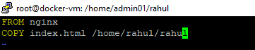

**Build Docker Image & run it, using following command:**

#docker build .

Check if the docker image has been pulled and is present in your system using the following command:

#docker images

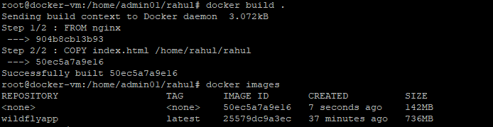

To check the dangling image in your system using the following the command:

#docker images -f dangling=true

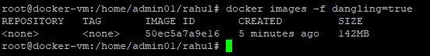

To tag the repositories and check dangling images using the following command:

#docker tag image_id rahulsharan/nginx:v2



Check if the docker image has been pulled and is present in your system using the following command:

#docker images



Create container from the above image, using the following command:

#docker run –d rahulsharan/nginx:v2



To display all the containers pulled, use the following command:

#docker ps –a

To check for containers in a running state, use the following command:

#docker ps

