GIT

# To install instance on cloud and install git on cloud and local windows machine create project and push and pull from GitHub remote repo.

## **To create two instance at different location on AWS:**

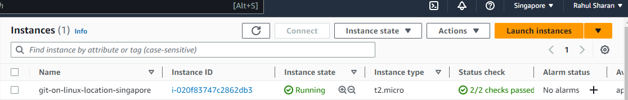

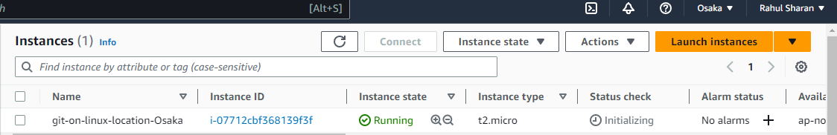

## **To install the git on aws and local windows:**

### Local windows:

<https://git-scm.com/downloads>

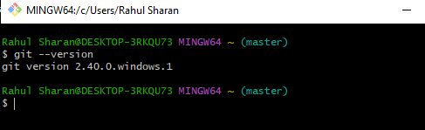

### AWS Linux:

#apt-get update

#apt-get install git

#git –version



## **To configure user name and password:**

### Local windows:

#git config –-global user.name “Mahesh”

#git config –-global user.email “[rsharan4545@gmail.com](mailto:rsharan4545@gmail.com)”

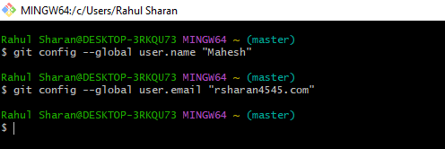

### AWS Linux:

#git config –-global user.name “Rahul”

#git config –-global user.email” [rahulsharan0512@gmail.com](mailto:rahulsharan0512@gmail.com)”



## **To check the user name and email id using following command:**

### AWS Linux:

#git config --list

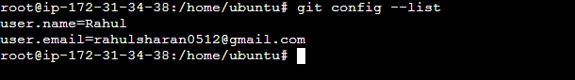

## **To create and signing GitHub account using following link:**

### Link : <https://github.com/>

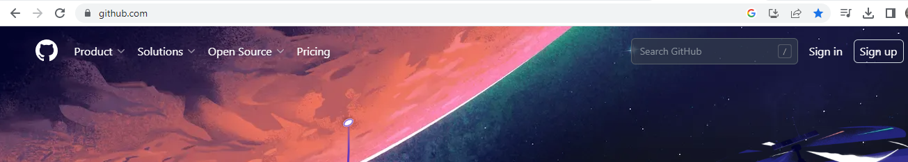

## **To create the directory and file:**

### Local windows:

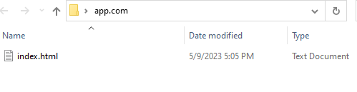

### AWS Linux:

#mkdir app.com

#vi index.html



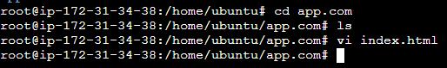

## **To create local repo in app.com using following command:**

### Local windows:

app.com#git init

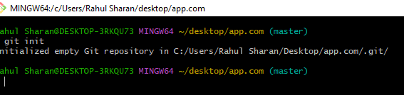

### AWS Linux:

app.com#git init

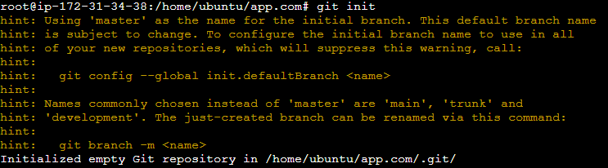

## **To check the Untracked files using the following command:**

### Local windows:

#git status

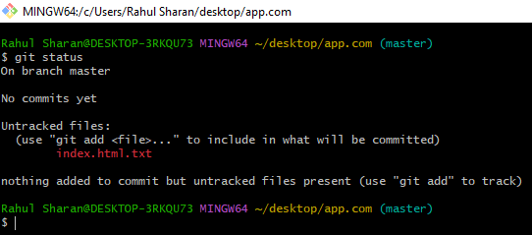

### AWS Linux:

#git status

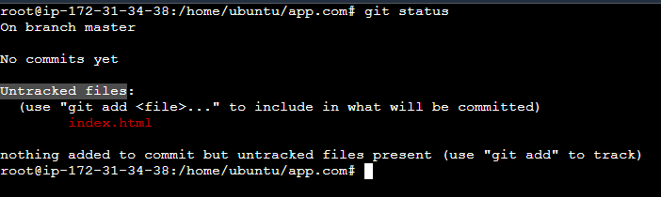

## **To add to staging stage using following command:**

#git add .

### Local windows:

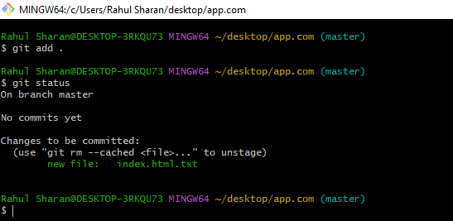

### AWS Linux:

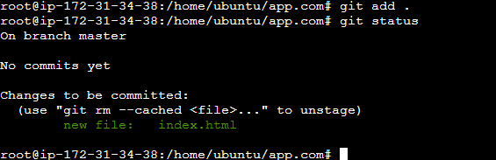

## **To commit file in local repo using following command:**

#git commit -m "login page created**"**

### Local windows:

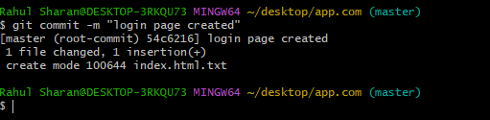

### AWS Linux:

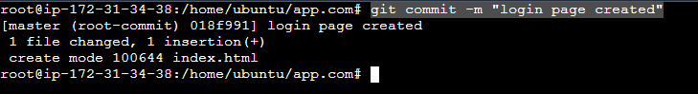

## **To check the files status and commit status using the following command:**

#git status

#git log

### Local windows:

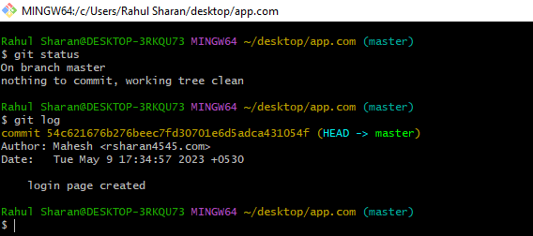

### AWS Linux:

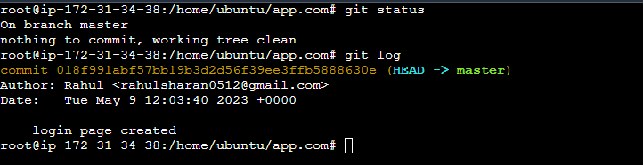

## **To check the file content by using the following command:**

#git show

### Local windows:

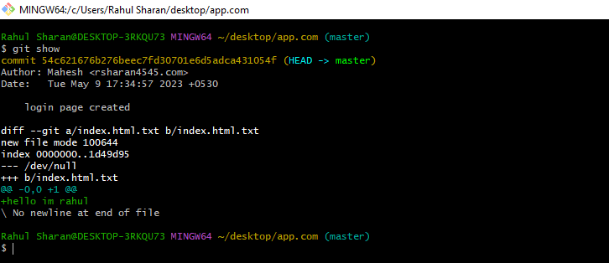

### AWS Linux:

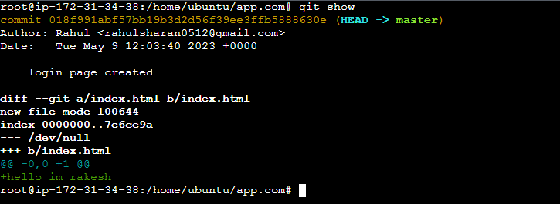

## **To create new repo in GitHub for store the code:**

### Using the GitHub repo:

<https://github.com/rahuls512/Python.git>

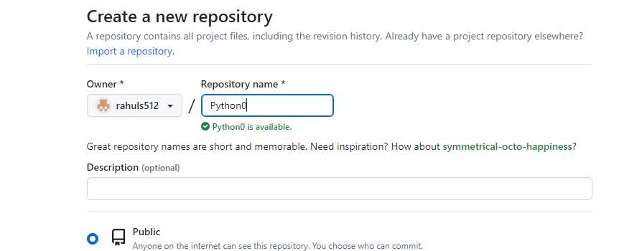

## **To local repo add and push with remote repo or GitHub using the following command:**

#git remote -v

#git init --bare python

#git remote add origin <https://github.com/rahuls512/Python.git>

#git push -u origin master

### Local windows:

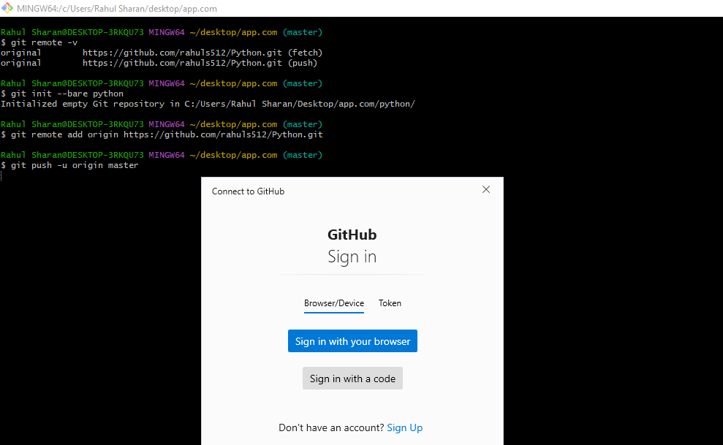

Click on browser and enter GitHub user name and password

