**Aim**: - To Linked Project, View, User management and Master slave concept in Jenkins.

**To linked the project:**

1. Upstream linked project

Login Jenkins portal: <http://localhost:8080/>

Create maven project:

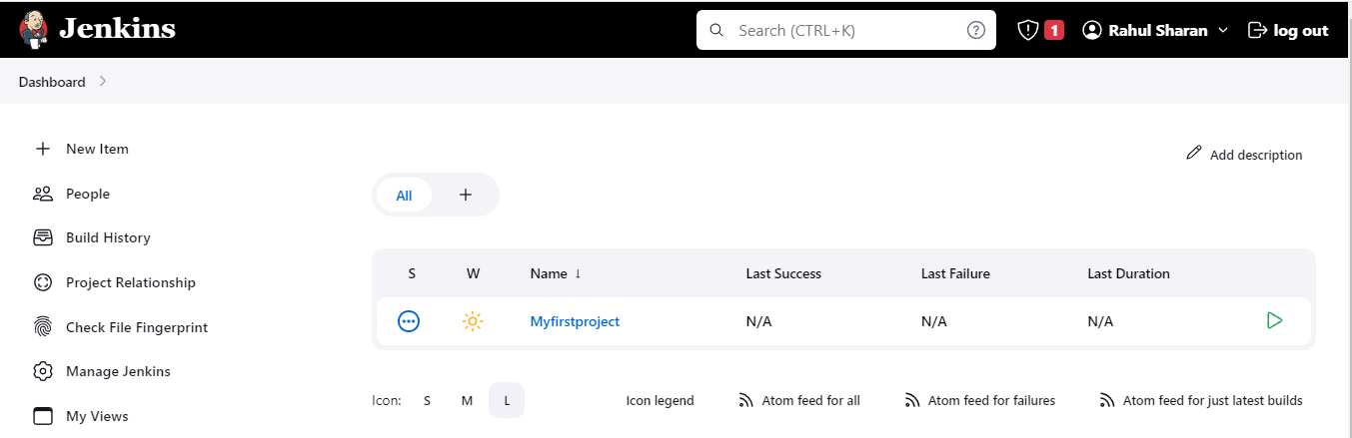

Copy the project:

Dashboard >+new item:Enter an item name: job01> Copy from: Myfirstproject>Ok>save

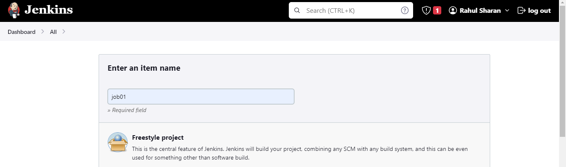

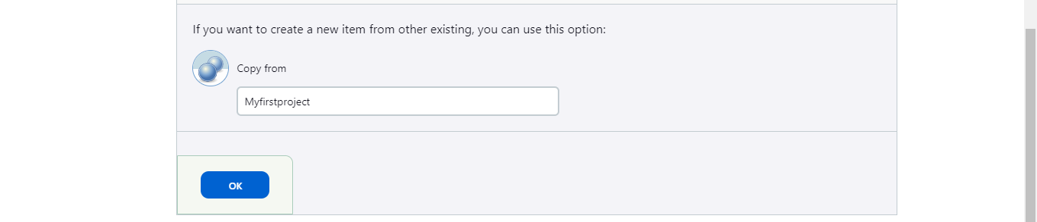

Right click on job01>configure: Post-build Actions: Build other projects: Projects to build: Myfirstproject,

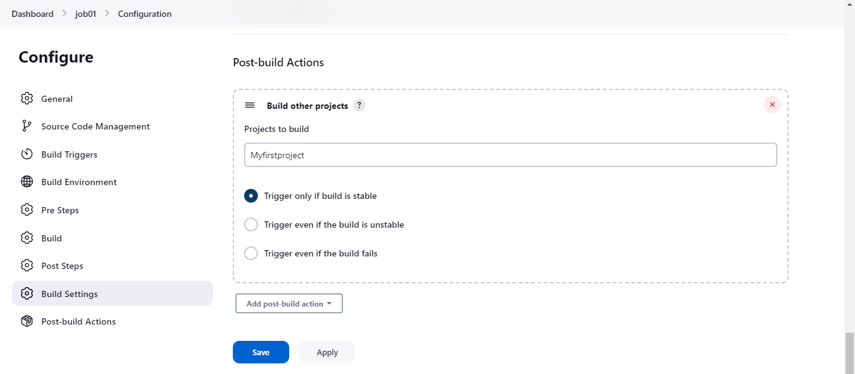

Now build the job01:

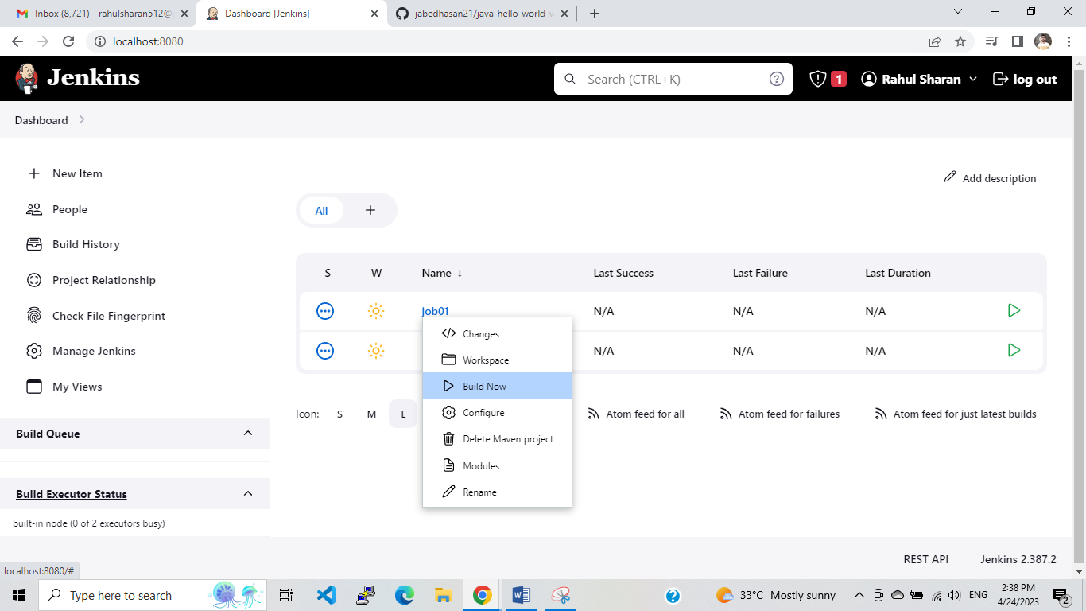

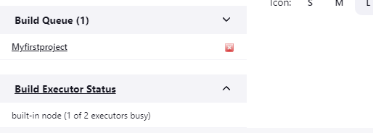

1. Downstream linked project:

Copy the project:

Dashboard >+new item:Enter an item name: job02> Copy from: Myfirstproject>Ok>save

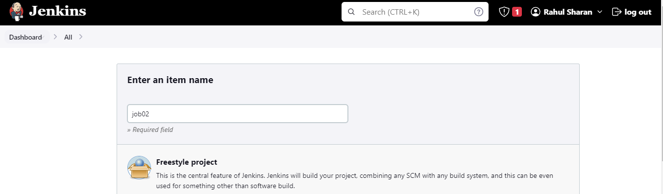

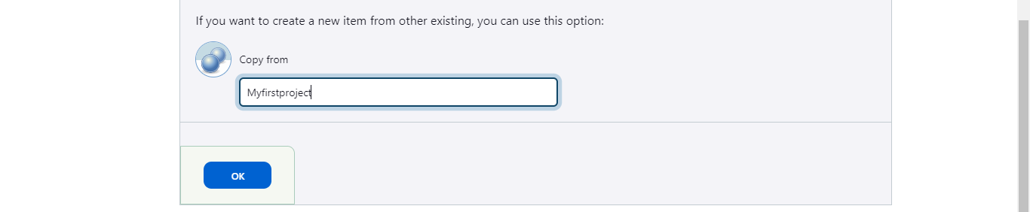

Right click on Myfirstproject>configure: Build Triggers: Build after other projects are built: Projects to watch: job02>Save

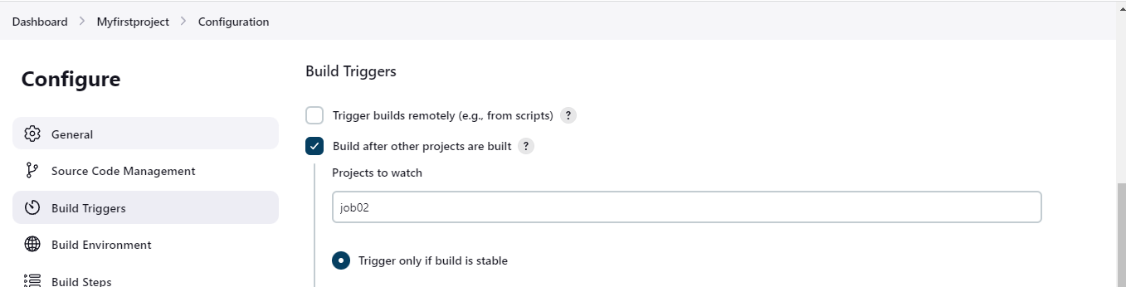

Now build the job02:

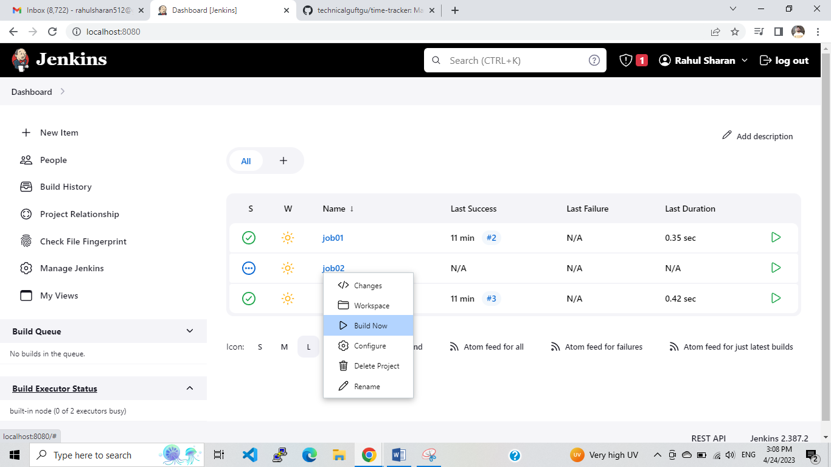

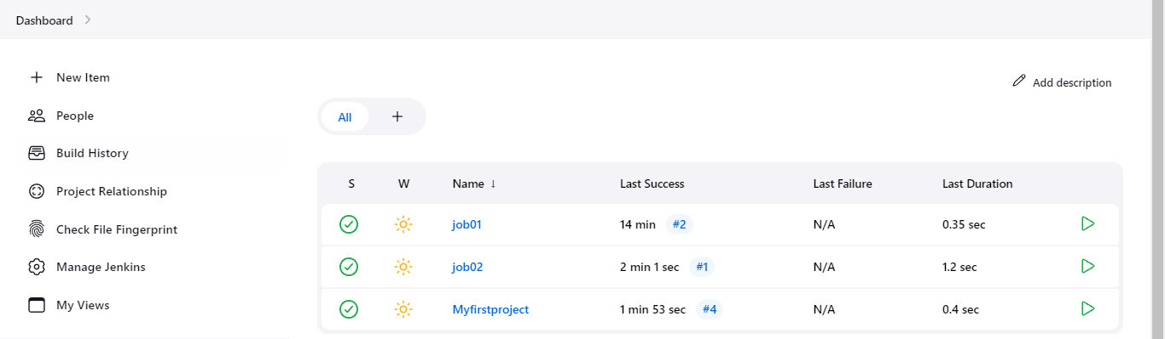

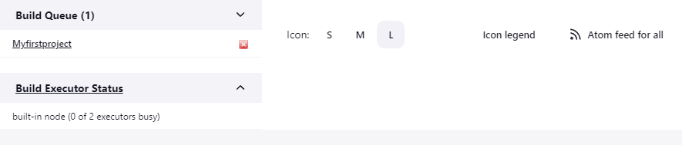

**Create a Project view:**

To create a project view as per requirement:

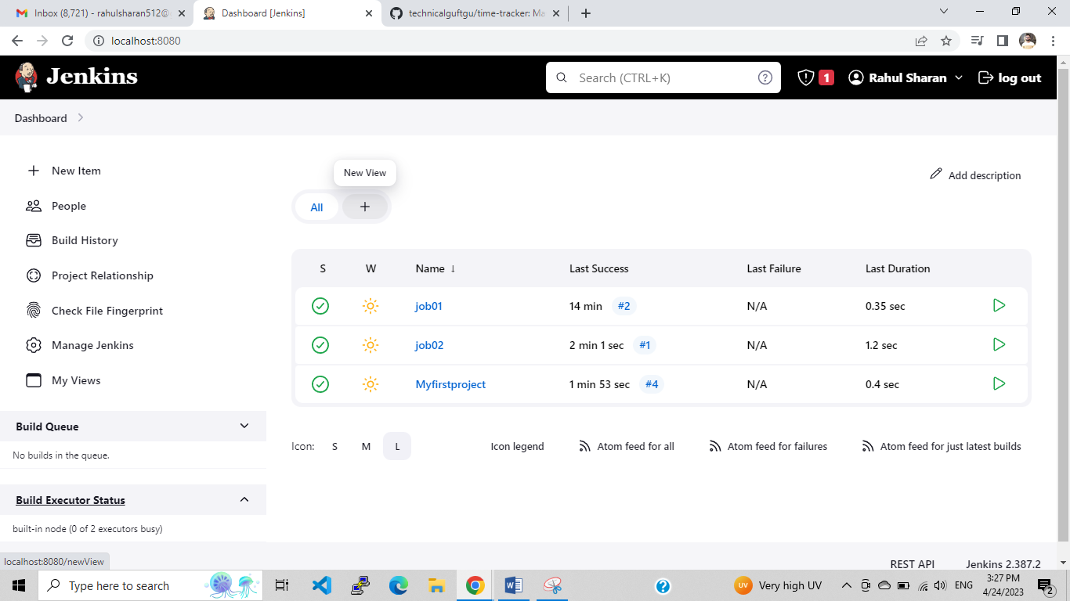

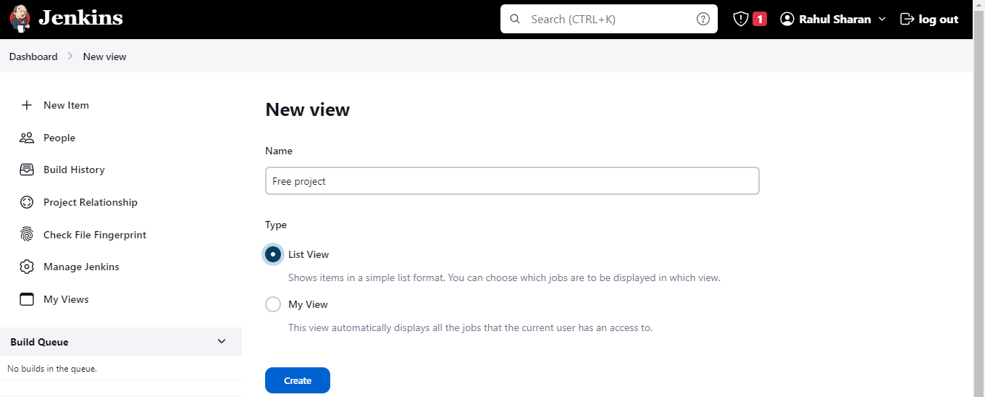

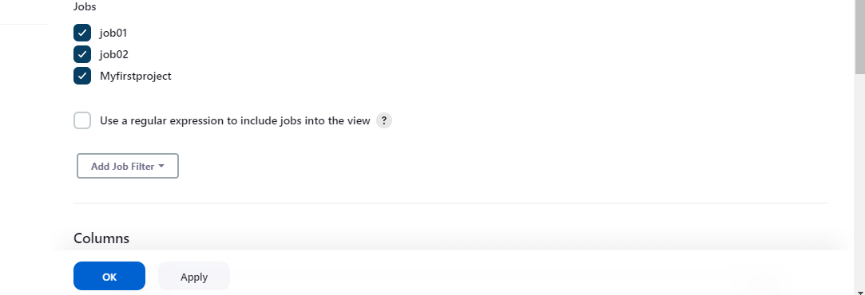

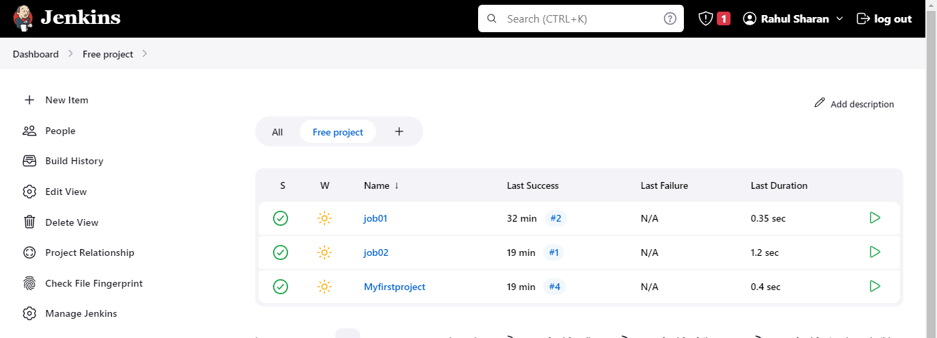

**User management in ansible portal:**

Go to Jenkins home page >Manage Jenkins>Manage user

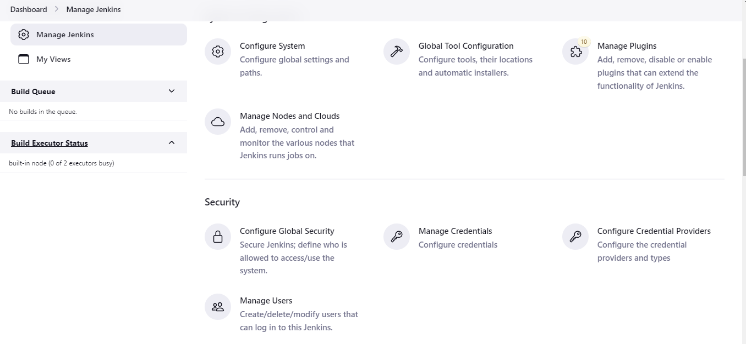

To create two users:

Dashbord>Manage Jenkins>Manage user:+Create user

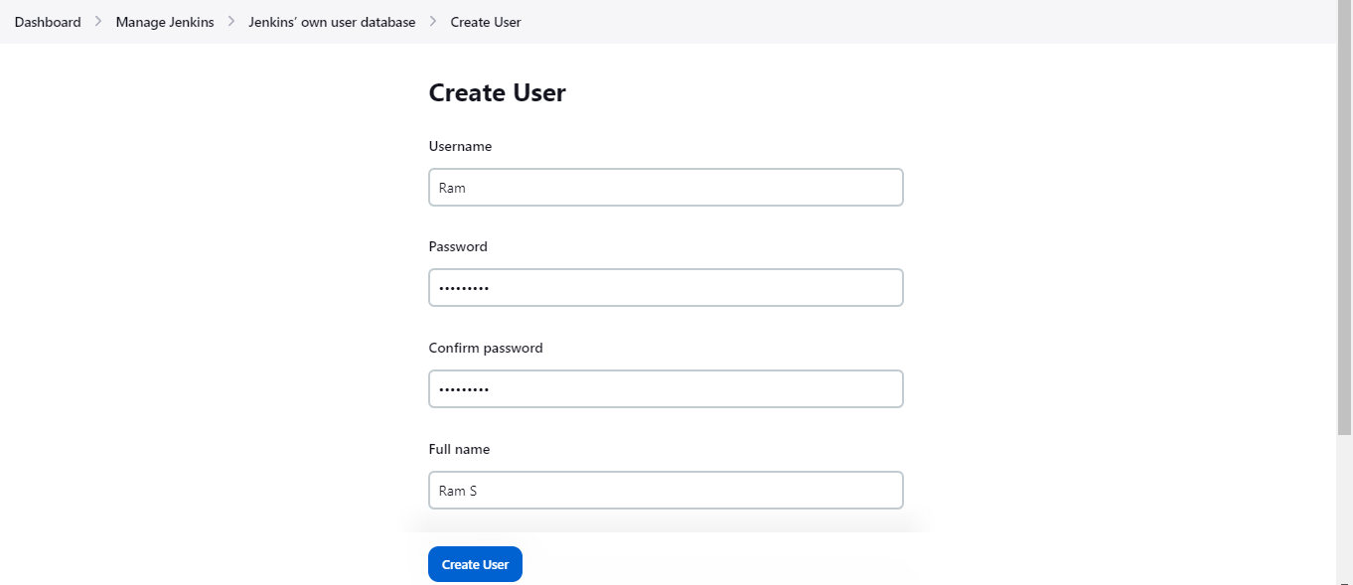

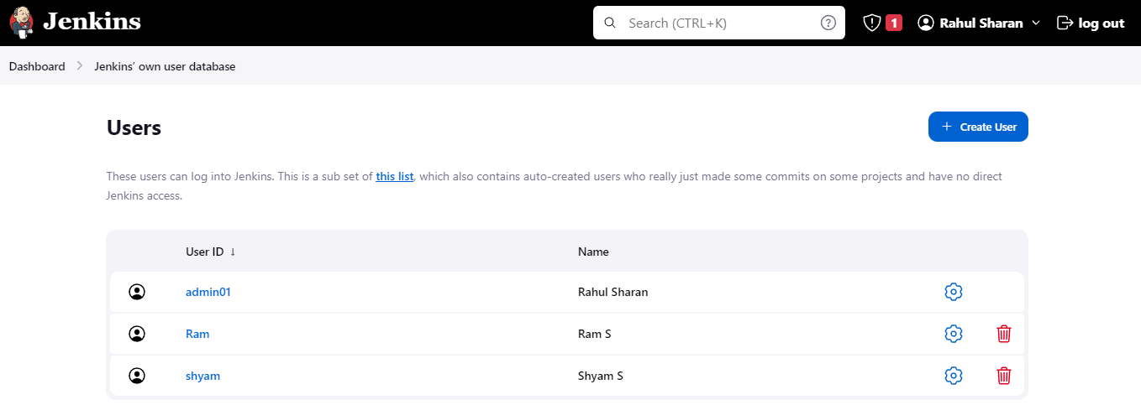

To check the login of Ram and shyam by using the following link:

<http://localhost:8080/>

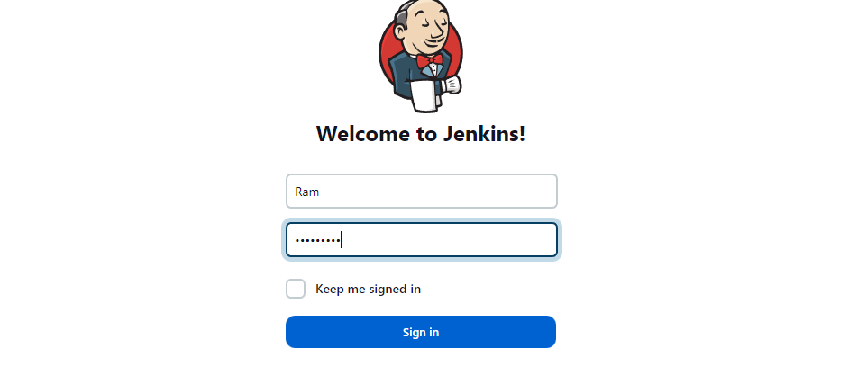

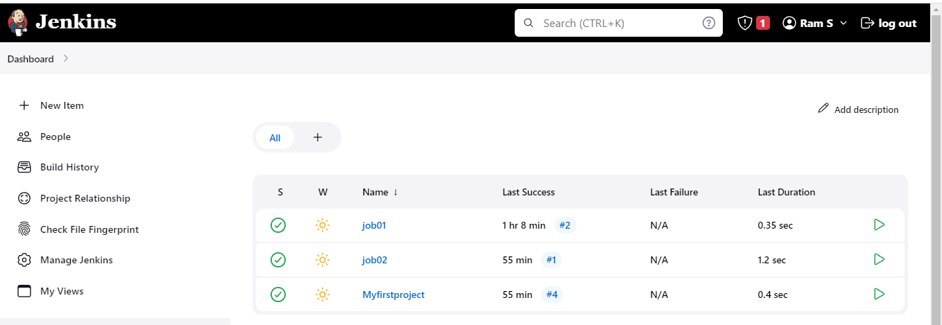

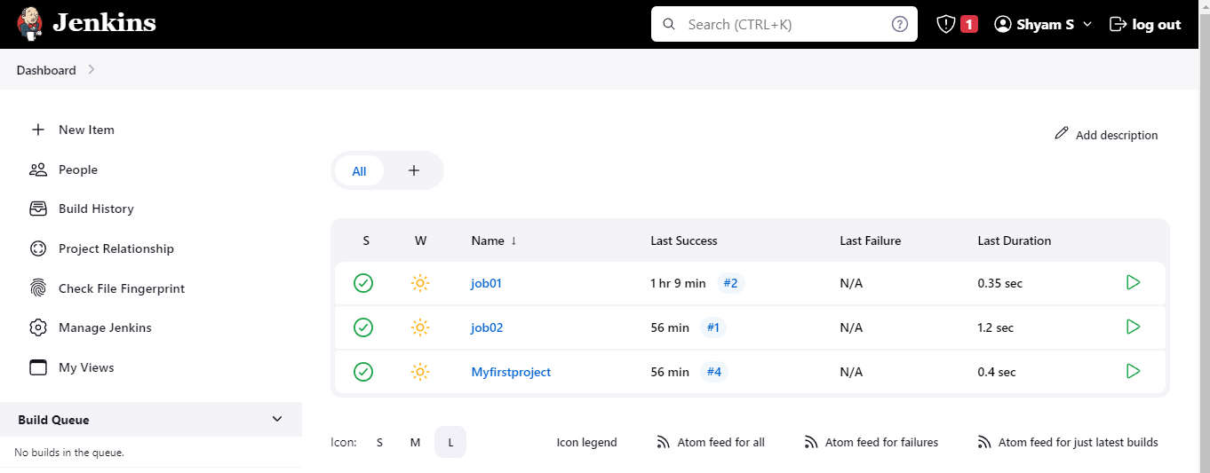

Plugin install on Ram login:

User login Ram>Dashboard>Manage Jenkins>Plugin Manager: Available Plugins:Role_base Authorization Strategy and Authorize Project>Install without restart.

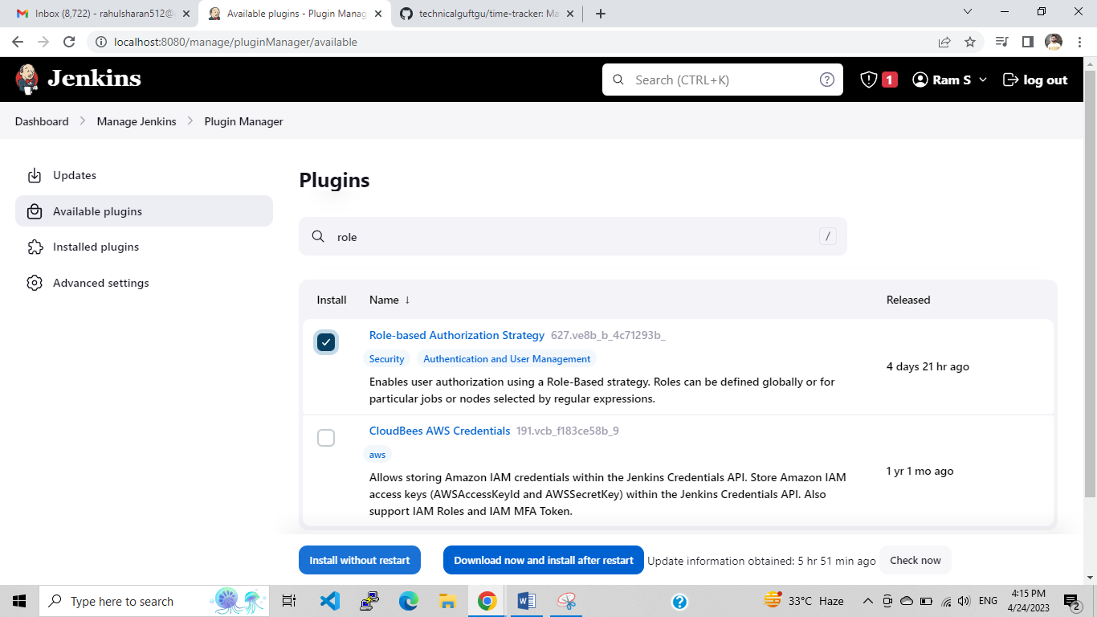

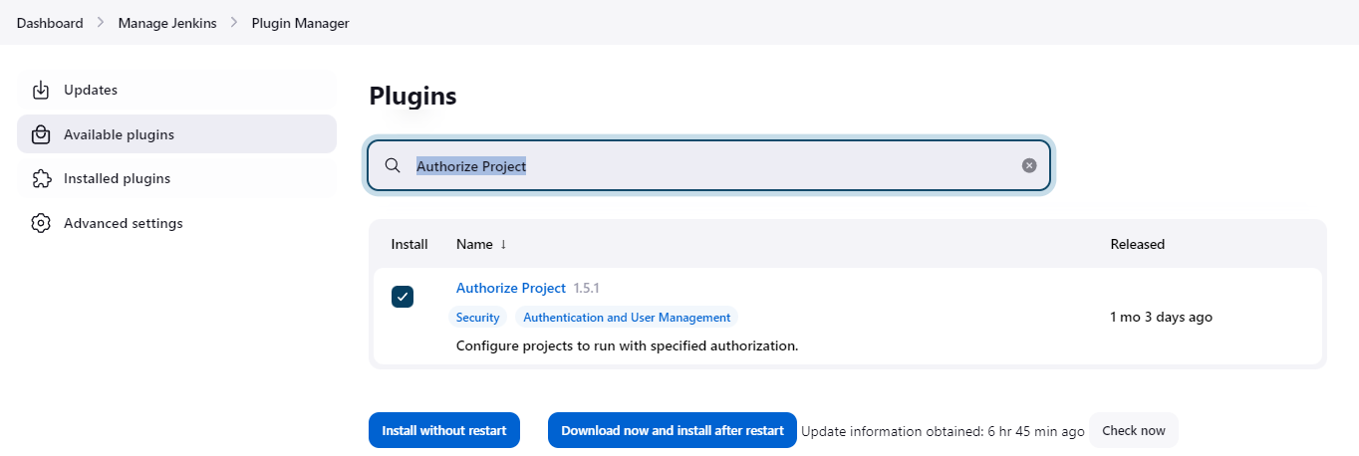

To Configure Global Security:

To Authorize the all user using the Authorization- Role base strategy.

Admin login>Dashboard>Manage Jenkins> Configure Global Security: Authorization- Role base strategy>Save

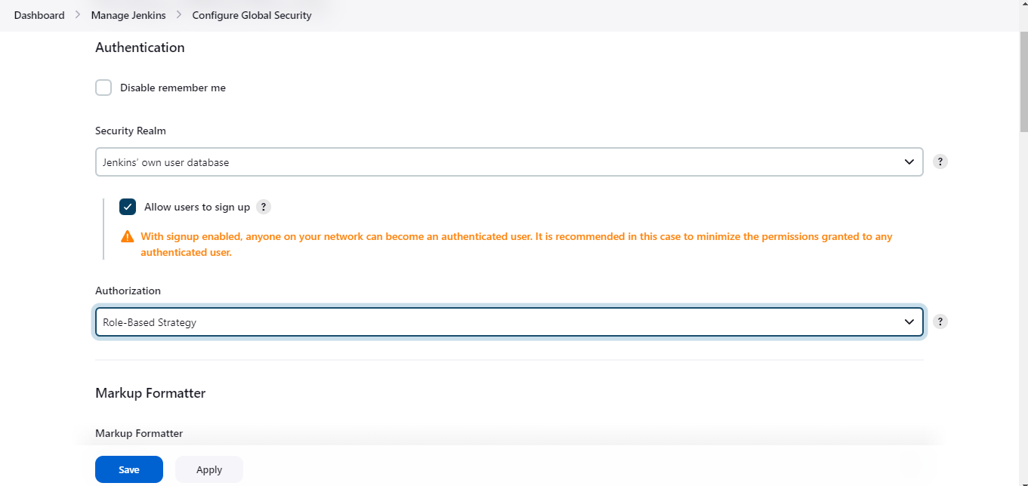

To check the access permissions, login Ram and shyam by using the following link:

<http://localhost:8080/>

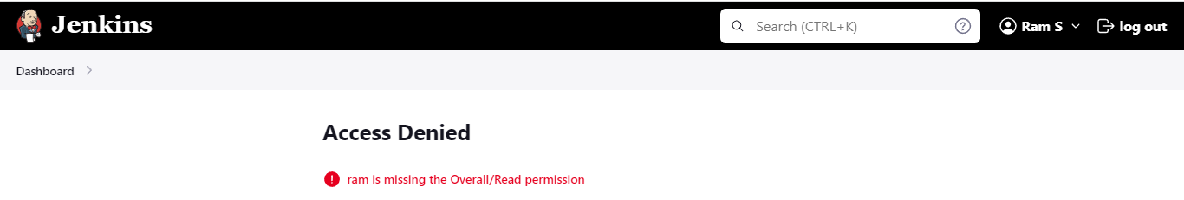

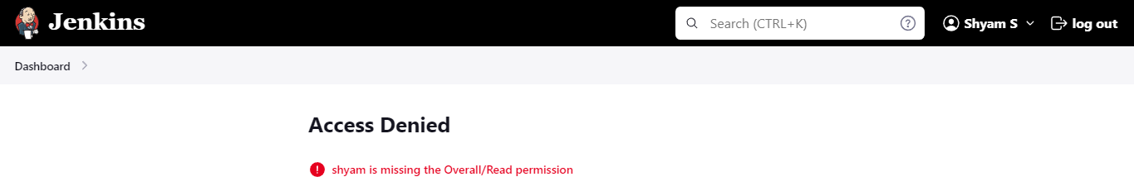

To create Role for users:

Admin login>Dashboard>Manage Jenkins>Security> Manage and Assign Roles: [Manage Roles](http://localhost:8080/manage/role-strategy/manage-roles)

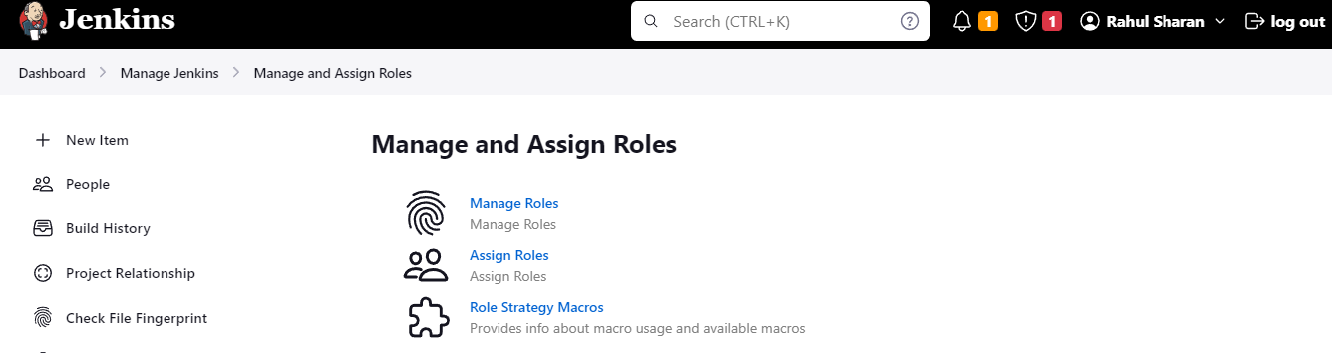

To Create Roles for users:

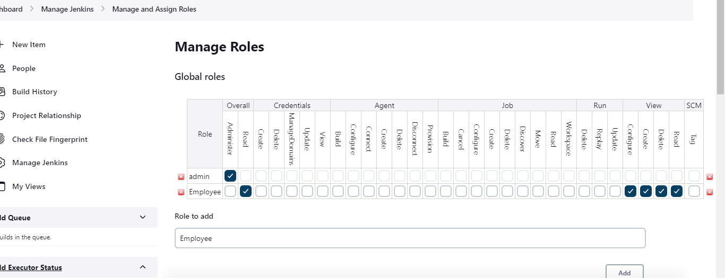

# 

To assign the created role to users:

# Admin login>Dashboard>Manage Jenkins>Security> Manage and Assign Roles: Assign Roles



To add the user in employee group:

# 

To add the user in Developer and tester group:

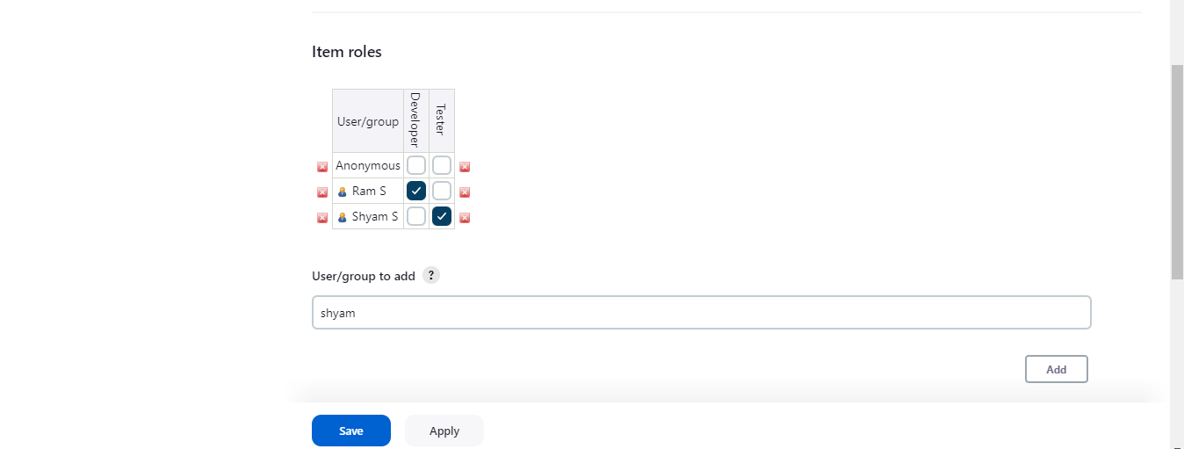

To create two jobs or projects:

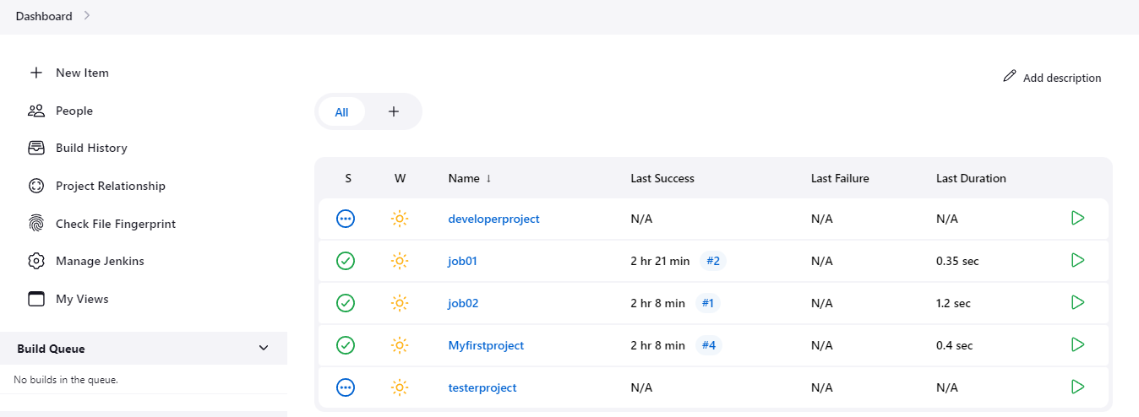

To Configure Global Security:

To add user for Authorization- Project-base Matrix Authorization strategy.

Admin login>Dashboard>Manage Jenkins> Configure Global Security: Project-base Matrix Authorization strategy: Add user: Ram and Shyam: assign Read and view access>Save

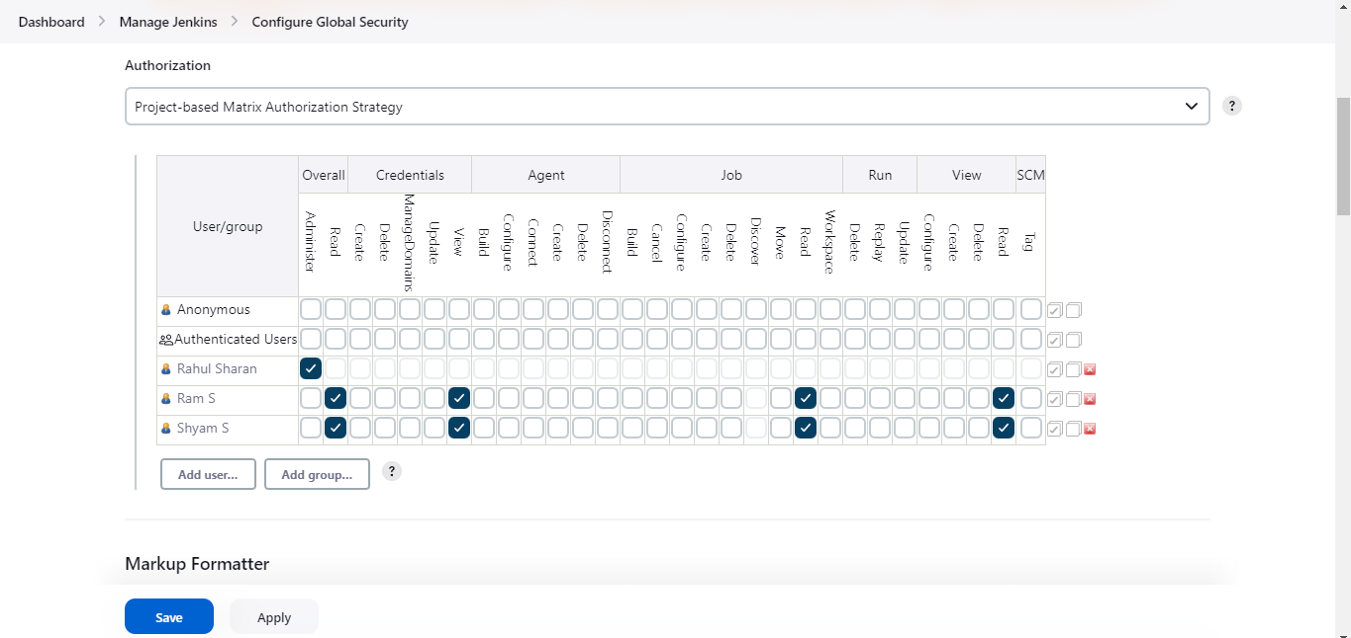

To check the access permissions, login Ram and shyam:

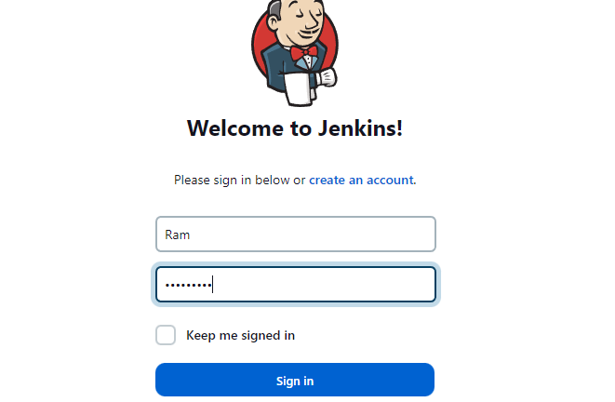

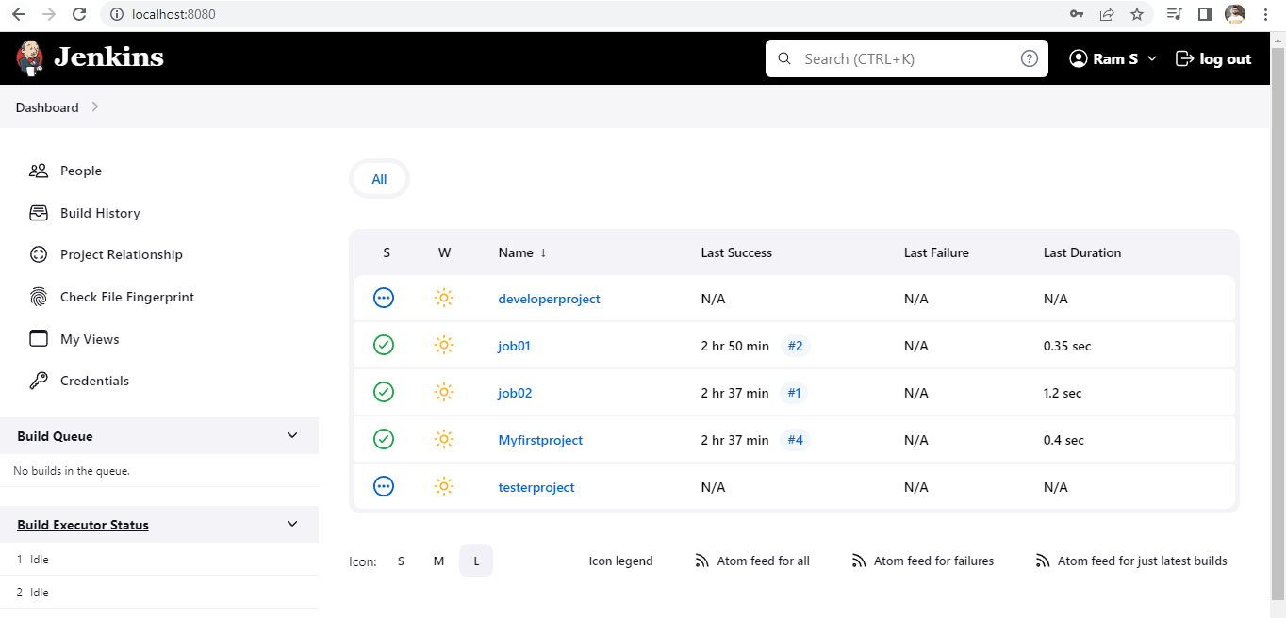

**Master and Slave in Jenkins:**

To create a Salves:

Admin >Dashboard>Manage Jenkins>System Configuration>Manage Node and Clouds:

+new Node:

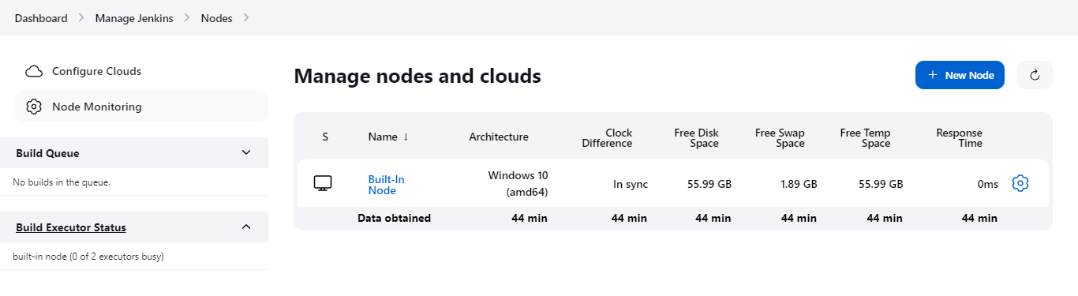

# 

# Launch method select: via execution of command on the contoller

# Download the agent.jar from [here](http://localhost:8080/jnlpJars/agent.jar), after download file cut paste in c drive:

# 

# Launch command: java -jar C:\agent.jar >Save

# 

# To create Slave02 using existing Slave01 configuration only use path different:

# 

# 

# Successfully created slave01 and slave02:

# 

# To check the build status of master and slave :

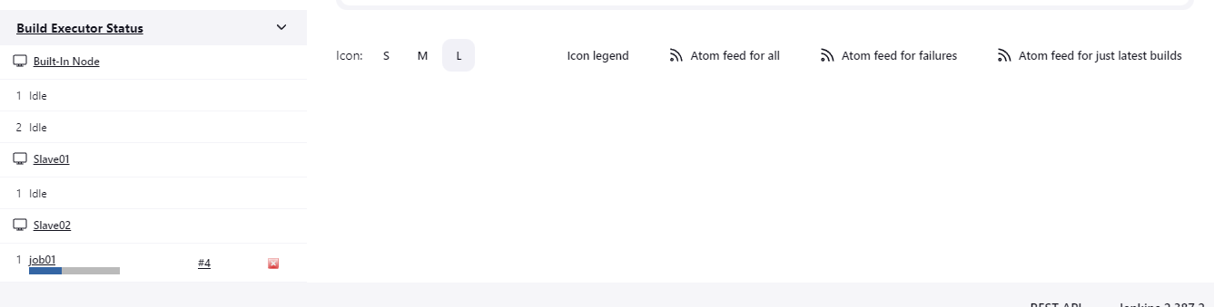

To run the project on dedicated Master or slave:

To Restrict where this project can be run:

Admin >Dashboard>Manage Jenkins>System Configuration>Manage Node and Clouds:

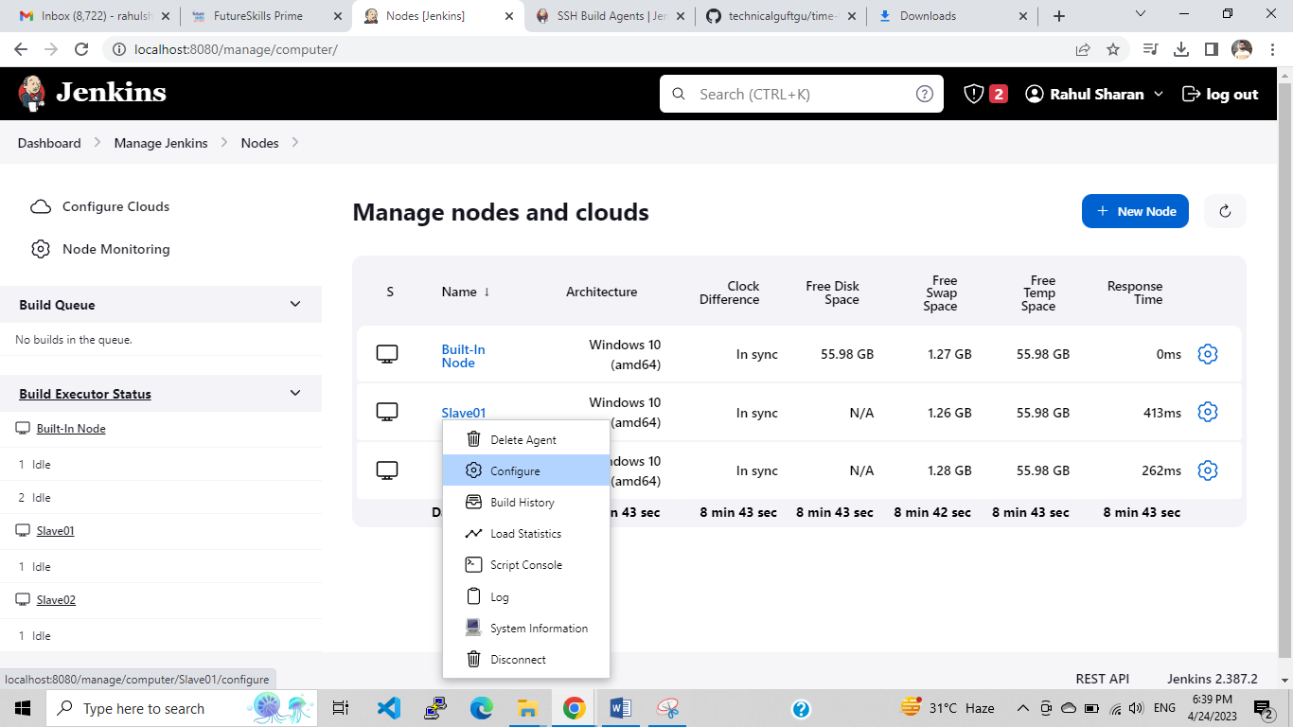

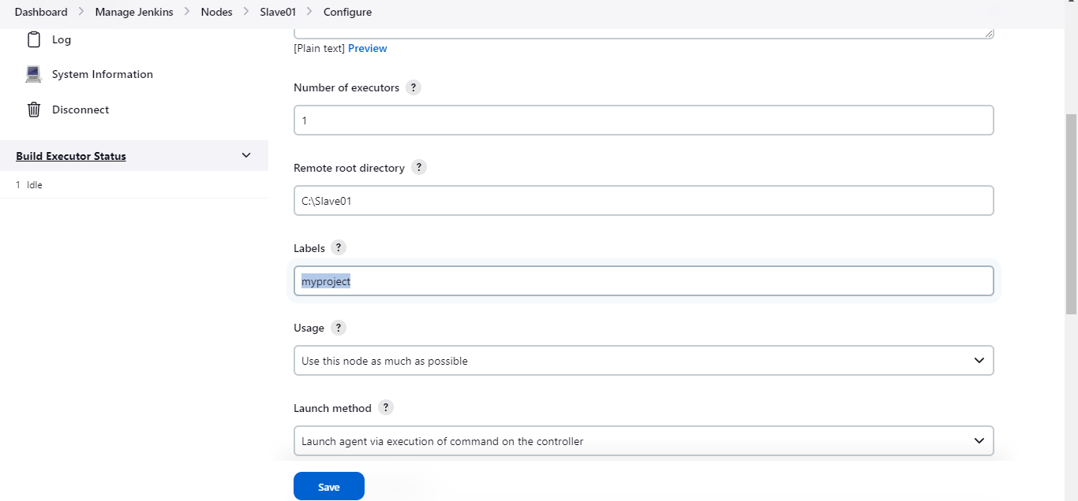

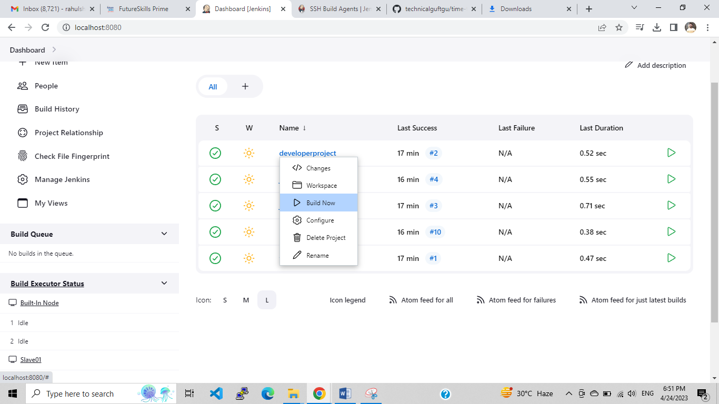

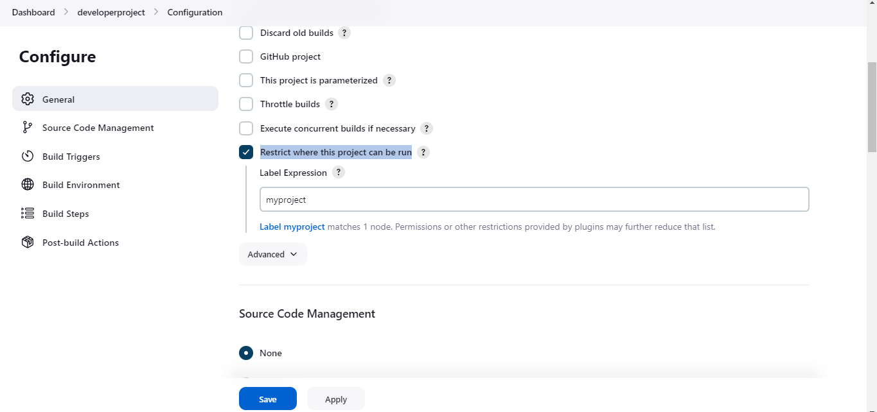

When we build the developerproject that time slave01 build the job because, we configure the label with the slave01 with the developerproject:

