**Shell Scripting**

**To analyze the health of a Node by using the following commands:**

#df

#free

#nproc

#top

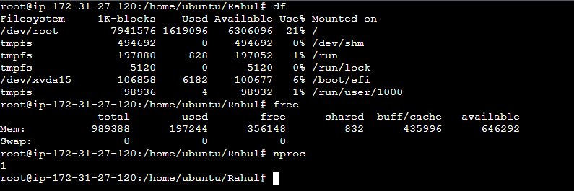

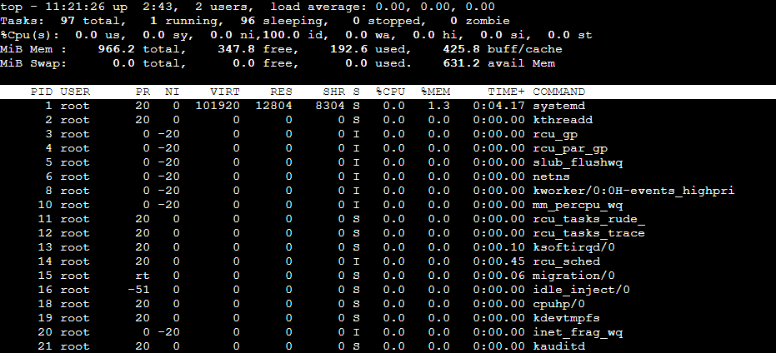

**To check the Node health using shell script:**

#vi NodeHealth.sh

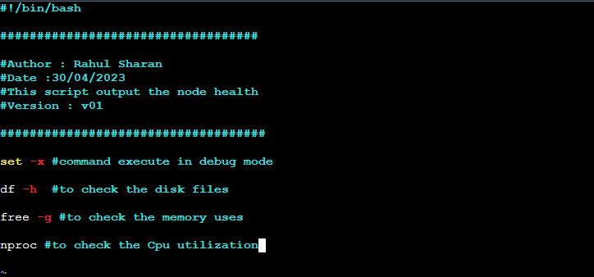

**To file permission and execute the file using the following commands:**

#chmod 777 NodeHealth.sh

#sh NodeHealth.sh

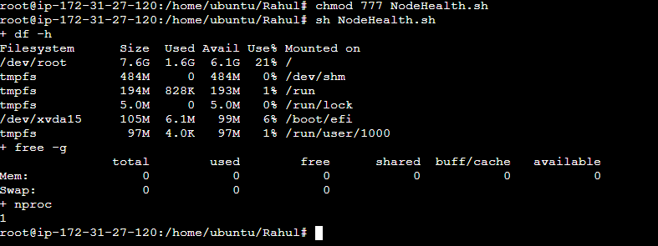

**To check the processes and to list them and find process ID:**

#ps

#ps -ef

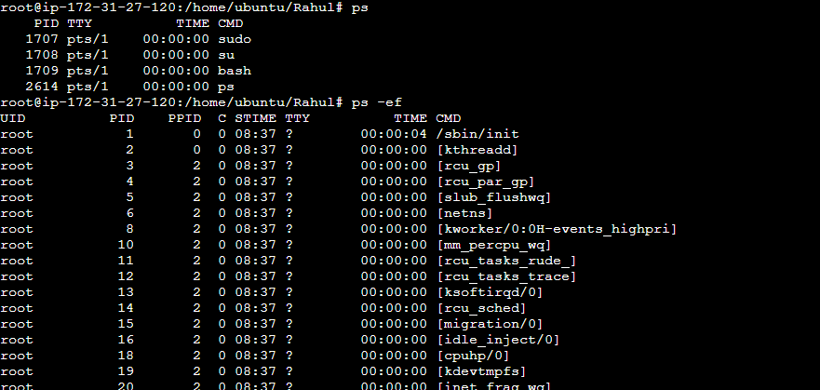

**To filter the output by using the grep and pipe commands:**

#ps –ef | grep “amazon” #filter all the amazon process running on Linux



**To filter the output by using the grep and pipe commands by shell scripting:**

#vi filter.sh



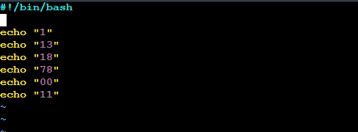

**To file permission and execute the file using the following commands:**

#chmod 777 filter.sh

#sh filter.sh

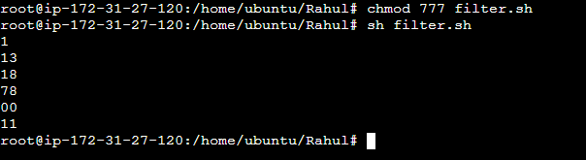

**To filter the output by using the grep and pipe commands:**

#sh filter.sh | grep 1

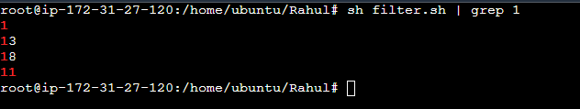

**To check the Node health using shell script:**

#vi NodeHealth.sh



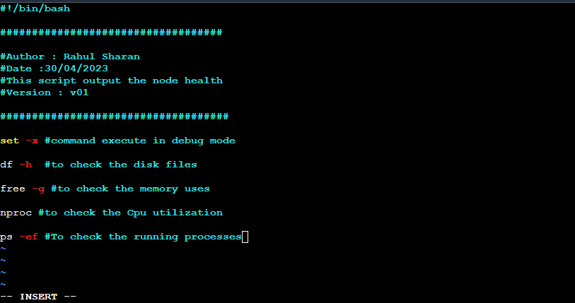

**To execute the file using the following commands:**

#sh NodeHealth.sh

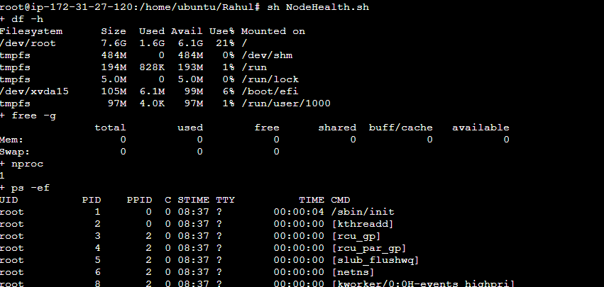

**To filter processes by using the AWK command:**

# ps -ef | grep "amazon" | awk -F" " '{print $1}'

ps -ef | grep "amazon" | awk -F" " '{print $2}'

ps -ef | grep "amazon" | awk -F" " '{print $1,$2}'

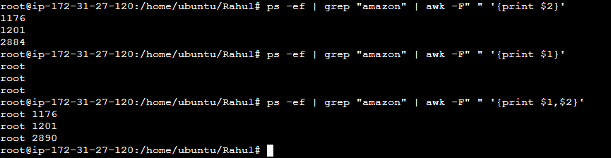

**To filter file using the grep ,pipe and awk command :**

#vi test

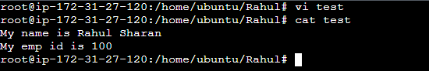

#grep name test | awk -F" " '{print $2,$4}'



**To exit the script when there is an error using set –e and set –o pipefail:**

#vi test.sh



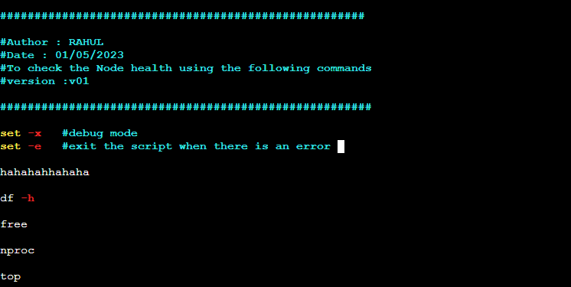

**To execute the file using the following commands:**

#sh test.sh

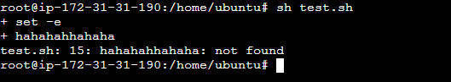

**To edit in test.sh file:**

#vi test.sh

**Hahahaha | echo**

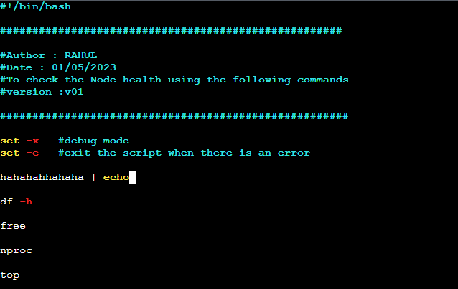

**To execute the edited test.sh file:**

#sh test.sh

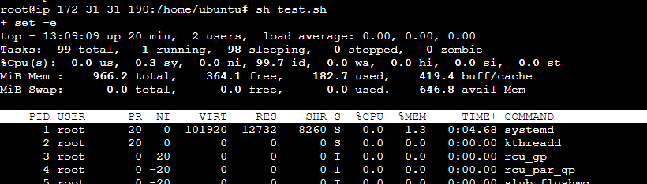

**To edit in test.sh file:**

#vi test.sh

**Hahahaha | echo | hehehehe**

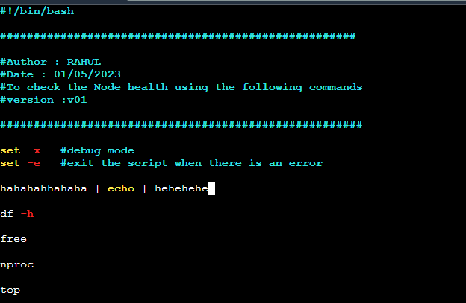

**To execute the edited test.sh file:**

#sh test.sh

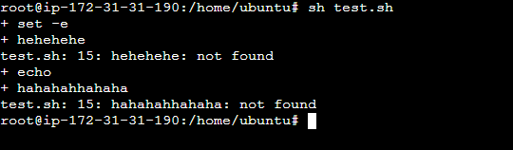

**CURL VS WGET command:**

CURL and WGET are two commonly used command-line tools for downloading files from the internet.

CURL is designed **to display the output directly** to the terminal window.

WGET can **display the output** to the terminal window, but it can **also save the output to a file**.

**CURL:**

#curl logfile_path | grep ERROR

#curl https://github.com/rahuls512/log/blob/main/log.evtx | grep error

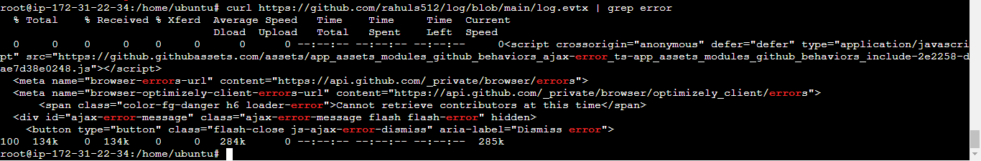

**WGET:**

#wget https://github.com/rahuls512/log/blob/main/log.evtx

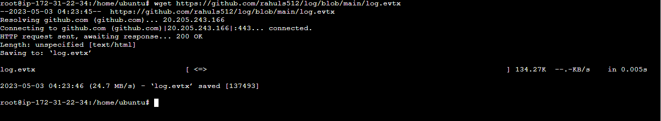

**To find the files and directory’s using the FIND command:**

#find / -name profile.d

/ :- find everything

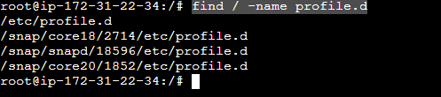

**IF-ELSE Condition using Shell Scripting:**

#vi if-else.sh



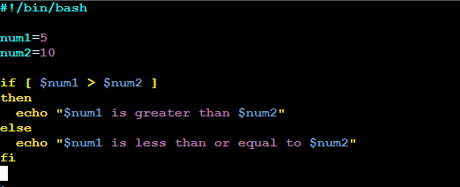

**To execute the if-else.sh file:**

#sh if-else.sh



**For loop Condition using Shell Scripting:**

#vi for-loop.sh



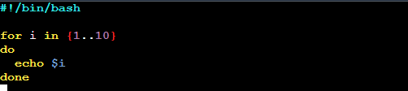

**To execute the if-else.sh file:**

#sh for-loop.sh

