Download, Install and configure Git, Terraform, VScode, AWS CLI, Packer, AWS STS User and GitHub Actions secrets & variables and authentication terraform with AWS using AWS Access key, JDK and Jenkins.

- To Download, Install and configure Git:

<https://git-scm.com/download/win>

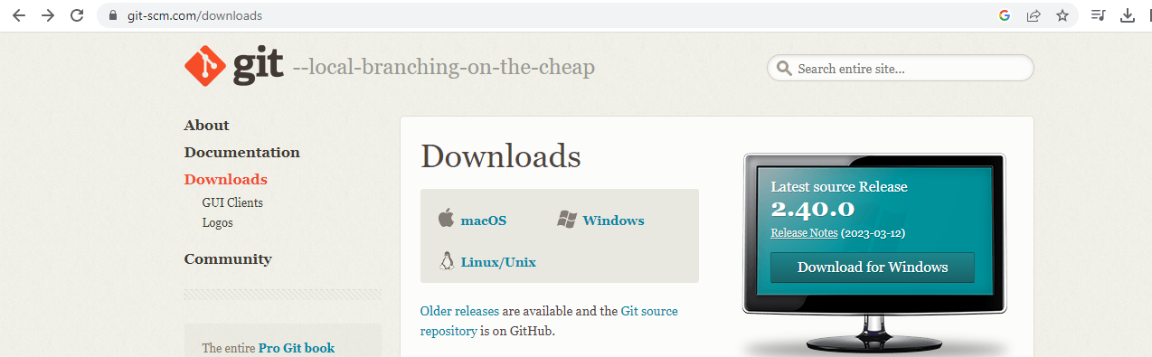

To install git on windows machine:

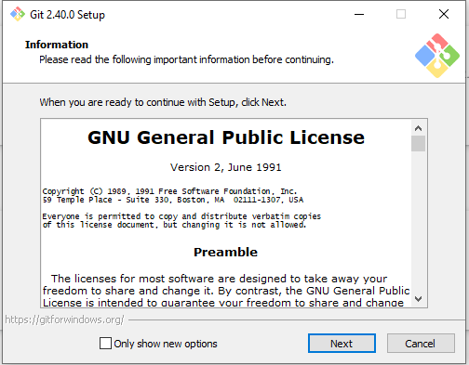

-Open the Git bash:

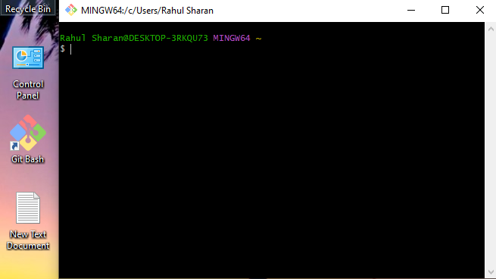

-To verify the git version:

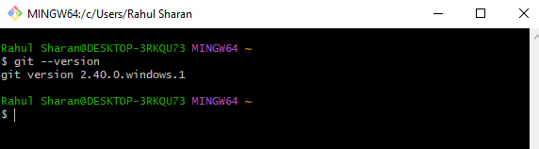

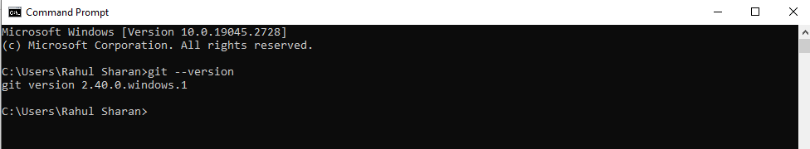

-To configure the Git:

> git config --global user.name "rahuls512"

> git config --global user.email [rahulsharan512@gmail.com](mailto:rahulsharan512@gmail.com)

> git config --global --list

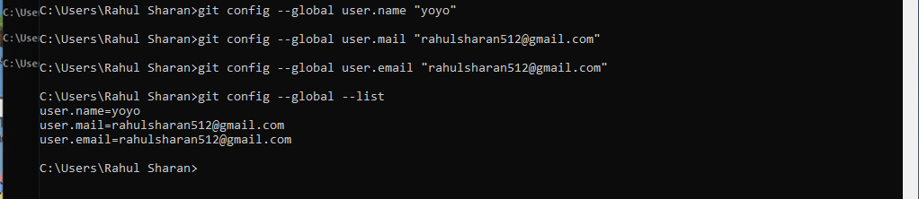

# **To Download, Install and configure terraform and Visual studio code.**

## -Download, Install and configure terraform:

To download terraform by using the following link:

- <https://developer.hashicorp.com/terraform/downloads>

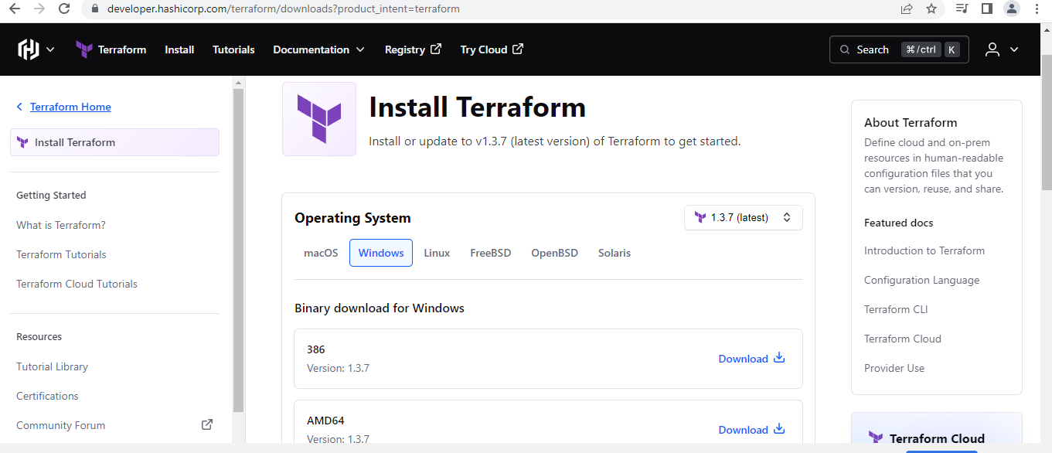

To create a folder terraform in c :> program files:

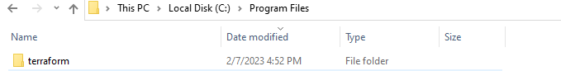

Terraform.exe file extract in c:>program files/terraform folder:

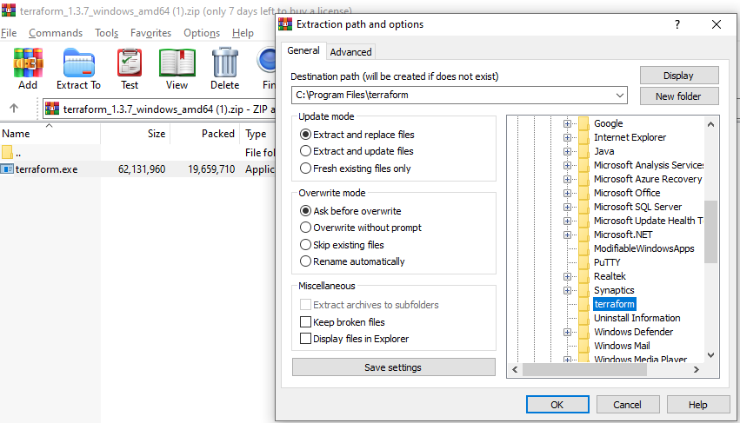

-To check the executable file in c :> program files>terraform:

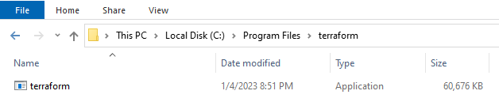

## -Add the environment variable: Path- C:\Program Files\terraform

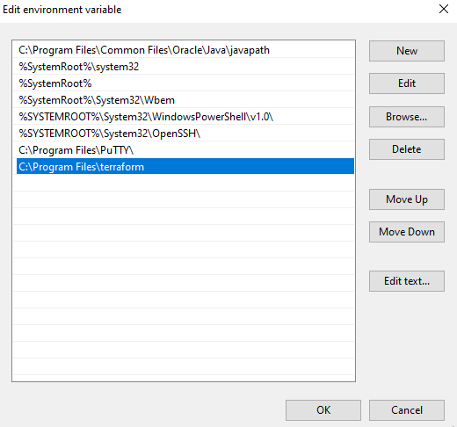

## -Open command prompt and check the terraform version by using the following the command:

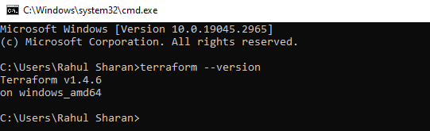

## -Download, Install and configure Visual studio code:

To download Visual studio code by using the following link:

-https://code.visualstudio.com/download

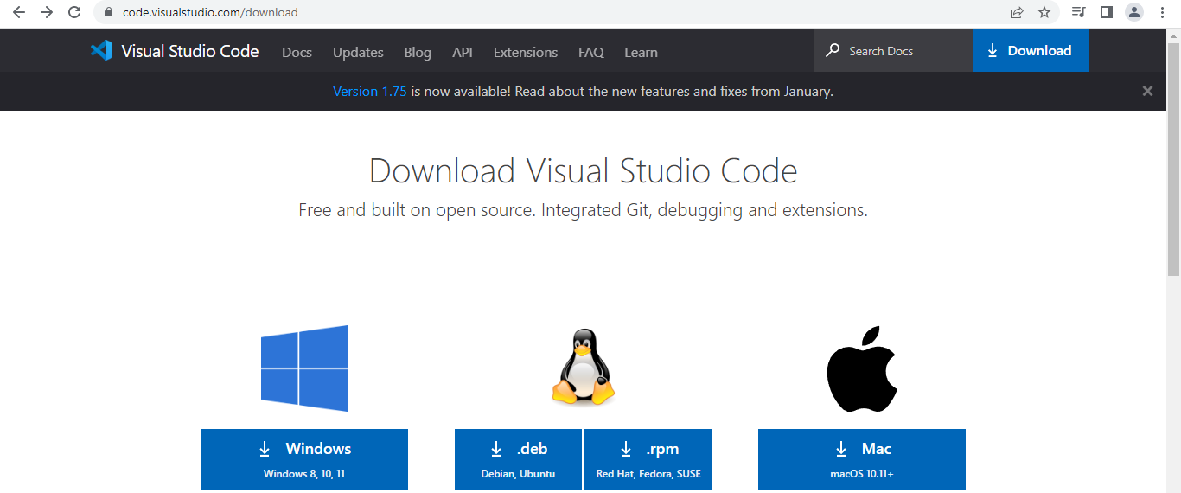

To install Visual studio code:

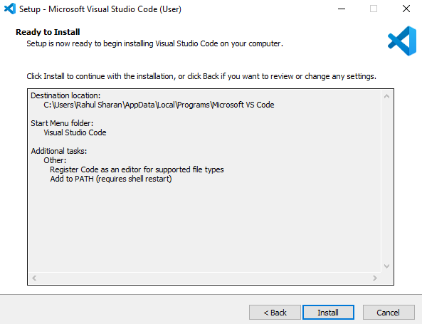

## -Add extensions in VScode -terraform and AWS terraform:

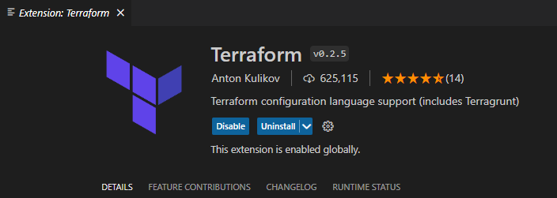

# **To Authentication terraform with AWS using AWS Access key:**

## -Download and install the AWS CLI for windows by using the following link:

<https://docs.aws.amazon.com/cli/latest/userguide/getting-started-install.html>

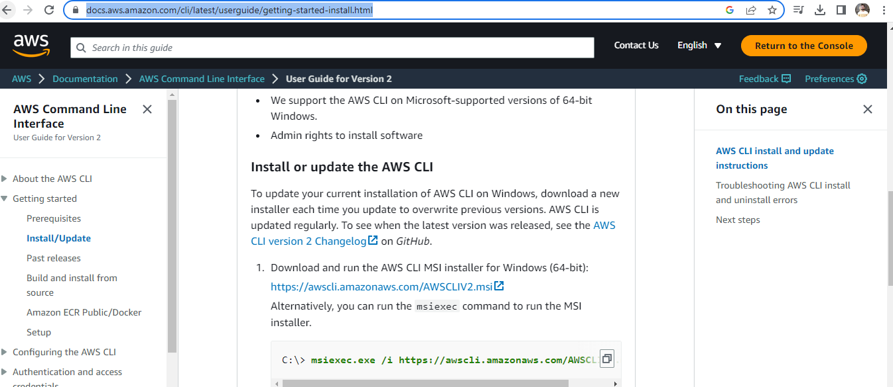

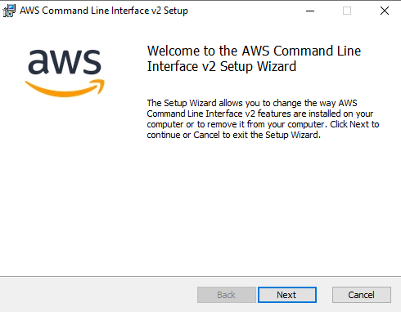

## - Check the Aws version on windows system:

Open the command prompt and check the Aws version by using the following command:

>aws --version

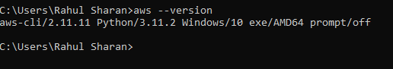

## -Create Access Key using IAM service:

IAM>Security Credentials>Access key: Create access key.

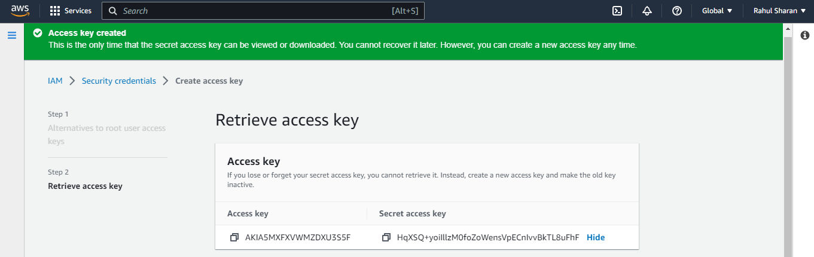

## -Configure the aws access key with terraform on windows:

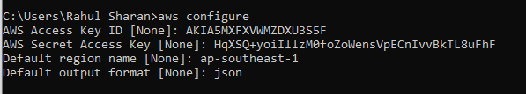

## -Check the created .aws folder and config and credentials files by using following path:

C:\Users\Rahul Sharan\.aws

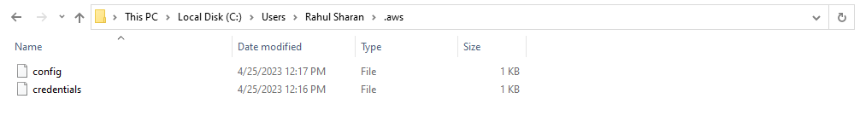

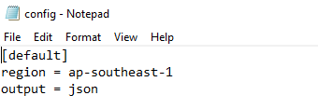

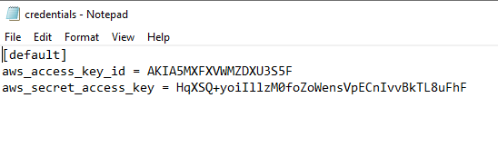

# **To create virtual private cloud by using the Aws Terraform:**

## -Configure the VPC file by using the HCL.

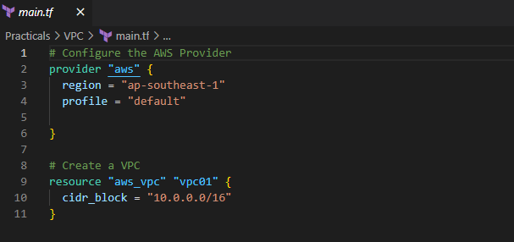

## -Initialize the terraform configuration file using the following command:

>terraform init

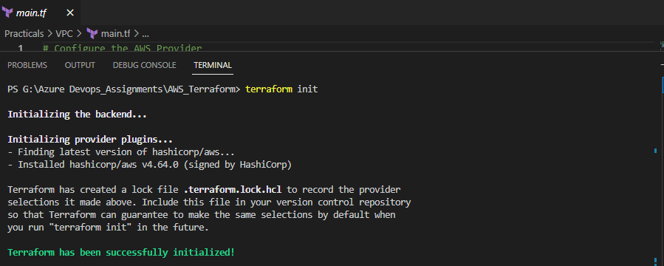

## -Create an execution plan for resource group by using the following command:

>terraform plan –out main.tfplan

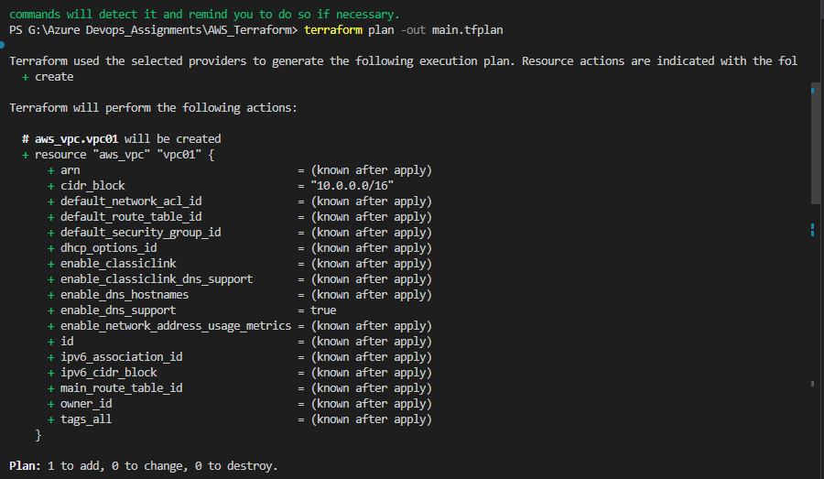

## -Execute the resource group by using the following command:

>terraform apply

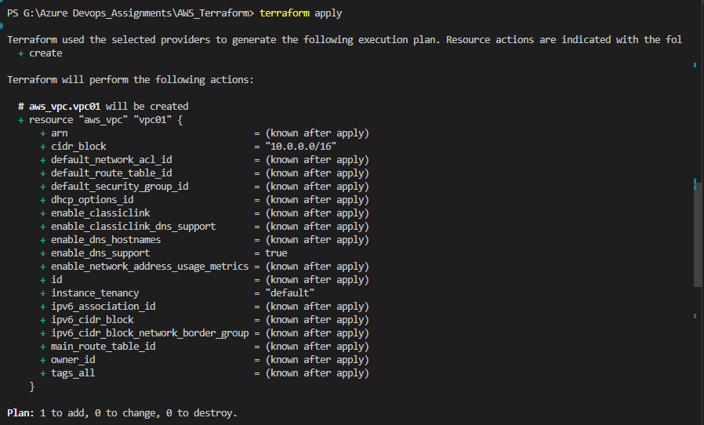

## -Verify the VPC in AWS portal:

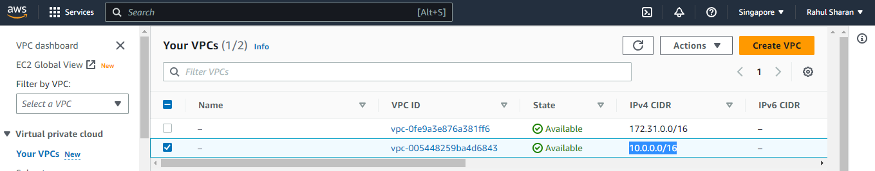

# **To Download, Install and configure Packer.**

## -Download, Install and configure packer:

To download packer by using the following link:

- (<https://www.packer.io/downloads>)

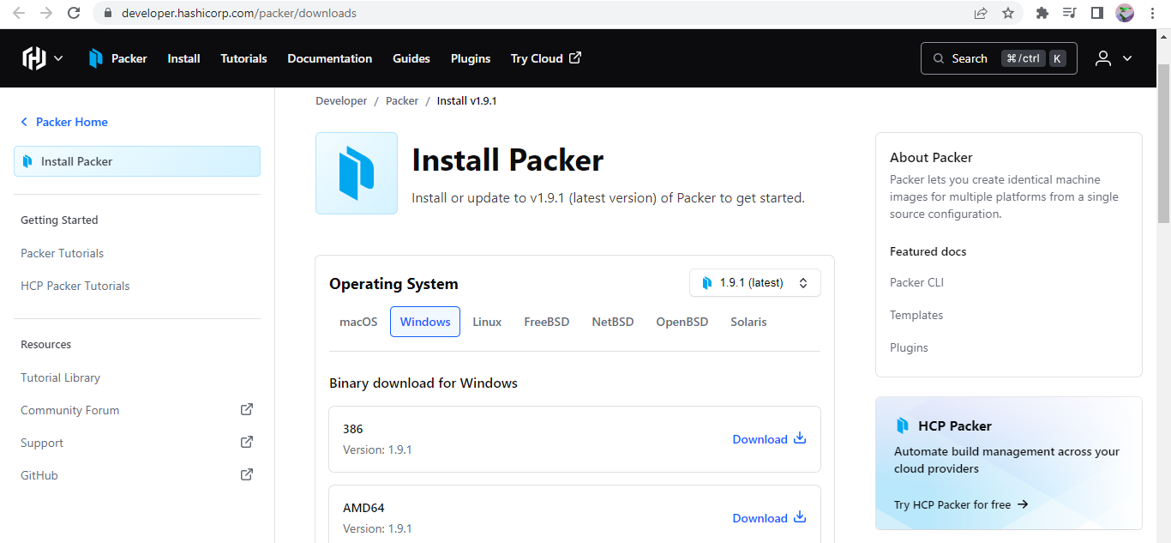

To create a folder packer in c :> program files:

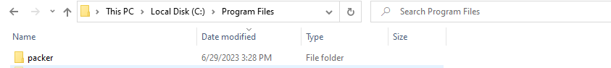

Packer.exe file extract in c :> program files/packer folder:

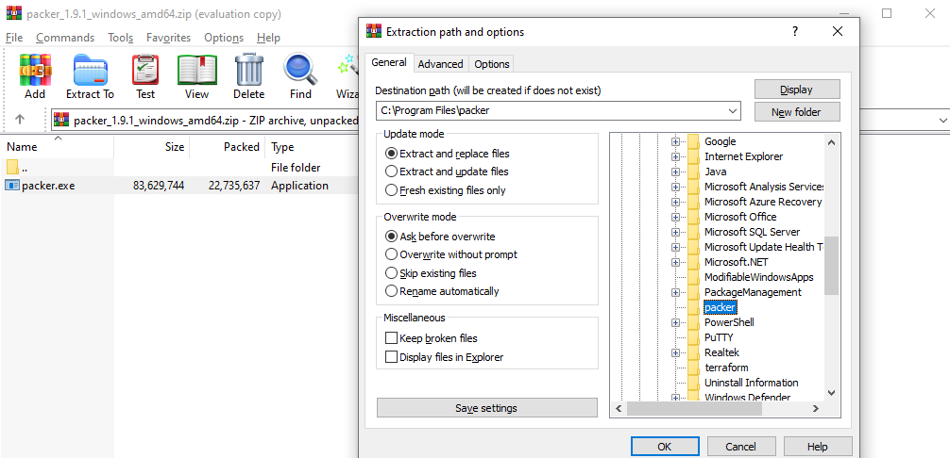

To check the executable file in c :> program files>packer:

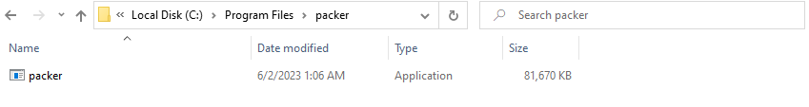

## -Add the environment variable: Path- C:\Program Files\packer

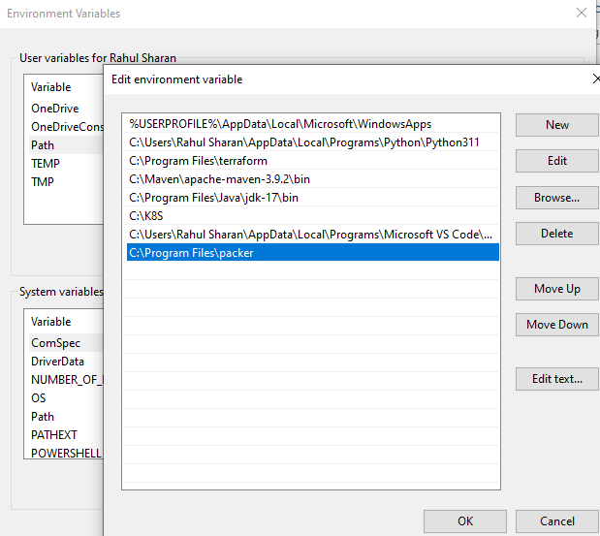

## -Open command prompt and check the packer version by using the following the command:

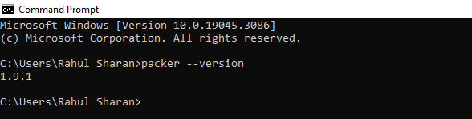

# **To configure the AWS Security Token Service (STS) using IAM (Identity and Access Management), you can follow these steps:**

### -Open the IAM console:

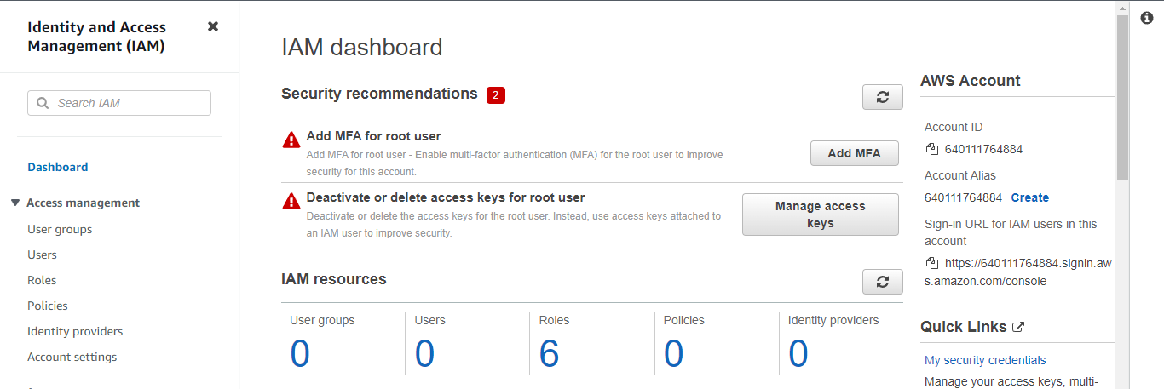

### -Create a user using IAM:

In the navigation pane, choose "user"->Set permission: Attach policies directly->next->create

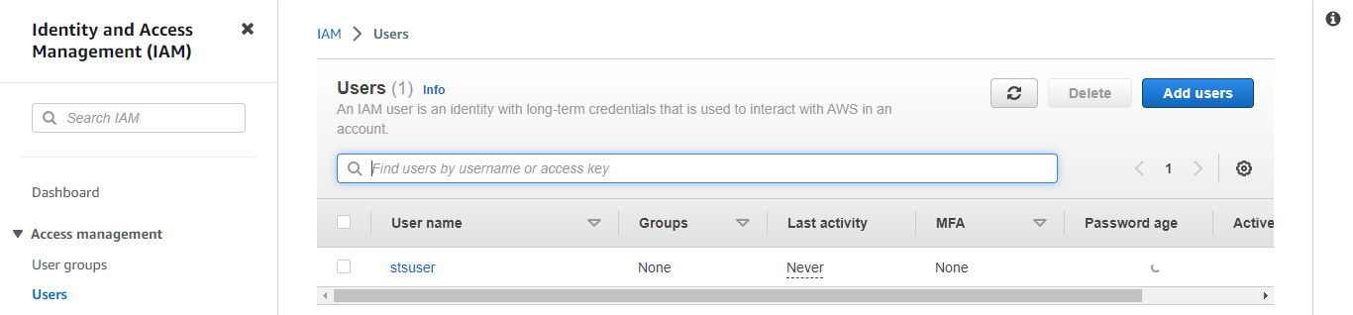

### -Create access key:

Click on “sts-user” to start creating an access key->Security credentials-> Access keys:Create Access key: local code->next->create access key->Done

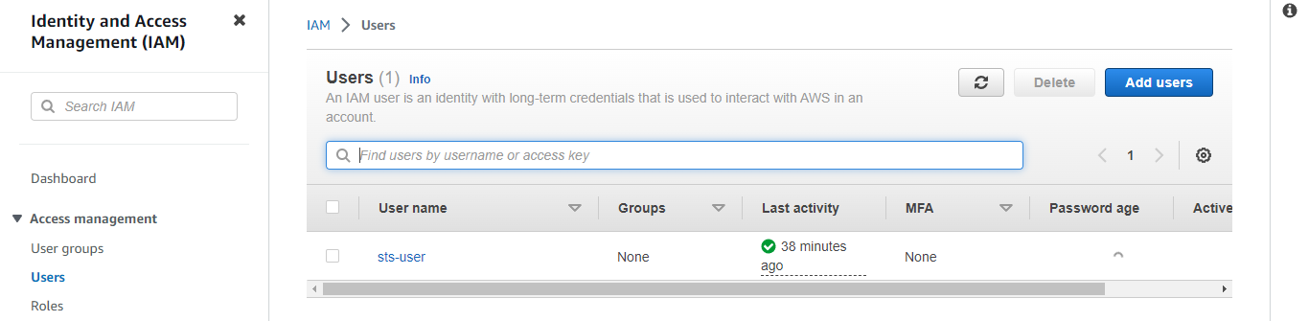

### -Delete the Credentials:

>cat ~/.aws/credentials

>rm –rf ~/.aws/credentials

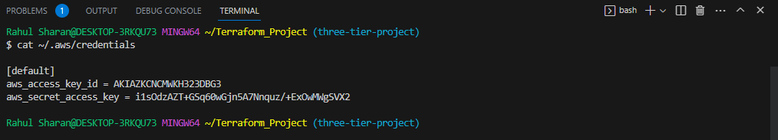

### -Configure the access key with terraform using the following command:

>aws configure

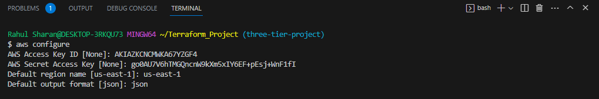

### -Check the .aws configuration file:

> cat ~/.aws/config and

>cat ~/.aws/credentials

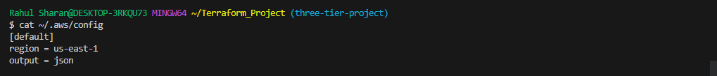

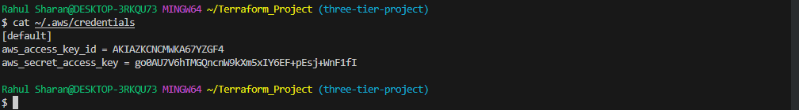

### -Create role:

Click on "Create role" to start creating a new role.

Trusted type->AWS account: use case->EC2->AWS Account: This account->Next->Add permission: Administrator access->next->Role name: “stsassume-role” ->Create role

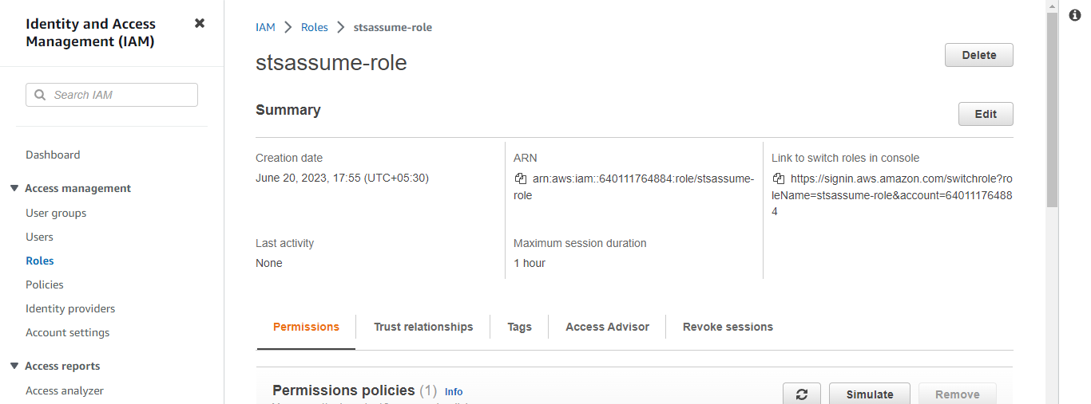

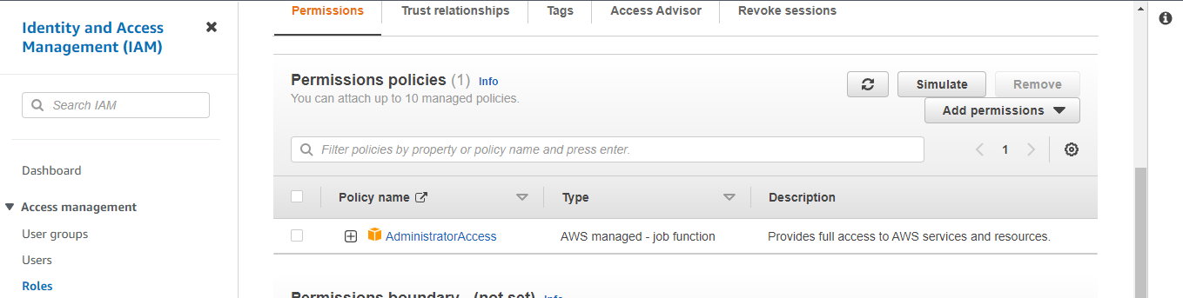

### -Add permission to user:

Create the inline policy by Configuring using a role by using below link:

<https://docs.aws.amazon.com/cli/latest/userguide/cli-configure-role.html>

IAM->User: sts-user->permission: add permission: Create inline policy: JSON:->Review policy and Create: name it as "stsassumerole-policy"

{

"Version": "2012-10-17",

"Statement": [

{

"Effect": "Allow",

"Action": "sts:AssumeRole",

"Resource": "arn:aws:iam::640111764884:role/stsassume-role"

}

]

}

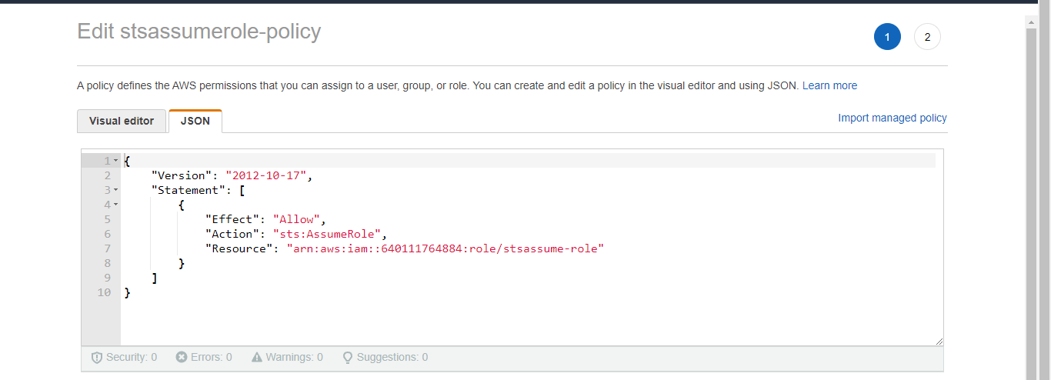

### -Successfully added the permission:

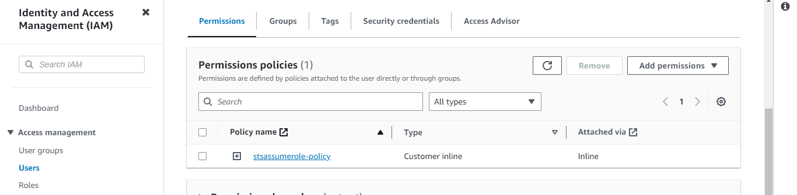

### -Configure the profile sts in configuration file:

>code ~/.aws/config

[profile sts]

role_arn = arn:aws:iam::640111764884:role/stsassume-role

source_profile =default

>cat ~/.aws/config

>aws s3 ls --profile sts

-> cat ~/.aws/credentials

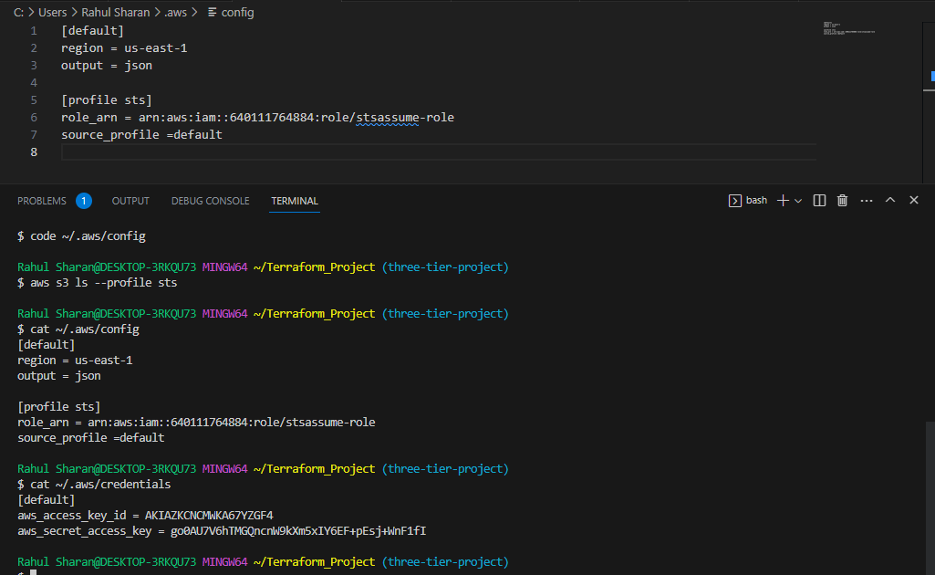

### -Check the session token by using the following commands:

> aws sts get-caller-identity

> aws sts assume-role --role-arn arn:aws:iam::640111764884:role/stsassume-role --role-session-name s3list

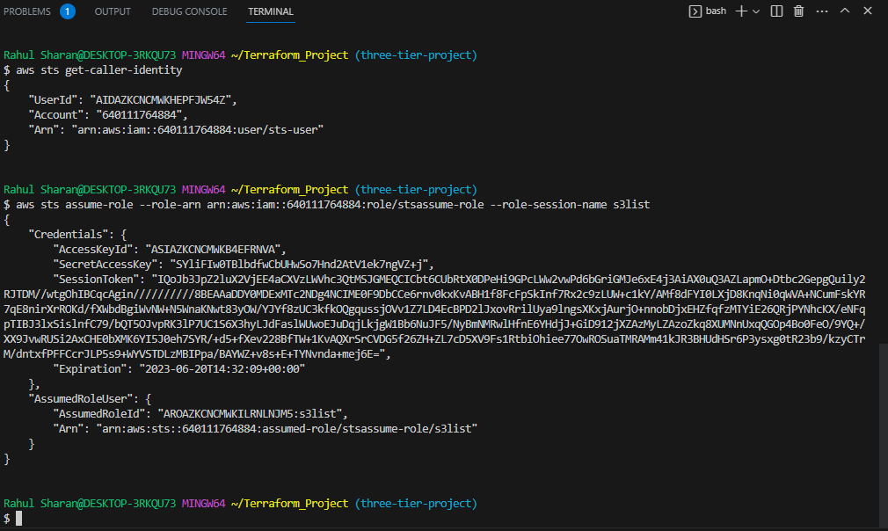

### -Check the S3 list using the following commands

> cat ~/.aws/config

> aws s3 ls --profile sts

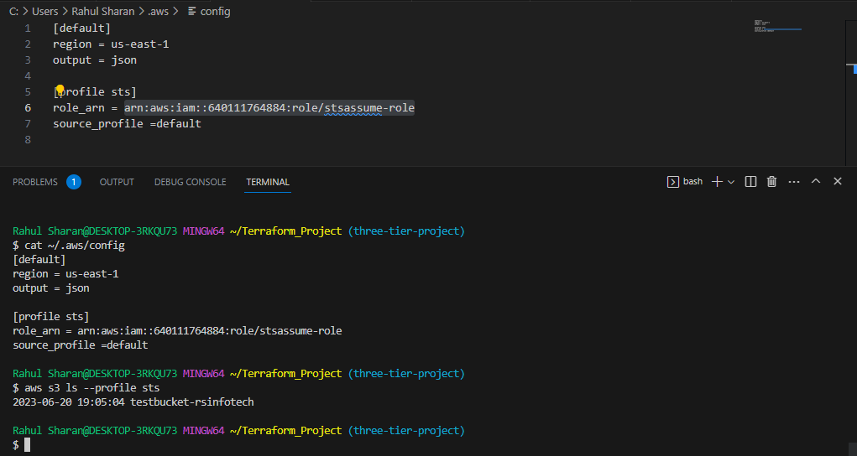

### -Go to provider.tf and configure assume role:

provider "aws" {

  region = "us-east-1"

  assume_role {

    role_arn     = "arn:aws:iam::640111764884:role/stsassume-role"

    session_name = "terraform-sts"

  }

}

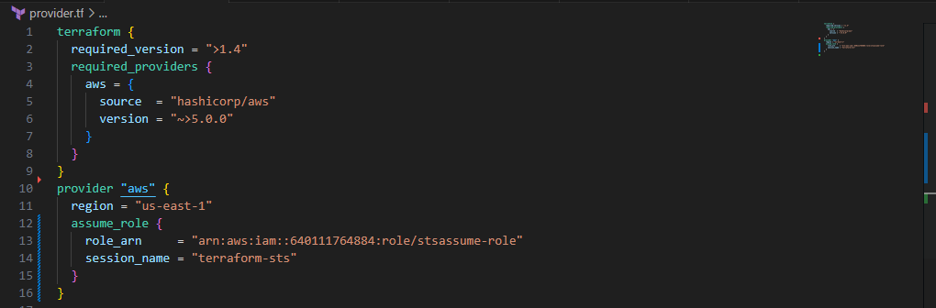

## -**To Configure the Actions secrets and variables**

AWS_ACCESS_KEY and AWS_SECRET_KEY:

These are your AWS access credentials used for programmatic access to AWS services. The AWS_ACCESS_KEY is similar to a username, and the AWS_SECRET_KEY is like a password.

SSH_PRIVATE_KEY:

The SSH private key is part of a pair of keys used for secure authentication when connecting to remote servers via SSH (Secure Shell).

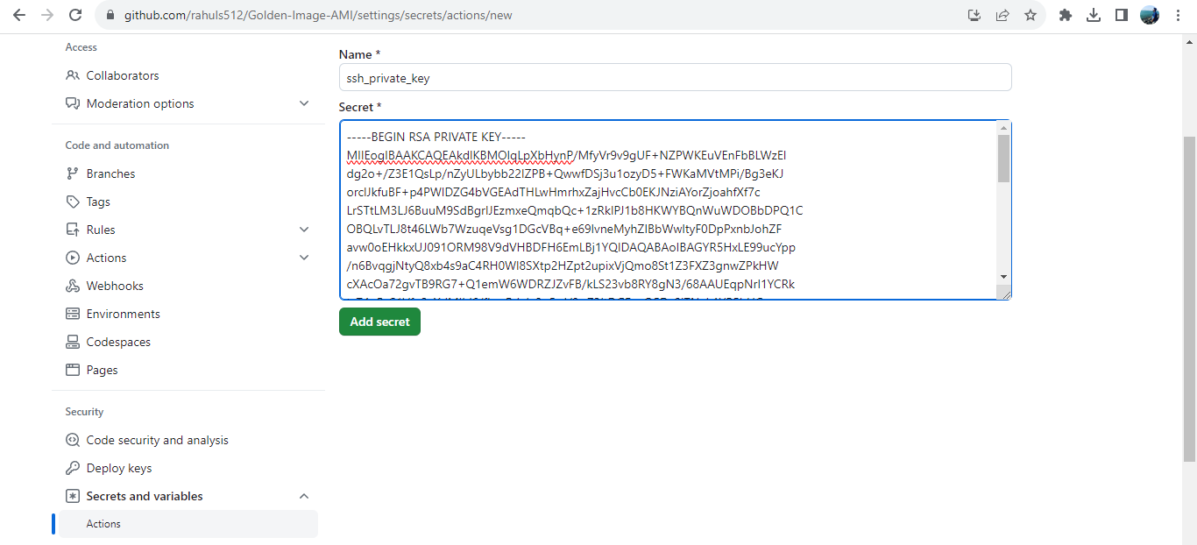

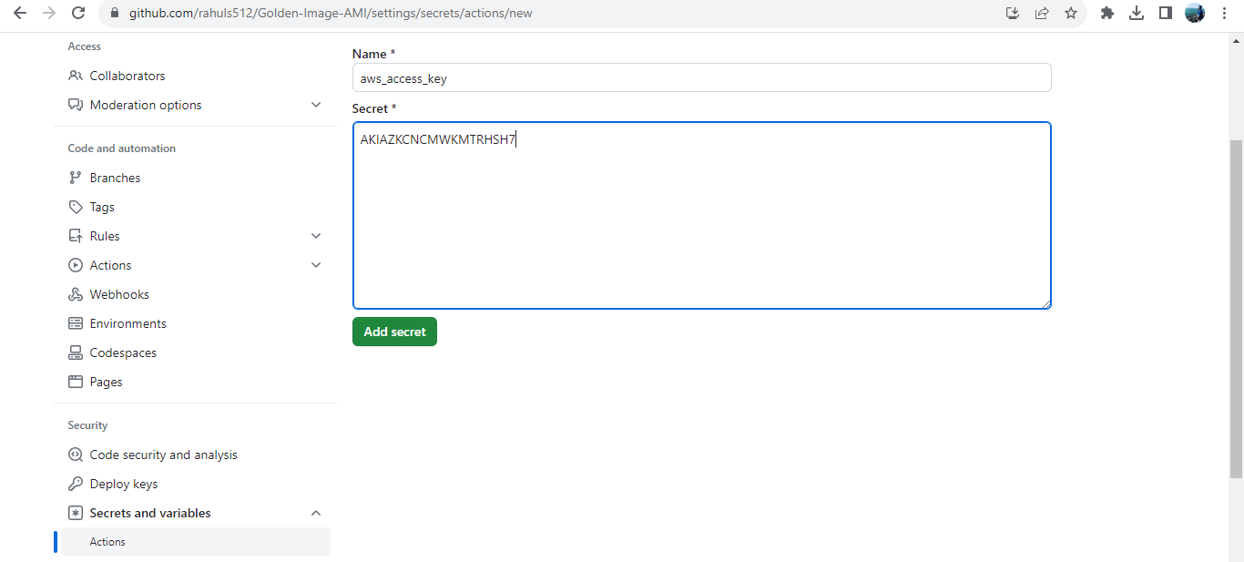

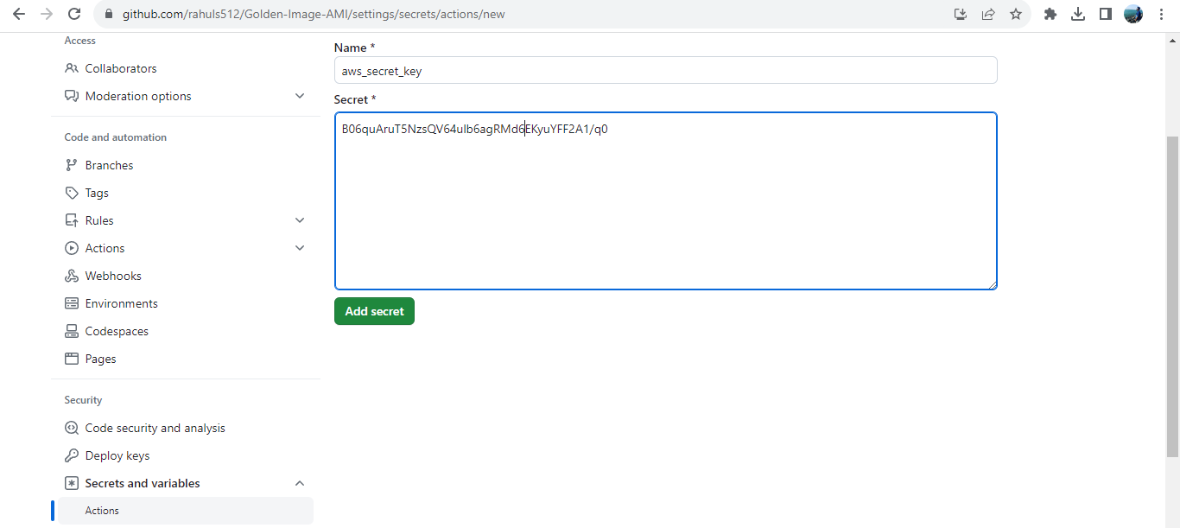

**- Download, Install and configure JDK:**

-Download the gdk from official side: <https://www.oracle.com/in/java/technologies/downloads/>

X64 installer

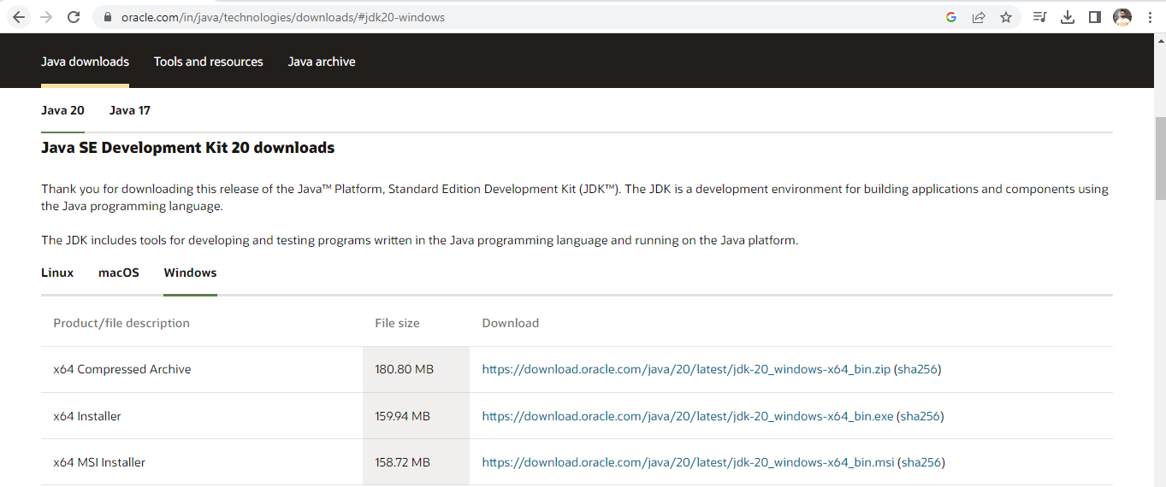

-Install gdk on windows machine:

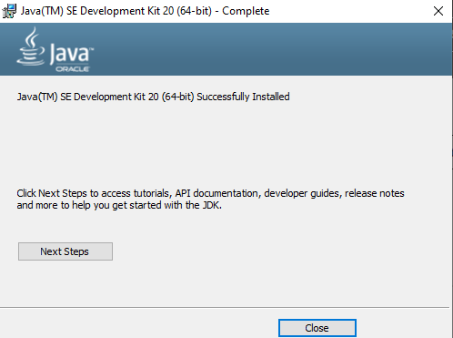

- Copy the path from C:\Program Files\Java\jdk-17\bin:

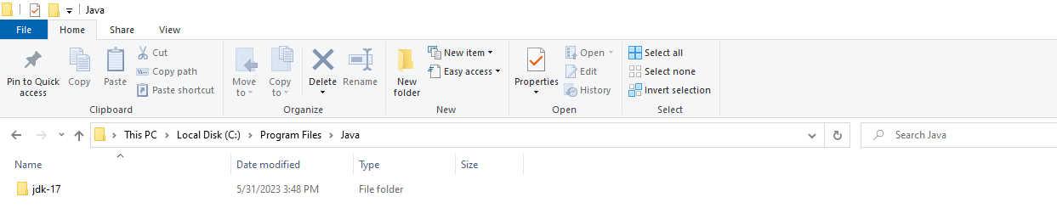

-Add the path in ENV Variable:

C:\Program Files\Java\jdk-17\bin

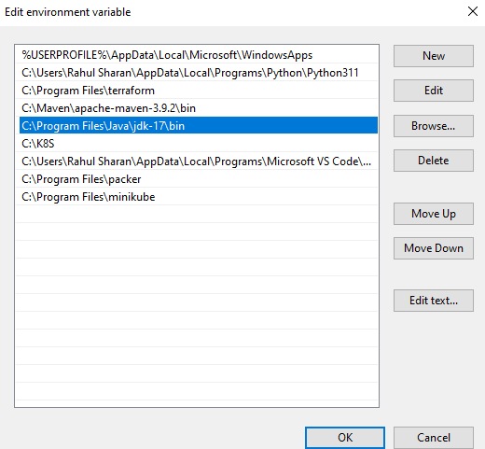

-Check the java version:

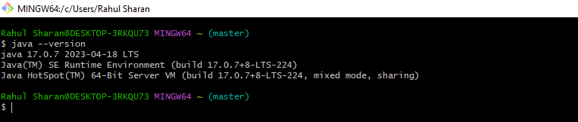

**-Download, Install and configure Jenkins:**

Download the Jenkins from official side: <https://www.jenkins.io/download/>

Stable (LTS): Download Jenkins 2.387.2 LTS for: Windows

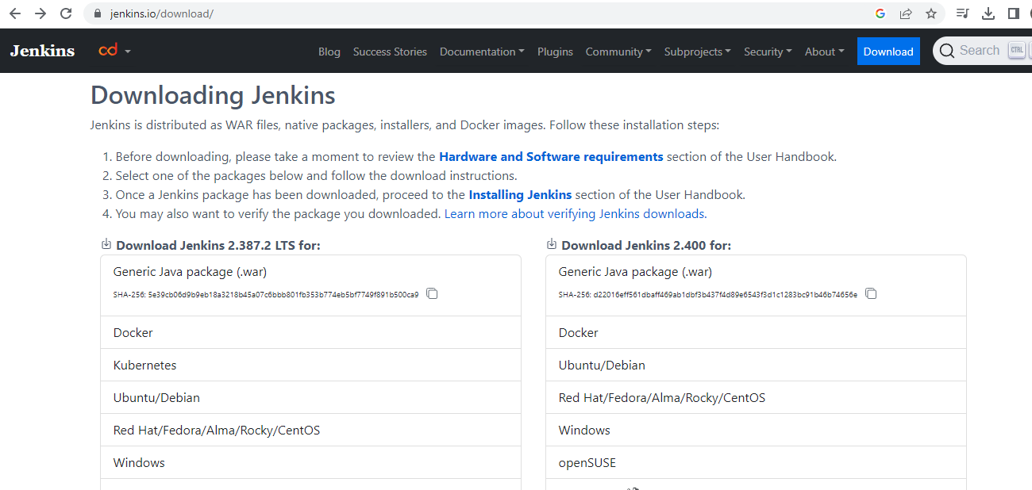

-Install Jenkins on windows machine:

Run System as LocalSytem>testport: 8080>Select java path C:\Program Files\Java\jdk-17\>next

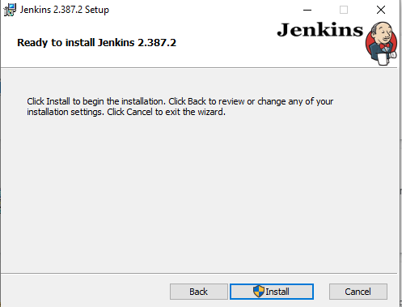

-Sign in the Jenkins portal: <http://localhost:8080/>

**Unlock Jenkins:**

C:\ProgramData\Jenkins\.jenkins\secrets\initialAdminPassword

**Administrator password:** e8eb9f2c9b964357bfb972443c0795

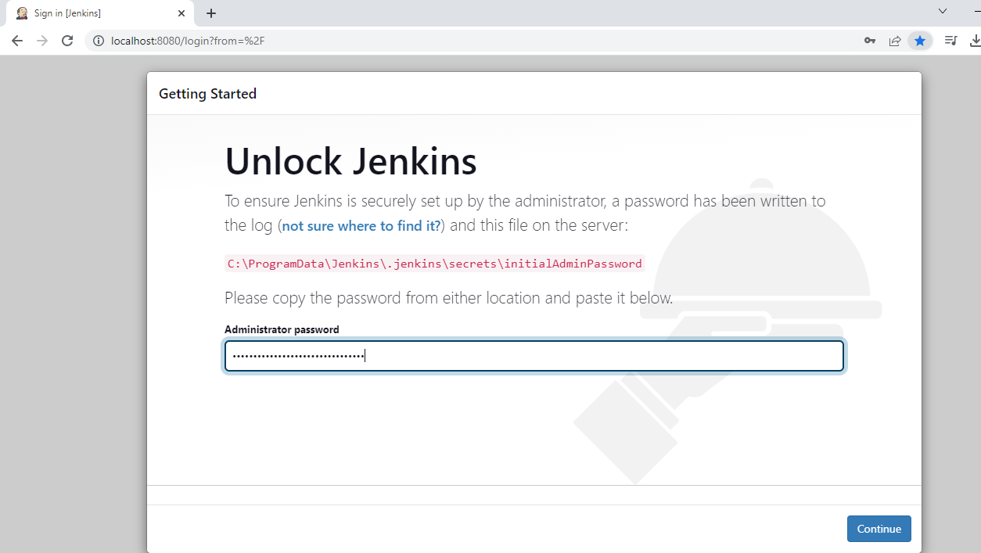

-Customize Jenkins:

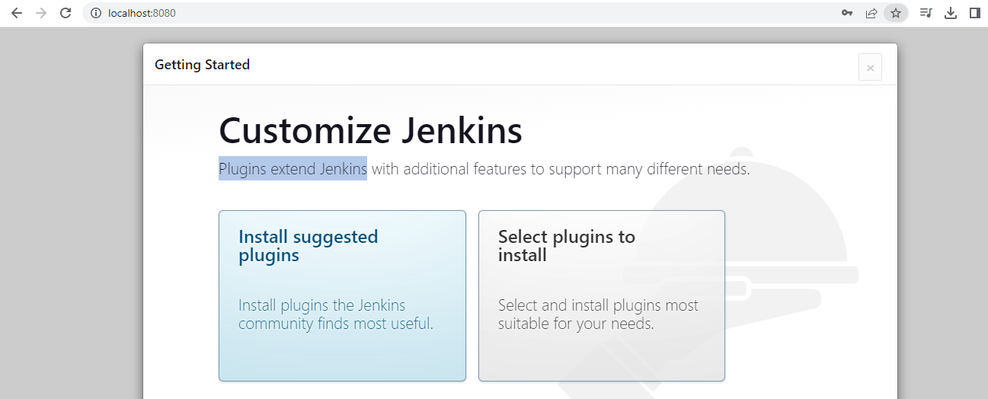

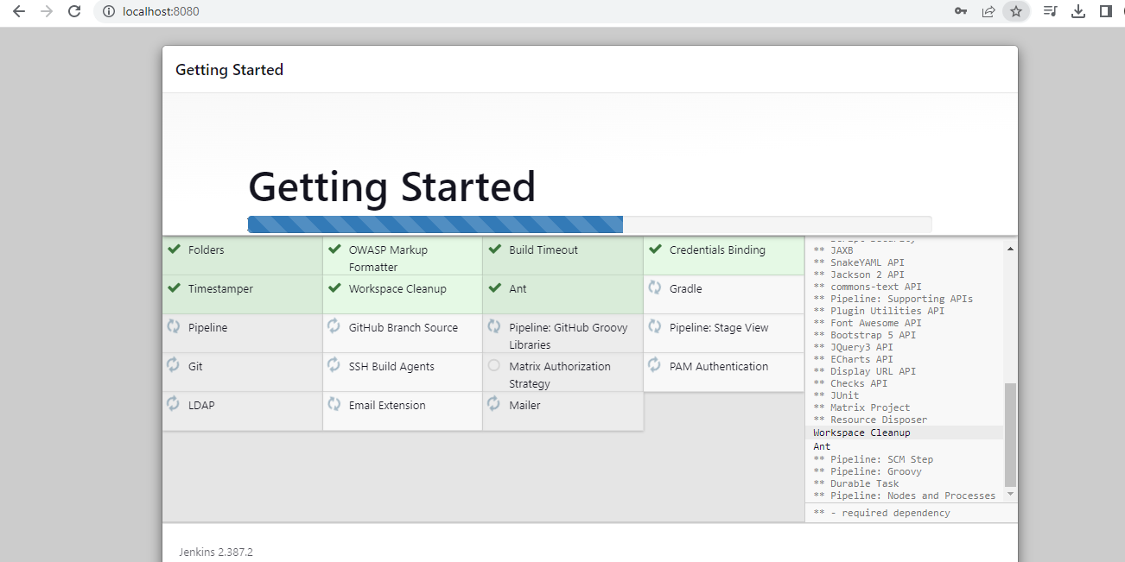

-Create First Admin User:

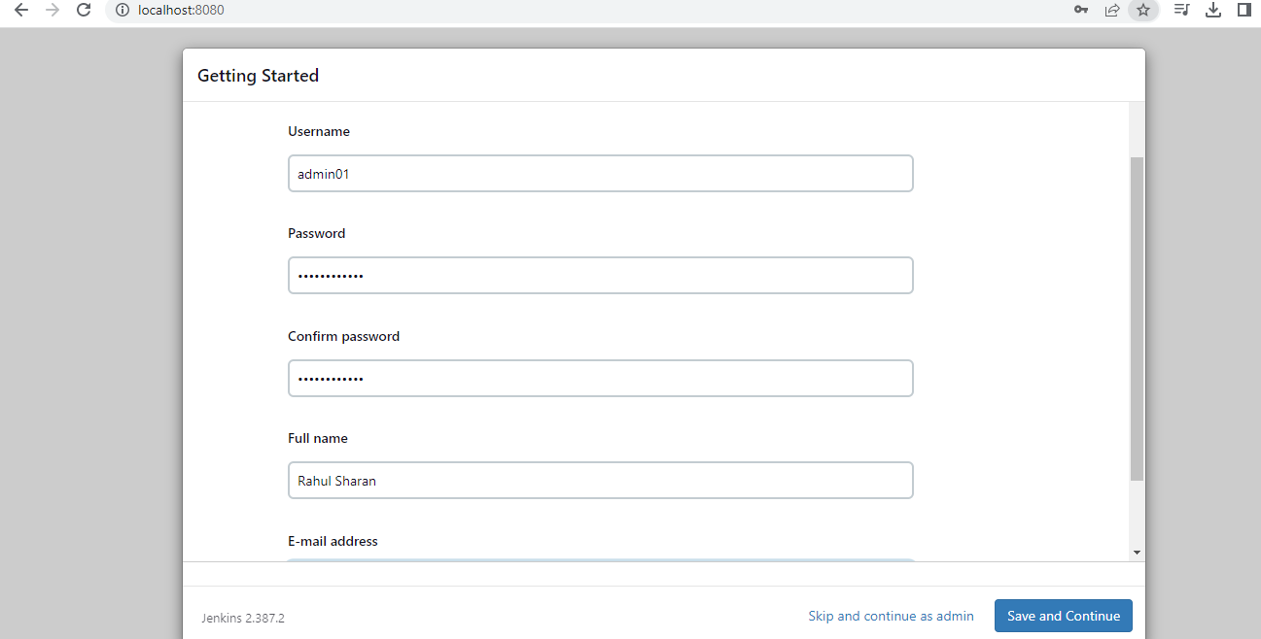

-Instance Configuration:

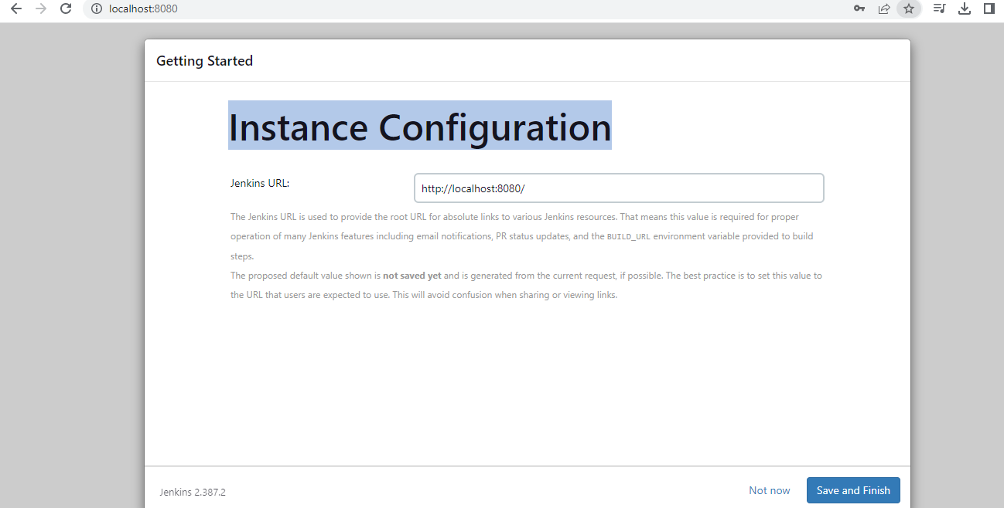

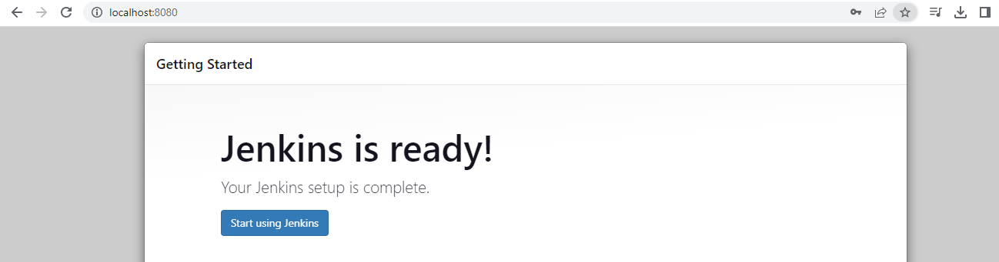

-Dashboard of Jenkins:

