This document contains some basic test scenarios

1. The client side validations:  
   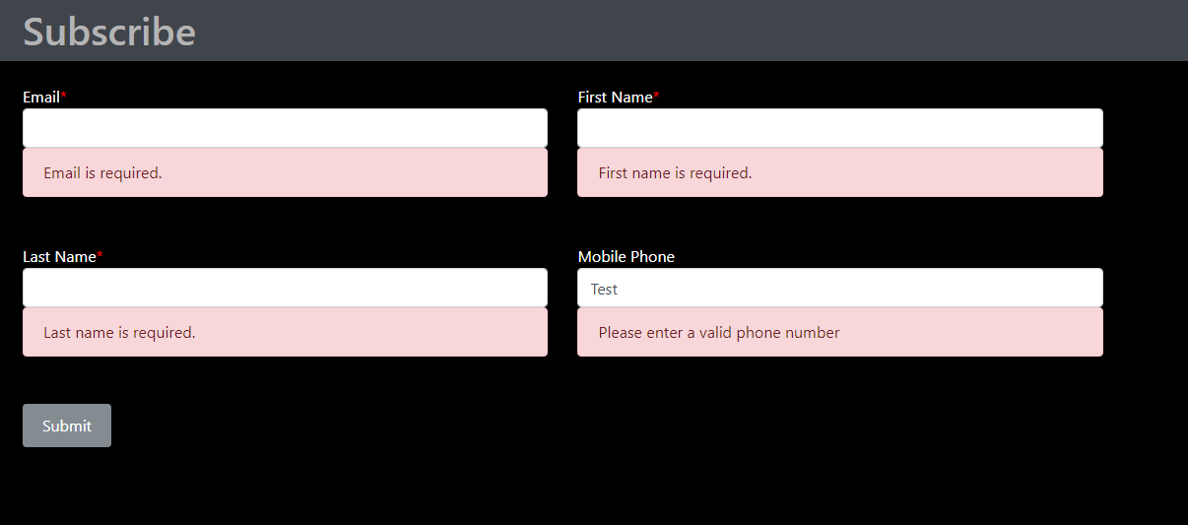
2. Once the form is successful submitted – Thank You screen  
   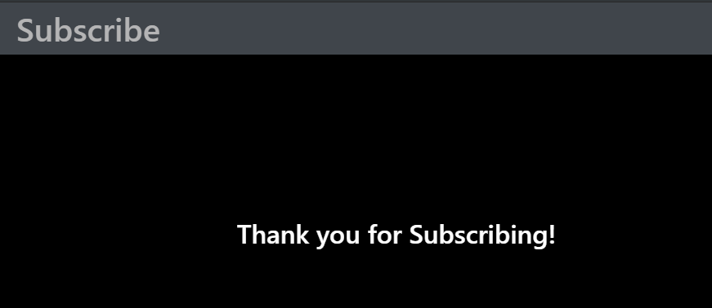
3. Responsive application – Mobile View  
     
   