**FUTURE INSTITUTE OF ENGINEERING AND MANGEMENT**

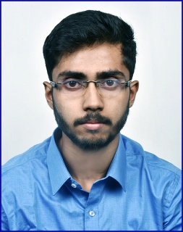Résumé

**Name**: Rahul Saha

**Mb**: (+91) 8240204957 **|** (+91) 9874644169

**Email**: saharahul384@gmail.com

**Career Objectives:**

To be a part of an organization where I could use and enhance my knowledge and talent for the development of both organization and myself.

**Academic Qualifications:**

|  |  |  |  |  |
| --- | --- | --- | --- | --- |
| **Qualification** | **Institute** | **Board/**  **University** | **Year of**  **passing** | **Aggregate %**  **/CGPA** |
| Bachelor of Technology in Computer Science and Engineering | Future Institute of Engineering and Management | MAKAUT (Formerly Known as WBUT) | 2018 | 7.57  (CGPA up to 6th semester) |
| Higher Secondary Examination (12th) | Mitra Institution (Bhowanipur Br.) | WBCHSE | 2015 | 76.8%  (best of 5) |
| Secondary Examination (10th) | Mitra Institution (Bhowanipur Br.) | WBBSE | 2013 | 83% |

**Details of B.Tech:**

|  |  |  |  |  |  |  |
| --- | --- | --- | --- | --- | --- | --- |
| **Semester** | 6th | 5th | 4th | 3rd | 2nd | 1st |
| **SGPA** | 7.92 | 7.73 | 8.27 | 7.55 | 7.07 | 6.93 |

**Training Undergone**

* Machine Learning from Webtek Private Limited (Summer Training) of 2018.

**Final Year Project**

* Face recognition using CCTV.

**Projects Completed**

* Loan prediction using machine learning.

**Extra-Curricular Activities**

* Have been working with several event organisations.
* Private tutor for past three years.

**Achievements**

* Finalist of **Smart India Hackathon** of 2017-18.
* Finalist of **Bengalathon** of 2017-18.

**Hobbies and Interests**

* Competitive Coding.
* Workout.
* Playing and Watching Cricket and Football.

**Subjects of Interests**

* Data Structure
* Database Management System

**Programming Languages**

* C
* Java (Core)
* Python (Basics)

**Personal Details**

**Father’s Name:** Mr. Pradip Saha

**Mother’s Name:** Mrs. Anita Saha

**Permanent Address:** 444b Kalighat road Kolkata-700026

**Date of Birth:** 17/06/1997

**Language known:** Bengali, Hindi (speaking) and English

**Gender:** Male

**Nationality:** Indian

**DATE:**

(SIGNATURE)