Dataset Construction Process

HOW constructed a dataset of 729 thoracic aorta shapes and corresponding wall stress distributions, which was used to train and test the DL model.

* In previous Experiment the data was calculated:

This is how they were calculated:

**25 Shapes from CT images:** De-identified clinical cardiac CT scans and resected Ascending Aortic Aneurysm (AsAA) tissues were obtained for a total of 25 patients. The resolution of the images is 0.7×0.7×2.50 mm, and the field of view covers the thoracic and abdominal aorta. For each patient, the 3D surface of the aorta was semi-automatically reconstructed from the clinical CT image data using Avizo software.

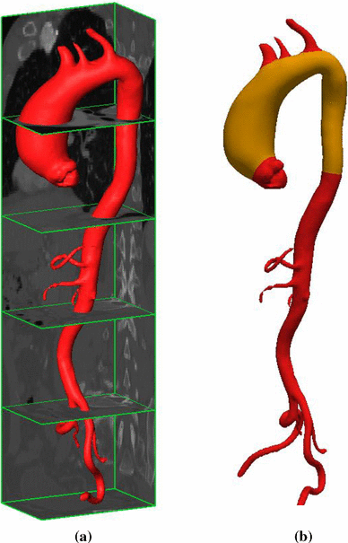The resulting surfaces were meshed to obtain a total of 25 aorta shapes in the form of triangle meshes with an arbitrary number of nodes and elements.

(a) The aorta segmented from a 3D CT image.

(**b)** Trimmed aorta surface in gold colour.

**Remeshing:** A remeshing method was developed to convert the triangle meshes to quad meshes with the same number of nodes and the same nodal connectivity among the elements for all patients.

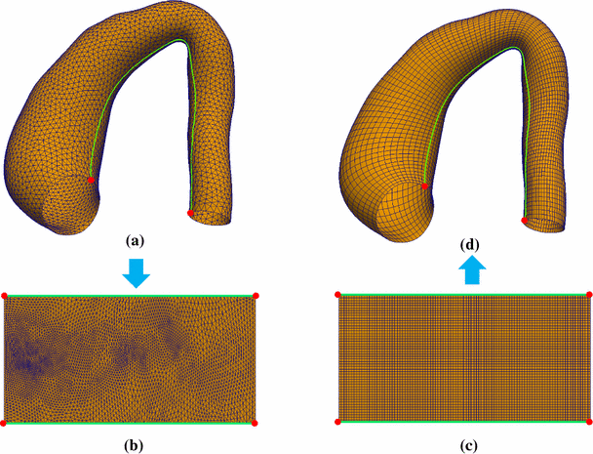

1. a 3D triangle surface mesh
2. a minimum-stretch-based mesh-parameterization was performed, resulting in a 2D triangle mesh in a rectangular shape of a predefined size
3. the 2D region was then discretized as a 2D quad mesh with 5100 nodes and 4950 elements
4. by using barycentric interpolation determined by the 3D surface mesh and the 2D triangle mesh, the 2D quad mesh was transformed into the 3D space and the nodes on the top and bottom of the rectangular mesh were merged to yield a 3D tubular surface mesh with 5000 nodes and 4950 elements

**Alignment:** After remeshing, each shape (25) was aligned to a common coordinate system by Generalized Procrustes Analysis (GPA). Here, a shape $X^{\left(k\right)}$  indexed by *k*, is a quad-surface mesh which can be represented by a vector

$$X^{\left(k\right)}=\left[x_{1}^{\left(k\right)},x_{2}^{\left(k\right)},x_{3}^{\left(k\right)},.....,x_{N}^{\left(k\right)}\right]$$

assembled from the coordinates of each point $x_{n}^{\left(k\right)}$  of the mesh with a total number of *N* points (i.e., nodes). The alignment process runs in an iterative manner: (1) transform each shape $X^{\left(k\right)}$  to the mean shape $\overline{X}$  by the similarity transform, where initially one of the training shapes is randomly chosen as the mean shape; (2) compute the mean shape from all the transformed shapes. The parameters of the similarity transform were determined by minimizing the objective function:

$$J\left(s,R,t\right)=\sum_{k=1}^{K}{\sum_{n=1}^{N}{{\left|\left|\overline{x_{n}}-sRx_{n}^{\left(k\right)}-t\right|\right|}^{2}}}$$

where, $\overline{X}=\frac{1}{K}\sum_{k=1}^{K}{X^{\left(k\right)}}$, the unknown parameters {s, R, t} are calculated. s=1 to keep the scale retained. Also, *K=25.*

**PCA:** Principal Component Analysis (PCA) can decompose the shapes into a mean shape and a set of linearly uncorrelated shape variations which are the principal components, also called the modes of shape variations. We create the covariance matrix and find its’ eigenvalues and eigenvectors using Singular Value Decomposition, where covariance is defined,

$$C=\frac{1}{K}\sum_{k=1}^{K}{\left(X^{\left(k\right)}-\overline{X}\right){\left(X^{\left(k\right)}-\overline{X}\right)}^{'}}$$

Thus, SSM was constructed with the mean shape $\overline{X}$ and the modes of shape variation $\left\{V^{\left(1\right)},…,V^{\left(K\right)}\right\}$

and corresponding eigenvalues $\left\{λ^{\left(1\right)},…,λ^{\left(K\right)}\right\}$ which are sorted from largest to smallest.

To understand PCA better visit [HERE](https://youtu.be/FgakZw6K1QQ) and [HERE](https://stats.stackexchange.com/questions/134282/relationship-between-svd-and-pca-how-to-use-svd-to-perform-pca).

**Shape Sampling:** By using the Statistical Shape Model (SSM), a shape *Y* can be approximated by the mean shape and a linear combination of the shape variation, given by,

$$Y=\overline{X}+\sum_{m=1}^{M}{c_{m}\sqrt{λ^{\left(m\right)}}V^{\left(m\right)}}$$

To obtain a set of representative shapes, the selected modes must be able to explain a large percentage of the total shape variation, which was given by first three 3 modes with 80.1% of total shape variation. Thus, a total number of 729 shapes were obtained automatically by uniformly sampling the parameters {c1, c2, c3} in the range of −2 to 2, i.e., within 2 standard deviations of the mean shape.

To know the complete process of SSM visit [SSM](https://www.sciencedirect.com/science/article/pii/S1361841509000425?via%3Dihub).

This way we calculated the shape data.

Now we will perform FEA, using Abaqus/Standard 6.14 (Simulia, RI), to find the stress data.

First, the backward displacement method was used to estimate the unpressurized geometry, and then each unpressurized geometry was inflated under the systolic pressure of 16 kPa. S4R shell elements were used during step 1, and to improve convergence S4 shell elements were used during step 2.

A fibre-reinforced hyperelastic material model based on the work of Gasser *et al*. was used to characterize the aortic wall mechanical response.

Once the simulation for a shape was completed, the stress values at each node were output from Abaqus and the average stress components across the thickness were calculated.