The Product Company

~ Final Data Mart Development Report ~

Team # 8

Team Members
Khyati Sharma
Rahul Balu Sakore
Weishi Shi

Date

ISTE Data Warehousing

~ Table of Contents ~

I. Data Mart Design Definition 2
1. Universe of Discourse 2
2. Information Package 2
II. Dimensional Model 3
III. Data Staging: ETL – Data Extract File Definitions 4
IV. Data Staging: ETL – Source-to-Target Mappings 5
V. SQL Code – Tables & Constraints 6
VI. Data Staging Activities - ETL 7
1. Data Cleansing 7
2. Data Transformation 7
3. Table Population 7
VII. End User Applications 8
1. SQL99 Queries 8
2. A Views 8
3. Aggregated Data Marts …….……………………………………………........9
VIII. Handling Slowly Changing Dimensions (SCD)……..…………………………. 10
IX. N-M Implementation Option………………………………………………….…11

I. Data Mart Design Definition

1. Universe of Discourse

Our Universe of Discourse is to study and implement Data Mart by ETL process with this we are able to investigate the Sales for the customer and the product and find relationship between the product and customer and can make decision on the sales amount.
Our Scope does not restrict to only analyze Sales but also includes functionality to summarize customer and product data by using Aggregated Fact Table and other functions like Slowly Changing Dimension.

2. Information Package

Process Name: Sales Analysis
Grain: Each individual customer, product for a purchase on given day
Customer | Product | SalesDate Time | OrderDate Time | Ship Detail(junk)
Customername | Description | Sales year | Order year | Order Method
State | Price1 | Sales month | Order month | Payment Method
City | Price2 | Sales day | Order day | Ship Method
Zip | Prodtypeid | SaleCalendar date | OrderCalendar date
Address | Prodtypedesc | fiscalDay | fiscalDay
SuitDep | Buid
Type name | prodtypename
Type id | Supplier name
 | Supplied by division
 | Unit cost
 | PEC unit cost
 | attention
 | PEC id
 | TPCW id
 | State
 | City
 | Zip
 | Street

Facts: Sales Amount, Quantity, Ship Cost

Instead of having supplier as an individual dimension, we denormalised the supplier into the product dimension.So in product dimension we have two kinds of supplier,one is the division supplying and the second being any other supplier.

Process name: Aggregated summary
Grain:month
CustomerbyCity | SaleDatebyMonth
State | Year
City | Month

Fact: amount
Process name: Aggregated Summary
Grain: Month(aggregated by product and state)

CustomerbyState | SaleDatebyMonth | Product
State | Year | Description
 | Month | Price1
 |  | Price2
 |  | Prodtypeid
 |  | Prodtypedesc
 |  | Buid
 |  | prodtypename
 |  | Supplier name
 |  | Supplied by division
 |  | Unit cost
 |  | PEC unit cost
 |  | attention
 |  | PEC id
 |  | TPCW id
 |  | State
 |  | City
 |  | Zip
 |  | Street

Fact: quantity

3. Entity Definitions

Entity | Entity Definition (genus differentia)
salesFact | sales Fact gives information of individual purchase.Measurement:amount,quantity,shipcost.
salesDateDimension | Gives the date of sale.
OrderDatedimension | Gives the date of order.
ShipDetail | Specifies shipping method, payment method and order method.
Productdimension | Gives the details of product.
CustomerDimesion | Gives the details of customer.
SalesFact by CustomerCity by Month | Aggregated fact by month and city.Measurement:amount
SalesDate by Months Dimension | Aggregated dimension table by month.
CustomerbyCity Dimension | Aggregated dimension table by city.
SalesFactbyCustomerState  byMonthbyProduct | Aggregated fact by customer state by month by product.Measurement:quantity
CustomerbyState Dimension | Aggregated Dimension table by state.

II. Dimensional Model

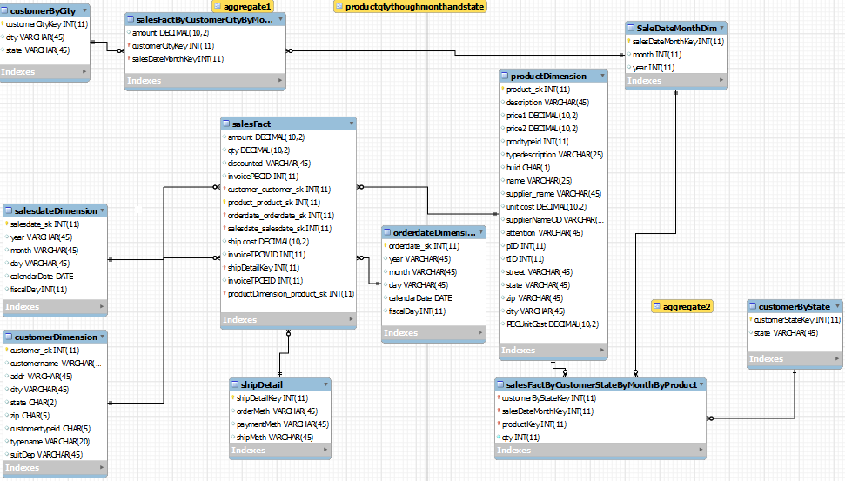

III. Data Staging: ETL – Data Extract File Definitions

FinalCustomerDim.csv

Final ProductDim.csv

- Final SalesFact.csv

- Day.csv

- Month.csv

- Year.csv

- OrderMeth.csv

- ShipMeth.csv

- PaymentMeth.csv

All the above files have (comma) as the delimiter with no enclosure.

The Day.csv, Month.csv and Year.csv are used to generate the Time Dimension, while the OrderMeth.csv,ShipMeth.csv and PaymentMeth.csv are used to generate the Junk dimension i.e. the Ship Detail.

- IV. Data Staging: ETL – Source-to-Target Mappings
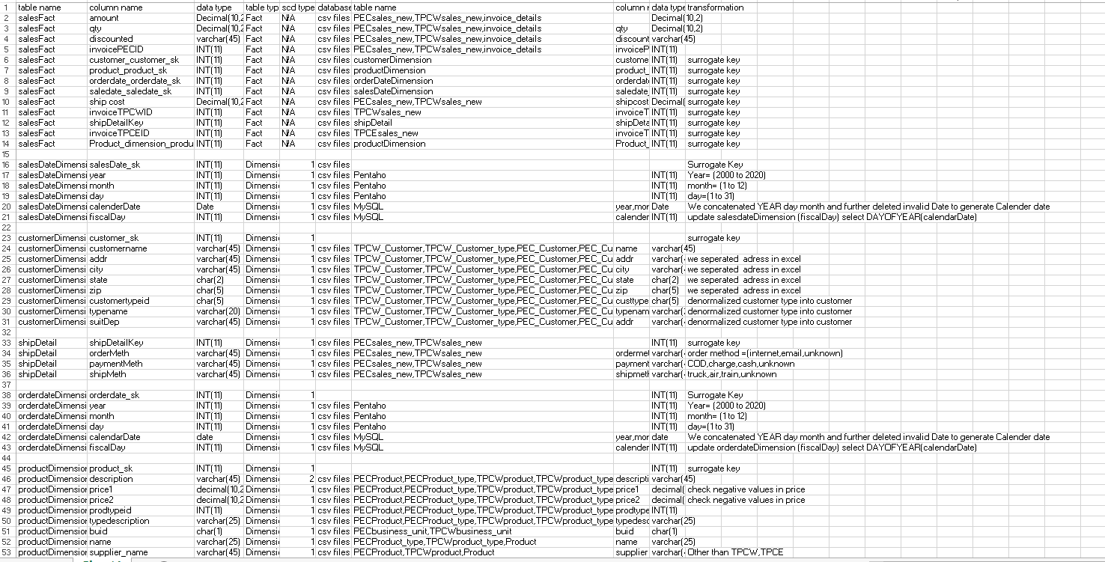

Note: To view the full table please check the mapping.xls file added to the dropbox.

V. SQL Code – Tables & Constraints
Table Creation Code
CUSTOMER DIMENSION
CREATE TABLE `customerDimension` (
`customer_sk` int(11) NOT NULL,
`customername` varchar(45) DEFAULT NULL,
`addr` varchar(45) DEFAULT NULL,
`city` varchar(45) DEFAULT NULL,
`state` char(2) DEFAULT NULL,
`zip` char(5) DEFAULT NULL,
`customertypeid` char(5) DEFAULT NULL,
`typename` varchar(20) DEFAULT NULL,
`suitDep` varchar(45) DEFAULT NULL,
PRIMARY KEY (`customer_sk`)
) ENGINE=InnoDB DEFAULT CHARSET=utf8;

PRODUCT DIMENSION
CREATE TABLE `productDimension` (
`product_sk` int(11) NOT NULL,
`description` varchar(45) DEFAULT NULL,
`price1` decimal(10,2) DEFAULT NULL,
`price2` decimal(10,2) DEFAULT NULL,
`prodtypeid` int(11) DEFAULT NULL,
`typedescription` varchar(25) DEFAULT NULL,
`buid` char(1) DEFAULT NULL,
`name` varchar(25) DEFAULT NULL,
`supplier_name` varchar(45) DEFAULT NULL,
`unit cost` decimal(10,2) DEFAULT NULL,
`supplierNameOD` varchar(45) DEFAULT NULL,
`attention` varchar(45) DEFAULT NULL,
`pID` int(11) DEFAULT NULL,
`tID` int(11) DEFAULT NULL,
`street` varchar(45) DEFAULT NULL,
`state` varchar(45) DEFAULT NULL,
`zip` varchar(45) DEFAULT NULL,
`city` varchar(45) DEFAULT NULL,
`PECUnitCost` decimal(10,2) DEFAULT NULL,
PRIMARY KEY (`product_sk`)
) ENGINE=InnoDB DEFAULT CHARSET=utf8;

SALESDATE DIMENSION
CREATE TABLE `salesdateDimension` (
`salesdate_sk` int(11) NOT NULL,
`year` varchar(45) DEFAULT NULL,
`month` varchar(45) DEFAULT NULL,
`day` varchar(45) DEFAULT NULL,
`calendarDate` date DEFAULT NULL,
`fiscalDay` int(11) DEFAULT NULL,
PRIMARY KEY (`salesdate_sk`)
) ENGINE=InnoDB DEFAULT CHARSET=utf8;

SALES FACT
CREATE TABLE `salesFact` (
`amount` decimal(10,2) DEFAULT NULL,
`qty` decimal(10,2) DEFAULT NULL,
`discounted` varchar(45) DEFAULT NULL,
`invoicePECID` int(11) DEFAULT NULL,
`customer_customer_sk` int(11) NOT NULL,
`product_product_sk` int(11) NOT NULL,
`orderdate_orderdate_sk` int(11) NOT NULL,
`salesdate_salesdate_sk` int(11) NOT NULL,
`ship cost` decimal(10,2) DEFAULT NULL,
`invoiceTPCWID` int(11) DEFAULT NULL,
`shipDetailKey` int(11) DEFAULT NULL,
`invoiceTPCEID` int(11) DEFAULT NULL,
PRIMARY KEY (`customer_customer_sk`,`product_product_sk`,`orderdate_orderdate_sk`,`salesdate_salesdate_sk`),
KEY `fk_sales_customer_idx` (`customer_customer_sk`),
KEY `fk_sales_product1_idx` (`product_product_sk`),
KEY `fk_sales_orderdate1_idx` (`orderdate_orderdate_sk`),
KEY `fk_sales_salesdate1_idx` (`salesdate_salesdate_sk`),
KEY `detail_fk_idx` (`shipDetailKey`),
KEY `fct` (`qty`,`amount`,`ship cost`),
CONSTRAINT `cstomer_fk` FOREIGN KEY (`customer_customer_sk`) REFERENCES `customerDimension` (`customer_sk`) ON DELETE NO ACTION ON UPDATE NO ACTION,
CONSTRAINT `detail_fk` FOREIGN KEY (`shipDetailKey`) REFERENCES `shipDetail` (`shipDetailKey`) ON DELETE NO ACTION ON UPDATE NO ACTION,
CONSTRAINT `orderdate_fk` FOREIGN KEY (`orderdate_orderdate_sk`) REFERENCES `orderdateDimension` (`orderdate_sk`) ON DELETE NO ACTION ON UPDATE NO ACTION,
CONSTRAINT `saledate_fk` FOREIGN KEY (`salesdate_salesdate_sk`) REFERENCES `salesdateDimension` (`salesdate_sk`) ON DELETE NO ACTION ON UPDATE NO ACTION
) ENGINE=InnoDB DEFAULT CHARSET=utf8;

SHIPDETAIL DIMENSION
CREATE TABLE `shipDetail` (
`shipDetailKey` int(11) NOT NULL,
`orderMeth` varchar(45) DEFAULT NULL,
`paymentMeth` varchar(45) DEFAULT NULL,
`shipMeth` varchar(45) DEFAULT NULL,
PRIMARY KEY (`shipDetailKey`)
) ENGINE=InnoDB DEFAULT CHARSET=utf8;

Note:The population part for above tables is done using pentaho.
VI. Data Staging Activities - ETL

1. Data Cleansing:

DM Table | Attribute | Problem | Resolution Strategy (attach code)
PECbusiness_unit.csv | ABBREV | missing value(BUID=D) | String Operations and Value Mapper using  pentaho.  Singletablecheck.ktr
PECsales_new.csv | salesDate/orderDate | should be set to string when loading into pentaho | Replace in String using pentaho  Singletablecheck.ktr
PECsales_new.csv | customerID  (20,000th row) | non-numeric value exists:”33 | Replace in String using pentaho  Singletablecheck.ktr
PECmanufacturingCosts.csv | Year, Month | Format should be in YYYY, MM | var year=Year.getInteger()  if(year.length=1)  {Year.setValue("200"+year)  ;}  else{Year.setValue("20"+year);}  Singletablecheck.ktr
tpcw sales_new | salesDate | varying date format | Used Excel sheet
tpcw sales_new | Customerid  (30727th row) | negative customer id value(-1)
tpcw sales _new | Qty  (4881th row) | null quantity value | If Field Value is null  In pentaho  Product.ktr
pec sales_new | 111 rowsalesDate  41002 row-invoice id | incorrect format  string value
PECcustomerupdate | Address | Standardization | Excel editor; PECcustomerupdate.csv
PECcustomerupdate | State | Standardization | Excel editor; PECcustomerupdate.csv
PECcustomerupdate | Custype | Standardization | Excel editor; PECcustomerupdate.csv
PECproductupdate | SuppierName,Unitcost | Null value | If field value is null on pentaho  PECsustomerTY_customer_relation_check
PECproductupdate | SuppierName | Double Quotes enclosure | Excel editor;  PECproductupdate.csv
PECproduct_typeupdate | TypeDiscription, BUID | Double quotes enclosre | Excel Editor  PECproduct_typeupdate.csv
PECsales_new_update2 | SalesDate, Orderdate | Standardized format into YYYY/MM/DD | Excel editor  PECsales_new_update2.csv
TPCbusiness_unit.csv | ABBREV | Null value(BUID=D)
TPCcustomerupdate | Address | Standardization | Excel editor; TPCWcustomerupdate.csv
TPCcustomerupdate | State | Standardization | Excel editor; TPCWcustomerupdate.csv
TPCcustomerupdate | Custype | Standardization | Excel editor; TPCWcustomerupdate.csv
TPCproduct_typeupdate | TypeDiscription, BUID | Double quotes enclosre | Excel editor;TPCxustomerupdate.csv
TPCsales_newupdate | Sales Date | Format into YYYY/MM/DD | Excel editor; TPCWcustomerupdate.csv

2. Data Transformation

DM Table | Image Creation Process (attach code)

TPC_customer | This is two sources are merged into one.  Product.ktr
PEC_customer
TPC_Product | This is two sources are merged into one.  Product.ktr
PEC_Product
TPC_Sales | This is two sources are merged into one.  Product.ktr
PEC_Sales
PEC_customer | This is two sources are denormalize onto one table  PECcustomerTY_customer_relation_check.ktr
PEC_customertype
PEC_Product | This is two sources are denormalize onto one table  PECcustomerTY_customer_relation_check.ktr
PEC_ProductType
TPC_customer | This is two sources are denormalize onto one table  PECcustomerTY_customer_relation_check.ktr
TPC_customertype

Customer Dimension table transformation:

For customer data both from TPC and PEC we denormalized Customer Type table and Customer table and checked whether if the rows from various sources are overlapped with each other if so we eliminated any duplicate data and made conformed customer dimension using pentaho and excel.We mapped the pentaho table data types to mysql datatype.After transforming we loaded the data into MYSQL database.
Following is the screen shot from the pentaho transformation.

Fig.1
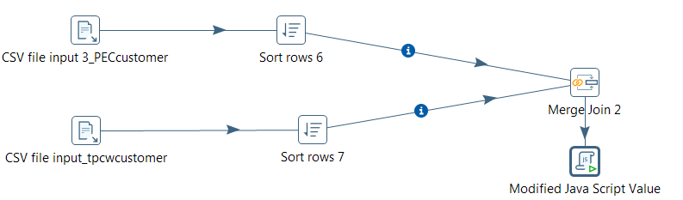

Fig.2
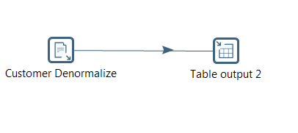

Product Table Transformation:
For Product we made TPC as our base table and mapped PEC data rows to TPC. We denormalized Product type into Product by merging function of pentaho and eliminated any duplicate or overlapped data from both the tables.

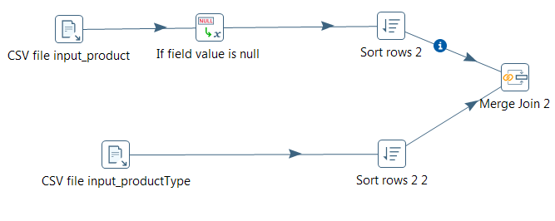
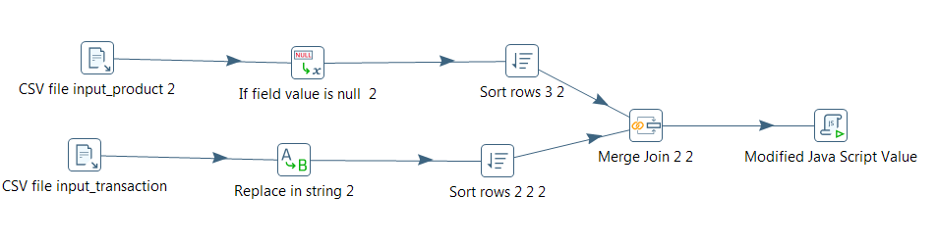
Sales Fact Table:
For Sales Fact Table we considered TPC Sales as our base table and mapped PEC sales table into TPC. We then eliminated all the overlapped data between TPC and PEC and made a conformed Sales fact table.

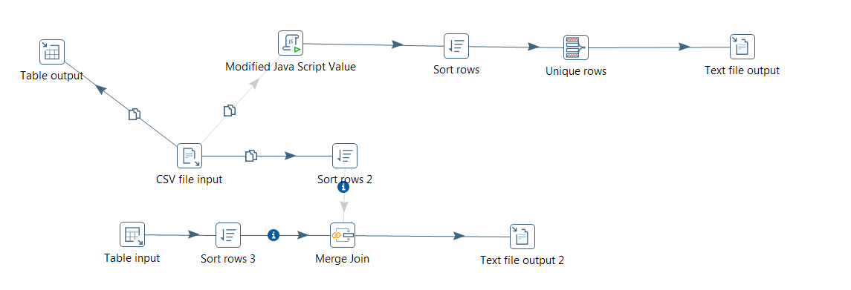

Junk Dimension:

We included Payment Method, Origin Method, Ship Method into Junk Dimension. We transformed data of the above attribute using Pentaho.
We extracted data into three different csv files and merged them into single Junk Dimension table.

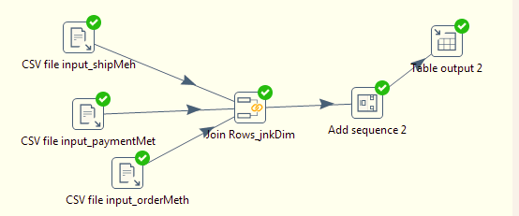

Time Dimension:

Time Dimension consist of Order date and sales date we have created time dimension using pentaho and directed the data into mysql. We extracted time data into three files that is day, month, and year from the source file then we Eliminated the overlapped values between the table using excel and petaho. Further we merged these three files into single time dimension table using pentaho.
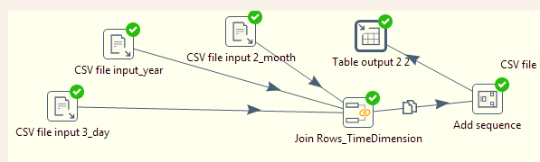

Fig. Conformation

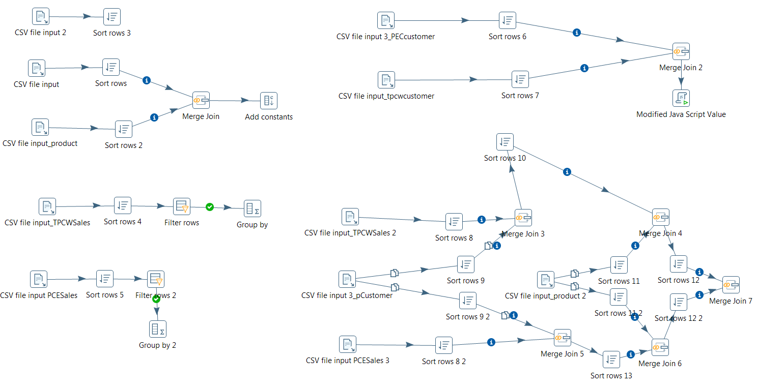
Above screenshot showcase the transformation of overall table like It checks for any overlapped data between tables.

Fig. Single Table Transformation:

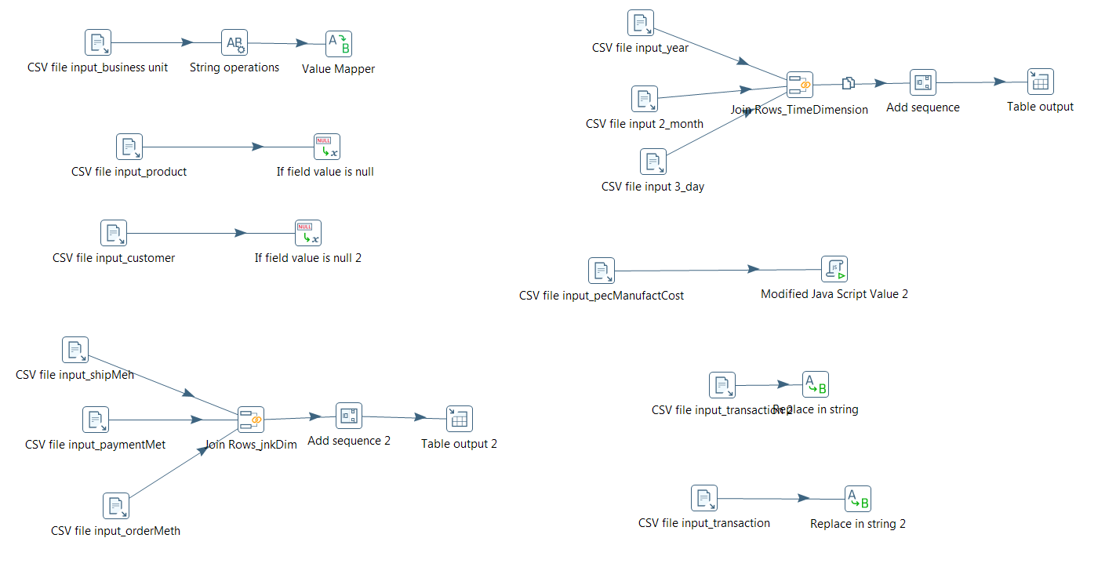
Above screen shot is about overall transformation of the tables where it checks for any duplicate values into the table and mapping of the values to make it conformed.

3. Table Population

DM Table | Table Population Process (attach code)
Customer Dimension | Customer Dim consist of surrogate key which refers to Fact table
Fact Table | Fact Table consist of fact and composite primary key which are combination of all surrogate key
Product Dimension | Product Dim consist of surrogate key which refers to Fact table
Junk Dimension | Junk Dim consist of surrogate key which refers to Fact table
Time Dimension | Time Dim consist of surrogate key which refers to Fact table

Customer Dimension:

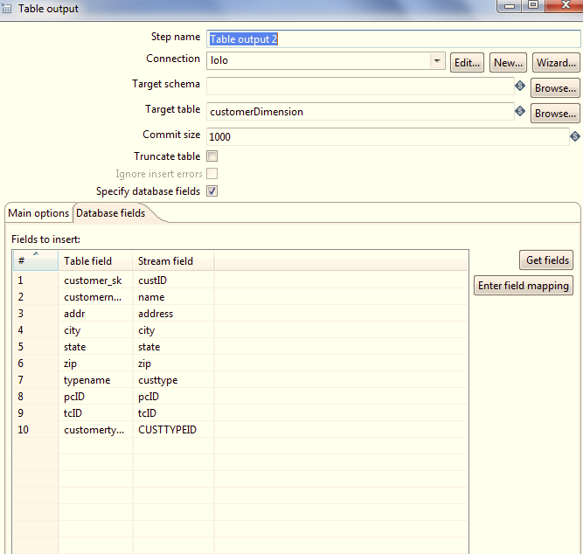

:

Ship Detail Dimension (Junk)
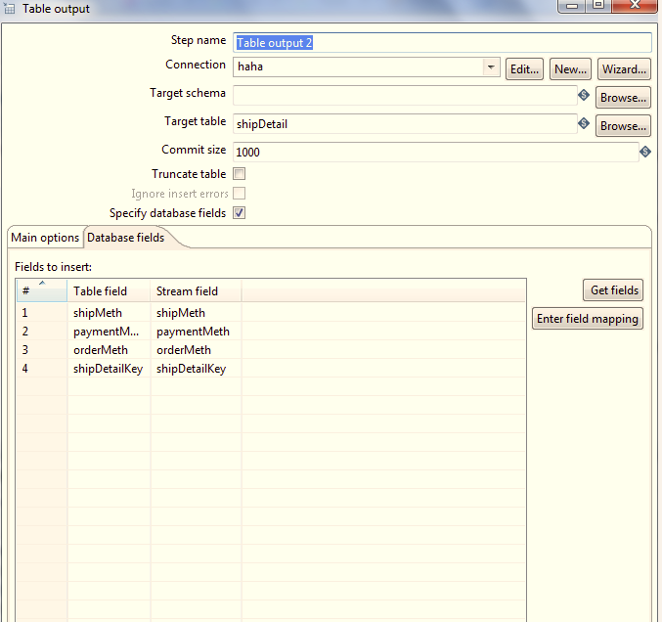

Product Dimension:

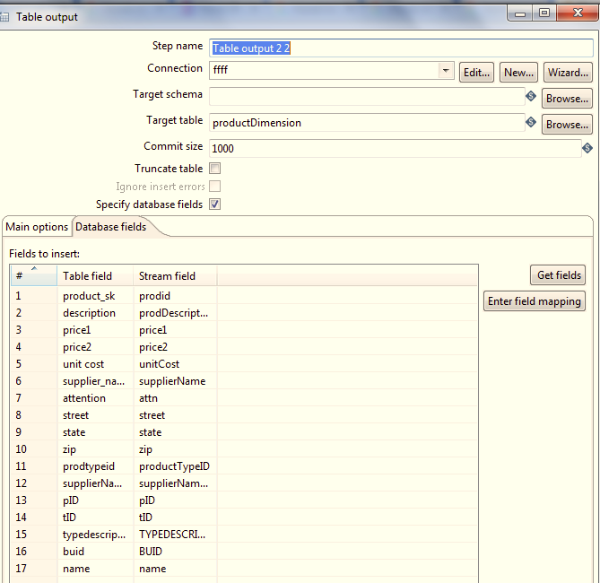

Time Dimension:

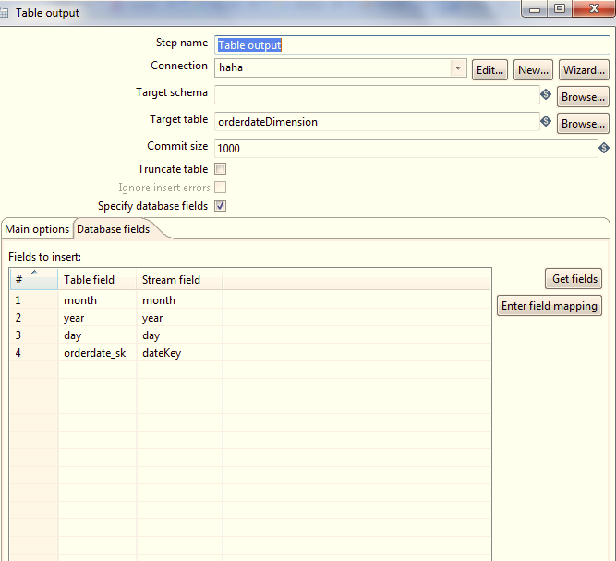

Sales Fact:

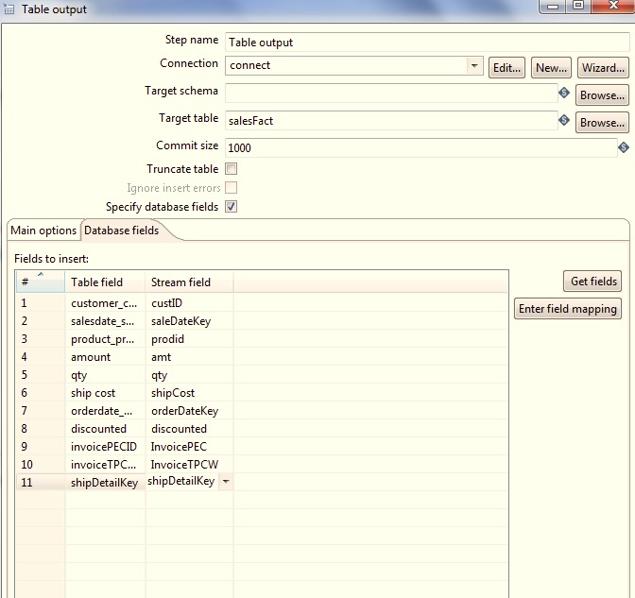

Note:After loading the table data for lab3 we had certain changes in our schema.These include the addition of calendar date and fiscal date in the Time dimension.The addition of PEC unitcost in the Product dimension,addition of SuitDep to the customer dimension and addition of TPCE invoice to the Sales Fact.The data population for the above changes has been done accordingly.

VII.End User Applications

1. Queries

User Question/Reporting Need
1 report shows the percentage of invoice that are COD.
SQL Code
select (select count(*) from salesFact a inner join shipDetail b on a.shipDetailKey=b.shipDetailKey where b.paymentMeth="COD")as CODINVOICE,(select count(*) from salesFact) as TotalInvoice,
concat((select count(*) from salesFact a inner join shipDetail b on a.shipDetailKey=b.shipDetailKey where b.paymentMeth="COD")/(select count(*) from salesFact)*100,"%") as percentage.
Result snapshot:
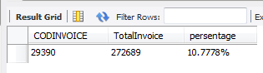

Supporting Index(es)
ALTER TABLE `mydb`.`salesFact` ADD INDEX `fct` (`amount` ASC),
ALTER TABLE `mydb`.`SaleDateMonthDim` ADD INDEX `year` (),
ADD INDEX `month` ();

User Question/Reporting Need
2 report shows sales by customer, by state, by product type and by business unit using roll up.
SQL Code
select sum(a.amount),b.state,b.customername,c.name as businessUnitName,c.typedescription from salesFact a inner join customerDimension b on a.customer_customer_sk=b.customer_sk inner join
productDimension c on a.product_product_sk=c.product_skgroup by b.state,b.customername,c.name,c.typedescription with rollup;
Result snapshot:
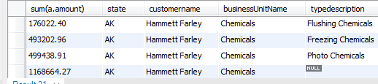
Supporting Index(es)
ALTER TABLE `mydb`.`salesFact` ADD INDEX `fct` (`amount` ASC),
ALTER TABLE `mydb`.`SaleDateMonthDim` ADD INDEX `year` (),
ADD INDEX `month` ();

User Question/Reporting Need
3.Side by side query for comparison of amount for different months in same year.
SQL Code
/*create a view for selfJoin(Cartesian product)*/
drop view IF EXISTS factJoinSaleDate;create view factJoinSaleDate as select sum(a.amount) as amount,b.year,b.month from salesFact a inner joinsalesdateDimension b on a.salesdate_salesdate_sk=b.salesdate_skgroup by b.year,b.monthorder by b.year asc,b.month asc;

/*use previous view to do side by side on month,according each individual year*/
select a.year,a.month as firstMon,a.amount as firstAmount,b.month as secondMon,b.amount as secondAmount from factJoinSaleDate a join factJoinSaleDate b on
a.month<b.month and a.year=b.year order by a.year,a.month,b.month;
drop view IF EXISTS factJoinSaleDate;
Result snapshot:
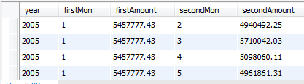
Supporting Index(es)
ALTER TABLE `mydb`.`salesFact` ADD INDEX `fct` (`amount` ASC),
ALTER TABLE `mydb`.`SaleDateMonthDim` ADD INDEX `year` (),
ADD INDEX `month` ();

Reason for using index on amount fact, year and month column:

1. the amount fact always appeared in where clause and used for sum function,
adding index on this column will improve the query performance.
2. the year and month column are always used in join clause, adding index on these col will improve the query performance

.

2. A View
We have Created View on Product Dimension:
Following is the Code for View:

create a view ProductQtyThoughMonthAndState
create view ProductQtyThoughMonthAndState as select a.qty,b.state,c.month,c.year,p.description from salesFact a
inner join customerDimension b on a.customer_customer_sk = b.customer_sk
inner join salesdateDimension c on a.salesdate_salesdate_sk=c.salesdate_sk
inner join productDimension p on a.product_product_sk=p.product_sk

select the view:

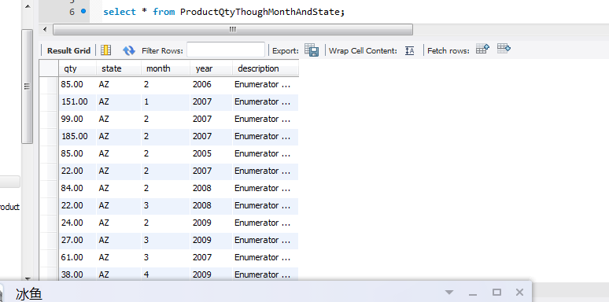

3. Aggregated Mata Marts

We have constructed Two Aggregated Fact Table:
1)The first aggregated fact table is salesFactByCustomerCityByMonth which summarize the CustomerCity by Month.

Use Case:

1.what are the cities that have a monthly sale greater than the avg
select amount,a.month,a.year,city from aggregate1 a inner join (select avg(amount) as avg,month,year from aggregate1 group by month,year) b
on a.year=b.year and a.month=b.month where a.amount>b.avg

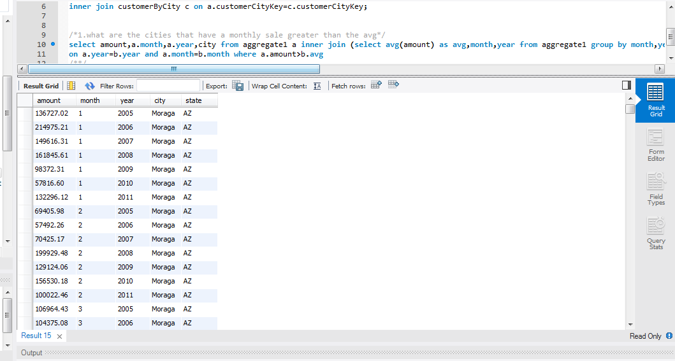
With the above Query the company can able to find the cities which are performing below average sale, such that companies marketing head can take required steps to improve it.

2 .the city Moraga's month 1-4 selling proformance after year 2005
select amount ,city,month,year from aggregate1 where city="Moraga" and year>2005 and month between 1 and 4
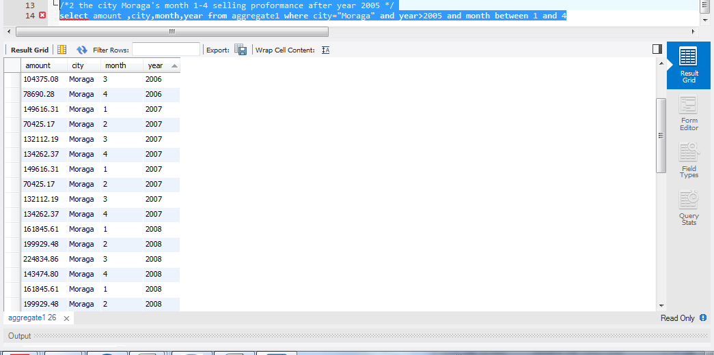

From the above query the Company can able to find the performance of City Moraga for each quarter after 2005 Year. Such that Company can find out in which quarter the City Moraga has to improve.

2) The Second Aggregate fact table is salesFactByCustomerStateByMonthByProduct which summarized the CustomerState by Month and Product.

Use Case:

1. for each state each year and each month,which product have the top sell among others.

select max(qty),a.month,a.year,a.state,a.description from aggregate2 a inner join (select avg(qty) as avg,month,year,description,state from aggregate2 group by month,year,description) b
on a.year=b.year and a.month=b.month and a.state=b.state and a.description=b.description where a.qty>b.avg
group by a.month,a.year,a.state

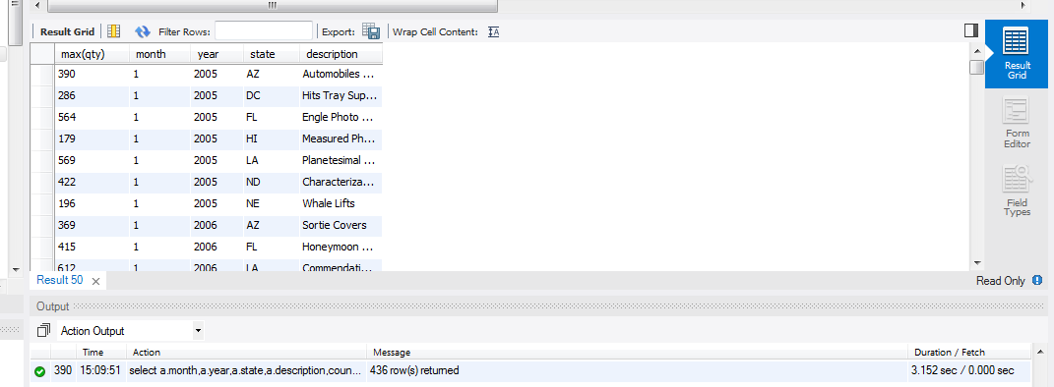

From the above query the company can able to find out the top selling Product for particular Year, Month and State, Such that the company can further commercialize the top product with other product to increase sell of other product.

2. what are the products which are sold more than average in a certain month and certain year and certain state.
select a.qty,a.month,a.year,a.state,a.description from aggregate2 a inner join (select avg(qty) as avg,month,year,description,state from aggregate2 group by month,year,description) b
on a.year=b.year and a.month=b.month and a.state=b.state and a.description=b.description where a.qty>b.avg

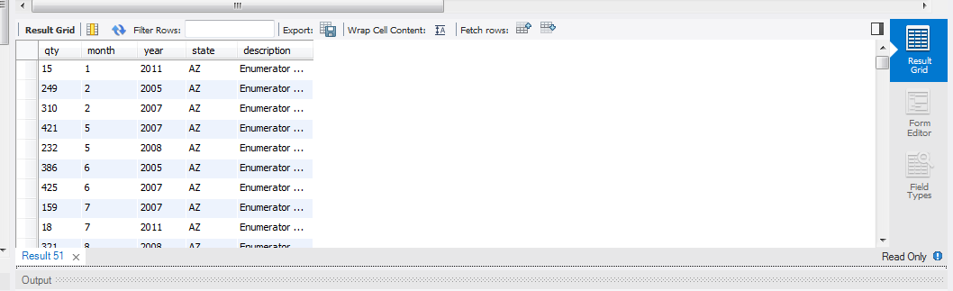

From the above query the company can able to find out the products which sales are above average for a particular Month, Year, and State.Such that the company can able to figure to improve product marketing to get that product into among top selling products.

Aggregation Method:
- For first Aggregated Fact we used Lost Dimension Method where we lost Junk, OrderDate, and Product Dimension.
- For Second Aggregated Fact we used Lost Dimension Method where we lost OrderDate and Junk dimension and shrunken the all other dimension other than Product Dimension.

Code for Population of two aggregated Fact Tables:

1) Aggregate fact table salesFactByCustomerStateByMonthByProduct:

insert into salesFactByCustomerStateByMonthByProduct (qty,customerByStateKey,salesDateMonthKey,productKey)

/*group by salemonth and customerState*/
select sum(f.qty),f.customerStateKey,f.salesDateMonthKey,f.product_sk from (

select d.qty,e.customerStateKey,g.salesDateMonthKey,d.product_sk from(
/*find the target subfact with qty ,state, saleMonth,prodctID*/
select a.qty,b.state,c.month,c.year,p.description from salesFact a
inner join customerDimension b on a.customer_customer_sk = b.customer_sk
inner join salesdateDimension c on a.salesdate_salesdate_sk=c.salesdate_sk
inner join productDimension p on a.product_product_sk=p.product_sk ) d
/*end find subfactt*/

inner join customerByState e on d.state=e.state inner join SaleDateMonthDim g on d.month=g.month and d.year=g.year)f
group by f.customerStateKey,f.salesDateMonthKey,f.product_sk;

We have also created Constraints and Index on aggregated fact table, Following is the code:
create constraint for aggregated fact

ALTER TABLE `mydb`.`salesFactByCustomerStateByMonthByProduct`
ADD INDEX `proctFK_idx` (`productKey` ASC);
ALTER TABLE `mydb`.`salesFactByCustomerStateByMonthByProduct`
ADD CONSTRAINT `proctFK`
FOREIGN KEY (`productKey`)
REFERENCES `mydb`.`productDimension` (`product_sk`)
ON DELETE NO ACTION
ON UPDATE NO ACTION;

ALTER TABLE `mydb`.`salesFactByCustomerStateByMonthByProduct`
ADD CONSTRAINT `cstomerStateFK`
FOREIGN KEY (`customerByStateKey`)
REFERENCES `mydb`.`customerByState` (`customerStateKey`)
ON DELETE NO ACTION
ON UPDATE NO ACTION;

ALTER TABLE `mydb`.`salesFactByCustomerStateByMonthByProduct`
ADD INDEX `saleDateMonthFK_idx` (`salesDateMonthKey` ASC);
ALTER TABLE `mydb`.`salesFactByCustomerStateByMonthByProduct`
ADD CONSTRAINT `saleDateMonthFK`
FOREIGN KEY (`salesDateMonthKey`)
REFERENCES `mydb`.`SaleDateMonthDim` (`salesDateMonthKey`)
ON DELETE NO ACTION
ON UPDATE NO ACTION;

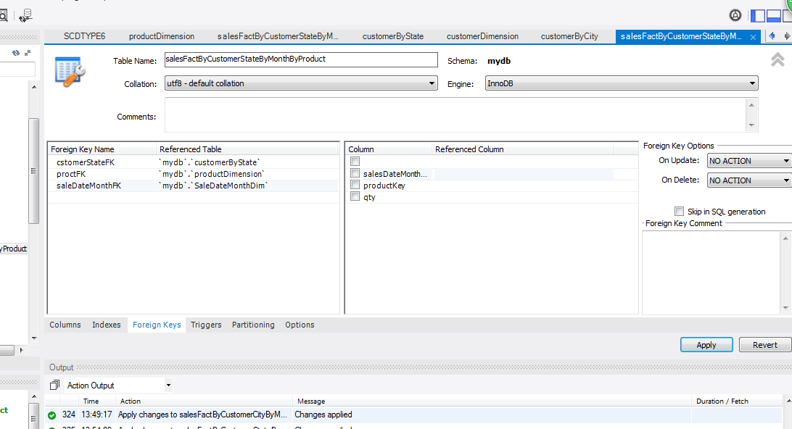

3) Aggregate fact by CustomerCity by month.
insert into salesFactByCustomerCityByMonth (amount,customerCityKey,salesDateMonthKey)

/*group by salemonth and customerCity*/
select sum(f.amount),f.customerCityKey,f.salesDateMonthKey from (select d.amount,e.customerCityKey,g.salesDateMonthKey from(

/*find the target subfact with amount ,city, saleMonth*/
select a.amount,b.city,b.state,c.month,c.year from salesFact a
inner join customerDimension b on a.customer_customer_sk = b.customer_sk
inner join salesdateDimension c on a.salesdate_salesdate_sk=c.salesdate_sk ) d

inner join customerByCity e on d.city=e.city and d.state=e.state inner join SaleDateMonthDim g on d.month=g.month and d.year=g.year)f
group by f.customerCityKey,f.salesDateMonthKey;

create constraint for aggregated fact:
ALTER TABLE `mydb`.`salesFactByCustomerCityByMonth`
ADD INDEX `DateMonth_idx` (`salesDateMonthKey` ASC);
ALTER TABLE `mydb`.`salesFactByCustomerCityByMonth`
ADD CONSTRAINT `DateMonth`
FOREIGN KEY (`salesDateMonthKey`)
REFERENCES `mydb`.`SaleDateMonthDim` (`salesDateMonthKey`)
ON DELETE NO ACTION
ON UPDATE NO ACTION;

ALTER TABLE `mydb`.`salesFactByCustomerCityByMonth`
ADD CONSTRAINT `CustomerCity`
FOREIGN KEY (`customerCityKey`)
REFERENCES `mydb`.`customerByCity` (`customerCityKey`)
ON DELETE NO ACTION
ON UPDATE NO ACTION;

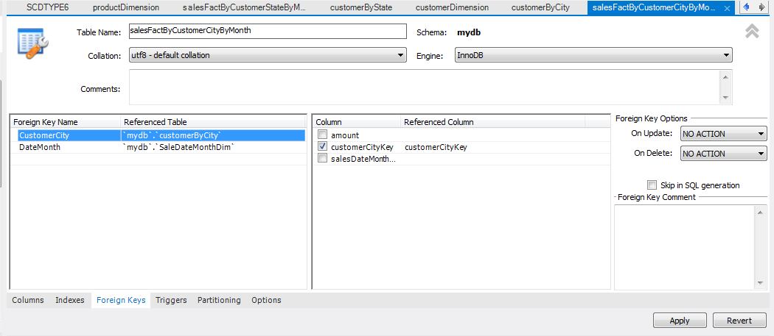

Note: Dump file for Aggregated Fact is included into the Main Dump file and added to Dropbox for your reference.

ER Diagram for Aggregated Fact Table:
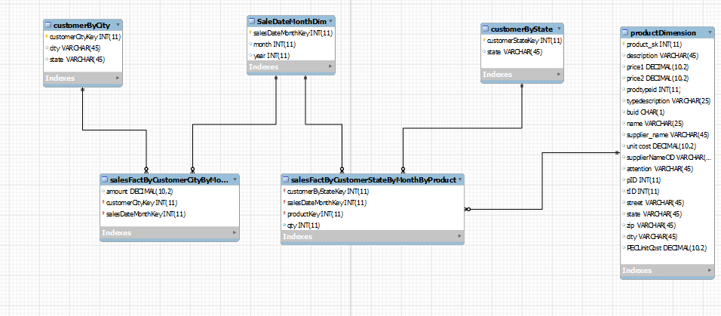

VIII. Handling Slowly Changing Dimensions (SCD)
We have created two type of SCD.
1) Type I
2) Type II

Following is the Code for creating Source Table :

.create a table for Product changing information and populate the table
CREATE TABLE `ProductUpdateFromPEC` (
`ID` int(11) DEFAULT NULL,
`unit cost` decimal(10,2) DEFAULT NULL,
`description` varchar(45) DEFAULT NULL,
`supplierNameOD` varchar(45) DEFAULT NULL,
`price1` decimal(10,2) DEFAULT NULL,
`price2` decimal(10,2) DEFAULT NULL,
`PECUnitCost` decimal(10,2) DEFAULT NULL,
`prodtypeid` int(11) DEFAULT NULL,
`typedescription` varchar(25) DEFAULT NULL,
`buid` char(1) DEFAULT NULL,
`name` varchar(25) DEFAULT NULL,
`supplier_name` varchar(45) DEFAULT NULL,
`attention` varchar(45) DEFAULT NULL,
`street` varchar(45) DEFAULT NULL,
`state` varchar(45) DEFAULT NULL,
`zip` varchar(45) DEFAULT NULL,
`city` varchar(45) DEFAULT NULL
) ENGINE=InnoDB DEFAULT CHARSET=utf8;

Target Table where we will update the data

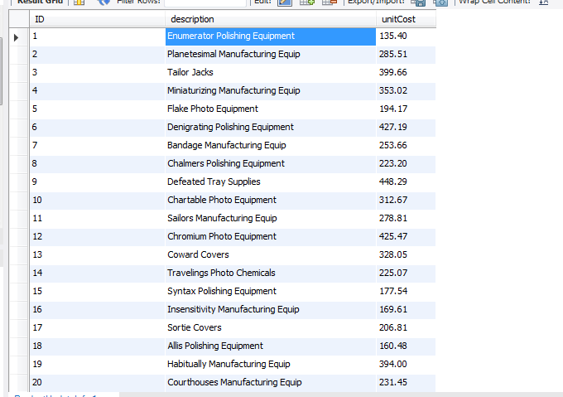
Code for populating the table:
insert into mydb.ProductUpdateInfo (`ID`,`description`,`unitCost`) select PID,description,`unit cost` from productDimension where PID between 1 and 20;

Source Data:This table is transaction data which we want to change in target table:
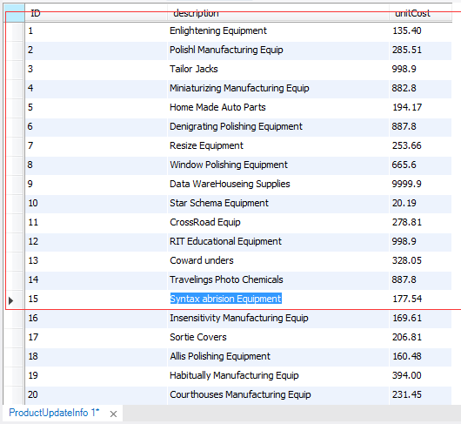

We have used Pentaho to implement SCD type I and SCD type II
Reason Why we Implemented Type I and Type II

We updated Description Column using SCD Type I and Unit Cost Column using SCD Type II.We used Type I on description Column because every time we detect the change in description we don’t want to keep track on description and overwrite it.
AND We used Type II on Unit cost Column because every time we detect the change in Unit Cost we want to keep track on Unit Cost so we added the new Row.

How we implemented Type I and Type II:

Step I:
Loading Source Table into Pentaho

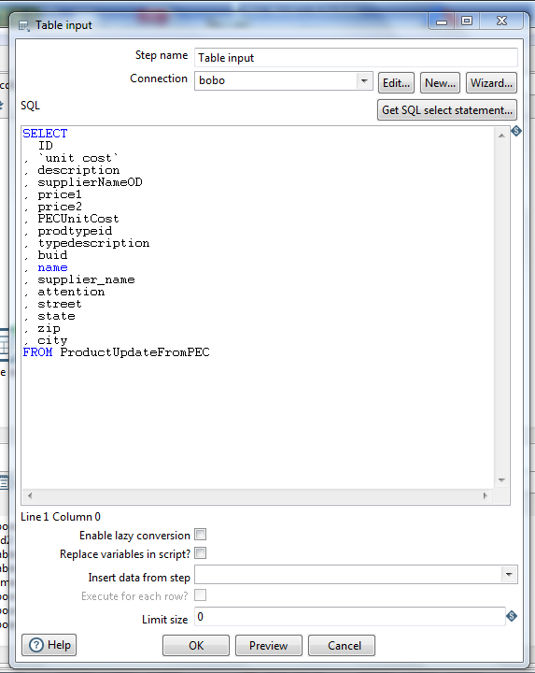

Step II:
We have used Punch Through for Type I and Insert for Type II
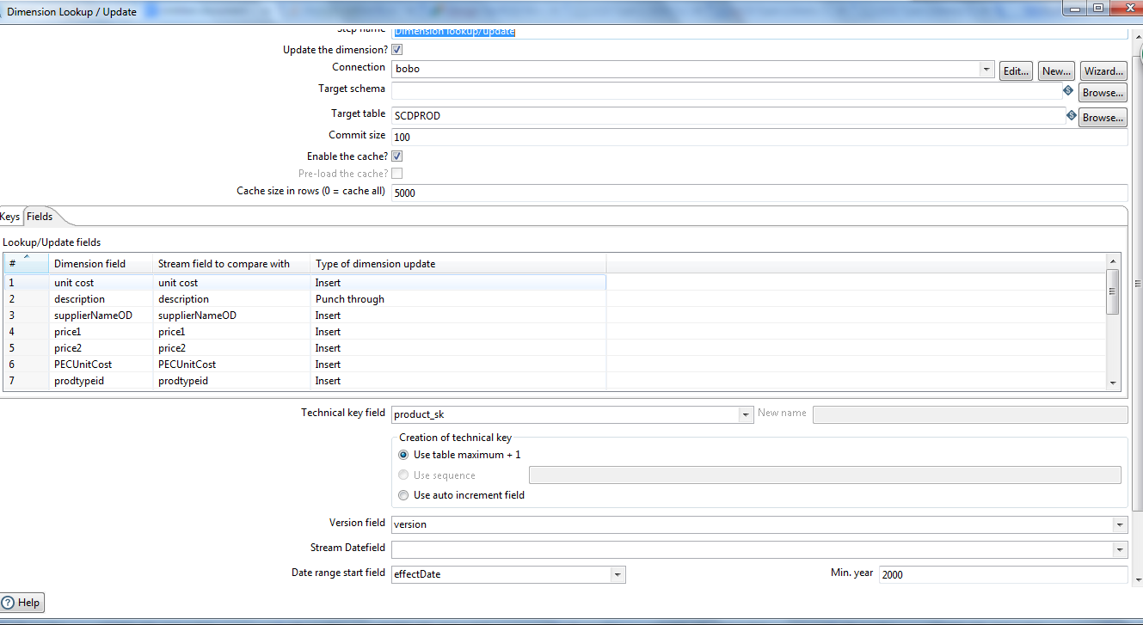

Results:
Table Before Updating:
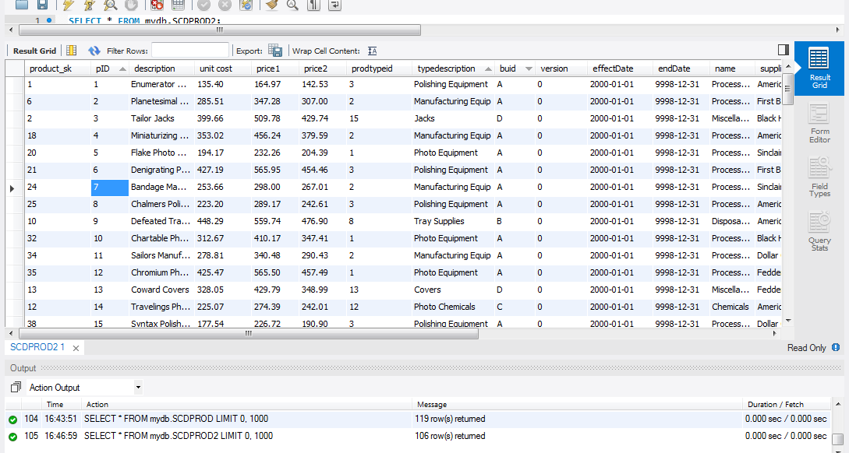

Table after updating:
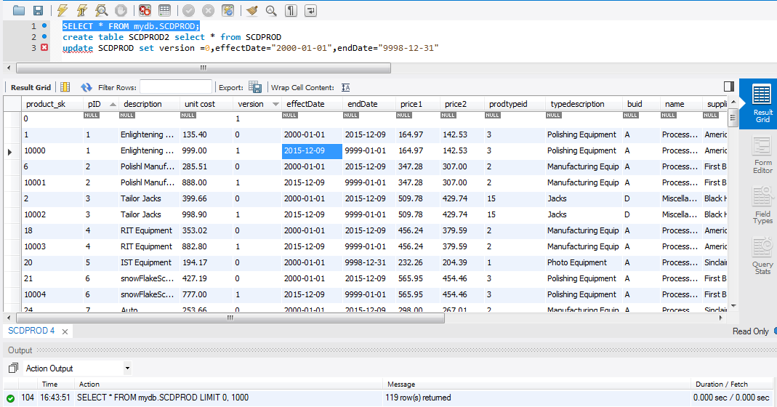

We have also implemented SCD type 6:

Procedure to Implement SCD Type 6:

DELIMITER //
drop procedure if exists SCD6Proc//
CREATE PROCEDURE SCD6Proc()
BEGIN
/* Step 1
First we declare required Column for SCD Type 6 */
declare colsrc,colHis,currcol,Curr varchar(45);
declare startD,endD date;

/* Step 2: updation
this is the row need to be updated*/
select a.description,b.HistoryDescription,b.CurrentDescription,b.currentFlag,b.effectDate,b.endDate
from
mydb.ProductUpdateInfoSCD6 a inner join SCDTYPE6 b on a.ID=b.pID and a.description!=b.CurrentDescription and b.currentFlag="current";

/*Step 3:
create a table to store data*/
create table tempor as
select a.description,b.HistoryDescription,b.CurrentDescription,b.currentFlag,b.effectDate,b.endDate,b.pID,
b.`unit cost`,b.price1,b.price2,b.prodtypeid,b.typedescription,b.buid,b.name,b.supplier_name,b.supplierNameOD,b.attention,b.tID,b.street,
b.state,b.zip,b.city,b.PECUnitCost
from
mydb.ProductUpdateInfoSCD6 a inner join SCDTYPE6 b on a.ID=b.pID and a.description!=b.CurrentDescription and b.currentFlag="current";
/*update the temporary table to insert into target Table*/
update tempor set currentFlag="current",HistoryDescription=description,CurrentDescription=description,effectDate=date_sub(curdate(),interval -1 day);

/*ready to insert but wait for update first.*/
/*999*/
/*update the currentFlag,endDate,and CurrentDescription the row that has no change will be ignored.cause of constraint in where statement :a.description!=b.CurrentDescription */
update
SCDTYPE6 b inner join mydb.ProductUpdateInfoSCD6 a on a.ID=b.pID and a.description!=b.CurrentDescription and b.currentFlag="current"
set b.CurrentDescription=a.description,
b.currentFlag="expire",
b.endDate= now();
/*Insert the new row*/
insert into SCDTYPE6
(HistoryDescription,CurrentDescription,currentFlag,effectDate,pID,
`unit cost`,price1,price2,prodtypeid,typedescription,buid,name,supplier_name,supplierNameOD,attention,tID,street,
state,zip,city,PECUnitCost)
select
HistoryDescription,CurrentDescription,currentFlag,effectDate,pID,
`unit cost`,price1,price2,prodtypeid,typedescription,buid,name,supplier_name,supplierNameOD,attention,tID,street,
state,zip,city,PECUnitCost
from tempor;
drop table tempor;
END//
DELIMITER ;

call SCD6Proc();
We wrap the Code into Procedure SCDProc() so that it is reusable.
So every time we run the SCD 6 We call the Procedure.

Target table:We want to update HistoryDescription Column Using SCD Type 6
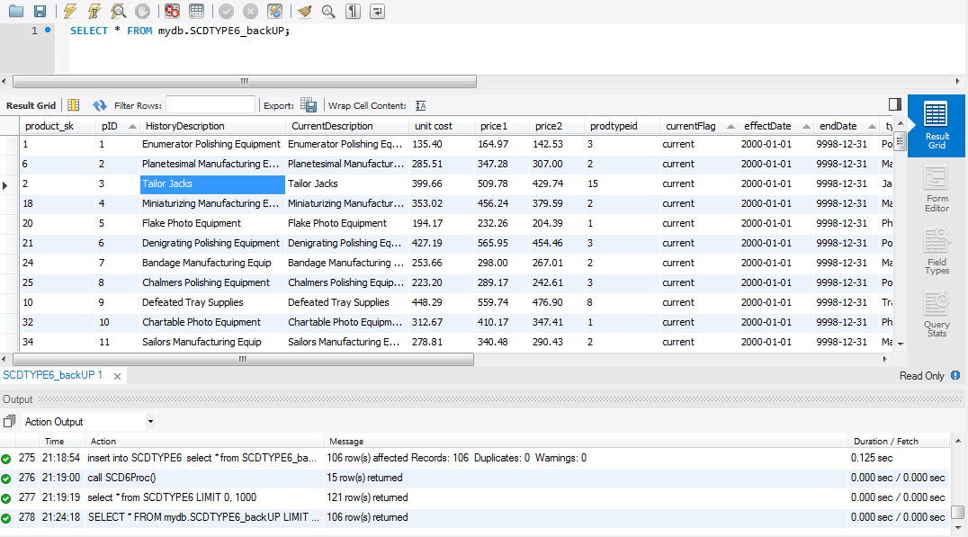

source table:
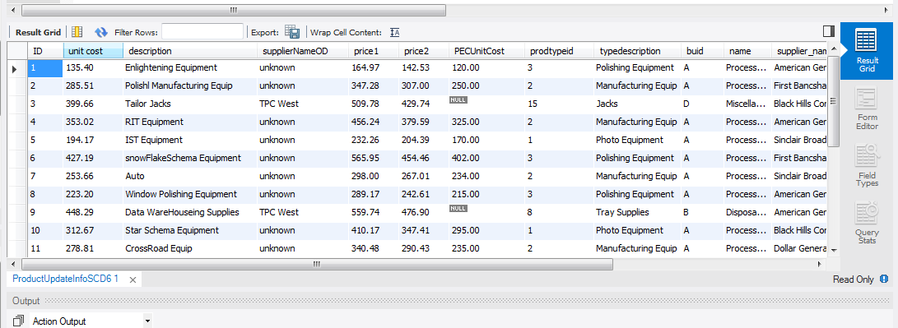

Results: After SCD6:
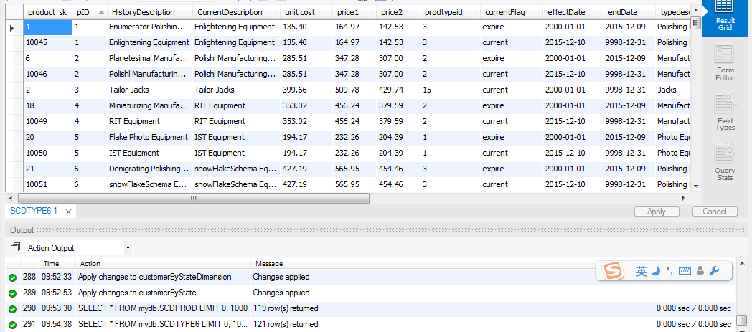
IX Many-to-Many (N-M) Relationship Implementation Option
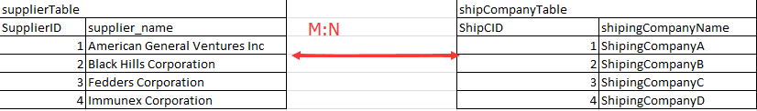

Assume that we have two tables supplier and ship Company. Ship company in charge of delivering product for suppliers.The many to many relationship exist between these tables.That is one supplier can have many ship companies and one ship company can serve many suppliers.

In relational database:
One way of dealing with this issue(used as bad example,we will not use that)is creating multiple columns in one table,each binary column indicate the existence of relationship:(value equal to other table’s ID):

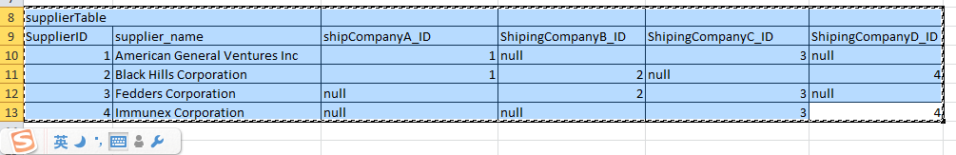
This solution:
- results in a sparse table
- increase the storage cost.
- is not easy to retrieve,
- the query is complex.
- is not scalable(or in other word,not easy to maintain) ,every time you have a new shipping company you need to add a column.
so we avoid using this solution

The other way of doing this is using associate table(also known as bridge table or intersection table),the associate table represent relationship between entities.The PK of the associate table is a concatenated key,consist of FK’s to other tables.(Just like what fact table in star schema did) .
In advance associate table could also include begindate and enddate which indicate when the relationship has been built or when it is end. The associate table will look like this:

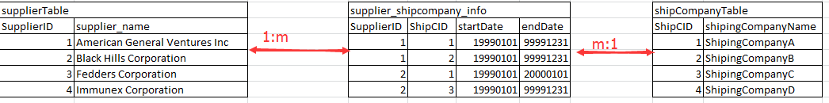
- The associate table break the M:N into 1:M,M:1.
- The associate table is easy to maintain.
- The associate table is easy to query.
- That is why we will use that solution.

Note: Incase of Non-sql db.(eg.mongo db)we can create shipCompanies[]: in supplierTable.shipCompanies[]: stores the index of shipCompany,so we can know how many shipCompany are owned by a supplier and who are they.shipCompany can use find({shipCompanies[]:}) to query from suppliers so we can know how many suppliers have this shipCompany and who are they.

E-R Diagram:

