 | Rochester Institute of Technology  Due: ____ / ____ / ____  Golisano College of Computing and Information Sciences  Department of Information Sciences & Technologies

Lab Exercise 3
By Rahul Sakore
Using a DBMS Performance Monitoring Tool

Overview
In this lab, you will investigate how a performance monitoring tool is used to collect data on a possible performance problem and how problems can be diagnosed from performance statistics. This exercise builds on the experience that you gained in Lab #2.

At the end of this exercise you should be:
- Familiar with using snapshot statistics to determine if a DB performance problem has occurred.
- Able to use a database performance monitoring tool, in this case Oracle’s ADDM analysis and tuning package, to review performance data and diagnose a simple SQL performance problem.
- Able to analyze performance statistics to identify the underlying cause(s) of poor query performance.
For this lab you will need the following:
- Access to your IPEDS database server from one of the IT Database Lab Windows machines.
Deliverables:
1) This completed Lab #3 Exercise document
2) AWR report and ADDM (Performance Hub) screen shots from IPEDS (submitted to the Lab 3 DropBox)
3) Lab #3 Report

Part I – Identifying a Problem Query
Activity #3-0. Connect to Your Database Server
At one of the Database Lab Windows machines, startup EM and connect to your IPEDS database server as the IPEDS DBA, instDBA. You may also want a command line or GUI interface.

Activity #3-1. Review Basic Concepts
Before you start, a quick review of important concepts from Lab #2 is in order. As you recall, Oracle 12c uses the Automatic Workload Repository (AWR) statistics repository utility to automatically collect and store statistics on system performance. The DBA can then use the Automatic Database Diagnostic Monitor (ADDM) self-diagnostic engine, enterprise manager graphical interface and utility to analyze database performance for user-specified periods of time. Figure 1 shows a general diagram of this process.

In summary, ADDM is a server-based “performance expert in a box” which can be used to find the root causes of problems through the analysis of performance statistics (stored in the SGA and in AWR tables) in real time. ADDM:
- identifies the root causes of performance problems
→ Importantly, ADDM also identifies areas of the database where no action is necessary!
- provides recommendations for correcting the problem(s) identified
- quantifies the expected benefits of resolving a problem
Figure 1. Oracle Performance Analysis Architecture
…

…

Reports

V$ views
Creation & Management Scripts
Statistics Repository
Engine
Displays

Before we go on to monitoring database performance, let’s get check out some fundamentals about using AWR and ADDM.

- What is a set of statistics that describe performance for a specific time period called?
- SNAPSHOTS and other statistics are:
Database Statistics such as Wait events, Time model Statistics. Operating system staitstics such as CPU Statistics, Virtual Memory Statistics, Disk Statistics and Network Statistics.

Oracle doesn’t discuss many specifics about the AWR tables; so investigate a little. Your instructor(s) suggest “SNAP” and “WR” as likely table-name stubs to use to search your database Hint: ‘%SNAP%’). Plus hunt around Tech Net and the Web for more information.
→ Document your all of findings and attach them to your lab; and be prepared to discuss your results in class.

- What snapshot-related tables does instDBA own? Summarize your findings and show your query/ies.
None, select table_name form dba_tables where table_name like %SNAP% and owner = instDBA;

- How many tables do you find as sys? Summarize your findings and show your query/ies.
17
Select table_name from dba_tables where owner = sys.

- How many views are related to snapshots? Summarize your findings and show your query/ies.

We can find views related to snapshot from select * from DBA_HIST;
In that following are the views related to snapshots:
- DBA_HIST_ACTIVE_SESS_HISTORY displays the history of the contents of the in-memory active session history for recent system activity.
- DBA_HIST_BASELINE displays information about the baselines captured on the system
- DBA_HIST_DATABASE_INSTANCE displays information about the database environment
- DBA_HIST_SNAPSHOT displays information on snapshots in the system
- DBA_HIST_SQL_PLAN displays the SQL execution plans
- DBA_HIST_WR_CONTROL displays the settings for controlling AWR

- Which seems to be the “main” snapshot view that lists all the snapshots?
- DBA_HIST_SNAPSHOT
How do you know? Demonstrate with a query/ies and explain.
It displays all the information about snapshot.
SELECT * FROM DBA_HIST_SNAPSHOT;
Following are attributes this view display about snapshot:

SNAP_ID NOT NULL NUMBER
DBID NOT NULL NUMBER
INSTANCE_NUMBER NOT NULL NUMBER
STARTUP_TIME NOT NULL TIMESTAMP(3)
BEGIN_INTERVAL_TIME NOT NULL TIMESTAMP(3)
END_INTERVAL_TIME NOT NULL TIMESTAMP(3)
FLUSH_ELAPSED INTERVAL DAY(5) TO SECOND(1)
SNAP_LEVEL NUMBER
ERROR_COUNT NUMBER
SNAP_FLAG NUMBER
SNAP_TIMEZON INTERVAL DAY(0) TO SECOND(0)
CON_ID NUMBER

Although Oracle expects DBAs to view performance data through the Oracle Enterprise Manager (EM) screens and AWR reports, Automatic Workload Repository information is also available through standard views. See Appendix A for an outline of these views.
As you know, to diagnose database performance issues, performance analysis can be done across two different AWR snapshots. However, for analysis, we must have the snapshots that we need; so …

- What is the default AWR snapshot interval and retention period? (From Lab 2 or EM)
- A snapshot is taken every Every Hour and
- A given snapshot is kept (retained) for 8 days.

- Does it matter (i.e. can a valid comparison be done) if the snapshot intervals are of different lengths – say 1 hour versus 45 minutes? Answer “YES” or “No” and explain.

YES, well it depends on the workload of the database, if DBA want to monitor problem which is apparent in small intervals then it does matter to change or compare the snapshot interval.

Not every database user will need to use AWR and ADDM. So, let’s investigate who can use them.
- What user privilege is needed to use AWR and ADDM?
- DBA role and Execute privilege
- Does instDBA have this privilege? How do you know? Explain. (Hint: How can you tell what privilages instDBA has?)
- Yes, Walk thorught this path in oracle EM : EM → security → users → instDBA

In addition to the AWR tables, don’t forget Oracle’s V$, or dynamic performance, view tables. These are views which allow you to access performance statistics stored in the memory structures of the SGA. These can be used to monitor the performance of the various processes in an Oracle instance. They are continuously updated while a database is open and in use. These performance statistics are captured and retained in a snapshot. Check them out – especially V$SESSTAT.

Note: TURN OFF your user background activity now and let your server “quiet down” while you complete this next section. You do not want your “corporate users” to interfere with the activity that you’re going to investigate in this lab. (See week 02 for instructions on how to block traffic on IPEDS) Remember that traffic would be blocked for couple of hours only.

Note the time when you turn off background activity
Activity #3-2. Selecting “Problem Framing” Snapshots
Let’s pick up where we left off in the last lab – investigating the capabilities of a performance monitoring tool. The first step in analyzing a database performance problem is to select snapshots that “bound” the time period in which a problem occurred. A starting, or baseline, snapshot is the status of the database before performance problem(s) occurred. An ending, or closing, snapshot is a snapshot taken after the time period in which performance was problematic. Then a statistical analysis is run (i.e. with AWR) to compare the performance statistics recorded in these two snapshots. Next, a performance diagnostic engine (i.e. ADDM) is used to identify problem(s). Finally, Oracle’s query-tuning inference engine is used to get suggestions for correcting any SQL performance issues found during the time period under investigation.

Before you start, let’s clarify a few basics.
- Would it make sense to run an AWR report on snapshots taken from two different startup instances of a given Oracle database? Answer “YES” or “NO” and explain.

AWR report is used to compare the statistics between two snapshots. Well it depends on the second or ending snapshot taken whether the ending snapshot is greater than baseline snapshot or not. If it greater then baseline then there is no problem but, if it is smaller than baseline DBA may miss some statistics.

- Can AWR analysis only be run between two consecutive snapshots, i.e. from snapshot ID n to snapshot n+1? Answer “YES” or “NO” and explain.
Yes, DBA can change the window of the two snapshots to monitor performance problems.

Okay; let’s get started, but … before you can analyze a problem, you have to have a problem. Do you have any user-reported problems? No – but we can make some! ☺ First, let’s start by checking out the snapshots that you have available now in your IPEDS database. So check the most recent snapshot and time using oracle view discussed in Lab-2
- What is your most recent (i.e. last) snapshot number? When was it taken? How long ago?
The most recent snapshot number is 1288, it was taken at 26-sep-2016, and 11.09.00 AM.
6 days ago.
The snapshot end time is 1-Nov-2016 at 11.27.00 pm, the interval was for 5 days.

Now take a starting snapshot from command line

Login to your oracle database as instdba from sqlplus to take the snapshot
Use anonymous block given below to generate you snapshot:

BEGIN
DBMS_WORKLOAD_REPOSITORY.CREATE_SNAPSHOT ();
END;
/
You can see the camera icon (denoting snapshot) on time picker on EM performance page. Verify the time shown and time in database, it should match.

This will be your starting, or baseline, snapshot. Now let’s create some user activity and then evaluate it for possible problems!

Activity #3-3 – Generating Database Activity
Run the userActivity.sql script (available from your instructor(s)) to generate some database usage activity. It may be helpful to just store this script on your database server, such as in your /home/oracle directory. You can use FileZilla or WinSCP or MobaXterm or some other program which is available on the Database Lab Windows machines or using editor copy and paste, to do this. (See week 02 for script if not already downloaded)

Note the timing after finishing the run. You can also observe changes in activity class on the home page of EM.

Activity #3-4 – Take the Closing Snapshot
Go back to the command line and take the snapshot using the same block given below

BEGIN
DBMS_WORKLOAD_REPOSITORY.CREATE_SNAPSHOT ();
END;
/

Verify your closing snapshot in same way as you did for starting snapshot. If you do not see the camera icon on time picker refresh the window. Below is the facsimile for same:

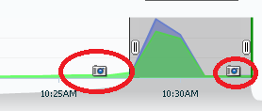

- What is your closing (i.e. the newest) snapshot number? When was it taken?
It was taken at Nov 1, 11.59 pm and snapshot number is 1289

Activity #3-5 – Run an AWR Workload Repository Report
Let’s generate an AWR report with our starting and closing snapshots. Go to performance hub in performance tab (same as discussed in lab2). Select the time period tab and provide correct details of the time window you want to you use in order to enable the AWR report option. By default, the time picker will include full hour to generate report. However, we want only for our two snapshots. Now drag the time picker window to point to the snapshots which you want to generate report for. Below is the facsimile for same:

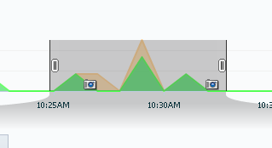

Generate an AWR report across your starting and ending snapshots to get a summary report of the database activity parameters for this time period.
Now, let’s look at how resources were used for the workload placed on the system by your user-activity script.

Note: If at any time you’re not sure what your snap id #’s are, just run a query against the base snapshot table
Note: If you use the command line interface to run an AWR report by hand ($ORACLE_HOME/ rdbms/admin/awrrpt.sql), any blank lines between groups of snapshot id’s indicate that the database instance was shut down between the times that these snapshots were taken.
Verify that your report is across the correct snapshots. Then, save your report so that you can analyze it and submit it with this lab.
Note: Your report can be saved to the default location for your browser (desktop for FireFox), or if you’re using the command line interface it will typically be spooled to the directory from which you logged into SQL*Plus. But here we are using EM to generate report so you will be prompted for location to save the report.

Activity #3-6 – Analyze the AWR Workload Repository Report
Carefully review your AWR Workload Repository report. As you will remember, this report contains statistics on both foreground and background processes, as well as information about the server hardware configuration.
Note: Remember, Appendix A of Lab #2 contained an outline of the format of an Oracle AWR report for your reference.

Sub-Activity #3-6.1 – Checkout the System-Related Sections of the Report
Look at the Report Summary section at the top of the AWR report – specifically the Load Profile, Instance Efficiency Percentages, and Top 5 Timed Events sections. (You may want to highlight these for future reference.) These are the events that consumed the most resources within the reported time period. Determine what each of these events means and whether or not the statistics shown represent a possible problem. You will need this for your Lab 3 report. You can find some information at the Oracle Technical Network site, but locate and use a variety of resources. Collect as much information as you can to analyze the report and to share with your classmates.
→ Document your references and findings for submission with your lab report.

Sub-Activity #3-6.2 – Checkout the SQL Statistics Section of the AWR Report
Now, look at the SQL Statistics section which is down towards the middle of the AWR report. Go to the SQL ordered by Reads portion of this section. This sub-section lists the high-cost queries that ran during the analysis period in descending order by the number of disk reads used.

- How are the individual queries identified – i.e. what value is used and how is it created?
The individual queries are identified by SQL Id. It’s an alphanumeric unique value

- Which query accessed disk for reading most often? Record its ID here
- 5hb5yzz1m1887 → the maximum physical reads taken by this sql id
- 9ntwdmf8zch4z → the maximum elapsed time taken by this sql id

Write down the performance statistics on this query – or cut/paste a screen shot of it – here.
Performance by elapsed time
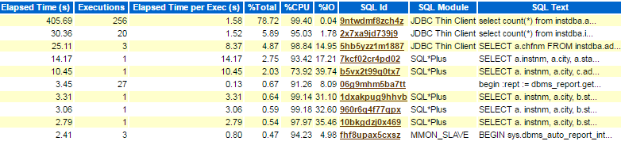
Performance by CPU Time
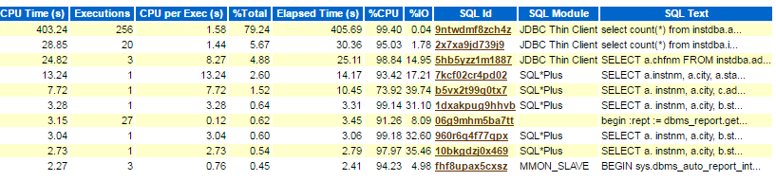
Performance by I/O time
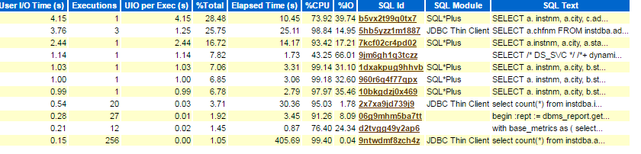
Performance By Gets
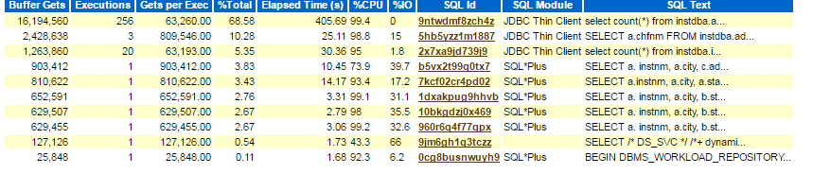
Performance By Reads
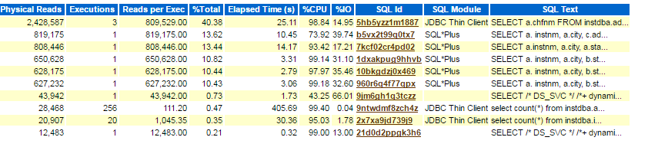
Performance By Physical reads
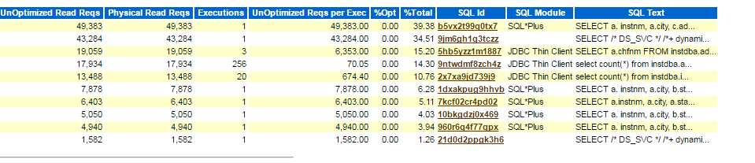
Performance by Execution time
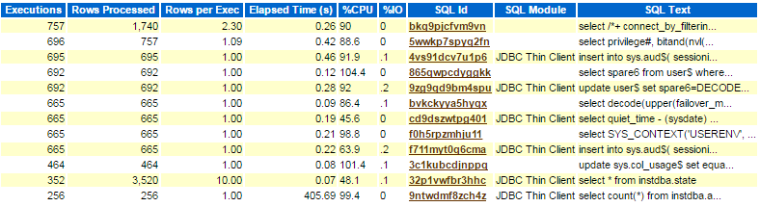
Performance by Parse call
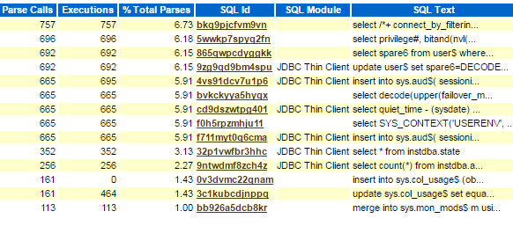

Record the SQL code for this query here:
SELECT a.chfnm FROM instdba.administrator a, instdba.institution i, instdba.state s WHERE a.instid = i.instid AND i.stateabbr = s.stateabbr AND s.stateabbr = 'NY' ORDER BY a.chfnm

Note: We’re only focusing on the most costly query here; the one listed first that showed the worst read performance. This does not mean that only one query can be problematic at a time. There may be other queries that also need tuning. However, for educational purposes, we’re limiting the scope of this lab to just the one query.

Part II – Investigating a Specific Query’s Performance
Activity #3-7 – Get More Tuning Information
Note: This section provides you details on how to deal with specific problems at industry level. Although, there might not be similar situations but knowledge of what you want to look at if problem occurs would help you in future. You need to analyze what things mean and what they do.

The performance hub gives detailed analysis and excellent graphical representation to understand the performance aspects. Go to EM performance tab → performance hub
Check out ADDM and suggestions for that time duration if any when you ran user Activity. Check
Since the query above is listed first in terms of I/O (disk reads) resource usage. It’s a “suspect” query for poor performance.

You can use time picker as well to analyze the performance hub report but for AWR you would need specific hour duration in order to generate it using EM.

Perform your analysis same way as you did in Activity #2-6 of lab-2. Analyze different tabs and check the queries. You will see all the queries from userActivity. Take screenshots of your findings and submit with your lab.

Go to activity tab and analyze SQL’s by selecting the sql id.
Each tab will have useful information about that SQL

Name | Description
Summary | It provides information about Configuration, Wait Class, Active sessions and Load profile per second
Activity | It provide CPU time information for a given SQL ID and it provide information for wait class for user I/O, CPU< System I/O
Execution Statistics | It provide statistics for elapsed time, CPU time, buffer gets, disk reads, rows processed, cursor fetches, the number of executions, the number of complete executions, optimizer cost, and the command type.
Monitored SQL | It provide performance statistics for a query
Plan Control | It stores the information of execution plans for sql statement and monitor them over period of time to improve the execution plan.

Now, on your ADDM page, (Be sure to check that your time window is correct.)

→ Take a screen shot of this page for submission with your lab.

- Do you find any potential problems in the Findings column? If not, provide you analysis and understanding here in your own words.
Yes, there are SQL statements found which took significant database time and had 96.5% of impact. The ADDM report provided two action plan to improve it out of which one action plan has of 89.4% benefit rate.

In addition to performance statistics, a DBA frequently investigates the execution plan for a suspect query. Feel free to take a peek at the plans shown in EM: current and anticipated future, after tuning. You’ll learn more about this in the next lab, but for now ... let’s interpret your results.

Activity #3-8 – Conclusion
OK. Put all this information together by filling out your Lab #3 Report.
→ Be prepared to discuss your findings in class.
No need to worry about tuning now. That’s a later lab!!! (Whew! Thank goodness! :-)

Activity #3-9 – Thought Question (Optional Challenge)
Look back at your SQL Details: <high_cost_query_ID> page in AWR.

a) What are cursors and what does Shared cursor statistics information mean?
For every SQL statement execution in Oracle Database, certain area in the memory is allocated. Oracle PL/SQL allows you to name this area. This private SQL area is called context area or cursor. These cursors take up space in the shared pool, which is essential memory component of Oracle Database, specifically in the library cache.
Shared cursor statistics gives information for efficiency of execution plan. The statistics it provide is Total parses, Hard parses, Child Parses, Loaded Plans, Invalidations, Largest cursor size, all cussor size, first load time and last load time.

b) Explain the Elapsed Time Breakdown section (right of the graph), in terms of the resources used in your query run, justify your answer with specific evidence from AWR. (+2)
(Hint: Explain Time model statistics and SQL ordered by elapsed time in your AWR report)
Elapsed Time = CPU Time + Wait Time
- 9ntwdmf8zch4z → the maximum elapsed time taken by this sql id.

Activity #3-10 – Terminate Session
Whew – finally done! Before you leave the lab, logout of EM, disconnect any users, and exit any sessions. Your instructor(s) recommend that you leave your database running.

Appendix A – DBA AWR Views

Per Oracle’s Tech Net website:

5.3.5 Using Automatic Workload Repository Views
Typically, you would view the AWR data through Oracle Enterprise Manager or AWR reports. However, you can also view the statistics using the following views:
- V$ACTIVE_SESSION_HISTORY
This view displays active database session activity, sampled once every second. See "Active Session History".
- V$ metric views provide metric data to track the performance of the system
The metric views are organized into various groups, such as event, event class, system, session, service, file, and tablespace metrics. These groups are identified in the V$METRICGROUP view.
- DBA_HIST views
The DBA_HIST views displays historical data stored in the database. This group of views includes:
  - DBA_HIST_ACTIVE_SESS_HISTORY displays the history of the contents of the in-memory active session history for recent system activity
  - DBA_HIST_BASELINE displays information about the baselines captured on the system, such as the time range of each baseline and the baseline type
  - DBA_HIST_BASELINE_DETAILS displays details about a specific baseline
  - DBA_HIST_BASELINE_TEMPLATE displays information about the baseline templates used by the system to generate baselines
  - DBA_HIST_DATABASE_INSTANCE displays information about the database environment
  - DBA_HIST_DB_CACHE_ADVICE displays historical predictions of the number of physical reads for the cache size corresponding to each row
  - DBA_HIST_DISPATCHER displays historical information for each dispatcher process at the time of the snapshot
  - DBA_HIST_DYN_REMASTER_STATS displays statistical information about the dynamic remastering process
  - DBA_HIST_IOSTAT_DETAIL displays historical I/O statistics aggregated by file type and function
  - DBA_HIST_SHARED_SERVER_SUMMARY displays historical information for shared servers, such as shared server activity, common queues and dispatcher queues
  - DBA_HIST_SNAPSHOT displays information on snapshots in the system
  - DBA_HIST_SQL_PLAN displays the SQL execution plans
  - DBA_HIST_WR_CONTROL displays the settings for controlling AWR

Hint: You are connected as instDBA, right? So which Oracle view-set would be appropriate (dba_, user_, all_, etc.)?
Note: Oracle also uses the term “baseline” in relation to snapshots. For AWR a “baseline” is performance data in a set of snapshots that have been saved and are used for comparisons with other similar time periods when workload performance problems occur. However, we’re only referring to the starting snapshot here.
Like Lab #2, make sure that you have appropriate time that was taken today, within the last hour. Plus, since Oracle will take a new snapshot every hour, if it is close to the time for a new snapshot either wait for it to occur or take a starting snapshot for yourself. Also, since you’ll likely be working over a longish time period, make sure that you’re using the correct snapshot interval.
https://docs.oracle.com/database/121/TGDBA/gather_stats.htm#TGDBA167

