Lab 6 Report – by: Rahul B. Sakore

Instructions:
The questions below are divided based on the activities in the lab. You should answer all questions completely with supporting references. Your instructor will tell you when to turn in the document containing your answers. In the absence of explicit instruction, assume the answers to the questions are to be handed in the next time your section of lab meets. “Graduate” questions are required questions for graduate students (726). Undergraduate students (436) may answer the “Graduate” questions for bonus credit.

Activity 1
- Paste the list of files you identified for backup from Activity 1-1 here.
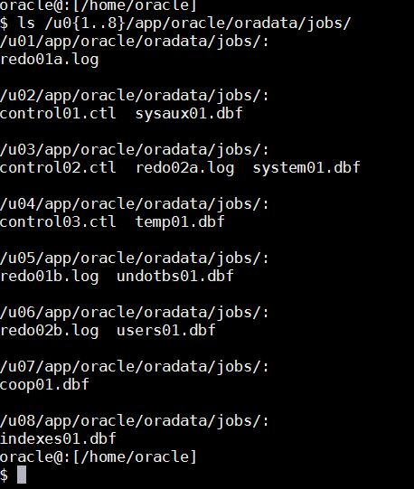
- /u03/labfiles/lab1/initJOBS.ora
- $ORACLE_HOME/dbs/orapwJOBS

- Paste the tar command you used to create a cold backup tar file from Activity 1-2 here.
- $ tar -Pscf coldBackup1.tar /u0{1..8}/app/oracle/oradata/jobs/
- gzip coldBackup1.tar
- In what state was the database after the recovery? Why? How did you open it?
- It is in Mounted state, because in mount stage, Oracle determines the location of the datafiles, but does not yet open them.
- Once the datafile locations have been identified, the database is ready to be opened.
- By giving this : Alter database open;
- Was the data on the quarter table? Why or why not? If the data was there, from where did it come? (Hint: Think about the different files in the database.)
- Yes, the data was on the quarter table because data was committed after inserting into table, data was stored in redo log file so that we were able to recover the data from redo log file during backup.

Activity 2
- How did you recover the missing file from your tarball? (paste your tar command here)
- $ tar –Psxf coldBackup.tar /u06/app/oracle/oradata/jobs/users01.dbf
- Why was the recovery in Activity 2-1 unsuccessful?
- Data was no longer available in the online redo log because we issued switch log command, due to which data which was stored in original redo log file was not available.
- When, in the real world, would we want to recover a datafile from a backup?
- We want to recover a datafile from a backup, when datafile is corrupted or when there is power loss or failed transaction.
- Before you enabled archive logging, what was the effect of the first of the two “ALTER SYSTEM SWITCH LOGFILE” commands? Be clear in explaining what happens to the redo log files and the data within them.
- Alter system switch logfile commands will force oracle to advance the log sequence i.e. it change (generate new) redo log file.
- From xml log file:
“Current log# 1 seq# 17 mem# 0: /u01/app/oracle/oradata/jobs/redo01a.log”
“Current log# 1 seq# 17 mem# 1: /u05/app/oracle/oradata/jobs/redo01b.log”
- So by two commands, two different log file are created redo01a.log and redo01b.log
- The data which were stored in original redo log file will not be available in new redo log file.

- Before you enabled archive logging, what did the second “ALTER SYSTEM SWITCH LOGFILE” command do to the log entry for the first of the two newer records you had inserted? Be clear in explaining what happens to the redo log files and the data within them.
- The second command will force to open new redo log file, so we will not able to trace or recover the two records inserted because it was in different redo log file.
- What conclusions can you draw regarding cold backups that don't use archiving?
- Cold Backup will restore database to the time when the last backup was taken.
(Unless archives are used – not required for cold backup)
- Data changes between last backup and system failure are lost, if no archiving.
- After you enabled archive logging, what occurred when you issued the “ALTER SYSTEM SWITCH LOGFILE”? Be clear in explaining what happens to the redo log files, archive log files, and the data within them.
- After enabling archive logging, redo log files and archive log files and data within them is copied (archived) to another location before being reused.
- This yields a complete history of all changes made to the database. So any Changes in any redo log file will be archived in given destination.
- After you enabled archive logging and performed the “RECOVER DATAFILE” command, was the data recovered? How? Clearly explain where the restored data comes from.
- Yes, data was restored.
- Data was restored from redo file which was archived in pfile in location u01/app/oracle/admin/jobs/arch/'.

Activity 3
- What was the major difference between performing a hot backup and performing a cold backup?
Cold backup:
- During a cold backup the database is closed and not available to users. All files of the database are copied (image copy).
- The datafiles do not change during the copy so the database is in sync upon restore
Hot backup:
- In a hot backup the database remains open and available to users. All files of the database are copied (image copy).
- There may be changes to the database as the copy is made and so all log files of changes being made during the backup must be saved too. Upon a restore, the changes in the log files are reapplied to bring the database in sync.
- If you were backing up multiple tablespaces in a hot backup, what steps would you take and what commands would you issue for each step. (Hint: how would you minimize time in a “fuzzy state”?).
- To take hot backup of multiple tablespaces we will issue: One by one for multiple tablespace.
- alter tablespace NAME begin backup;
- alter tablespace NAME end backup;
- we do not need to apply redo to datafiles in this backup where datafile Contain no changes past the checkpoint SCN, that is, are not fuzzy
- Graduate Question: What are the advantages and disadvantages of using and not using archive logs?
- Archive log mode simply means that a redo log file is copied (archived) to another location before being reused.
Advantage:
- Yields a complete history of all changes made to the database in the event of an operating system or disk failure, even if there are many log switch commands.
- We can use a backup taken while the database is open and in normal system use.
- Can recover when database is open except for system or rollback segment tablespaces.
Disadvantage:
- Excessive log switch command may hang the database resulting performance issue.
- Requires Maintaining LOG_ARCHIVE_DEST for changes made into log file or else will result into space problem.

