A Project Report On
Gaming Website (Funville)
Chitkara University, Himachal Pradesh

Submitted in partial fulfilment of the requirement for the award of a Degree of
“Bachelor of Computer Application”

Submitted To
Department Of Computer Applications

Submitted By
Rahul Samanta
2213986057

Under the supervision of

Dr Utpal Shrivastava
Associate Professor



Session: 2024 - 2025
Chitkara University, Himachal Pradesh

CERTIFICATE OF APPROVAL

The synopsis for the project entitled "Funville" has been thoroughly reviewed, examined, and evaluated by us and is hereby approved for the award of the degree "Bachelor of Computer Applications (BCA)", for which it has been submitted. It is understood that by granting this approval, the undersigned does not necessarily endorse or approve any specific statements made, opinions expressed, or conclusions drawn within the report or project. The approval is provided solely for the purpose of fulfilling the academic requirements for the award of the degree, and it does not imply the endorsement of the methodologies, findings, or recommendations presented therein. This certificate acknowledges the student's efforts in the research and development process while complying with the university’s academic standards.
The project Funville represents an innovative and forward-thinking approach to the design and development of interactive digital platforms aimed at children. The platform strives to foster an educational yet engaging atmosphere, combining entertainment with learning in a way that promotes the development of essential skills such as critical thinking, problem-solving, creativity, and social interaction. Funville provides a diverse array of age-appropriate games, activities, and resources, ensuring that young users remain engaged while simultaneously benefiting from educational content.
The platform integrates modern and widely used web technologies, including JavaScript, HTML, CSS, MongoDB, and other industry-standard tools, ensuring the creation of a responsive, intuitive, and scalable system. The seamless user experience is designed to be adaptive, catering to a wide range of devices and screen sizes, ensuring accessibility and usability across multiple platforms. This project exemplifies the student’s capability to implement full-stack development principles, efficiently manage databases, and employ innovative web technologies to create a functional and user-friendly product.
The development of Funville is also a testament to the student’s proficiency in applying theoretical knowledge into practical real-world solutions. It showcases their ability to plan, execute, and manage all aspects of a complex project—from conceptualization and design to coding, testing, and deployment. Furthermore, the project reflects strong problem-solving skills, effective communication, and attention to detail, enabling the delivery of a fully functional, user-centered web application that appeals to children while meeting educational objectives.

Project Guide: Dr Utpal Shrivastava
Designation: Head of Department

Project Details

Project Name: Funvelle
Project Title: A Multigaming Website for Children
Project Members: 01
- Student Name: Rahul Samanta, Signature:

Project Guide:
Faculty Name: Dr Utpal Shrivastava
Designation: Head of Department

Contents
Session: 2024 - 2025 1
CERTIFICATE OF APPROVAL 2
1. Introduction 5
2. Background and History 5
3. Purpose 5
4. Objective and scope of Project 5
5. Technology and Domain 6
6. Feasibility Study 6
7. Hardware and Software Requirement 6
8. Working of Project and output 7
9. Conclusion 7
10. Suggestions for Further Work 7
11. Flow Chert 8
12. References 8

Introduction

In today’s digital world, providing children with a safe and engaging online experience is essential. Funville aims to meet this need by offering a secure, ad-free, and interactive multigaming platform specifically designed for children. The website features a simple, user-friendly interface and age-appropriate content, ensuring a fun yet safe environment for young users. Built with modern web technologies, Funville ensures compatibility across different devices, allowing children to enjoy their games anywhere. The platform’s goal is not only to entertain but also to provide a controlled space for children to explore, learn, and play.

Background and History

Funville was created to address the need for a safe and engaging online platform for children. With the rise of digital content, the project aimed to provide a fun, ad-free gaming experience while ensuring security and ease of use. Built using modern web technologies, Funville has evolved into a child-friendly platform offering age-appropriate games, with plans for future updates and new features.

Purpose

The primary purpose of Funville is to create a secure and enjoyable online environment for children to explore a variety of interactive games. With an increasing amount of online content available to young audiences, Funville focuses on providing a platform that is both fun and safe. The website is designed to ensure that children can enjoy gaming without encountering inappropriate content or advertisements, fostering a positive digital experience. Additionally, Funville aims to encourage creativity, problem-solving, and social interaction through games, all while prioritizing a simple, child-friendly interface that parents can trust.

Objective and scope of Project

The main objective of Funville is to provide a safe, engaging, and user-friendly online gaming platform for children. It aims to offer a variety of interactive and age-appropriate games, ensuring a secure environment that is free from ads and harmful content.The scope of the project includes creating a simple, colorful, and intuitive interface designed specifically for children, ensuring ease of navigation. The platform will be accessible across multiple devices, including desktops, tablets, and smartphones. Additionally, the project plans to expand its game library, incorporating more games, multiplayer features, and educational content. The focus will remain on maintaining a secure environment with tailored content for young users, making Funville a trustworthy and enjoyable digital space.

Technology and Domain

Technology: Funville utilizes web development technologies such as HTML, CSS, JavaScript, Tailwind CSS, and Bootstrap for front-end design, with MongoDB for database management. The project also makes use of design tools like Figma, Canva, and Adobe Express to create visually appealing graphics. The platform is hosted and deployed on Vercel.app and Render, ensuring reliable performance and scalability.
Domain: The project falls under the Edutainment domain, which combines educational and entertainment content, providing a safe and enjoyable gaming experience for children.

Feasibility Study

The Funville project is technically feasible, as it utilizes widely available web development technologies (HTML, CSS, JavaScript) and tools (MongoDB, Vercel.app, Render) that ensure smooth functionality and scalability. The financial feasibility is also positive, as the initial development and hosting costs are low, with potential for revenue generation through safe, child-friendly features. Socially, the platform fills a gap for secure, age-appropriate entertainment for children, aligning with growing concerns around online safety. Legally, the project complies with child protection regulations, ensuring a secure and trustworthy environment for young users.

Hardware and Software Requirement

Hardware Requirement
Sr. No. | Specification
1. | 8th Gen Intel Core i5-7300HQ processor or higher
2. | 8 GB or more
3. | NVIDIA GTX 1050 graphics

Software Requirement
Sr.  No. | Component Name | Specification
1 | Operating System | Windows 10
2 | Frontend Development | HTML5,CSS3,  JavaScript
3 | Database | MySQL 8.0 or higher
4 | IDE | Visual Studio Code
5 | Frontend Development | HTML5, CSS3,  JavaScript

Working of Project and output

Funville operates as an interactive and secure gaming platform designed specifically for children. The platform allows users to access a variety of age-appropriate games, each offering engaging content that promotes fun, creativity, and cognitive development. The website’s interface is simple, vibrant, and easy to navigate, ensuring that children can independently explore and enjoy the games without difficulty.
Behind the scenes, the platform is built using modern web technologies such as HTML, CSS, JavaScript, and MongoDB, which ensure a smooth and responsive experience across various devices, including desktops, tablets, and smartphones. Funville prioritizes safety by offering an ad-free environment and carefully curating content to ensure it aligns with appropriate standards for children.
The output of this project is a secure, engaging, and user-friendly gaming platform that provides children with hours of entertainment in a safe and controlled environment. The platform ensures a consistent and enjoyable experience, whether accessed on a computer or mobile device, and aims to continuously grow by expanding the game library and adding new features, such as multiplayer games and educational content.

Conclusion

In conclusion, Funville successfully addresses the need for a safe, interactive, and engaging online gaming platform for children. By combining secure, age-appropriate content with a user-friendly interface, the platform ensures that children can enjoy entertainment in a controlled and protected environment. The project not only offers a fun experience but also prioritizes safety, making it a trusted space for young users. As the platform continues to evolve with new games and features, it lays a strong foundation for future growth, positioning itself as a go-to destination for children’s online gaming.

Suggestions for Further Work

To enhance Funville and expand its offerings, several improvements can be made. Firstly, integrating multiplayer functionality would allow children to interact and collaborate with friends or other users, fostering social skills. Additionally, incorporating educational games that combine fun with learning could add value to the platform, making it not only entertaining but also educational.Further work can also focus on implementing customizable user profiles where children can track their progress, set game preferences, and earn rewards. Adding parental control features would allow parents to monitor their child’s activity and ensure content appropriateness. Expanding the game library with more diverse genres, such as puzzle games or story-driven adventures, would keep the platform fresh and engaging. Lastly, improving the platform’s accessibility with multi-language support could make it accessible.

Flow Chert

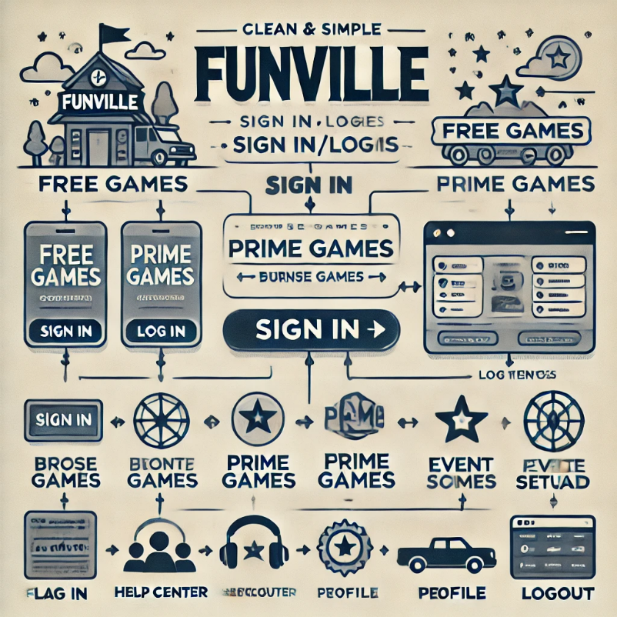

References

Mozilla Developer Network (MDN). "HTML5 and JavaScript for Beginners". https://developer.mozilla.org/en-US/docs/Web/HTML

W3Schools. "CSS Tutorial". https://www.w3schools.com/css/

MongoDB Documentation. "MongoDB Basics". https://mongodb://localhost:27017/

Figma. "Figma Design Tools". https://www.figma.com/

Vercel Documentation. "Deploying on Vercel". https://rahul-funville.vercel.app/

Render Documentation. "Getting Started with Render". https://render.com/docs

