**RAHUL SARASWAT**

Amar colony goverdhan road, Mathura

[rahulsaraswatr31@gmail.com](mailto:rahulsaraswatr31@gmail.com)

+91 7535929083

-

-

**SUMMARY**

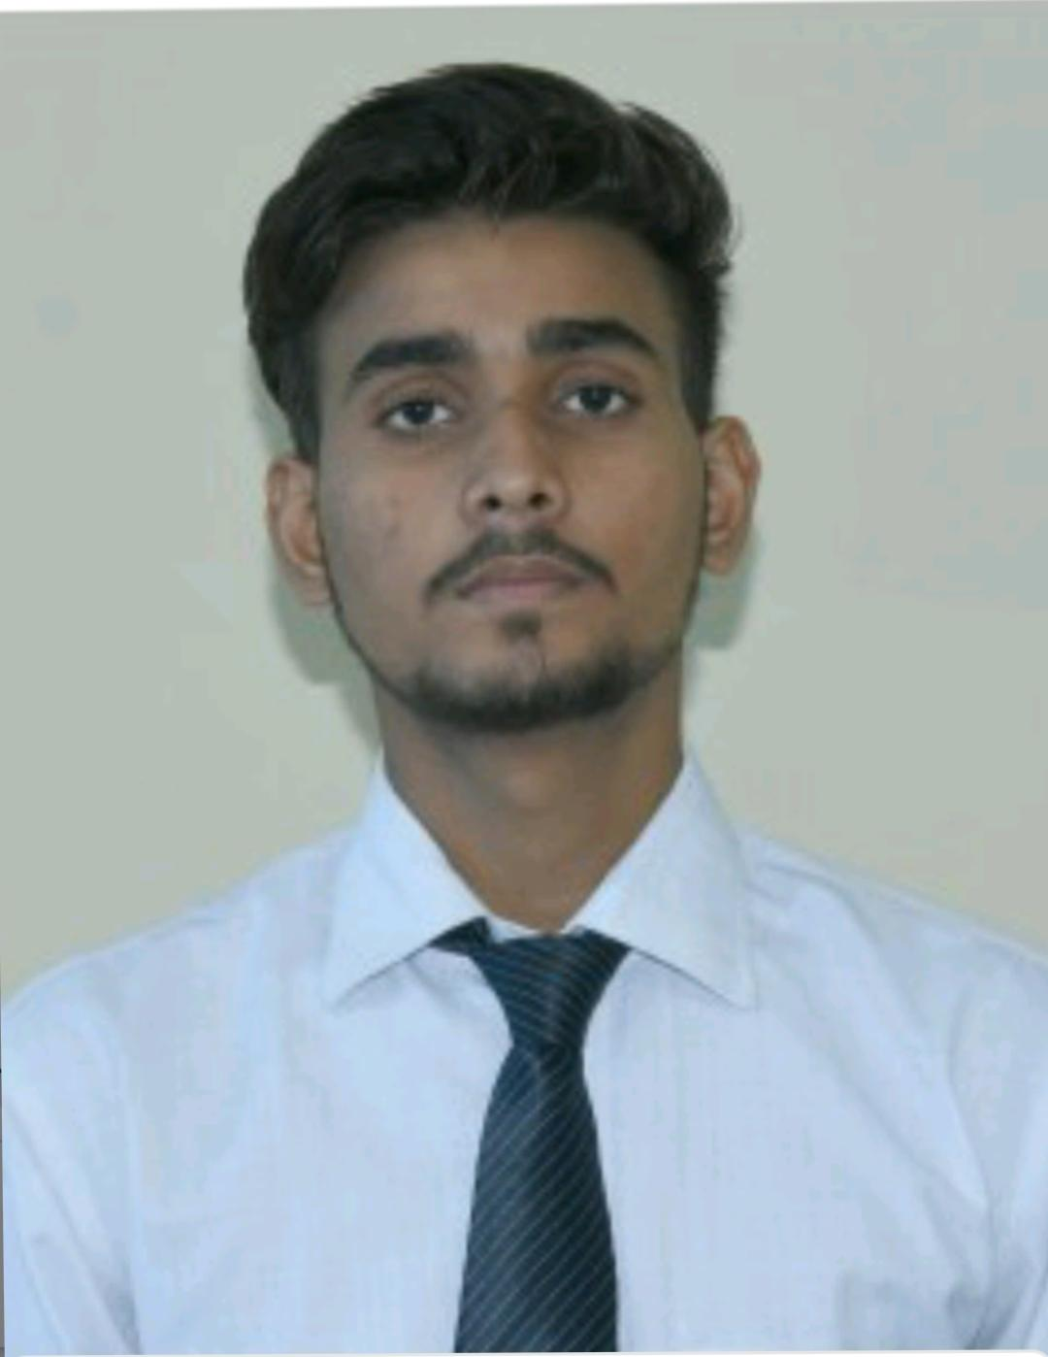

Enthusiastic learner, eager to contribute to team success through hard work, attention to details and excellent organizational skills. Clear understanding of given task requirements and training in Programming.

**EDUCATION**

**Bachelor of Technology**

GLA University, Mathura 2018 - 2022

**Intermediate**

Ramanlal shorawala public school,Mathura 2018

# High School

Grace convent senior secondary school, Mathura 2016

**INTERNSHIP EXPERIENCE**

**JPMorgan Chase & Co.** [Inside Sherpa] 10 May, 2020 - 24 June, 2020

*Software Engineering Virtual Experience*

* Review and Established the Financial Data Feeds.
* Frontend Web Development by implementing and designing Personal Portfolio website. • Data Visualization with Perspective.

**World Youth Council**, [Internshala] 9 June 2020 – 10 Oct 2020

*COVID-19 Teach from home*

* Insisted underprivileged students around us to learn English and Mathematics.
* Taught the students in local language of our region

**NinthSem** *(Campus Ambassador)* 9 June 2020 – 10 Oct 2020

* Creating brand awareness for NinthSem.
* Class to class services and campaigns in university.

# PROJECTS

**Personal Portfolio Website** *(Full Stack Frontend web Technologies)*

* Live personal portfolio website built using Full Stack Frontend web Technologies such as HTML, CSS, and JavaScript.
* Link for the portfolio:- <https://manishgautam30.github.io/Manish_Gautam/> **GamingZone Website** *(Full Stack web Technologies)*
* Live Gaming website built using Full Stack web Technologies such as Angular and NodeJS. **Invisible Cloak** *(Python using OpenCV)*
* A project based on masking technique using OpenCV in Python as represented in Harry Potter. **Car-Selling Price Prediction** *(Python using Flask)*
* ML model deployed on a Heroku cloud platform in order to predict car selling price using Python and Flask. **WebChat** *(FullStack web technologies)*
* A online chat web application hosted on a local server, implemented using FullStack technologies such as HTML, CSS, JavaScript, NodeJS and SocketIO. **Grossify** *(Android using Java)*
* Android application based on online grocery shopping also implemented as College Mini Project for the session 2020-2021.

# SKILLS

**Technical**: Python, C, Java, PHP, HTML, CSS, JavaScript, Angular, NodeJS, MySQL.

**Professional:** Ability to identify and solve problems, Team & Management, Leadership, Interpersonal Communication.

**Tools:** Git & Github, Android studio, IntelliJ Idea, VSCode.

# CERTIFICATIONS

* Introduction to JAVA.
* Introduction to Python.
* Participated in Hacktober Fest 2020, 2021.
* Cisco Netacad Introduction to IOT. • ML Data Visualization.
* Intel ‘AI from data center to the edge’.
* Nasscom Future Skills Introduction to Packet Tracer.
* Azure Durable Functions and secured 60% in Graded Quiz.

# Extra/Co-Curricular Activities

* Coordinated SRIJAN (Cultural Fest, GLA) and participated in MAITREE (Sports Fest, GLA).
* Secured Runner up position in University level North India Basketball Tournament (09/2018).

# INTERESTS

* Programming & Coding
* Reading Books
* Listening Music & Watching Movies
* Basketball
* Travel

# DECLARATION

I hereby declare that all the above mentioned information is true and correct to the best of my knowledge.