EMT-ViSTA
Virtual Spatial Staining of Epithelial-Mesenchymal Plasticity From Routine H&E
Complete project report • methodology reference • interpretation guide • interview preparation
Project position
An operational research pipeline with real public-data benchmarks and explicit safety gates. Current maps are hypotheses for assay triage and validation, not clinical molecular measurements.

Prepared 21 August 2026
Repository: AI in Cancer Drug Discovery

How to use this document
This document has three uses: understanding the research design, presenting the project to scientists and clinicians, and preparing concise but technically sound interview answers.
- Read Sections 1–5 to understand the biological problem, hypothesis, questions and data.
- Use Sections 6–9 to explain the methodology, technical implementation and findings.
- Use Sections 10–14 for interpretation, limitations, pitch, interview framing and future work.

Contents
Section | Purpose
1. Executive summary | The project in one page
2. Scientific background | Why epithelial-mesenchymal plasticity matters
3. Hypothesis and questions | Falsifiable aims and expected outcomes
4. Data and literature | Public databases, datasets and scientific grounding
5. Methodology | End-to-end workflow and why each choice matters
6. Technical implementation | Tools, models, outputs and reproducibility
7. Results | Actual held-out lung and colorectal benchmark
8. Interpretation | Valid and invalid conclusions
9. Pros, cons and novelty | Strengths, limitations and differentiators
10. Project pitch | 30-second, 2-minute and 5-minute versions
11. Interview reference | High-yield answers and technical talking points
12. Future study | Publication and validation roadmap

1. Executive summary
EMT-ViSTA is a multimodal computational pathology project that tests whether routine H&E morphology can predict spatial epithelial, mesenchymal, partial-EMT, CAF, TAM, hypoxia, ECM-remodeling and stromal-contamination programs learned from paired spatial transcriptomics. The project is designed around a central safety problem: a mesenchymal-looking spatial spot can reflect malignant plasticity, fibroblast-rich stroma or simple spot mixing.
Central contribution
EMT-ViSTA predicts the candidate molecular program, a stromal-inflation risk and predictive uncertainty together. It can abstain when the evidence is not adequate.

Five public aligned 10x cancer datasets supplied 16,862 scored spots. Breast and prostate were assigned to training, ovarian to validation, and lung squamous plus colorectal/intestinal cancer to held-out technical testing. Handcrafted and ImageNet ResNet50 baselines did not pass the predefined molecular-performance gates. Both passed the pure-stroma false-positive criterion. The negative benchmark is a useful scientific result because it demonstrates that software completion is not equivalent to biomarker validation.
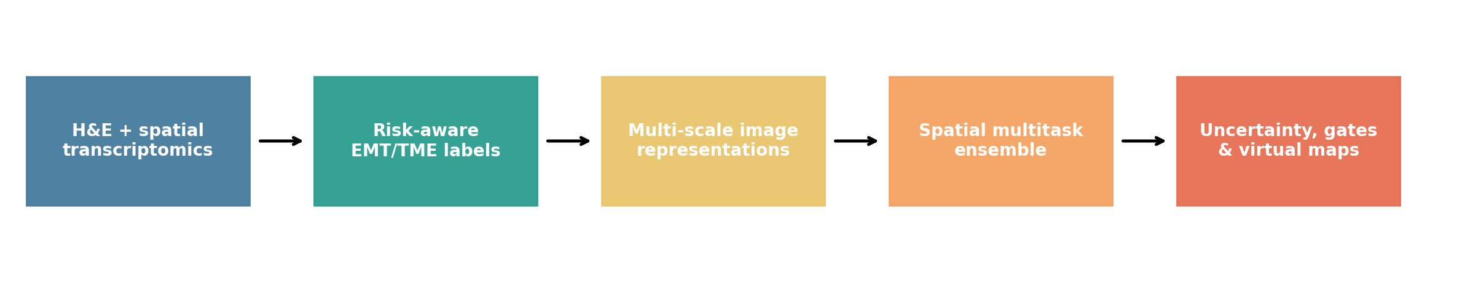
Figure 1. Executed EMT-ViSTA workflow.

2. Scientific background and project importance

2.1 Epithelial-mesenchymal plasticity
Cancer EMT is increasingly understood as epithelial-mesenchymal plasticity rather than a binary conversion. Tumour cells can occupy partial or hybrid states, transition over time and interact with fibroblasts, macrophages, hypoxia and ECM. These states are associated with invasion, metastatic dissemination and treatment adaptation, but identifying them in human tissue remains difficult.

2.2 Why spatial context matters
Bulk RNA averages malignant and stromal compartments. Single-cell RNA provides cell-level resolution but often loses intact tissue architecture. Spatial transcriptomics connects molecular programs to tissue regions, while H&E provides routine morphology. Paired H&E-spatial data therefore create a supervised setting for testing whether morphology can nominate molecularly interesting regions.

2.3 Why the project matters
- Spatial transcriptomics is informative but costly and not routine for every specimen.
- H&E is available at clinical scale and can support retrospective cohorts.
- Reliable virtual maps could prioritize laser-capture, spatial assays, pathology review and pharmacodynamic studies.
- Explicit abstention and contamination flags can prevent attractive but unreliable maps from becoming clinical claims.

3. Hypothesis, research questions and aims
Central hypothesis
Multi-scale H&E morphology contains transferable information about spatial epithelial-mesenchymal plasticity and its tumour microenvironment, but meaningful prediction requires explicit modeling of stromal admixture, domain shift and uncertainty.

3.1 Primary research questions
- Can routine H&E predict epithelial, mesenchymal and partial-EMT program scores learned from spatial transcriptomics?
- Can the model distinguish candidate malignant partial EMT from CAF-rich or stromal-inflated expression?
- Do local tissue-neighborhood representations improve prediction beyond image-only features?
- Does model uncertainty identify regions where abstention reduces prediction error?
- Do learned representations generalize to held-out lung squamous and colorectal datasets?
- Can the resulting maps support hypothesis generation without being confused with measured RNA or clinical diagnosis?

3.2 Specific aims
Aim | Execution | Success criterion
Aim 1: Labels | Construct EMT/TME scores and contamination-aware partial-EMT targets. | Biological definitions are explicit and versioned.
Aim 2: Morphology | Compare handcrafted, generic and pathology-foundation representations. | Learned features beat transparent controls on held-out data.
Aim 3: Spatial context | Add nearest-neighbor image representations. | Spatial refinement improves patient-safe evaluation.
Aim 4: Safety | Calibrate, quantify uncertainty and abstain. | Selective prediction lowers error and stroma FPR stays below 0.15.
Aim 5: Translation | Export H&E overlays and hotspots. | Outputs remain reviewable and traceable to confidence fields.

4. Data sources and literature grounding

4.1 Databases and datasets
Resource | Role | Used in v1 | Notes
10x Genomics public Visium | Aligned H&E, coordinates and gene counts | Yes | Breast, prostate, ovarian, lung squamous and intestinal/CRC.
Local spatial EMT pipeline | Molecular program scores and metadata | Yes | Provides EMT, CAF, TAM, hypoxia, ECM and stromal features.
Hugging Face: owkin/phikon-v2 | Pathology foundation embeddings | Adapter + smoke run | Ungated operational backend; full benchmark needs CUDA scale.
Hugging Face: Bioptimus H-Optimus-0 | Large pathology foundation model | Adapter ready | Model host requires user-specific access workflow and token.
HEST-1k | Large paired histology-spatial scale-up | Planned validation | 1,229 profiles and multimodal benchmarking framework.
HTAN / GEO spatial cohorts | Multi-patient external validation | Planned | Needed for institution and patient-level generalization.
CELLxGENE / GEO scRNA-seq | Compartment-resolved reference | Planned | Needed for malignant versus stromal deconvolution.

4.2 Key literature
Reference | Contribution to the project
Dong & Blanpain, Nature Reviews Cancer, 2026 | Defines EMT tumour states, partial states and therapeutic interpretation.
Thompson et al., Nature Reviews Clinical Oncology, 2025 | Clinical framing of epithelial-mesenchymal plasticity, metastasis and treatment resistance.
Jaume et al., HEST-1k, NeurIPS 2024 | Large-scale paired histology-spatial dataset and benchmark design.
Filiot et al., Phikon-v2, 2024 | Public pathology foundation-model representation for biomarker prediction.
STPath, npj Digital Medicine, 2025 | Large-scale generative H&E-to-spatial expression modeling and cross-platform considerations.
Towards robust foundation models for digital pathology, Nature Communications, 2026 | Shows medical-center confounding and the importance of out-of-domain evaluation.

Links and full citations appear in Section 14.

5. Methodology and why each step matters
Step | What was done | Why it is important
1. Pairing and QC | Match H&E coordinates to molecular spots and retain tissue/QC metadata. | Prevents image-label misalignment and makes missing data visible.
2. Program scoring | Compute epithelial, mesenchymal, partial-EMT, CAF, TAM-SPP1, hypoxia, ECM and stromal-risk targets. | Program scores are more stable and interpretable than thousands of individual genes.
3. Malignant gating | Require joint epithelial/mesenchymal activity and penalize high stromal risk. | Reduces the chance of calling fibroblast-rich spots tumour EMT.
4. Multi-scale tiles | Extract 224-pixel center and 448-pixel context regions. | Captures local cells plus glands, desmoplasia, necrosis, vessels and invasive architecture.
5. Representations | Compare handcrafted, ResNet50, Phikon-v2 and H-Optimus adapters. | Separates simple stain/texture signal from learned pathology-specific representations.
6. Spatial context | Append mean k-nearest-neighbor image features. | Models tissue neighborhoods without an opaque full GNN in the first benchmark.
7. Multitask ensemble | Bootstrap PCA plus ridge models predict eight programs together. | Provides a transparent baseline and ensemble spread for uncertainty.
8. Calibration | Measure partial-EMT AUPRC, calibration and stroma false positives. | A virtual stain must be both accurate and honest about probability.
9. Abstention | Reject high-uncertainty or high-risk predictions. | Tests whether silence improves safety and error.
10. Export | Create TSV, JSON, PNG overlays and GeoJSON hotspots. | Enables review, downstream tooling and reproducibility.

5.1 Label definitions
- Epithelial score: epithelial identity and cell-cell adhesion program.
- Mesenchymal score: motility, matrix interaction and mesenchymal program.
- Partial-EMT score: co-activity of epithelial and mesenchymal programs rather than an average along one axis.
- Stromal contamination risk: likelihood that mesenchymal expression is explained by fibroblast/ECM-rich admixture.
- Malignant-gated partial-EMT probability: partial-EMT evidence retained only when epithelial evidence is adequate and stromal risk is controlled.

5.2 Predefined go/no-go criteria
Criterion | Threshold | Purpose
Median test Spearman | >= 0.35 | Overall held-out molecular ranking accuracy.
Programs above 0.35 | >= 4 | Prevents one easy target from hiding broad failure.
Partial-EMT AUPRC above prevalence | >= 0.15 | Measures discrimination beyond class prevalence.
Pure-stroma false-positive rate | < 0.15 | Safety against stromal mimicry.
Partial-EMT calibration error | < 0.10 | Probability reliability.
Abstention error improvement | >= 0.15 | Confirms uncertainty is useful rather than decorative.

6. Technical implementation and tools
Tool | Project role | Advantage | Limitation
Python 3.10 | Reproducible runtime | Stable scientific ecosystem | Separate environment required from system Python 3.14
pandas / NumPy | Tables and numerical processing | Transparent, inspectable transformations | Memory-bound at very large scale
scikit-learn | PCA, ridge, neighbors, metrics | Strong interpretable baselines | No end-to-end image learning
PyTorch / torchvision | ResNet and tensor inference | Standard accelerated ecosystem | CUDA needed for scale
Transformers | Phikon-v2 adapter | Public pathology-specific features | Large model and license considerations
timm | H-Optimus adapter | Broad ViT model support | Weights require host access workflow
Matplotlib / seaborn | Scientific plots and maps | Reproducible static figures | Not a clinical WSI viewer
GeoJSON | Hotspot exchange | Interoperable spatial output | Coordinates require slide metadata
pytest | Regression and safety testing | 28 passing tests prevent silent breakage | Cannot establish biological validity

6.1 Repository deliverables
- Numbered scripts 09–16 for pairing, embeddings, baselines, multitask training, evaluation, inference, maps and paper figures.
- A reusable emt_virtual_spatial_staining Python package.
- A five-cohort YAML configuration and end-to-end orchestrator.
- Machine-readable predictions, metrics, safety tables, manifests and model metadata.
- Student report, interview guide, manuscript draft and implementation report.

7. Results from the real-data run
Representation | Held-out spots | Median Spearman | Best program | Best Spearman | Gates passed
Handcrafted multi-scale | 1,024 | 0.014 | Epithelial | 0.310 | 2/7
ResNet50 ImageNet | 256 | -0.086 | Partial-EMT score | -0.032 | 2/7

The handcrafted model did not meet the median 0.35 gate, although epithelial score reached 0.310. ResNet50 did not improve transfer. Partial-EMT discrimination, calibration and abstention-improvement gates failed. Both controls passed the pure-stroma false-positive threshold.
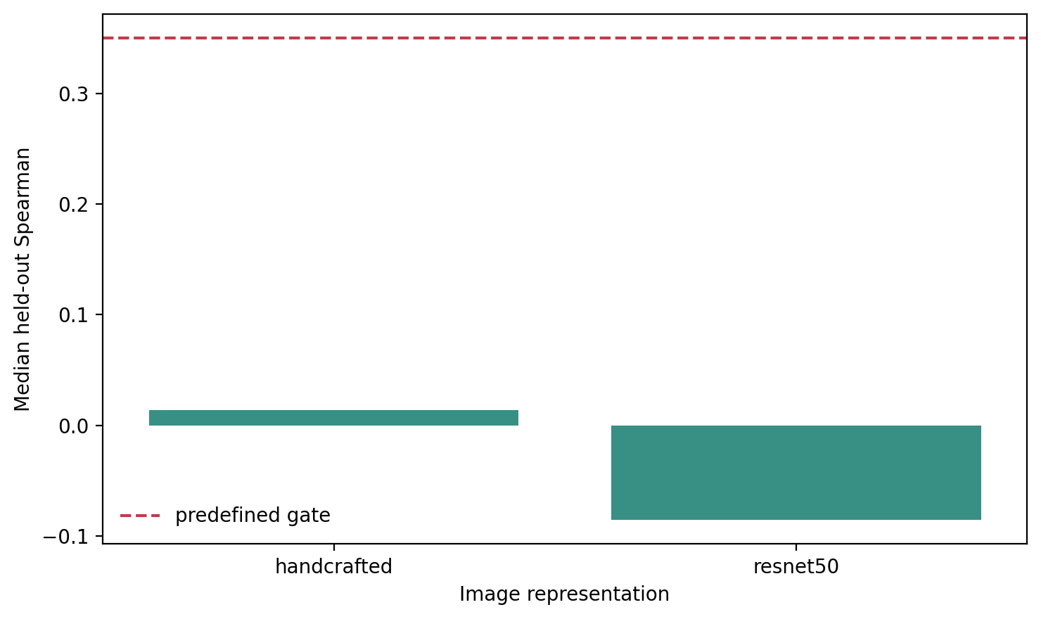
Figure 2. Median held-out performance versus the predefined gate.
Primary finding
The engineering pipeline is operational, but simple morphology and generic ImageNet features do not provide reliable cross-cancer molecular virtual stains in this sampled benchmark.

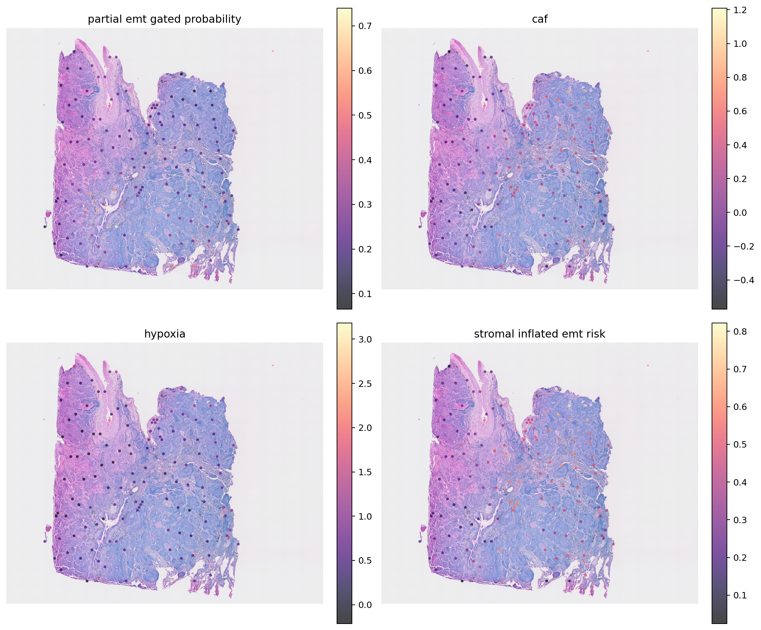
Figure 3. Held-out lung squamous H&E overlay. Spatial alignment is correct; molecular accuracy gates remain failed.

8. Interpretation: what the findings mean

8.1 Valid conclusions
- The complete paired-data, modeling, uncertainty, evaluation and export workflow runs on real public slides.
- Dataset-level holdouts expose substantial cross-cancer domain shift.
- Handcrafted features retain more epithelial ranking signal than the sampled ResNet50 control but still fail the release gate.
- The stromal false-positive control behaves conservatively in the first run.
- A pathology-specific representation and better ground truth are justified as the next experiment.

8.2 Invalid conclusions
- H&E has not been shown to directly measure EMT or spatial RNA.
- Predicted hotspots have not been established as invasive fronts or metastatic niches.
- The lung and colorectal slides are technical holdouts, not multi-patient clinical validation.
- The negative controls do not prove that pathology foundation models will succeed.
- No treatment or patient decision should be based on these outputs.
Interpretation rule
A high virtual partial-EMT probability means that morphology resembles molecularly scored training regions under this label definition. It must be reviewed together with stromal risk, uncertainty, tissue region and orthogonal molecular or pathology evidence.

9. Advantages, disadvantages and novelty
Advantages | Disadvantages / risks
Routine H&E input; public reproducible data; program-level biological targets; explicit contamination risk; uncertainty and abstention; interpretable controls; reviewable maps and GeoJSON; honest negative results. | Few slides/patients; mixed spatial spots; bounded CPU samples; foundation model not yet benchmarked at full scale; no blinded pathologist regions; no untouched institution; no prospective endpoint; domain and stain shift.

9.1 Novel contributions
- Risk-aware partial EMT rather than unqualified H&E-to-expression regression.
- Joint prediction of molecular program, contamination risk and uncertainty.
- Multi-scale morphology plus spatial-neighbor refinement.
- Predefined biological and calibration gates that can reject attractive outputs.
- Lung and colorectal transfer experiments embedded in a pan-cancer pipeline.

10. Project pitch

10.1 Thirty-second pitch
Pitch
I built EMT-ViSTA, a multimodal pipeline that learns spatial EMT and tumour-microenvironment programs from routine H&E using paired spatial transcriptomics. Its novelty is contamination-aware partial-EMT prediction with uncertainty and abstention. The first lung and colorectal holdouts rejected simple image baselines, giving an honest roadmap toward pathology-foundation, patient-level and pathologist-validated studies.

10.2 Two-minute pitch
Spatial EMT and its CAF, macrophage, hypoxia and ECM context matter for metastasis and therapy resistance, but spatial transcriptomics is too expensive for routine use. EMT-ViSTA asks whether routine H&E can nominate these spatial programs. I paired five public cancer H&E-spatial datasets, built program-level labels, and introduced a malignant partial-EMT gate so fibroblast-rich spots are not automatically called tumour EMT. The model combines center and context image representations with spatial-neighbor features, predicts eight targets through a bootstrap ensemble, and exports uncertainty, abstention and H&E overlays.
The first held-out lung and colorectal experiment produced a negative but important finding. Handcrafted and generic ResNet50 features did not meet predefined molecular-performance or calibration gates, while the pure-stroma false-positive gate passed. That means the software is operational but the biomarker is not validated. The next decisive experiment is full-scale pathology-foundation extraction followed by leave-patient-out validation, scRNA-based compartment labels and blinded pathologist annotations.

10.3 Five-minute presentation structure
- Problem: spatial EMT matters, but routine H&E does not directly measure it.
- Hypothesis: morphology contains transferable signal if contamination and uncertainty are modeled.
- Method: paired public data, risk-aware labels, multi-scale representations, spatial ensemble and safety gates.
- Finding: simple controls fail held-out molecular criteria; stroma safety passes.
- Interpretation: framework ready, biomarker not ready.
- Next study: pathology foundation models, patient-level cohorts, pathologist/scRNA ground truth and external centers.

11. Interview reference

11.1 High-yield answers
Question | Best concise answer
What is the project? | A contamination-aware H&E-to-spatial-program research pipeline for EMT and the tumour microenvironment.
What is the novelty? | It predicts partial EMT, stromal risk and uncertainty together and can abstain.
Why program scores? | They reduce spatial-RNA dropout and match the biological question better than thousands of single genes.
Why dataset-level splits? | Random spot splits leak slide-specific stain and local tissue information.
Why PCA plus ridge? | It is a transparent regularized baseline that reveals domain shift before larger models hide it.
What was the result? | The first handcrafted and ResNet controls failed held-out molecular gates; pure-stroma safety passed.
Was the project successful? | The platform succeeded and the baselines were correctly falsified; biological validation remains incomplete.
What is next? | Full pathology-foundation runs, patient-level cohorts, scRNA deconvolution, pathologist regions and external validation.

11.2 Technical talking points
- Unit of validation: patient and institution, not individual neighboring spots.
- Primary continuous metric: held-out Spearman correlation; partial EMT also needs AUPRC and calibration.
- Uncertainty: spread across bootstrap ensemble predictions.
- Selective risk: error after abstaining on the most uncertain spots.
- Safety metric: false-positive partial EMT in molecularly defined pure-stroma regions.
- Failure analysis: domain shift, weak labels, spot mixing, small cohort size and non-pathology ImageNet features.
The companion PDF contains the full interview and viva question bank.

12. Future execution and publication roadmap
Phase | Execution | Evidence produced | Estimated effort
Foundation scale-up | Full Phikon-v2 and H-Optimus extraction on CUDA. | Fair representation benchmark under frozen gates. | 1–2 weeks
Ground-truth refinement | Matched scRNA deconvolution and two-pathologist annotations. | Malignant/stromal compartment labels and agreement. | 3–6 weeks
Patient-level validation | Multi-patient lung and CRC leave-one-patient-out analysis. | Confidence intervals and disease-specific models. | 4–8 weeks
External center | Untouched institution, scanner and platform. | Out-of-domain generalization and failure cases. | 6–12 weeks
Prospective utility | Assay-triage endpoint and region-selection study. | Clinical workflow utility, not just correlation. | 3–9 months

12.1 Publication decision rule
The manuscript should be submitted as a positive molecular virtual-stain study only if frozen patient-level external gates pass. Otherwise, the appropriate article is a rigorous framework and negative-benchmark report focused on contamination controls, domain shift and reproducible failure analysis.
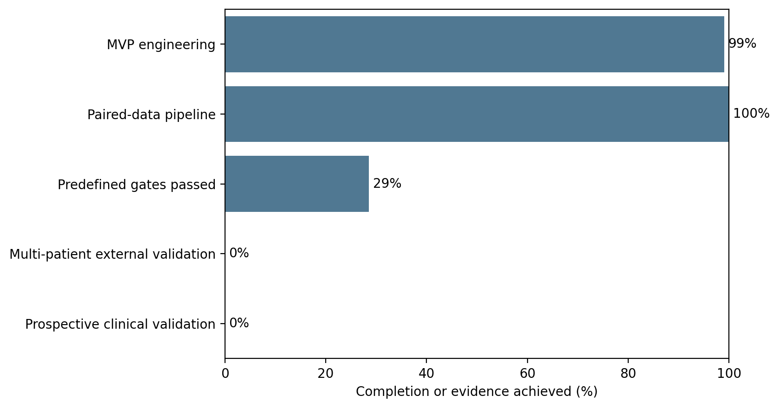
Figure 4. Engineering completion and scientific validation are reported separately.

13. Conclusion
EMT-ViSTA is a completed executable research MVP and an incomplete biological biomarker. Its strongest contribution is the combination of spatial EMT hypotheses with contamination risk, uncertainty, abstention and predefined falsification. The project provides a credible platform for pathology-foundation and patient-level studies while demonstrating the scientific value of refusing unsupported claims.
Final message
A trustworthy virtual stain must know when not to stain.

14. References and project resources
- Dong A, Blanpain C. Identification, functional insights and therapeutic targeting of EMT tumour states. Nature Reviews Cancer. 2026. https://www.nature.com/articles/s41568-025-00873-0
- Thompson EW et al. EMT and cancer: what clinicians should know. Nature Reviews Clinical Oncology. 2025. https://www.nature.com/articles/s41571-025-01058-2
- Jaume G et al. HEST-1k: A Dataset for Spatial Transcriptomics and Histology Image Analysis. NeurIPS Datasets and Benchmarks. 2024. https://proceedings.neurips.cc/paper_files/paper/2024/file/60a899cc31f763be0bde781a75e04458-Paper-Datasets_and_Benchmarks_Track.pdf
- Filiot A et al. Phikon-v2, a large and public feature extractor for biomarker prediction. 2024. https://arxiv.org/abs/2409.09173
- STPath: a generative foundation model for integrating spatial transcriptomics and whole-slide images. npj Digital Medicine. 2025. https://www.nature.com/articles/s41746-025-02020-3
- Towards robust foundation models for digital pathology. Nature Communications. 2026. https://www.nature.com/articles/s41467-026-73923-2
- Bioptimus H-Optimus model family. https://www.bioptimus.com/h-optimus
- HEST official repository. https://github.com/mahmoodlab/hest
- Project protocol: docs/emt_virtual_spatial_staining/detailed_project_plan.md
- Project implementation report: docs/emt_virtual_spatial_staining/implementation_report.md
- Project article draft: docs/emt_virtual_spatial_staining/research_article_draft.md

