**Cloudwiry Hackathon - 2022**

**Simple Blob Storage System**

I have developed a blob storage system that stores files in the server using FastAPI (Python), MongoDB, React. The application is deployed as follows:

Backend FastAPI is deployed on Heroku: <https://simple-blob-cloudwiry.herokuapp.com/docs>

Frontend React site is deployed on Netlify:

<https://filestore.netlify.app/>

**IMPLEMENTATION:**

**CheckPoint A: User authentication and session management**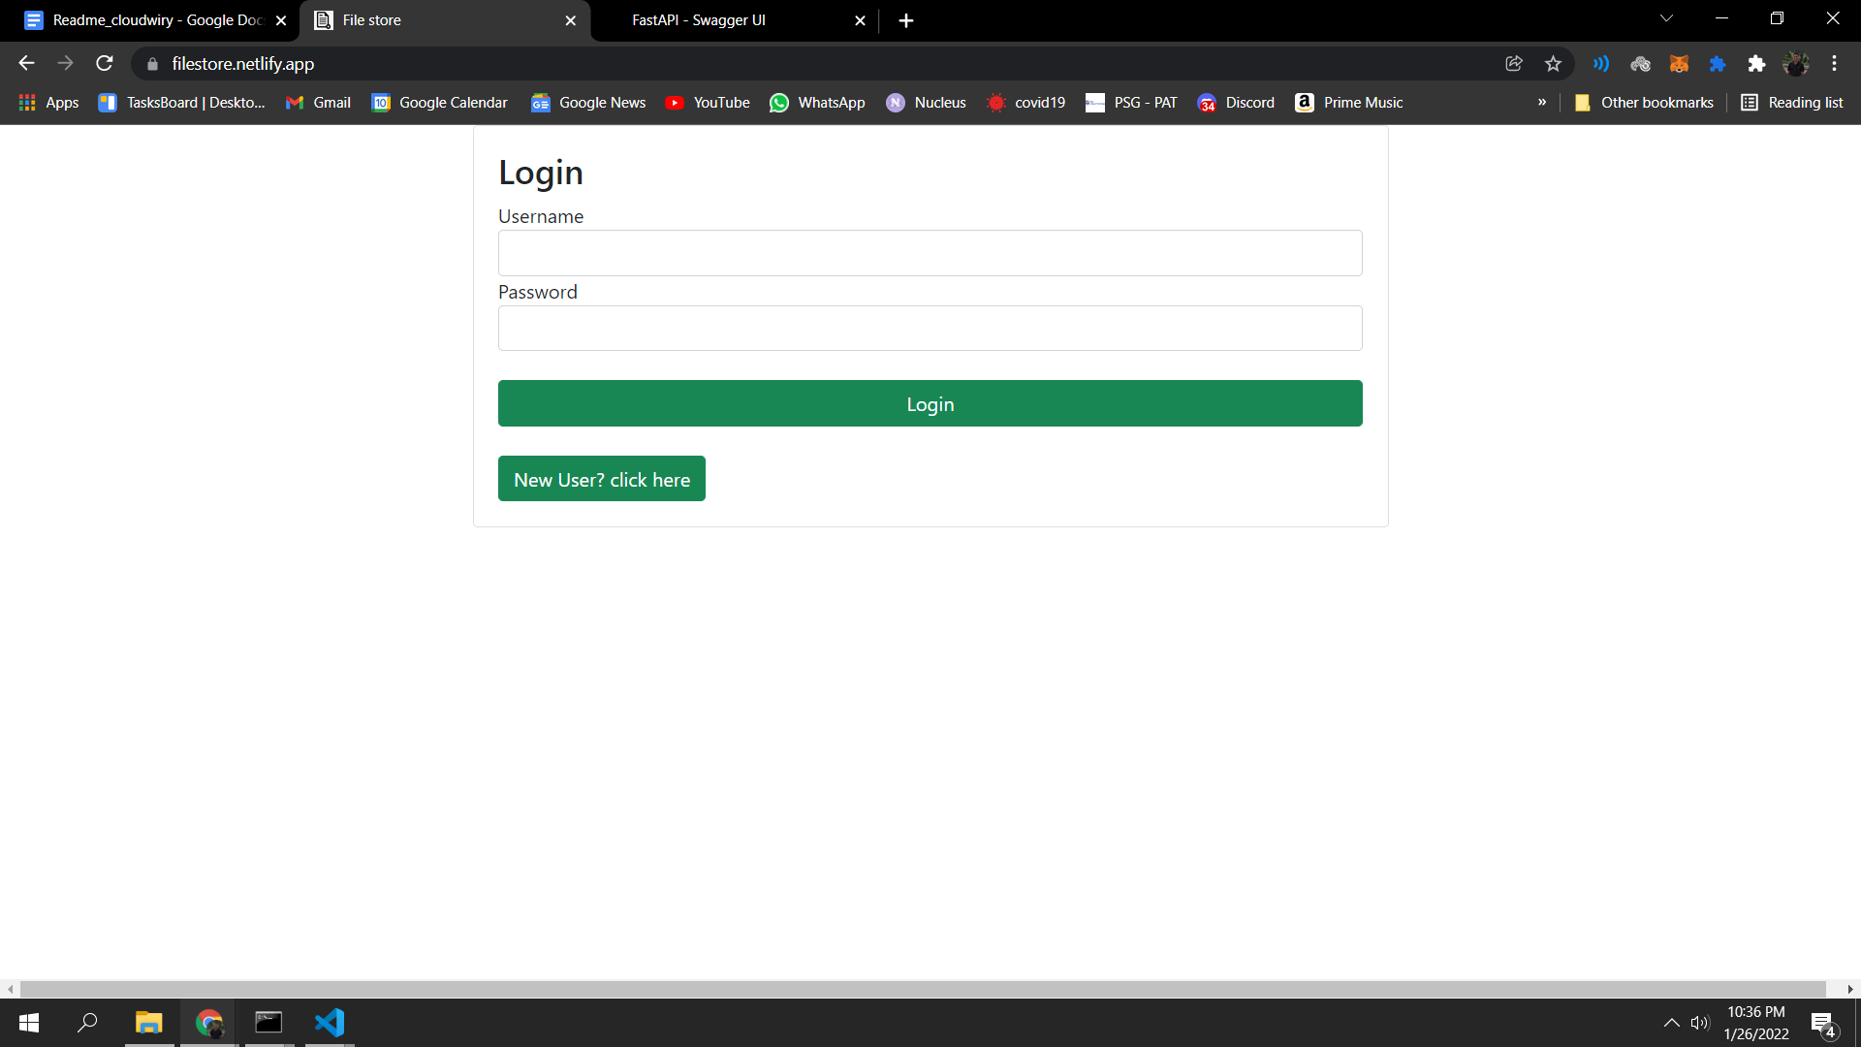

On Atlas, I have a mongodb database with a users collection that comprises documents with fields **username(string), password(string), files created(list), and shared with me (list)**. The locations of the files created by the user are pushed into a list in MongoDB, but the files themselves are not saved there. A post request to route (‘/’) will create a new user.

**CheckPoint B: Implementation of the blob storage server**

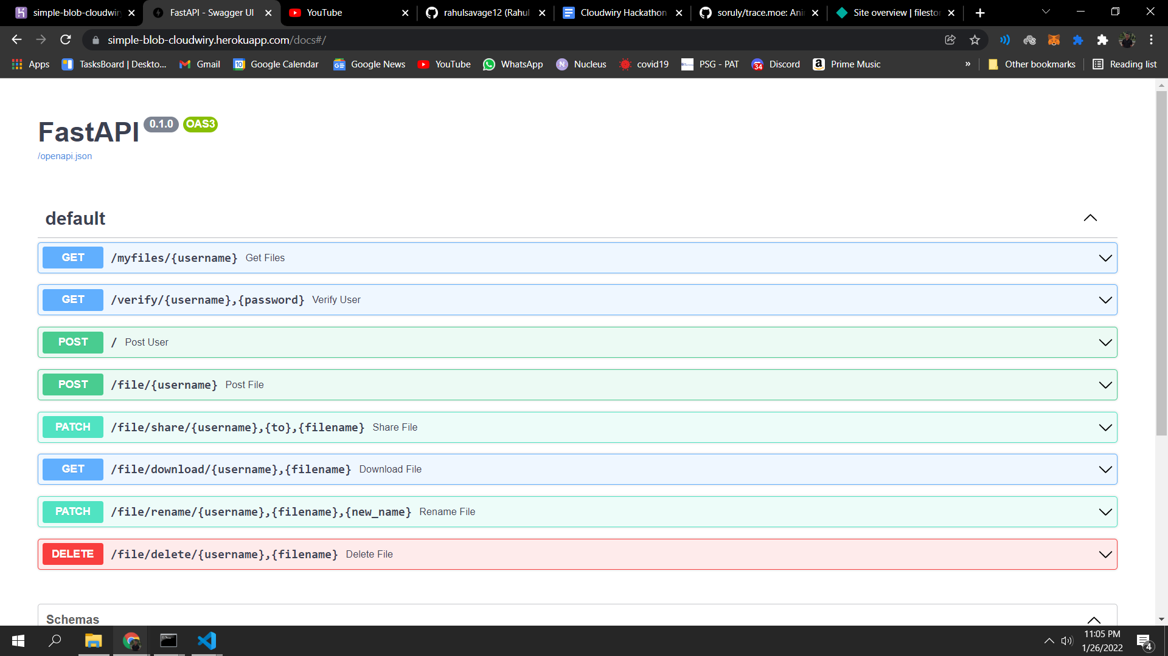

**Upload File:**

Files posted by the user are kept in a folder called after the user's username. This is accomplished with the help of Python's **shutil package**. In MongoDB, the file location is pushed into the files created list under the user's document.

**Rename/Delete File:**

The **os library** is used to rename and delete files on the server. The file locations in the files created and shared with me lists are also updated in MongoDB.

**Download File:**

The requested file can be acquired from the response of an api call using the **starlette library** in python.

**Share File:**

When sharing files, the location of the file will be appended to the shared to me list in MongoDB present in the document of the person to whom the file is shared.

**CheckPoint C: Client application (CLI/ web based) for file upload, download, rename and delete**

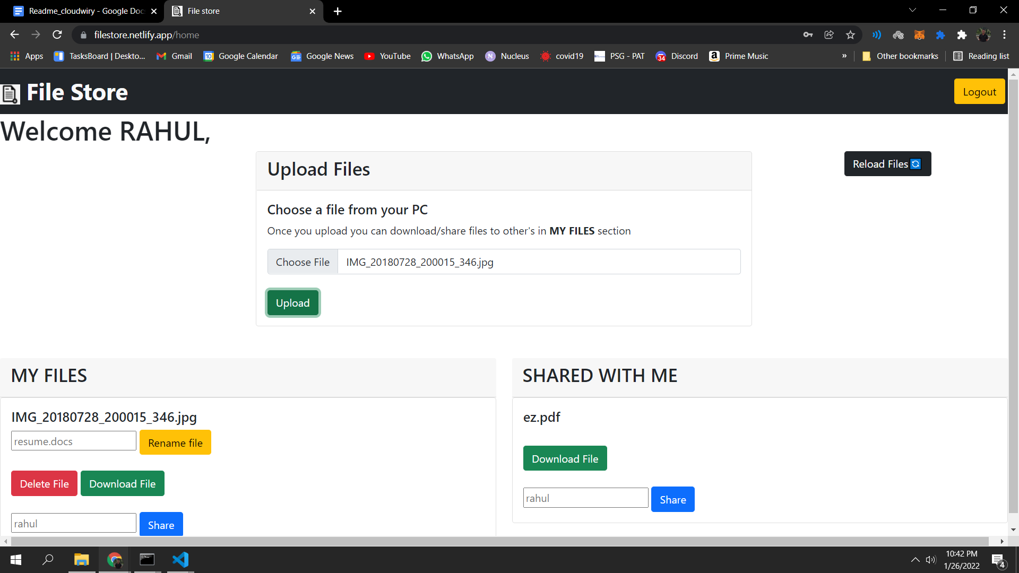

I used **React** to provide user **authentication, session management (through Logout), file upload, download, rename, delete, and share** capabilities. The **Axios library** is used to make API calls.

**CHECKPOINT D:User based access control on who can access the files**

Users who have been given access to the file can only view/download it.

**CHECKPOINT E:Deploy the application**

The application has been deployed on the following platforms:

The Heroku backend FastAPI is available here: <https://simple-blob-cloudwiry.herokuapp.com/docs>

Netlify is hosting the frontend React site:

<https://filestore.netlify.app/>