***CSE/MCA EVENT***

***“e-Collage”***

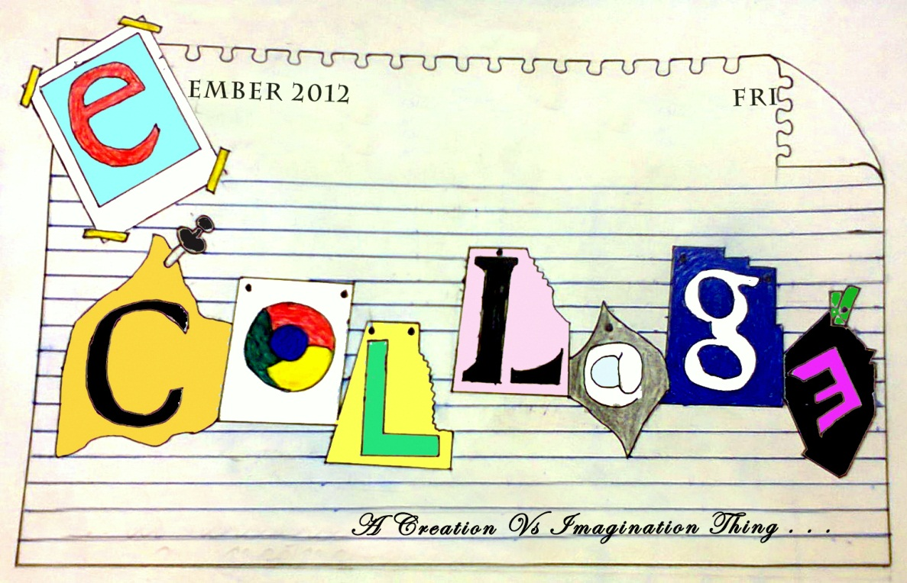

**It’s a Creation Vs Imagination Thing!**

**A participant has to get into the world of creativity and imagination over how to use pictures to create an e-collage with the help of some defined software tools (like Picasa, Adobe Photoshop, MSPaint). The collage has to be created on the basis of given themes and given pictures. There will be two rounds pre and main. So come..Lets have fun..!**

**Event Managers: Co-Conveners: Volunteers: MCA 2ndyr**

1.ShivankGarg (MCA Final yr) Hem Chandra Bhatt(MCA 2ndyr) Kanika Gupta

(8954644080) (9927893855) JeeniyaRana

2.RohitVerma(MCA Final yr) PoojaPandey(MCA 2ndyr) Manish Panwar

(9045622652) NeelamBisht(MCA 2ndyr) Saraswati

3.Suman Joshi(MCA Final yr) Rajni Bora(MCA 2ndyr)

**“e-COLLAGE”**

**RULES:**

1. THIS EVENT IS OPEN FOR ALL.
2. There will be two rounds in this event- pre and main.
3. In pre round, the particiants will be given images/ pre designed collages and they have to write appropriate theme/tag line for the respective pictures.
4. In the main round, the participants will be given themes and they have to design a collage on any one of the themes.
5. All the pictures wiil be provided to the participants.
6. No use of internet is allowed. However, participants can edit the given pictures.
7. The tools that can be used are:
8. **Picasa**
9. **Adobe photoshop**
10. **MS paint**
11. Participants are required to register in a team of 2 members in both the rounds.
12. The limit of pictures in main round while creating collage is min 10 to max 100.
13. Time limit:

Pre round: 15 mins

Main round: 30 mins

1. Selection and disqualification will be decided by the event managers.