**Extra Credit Report.**

Submitted by:

Rahul Sethi

Masters in Computer Science

Student Id: 200241349

**Question:**

1. Having fun in Disneyland! A visit at Disneyland involves a fair amount of waiting in lines during the high season. One has to queue up to buy a ticket, and then once in the park, one has to queue up for each theme. Does one spend more time queueing up or enjoying the themes? That depends on the arrival rates of customers and service times (i.e. the time to see a theme). The queueing network in figure 1 depicts the ticket counters, four themes, and the food court. Answer the following questions:

1. Are all the queues stable?
2. What is the utilization of each ticket counter?
3. What is the probability that a customer will get served immediately upon arrival at the food court?
4. What is the mean waiting time at each theme?
5. How long would it take on the average to visit all themes once, and of that time how much one spends waiting in a queue?

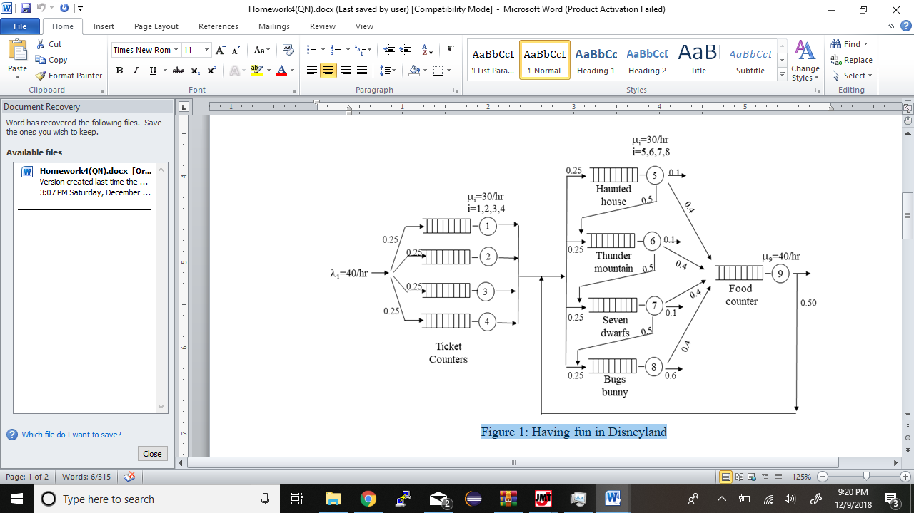

Figure 1: Having fun in Disneyland

**Technology Used:**

* Simulation was carried out using JMT i.e Java Modeling Tool.

**Results:**

Results of the simulation are inserted below.

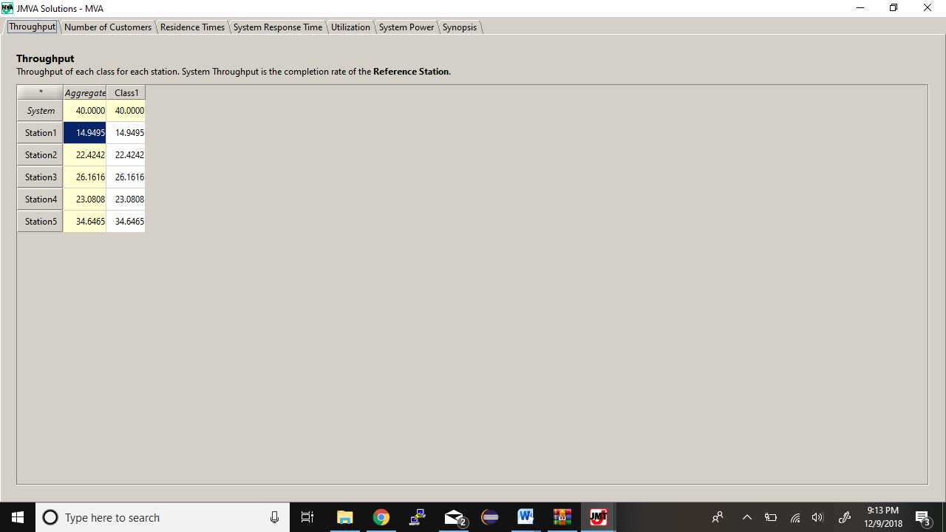

(Throughput Results)

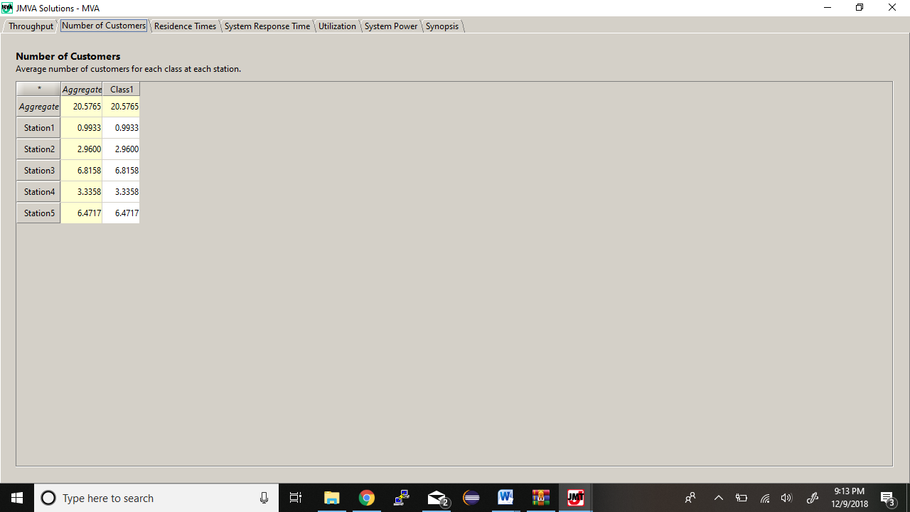

(No of Customers)

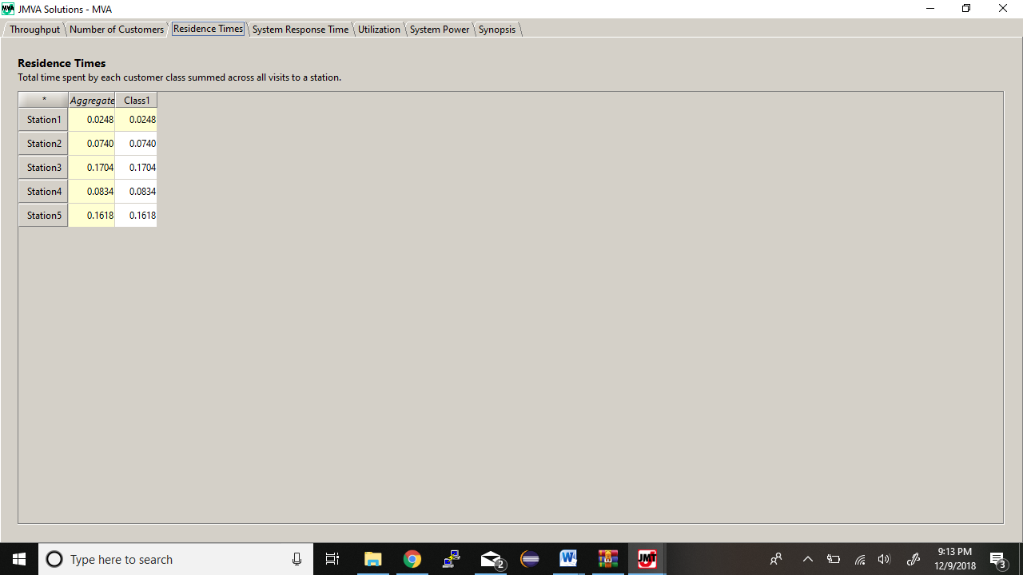

(Residence Times)

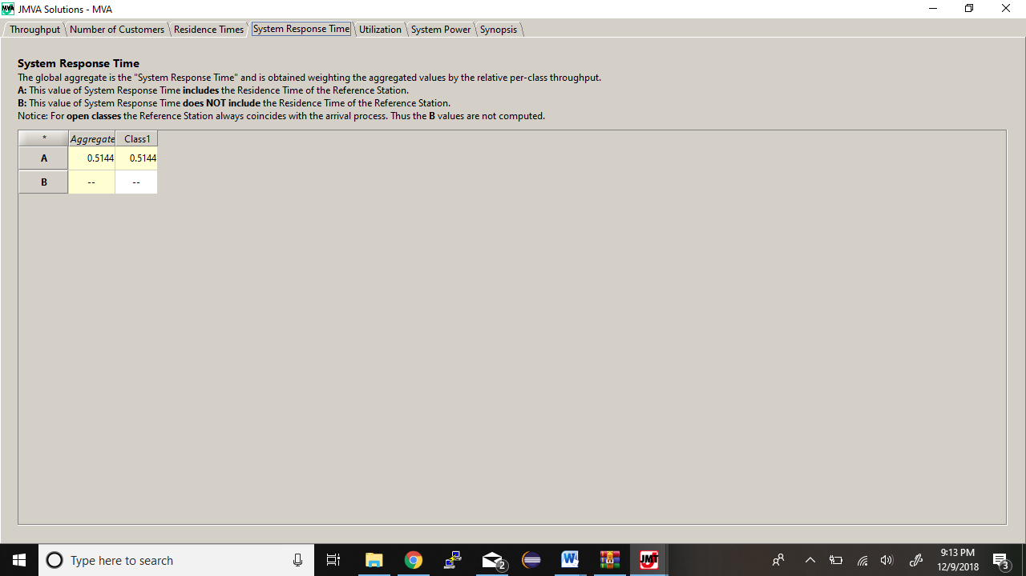

(System Response Time)

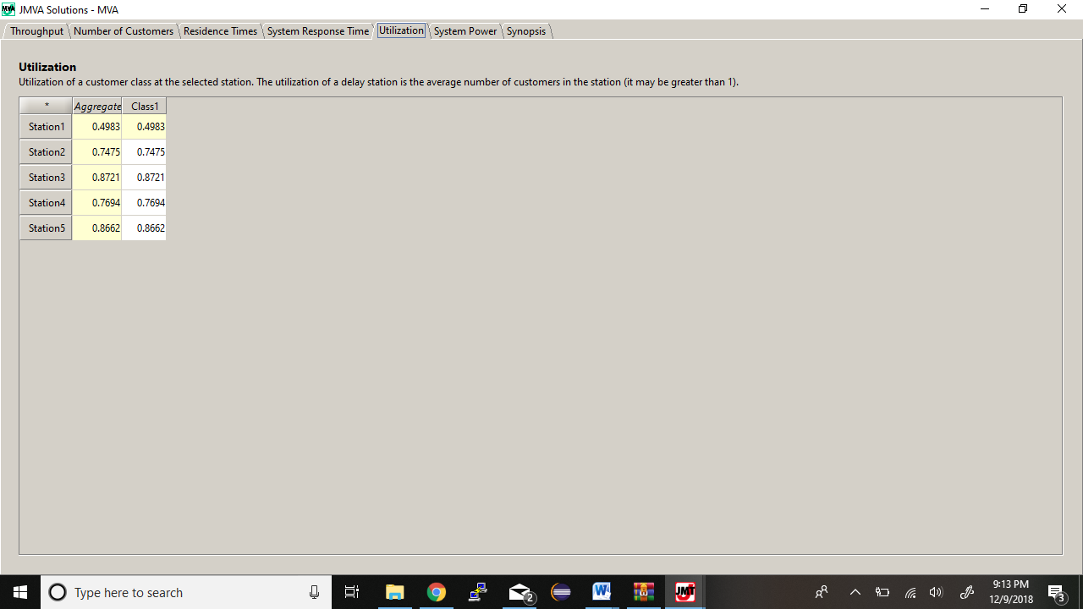

(Utilization Results)

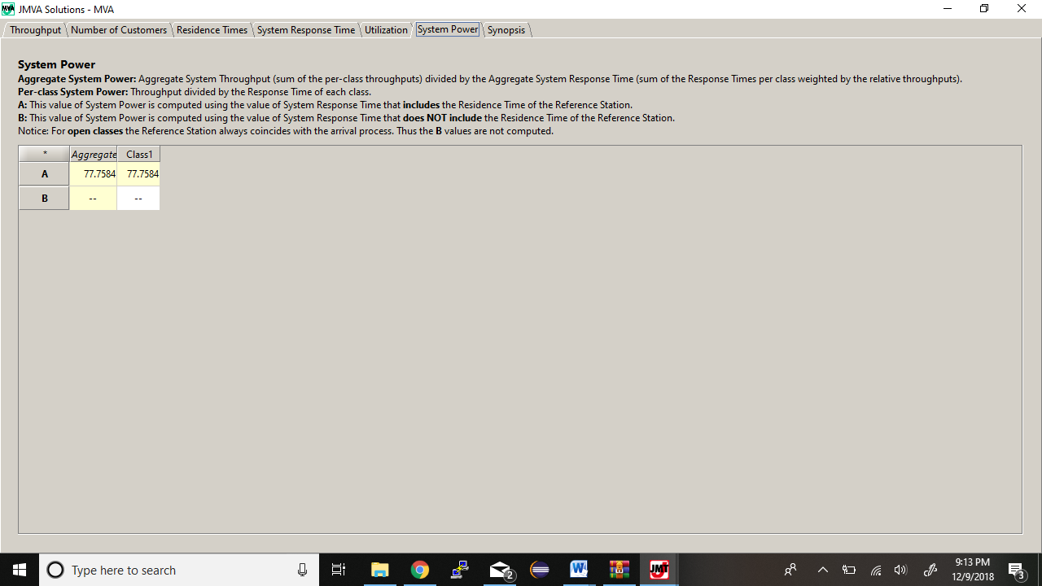

(System Power Results)

**Calculations:**

a - Are all the queues stable?

* *Yes the queues are stable*

**

*Here we can see that throughput is less than μ for every queue. μ1 = μ2 = μ3 = μ4 = 30 and μ5 = 40.*

*So all the queues are stable*

c - What is the probability that a customer will get served immediately upon arrival at the food court?

*P0 = 1 - ρ*

*ρ = 0.8662*

*P0 = 1 – 0.8662 = 0.1338*

d - What is the mean waiting time at each theme?



* M1 = 0.0248
* M2 = 0.0740
* M3 = 0.1704
* M4 = 0.0834
* M5 = 0.1618

e - How long would it take on the average to visit all themes once, and of that time how much one spends waiting in a queue?

* Average time to visit all themes once = (0.0248 + 0.0740 + 0.1704 + 0.0834 + 0.1618) = 0.5144