30 may 2024

Assignment

### Scenario 1: Diagnosing High CPU Usage

Your team has reported that the production server is experiencing high CPU usage, which is affecting performance.

1. **Task: Identify the cause of high CPU usage.**
   * Use top to monitor real-time CPU usage and identify processes consuming the most CPU.
   * Capture the output and identify the top 3 processes with the highest CPU usage.

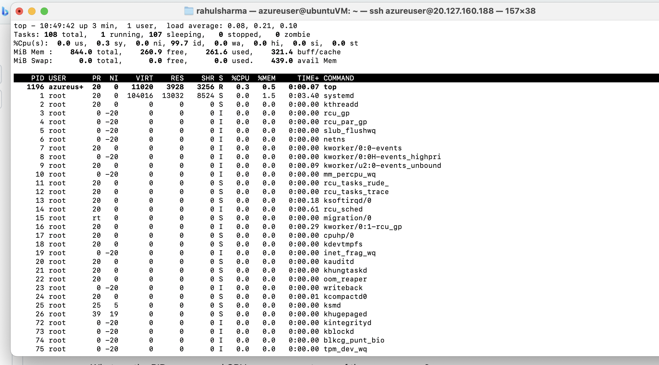

1. **Questions:**
   * What are the PIDs, users, and CPU usage percentages of these processes?

PID: 1196,1,2

User: azureuser, root, root

CPU: 0.3%

* + What steps would you take to mitigate high CPU usage caused by these processes?
    1. Kill the process by **pid by command kill -9 p_id**
    2. **Reboot the system**

### Scenario 2: Disk Space Management

The server is running out of disk space on the root filesystem, which is causing application errors.

1. **Task: Identify and clean up unnecessary files to free up space.**
   * Use df -h to check disk usage and identify the full filesystem.
   * Use du -h / to find large directories and files consuming space.

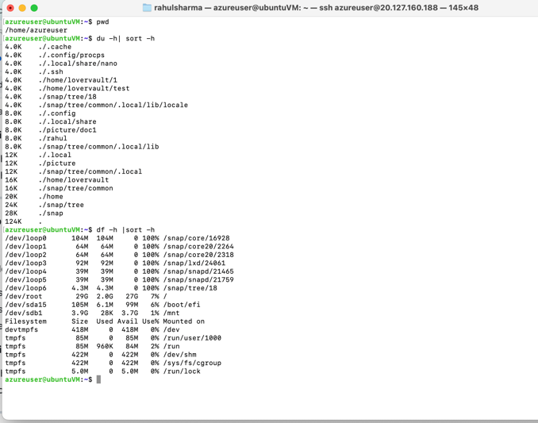

* + Delete or archive unnecessary log files in /var/log.

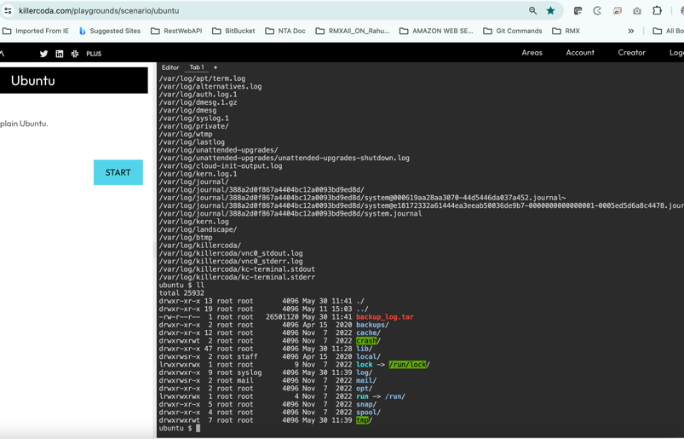

Command: tar -cvf backup_log.tar /var/log **Backup_log.tar**

In own vm it showed permission denied

1. **Questions:**
   * Which directories or files were consuming the most space?

/dev/root is taking most space in internal device that is 7% and 2 gb is used. For external device /dev/loop1-6 is 100% used

* + How much space were you able to free up, and what steps did you take?

If directory is not the root directory then we can take a backup and archive it and remove it if it is not use in future

### Scenario 3: System Health Check

Regular system health checks are essential to ensure the server is running optimally.

1. **Task: Perform a comprehensive health check of the server.**
   * Use lscpu to review CPU details.
   * Use free -h to check memory usage.
   * Use df -h to review disk space.
   * Use uptime to check system load and uptime.
   * Use ps aux to list all running processes.
   * Use cat /etc/os-release to document the OS version.

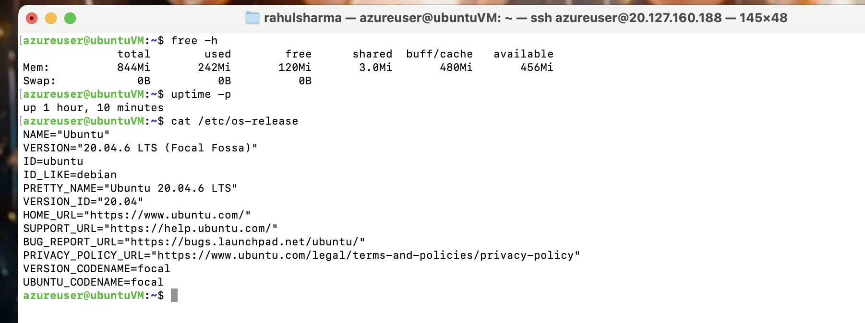

1. **Questions:**
   * Summarize the overall health of the server based on the outputs.
   * Are there any immediate issues that need addressing? If so, what are they?

### Scenario 4: Process Management

A rogue process is consuming excessive resources and needs to be terminated to stabilize the system.

1. **Task: Identify and terminate the rogue process.**
   * Use top or ps aux to find the process consuming the most resources. **done**
   * Use kill -9 [PID] to terminate the process. **done**
2. **Questions:**
   * Which process did you identify as rogue? Provide its PID, user, and resource consumption details.
   * What was the result of terminating the process? Did it stabilize the system?
   * 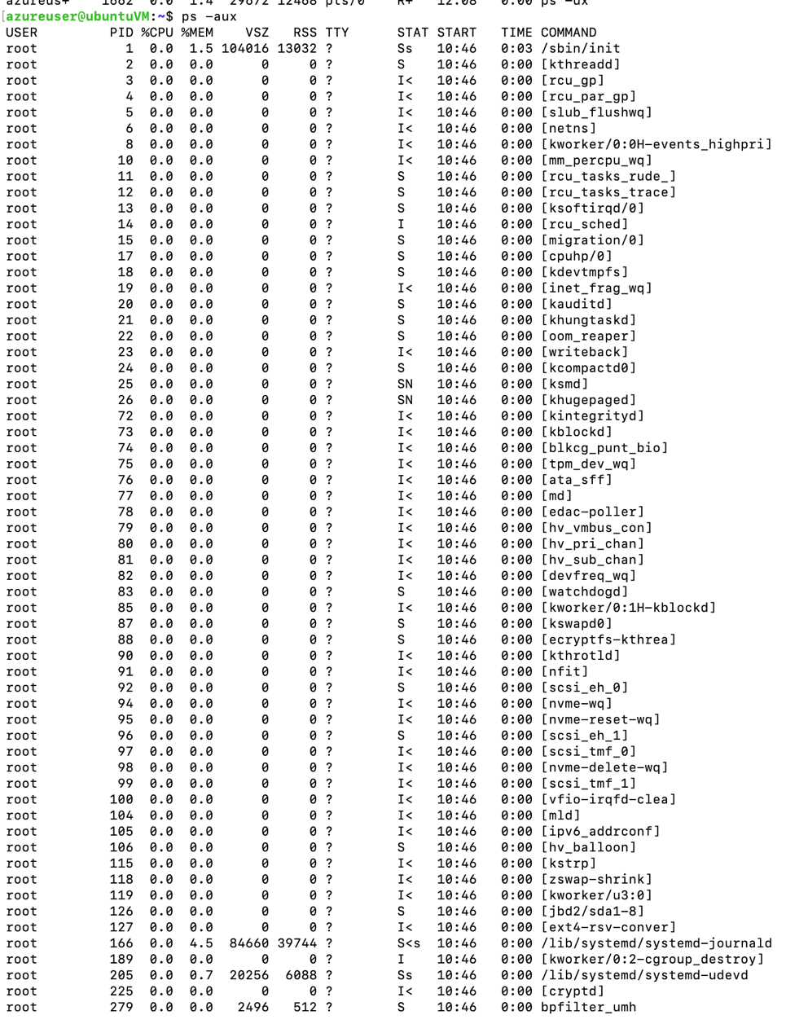

**In my vm all process show 0% utilize the cpu**

# **Assignment 2: Deploy Streamflix Application on Killerkoda Ubuntu Playground**

