INFINITY INTERNS
A unit of Infinitya1 Career Counselling Private Limited

SUMMER INTERNSHIP PROJECT REPORT
A STUDY ON
FINANCIAL MANAGEMENT PRACTICES, BUDGETARY CONTROL
AND FINANCIAL PERFORMANCE ANALYSIS
at
Infinitya1 Career Counselling Private Limited
B-Hub, Maurya Lok Complex, Dak Bungalow Road, Patna, Bihar 800001
Submitted in partial fulfilment of the requirements for the award of the degree of
MASTER OF BUSINESS ADMINISTRATION (M.B.A.)
Specialisation: Financial Management (FM)
Submitted by | Ganga Kumari Singh
Father's Name | Shri Krishna Prasad Singh
Roll Number | 24269010026
Registration Number | 1053595/20
Programme | M.B.A. | Semester IV | Session 2024 - 2026

MAGADH UNIVERSITY, BODH GAYA
Department of Business Administration
Internship Period: 6th June 2026 to 21st July 2026

CERTIFICATE OF COMPLETION
Issued by the Training Organisation


This is to certify that Ms. Ganga Kumari Singh, daughter of Shri Krishna Prasad Singh, a bona fide student of the Master of Business Administration (M.B.A.) programme of Magadh University, Bodh Gaya, bearing University Roll Number 24269010026 and Registration Number 1053595/20, has successfully completed a Summer Internship in the Finance and Accounts function of Infinity Interns, a unit of Infinitya1 Career Counselling Private Limited, from 6th June 2026 to 21st July 2026, a period of Six Weeks and Five Days (46 Days).
During the tenure of the internship she was assigned to the areas of financial record keeping, working capital and receivables monitoring, budgetary control and the preparation of management information reports. She studied the organisation's financial statements for three financial years and prepared a project report titled “A Study on Financial Management Practices, Budgetary Control and Financial Performance Analysis”.
Her conduct during the internship was found to be satisfactory and professional. She displayed sincerity, punctuality, analytical ability and a willingness to learn. The work submitted by her is, to the best of our knowledge, her own original effort.
We wish her every success in her future academic and professional endeavours.

Training & Placement Mentor  Infinity Interns, Patna | Authorised Signatory  Infinitya1 Career Counselling Private Limited

Registered Office: B-Hub, Maurya Lok Complex, Dak Bungalow Road, Patna, Bihar 800001

CERTIFICATE OF THE GUIDE
Department of Business Administration

This is to certify that the Summer Internship Project Report entitled “A Study on Financial Management Practices, Budgetary Control and Financial Performance Analysis”, carried out at Infinity Interns (Infinitya1 Career Counselling Private Limited), B-Hub, Maurya Lok Complex, Patna, Bihar, is a record of original work done by Ms. Ganga Kumari Singh under my supervision and guidance.
The report is submitted in partial fulfilment of the requirements for the award of the degree of Master of Business Administration (M.B.A.) with specialisation in Financial Management of Magadh University, Bodh Gaya for the academic session 2024 - 2026.
To the best of my knowledge and belief, the work embodied in this report has not been submitted, either in part or in full, to any other university or institution for the award of any degree or diploma. The candidate has completed the prescribed period of training and has fulfilled the requirements of the internship component of the curriculum.

Candidate
Ms. Ganga Kumari Singh
Roll Number
24269010026
Registration Number
1053595/20
Programme
Master of Business Administration (M.B.A.) – Semester IV
Specialisation
Financial Management (FM)
Session
2024 - 2026

Project Guide  Department of Business Administration | Head of the Department  Magadh University, Bodh Gaya

DECLARATION
By the Candidate

I, Ganga Kumari Singh, daughter of Shri Krishna Prasad Singh, a student of Master of Business Administration (M.B.A.) (Semester IV) with specialisation in Financial Management at Magadh University, Bodh Gaya, do hereby solemnly declare that the Summer Internship Project Report entitled “A Study on Financial Management Practices, Budgetary Control and Financial Performance Analysis” is the outcome of my own independent study and investigation carried out at Infinity Interns, B-Hub, Maurya Lok Complex, Patna, Bihar, during the period from 6th June 2026 to 21st July 2026.
I further declare that:
1. The work presented in this report is original and has been carried out by me under the guidance of my faculty supervisor and the mentor assigned by the organisation.
2. The financial and operational information reproduced in this report has been used purely for academic analysis, with the permission of the organisation, and no confidential data has been disclosed in a manner prejudicial to its interests.
3. The figures presented are indicative management figures made available for the limited purpose of this academic study and do not represent audited statutory accounts.
4. Wherever the work of other authors has been referred to, due acknowledgement has been made in the body of the report and in the bibliography.
5. This report has not been submitted, in whole or in part, to any other university or institution for the award of any degree, diploma or certificate.

Academic Integrity
I understand that any misrepresentation, plagiarism or fabrication of data would render this report liable to rejection and would attract such action as the University may deem appropriate.

Signature of the Candidate | Ganga Kumari Singh

Place: Patna Date: 21st July 2026

ACKNOWLEDGEMENT
Gratitude and Appreciation

The completion of this internship and the preparation of this report would not have been possible without the guidance, encouragement and generosity of a number of people, and it is a privilege to record my gratitude to them.
At the outset, I express my sincere thanks to the Department of Business Administration, Magadh University, Bodh Gaya, for incorporating a structured summer internship into the curriculum. The opportunity to test classroom theory against the practical realities of an enterprise has been the single most valuable part of my postgraduate study.
I am deeply indebted to my faculty guide for patiently reviewing my drafts, for insisting on analytical rigour rather than description, and for repeatedly directing my attention from what the numbers were to what the numbers meant.
I owe a special debt to Infinity Interns, a unit of Infinitya1 Career Counselling Private Limited, for accepting me as an intern and for the openness with which the finance function was explained to me. I thank the management and the Authorised Signatory for permitting access to the organisation's records, and my company mentor for the weekly review meetings that shaped the direction of this study. The team at the B-Hub facility in Maurya Lok made an outsider feel like a colleague from the first day.
I am grateful to the colleagues in the accounts, admissions and programme delivery teams who spared time from demanding schedules to answer my questions on vouchers, collections, mentor payouts and cohort costing. Whatever practical understanding this report reflects has been built on their explanations.
Finally, and most importantly, I thank my father, Shri Krishna Prasad Singh, and my family, for the sacrifices they have made for my education and for their unwavering confidence in me. Any merit in this work belongs in large measure to them; the shortcomings are entirely my own.

Ganga Kumari Singh | Roll No. 24269010026

PREFACE
Scope and Purpose of this Report

Management education is, in the end, a preparation for judgement under uncertainty. A textbook can supply the ratio; only an enterprise can supply the context in which that ratio either matters or does not. The summer internship is the bridge between the two, and this report is an account of crossing it.
The internship was undertaken at Infinity Interns, the internship and career-services unit of Infinitya1 Career Counselling Private Limited, at the B-Hub incubation facility in Maurya Lok Complex, Patna, over six weeks and five days from 6th June 2026 to 21st July 2026. The organisation was a particularly instructive choice for a student of Financial Management: it is young enough that the financial consequences of every managerial decision are still visible on the face of the accounts, and organised enough that those accounts are properly maintained.
The report is arranged in ten chapters. The first two establish the setting — the objectives and methodology of the study, and the profile of the organisation. The third records the work actually performed, week by week. Chapters four, five and six form the analytical core: an examination of the company's financial management practices, of its budgeting and cost control system, and a three-year ratio and financial statement analysis. The remaining chapters set out what was learnt, the difficulties encountered, the findings and suggestions that emerged, and the conclusions drawn. A bibliography and a set of annexures follow.
Two limitations should be stated at the outset and are repeated in Chapter One. First, the figures used are indicative management figures released for academic purposes and are not audited statutory accounts; the analysis should therefore be read as an exercise in method rather than as an audit opinion. Second, the period of observation was a single summer, and a single summer in a seasonal business can mislead the unwary. Both constraints have been borne in mind in drawing conclusions.
If the report succeeds, it will be less because it computes ratios correctly than because it explains why an organisation with a negative cash conversion cycle, a comfortable interest cover and a falling debt-equity ratio should nevertheless worry about its receivables and its third quarter.

Ganga Kumari Singh | M.B.A. – Financial Management

TABLE OF CONTENTS

Page numbers are inserted by Word: open the document, select the contents above, then press F9 (or right-click and choose Update Field) to populate them.

LIST OF TABLES

Table 1.1 Sources of data used in the study –
Table 1.2 Organisation of the report –
Table 2.1 Organisational particulars –
Table 2.2 Service lines and their financial characteristics –
Table 2.3 Functions and their financial responsibilities –
Table 2.4 Three-year growth record –
Table 2.5 SWOT appraisal with financial implications –
Table 3.1 Particulars of the internship –
Table 3.2 Week-wise work programme –
Table 3.3 Mapping of tasks to skills and to report chapters –
Table 4.1 Statement of Profit and Loss for three years (₹ in lakh) –
Table 4.2 Quarterly revenue and share of the year, FY 2025-26 –
Table 4.3 Common-size Statement of Profit and Loss (percentage of revenue from operations) –
Table 4.4 Profitability summary (₹ in lakh and per cent) –
Table 4.5 Composition of working capital (₹ in lakh) –
Table 4.6 Receivables and the collection period –
Table 4.7 Ageing of trade receivables as at the close of FY 2025-26 –
Table 4.8 Cash Flow Statement for FY 2025-26 (₹ in lakh) –
Table 4.9 Balance Sheet as at the close of each year (₹ in lakh) –
Table 5.1 Budgets prepared and their status –
Table 5.2 Budget against actual for FY 2025-26 (₹ in lakh) –
Table 5.3 Classification of costs by behaviour –
Table 5.4 Segregation of costs into variable and fixed for FY 2025-26 (₹ in lakh) –
Table 5.5 Cost-volume-profit computation for FY 2025-26 –
Table 5.6 Cost control measures and their observed effect –
Table 5.7 Leverage computation for FY 2025-26 –
Table 5.8 Appraisal of the budgetary control system –
Table 6.1 Liquidity ratios –
Table 6.2 Profitability ratios (per cent) –
Table 6.3 Solvency and capital structure ratios –
Table 6.4 Activity ratios –
Table 6.5 Working capital cycle –
Table 6.6 Common-size Balance Sheet (percentage of balance sheet total) –
Table 6.7 DuPont decomposition of return on equity –
Table 6.8 Consolidated assessment of financial position –
Table 7.1 Objectives and their achievement –
Table 7.2 Classroom concept against observed practice –
Table 8.1 Challenges, responses and lessons –
Table 9.1 Prioritised recommendations –
Table A1.1 Statement of Profit and Loss for three years (₹ in lakh) –
Table A2.1 Balance Sheet as at the close of each year (₹ in lakh) –
Table A3.1 All ratios computed in this report –
Table A4.1 Cash Flow Statement for FY 2025-26 (₹ in lakh) –
Table A5.1 Fixed and variable cost segregation for FY 2025-26 (₹ in lakh) –
Table A7.1 Weekly record of work, deliverables and review –
Table A8.1 Summary of attendance –

LIST OF FIGURES
Figure 2.1 Composition of revenue by service line, FY 2025-26 –
Figure 2.2 Revenue from operations and net profit margin over three years –
Figure 4.1 Total income against total expenditure and profit before tax –
Figure 4.2 Quarterly pattern of revenue, FY 2025-26 –
Figure 4.3 Structure of total expenditure, FY 2025-26 –
Figure 4.4 Behaviour of major expense heads over three years –
Figure 4.5 Profitability margins over three years –
Figure 4.6 Debtor days, creditor days and the cash conversion cycle –
Figure 4.7 Cash flow bridge from opening to closing cash, FY 2025-26 –
Figure 4.8 Pattern of long-term funding over three years –
Figure 5.1 Budget against actual: percentage variance by head, FY 2025-26 –
Figure 5.2 Budgeted and actual amounts by head, FY 2025-26 –
Figure 5.3 Segregation of costs into variable and fixed, FY 2025-26 –
Figure 5.4 Cost-volume-profit chart showing break-even sales and the margin of safety –
Figure 6.1 Financial scorecard at a glance, FY 2025-26 –
Figure 6.2 Liquidity ratios over three years –
Figure 6.3 Return on equity, capital employed and total assets –
Figure 6.4 Debt-equity ratio and interest coverage –
Figure 6.5 Activity ratios: asset utilisation –
Figure 6.6 DuPont decomposition of return on equity –

EXECUTIVE SUMMARY

This report records a six-week internship in the finance function of Infinity Interns and presents a three-year analysis of the organisation's financial management, budgetary control and financial performance.
The Organisation
Infinity Interns is the internship and career-services brand of Infinitya1 Career Counselling Private Limited, a private limited company operating from the B-Hub incubation centre at Maurya Lok Complex, Patna. It earns revenue from five service lines: paid internship programmes, career counselling and mentoring, business-to-business tie-ups with colleges and corporates, certification and assessment, and short workshops. Paid internship programmes contributed 52.56 per cent of turnover in FY 2025-26.
Headline Findings
₹ 214.60 L  Revenue from operations  FY 2025-26, up 44.3 per cent | 8.63%  Net profit margin  against 3.27% in FY 2023-24 | 53.23%  Return on capital employed  against 21.77% in FY 2023-24 | 0.26  Debt-equity ratio  down from 0.86 in FY 2023-24

1. Growth has been rapid and profitable. Revenue from operations rose from ₹ 96.40 lakh in FY 2023-24 to ₹ 214.60 lakh in FY 2025-26, a compound annual growth rate of approximately 49 per cent. Profit after tax rose almost six-fold, from ₹ 3.15 lakh to ₹ 18.53 lakh, so the growth has been accompanied by, and not purchased at the expense of, profitability.
2. Margins have widened at every level. The gross contribution margin improved from 60.37 per cent to 63.05 per cent, the operating margin from 5.50 per cent to 12.26 per cent and the net margin from 3.27 per cent to 8.63 per cent. The widening is largely the effect of a broadly fixed overhead base being spread over a much larger revenue.
3. Liquidity is adequate but not comfortable. The current ratio stood at 1.88:1 and the quick ratio at 1.72:1 at the close of FY 2025-26. Both are below the conventional 2:1 and 1:1 benchmarks read together, although the absence of inventory makes the conventional benchmark a generous test in this business.
4. Solvency has strengthened markedly. The debt-equity ratio fell from 0.86 to 0.26 and interest coverage rose from 4.82 times to 16.44 times. Retained earnings, not fresh borrowing, have financed the expansion.
5. The working capital cycle is structurally favourable. Debtors were collected in about 34.0 days while trade creditors were settled in about 62.4 days, producing a negative cash conversion cycle of about 28.4 days. Operations are therefore partly financed by trade credit.
6. Budgetary control is operative but incomplete. Revenue exceeded budget by 4.68 per cent, yet marketing and digital promotion overshot its provision by 10.33 per cent and direct programme cost by 4.34 per cent. Variance analysis is performed annually rather than monthly, which delays corrective action.
7. Cash generation is genuine. Net cash from operating activities of ₹ 18.61 lakh financed the entire capital programme of ₹ 8.50 lakh and still left an increase of ₹ 10.41 lakh in cash balances, which is the strongest single indicator in the accounts.
Principal Suggestions
- Introduce a monthly, not annual, budget-versus-actual review, with a formal explanation required for any head deviating by more than five per cent.
- Tighten credit control over institutional receivables through a documented credit policy, milestone-linked invoicing and a monthly ageing review.
- Measure marketing spend against cost per enrolled intern by channel, so that the overspend becomes a decision about efficiency rather than an accident of budgeting.
- Build a formal cash budget for the lean third quarter and consider arranging a modest working capital limit before it is needed rather than after.
- Adopt cohort-wise contribution reporting so that pricing and mentor-payout decisions can be taken on the basis of contribution rather than gross revenue.
The overall conclusion of the study is that Infinity Interns is a financially sound and rapidly improving enterprise whose principal financial risks lie not in profitability or solvency but in the management of receivables, the seasonality of its cash flows and the discipline of its cost control. Each of these is capable of being addressed by systems rather than by capital.

CHAPTER  1 | INTRODUCTION

The purpose, scope, objectives and method of the study, and the limitations within which its conclusions should be read.
An internship is not merely an exposure visit. It is a controlled experiment in which a student discovers which parts of what has been taught actually survive contact with an operating enterprise.
1.1 Background of the Study
Financial management is concerned with three decisions that every enterprise must take repeatedly: how much to invest and in what, how to raise the money for that investment, and how much of the resulting surplus to retain. In the large, established company these decisions are taken at intervals by committees and are insulated from daily operations. In a young, growing enterprise they are taken almost continuously, often by the same two or three people, and their consequences appear on the face of the accounts within a quarter. For a student of Financial Management, the second setting is by far the more instructive.
The Indian education and career-services sector has expanded rapidly over the last decade, driven by a large cohort of graduates entering a labour market that increasingly values demonstrated practical exposure over certification alone. A category of organisation has emerged to serve that need: the structured internship provider, which mediates between students seeking experience, colleges seeking placement outcomes and employers seeking pre-screened talent. Infinity Interns, the internship and career-services unit of Infinitya1 Career Counselling Private Limited, is an enterprise of exactly this description, operating from the B-Hub incubation facility at Maurya Lok Complex in Patna.
Such an organisation presents a distinctive financial structure. It holds no inventory. Its principal cost is the cost of delivering a programme — mentor honoraria, content, assessment and certification — which varies directly with the number of enrolments. Its overheads, by contrast, are largely committed: salaries, platform subscriptions, incubation charges and brand marketing do not fall if a cohort is small. Revenue is strongly seasonal, concentrated in the summer and winter internship windows. Collections from individual students are immediate, while collections from institutional clients are not. Each of these features has a direct bearing on liquidity, on the behaviour of costs and on the design of a budgetary control system, and each is examined in the chapters that follow.
1.2 Rationale for Selecting the Organisation
Three considerations governed the choice of the host organisation:
1. Visibility of the finance function. In a small company the entire finance cycle — from the raising of an invoice to the reconciliation of a bank statement and the preparation of a management report — can be observed by one person within a few weeks. In a large company an intern would see one narrow slice of it.
2. Relevance to the specialisation. The organisation had live questions of exactly the kind the Financial Management syllabus addresses: whether marketing spend was earning its keep, why cash was tight in a profitable quarter, and how much of the cost base would fall if enrolments fell.
3. Access and consent. The management was willing to explain its records and to permit the use of indicative figures for academic analysis. Without that consent, a study of this kind degenerates into description of publicly available material.
1.3 Statement of the Problem
A rapidly growing enterprise can fail for reasons that have nothing to do with the attractiveness of its market. It can grow faster than its working capital permits; it can allow the cost of acquiring a customer to rise faster than the contribution that customer generates; it can mistake a favourable revenue variance for good performance while adverse cost variances quietly consume the gain. The problem this study addresses is therefore not whether Infinity Interns is growing, which is evident, but whether the financial management practices supporting that growth are adequate to sustain it.
The Question the Study Sets Out to Answer
Are the financial management, budgetary control and cost control practices of Infinity Interns adequate to the scale and the seasonality of the business it now operates, and if not, what specific, implementable changes would make them so?

1.4 Objectives of the Study
The study was framed around one primary objective and seven secondary objectives.
Primary Objective
- To study and evaluate the financial management practices of Infinity Interns, with particular reference to budgeting, cost control and financial performance, and to draw implementable conclusions from that evaluation.
Secondary Objectives
1. To understand the organisational structure of the finance function and the flow of financial information within it.
2. To examine the system of books of account, vouchers and internal checks maintained by the organisation.
3. To analyse the composition and behaviour of revenue and cost over the three financial years from FY 2023-24 to FY 2025-26.
4. To evaluate the budgeting process and to quantify and interpret the variance between budgeted and actual performance for FY 2025-26.
5. To compute and interpret the liquidity, profitability, solvency and activity ratios of the organisation and to identify the trends they reveal.
6. To segregate costs into their fixed and variable components and to derive the contribution, profit-volume ratio, break-even sales and margin of safety.
7. To identify the principal weaknesses in the existing system and to frame specific suggestions for improvement.
1.5 Scope of the Study
The scope of the study is defined along four dimensions.
Functional scope
The study is confined to the finance and accounts function. Marketing, human resource and technology matters are considered only to the extent that they have a direct financial consequence.
Organisational scope
The study covers Infinity Interns as a unit of Infinitya1 Career Counselling Private Limited, operating from the single location at Maurya Lok Complex, Patna.
Period of analysis
The financial analysis covers the three financial years FY 2023-24, FY 2024-25 and FY 2025-26. Three years is the minimum period over which a trend can be distinguished from an aberration.
Period of observation
The internship itself ran from 6th June 2026 to 21st July 2026, a period of 46 Days.
1.6 Research Methodology
The study is analytical and descriptive in design. It does not test a hypothesis statistically; it reconstructs the financial position of an enterprise from its records and interprets that reconstruction against established benchmarks and against its own history.
1.6.1 Sources of Data
Table 1.1 Sources of data used in the study
Type | Source | Use made of the source
Primary | Discussions with the company mentor and the accounts team | Understanding of process, approval limits and the reasons behind variances
Primary | Direct observation of voucher entry, reconciliation and reporting | Assessment of internal check and of the practical control environment
Primary | Structured questionnaire and unstructured interviews | Collection of qualitative views on budgeting discipline and collection practice
Secondary | Indicative Statement of Profit and Loss and Balance Sheet, FY 2023-24 to FY 2025-26 | Ratio analysis, trend analysis and cash flow construction
Secondary | Internal budget statements and cohort cost sheets for FY 2025-26 | Budget-versus-actual variance analysis and cost behaviour study
Secondary | Trade receivable ageing statements and collection registers | Computation of debtor days and assessment of credit control
Secondary | Textbooks, journals and regulatory publications | Framework, benchmarks and definitions used in interpretation
Note: Primary data was collected during the internship period; secondary data was made available by the organisation for academic use.
1.6.2 Tools of Analysis
The following analytical tools were applied. Each is explained at the point of first use in the chapters that follow, so that the report can be read without recourse to a separate text.
- Comparative and trend analysis of the Statement of Profit and Loss and the Balance Sheet over three years, expressed in both absolute and percentage terms.
- Common-size statement analysis, in which every line is expressed as a percentage of revenue or of the balance sheet total, so that a change in structure can be separated from a change in scale.
- Ratio analysis under four heads — liquidity, profitability, solvency and activity — computed for all three years.
- DuPont decomposition of return on equity into net profit margin, total asset turnover and the equity multiplier, to establish which of the three is driving the return.
- Budgetary control and variance analysis, with variances signed so that a favourable outcome is always positive.
- Cost-volume-profit analysis, including the segregation of semi-variable costs, the profit-volume ratio, break-even sales, margin of safety and operating and financial leverage.
- Cash flow analysis under the indirect method, prepared from the two statements and reconciled to the movement in cash balances.
- Graphical presentation through twenty exhibits, since a trend is very often seen before it is calculated.
1.6.3 Method of Analysis
Figures were first tabulated in a single worksheet so that every derived number could be traced to a source line. Ratios were then computed on a consistent basis and, where a ratio can be computed on either closing or average balances, the basis adopted has been stated alongside the table. Interpretation proceeded in three steps: comparison with the organisation's own prior years, comparison with a conventional benchmark, and an attempt to explain the movement by reference to an operating cause rather than an accounting one.
1.7 Significance of the Study
- To the organisation, the study offers an independent reading of its own numbers, a quantified variance analysis it did not previously prepare monthly, and a short list of improvements that require system discipline rather than capital.
- To the student, it provides the experience of building an analysis from primary records rather than from a prepared case, including the discovery that records are rarely as tidy as textbook illustrations.
- To the institution, it documents the kind of financial work a small enterprise in Bihar's emerging services sector actually requires, which may inform the design of future internships.
- To future researchers, it offers a template for analysing an asset-light, seasonal services business in which the conventional liquidity benchmarks require careful qualification.
1.8 Limitations of the Study
The following limitations are material and should be kept in view when reading the findings of Chapter Nine.
1. The figures are indicative, not audited. The financial data was made available as management information for the limited purpose of academic analysis. It has not been subjected to statutory audit, and the analysis therefore constitutes an exercise in method rather than an opinion on the accounts.
2. The period of observation was short. 46 Days spanning a single peak season cannot capture the full annual cycle of a seasonal business. The seasonality described in Chapter Four is inferred from recorded quarterly figures rather than observed.
3. Comparison with industry averages was not possible. Reliable published financial benchmarks for unlisted, small-scale structured internship providers are not available in India. Interpretation has therefore been made against conventional rules of thumb and against the organisation's own history, and the rules of thumb are not industry averages.
4. Certain cost allocations required judgement. The segregation of semi-variable costs in Chapter Five — particularly the split of marketing and of administrative expenses — rests on discussion with management and on the observed behaviour of those heads, not on a statistical regression. A different analyst might allocate slightly differently and would obtain a slightly different break-even point.
5. Confidentiality constrained disclosure. Client-wise and cohort-wise data has been aggregated. Individual contract terms, mentor rates and client names are not disclosed.
6. Ratios computed on closing balances have a known bias. Return on equity and return on capital employed have been computed on closing figures. In a rapidly growing business this understates the return, because the closing capital base is larger than the base that actually earned the year's profit. The direction of the bias is stated wherever it is material.
1.9 Chapter Scheme
Table 1.2 Organisation of the report
Chapter | Title | Content
One | Introduction | Background, rationale, problem, objectives, scope, methodology, significance and limitations
Two | Company Profile | Constitution, history, service lines, organisation structure, finance function, competitive position and SWOT appraisal
Three | Internship Tasks | Week-by-week record of work performed, deliverables produced and skills applied
Four | Financial Management Analysis | Revenue and cost structure, profitability, working capital, cash flow and the pattern of financing
Five | Budgeting and Cost Control | The budget cycle, budget-versus-actual variance analysis, cost behaviour, break-even analysis and leverage
Six | Ratio and Financial Analysis | Liquidity, profitability, solvency and activity ratios, common-size statements and DuPont decomposition
Seven | Learning Outcomes | Technical, analytical, behavioural and professional learning, mapped to the objectives of Chapter One
Eight | Challenges Faced | Difficulties encountered, how each was addressed and what it taught
Nine | Findings and Suggestions | Consolidated findings and specific, prioritised recommendations
Ten | Conclusion | Overall appraisal and concluding observations
— | Bibliography and Annexures | Sources consulted and supporting statements, questionnaire and certificates

CHAPTER  2 | COMPANY PROFILE

The constitution, service lines, organisation and competitive position of Infinity Interns, and the structure of its finance function.

2.1 Identity and Constitution
Infinity Interns is the internship and career-services brand under which Infinitya1 Career Counselling Private Limited operates. The distinction between the brand and the legal entity matters for a financial report: contracts, statutory filings and the financial statements analysed in this study belong to the company, while the brand is the name under which programmes are marketed to students and institutions.
Table 2.1 Organisational particulars
Particulars | Details
Brand name | Infinity Interns
Registered name | Infinitya1 Career Counselling Private Limited
Constitution | Private Limited Company, incorporated under the Companies Act, 2013
Nature of business | Career counselling, structured internship programmes, skill certification and employability services
Registered office | B-Hub, Maurya Lok Complex, Dak Bungalow Road, Patna, Bihar 800001
Operating facility | B-Hub, the startup incubation centre promoted at Maurya Lok Complex, Dak Bungalow Road, Patna
Area of operation | Bihar, with online delivery to candidates across India
Principal clients | Students of graduate and postgraduate programmes; colleges and universities; small and medium employers
Service delivery mode | Blended — online mentoring and assessment with periodic in-person workshops
Functional departments | Programme Delivery; Admissions and Counselling; Corporate and Institutional Relations; Finance and Accounts; Technology and Content
Note: Compiled from organisational records and discussions with management during the internship.
2.2 The B-Hub Setting
The organisation operates from B-Hub, the startup incubation facility at Maurya Lok Complex in central Patna. The choice of an incubation centre rather than independent commercial premises has a direct and favourable effect on the financial structure of the business, and it is worth stating explicitly because it explains part of the cost advantage visible in Chapter Four.
- Occupancy cost is contained. Incubation charges are materially below the commercial rent for equivalent space in the same locality, which holds down the largest single component of committed overhead for a service business of this size.
- Shared infrastructure avoids capital expenditure. Conference facilities, reception and internet backbone are shared, so the organisation has not had to capitalise assets it would use intermittently. This is visible in the modest property, plant and equipment balance of ₹ 13.20 lakh.
- Central location supports the counselling business. Maurya Lok is served by public transport and is within reach of several colleges, which matters for a service that still depends partly on walk-in counselling and in-person workshops.
- Proximity to the startup ecosystem generates referrals. Co-located ventures are themselves potential employers of interns, which has supported the business-to-business service line at negligible acquisition cost.
2.3 Vision, Mission and Values
“To make structured, verifiable work experience accessible to every student in Bihar and beyond, so that a candidate is judged on what they can demonstrably do rather than only on what their certificate states.”
— Vision, as articulated by the management
Mission
- To design internship programmes with defined deliverables, mentor review and an assessed outcome, rather than unsupervised attendance.
- To provide career counselling grounded in the candidate's aptitude and the realities of the regional labour market.
- To build durable relationships with colleges so that employability support becomes part of the curriculum rather than an event.
- To keep programmes affordable by controlling the cost of delivery rather than by diluting its content.
Core Values
Verifiability
An outcome that cannot be evidenced is not claimed. Certificates are issued against assessed deliverables.
Accessibility
Pricing and delivery are designed for the regional student rather than the metropolitan one.
Mentorship
The relationship between mentor and intern is treated as the product, not as an overhead on it.
Fiscal prudence
Growth is financed as far as possible from internal accruals, a policy whose effect is evident in the falling debt-equity ratio examined in Chapter Six.
2.4 Service Lines and Revenue Model
The organisation earns revenue from five identifiable service lines. The financial significance of the distinction is that they differ sharply in contribution margin, in collection period and in seasonality — three characteristics that drive the analysis in Chapters Four and Five.
Table 2.2 Service lines and their financial characteristics
Service line | What is delivered | Revenue basis | Collection | FY26 ₹ L
Paid Internship Programmes | Structured cohorts of four to eight weeks with mentor review and assessed deliverables | Per-candidate programme fee | Advance | 112.80
Career Counselling & Mentoring | Aptitude assessment, one-to-one counselling and career-path mapping | Per-session or package fee | Advance | 38.60
College & Corporate B2B Tie-ups | Institution-wide employability programmes and campus engagement | Contract value per institution | Credit | 34.90
Certification & Assessment | Skill assessment and issue of verifiable certificates | Per-certificate fee | Advance | 18.40
Workshops, Webinars & Bootcamps | Short intensive sessions on employability skills | Per-participant fee | Advance | 9.90
Total |  |  |  | 214.60
Note: Figures are revenue from operations for FY 2025-26 in ₹ lakh. Only the business-to-business line is sold on credit, which is why it accounts for substantially all of the trade receivable balance.
Why the Revenue Mix Governs the Liquidity Analysis
Four of the five service lines are collected in advance, and one — the business-to-business line, at 34.90 lakh or 16.26 per cent of turnover — is sold on credit. The trade receivable balance of ₹ 23.10 lakh therefore arises almost entirely from a sixth of the revenue. Read against that sixth rather than against total turnover, the effective credit period is far longer than the 34.0 days that the conventional debtor-days calculation reports. This is the single most important qualification in the whole analysis, and it is developed in Section 6.6.

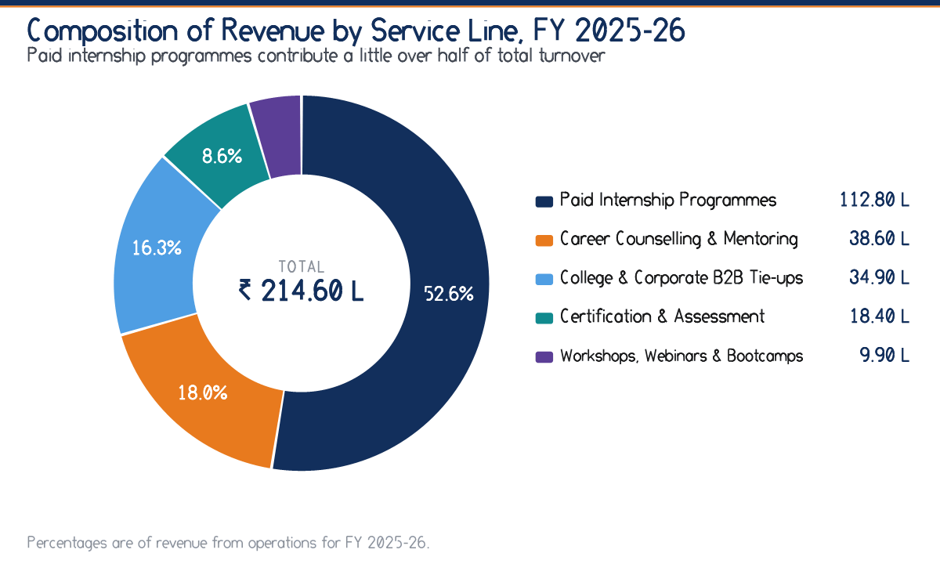
Figure 2.1 Composition of revenue by service line, FY 2025-26
Compiled from management accounts.
2.5 Organisation Structure
The organisation follows a flat functional structure. Five functions report to the management, and the finance function is deliberately positioned as a service to the other four rather than as a control tower over them — an arrangement that encourages cooperation but, as Chapter Five observes, also weakens the authority of the budget.
Table 2.3 Functions and their financial responsibilities
Function | Principal responsibility | Financial interface
Management | Strategy, pricing approval, capital and borrowing decisions | Approves the annual budget and authorises expenditure above delegated limits
Programme Delivery | Cohort design, mentor allocation, assessment and certification | Originates mentor honoraria and content cost, the principal variable cost
Admissions & Counselling | Enquiry handling, counselling and enrolment | Originates collections; operates the payment gateway interface
Corporate & Institutional Relations | College and employer tie-ups and contract negotiation | Originates credit sales and therefore the receivable balance
Finance & Accounts | Books of account, collections, payments, statutory compliance and reporting | Maintains records, prepares budgets and management information
Technology & Content | Platform, learning content and data security | Originates subscription and development cost, largely committed

2.6 The Finance and Accounts Function
The finance function is small, and the intern was attached to it. Its work divides into five recurring cycles, which together constitute the process that Chapter Three records and Chapters Four to Six analyse.
1. The collection cycle. Programme fees are received through the payment gateway, by bank transfer or, less often, in cash. Gateway settlements are reconciled against enrolment records, and the difference between gross collection and net settlement — the gateway commission — is recognised as a cost rather than netted against revenue.
2. The payment cycle. Mentor honoraria, content charges, platform subscriptions and incubation fees are processed against approved vouchers. Mentor payouts are the largest recurring payment and are released after the delivery of the assessed cohort.
3. The recording cycle. Vouchers are classified, posted and filed, and ledgers are scrutinised periodically. Bank reconciliation is performed monthly.
4. The compliance cycle. Goods and services tax, tax deducted at source and statutory returns are prepared with professional assistance. Compliance work is concentrated at month and quarter ends, which is when the function is most stretched.
5. The reporting cycle. A monthly revenue and collection statement is prepared for management. A full budget-versus-actual comparison is, at present, prepared annually — a gap identified as a finding in Chapter Nine.
2.7 Growth Record
The organisation has grown rapidly over the three years under review. Revenue from operations has risen from ₹ 96.40 lakh to ₹ 214.60 lakh and profit after tax from ₹ 3.15 lakh to ₹ 18.53 lakh. The pattern — revenue growth accompanied by a faster growth in profit — indicates operating leverage at work, and it is examined quantitatively in Section 5.7.
Table 2.4 Three-year growth record
Particulars | FY 2023-24 | FY 2024-25 | FY 2025-26 | Growth
Revenue from Operations (₹ L) | 96.40 | 148.75 | 214.60 | 44.3%
Total Income (₹ L) | 97.60 | 150.80 | 218.00 | 44.6%
EBITDA (₹ L) | 7.50 | 16.90 | 29.80 | 76.3%
Profit Before Tax (₹ L) | 4.20 | 12.70 | 24.70 | 94.5%
Profit After Tax (₹ L) | 3.15 | 9.53 | 18.53 | 94.4%
Net Worth (₹ L) | 14.85 | 24.38 | 42.91 | 76.0%
Balance Sheet Total (₹ L) | 40.00 | 55.40 | 80.51 | 45.3%
Note: Growth column shows the year-on-year increase in FY 2025-26 over FY 2024-25.
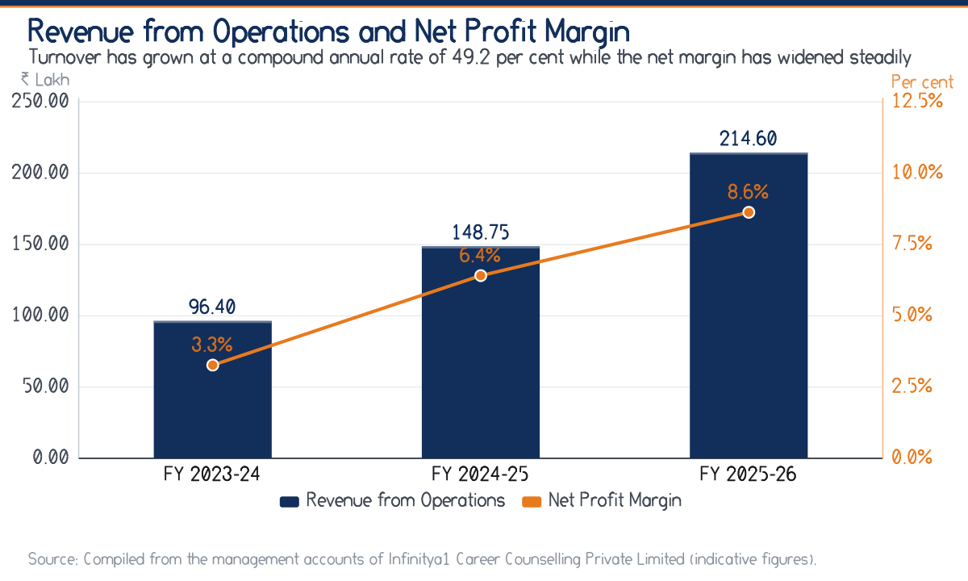
Figure 2.2 Revenue from operations and net profit margin over three years
Computed from the Statement of Profit and Loss.
2.8 Competitive Position
The organisation competes in a fragmented market with three kinds of rival: national online internship platforms with large marketing budgets and negligible local presence; local coaching and placement consultancies with local presence but no structured programme design; and college placement cells offering the service free of charge. Its defensible position lies in combining structured, assessed programme design with a local presence and a price point suited to the regional market.
SWOT Appraisal
Table 2.5 SWOT appraisal with financial implications
Dimension | Observation | Financial implication
Strengths
 | Asset-light model requiring no inventory and little fixed capital | High fixed asset turnover of 10.73 times and a low capital requirement for growth
 | Four of five service lines collected in advance | Negative cash conversion cycle of about 28.4 days
 | Growth financed from retained earnings | Debt-equity down to 0.26 and interest cover of 16.44 times
 | Low occupancy cost through incubation | Contained committed overhead and a lower break-even point
Weaknesses
 | Concentration of revenue in one service line | 52.56 per cent of turnover from paid internship programmes
 | Institutional receivables not governed by a written credit policy | Trade receivables of ₹ 23.10 lakh arising from a sixth of revenue
 | Budget review performed annually rather than monthly | Adverse variances identified after the year has closed
 | Marketing spend not measured per enrolment by channel | Marketing overspend of 10.33 per cent against budget
Opportunities
 | Expansion of institutional tie-ups across Bihar | Contracted, predictable revenue that reduces seasonality
 | Government and CSR-funded skilling programmes | Large-ticket revenue, though with longer credit periods
 | Reuse of content across cohorts | Falling variable cost per intern and a rising contribution margin
Threats
 | Price competition from national platforms | Pressure on the profit-volume ratio of 53.44 per cent
 | Dependence on a panel of external mentors | Rising honoraria would directly compress contribution
 | Seasonal concentration of enrolment | Third-quarter revenue of only ₹ 41.20 lakh against ₹ 62.30 lakh in the first quarter

CHAPTER  3 | INTERNSHIP TASKS

A week-by-week record of the work actually performed, the deliverables produced and the skills each task required.
The internship was organised as a progression rather than a rotation: each week's work depended on an understanding acquired in the week before, so that the analysis of Chapters Four to Six could rest on records the intern had personally handled.
3.1 Terms of the Internship
Table 3.1 Particulars of the internship
Particulars | Details
Organisation | Infinity Interns (Infinitya1 Career Counselling Private Limited)
Location | B-Hub, Maurya Lok Complex, Patna
Function assigned | Finance and Accounts
Designation | Summer Intern — Finance
Period | 6th June 2026 to 21st July 2026
Duration | Six Weeks and Five Days (46 Days)
Working pattern | Six days a week, Monday to Saturday
Reporting | Company mentor, with a weekly review meeting every Saturday
Mode | In-person at the B-Hub facility, with limited remote work on report compilation

3.2 Overview of the Work Programme
Table 3.2 Week-wise work programme
Week | Dates | Area of work
Week 1 | 08 Jun - 13 Jun 2026 | Induction, orientation and organisation study
Week 2 | 15 Jun - 20 Jun 2026 | Books of account and voucher verification
Week 3 | 22 Jun - 27 Jun 2026 | Working capital and receivables management
Week 4 | 29 Jun - 04 Jul 2026 | Budgeting and variance analysis
Week 5 | 06 Jul - 11 Jul 2026 | Ratio analysis and performance interpretation
Week 6 | 13 Jul - 18 Jul 2026 | Cost control study and CVP analysis
Week 7 | 20 Jul - 21 Jul 2026 | Report compilation and presentation

3.3 Week One — Induction and Organisation Study
The first week was devoted to understanding the organisation before attempting to analyse it. The company mentor explained the five service lines, the reporting structure and the statutory registrations, and the intern was taken through the sequence by which an enquiry becomes an enrolment, an enrolment becomes a collection, and a collection becomes an entry in the books.
Two observations from this week shaped the remainder of the study. The first was that the organisation's cost structure is dominated by a single variable head — the cost of delivering a programme — and that everything else is broadly committed. The second was that revenue arrives on two entirely different terms depending on whether the customer is a student or an institution. Both observations are pursued quantitatively in Chapter Four.
Deliverables
- A process note describing the enquiry-to-collection cycle, reproduced in substance in Section 2.6.
- An internal control checklist covering approval limits, segregation of duties and documentation requirements.
- A list of the accounting heads in use, with a note on the nature of each — the starting point for the cost behaviour study of Chapter Five.
3.4 Week Two — Books of Account and Voucher Verification
The second week was the most clerical and, in retrospect, the most valuable. The intern classified and verified vouchers, posted receipts and payments, and scrutinised ledgers for misclassification. The central task was the reconciliation of the payment-gateway settlement statement with recorded collections.
That reconciliation taught a lesson no textbook had conveyed. The gateway settles net of its commission and settles on a lag, so the gross fee recorded against an enrolment, the net amount credited to the bank and the date on which it is credited are three different things. Recognising revenue gross and the commission as an expense — rather than recognising the net receipt as revenue — is the correct treatment, and it matters: netting would understate both turnover and cost and would distort the profit-volume ratio computed in Chapter Five.
A Practical Discovery
Three unreconciled gateway items from the preceding quarter were identified during this exercise and were traced to a failed settlement that had been re-credited under a different reference. The point is not the amount, which was small, but the demonstration that reconciliation is a control and not a formality.

Deliverables
- A reconciliation statement between gateway settlements and recorded collections for the period under review.
- A schedule of unreconciled items with the reason for each.
- A note on the correct treatment of gateway commission, accepted by the accounts team.
3.5 Week Three — Working Capital and Receivables
The third week turned to working capital. The intern prepared an ageing analysis of trade receivables, maintained the follow-up register for institutional clients, computed debtor days and drew up a collection priority list.
The ageing analysis produced the study's most important single finding. Because only the business-to-business line is sold on credit, the entire receivable balance of ₹ 23.10 lakh arises from revenue of about ₹ 34.90 lakh. The conventional debtor-days computation, which divides the receivable by total revenue, therefore reports a comfortable 34.0 days and conceals a credit period on the credit-sold portion that is several times longer. This is developed in Section 6.6 and appears as Finding 4 in Chapter Nine.
Deliverables
- An ageing statement of trade receivables in the buckets reproduced as Table 4.7.
- A revised follow-up register with a defined escalation sequence.
- A computation of debtor days on both the conventional and the credit-sales basis, with a note explaining the difference.
- A collection priority list ranked by amount and age.
3.6 Week Four — Budgeting and Variance Analysis
The fourth week addressed budgeting. The intern built a cohort-wise cost sheet, compared budgeted against actual figures for each head, quantified the variances and attempted to separate the controllable from the uncontrollable.
The exercise established that the organisation prepares a competent annual budget but reviews it against actuals only at the year end. Marketing and digital promotion had exceeded its provision by 10.33 per cent and direct programme cost by 4.34 per cent, while the favourable revenue variance of 4.68 per cent had masked both. A monthly review would have surfaced the marketing overspend by the second quarter, when it could still have been corrected.
Deliverables
- A cohort-wise cost sheet showing contribution per intern.
- A budget-versus-actual variance statement, reproduced as Table 5.2.
- A draft format for a monthly variance report with a five per cent explanation threshold.
3.7 Week Five — Ratio Analysis and Interpretation
The fifth week was the analytical centre of the internship. Working from the three-year statements, the intern computed the liquidity, profitability, solvency and activity ratios set out in Chapter Six, prepared the trend charts and carried out the DuPont decomposition of return on equity.
The DuPont exercise was the most instructive. Return on equity had risen from 21.21 per cent to 43.18 per cent, and the natural assumption was that leverage had contributed. Decomposition showed the opposite: the equity multiplier had fallen from 2.69 to 1.88, so the entire improvement came from margin and asset turnover. The return had improved for the right reasons — a conclusion that could not have been reached from the headline ratio alone.
Deliverables
- A three-year ratio schedule under four heads, reproduced as Tables 6.1 to 6.5.
- Common-size Statement of Profit and Loss and Balance Sheet.
- A DuPont decomposition for each of the three years.
- A cash flow statement under the indirect method, reconciled to the movement in cash.
3.8 Week Six — Cost Control and CVP Analysis
The sixth week applied cost accounting technique. Each expense head was examined and segregated into its fixed and variable components, from which the contribution, profit-volume ratio, break-even sales, margin of safety and the two leverages were derived.
The segregation required judgement rather than arithmetic, and the marketing head illustrates why. Performance advertising scales directly with enrolment and is variable; brand-building and sponsorship do not and are committed. Discussion with management established a split of about fifty-five to forty-five, and the resulting break-even sales figure of ₹ 174.76 lakh is sensitive to that judgement. The sensitivity is stated openly in Section 5.6 and again among the limitations.
Deliverables
- A fixed-variable cost segregation statement, reproduced as Table 5.5.
- A cost-volume-profit analysis with break-even sales and margin of safety.
- A computation of operating, financial and combined leverage.
- A sensitivity note showing the effect on break-even sales of varying the marketing split by ten percentage points either way.
3.9 Week Seven — Compilation and Presentation
The final two days were spent consolidating the findings, drafting the suggestions of Chapter Nine and presenting the concluding summary to the company mentor. The mentor's principal criticism — that an early draft recommended improvements without stating who would own them or how often they would be performed — led to the reframing of every suggestion in Chapter Nine in terms of an owner, a frequency and a measurable trigger. It was the most useful correction received during the internship.
3.10 Skills Applied and Acquired
Table 3.3 Mapping of tasks to skills and to report chapters
Task | Skill applied | Feeds into
Voucher classification and ledger scrutiny | Accounting fundamentals, attention to documentation | Section 2.6 — the recording cycle
Gateway reconciliation | Reconciliation technique, revenue recognition judgement | Section 4.2 — revenue analysis
Receivable ageing and follow-up | Working capital management, credit control | Sections 4.5 and 6.6 — liquidity and activity
Cohort cost sheet | Cost accounting, marginal costing | Sections 5.4 and 5.5 — cost behaviour and CVP
Budget-versus-actual comparison | Budgetary control, variance analysis | Section 5.3 — variance analysis
Ratio computation and DuPont | Financial statement analysis, interpretation | Chapter Six — ratio analysis
Cash flow construction | Indirect method, reconciliation discipline | Section 4.6 — cash flow analysis
Report drafting and presentation | Business writing, structuring of an argument | Chapters Nine and Ten

CHAPTER  4 | FINANCIAL MANAGEMENT ANALYSIS

An examination of how the organisation earns, spends, funds and converts its money: revenue structure, cost structure, profitability, working capital, cash flow and the pattern of financing.
Financial management asks four questions of any enterprise: where does the money come from, where does it go, how much of it stays, and does it actually arrive as cash. This chapter answers them in that order.
4.1 The Statement of Profit and Loss
The three-year Statement of Profit and Loss is set out below. It is the foundation for the whole of the remaining analysis, and every figure used elsewhere in this report is derived from it or from the Balance Sheet in Section 4.7.
Table 4.1 Statement of Profit and Loss for three years (₹ in lakh)
Particulars | FY 2023-24 | FY 2024-25 | FY 2025-26
Revenue from Operations | 96.40 | 148.75 | 214.60
Other Income | 1.20 | 2.05 | 3.40
Total Income | 97.60 | 150.80 | 218.00
Direct Programme Cost | 38.20 | 56.90 | 79.30
Employee Benefit Expenses | 24.60 | 37.40 | 52.80
Marketing & Digital Promotion | 14.80 | 22.60 | 33.10
Administrative & Office Expenses | 7.90 | 10.20 | 13.60
Technology & Platform Expenses | 4.60 | 6.80 | 9.40
Finance Cost | 1.10 | 1.40 | 1.60
Depreciation & Amortisation | 2.20 | 2.80 | 3.50
Total Expenses | 93.40 | 138.10 | 193.30
Profit Before Tax | 4.20 | 12.70 | 24.70
Provision for Taxation | 1.05 | 3.17 | 6.17
Profit After Tax | 3.15 | 9.53 | 18.53
Note: Indicative management figures compiled for academic analysis. Provision for taxation is computed at 25 per cent of profit before tax.
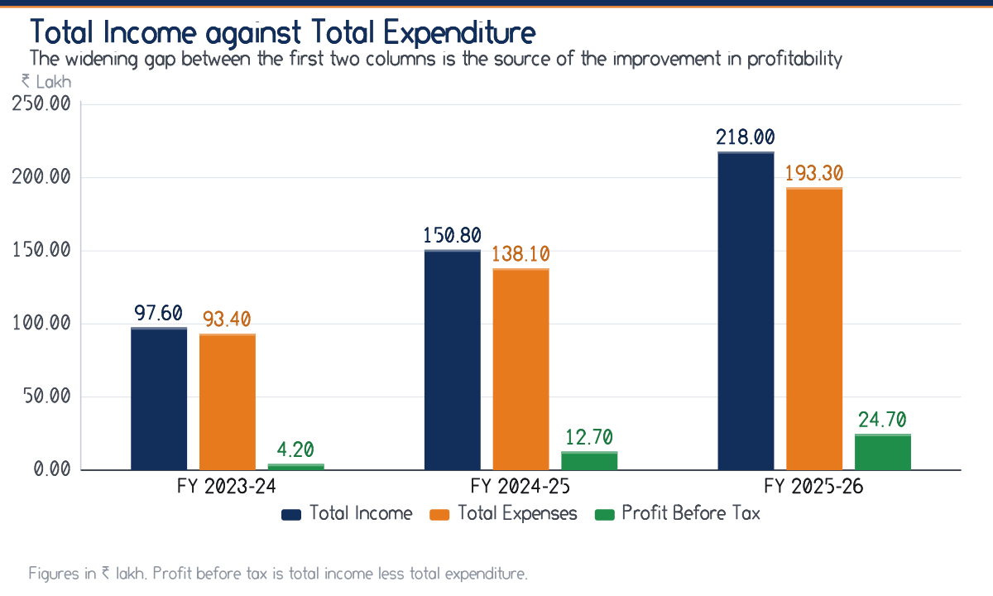
Figure 4.1 Total income against total expenditure and profit before tax
Computed from Table 4.1.
4.2 Analysis of Revenue
Revenue from operations grew from ₹ 96.40 lakh in FY 2023-24 to ₹ 148.75 lakh in FY 2024-25 and ₹ 214.60 lakh in FY 2025-26 — increases of 54.3 per cent and 44.3 per cent respectively. Growth has decelerated slightly in percentage terms, which is arithmetically inevitable on a rising base, but the absolute increment has widened from ₹ 52.35 lakh to ₹ 65.85 lakh.
4.2.1 Composition of Revenue
The five service lines contribute very unequally. Paid internship programmes at ₹ 112.80 lakh account for 52.56 per cent of turnover; the remaining four together account for the balance. The concentration is a strength in that it reflects a proven core product, and a weakness in that a regulatory or competitive shock to that single line would affect more than half of revenue.
4.2.2 Seasonality
Revenue is materially seasonal. The first quarter, which coincides with the opening of the summer internship cycle, contributed ₹ 62.30 lakh, while the third quarter contributed only ₹ 41.20 lakh — a difference of about 51 per cent between the peak and the trough. Since a substantial part of the cost base is committed and does not fall with revenue, the third quarter is the period of greatest financial strain. The absence of a formal cash budget for that quarter is noted as a finding in Chapter Nine.
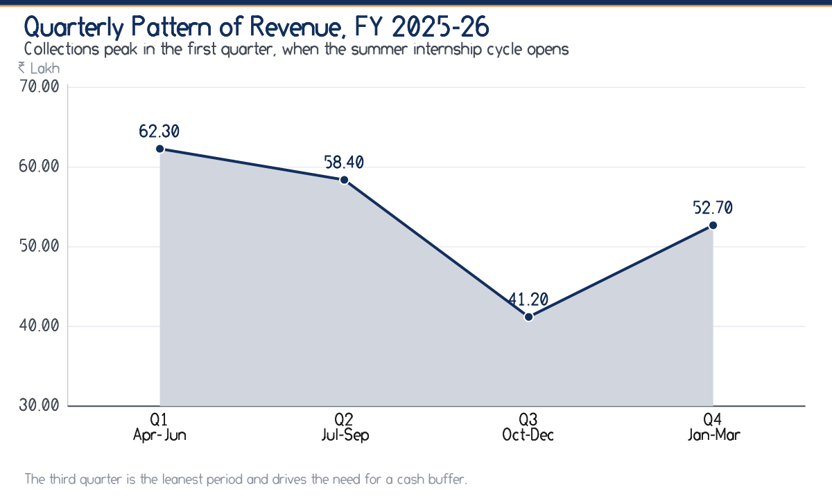
Figure 4.2 Quarterly pattern of revenue, FY 2025-26
Compiled from monthly collection statements.
Table 4.2 Quarterly revenue and share of the year, FY 2025-26
Quarter | Revenue (₹ L) | Share of year | Index (average = 100)
Q1 Apr-Jun | 62.30 | 29.03 | 116
Q2 Jul-Sep | 58.40 | 27.21 | 109
Q3 Oct-Dec | 41.20 | 19.20 | 77
Q4 Jan-Mar | 52.70 | 24.56 | 98
Total | 214.60 | 100.00 | 100

4.3 Analysis of Cost Structure
Total expenditure rose from ₹ 93.40 lakh to ₹ 193.30 lakh over the period, an increase of 107.0 per cent, against a revenue increase of 122.6 per cent. That costs grew more slowly than revenue is the arithmetic source of the entire improvement in margin, and the reason is that a largely committed overhead base was spread over a much larger turnover.
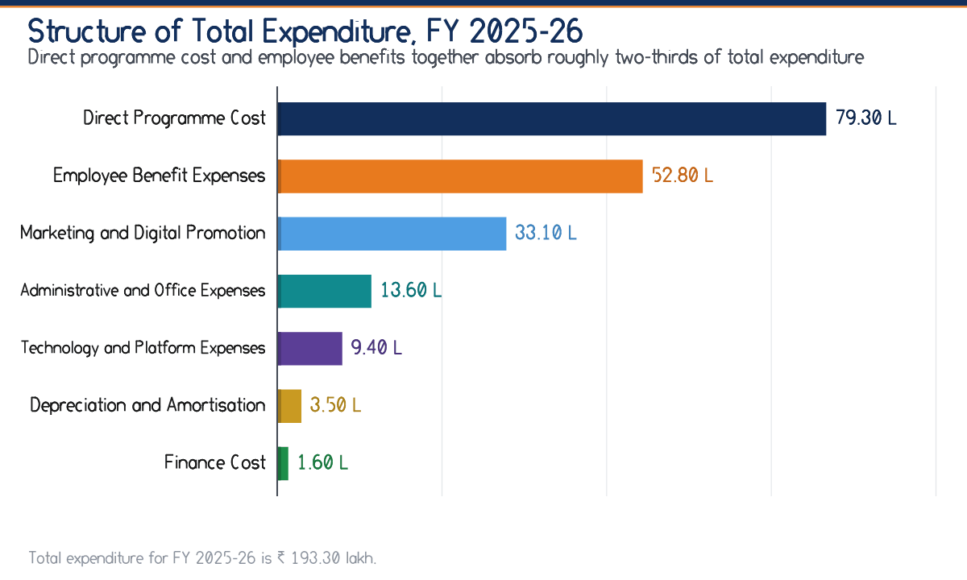
Figure 4.3 Structure of total expenditure, FY 2025-26
Computed from Table 4.1.
4.3.1 Common-size Analysis
Expressing each head as a percentage of revenue separates a change in structure from a change in scale. The table below does this for all three years, and it is the most revealing single exhibit in the chapter.
Table 4.3 Common-size Statement of Profit and Loss (percentage of revenue from operations)
Particulars | FY 2023-24 | FY 2024-25 | FY 2025-26
Revenue from Operations | 100.00 | 100.00 | 100.00
Direct Programme Cost | 39.63 | 38.25 | 36.95
Employee Benefit Expenses | 25.52 | 25.14 | 24.60
Marketing & Digital Promotion | 15.35 | 15.19 | 15.42
Administrative & Office Expenses | 8.20 | 6.86 | 6.34
Technology & Platform Expenses | 4.77 | 4.57 | 4.38
Finance Cost | 1.14 | 0.94 | 0.75
Depreciation & Amortisation | 2.28 | 1.88 | 1.63
Profit Before Tax | 4.36 | 8.54 | 11.51
Note: Read down each column to see structure; read across each row to see the direction of change.
Three movements in Table 4.3 deserve comment. Direct programme cost fell from 39.63 per cent of revenue to 36.95 per cent, which indicates that content and assessment material is being reused across cohorts and that the marginal cost of an additional intern is falling. Employee benefit expenses fell from 25.52 per cent to 24.60 per cent, the classic signature of operating leverage in a service business. Marketing, by contrast, has held almost constant at about 15.4 per cent of revenue, which means that revenue growth is still being bought rather than compounding from reputation and referral — the single most important qualification to an otherwise favourable cost story.
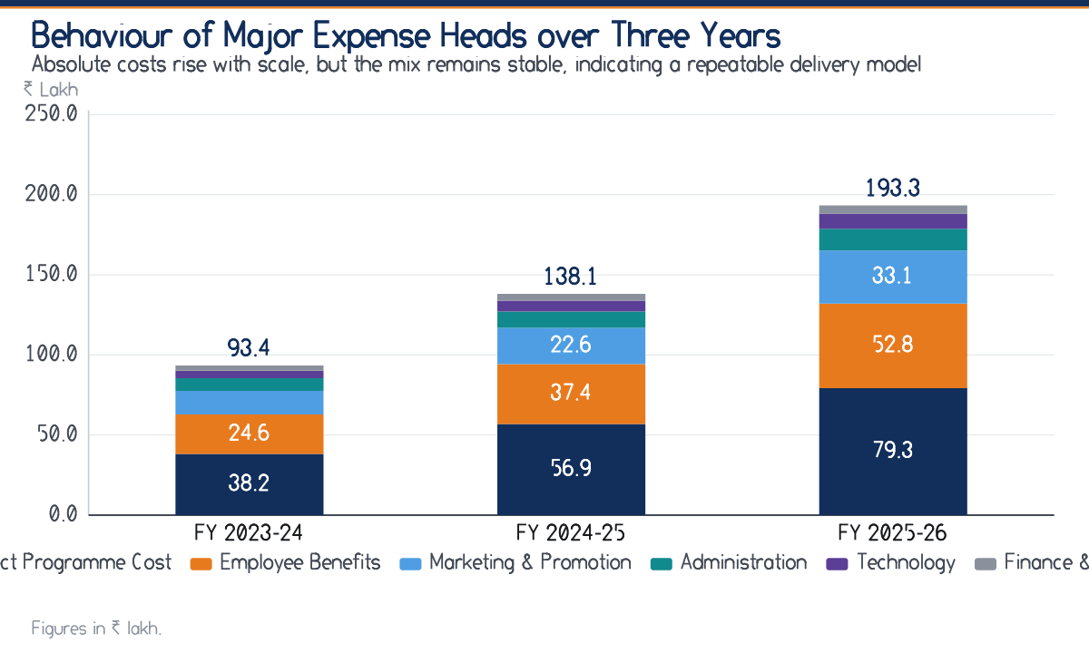
Figure 4.4 Behaviour of major expense heads over three years
Computed from Table 4.1.
4.4 Profitability
Profitability has improved at every level of the statement, and the improvement is progressive rather than the result of a single favourable year.
Table 4.4 Profitability summary (₹ in lakh and per cent)
Particulars | FY 2023-24 | FY 2024-25 | FY 2025-26
Gross Contribution | 58.20 | 91.85 | 135.30
Gross Contribution Margin (%) | 60.37 | 61.75 | 63.05
EBITDA | 7.50 | 16.90 | 29.80
EBITDA Margin (%) | 7.78 | 11.36 | 13.89
EBIT (Operating Profit) | 5.30 | 14.10 | 26.30
Operating Margin (%) | 5.50 | 9.48 | 12.26
Profit Before Tax | 4.20 | 12.70 | 24.70
Profit After Tax | 3.15 | 9.53 | 18.53
Net Profit Margin (%) | 3.27 | 6.41 | 8.63
Note: Gross contribution is revenue from operations less direct programme cost. EBIT is inclusive of other income.
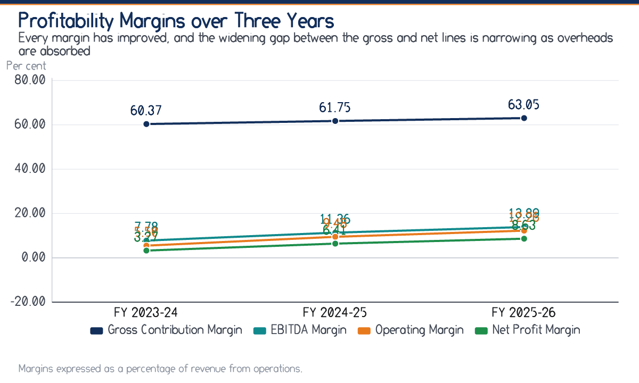
Figure 4.5 Profitability margins over three years
Computed from Table 4.4.
The gap between the gross contribution margin of 63.05 per cent and the net margin of 8.63 per cent represents the overhead burden of the business. That gap has narrowed from 57.10 percentage points in FY 2023-24 to 54.42 percentage points in FY 2025-26. A narrowing gap on a rising revenue is the clearest available evidence that the business model scales.
4.5 Working Capital Management
Working capital — current assets less current liabilities — rose from ₹ 11.35 lakh to ₹ 27.41 lakh. The composition of that working capital is unusual and favourable: there is no inventory at all, and cash constitutes the largest single current asset.
Table 4.5 Composition of working capital (₹ in lakh)
Particulars | FY 2023-24 | FY 2024-25 | FY 2025-26
Current Assets
Trade Receivables | 11.80 | 16.90 | 23.10
Cash & Bank Balances | 9.70 | 14.20 | 24.61
Short-term Loans & Advances | 2.90 | 4.10 | 5.80
Other Current Assets | 2.60 | 3.70 | 5.00
Total Current Assets | 27.00 | 38.90 | 58.51
Current Liabilities
Short-term Borrowings | 3.20 | 4.10 | 4.60
Trade Payables | 7.40 | 11.30 | 15.80
Other Current Liabilities & Provisions | 5.05 | 7.62 | 10.70
Total Current Liabilities | 15.65 | 23.02 | 31.10
Net Working Capital | 11.35 | 15.88 | 27.41

4.5.1 Trade Receivables
Trade receivables rose from ₹ 11.80 lakh to ₹ 23.10 lakh. On the conventional basis — revenue divided by average receivables — the debtors turnover ratio was 10.73 times and the collection period about 34.0 days, both marginally better than the preceding year.
The Debtor-Days Figure Understates the Real Credit Period
Only the business-to-business service line is sold on credit. Measured against that line's revenue of about ₹ 34.90 lakh rather than against total turnover of ₹ 214.60 lakh, the effective collection period on credit sales is of the order of 209 days rather than 34.0 days. The conventional ratio is not wrong, but it is the wrong ratio for this revenue mix, and relying on it would give false comfort.

Table 4.6 Receivables and the collection period
Particulars | FY 2024-25 | FY 2025-26
Closing Trade Receivables (₹ L) | 16.90 | 23.10
Average Trade Receivables (₹ L) | 14.35 | 20.00
Debtors Turnover (times) | 10.37 | 10.73
Collection Period on total revenue (days) | 35.2 | 34.0
Collection Period on credit sales only (days) | 213 | 209
Note: Credit sales are taken as the business-to-business service line only: ₹ 24.60 lakh in FY 2024-25 and ₹ 34.90 lakh in FY 2025-26.
4.5.2 Ageing of Receivables
Table 4.7 Ageing of trade receivables as at the close of FY 2025-26
Age bucket | Amount (₹ L) | Share | Assessment
Not yet due | 8.40 | 36.36 | Normal
1 to 30 days overdue | 6.10 | 26.41 | Routine follow-up
31 to 60 days overdue | 4.20 | 18.18 | Needs attention
61 to 90 days overdue | 2.60 | 11.26 | Escalate
Over 90 days overdue | 1.80 | 7.79 | Provision merited
Total | 23.10 | 100.00
Note: Compiled by the intern from the receivable ledger. Amounts overdue by more than sixty days constitute 19.05 per cent of the balance.
4.5.3 The Operating Cycle
Because the organisation holds no inventory, its operating cycle consists only of the collection period less the credit period enjoyed from suppliers. Trade creditors were settled in about 62.4 days against a collection period of 34.0 days, producing a cash conversion cycle of about -28.4 days. A negative cycle means that suppliers and mentors are, in effect, financing part of the working capital requirement. It is a genuine structural advantage, and it explains how the business has funded rapid growth without a proportionate increase in borrowing.
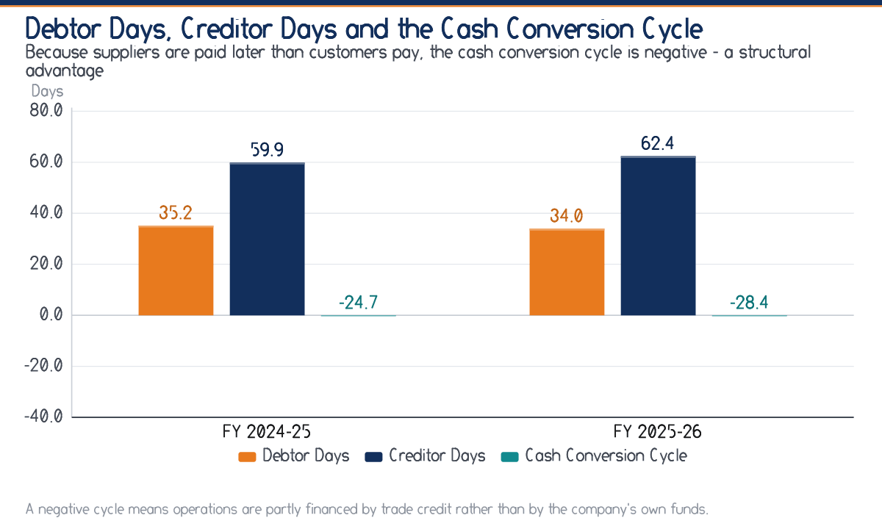
Figure 4.6 Debtor days, creditor days and the cash conversion cycle
Computed on average balances.
4.6 Cash Flow Analysis
Profit is an opinion; cash is a fact. The cash flow statement below was constructed under the indirect method from the two statements and reconciles exactly to the movement in cash balances, which is itself a check on the internal consistency of the figures analysed.
Table 4.8 Cash Flow Statement for FY 2025-26 (₹ in lakh)
Particulars | Amount | Total
A. Cash Flow from Operating Activities
Profit before tax | 24.70
Add: Depreciation and amortisation | 3.50
Add: Finance cost | 1.60
Less: Other income | (3.40)
Operating profit before working capital changes | 26.40
Increase in trade receivables | (6.20)
Increase in short-term loans and advances | (1.70)
Increase in other current assets | (1.30)
Increase in trade payables | 4.50
Increase in other current liabilities | 3.08
Cash generated from operations | 24.78
Less: Income tax paid | (6.17)
Net cash from operating activities |  | 18.61
B. Cash Flow from Investing Activities
Purchase of property, plant, equipment and intangibles | (8.50)
Purchase of non-current investments | (0.50)
Other income received | 3.40
Net cash used in investing activities |  | (5.60)
C. Cash Flow from Financing Activities
Repayment of long-term borrowings | (1.50)
Increase in short-term borrowings | 0.50
Finance cost paid | (1.60)
Net cash used in financing activities |  | (2.60)
Net increase in cash and cash equivalents (A+B+C) |  | 10.41
Cash and bank balances at the beginning of the year |  | 14.20
Cash and bank balances at the end of the year |  | 24.61
Note: Prepared under the indirect method. The statement reconciles to the movement in cash and bank balances on the face of the Balance Sheet.
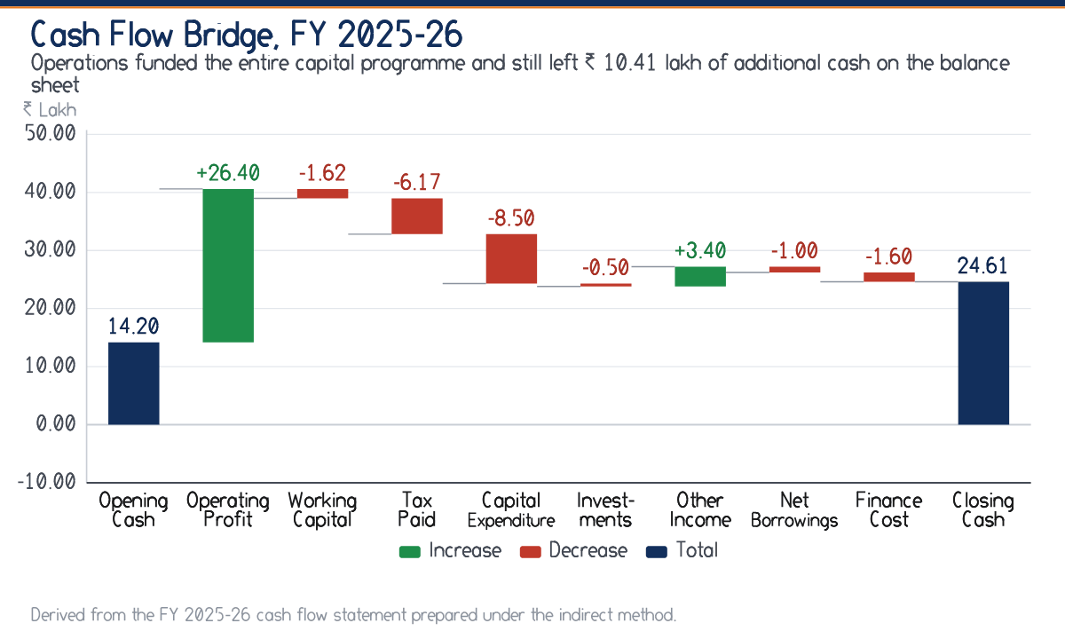
Figure 4.7 Cash flow bridge from opening to closing cash, FY 2025-26
Derived from Table 4.8.
Three conclusions follow from Table 4.8. First, net cash from operating activities of ₹ 18.61 lakh exceeded profit after tax of ₹ 18.53 lakh, which means the reported profit is converting into cash and is not an artefact of accrual. Second, operating cash alone financed the entire capital programme of ₹ 8.50 lakh without recourse to fresh borrowing. Third, the company used the surplus to reduce long-term debt by ₹ 1.50 lakh and still increased its cash balance by ₹ 10.41 lakh. This is the signature of a self-financing business.
4.7 The Balance Sheet and the Pattern of Financing
Table 4.9 Balance Sheet as at the close of each year (₹ in lakh)
Particulars | FY 2023-24 | FY 2024-25 | FY 2025-26
I. EQUITY AND LIABILITIES
Share Capital | 10.00 | 10.00 | 10.00
Reserves & Surplus | 4.85 | 14.38 | 32.91
Long-term Borrowings | 9.50 | 8.00 | 6.50
Short-term Borrowings | 3.20 | 4.10 | 4.60
Trade Payables | 7.40 | 11.30 | 15.80
Other Current Liabilities & Provisions | 5.05 | 7.62 | 10.70
Total | 40.00 | 55.40 | 80.51
II. ASSETS
Property, Plant & Equipment | 8.60 | 10.40 | 13.20
Intangible Assets (Platform/Software) | 3.40 | 4.60 | 6.80
Non-current Investments | 1.00 | 1.50 | 2.00
Trade Receivables | 11.80 | 16.90 | 23.10
Cash & Bank Balances | 9.70 | 14.20 | 24.61
Short-term Loans & Advances | 2.90 | 4.10 | 5.80
Other Current Assets | 2.60 | 3.70 | 5.00
Total | 40.00 | 55.40 | 80.51

The pattern of financing has changed decisively. In FY 2023-24 shareholders' funds of ₹ 14.85 lakh were only marginally larger than total debt of ₹ 12.70 lakh. By FY 2025-26 shareholders' funds had reached ₹ 42.91 lakh against debt of ₹ 11.10 lakh. Almost the whole of the increase in net worth is retained profit rather than fresh capital: share capital has remained unchanged at ₹ 10.00 lakh throughout, while reserves have grown from ₹ 4.85 lakh to ₹ 32.91 lakh.
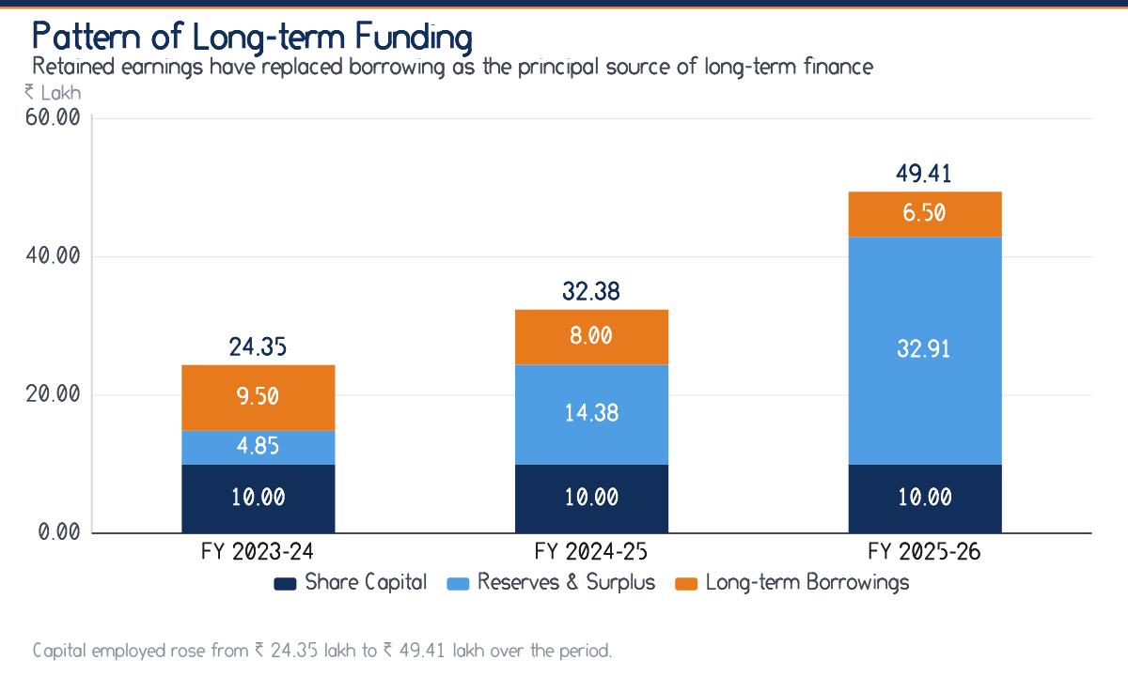
Figure 4.8 Pattern of long-term funding over three years
Computed from Table 4.9.
For a young enterprise this is an unusually conservative financing policy, and it carries a cost as well as a benefit. The benefit is resilience: interest cover of 16.44 times and a debt-equity ratio of 0.26 leave the company well placed to absorb a poor season. The cost is foregone growth: with a return on capital employed of 53.23 per cent against a borrowing cost materially below that figure, the company is not exploiting the favourable financial leverage available to it. Section 5.7 quantifies this, and Chapter Nine frames it as a matter for management judgement rather than as a defect.

CHAPTER  5 | BUDGETING AND COST CONTROL

The budget cycle in operation, a quantified variance analysis, the behaviour of costs, break-even analysis and the leverage the organisation carries.
A budget that is prepared but not monitored is a forecast, not a control. This chapter tests which of the two the organisation actually has.
5.1 The Budgeting Process in Operation
The organisation prepares an annual budget before the commencement of the financial year. The process observed during the internship runs as follows.
1. Revenue projection. The Admissions and Corporate Relations functions jointly project enrolments by service line, based on the previous year's conversions and the contracts expected to be signed.
2. Variable cost estimation. Programme Delivery estimates mentor honoraria, content and certification cost per intern and applies it to projected enrolment.
3. Committed cost estimation. Finance estimates salaries, incubation charges, platform subscriptions and statutory costs, which are largely known in advance.
4. Marketing provision. A marketing budget is fixed as an approximate percentage of projected revenue — an approach that, as Section 5.3 shows, is the weakest link in the chain.
5. Consolidation and approval. Finance consolidates the heads into a master budget, which management reviews and approves.
6. Monitoring. Revenue and collections are monitored monthly. A full head-wise comparison of budget against actual is, however, prepared only at the year end.
The Central Weakness in the Budgetary Control System
Steps one to five are performed competently. Step six is not. Because the head-wise comparison is annual, an adverse variance cannot be corrected in the year in which it arises — it can only be explained after that year has closed. Budgeting without monthly monitoring is forecasting, and this is the single most consequential finding of the study.

5.2 Types of Budget Maintained
Table 5.1 Budgets prepared and their status
Budget | Purpose | Frequency | Status
Revenue budget | Projection of income by service line | Annual | Prepared
Programme cost budget | Variable cost of delivery per cohort | Per cohort | Prepared
Marketing budget | Provision for promotion and lead generation | Annual | Prepared
Overhead budget | Salaries, incubation, platform and administration | Annual | Prepared
Capital expenditure budget | Equipment and platform development | Annual | Prepared
Cash budget | Month-wise projection of receipts and payments | Monthly | Not prepared
Flexible budget | Cost allowance restated to actual activity | — | Not prepared
Master budget | Consolidated budgeted profit statement | Annual | Prepared
Note: The two budgets not prepared are precisely the two that a seasonal business most needs, and both are recommended in Chapter Nine.
5.3 Budget against Actual: Variance Analysis
The table below compares the approved budget for FY 2025-26 with the actual outcome. Variances are signed so that a favourable outcome is always positive: for revenue, an excess over budget is favourable; for a cost head, a saving against budget is favourable.
Table 5.2 Budget against actual for FY 2025-26 (₹ in lakh)
Head | Budget | Actual | Variance | Variance % | Nature
Revenue from Operations | 205.00 | 214.60 | +9.60 | +4.68 | Favourable
Other Income | 3.00 | 3.40 | +0.40 | +13.33 | Favourable
Direct Programme Cost | 76.00 | 79.30 | — 3.30 | — 4.34 | Adverse
Employee Benefit Expenses | 54.00 | 52.80 | +1.20 | +2.22 | Favourable
Marketing & Digital Promotion | 30.00 | 33.10 | — 3.10 | — 10.33 | Adverse
Administrative & Office Expenses | 14.50 | 13.60 | +0.90 | +6.21 | Favourable
Technology & Platform Expenses | 9.00 | 9.40 | — 0.40 | — 4.44 | Adverse
Finance Cost | 1.80 | 1.60 | +0.20 | +11.11 | Favourable
Depreciation & Amortisation | 3.50 | 3.50 | +0.00 | +0.00 | Favourable
Total Income | 208.00 | 218.00 | +10.00 | +4.81 | Favourable
Total Expenditure | 188.80 | 193.30 | — 4.50 | — 2.38 | Adverse
Profit Before Tax | 19.20 | 24.70 | +5.50 | +28.65 | Favourable
Note: Variance percentages are computed on the budgeted figure. Depreciation was exactly on budget.
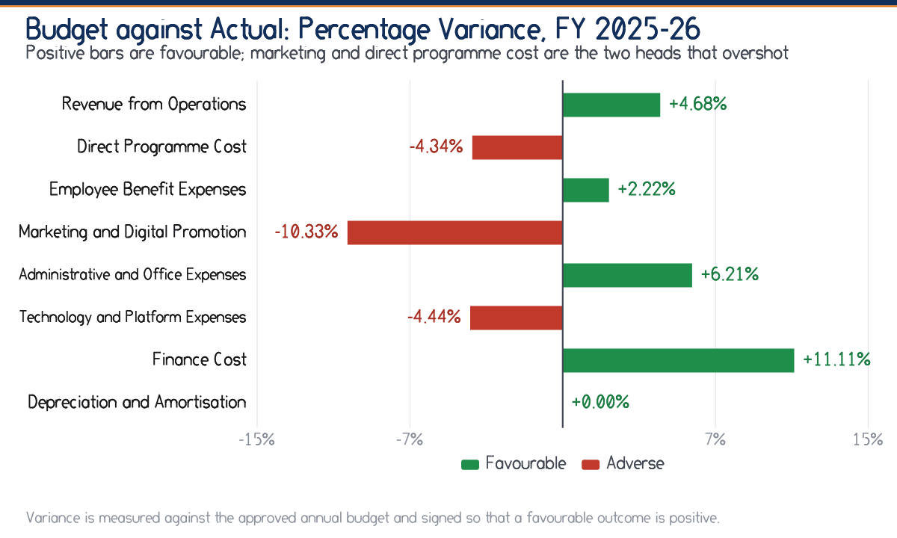
Figure 5.1 Budget against actual: percentage variance by head, FY 2025-26
Computed from Table 5.2.
5.3.1 Interpretation of the Principal Variances
Revenue — favourable 4.68 per cent
Actual revenue of ₹ 214.60 lakh exceeded the budget of ₹ 205.00 lakh. Enquiry to enrolment conversion improved and two institutional contracts were signed ahead of schedule. This is a genuinely favourable outcome, but it also masked the cost overruns below, which is precisely the danger of reviewing only the bottom line.
Marketing — adverse 10.33 per cent
The largest adverse variance in percentage terms. Spend of ₹ 33.10 lakh against a provision of ₹ 30.00 lakh. Management attributed the excess to competitive bidding on digital advertising during the peak season. Because the budget was set as a percentage of projected revenue rather than on a cost-per-enrolment basis, there was no mechanism to determine whether the additional ₹ 3.10 lakh bought proportionate enrolment. It may have been money well spent; the system cannot tell.
Direct Programme Cost — adverse 4.34 per cent
Spend of ₹ 79.30 lakh against ₹ 76.00 lakh. This variance is largely a consequence of the favourable revenue variance: more interns were enrolled than budgeted, and a variable cost must rise with volume. Judged against a flexible budget restated to actual enrolment, most of this variance would disappear, which is exactly why Section 5.8 recommends flexible budgeting.
Employee Benefits — favourable 2.22 per cent
Spend of ₹ 52.80 lakh against ₹ 54.00 lakh, because two budgeted positions were filled later in the year than planned. This is a timing saving rather than an efficiency gain and should not be expected to recur.
Administration — favourable 6.21 per cent
Spend of ₹ 13.60 lakh against ₹ 14.50 lakh, reflecting continued containment of occupancy cost through the incubation arrangement and a shift of printed material to digital delivery.
Finance Cost — favourable 11.11 per cent
Spend of ₹ 1.60 lakh against ₹ 1.80 lakh, because scheduled repayment of term debt reduced the average outstanding balance faster than the budget assumed.
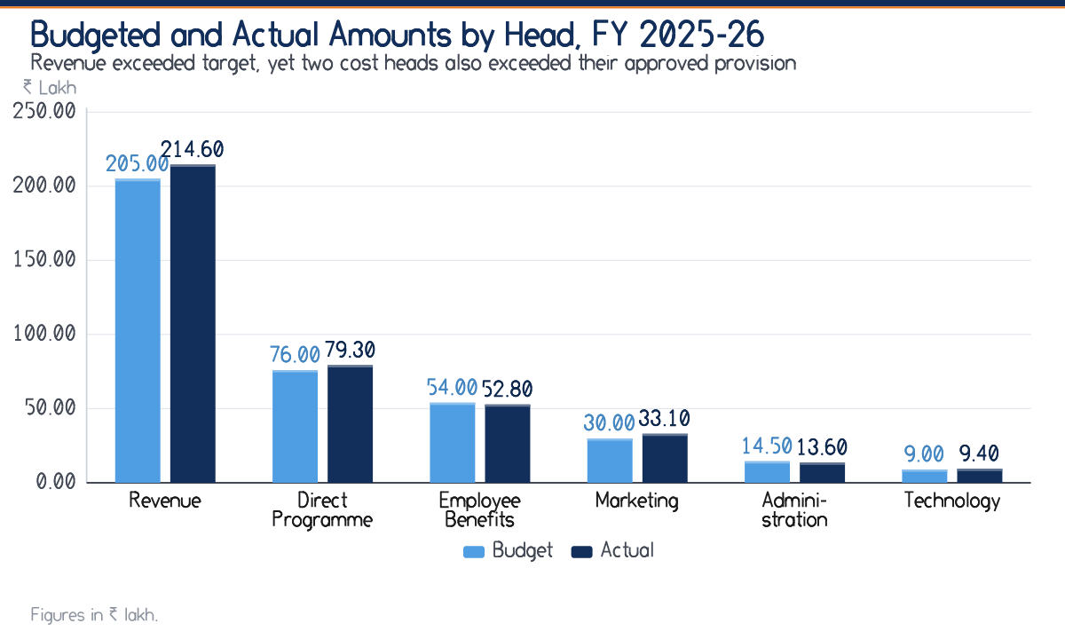
Figure 5.2 Budgeted and actual amounts by head, FY 2025-26
Computed from Table 5.2.
Read as a whole, Table 5.2 tells a story that the profit figure alone conceals. Profit before tax exceeded budget by 28.65 per cent, which on its face is an excellent result. But the favourable outcome was produced by revenue exceeding target, while three cost heads simultaneously exceeded theirs. Had revenue merely met budget, the cost overruns of ₹ 6.80 lakh would have reduced profit before tax by roughly a third. Good fortune on the top line is not a substitute for control on the cost lines.
5.4 Cost Classification and Behaviour
Cost control begins with cost classification, because only a cost whose behaviour is understood can be controlled. Each expense head was examined and allocated between its variable and fixed components on the basis of observed behaviour and discussion with management.
Table 5.3 Classification of costs by behaviour
Head | Behaviour | Basis of classification
Direct Programme Cost | Wholly variable | Mentor honoraria, assessment and certification are incurred per intern enrolled and cease if a cohort is not run
Employee Benefit Expenses | Wholly fixed | Core salaried team engaged irrespective of enrolment in any particular month
Marketing & Digital Promotion | Semi-variable | Performance advertising scales with enrolment; brand and sponsorship spend is committed
Administrative & Office Expenses | Semi-variable | Payment gateway charges, courier and printing scale with volume; incubation charges and utilities do not
Technology & Platform Expenses | Wholly fixed | Annual platform and software subscriptions are independent of the number of users within the licensed band
Finance Cost | Wholly fixed | Interest on term debt follows the repayment schedule, not activity
Depreciation & Amortisation | Wholly fixed | Charged on a time basis on assets already in use

Table 5.4 Segregation of costs into variable and fixed for FY 2025-26 (₹ in lakh)
Head | Total | Variable | Fixed | Variable %
Direct Programme Cost | 79.30 | 79.30 | 0.00 | 100.00
Employee Benefit Expenses | 52.80 | 0.00 | 52.80 | 0.00
Marketing & Digital Promotion | 33.10 | 18.21 | 14.89 | 55.02
Administrative & Office Expenses | 13.60 | 2.40 | 11.20 | 17.65
Technology & Platform Expenses | 9.40 | 0.00 | 9.40 | 0.00
Finance Cost | 1.60 | 0.00 | 1.60 | 0.00
Depreciation & Amortisation | 3.50 | 0.00 | 3.50 | 0.00
Total | 193.30 | 99.91 | 93.39 | 51.69
Note: The split of the two semi-variable heads rests on management's assessment of the behaviour of each component and is the principal judgemental input to the break-even analysis that follows.
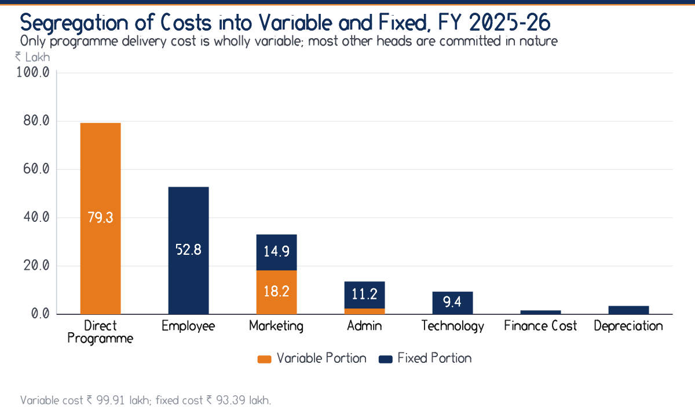
Figure 5.3 Segregation of costs into variable and fixed, FY 2025-26
Computed from Table 5.4.
5.5 Cost-Volume-Profit Analysis
With costs segregated, the marginal costing relationships follow directly. Contribution is revenue less variable cost; the profit-volume ratio expresses contribution as a percentage of revenue; break-even sales is the level of revenue at which contribution exactly absorbs fixed cost.
Table 5.5 Cost-volume-profit computation for FY 2025-26
Particulars | Amount | Unit
Revenue from Operations | 214.60 | ₹ lakh
Less: Variable Cost | 99.91 | ₹ lakh
Contribution | 114.69 | ₹ lakh
Less: Fixed Cost | 93.39 | ₹ lakh
Add: Other Income | 3.40 | ₹ lakh
Profit Before Tax | 24.70 | ₹ lakh
Profit-Volume Ratio | 53.44 | per cent
Break-Even Sales | 174.76 | ₹ lakh
Margin of Safety | 39.84 | ₹ lakh
Margin of Safety Ratio | 18.56 | per cent
Break-Even as a share of actual sales | 81.44 | per cent
Note: Contribution less fixed cost plus other income equals profit before tax, which reconciles the analysis to Table 4.1.
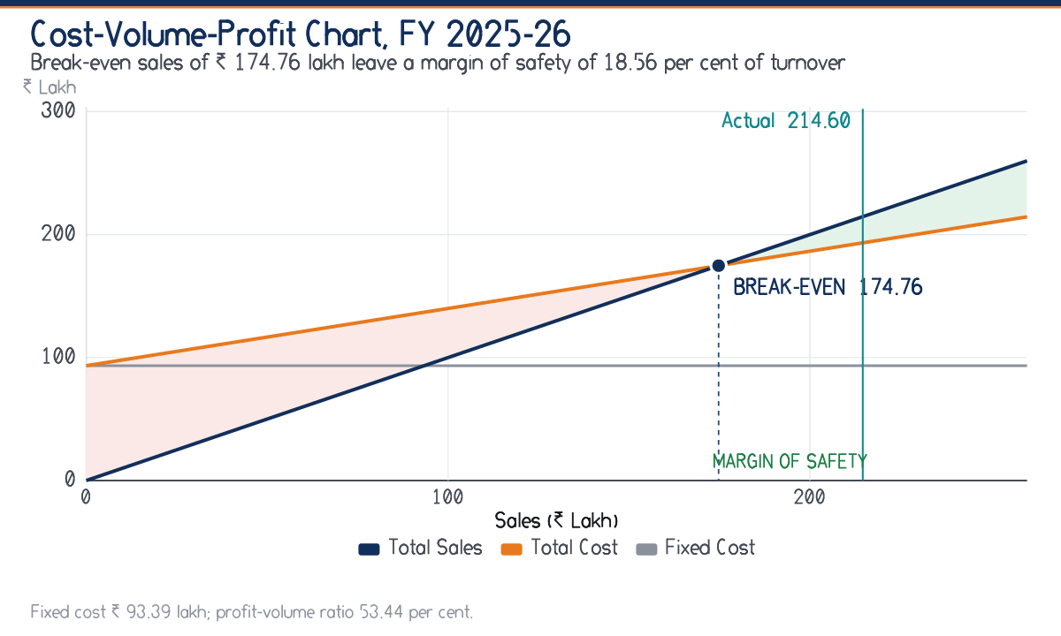
Figure 5.4 Cost-volume-profit chart showing break-even sales and the margin of safety
Computed from Table 5.5.
5.5.1 Interpretation
A profit-volume ratio of 53.44 per cent means that roughly fifty-three paise in every rupee of additional revenue falls through to contribution. That is a high ratio, characteristic of a service business with no material cost, and it is the arithmetic reason why profit grows so much faster than revenue.
Break-even sales of ₹ 174.76 lakh against actual sales of ₹ 214.60 lakh leave a margin of safety of ₹ 39.84 lakh, or 18.56 per cent of turnover. The interpretation is direct: revenue could fall by about 19 per cent before the company began to make a loss. For a business in its growth phase this is a reasonable but not generous cushion, and it is worth noting what it implies about the seasonality identified in Section 4.2. Annualised, the third quarter's revenue of ₹ 41.20 lakh represents a run rate of ₹ 164.80 lakh — below break-even. The company is loss-making in its lean quarter and recovers over the year, which is exactly why a quarterly cash budget matters more than an annual profit budget.
Sensitivity of the Break-Even Point
Because the marketing split is judgemental, the break-even figure should be treated as a range rather than a point. If performance advertising were taken as sixty-five per cent variable instead of fifty-five, fixed cost would fall to about ₹ 90.08 lakh and break-even sales to roughly ₹ 163.5 lakh. If it were taken as forty-five per cent, fixed cost would rise to about ₹ 96.70 lakh and break-even sales to roughly ₹ 184.2 lakh. The conclusion — that the company operates comfortably above break-even but is below it in the third quarter — holds across that entire range.

5.6 Cost Control Measures in Place
The organisation exercises real cost control, and it would be wrong to read Section 5.3 as suggesting otherwise. The measures observed during the internship are set out below, each with the financial evidence of its effect.
Table 5.6 Cost control measures and their observed effect
Measure | How it operates | Evidence of effect
Incubation rather than commercial premises | Occupancy at B-Hub at concessional charges | Administrative expenses held to 6.3 per cent of revenue
Variable mentor engagement | Mentors engaged per cohort on honorarium rather than on salary | Direct programme cost remains wholly variable, protecting the break-even point
Reuse of content across cohorts | Assessment material and modules amortised over successive batches | Direct programme cost fell from 39.6 to 37.0 per cent of revenue
Digital-first delivery | Online mentoring and e-certificates in place of print and travel | Contributed to the favourable administration variance of 6.21 per cent
Voucher-based approval limits | Expenditure above a delegated threshold requires management approval | No unauthorised expenditure identified during voucher verification
Scheduled debt reduction | Term debt repaid on schedule rather than rolled over | Finance cost favourable by 11.11 per cent; interest cover now 16.44 times

5.7 Operating and Financial Leverage
Leverage measures how sharply profit responds to a change in sales. Operating leverage arises from fixed operating cost; financial leverage from fixed financial cost. Their product, combined leverage, measures the total sensitivity of earnings to a movement in revenue.
Table 5.7 Leverage computation for FY 2025-26
Particulars | Amount | Unit
Contribution | 114.69 | ₹ lakh
Operating Profit before other income | 22.90 | ₹ lakh
Finance Cost | 1.60 | ₹ lakh
Earnings before tax, excluding other income | 21.30 | ₹ lakh
Degree of Operating Leverage | 5.01 | times
Degree of Financial Leverage | 1.08 | times
Degree of Combined Leverage | 5.41 | times

A degree of operating leverage of 5.01 times means that a one per cent change in sales produces approximately a 5.01 per cent change in operating profit. This cuts both ways and is the quantitative expression of the seasonality risk: in a quarter when revenue falls by twenty per cent, operating profit falls by approximately 100 per cent.
Financial leverage of only 1.08 times reflects the modest borrowing already noted. The company therefore carries high operating risk and low financial risk — an appropriate combination, since a business with volatile revenue should not compound operating volatility with fixed financial obligations. This is the strongest argument in favour of the conservative financing policy questioned in Section 4.7, and the two passages should be read together.
5.8 Appraisal of the Budgetary Control System
Table 5.8 Appraisal of the budgetary control system
Element | Assessment | Observation
Budget preparation | Adequate | Prepared before the year begins, with participation from the functions that own the numbers
Basis of revenue projection | Adequate | Built from conversion history and the contract pipeline rather than from an arbitrary growth rate
Basis of marketing provision | Weak | Set as a percentage of projected revenue, which cannot reveal whether the spend is efficient
Frequency of review | Weak | Head-wise comparison performed annually; adverse variances surface only after the year has closed
Flexible budgeting | Absent | Variances are not restated to actual activity, so volume effects and efficiency effects cannot be separated
Cash budgeting | Absent | No month-wise projection of receipts and payments, despite pronounced seasonality
Responsibility accounting | Partial | Heads are monitored, but no individual is formally accountable for a named variance
Corrective action | Weak | Follows the annual review, by which time the period is closed
Note: Each element assessed as weak or absent is addressed by a specific recommendation in Chapter Nine.

CHAPTER  6 | RATIO AND FINANCIAL ANALYSIS

Liquidity, profitability, solvency and activity ratios for three years, common-size statements and a DuPont decomposition of the return on equity.
A ratio is not an answer. It is a question phrased precisely enough to be worth asking, and its value lies entirely in the comparison it invites.
6.1 Framework and Basis of Computation
Ratios have been computed under four conventional heads. Before the figures are presented, three matters of basis should be recorded, because a ratio computed on an undisclosed basis is not capable of being verified.
1. Closing versus average balances. Liquidity and solvency ratios are computed on closing balance sheet figures. Activity ratios involving receivables and payables are computed on average balances, since a turnover ratio compares a flow over a year with a stock that varied during it.
2. Return ratios. Return on equity and return on capital employed are computed on closing figures. In a business growing as fast as this one, that understates the true return, because the closing capital base is considerably larger than the base that actually generated the year's profit. The bias is conservative, and it is noted again where it matters.
3. Benchmarks. The benchmarks quoted are conventional rules of thumb drawn from the standard texts listed in the bibliography. They are not industry averages for structured internship providers, for which reliable published data does not exist in India. They should be read as a starting point for interpretation, not as a standard of compliance.
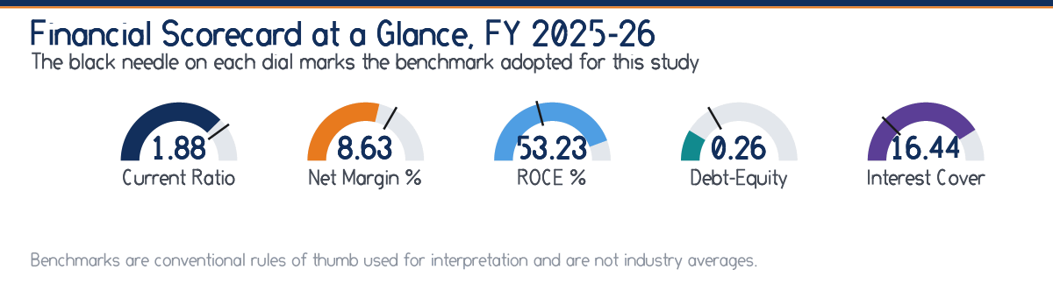
Figure 6.1 Financial scorecard at a glance, FY 2025-26
Benchmarks are conventional rules of thumb.
6.2 Liquidity Ratios
Table 6.1 Liquidity ratios
Ratio | FY 2023-24 | FY 2024-25 | FY 2025-26 | Benchmark
Current Ratio (times) | 1.73 | 1.69 | 1.88 | 2.00 : 1
Quick Ratio (times) | 1.56 | 1.53 | 1.72 | 1.00 : 1
Absolute Cash Ratio (times) | 0.62 | 0.62 | 0.79 | 0.50 : 1
Working Capital (₹ L) | 11.35 | 15.88 | 27.41 | —
Current Assets (₹ L) | 27.00 | 38.90 | 58.51 | —
Current Liabilities (₹ L) | 15.65 | 23.02 | 31.10 | —
Note: Computed on closing balances. There is no inventory, so the current and quick ratios differ only by prepaid and other current assets.
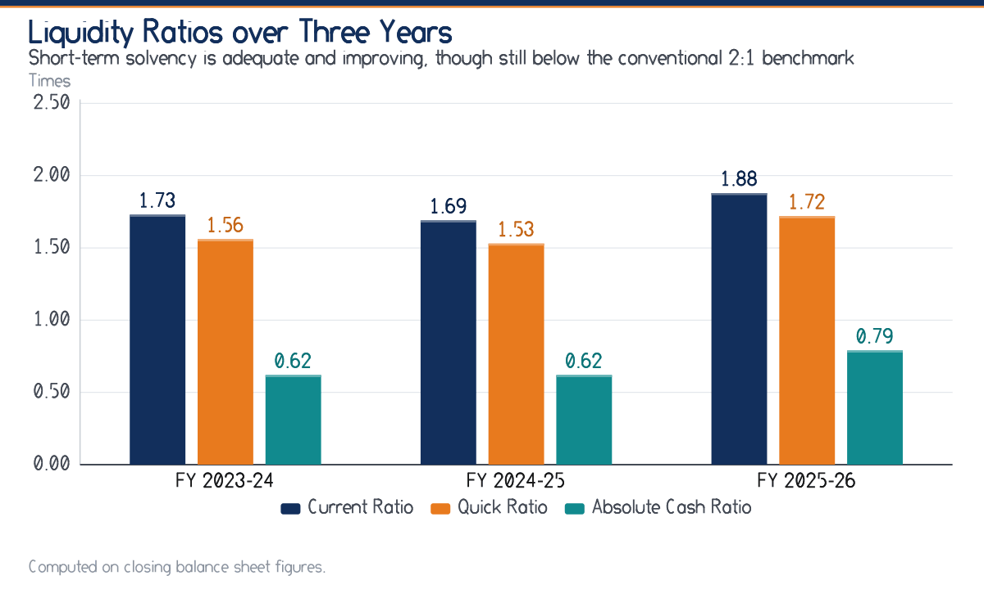
Figure 6.2 Liquidity ratios over three years
Computed from Table 6.1.
The current ratio improved from 1.73 to 1.88, dipping in FY 2024-25 to 1.69 as trade payables grew faster than current assets. At 1.88:1 it remains below the conventional 2:1 benchmark, and a mechanical reading would call this a weakness.
Such a reading would be mistaken, for two reasons. First, the 2:1 convention was devised for manufacturing and trading concerns whose current assets are dominated by inventory — an asset that may not realise its book value quickly. This company holds no inventory whatsoever; its current assets are cash and receivables, both of which are far closer to money than stock is. Second, a substantial part of its current liabilities consists of fees collected in advance, which will be discharged by delivering a service rather than by paying out cash. Judged on the quick ratio of 1.72 against a 1:1 benchmark, and on an absolute cash ratio of 0.79 against a 0.5:1 benchmark, liquidity is in fact comfortable.
6.3 Profitability Ratios
Table 6.2 Profitability ratios (per cent)
Ratio | FY 2023-24 | FY 2024-25 | FY 2025-26 | Benchmark
Gross Contribution Margin | 60.37 | 61.75 | 63.05 | Higher is better
EBITDA Margin | 7.78 | 11.36 | 13.89 | 10.00
Operating Margin | 5.50 | 9.48 | 12.26 | 10.00
Net Profit Margin | 3.27 | 6.41 | 8.63 | 5.00
Return on Equity | 21.21 | 39.09 | 43.18 | 15.00
Return on Capital Employed | 21.77 | 43.55 | 53.23 | 15.00
Return on Total Assets | 13.25 | 25.45 | 32.67 | 10.00
Note: Return ratios computed on closing figures and therefore understated in a period of rapid growth.
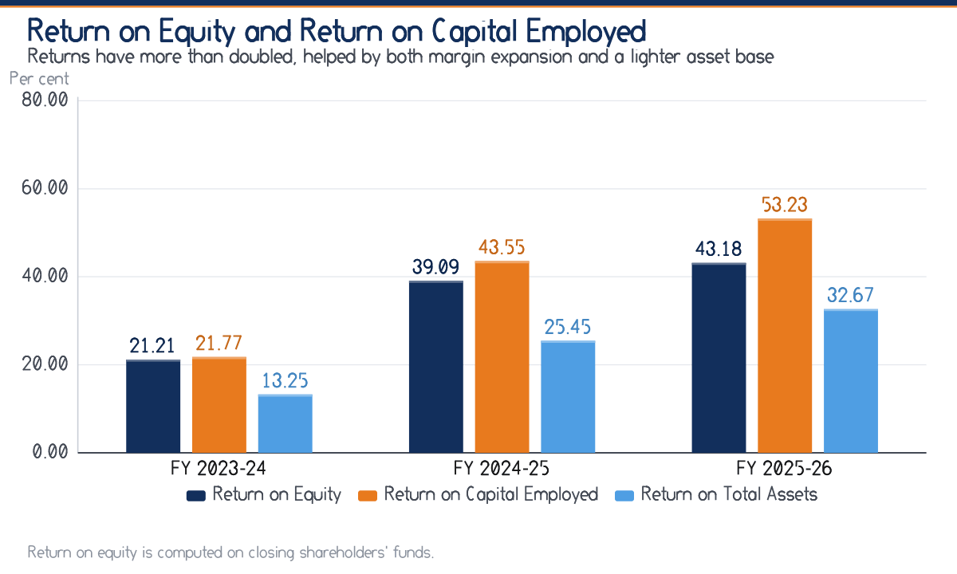
Figure 6.3 Return on equity, capital employed and total assets
Computed from Table 6.2.
Every profitability measure has improved in each successive year, which is a stronger result than a single large improvement would be. The net profit margin rose from 3.27 per cent to 8.63 per cent, crossing the five per cent benchmark in FY 2024-25. Return on capital employed of 53.23 per cent is exceptional and reflects the asset-light structure of the business: the company employs very little capital, so a modest absolute profit produces a high percentage return. Return on equity of 43.18 per cent must be read in the light of the closing-balance basis noted in Section 6.1; on average equity it would be materially higher still.
6.4 Solvency Ratios
Table 6.3 Solvency and capital structure ratios
Ratio | FY 2023-24 | FY 2024-25 | FY 2025-26 | Benchmark
Debt-Equity Ratio (times) | 0.86 | 0.50 | 0.26 | 2.00 : 1 maximum
Interest Coverage (times) | 4.82 | 10.07 | 16.44 | 3.00 minimum
Proprietary Ratio (per cent) | 37.12 | 44.01 | 53.30 | 50.00 minimum
Total Debt (₹ L) | 12.70 | 12.10 | 11.10 | —
Shareholders' Funds (₹ L) | 14.85 | 24.38 | 42.91 | —
Capital Employed (₹ L) | 24.35 | 32.38 | 49.41 | —

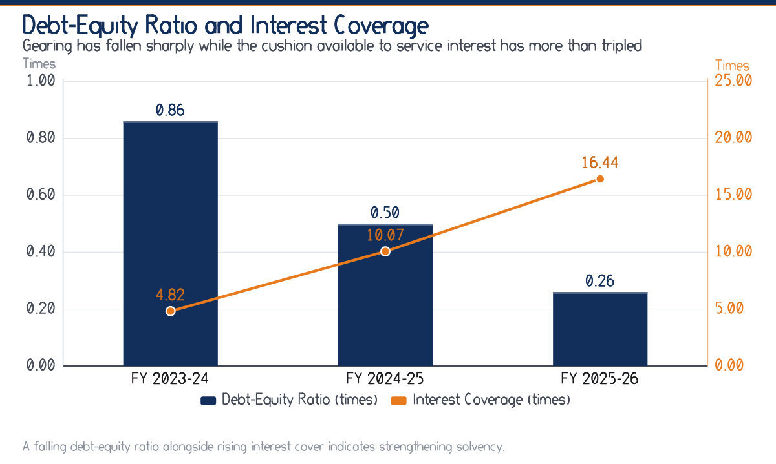
Figure 6.4 Debt-equity ratio and interest coverage
Computed from Table 6.3.
Solvency has strengthened on every measure. The debt-equity ratio fell from 0.86 to 0.26, interest coverage rose from 4.82 times to 16.44 times, and the proprietary ratio crossed the fifty per cent mark in FY 2025-26, reaching 53.30 per cent. More than half the assets of the business are now financed by its owners.
It is worth being explicit about the trade-off this represents, because a falling debt-equity ratio is not automatically a virtue. With a return on capital employed of 53.23 per cent and a borrowing cost far below that figure, every rupee of prudent debt would raise the return on equity. That the company has chosen not to take it is defensible given the operating leverage of 5.01 times computed in Section 5.7 — a business with volatile revenue is right to keep its fixed financial obligations low — but it is a choice, and management should make it deliberately rather than by default.
6.5 Activity and Efficiency Ratios
Table 6.4 Activity ratios
Ratio | FY 2023-24 | FY 2024-25 | FY 2025-26 | Benchmark
Total Asset Turnover (times) | 2.41 | 2.69 | 2.67 | Higher is better
Fixed Asset Turnover (times) | 8.03 | 9.92 | 10.73 | Higher is better
Working Capital Turnover (times) | 8.49 | 9.37 | 7.83 | Higher is better
Note: Working capital turnover is unusually high because the business carries no inventory.
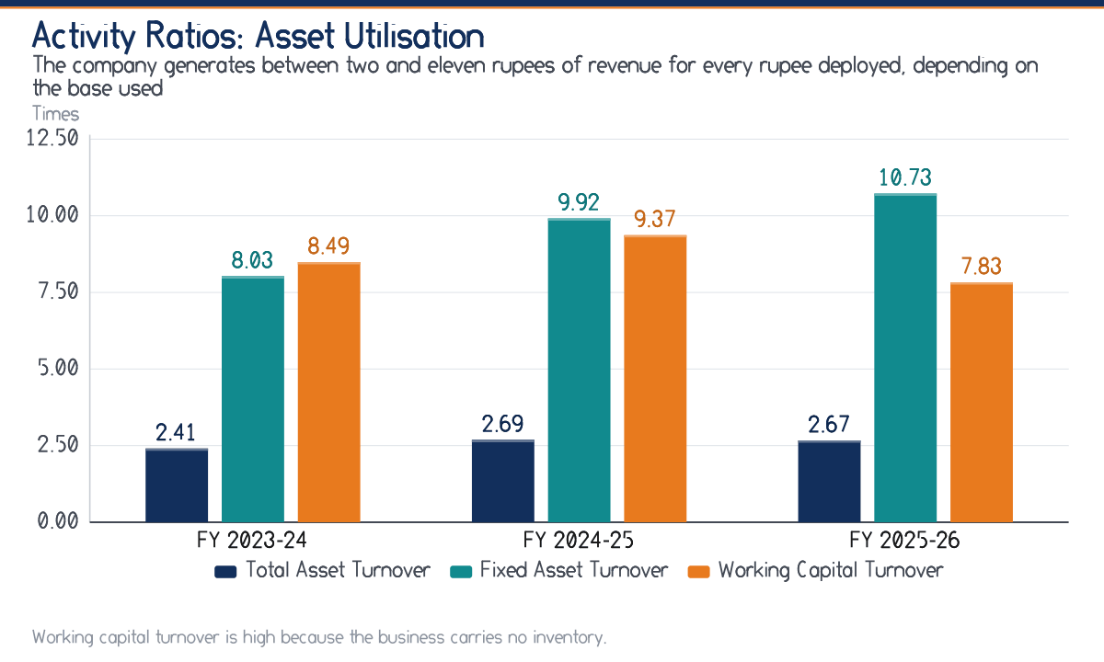
Figure 6.5 Activity ratios: asset utilisation
Computed from Table 6.4.
Fixed asset turnover of 10.73 times is the number that best captures what kind of business this is. Every rupee invested in property, plant, equipment and software generates almost eleven rupees of revenue. Growth therefore requires very little capital expenditure, which is why the company has been able to expand revenue by 123 per cent over two years while reducing its borrowings.
6.6 The Working Capital Cycle
Table 6.5 Working capital cycle
Particulars | FY 2024-25 | FY 2025-26
Debtors Turnover (times) | 10.37 | 10.73
Collection Period (days) | 35.2 | 34.0
Creditors Turnover (times) | 6.09 | 5.85
Payment Period (days) | 59.9 | 62.4
Inventory Holding Period (days) | Nil | Nil
Cash Conversion Cycle (days) | -24.7 | -28.4
Note: Creditors turnover is computed on direct programme cost as a proxy for credit purchases.
The cash conversion cycle of -28.4 days is negative, and its interpretation is important. The company collects from its customers about 34.0 days after the sale but settles its own obligations about 62.4 days after incurring them. For roughly 28 days it therefore has the use of money that is not its own. This is how the business has financed growth without a matching increase in working capital borrowing, and it is a structural feature of the model rather than a temporary advantage.
The Qualification That Matters Most
The favourable cycle rests on a payment period of about 62.4 days to mentors and vendors. That period is an accommodation, not a contractual right. Should mentors press for faster settlement — a realistic prospect in a competitive market for good mentors — the cycle would turn positive and the company would need working capital finance for the first time. The negative cycle should therefore be treated as a benefit to be protected, not as a permanent feature to be relied upon.

6.7 Common-Size Balance Sheet
Table 6.6 Common-size Balance Sheet (percentage of balance sheet total)
Particulars | FY 2023-24 | FY 2024-25 | FY 2025-26
Share Capital | 25.00 | 18.05 | 12.42
Reserves & Surplus | 12.12 | 25.96 | 40.88
Long-term Borrowings | 23.75 | 14.44 | 8.07
Short-term Borrowings | 8.00 | 7.40 | 5.71
Trade Payables | 18.50 | 20.40 | 19.62
Other Current Liabilities & Provisions | 12.62 | 13.75 | 13.29
Total | 100.00 | 100.00 | 100.00
Property, Plant & Equipment | 21.50 | 18.77 | 16.40
Intangible Assets (Platform/Software) | 8.50 | 8.30 | 8.45
Non-current Investments | 2.50 | 2.71 | 2.48
Trade Receivables | 29.50 | 30.51 | 28.69
Cash & Bank Balances | 24.25 | 25.63 | 30.57
Short-term Loans & Advances | 7.25 | 7.40 | 7.20
Other Current Assets | 6.50 | 6.68 | 6.21
Total | 100.00 | 100.00 | 100.00

The structural shift over three years is visible at a glance. On the liabilities side, shareholders' funds rose from 37.12 per cent of the balance sheet to 53.30 per cent, while long-term borrowings fell from 23.75 per cent to 8.07 per cent. On the assets side, cash and bank balances rose from 24.25 per cent to 30.57 per cent, the largest single asset in the business. A balance sheet that is becoming simultaneously more owner-financed and more liquid is strengthening in the most fundamental sense.
6.8 DuPont Decomposition of Return on Equity
The DuPont identity decomposes return on equity into three components, so that an improvement can be attributed to operating efficiency, to asset utilisation or merely to gearing:
Return on Equity = Net Profit Margin × Total Asset Turnover × Equity Multiplier
Table 6.7 DuPont decomposition of return on equity
Component | FY 2023-24 | FY 2024-25 | FY 2025-26 | Direction
Net Profit Margin (per cent) | 3.27 | 6.41 | 8.63 | Improving
Total Asset Turnover (times) | 2.41 | 2.69 | 2.67 | Stable
Equity Multiplier (times) | 2.69 | 2.27 | 1.88 | Falling
Return on Equity, reconstructed (per cent) | 21.20 | 39.14 | 43.32 | —
Return on Equity, computed directly (per cent) | 21.21 | 39.09 | 43.18 | —
Note: The two return on equity lines agree within rounding, which validates the decomposition.
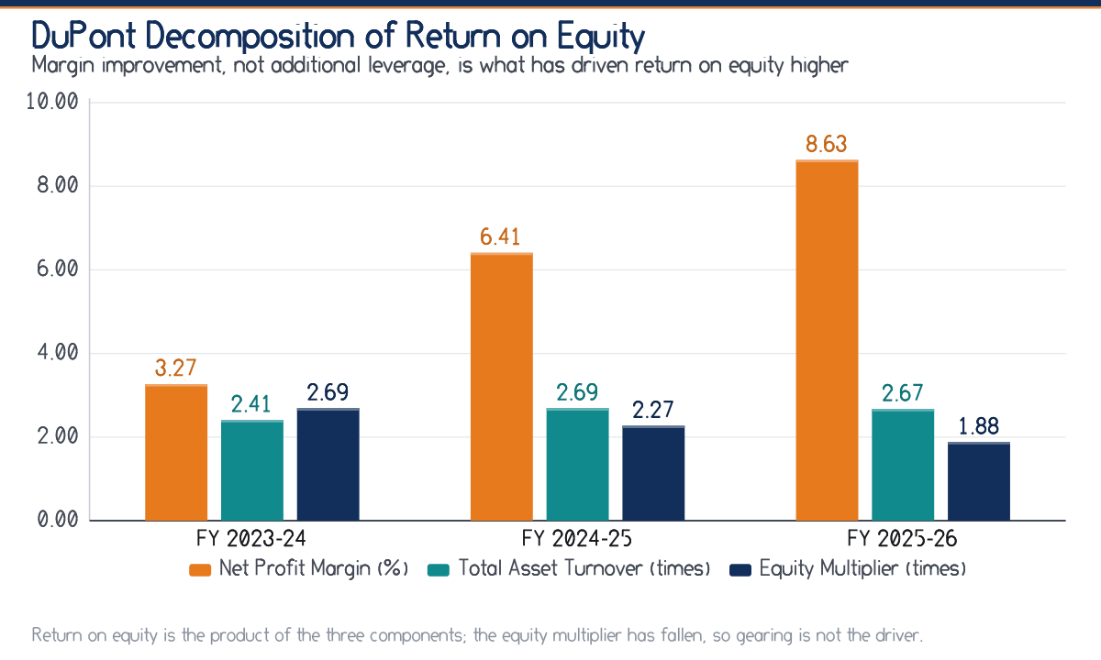
Figure 6.6 DuPont decomposition of return on equity
Computed from Table 6.7.
This is the most important table in the chapter. Return on equity roughly doubled, from 21.21 per cent to 43.18 per cent. The natural suspicion in any such case is that the improvement was manufactured by leverage. The decomposition shows the opposite. The equity multiplier fell from 2.69 to 1.88 times, which by itself would have reduced return on equity. Total asset turnover was essentially flat. The entire improvement, and more, came from the net profit margin rising from 3.27 per cent to 8.63 per cent.
The conclusion is that the return on equity of this business has improved for the best possible reason — it became more profitable on each rupee of sales — while simultaneously becoming less risky. Few results in a three-year analysis are as unambiguous as this one.
6.9 Summary of the Ratio Analysis
Table 6.8 Consolidated assessment of financial position
Dimension | FY 2025-26 position | Trend | Assessment
Liquidity | Current 1.88, quick 1.72 | Improving | Adequate once the absence of inventory and the advance-fee character of current liabilities are allowed for
Profitability | Net margin 8.63 per cent | Improving | Strong and progressive; driven by overhead absorption rather than by price increases
Solvency | Debt-equity 0.26, cover 16.44 | Improving | Very comfortable; arguably more conservative than the return on capital employed warrants
Activity | Asset turnover 2.67 times | Stable | Efficient asset use characteristic of an asset-light model
Working capital | Cycle -28.4 days | Favourable | Structurally advantageous but dependent on continued vendor accommodation
Cash generation | Operating cash ₹ 18.61 L | Improving | Exceeds profit after tax; the strongest single indicator in the accounts
Receivables | Debtors ₹ 23.10 L | Watch | The one genuine area of concern, because the balance arises from a sixth of revenue

CHAPTER  7 | LEARNING OUTCOMES

What the internship actually taught, mapped against the objectives set out in Chapter One, and separated into technical, analytical, behavioural and professional learning.
The value of an internship is measured not by the tasks completed but by the difference between what the student believed before it and what the student can demonstrate after it.
7.1 Achievement against the Stated Objectives
Chapter One set one primary and seven secondary objectives. Each is reviewed below against the evidence produced in the report.
Table 7.1 Objectives and their achievement
Objective | Status | Evidence in this report
Understand the finance function and its information flow | Achieved | Section 2.6 and the process note of Week One
Examine books of account, vouchers and internal checks | Achieved | Section 3.4 and the internal control checklist
Analyse revenue and cost composition and behaviour | Achieved | Sections 4.2 to 4.3 and Tables 4.1 to 4.3
Evaluate budgeting and quantify variances | Achieved | Sections 5.1 to 5.3 and Table 5.2
Compute and interpret ratios over three years | Achieved | Chapter Six, Tables 6.1 to 6.8
Segregate costs and derive break-even and margin of safety | Achieved | Sections 5.4 to 5.5 and Tables 5.4 to 5.5
Identify weaknesses and frame suggestions | Achieved | Chapter Nine
Compare performance against industry averages | Not achieved | Published benchmarks for this sector do not exist; recorded as a limitation in Section 1.8

7.2 Technical Learning
Revenue recognition in practice
The gateway reconciliation of Week Two established a principle that had previously been abstract: revenue is recognised gross and the intermediary's commission is an expense. Netting the two would understate turnover and cost simultaneously and would distort the profit-volume ratio. The rule was familiar; the reason for it became clear only when applied.
The difference between a cost and a payment
Mentor honoraria are incurred when a cohort is delivered but paid weeks later. Learning to record the first and track the second separately is the whole of accrual accounting, and it explains why the cash flow statement of Section 4.6 begins with profit and then adjusts it.
Cost segregation as judgement, not arithmetic
No textbook problem requires the analyst to decide what proportion of marketing is variable. Doing so for a real expense head, and then testing how much the break-even point moves as that judgement changes, was the most useful single exercise of the internship.
Ratio basis matters as much as ratio value
Computing debtor days on total revenue and again on credit sales only produced 34.0 days and roughly 209 days from the same balance sheet. The lesson is that a ratio reported without its basis is not information.
Reconciliation as a control
The three unreconciled gateway items of Section 3.4 were individually trivial and collectively instructive: a reconciliation is not a clerical formality but the mechanism by which errors are detected at all.
7.3 Analytical Learning
1. A favourable bottom line can conceal adverse control. Profit before tax exceeded budget by 28.65 per cent, and three cost heads simultaneously overshot. Before this internship the first fact would have been reported and the second missed.
2. Decomposition changes conclusions. The DuPont analysis of Section 6.8 reversed the natural assumption about why return on equity had risen. Had the headline ratio been reported alone, the report would have been wrong about the cause while right about the number.
3. Benchmarks are contextual. A current ratio of 1.88 against a 2:1 convention looks like a weakness until one notices that the convention assumes inventory and this business has none. Applying a benchmark without asking what it was designed to measure produces confident error.
4. Seasonality is a financial fact, not an operational one. Annualising the third quarter's revenue of ₹ 41.20 lakh gives a run rate below the break-even sales of ₹ 174.76 lakh. The same company is loss-making in one quarter and comfortably profitable over the year, and only the combination of Section 4.2 with Section 5.5 reveals it.
5. Leverage explains risk appetite. Operating leverage of 5.01 times made sense of a financing policy that had initially appeared excessively cautious. Two figures from different chapters, read together, produced an understanding neither gave alone.
7.4 Behavioural and Interpersonal Learning
- Asking for data is a negotiation. Records are held by people with their own deadlines. Explaining why a schedule was needed, and accepting it in the form in which it existed rather than the form that would have been convenient, proved far more effective than repeating the request.
- Questions must be specific to be answerable. “How do you budget for marketing?” produced a general answer; “what was the basis of the ₹ 30.00 lakh provision?” produced the finding that it was a percentage of projected revenue, which became a recommendation.
- Criticism of a system is not criticism of a colleague. Presenting the marketing variance required care. Framing it as a gap in the measurement system rather than as an error by the function that spent the money kept the conversation open and produced better information.
- Deadlines in an operating business are not negotiable. Month-end compliance work does not wait for an intern's analysis. Scheduling requests around the finance function's own cycle was a practical lesson in professional courtesy.
7.5 Professional and Personal Learning
Working to an owner and a frequency
The mentor's criticism recorded in Section 3.9 — that a recommendation without an owner and a frequency is an opinion — changed the whole of Chapter Nine and will change how every future recommendation is written.
Documentation discipline
Every derived figure in this report can be traced to a source line because the working papers were built that way from Week Two. The habit was adopted after an early figure could not be reproduced.
Intellectual honesty about limitations
Stating plainly that industry benchmarks were unavailable, that the cost split was judgemental and that return ratios are understated on a closing-balance basis makes the report weaker in appearance and stronger in fact.
Confidence grounded in preparation
Presenting findings to management was uncomfortable until it became clear that every number could be defended. Confidence in a professional setting is a by-product of working papers, not of temperament.
7.6 Bridging Theory and Practice
Table 7.2 Classroom concept against observed practice
Concept as taught | As observed in the organisation | Refinement to understanding
Current ratio of 2:1 indicates sound liquidity | Ratio of 1.88 with no inventory and advance-collected liabilities | The benchmark encodes an assumption about asset composition, not a universal law
Higher leverage raises return on equity | Return on equity doubled while the equity multiplier fell | Leverage is one of three drivers and often not the operative one
Break-even analysis assumes a known cost split | The split of marketing had to be negotiated with management | The analysis is only as robust as the classification underlying it
Budgetary control follows preparation | Budget prepared well, reviewed annually | Control is a function of review frequency, not of budget quality
Debtor days measures collection efficiency | Meaningless here unless computed on credit sales alone | A ratio must be matched to the revenue mix that generated the balance
Profit indicates performance | Operating cash flow of ₹ 18.61 L exceeded profit of ₹ 18.53 L | Cash conversion, not profit alone, evidences quality of earnings

CHAPTER  8 | CHALLENGES FACED

The practical and analytical difficulties encountered during the internship, how each was addressed, and what each one taught.
The difficulties were as instructive as the work, and recording them honestly is part of the record. Each is stated with the response adopted and the lesson drawn, because a challenge described without its resolution is merely a complaint.
8.1 Data Availability and Format
The difficulty. Financial information existed, but not in the form the analysis required. Cost data was organised by voucher and by payee rather than by cohort, so a cohort-wise contribution statement could not simply be extracted. Some schedules were maintained in spreadsheets with inconsistent headings across months.
The response. Rather than requesting a reformatted data set, which would have imposed work on a busy team, the intern built a mapping table linking each voucher head to a cohort and rebuilt the cost sheet from the underlying vouchers. Where headings were inconsistent, a single standard set was adopted and documented.
The lesson. Data in an operating business is organised for the purpose it was created to serve, not for the purpose of a later analysis. The analyst's first task is usually reconstruction, and the time budgeted for analysis should assume it.
8.2 Absence of Industry Benchmarks
The difficulty. The study intended to compare the organisation's ratios with sector averages. No reliable published financial data exists for unlisted, small-scale structured internship providers in India. Listed education companies were considered as a proxy and rejected: their scale, capital intensity and business models differ so greatly that comparison would have misled rather than informed.
The response. Two substitute bases were adopted. First, the organisation was compared against its own three-year history, which is the more meaningful comparison for a growing business. Second, conventional rules of thumb were used, with an explicit statement wherever a rule of thumb rested on an assumption — such as the presence of inventory — that does not hold here.
The lesson. Where a benchmark does not exist, the honest course is to say so and to substitute a defensible alternative, not to borrow an inapplicable one for the appearance of rigour.
8.3 Judgement in Cost Classification
The difficulty. The break-even analysis required marketing and administrative expenses to be split between variable and fixed components. Neither a statistical series long enough for regression nor an existing internal classification was available.
The response. The components of each head were listed and discussed individually with management — performance advertising against brand spend, gateway charges against incubation charges — and a split agreed on the basis of observed behaviour. The judgement was then stress-tested: the sensitivity note in Section 5.5 shows that break-even sales range from about ₹ 163.5 lakh to ₹ 184.2 lakh across a twenty-point variation in the marketing assumption, and that the conclusion drawn holds throughout that range.
The lesson. A judgemental input does not invalidate an analysis, provided the judgement is disclosed and the conclusion is shown to be robust to it. Concealing the judgement would have been the only real failure.
8.4 Reconciling Conflicting Records
The difficulty. Enrolment numbers held by the Admissions function did not always agree with the count implied by collections recorded in the books. The differences were small but persistent, and until they were understood no cohort-wise contribution figure could be relied upon.
The response. Each difference was traced individually. Three causes emerged: candidates enrolled in one month and paid in the next, part-payments recorded as full enrolments, and a small number of scholarship waivers recorded in the enrolment system but correctly absent from collections. Once the three causes were identified, a reconciliation format was devised that accommodated all of them.
The lesson. Two records of the same event rarely differ because one is wrong; usually they differ because they measure slightly different things. Identifying what each actually measures resolves most discrepancies.
8.5 Working within Confidentiality Constraints
The difficulty. Client-wise contract values, individual mentor rates and candidate details are commercially sensitive. Reproducing them would have been a breach of the trust on which access was granted; omitting them entirely would have weakened the analysis.
The response. All such data has been aggregated. Receivables appear by age bucket rather than by client, revenue by service line rather than by contract, and mentor cost in total rather than by individual. The analytical conclusions do not depend on the suppressed detail, and where aggregation limits what can be concluded, the limitation is stated.
The lesson. Confidentiality and analytical usefulness are usually reconcilable through the right level of aggregation. The question to ask is what level of detail the conclusion actually requires, which is often less than the analyst first assumes.
8.6 Time Pressure and Competing Priorities
The difficulty. 46 Days is a short period in which to understand a business, reconstruct three years of analysis and write a report. The internship also coincided with the organisation's peak season, when the finance function was least able to spare time for explanation, and with month-end and quarter-end compliance work.
The response. A written work plan was agreed with the mentor in Week One and reviewed each Saturday. Questions were batched and raised in the weekly review rather than as they arose, and clerical work was scheduled into the periods when the accounts team was busiest, with analytical work reserved for quieter days.
The lesson. In an operating business the analyst's schedule must yield to the business's schedule. Batching questions and working to a visible plan obtained more cooperation than persistence would have.
8.7 Transition from Academic to Professional Standards
The difficulty. Academic work is assessed on completeness of exposition; professional work is assessed on usefulness of conclusion. An early draft of the analysis was returned by the mentor with the observation that it explained the computation of every ratio at length and said too little about what management should do differently.
The response. The report was restructured. Method was compressed to what a reader needs in order to trust the figure, and every analytical section was required to end in an interpretation rather than a number. Chapter Nine was rewritten so that each recommendation names an owner, a frequency and a measurable trigger.
The lesson. The most valuable correction of the internship. Analysis that does not terminate in a decision is an exercise, not advice.
8.8 Summary
Table 8.1 Challenges, responses and lessons
Challenge | Response | Lesson
Data not in analysable form | Built a voucher-to-cohort mapping and rebuilt the cost sheet | Reconstruction precedes analysis
No industry benchmarks | Compared against own history and qualified rules of thumb | State the absence rather than borrow a false standard
Judgemental cost split | Agreed the split with management and stress-tested it | Disclose the judgement and test the conclusion
Conflicting enrolment records | Traced each difference to one of three identifiable causes | Records differ because they measure different things
Confidentiality limits | Aggregated by bucket, line and total | Match the level of detail to the conclusion required
Short time in peak season | Written plan, weekly review, batched questions | The analyst's schedule yields to the business's
Academic writing habits | Restructured so every section ends in an interpretation | Analysis must terminate in a decision

CHAPTER  9 | FINDINGS AND SUGGESTIONS

The consolidated findings of the study and a prioritised set of recommendations, each with a named owner, a stated frequency and a measurable trigger.
Findings are stated first and separately from recommendations, so that the evidence can be judged independently of the advice drawn from it.
9.1 Findings
9.1.1 Findings on Growth and Profitability
1. Growth has been rapid and has been profitable. Revenue from operations rose from ₹ 96.40 lakh to ₹ 214.60 lakh over three years while profit after tax rose from ₹ 3.15 lakh to ₹ 18.53 lakh. Profit grew faster than revenue in each year, which is evidence of operating leverage rather than of price increases.
2. Margin improvement is structural, not incidental. The common-size analysis of Table 4.3 shows direct programme cost falling from 39.6 to 37.0 per cent of revenue and employee benefits from 25.5 to 24.6 per cent. Content reuse and overhead absorption, not pricing, are doing the work.
3. Return on equity improved for the right reasons. The DuPont decomposition shows the equity multiplier falling from 2.69 to 1.88 times while return on equity doubled. The improvement came from margin, not gearing.
4. Marketing intensity has not declined. Marketing has held at approximately 15.4 per cent of revenue in every year. Growth is still being purchased rather than compounding from reputation and referral, and this is the most important qualification to an otherwise favourable cost story.
9.1.2 Findings on Liquidity and Working Capital
1. Liquidity is adequate once correctly interpreted. The current ratio of 1.88 is below the 2:1 convention, but the convention assumes inventory that this business does not hold, and a material part of current liabilities represents fees collected in advance that will be discharged by service rather than by cash.
2. The cash conversion cycle is negative and favourable. Collection in about 34.0 days against payment in about 62.4 days yields a cycle of about -28.4 days, so operations are partly financed by trade credit.
3. That favourable cycle rests on an accommodation, not a right. The payment period of about 62.4 days to mentors and vendors is not contractual. If mentors pressed for faster settlement the cycle would turn positive and working capital finance would be needed for the first time.
4. The reported debtor-days figure gives false comfort. Because only the business-to-business line is sold on credit, trade receivables of ₹ 23.10 lakh arise from revenue of about ₹ 34.90 lakh. Measured against credit sales the collection period is of the order of 209 days, not 34.0 days. This is the single most significant weakness identified by the study.
5. Receivables ageing shows real slippage. 19.05 per cent of the closing receivable balance was overdue by more than sixty days, and ₹ 1.80 lakh by more than ninety days. There is no written credit policy and no formal provisioning norm.
6. Cash generation is genuine. Net cash from operations of ₹ 18.61 lakh exceeded profit after tax of ₹ 18.53 lakh, funded the whole capital programme of ₹ 8.50 lakh, permitted debt repayment of ₹ 1.50 lakh and still increased cash by ₹ 10.41 lakh.
9.1.3 Findings on Budgeting and Cost Control
1. Budgets are prepared competently but monitored inadequately. Preparation is participative and evidence-based; head-wise comparison against actuals is performed only at the year end, so an adverse variance cannot be corrected in the period in which it arises.
2. A favourable revenue variance masked adverse cost variances. Revenue exceeded budget by 4.68 per cent while marketing overshot by 10.33 per cent, direct programme cost by 4.34 per cent and technology by 4.44 per cent. Had revenue merely met budget, the overruns would have reduced profit before tax by roughly a third.
3. The marketing budget is set on a basis that cannot be controlled. Fixing the provision as a percentage of projected revenue makes overspend arithmetically likely when revenue exceeds projection and provides no test of whether the spend bought proportionate enrolment.
4. No flexible budget exists. Because variances are not restated to actual activity, the direct programme cost variance of 4.34 per cent cannot be separated into a volume effect, which is expected and harmless, and an efficiency effect, which would matter.
5. No cash budget exists, despite pronounced seasonality. Third-quarter revenue of ₹ 41.20 lakh annualises to a run rate below break-even sales of ₹ 174.76 lakh. The company is loss-making in its lean quarter and has no formal month-wise projection of receipts and payments.
6. Cost control measures that do exist are effective. The incubation arrangement, variable mentor engagement, content reuse and digital delivery are all visible in the common-size statements and in the favourable administration and finance cost variances.
9.1.4 Findings on Solvency and Structure
1. Solvency has strengthened on every measure. Debt-equity fell from 0.86 to 0.26, interest cover rose from 4.82 to 16.44 times and the proprietary ratio reached 53.30 per cent.
2. Financing may be more conservative than the returns warrant. With return on capital employed of 53.23 per cent against a materially lower borrowing cost, prudent additional debt would raise return on equity. The caution is defensible given operating leverage of 5.01 times, but it should be a deliberate choice.
3. Revenue is concentrated in a single service line. Paid internship programmes contribute 52.56 per cent of turnover. A competitive or regulatory shock to that line would affect more than half of revenue.
9.2 Suggestions
Each suggestion below states what should be done, who should own it, how often it should occur and what measurable trigger should prompt action. Recommendations are ordered by priority, and the priority reflects the ratio of expected benefit to implementation difficulty rather than the size of the underlying number.
Table 9.1 Prioritised recommendations
No. | Recommendation | Owner | Frequency | Trigger for action
1 | Institute a monthly budget-versus-actual review covering every head, not merely revenue | Finance | Monthly | Written explanation required for any head deviating by more than five per cent
2 | Issue a written credit policy for institutional clients, with credit limits, milestone-linked invoicing and approval for exceptions | Corporate Relations with Finance | On adoption | No new contract signed without an assigned credit limit
3 | Report debtor days on credit sales only, alongside the conventional figure | Finance | Monthly | Escalation when the credit-sales collection period exceeds seventy-five days
4 | Prepare a rolling twelve-month cash budget by month | Finance | Monthly rolling | Action when projected closing cash in any month falls below one month of committed cost
5 | Recast the marketing budget on a cost-per-enrolment basis by channel in place of a percentage of revenue | Marketing with Finance | Annual, reviewed monthly | Channel review when cost per enrolment exceeds the approved figure by ten per cent
6 | Introduce flexible budgeting so that variances are restated to actual activity | Finance | Monthly | Separate reporting of volume and efficiency variances on all variable heads
7 | Adopt an ageing-based provisioning norm for doubtful receivables | Finance | Quarterly | Provision considered on balances overdue beyond ninety days
8 | Introduce cohort-wise contribution reporting to support pricing and mentor-payout decisions | Programme Delivery with Finance | Per cohort | Review of any cohort whose contribution margin falls below forty per cent
9 | Arrange a modest working capital limit in advance of need, as insurance against a lengthening cycle | Management | Annual review | Arrange before the cash conversion cycle turns positive, not after
10 | Diversify revenue by expanding institutional and CSR-funded programmes | Corporate Relations | Annual target | Reduce the share of the largest service line below fifty per cent of turnover
11 | Formalise responsibility accounting so that each budget head has a named owner | Management | On adoption | Every head in the master budget attributed to one individual
12 | Review the capital structure deliberately in the light of the return on capital employed | Management | Annual | Explicit decision recorded, whether or not gearing is increased
Note: Recommendations 1 to 4 are considered to have the highest ratio of benefit to implementation effort and are capable of being adopted within one quarter.
9.2.1 The Four Changes That Matter Most
Monthly variance review
Of everything in Table 9.1 this is the most consequential and the cheapest. It requires no capital, no system and no additional staff — only a standing monthly meeting and a one-page format. It would have surfaced the marketing overspend of ₹ 3.10 lakh by the second quarter, when it could still have been corrected.
Credit policy and correct debtor reporting
The receivable balance is the one genuine financial weakness in the accounts, and it is currently measured by a ratio that conceals it. A written credit policy and a collection period computed on credit sales together convert an invisible risk into a managed one.
Rolling cash budget
The company is loss-making in its third quarter and has no month-wise projection of receipts and payments. Given a negative cash conversion cycle that depends on vendor accommodation, this is the exposure most likely to cause difficulty at short notice.
Marketing measured per enrolment
Marketing is the second-largest discretionary cost and the only major head whose intensity has not fallen with scale. Measuring cost per enrolment by channel turns the overspend from an accident of budgeting into a decision about efficiency.
An Observation on Implementation
None of the first eight recommendations requires capital expenditure, additional borrowing or new software. They require regularity, a named owner and a written format. The financial weaknesses identified by this study are weaknesses of system discipline rather than of financial capacity, which is the most encouraging conclusion available to a company of this size.

CHAPTER  10 | CONCLUSION

An overall appraisal of the financial position and management of Infinity Interns, and concluding observations on the internship itself.
The question posed in Chapter One was whether the financial management practices supporting rapid growth are adequate to sustain it. The answer, on the evidence assembled, is a qualified yes.
10.1 Overall Financial Appraisal
Infinity Interns is a financially sound enterprise that has grown quickly without impairing its balance sheet. Over the three years examined, revenue from operations rose from ₹ 96.40 lakh to ₹ 214.60 lakh and profit after tax from ₹ 3.15 lakh to ₹ 18.53 lakh, while the debt-equity ratio fell from 0.86 to 0.26 and interest coverage rose to 16.44 times. Growth financed largely from retained earnings, accompanied by improving margins and falling gearing, is the most favourable combination a small enterprise can present.
Three features of the business deserve particular emphasis because they are structural rather than cyclical. The first is the asset-light model: fixed asset turnover of 10.73 times means growth requires very little capital. The second is the high profit-volume ratio of 53.44 per cent, which causes profit to grow much faster than revenue. The third is the negative cash conversion cycle of about -28.4 days, which allows operations to be financed partly by trade credit. Together these explain how a company with net worth of only ₹ 42.91 lakh supports a turnover of ₹ 214.60 lakh.
The qualification attaching to the affirmative answer concerns systems rather than performance. The organisation manages its money well but measures it incompletely. Its budget is prepared with care and reviewed too late; its most significant receivable exposure is monitored by a ratio that conceals it; its lean quarter is loss-making and unaccompanied by a cash budget; and its second largest discretionary cost is set on a basis that cannot be controlled. None of these is a financial weakness in the sense of insufficient resources. Each is a weakness of measurement, and measurement is the cheapest thing a company of this size can improve.
10.2 Sustainability of the Present Performance
Whether the trajectory can be sustained turns on three questions that the accounts pose but cannot answer.
1. Will marketing intensity fall? Marketing has remained at about 15.4 per cent of revenue throughout. If reputation and referral begin to substitute for paid acquisition, margins will widen further; if not, growth will continue to cost what it has cost.
2. Will the vendor accommodation hold? The negative cash conversion cycle depends on settling mentor and vendor obligations in about 62.4 days. In a competitive market for capable mentors this is the assumption most likely to change, and it is the one the company controls least.
3. Will the revenue base broaden? With 52.56 per cent of turnover in one service line, diversification is a matter of risk management rather than ambition.
On the evidence available, the answers are more likely than not to be favourable, and in any event the company has the balance sheet to withstand an unfavourable one. Operating cash flow of ₹ 18.61 lakh, cash balances of ₹ 24.61 lakh and a margin of safety of 18.56 per cent of turnover together provide a reasonable cushion.
10.3 Concluding Observations on the Internship
The internship achieved the objectives set out in Chapter One, with the single exception of comparison against industry averages, which proved impossible for the reasons recorded in Section 8.2. More importantly, it produced three understandings that no classroom exercise could have supplied.
The first is that financial analysis is an act of interpretation rather than computation. A current ratio of 1.88 means one thing in a business holding inventory and quite another in a business holding none; a debtor-days figure of 34.0 days means nothing at all unless one knows what proportion of revenue was sold on credit. The arithmetic is the easy part.
The second is that a correct number and a useful conclusion are different achievements. The DuPont decomposition of Section 6.8 produced the same return on equity as the direct computation, but a completely different explanation of it, and the explanation was what management could act upon.
The third is that advice must be implementable to be advice at all. The mentor's insistence that every recommendation name an owner, a frequency and a trigger was the most valuable correction received, and it is the reason Chapter Nine takes the form it does.
For a student of Financial Management, the experience of working through the finance function of a young, growing enterprise — where the consequence of every decision appears on the face of the accounts within a quarter — has been worth a great deal more than the equivalent time spent in a larger organisation observing one narrow slice of a process. I record my gratitude to Infinity Interns for that opportunity, and to Magadh University, Bodh Gaya for requiring it.

Ganga Kumari Singh | M.B.A. – Financial Management

BIBLIOGRAPHY

Books, journals, statutory material and electronic sources consulted in the preparation of this report.
A. Books
Khan, M. Y. and Jain, P. K. (2022). Financial Management: Text, Problems and Cases, 8th edition. New Delhi: McGraw Hill Education.
Pandey, I. M. (2021). Financial Management, 12th edition. Noida: Pearson India Education Services.
Chandra, Prasanna (2019). Financial Management: Theory and Practice, 10th edition. Chennai: McGraw Hill Education.
Maheshwari, S. N., Maheshwari, S. K. and Maheshwari, C. B. (2021). Principles of Management Accounting, 20th edition. New Delhi: Sultan Chand and Sons.
Horngren, C. T., Datar, S. M. and Rajan, M. V. (2018). Cost Accounting: A Managerial Emphasis, 16th edition. Harlow: Pearson Education.
Gupta, Shashi K. and Sharma, R. K. (2020). Management Accounting: Principles and Practice, 14th edition. New Delhi: Kalyani Publishers.
Brigham, E. F. and Ehrhardt, M. C. (2020). Financial Management: Theory and Practice, 16th edition. Boston: Cengage Learning.
Kothari, C. R. and Garg, Gaurav (2019). Research Methodology: Methods and Techniques, 4th edition. New Delhi: New Age International Publishers.
Van Horne, J. C. and Wachowicz, J. M. (2018). Fundamentals of Financial Management, 13th edition. Harlow: Pearson Education.
Bhattacharyya, Debarshi (2021). Management Accounting, 2nd edition. Noida: Pearson India Education Services.
Narayanaswamy, R. (2022). Financial Accounting: A Managerial Perspective, 7th edition. New Delhi: PHI Learning.
Damodaran, Aswath (2015). Applied Corporate Finance, 4th edition. Hoboken: John Wiley and Sons.
B. Journals and Periodicals
The Chartered Accountant, monthly journal of the Institute of Chartered Accountants of India, New Delhi.
The Management Accountant, monthly journal of the Institute of Cost Accountants of India, Kolkata.
Indian Journal of Finance and Banking, selected issues on working capital management in small and medium enterprises.
Vikalpa: The Journal for Decision Makers, Indian Institute of Management Ahmedabad, selected articles on cost behaviour in service enterprises.
Economic and Political Weekly, selected articles on skill development and employability in eastern India.
Business Standard and The Economic Times, selected reports on the Indian education technology and employability services sector, 2024 to 2026.
C. Statutory and Regulatory Material
Government of India (2013). The Companies Act, 2013, as amended, with particular reference to Schedule III on the form of the Balance Sheet and Statement of Profit and Loss.
Institute of Chartered Accountants of India. Accounting Standard 3: Cash Flow Statements, applied in the preparation of the statement in Section 4.6.
Institute of Chartered Accountants of India. Guidance Note on Reporting under Schedule III, referred to for classification of current and non-current items.
Government of India (2017). The Central Goods and Services Tax Act, 2017, referred to in connection with the compliance cycle described in Section 2.6.
Ministry of Micro, Small and Medium Enterprises, Government of India. Annual Report 2024-25, referred to for context on small enterprise finance.
D. Electronic and Institutional Sources
Ministry of Corporate Affairs, Government of India — www.mca.gov.in, referred to for the statutory framework applicable to private limited companies.
Institute of Chartered Accountants of India — www.icai.org, referred to for accounting standards and guidance notes.
Reserve Bank of India — www.rbi.org.in, referred to for prevailing interest rate context in assessing the cost of debt.
Department for Promotion of Industry and Internal Trade, Startup India — www.startupindia.gov.in, referred to for the policy framework applicable to incubated ventures.
Bihar Industrial Area Development Authority and the B-Hub incubation programme, Patna — referred to for the terms on which incubation facilities are provided.
Magadh University, Bodh Gaya — www.magadhuniversity.ac.in, referred to for the curriculum and internship requirements of the M.B.A. programme.
E. Organisational Records
Indicative Statement of Profit and Loss of Infinitya1 Career Counselling Private Limited for the financial years 2023-24, 2024-25 and 2025-26, made available for academic use.
Indicative Balance Sheet of Infinitya1 Career Counselling Private Limited as at 31st March 2024, 2025 and 2026, made available for academic use.
Internal annual budget statement for the financial year 2025-26.
Cohort-wise programme cost sheets for the financial year 2025-26.
Trade receivable ageing statements and collection follow-up registers.
Payment gateway settlement statements for the period of the internship.
Discussions and structured interviews with the management, the company mentor and the accounts, admissions and programme delivery teams, conducted between 6th June 2026 and 21st July 2026.

A Note on Citation
Where a textbook definition or a conventional benchmark has been used in the interpretation of a ratio, the source is among the works listed under heading A. The benchmarks quoted in Chapter Six are rules of thumb drawn from those texts and are not industry averages; this is stated again in Section 6.1 and among the limitations in Section 1.8.

ANNEXURES

Supporting statements, the questionnaire used during the internship, the daily diary and the certificates relied upon.
Annexure I — Abridged Statement of Profit and Loss
Table A1.1 Statement of Profit and Loss for three years (₹ in lakh)
Particulars | FY 2023-24 | FY 2024-25 | FY 2025-26
Revenue from Operations | 96.40 | 148.75 | 214.60
Other Income | 1.20 | 2.05 | 3.40
Total Income | 97.60 | 150.80 | 218.00
Direct Programme Cost | 38.20 | 56.90 | 79.30
Employee Benefit Expenses | 24.60 | 37.40 | 52.80
Marketing & Digital Promotion | 14.80 | 22.60 | 33.10
Administrative & Office Expenses | 7.90 | 10.20 | 13.60
Technology & Platform Expenses | 4.60 | 6.80 | 9.40
Finance Cost | 1.10 | 1.40 | 1.60
Depreciation & Amortisation | 2.20 | 2.80 | 3.50
Total Expenses | 93.40 | 138.10 | 193.30
Profit Before Tax | 4.20 | 12.70 | 24.70
Provision for Taxation | 1.05 | 3.17 | 6.17
Profit After Tax | 3.15 | 9.53 | 18.53
Note: Indicative management figures. Reproduced from Table 4.1 for ease of reference.
Annexure II — Abridged Balance Sheet
Table A2.1 Balance Sheet as at the close of each year (₹ in lakh)
Particulars | FY 2023-24 | FY 2024-25 | FY 2025-26
I. EQUITY AND LIABILITIES
Share Capital | 10.00 | 10.00 | 10.00
Reserves & Surplus | 4.85 | 14.38 | 32.91
Long-term Borrowings | 9.50 | 8.00 | 6.50
Short-term Borrowings | 3.20 | 4.10 | 4.60
Trade Payables | 7.40 | 11.30 | 15.80
Other Current Liabilities & Provisions | 5.05 | 7.62 | 10.70
Total | 40.00 | 55.40 | 80.51
II. ASSETS
Property, Plant & Equipment | 8.60 | 10.40 | 13.20
Intangible Assets (Platform/Software) | 3.40 | 4.60 | 6.80
Non-current Investments | 1.00 | 1.50 | 2.00
Trade Receivables | 11.80 | 16.90 | 23.10
Cash & Bank Balances | 9.70 | 14.20 | 24.61
Short-term Loans & Advances | 2.90 | 4.10 | 5.80
Other Current Assets | 2.60 | 3.70 | 5.00
Total | 40.00 | 55.40 | 80.51

Annexure III — Consolidated Ratio Schedule
Table A3.1 All ratios computed in this report
Ratio | FY 2023-24 | FY 2024-25 | FY 2025-26
Current Ratio (times) | 1.73 | 1.69 | 1.88
Quick Ratio (times) | 1.56 | 1.53 | 1.72
Absolute Cash Ratio (times) | 0.62 | 0.62 | 0.79
Gross Contribution Margin (%) | 60.37 | 61.75 | 63.05
EBITDA Margin (%) | 7.78 | 11.36 | 13.89
Operating Margin (%) | 5.50 | 9.48 | 12.26
Net Profit Margin (%) | 3.27 | 6.41 | 8.63
Return on Equity (%) | 21.21 | 39.09 | 43.18
Return on Capital Employed (%) | 21.77 | 43.55 | 53.23
Return on Total Assets (%) | 13.25 | 25.45 | 32.67
Debt-Equity Ratio (times) | 0.86 | 0.50 | 0.26
Interest Coverage (times) | 4.82 | 10.07 | 16.44
Proprietary Ratio (%) | 37.12 | 44.01 | 53.30
Total Asset Turnover (times) | 2.41 | 2.69 | 2.67
Fixed Asset Turnover (times) | 8.03 | 9.92 | 10.73
Working Capital Turnover (times) | 8.49 | 9.37 | 7.83
Equity Multiplier (times) | 2.69 | 2.27 | 1.88
Debtors Turnover (times) | — | 10.37 | 10.73
Collection Period (days) | — | 35.2 | 34.0
Creditors Turnover (times) | — | 6.09 | 5.85
Payment Period (days) | — | 59.9 | 62.4
Cash Conversion Cycle (days) | — | -24.7 | -28.4
Note: Activity ratios involving receivables and payables are computed on average balances and are therefore not available for the first year. All other ratios are computed on closing balances.

Annexure IV — Cash Flow Statement
Table A4.1 Cash Flow Statement for FY 2025-26 (₹ in lakh)
Particulars | Amount | Total
A. Operating Activities
Profit before tax | 24.70
Adjustments for depreciation and finance cost | 5.10
Less: other income | (3.40)
Operating profit before working capital changes | 26.40
Net change in working capital | (1.62)
Income tax paid | (6.17)
Net cash from operating activities |  | 18.61
B. Investing Activities
Capital expenditure | (8.50)
Investments made | (0.50)
Other income received | 3.40
Net cash used in investing activities |  | (5.60)
C. Financing Activities
Net movement in borrowings | (1.00)
Finance cost paid | (1.60)
Net cash used in financing activities |  | (2.60)
Net increase in cash |  | 10.41
Opening cash and bank balances |  | 14.20
Closing cash and bank balances |  | 24.61

Annexure V — Cost-Volume-Profit Working
Table A5.1 Fixed and variable cost segregation for FY 2025-26 (₹ in lakh)
Head | Total | Variable | Fixed | Basis
Direct Programme Cost | 79.30 | 79.30 | 0.00 | Variable
Employee Benefit Expenses | 52.80 | 0.00 | 52.80 | Fixed
Marketing & Digital Promotion | 33.10 | 18.21 | 14.89 | Split
Administrative & Office Expenses | 13.60 | 2.40 | 11.20 | Split
Technology & Platform Expenses | 9.40 | 0.00 | 9.40 | Fixed
Finance Cost | 1.60 | 0.00 | 1.60 | Fixed
Depreciation & Amortisation | 3.50 | 0.00 | 3.50 | Fixed
Total | 193.30 | 99.91 | 93.39
Note: Contribution ₹ 114.69 lakh; profit-volume ratio 53.44 per cent; break-even sales ₹ 174.76 lakh; margin of safety ₹ 39.84 lakh (18.56 per cent).

Annexure VI — Questionnaire Used during the Internship
The following structured questions were put to the management, the company mentor and the accounts team during the internship. Responses were recorded in the working papers and are reflected in the analysis; individual responses are not reproduced, in keeping with the confidentiality undertaking described in Section 8.5.
Part A — Organisation and the Finance Function
1. What are the principal service lines and how does each generate revenue?
2. How is the finance and accounts function organised and to whom does it report?
3. What books of account and subsidiary registers are maintained, and in what form?
4. What are the delegated approval limits for expenditure, and how are they evidenced?
5. Which activities are performed in-house and which with professional assistance?
Part B — Revenue, Collection and Receivables
1. On what terms is each service line sold — in advance, on delivery or on credit?
2. How are payment gateway settlements reconciled with recorded collections, and how frequently?
3. Is there a written credit policy for institutional clients? If not, how are credit limits determined?
4. How is an overdue receivable followed up, and at what point is it escalated?
5. Is any provision made for doubtful debts, and on what basis?
6. What proportion of revenue is contracted in advance at the start of a financial year?
Part C — Budgeting and Cost Control
1. How is the annual budget prepared, and which functions participate?
2. On what basis is the marketing provision determined?
3. How frequently is actual performance compared against budget, and by whom?
4. Is any individual formally accountable for a named budget head?
5. Is a cash budget prepared? If not, how is the lean quarter planned for?
6. Which costs are regarded by management as fixed and which as variable, and why?
7. What specific cost control measures have been introduced in the last three years, and what effect have they had?
Part D — Financing, Investment and Performance
1. How has growth been financed over the last three years?
2. What is the policy on borrowing, and has a working capital limit been considered?
3. How are capital expenditure proposals evaluated and approved?
4. Which financial indicators does management actually monitor, and at what interval?
5. What does management regard as the principal financial risk facing the business?
6. How is the seasonality of enrolment planned for financially?

Annexure VII — Weekly Diary of Work Performed
Table A7.1 Weekly record of work, deliverables and review
Week | Dates | Work performed | Reviewed | Chapter
Week 1 | 08 Jun - 13 Jun 2026 | Company overview, service lines, reporting structure, statutory registrations, familiarisation with the accounting environment and the internal control checklist. | Saturday | 2, 3
Week 2 | 15 Jun - 20 Jun 2026 | Classification of vouchers, ledger scrutiny, receipt and payment posting, reconciliation of the payment-gateway statement with recorded collections. | Saturday | 3, 4
Week 3 | 22 Jun - 27 Jun 2026 | Ageing of trade receivables, follow-up register for college tie-ups, computation of debtor days and preparation of a collection priority list. | Saturday | 4, 6
Week 4 | 29 Jun - 04 Jul 2026 | Building the cohort-wise cost sheet, comparing budgeted and actual heads, quantifying variances and identifying controllable overspends. | Saturday | 5
Week 5 | 06 Jul - 11 Jul 2026 | Computation of liquidity, profitability, solvency and activity ratios for three years, trend charts and DuPont decomposition of return on equity. | Saturday | 6
Week 6 | 13 Jul - 18 Jul 2026 | Segregation of fixed and variable costs, contribution and P/V ratio, break-even sales, margin of safety and leverage computation. | Saturday | 5
Week 7 | 20 Jul - 21 Jul 2026 | Consolidation of findings, drafting of suggestions, review with the company mentor and presentation of the concluding summary. | Saturday | 9, 10
Note: The weekly review with the company mentor was held every Saturday. The final column records the chapter of this report into which the week's work fed.

Annexure VIII — Attendance and Certification Record
Table A8.1 Summary of attendance
Particulars | Details
Date of commencement | 6th June 2026
Date of completion | 21st July 2026
Total calendar period | 46 Days
Effective duration | Six Weeks and Five Days
Working pattern | Monday to Saturday
Reporting frequency | Weekly review every Saturday with the company mentor
Function | Finance and Accounts
Place of work | B-Hub, Maurya Lok Complex, Patna
Certificate issued | Certificate of Completion, reproduced in the front matter of this report

Annexure IX — List of Exhibits Generated
Twenty exhibits were prepared from the organisation's records during the internship. Each is listed in the List of Figures in the front matter, together with the page on which it appears. The underlying computations are held in the working papers and were reviewed by the company mentor before inclusion.

Declaration Regarding the Annexures
All statements reproduced in these annexures have been prepared by the candidate from records made available by Infinitya1 Career Counselling Private Limited for the limited purpose of this academic study. They are indicative management figures and do not constitute audited statutory accounts. No confidential client, candidate or mentor-specific information has been reproduced.

Ganga Kumari Singh | Roll No. 24269010026 | Reg. No. 1053595/20

