**Info-Solution Graph**

For 1 hyperlink:

Error is as follows

Phone no validation not present.

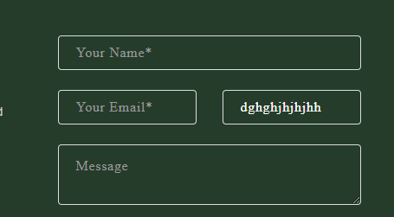

For 2 hyperlink:

Spacing between Heading and Content is not same



For 3 hyperlink:

About us is not present.

Required field * is not present.

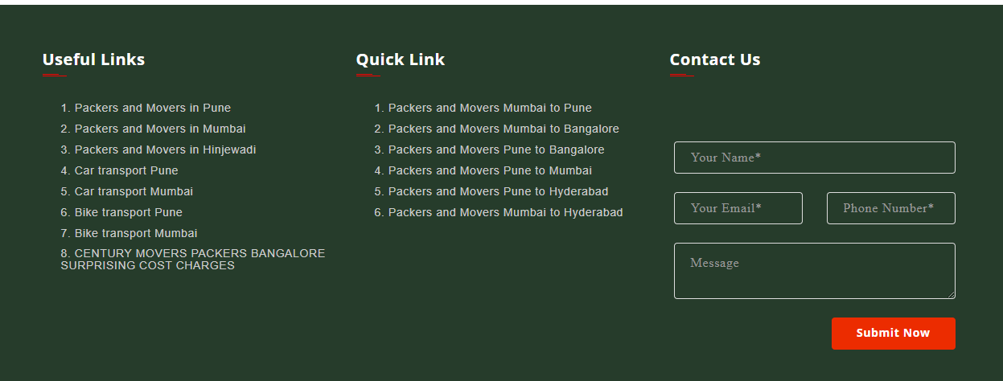



For 4 hyperlink:

Numbered list present for Title and content while others don’t have

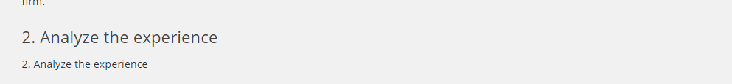

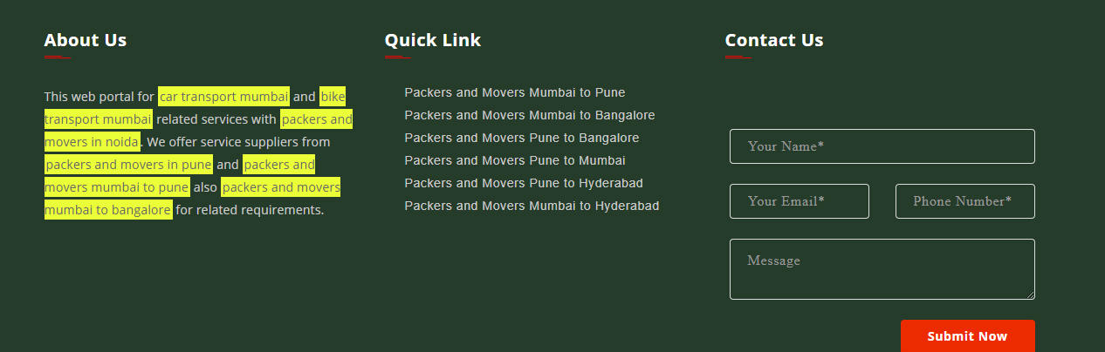

For 5 hyperlink:

Validation for the Advertise form is not done.

Directly form gets submitted without popping any error message.

