A Comparative Study of Chunking Strategies, Embedding Models and Retrieval Pipelines for RAG over Health and Legal Documents
Vinayak Kalal, Samvit Nandakishore, Sabbir Mondal, Rahul Shenoy
SRNs: PES2UG25AM809, PES2UG24AM144, PES2UG24AM141, PES2UG24AM129
Abstract—Retrieval-augmented generation (RAG) depends on how documents are split into chunks, how chunks are embedded and how retrieval is performed, yet these choices are often made by habit. We present a staged empirical study of nine chunking strategies, four open-source embedding models and three retrieval pipelines (dense, hybrid BM25 plus dense, and hybrid with a cross-encoder reranker) on two document domains, health fact sheets and legal texts. Retrieval is scored with chunk-size-independent span-overlap metrics against 58 LLM-drafted, evidence-grounded questions (36 health, 22 legal), answer quality with an LLM judge on 12-question subsets, and the results are mapped to the measures of ITU-T F.748.52. The best chunker depends on the document: semantic chunking is best on health documents (f_{ctx} 0.918) but only sixth on legal documents, where eight-sentence groups lead (0.951), and the two chunker rankings are uncorrelated (Spearman −0.02). The best embedder also differs (e5-small for health, bge-small for legal). Hybrid retrieval raises mean f_{ctx} from 0.848 to 0.878 (health) and from 0.876 to 0.941 (legal); a reranker adds 0.031 and 0.013 more at 27 to 36 times the latency of hybrid retrieval and narrows the gap between the best and worst chunker to about 0.07 and 0.06. Truncating embeddings to 256 dimensions keeps 95 to 98% of quality. With 22 to 36 questions, most pairwise differences are within noise. We distil the results into a decision matrix and a Config Advisor application.
Index Terms—Retrieval-augmented generation, chunking, text embeddings, hybrid retrieval, reranking, RAG evaluation, ITU-T F.748.52

I. Introduction

A. Motivation
Retrieval-augmented generation (RAG) grounds a large language model in external documents by retrieving relevant passages at query time [1]. The quality of a RAG answer is bounded by the quality of retrieval: if the needed evidence is missing from the retrieved context, or buried among irrelevant text, the generator cannot recover [3]–[5]. Three engineering decisions determine what the generator sees: how documents are split into chunks, which embedding model represents the chunks, and how candidates are retrieved and ordered. Tutorials and framework defaults usually suggest a fixed chunk size with some overlap and a popular embedding model, and teams rarely test whether that default suits their own documents.

B. Problem and Gap
Prior work examines these decisions mostly one at a time. Studies of chunking compare strategies on a single dataset or domain [7]–[10]. Embedding benchmarks such as MTEB and BEIR score models on passages that are already segmented [18], [19]. Evaluations of RAG components seldom break results down by document type [25]. In the works we reviewed we found no study that varies chunking, embedding model and retrieval pipeline together using a metric that does not depend on chunk size, nor one that also reports what embedding compression costs in quality. A practitioner therefore cannot tell whether a published recommendation transfers to their own documents.

C. Objectives and Contributions
This paper addresses Problem Statement 6 of the course: a systematic comparison of chunking strategies and embedding models on RAG retrieval. We ask three research questions. RQ1: does the best chunking and embedding combination depend on the document and on the pipeline around it? RQ2: does a stronger retrieval pipeline reduce the sensitivity of results to the chunking choice? RQ3: how much quality is lost when embeddings are truncated or quantized? These map to three hypotheses: H1, structure-aware chunking outperforms fixed-size and semantic chunking on structured documents; H2, a reranker narrows the gap between chunking strategies; H3, truncated or binary embeddings lose little accuracy while cutting storage and latency.
Our contributions are:
- A span-based evaluation protocol in which gold evidence is stored as character offsets, so retrieval metrics are comparable across chunk sizes and need no LLM.
- A staged experimental design that keeps the 9 × 4 × 3 grid of chunkers, embedders and retrieval modes tractable on a CPU-only machine.
- Empirical results on two document domains, health and legal, covering chunking strategy, embedding model, retrieval pipeline, answer quality and compression, with bootstrap confidence intervals and paired significance tests. The best configuration turns out to depend on the domain.
- An evaluation mapped to the measures of ITU-T F.748.52 [30], the international standard for RAG evaluation, with a clause-by-clause alignment review.
- A decision matrix and a Config Advisor application (Streamlit), backed by a single reproducible notebook in which the LLM provider can be switched; the application supports eleven provider options.

D. Paper Organisation
Section II reviews related work and states the research gap. Section III describes the data and methodology, Section IV the implementation and Section V the experimental setup. Section VI presents the results, Section VII the ITU-T F.748.52 evaluation, and Section VIII the decision matrix and advisor. Section IX relates the findings to the research questions and prior work, Section X discusses limitations and future work, and Section XI concludes. The Appendix lists the prompts and fixed settings.

E. Relevance to Prompt Engineering
Although the subject is retrieval, prompt design is part of the method in three places: the prompts that draft evaluation questions with verifiable evidence, the constrained generation prompt that makes abstention detectable, and the judge prompt that scores answers, including the ITU-T Annex A grades, in a single call. Section IV.C explains these design choices, and the Appendix gives the prompts in full. Because the generator is instructed to rely only on retrieved context, differences in answer quality can be attributed to what was retrieved and not to the model’s own knowledge.

II. Related Work

A. RAG Foundations and Failure Modes
Lewis et al. [1] combined a parametric generator with a retrieval memory, and dense retrievers such as DPR [2] made semantic passage retrieval practical. Gao et al. [3] group RAG systems into naive, advanced and modular designs, where advanced systems add query rewriting before retrieval and reranking after it. Barnett et al. [4] report seven failure points from engineering experience, several concerning evidence that is missing, ranked too low or not usable in the final context. Liu et al. [5] show that models use information less reliably when it sits in the middle of a long context, and Cuconasu et al. [6] find that the kind of irrelevant text in the retrieved context changes accuracy in non-obvious ways. Together these results motivate measuring recall, precision and noise jointly.

B. Chunking
Fixed-size chunking with overlap is the framework default. Semantic chunking, which splits where neighbouring sentences diverge, is popular in practitioner material, but Qu et al. [7] report that its gains over fixed-size chunking are not consistent enough to justify the extra computation. Chen et al. [8] study retrieval granularity and show that indexing propositions can improve retrieval and downstream question answering at the price of LLM preprocessing. Yepes et al. [9] propose element-based chunking that follows the structure of financial reports and report gains over fixed-size baselines, and Finardi et al. [10] study how retriever, chunking and generator choices jointly affect RAG quality. Late chunking [11] and Contextual Retrieval [12] enrich chunk representations with document context, while parent-document (small-to-big) retrieval embeds small units but returns a larger parent section.

C. Embedding Models and Compression
Sentence-BERT [13] established bi-encoder sentence embeddings. Open models such as E5 [14], BGE [15], GTE [16] and Nomic Embed [17] are trained with large-scale contrastive learning. MTEB [18] and BEIR [19] average performance over many tasks and mostly evaluate pre-segmented passages, so they say little about behaviour after chunking or across document types. Matryoshka Representation Learning [20] trains vectors whose leading dimensions remain useful when truncated, and binary or scalar quantization can shrink indexes while keeping much of retrieval quality [21]. These results come from benchmark settings, not from combinations with chunking choices.

D. Retrieval Pipelines and Evaluation
BM25 [22] remains a strong sparse baseline for exact terms and identifiers. Reciprocal Rank Fusion (RRF) [23] merges sparse and dense rankings without training, and cross-encoder rerankers [24] re-score a short candidate list jointly with the query. Wang et al. [25] compare combinations of RAG components, and FAISS [26] provides efficient vector search. RAGAS [27] defines reference-free RAG metrics that rely on an LLM judge, which Zheng et al. [28] show agrees well with humans but has position, verbosity and self-enhancement biases. We avoid LLM judging for retrieval and keep it for answer-level metrics. ITU-T F.748.52 [30] standardises requirements and evaluation methods for RAG systems: retrieval accuracy, recall and average precision, five-level grades for answer relevance, faithfulness and truthfulness, negative rejection, information integration, throughput and response time. Section VII maps our evaluation to it.
Table I compares 21 of the 30 sources reviewed, grouped by theme, and states how each relates to this study. In almost every case the work varies one or two factors on one dataset, which is the gap this study addresses.

TABLE I
Comparison of key works
Work | Focus | Main finding | Relation to this study
Lewis et al. [1] | RAG formulation | Generator combined with a retrieval memory for knowledge-intensive tasks | Basis of our pipeline
Gao et al. [3] | RAG survey | Naive, advanced and modular RAG | Frames our dense, hybrid, reranked progression
Barnett et al. [4] | Failure points | Seven failure points, several in retrieval | Motivates retrieval-focused metrics
Qu et al. [7] | Semantic vs fixed chunking | Semantic gains not consistent enough for the cost | We compare it across embedders and domains
Chen et al. [8] | Retrieval granularity | Proposition units can improve retrieval and QA | We test cheaper units and parent-child
Yepes et al. [9] | Element-based chunking | Structure-aware chunking helped on financial reports | We test it on health and legal documents
Finardi et al. [10] | Retriever, chunk, generator | Components interact and should be studied together | Supports our staged design
Günther et al. [11] | Late chunking | Embeds long text first, then pools chunk vectors | Future extension
Anthropic [12] | Contextual Retrieval | Prepends LLM-written context to each chunk | Future extension
Reimers and Gurevych [13] | Sentence-BERT | Established bi-encoder sentence embeddings | Basis of our embedding comparison
Wang et al. [14] | E5 embeddings | Weakly-supervised contrastive pre-training | e5-small is one of our models
Xiao et al. [15] | BGE embeddings | Open general-purpose embedding family | bge-small is one of our models
Kusupati et al. [20] | Matryoshka vectors | Leading dimensions stay useful when truncated | Basis of our truncation tests
Shakir et al. [21] | Binary and scalar quantization | Smaller indexes that keep much of the quality | Basis of our binary tests
Robertson and Zaragoza [22] | BM25 | Strong sparse baseline for exact terms | Sparse half of hybrid mode
Cormack et al. [23] | Reciprocal Rank Fusion | Training-free merging of rankings | Our hybrid fusion
Nogueira and Cho [24] | Cross-encoder reranking | Joint query and passage scoring improves ordering | Our reranking stage
Wang et al. [25] | RAG best practices | Recommends balanced component combinations | General; we examine chunkers in detail
Es et al. [27] | RAGAS metrics | Reference-free RAG metrics using an LLM judge | We use span metrics for retrieval
Zheng et al. [28] | LLM-as-a-judge | High agreement with humans but known biases | Motivates our caution about judge bias
ITU-T F.748.52 [30] | RAG evaluation standard | Requirements and evaluation methods for RAG | Our evaluation is mapped to its measures

E. Research Gap
Taken together, the reviewed work leaves five gaps that this study addresses.
- Limited document diversity. Comparisons usually use one generic or single-domain corpus, so it is unclear whether a recommendation transfers between document types.
- Components studied in isolation. Chunking, embedding model and retrieval pipeline are rarely varied together, and it is untested whether reranking reduces the importance of the chunking choice.
- Metrics tied to chunk boundaries. Common retrieval metrics depend on how the corpus was chunked, which complicates fair comparison between chunkers of different sizes.
- Efficiency studied separately. Truncation and quantization are evaluated on benchmarks and not jointly with chunking, latency and index size.
- No practitioner-ready output. Findings are seldom turned into a decision aid mapping document type and priorities to a configuration.

III. Dataset and Methodology

A. Corpora
We prepared four corpora of two documents each and use two of them, health and legal, for all main results. The health corpus consists of the WHO fact sheets on asthma and diabetes. The legal corpus consists of an explanatory page on a national constitution and the Universal Declaration of Human Rights (PDF); its gold evidence lies in one of the two documents, so the other acts as a distractor. The AI governance corpus (the OECD AI Principles page and a second AI-policy document) has only four gold questions and every sensible configuration scores at or near the ceiling, so we treat it as a pilot and do not draw conclusions from it. The fourth corpus, Python library documentation, is excluded: its 85 gold questions refer to the argparse and re pages, but the documents loaded for that run were bisect and heapq, so every retrieval score was exactly zero (Section X). Table II summarises the corpora.
TABLE II
Corpora and their role
Corpus | Docs | Words | Gold questions | Role
health | 2 | 2,495 | 36 (21 single, 15 multi) | main
legal | 2 | 2,301 | 22 (7 single, 15 multi) | main
ai_governance | 2 | 859 | 4 (3 single, 1 multi) | pilot
tech_docs | 2 | 3,910 | 85 (60, 15, 10 unans.) | excluded

HTML is converted to lightly structured text: headings become markdown-style lines, code becomes fenced blocks and tables become pipe-separated rows. The loader also accepts PDF and text files, so a new document type can be added without code changes.

B. Preprocessing and Leakage Control
Pages are cleaned before any chunking: scripts, navigation, headers and footers are removed, anchor symbols are dropped, code blocks are wrapped in fences so that they are never cut mid-block, and whitespace is normalised. After cleaning, each document is a single string, and that same string is used for chunking, for locating evidence and for scoring, so character offsets stay valid throughout. Several design choices prevent leakage between the components. Gold evidence is taken from the document itself and is independent of any chunker, so no chunking strategy is advantaged by how the questions were made. The model that splits text for semantic chunking (MiniLM) is used only for splitting and its retrieval scores are not used to build questions. The LLM that drafts questions sees only a text window, never the retrieval systems or their outputs. No hyperparameter was tuned on the gold set: sizes, k and fusion constants were fixed in advance, so the questions act as a pure test set and there is no train–test overlap to control.

C. Gold Question Set
Each corpus has its own gold set, drafted with an LLM from randomly sampled windows of roughly 100 to 260 words. For a single-hop question the model returns a question, a short answer and one or two sentences copied verbatim from the window as evidence. Evidence is located in the source document by exact string matching, and questions whose evidence cannot be found are discarded, so every answerable question carries character offsets (document, start, end). Multi-hop questions combine two non-adjacent windows of one document and have two evidence spans. The notebook targets 60 single-hop, 15 multi-hop and 10 unanswerable questions per corpus, but our corpora are short, so fewer distinct windows were available: the health set has 36 questions (21 single-hop, 15 multi-hop) and the legal set 22 (7 single-hop, 15 multi-hop). Neither contains unanswerable questions, so negative rejection cannot be measured on them. Answer-level evaluation uses a fixed random subset of 12 questions per configuration, which contains seven multi-hop questions. None of the 58 questions has been manually verified yet (the notebook records zero verified rows), and the drafting model is not stored in the gold files (Section X). The prompts are listed in the Appendix.

D. Chunking Strategies
All chunkers return character spans into the original document, which is what allows a common evaluation. Table III lists the nine configurations. Fixed chunks contain a given number of words with optional overlap. Sentence chunks group consecutive sentences (a regular-expression splitter that keeps headings and fenced code as single units). Semantic chunking embeds each sentence together with its neighbours (buffer of one) using a small separate model (all-MiniLM-L6-v2), starts a new chunk where the cosine distance between adjacent windows exceeds the 90th percentile, merges chunks under 40 words and caps chunks at 300 words. Structure-aware chunking works on paragraph and code blocks and starts a new chunk at a heading (or clause marker such as “Section 5”) once the current chunk has at least 40 words, or when adding a block would exceed 300 words. Parent-child (hierarchical) retrieval embeds 100-word child chunks and returns the enclosing structure-aware section of up to 400 words, de-duplicated across hits.
TABLE III
Chunking configurations: chunks / average words
Chunker | Parameters | Health | Legal
fixed_128_o0 | 128 words, no overlap | 20 / 124.8 | 18 / 127.8
fixed_128_o32 | 128 words, 32 overlap | 26 / 125.5 | 24 / 125.2
fixed_256_o0 | 256 words, no overlap | 10 / 249.5 | 9 / 255.7
fixed_256_o64 | 256 words, 64 overlap | 14 / 233.1 | 12 / 245.1
sent_4_o1 | 4 sentences, 1 overlap | 69 / 47.9 | 45 / 65.1
sent_8_o2 | 8 sentences, 2 overlap | 34 / 97.4 | 22 / 130.8
semantic_p90 | 90th percentile, 40-300 words | 19 / 131.3 | 18 / 127.8
structure_300 | headings, blocks, max 300 words | 20 / 124.8 | 15 / 153.4
parent_child | child 100 words, parent max 400 | 26 / 96.0 | 24 / 95.9

E. Embedding Models
We compare four open models, all producing 384-dimensional vectors and run locally: BGE-small-en-v1.5 [15] with its query instruction prefix, e5-small-v2 [14] with “query:” and “passage:” prefixes, GTE-small [16] and all-MiniLM-L6-v2 [13]. Inputs are truncated to 512 tokens and vectors are L2-normalised, so inner product equals cosine similarity. Vectors are stored in an exact FAISS flat index [26]. Embeddings are cached on disk so that reruns are deterministic and fast. The maximum input length is 512 tokens for BGE, E5 and GTE and 256 tokens for MiniLM, so MiniLM silently truncates longer inputs; the 256-word chunk sets (about 230 to 256 words on average) exceed that limit and MiniLM’s scores on them should be read with this in mind. API embedders (Gemini, OpenAI) are supported by the code but were not used.

F. Retrieval Pipelines
Dense retrieval returns the top-5 units by cosine similarity. Hybrid retrieval runs BM25 [22] over the chunk text in parallel with dense search, takes the top 30 of each and merges them with RRF (k = 60) [23]. Hybrid + rerank re-scores the top 20 fused units with the cross-encoder ms-marco-MiniLM-L-6-v2 [24] and returns the best five. For parent-child chunking the retrieved children are mapped to their parents and de-duplicated before the fusion output is cut to five units.

G. Evaluation Metrics
Let E be the evidence spans of a question and U the retrieved units, all as character intervals. The coverage of an evidence span e is the share of its characters inside retrieved units, and context recall averages it over the spans (so a multi-hop question is rewarded only for finding both pieces):
cov(e) = |e ∩ ⋃_{*u*∈*U*} u| / |e| (1)
R = (1/|E|) Σ_{*e*∈*E*} cov(e) (2)
A retrieved unit is relevant if it covers at least 30% of an evidence span or if at least half of the unit lies inside one. Context precision is the rank-aware average precision over the m relevant units at ranks k₁ < … < k_{m} (zero if none are found), and f_{ctx} is their harmonic mean, our primary ranking metric:
P = (1/m) Σ_{*i*=1…*m*} i / k_{*i*}, f_{ctx} = 2RP / (R + P) (3)
We also report Hit@5 (some evidence span at least half covered), MRR, density (evidence characters divided by retrieved characters, a measure of noise) and the number of words passed to the generator. Section VII adds the measures of ITU-T F.748.52: accuracy P_{A}, recall R_{A} and MAP@5 for retrieval, and exact match, the Annex A grades, negative rejection and information integration for answers. Answer quality uses an LLM judge in a single call per question that returns groundedness (fraction of claims in the answer supported by the retrieved context), correctness (1, 0.5 or 0 against the reference answer), an abstention flag and the three five-level Annex A grades. Confidence intervals are 95% percentile bootstrap intervals over questions (2,000 resamples), and differences between configurations use a paired bootstrap on per-question f_{ctx} (5,000 resamples). Latency is the median and 95th percentile of 15 single-query retrievals after a warm-up call, with uncached query encoding. Index size is the stored vector bytes.

H. Worked Example
To make the metrics concrete, consider an illustrative question (numbers constructed for illustration) whose evidence span has 200 characters. Suppose the top-ranked unit has 600 characters and contains 180 of the evidence characters, so cov = 0.90 and R = 0.90. The unit is relevant and sits at rank 1, so P = 1 and f_{ctx} = 0.947. If the same unit were ranked third behind two irrelevant units, R would be unchanged but P = 1/3, and f_{ctx} falls to 0.486. If a 60-character unit lying inside the evidence were retrieved instead, it would also count as relevant (more than half of it lies in the span), but R could be at most 0.30. The metrics therefore reward finding the evidence, ranking it early and not diluting it with other text, regardless of how the document was cut.

I. Proposed Pipeline
Fig. 1 shows the end-to-end workflow and Table IV summarises the components. Everything runs from one notebook in which the LLM provider is a switchable option and the model is selected from the list available to the user’s API key.
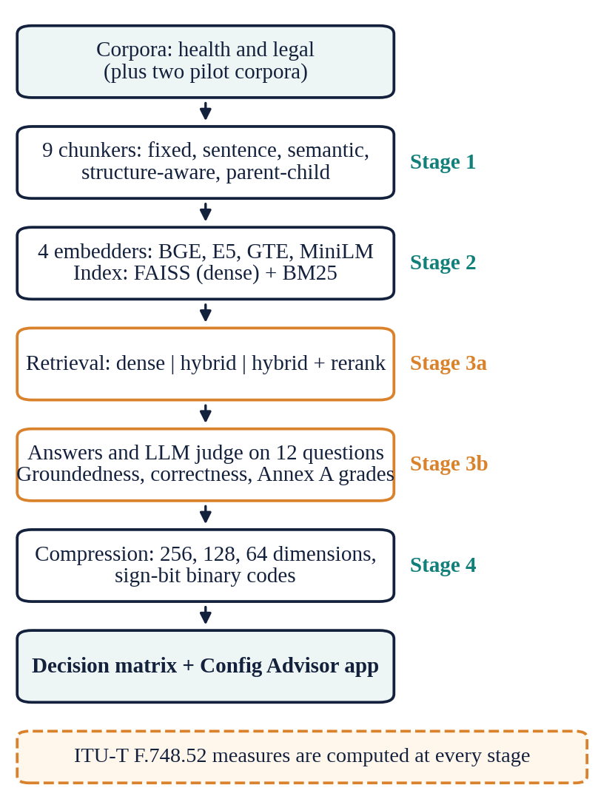
Fig. 1. End-to-end pipeline and the experimental stages run on it.
TABLE IV
Compact methodology summary
Component | Description | Key setting
Corpora | Health and legal (main); two pilot corpora | 2 docs each, 2.3 to 2.5k words
Gold set | LLM-drafted questions with verbatim evidence spans | 36 health, 22 legal
Chunking | Fixed, sentence, semantic, structure-aware, parent-child | 9 configurations
Embeddings | Local bi-encoders, cosine over normalised vectors | 4 models, 384-d
Retrieval | FAISS flat index, BM25, RRF, cross-encoder | top-5 from 30 candidates
Metrics | Span recall, precision, f_{ctx}; LLM groundedness and correctness | 95% bootstrap CIs
Standard | ITU-T F.748.52 measures and alignment review | 20 clauses reviewed
LLM | Stage 3b answers and judge: Gemini 3.5 Flash-Lite, temperature 0, cached | 12 questions per setting
Reproducibility | Single notebook, disk caches, fixed seed | seed 42

IV. Implementation

A. Software Architecture
The study is implemented as a single Jupyter notebook organised into the modules of Table V, so that every experiment can be re-run from a clean environment. Each module is a small set of functions whose only hidden state is an on-disk cache. The results are explored through a separate Streamlit application (Section VIII).
TABLE V
Software modules of the notebook and application
Module | Function
Corpus loader | Converts HTML, PDF and text into structured text; keeps one normalised string per document so offsets stay valid; checks that gold evidence documents are loaded
Chunkers | Nine span-based chunkers (words, sentences, semantic, structure-aware, parent-child)
Embedder wrapper | Local sentence-transformers or optional API embedders; query and passage prefixes; truncation; disk cache
Retriever | FAISS flat or binary index, BM25, reciprocal rank fusion, cross-encoder reranking
Gold-set generator | LLM drafting, verbatim-evidence location, CSV export for manual review
Evaluator | Span metrics, LLM judge, latency, index size, bootstrap confidence intervals
F.748.52 module | P_{A}, R_{A}, MAP@5, Annex A grades, negative rejection, information integration, throughput, response time, alignment table
LLM layer | Provider switch (Gemini, OpenRouter, Ollama), key-based model picker, retries, SQLite response cache
Reporting and app | Heatmaps, pipeline plots, decision matrix; Streamlit app with results, F.748.52 and document Q&A tabs

B. LLM Layer and Model Selection
All LLM calls in the notebook go through one function. The provider is a configuration option (Gemini through Google AI Studio, OpenRouter, or a local Ollama model), so the same experiment can be repeated with a different generator and judge. Model identifiers change frequently and free-tier models rotate, so none are hard-coded: after the user supplies an API key, the notebook lists the models that key can call, lets the user choose one from a numbered list or a dropdown, and confirms the choice with a one-word test call. Responses are cached in SQLite under a key made from provider, model, temperature and prompt, so identical calls are never repeated and switching provider never mixes results. Failed calls are retried with exponential back-off and longer waits on rate limiting (the saved log shows several rate-limit waits during Stage 3b). The Streamlit application supports eleven provider options: Gemini, OpenRouter, OpenAI, Groq, SiliconFlow, Together AI, DeepSeek, Mistral, Z.ai, Anthropic and Ollama, plus an offline mode.

C. Prompt Design
The study uses LLMs for three tasks, and each prompt was designed around a specific failure risk. Question drafting requires evidence copied verbatim, which lets the pipeline verify by exact string matching that the evidence exists and recover its character offsets; hallucinated or paraphrased evidence is discarded automatically. The prompt also demands self-contained questions that never refer to “the passage”, since such questions cannot be retrieved without that context, and a JSON-only output that is parsed defensively. Generation restricts the model to the retrieved context and prescribes an exact abstention phrase, which makes abstention detectable and prevents answers from parametric knowledge from inflating groundedness. The judge receives context, question, reference and answer and returns all its scores in one call, which halves the number of requests compared with separate calls, an important saving under free-tier rate limits. Its three five-level grades follow the scales of ITU-T F.748.52 Annex A. All calls use temperature 0. The prompts are given in the Appendix.

D. Reproducibility and Cost Control
Embeddings are cached on disk under a key made from model, prefixes and a hash of the texts, retrievers are cached per (corpus, chunker, embedder, dimension, quantization), and every evaluated configuration is appended to a results file with its stage, settings, provider and model. Before the answer-quality stage the notebook prints the number of LLM requests it will make (about 576: two per question, 12 questions, three modes, two pairs and four corpora), and the gold set is stored as a CSV that can be reviewed and marked as verified, after which only verified rows are used.

V. Experimental Setup

A. Staged Design
A full grid of nine chunkers, four embedders and three retrieval modes would need 108 configurations per corpus before any compression or LLM evaluation. We instead use stages in which each stage narrows the next. Stage 1 compares all nine chunkers with one fixed embedder (BGE-small, dense). Stage 2 crosses the three best chunkers with all four embedders. Stage 3a runs all nine chunkers with the best Stage 2 embedder (e5-small for health, bge-small for legal) in the three retrieval modes, which is the test of H2. Stage 3b adds answer generation and judging for the two best (chunker, embedder) pairs in all three modes. Stage 4 takes the best pair and evaluates truncation to 256, 128 and 64 dimensions and sign-bit binary quantization. Stages 1, 2, 3a and 4 need no LLM calls.

B. Environment and Settings
Experiments ran on a CPU-only machine in Python with sentence-transformers, FAISS (CPU), rank_bm25, pandas and SciPy. The random seed is 42. Stage 3b answer generation and judging used Gemini 3.5 Flash-Lite through Google AI Studio at temperature 0, with responses cached on disk keyed by provider, model and prompt. Retrieval settings were fixed in advance and not tuned: top-5 units, a pool of 30 candidates, a rerank pool of 20, RRF constant 60 and a relevance threshold of 0.3. The reported numbers therefore describe sensible defaults, not the best attainable per method.

C. Primary Metric
We rank configurations by f_{ctx} because the application needs both evidence coverage and low noise: recall alone favours large chunks, and precision alone favours tiny ones. Because f_{ctx} is computed from character overlap, a 48-word sentence group and a 250-word fixed chunk are judged by the same standard.

D. Statistical Procedures
Per-question scores are resampled with replacement to obtain 95% percentile intervals for a configuration mean (2,000 resamples). To compare two configurations on the same questions we resample the per-question differences (5,000 resamples) and report the mean difference, its 95% interval and a two-sided p-value taken as twice the smaller tail proportion of the resampled differences. We regard a comparison as clear only when the interval excludes zero. Three comparisons per domain were planned in advance for H1 (structure-aware against the best fixed-size, sentence and semantic chunker), six in all, and no multiple-comparison correction was applied; all other contrasts in Section VI are descriptive and are labelled as such. The correlation between the two domains’ chunker rankings is a Spearman coefficient over the nine chunkers. Answer-level metrics use 12 questions and are reported without intervals because they are too few for them to be informative.

VI. Results and Discussion

A. Chunking Strategies (Stage 1)
Table VI and Fig. 2 give the Stage 1 results. The two domains rank the chunkers very differently. On health documents semantic chunking scores highest (f_{ctx} 0.918, 95% CI 0.873 to 0.959) and parent-child retrieval lowest (0.742, CI 0.655 to 0.825). On legal documents eight-sentence groups lead (0.951, CI 0.913 to 0.982) and 128-word chunks with overlap are lowest (0.826, CI 0.748 to 0.898). In both domains the interval of the best chunker does not overlap that of the worst, but most of the middle of each ranking lies within noise.
The most striking result is cross-domain: the Spearman correlation between the two chunker rankings is −0.02 (p = 0.97, nine chunkers). Semantic chunking is first on health but sixth on legal; eight-sentence groups are first on legal but sixth on health; parent-child retrieval is last on health but second on legal. This answers the document-type part of RQ1: a chunking recommendation does not transfer between these two domains.
TABLE VI
Stage 1: chunker comparison (BGE-small, dense, top-5). H = health, L = legal
Chunker | H R | H P | H f_{ctx} | L R | L P | L f_{ctx}
fixed_128_o0 | .909 | .770 | .799 | .890 | .838 | .845
fixed_128_o32 | .903 | .824 | .828 | .883 | .821 | .826
fixed_256_o0 | .986 | .780 | .849 | .988 | .764 | .842
fixed_256_o64 | .986 | .800 | .861 | .920 | .858 | .863
sent_4_o1 | .875 | .880 | .851 | .955 | .911 | .910
sent_8_o2 | .875 | .850 | .830 | .999 | .918 | .951
semantic_p90 | .958 | .914 | .918 | .977 | .793 | .854
structure_300 | .958 | .855 | .878 | .977 | .825 | .873
parent_child | .875 | .711 | .742 | .955 | .894 | .921

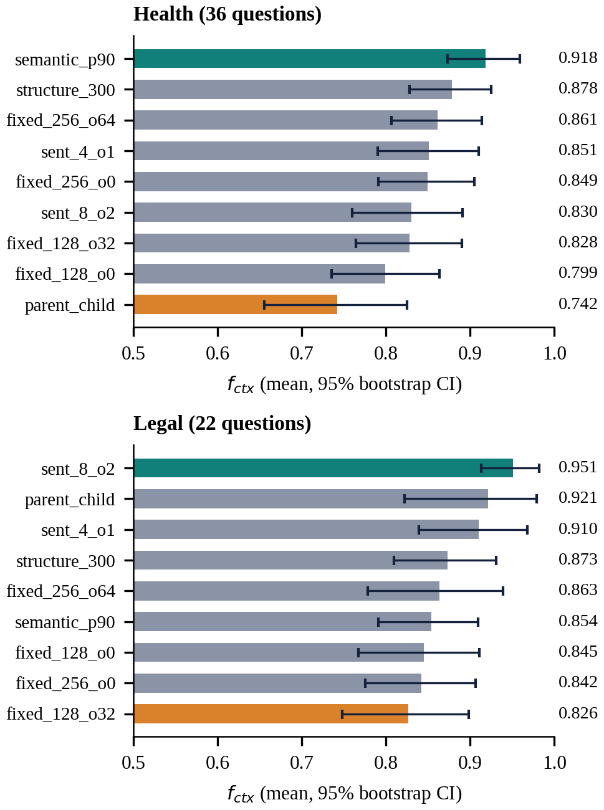
Fig. 2. Stage 1 f_{ctx} per chunker with 95% bootstrap confidence intervals. The best chunker is teal and the lowest orange.
Structure-aware chunking, which H1 predicted to win, ranks second on health (0.878) and fourth on legal (0.873). Table VII gives the three planned paired comparisons per domain, each against the best chunker of another family. On health, structure-aware chunking is numerically ahead of the best fixed-size (+0.017) and sentence-based (+0.028) chunkers and behind semantic chunking (−0.040), but none of these intervals excludes zero. On legal documents it is clearly worse than eight-sentence groups (−0.078, CI −0.129 to −0.029, p = 0.002) and not clearly different from the other two. H1 is therefore not supported in either domain. We made six planned comparisons without correction; the one clear difference would survive a Bonferroni threshold of 0.05/6.
TABLE VII
H1: structure_300 against the best chunker of each family (paired bootstrap on f_{ctx})
Domain | Compared with | Diff. | 95% CI | p
Health | fixed_256_o64 | +0.017 | [−0.044, +0.082] | 0.618
Health | sent_4_o1 | +0.028 | [−0.023, +0.076] | 0.275
Health | semantic_p90 | −0.040 | [−0.091, +0.011] | 0.130
Legal | fixed_256_o64 | +0.010 | [−0.076, +0.109] | 0.829
Legal | sent_8_o2 | −0.078 | [−0.129, −0.029] | 0.002
Legal | semantic_p90 | +0.019 | [−0.047, +0.090] | 0.570

Overlap and size effects are inconsistent. Adding 32 words of overlap to 128-word chunks raised f_{ctx} on health (0.828 against 0.799) and lowered it on legal (0.826 against 0.845); adding 64 words to 256-word chunks raised it in both (0.861 against 0.849 and 0.863 against 0.842). All of these changes lie inside the intervals. Larger fixed chunks scored higher than smaller ones on health (0.849 and 0.861 against 0.799 and 0.828); on legal the picture is mixed (0.842 against 0.845 without overlap, 0.863 against 0.826 with overlap). With 36 and 22 questions the 95% intervals of single configurations are about ±0.05 to ±0.09 wide, so only differences of roughly 0.09 or more in f_{ctx} can be detected reliably, and we treat the order of the middle chunkers as provisional.
Chunk choice also changes how much text reaches the generator (top five units). Four-sentence groups pass only 284 words on health and 493 on legal, with the highest evidence density (0.098 and 0.084), whereas 256-word chunks pass 1,187 to 1,278 words. Using roughly 1.3 tokens per English word, the retrieved context costs about 370 prompt tokens for four-sentence groups on health against about 1,540 for 256-word chunks with overlap, a factor of 4.2 (2.6 on legal). On health, four-sentence groups score 0.851 against 0.861 for the larger chunks, so the saving comes with little loss; on legal they score 0.910 against 0.863.

B. Embedding Models (Stage 2)
Fig. 3 crosses the three best Stage 1 chunkers of each domain with the four embedders. The best embedder changes with the domain and the chunker. On health documents e5-small is best for semantic chunking (0.942) and structure-aware chunking (0.905), and gte-small for 256-word chunks with overlap (0.872). On legal documents bge-small is best for eight-sentence groups (0.951) and parent-child retrieval (0.921), and gte-small ties it for four-sentence groups (0.911 against 0.910). MiniLM is lowest in five of the six rows. The spread across embedders within a chunker ranges from 0.045 to 0.118, so the embedding choice can move f_{ctx} about as much as the chunker choice. The best pair is semantic chunking with e5-small on health (0.942) and eight-sentence groups with bge-small on legal (0.951). This extends the answer to RQ1: chunker and embedder cannot be chosen independently of each other or of the document type. Because the three chunkers were chosen with BGE-small in Stage 1, other chunkers were not crossed with all embedders (Section X).
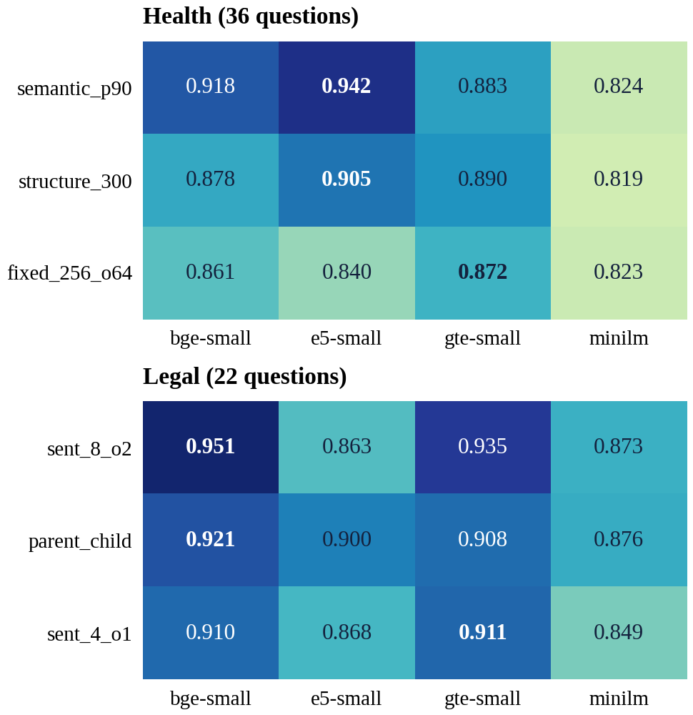
Fig. 3. Stage 2 f_{ctx} for the three best Stage 1 chunkers across four embedders (dense retrieval). The best embedder in each row is in bold.

C. Retrieval Pipeline (Stage 3a)
Fig. 4 and Table VIII compare the three retrieval modes for all nine chunkers, using the best Stage 2 embedder of each domain. Hybrid retrieval raised the mean f_{ctx} from 0.848 to 0.878 on health and from 0.876 to 0.941 on legal. It improved eight of nine chunkers on health (up to +0.081 for 128-word chunks with overlap; parent-child fell by 0.012) and all nine on legal (+0.008 to +0.108). On legal documents the gain is larger where dense retrieval was weaker (Pearson r = −0.82 between the dense score and the gain), as expected if BM25 repairs weak dense matches; on health the relationship is absent (r = −0.09).
Adding the reranker raised the mean again, by +0.031 on health and +0.013 on legal, but at about 27 and 36 times the latency of hybrid retrieval (706 and 990 ms against 27 ms per query). Its effect varied by chunker: it helped eight of nine on health (parent-child +0.142, semantic chunking −0.013) and six of nine on legal, lowered two (256-word chunks with overlap −0.038, semantic chunking −0.017) and left structure-aware chunking unchanged.
H2 is supported descriptively. The spread between the best and worst chunker was about 0.18 (dense), 0.21 (hybrid) and 0.07 (hybrid + rerank) on health and 0.13, 0.08 and 0.06 on legal. The reranker therefore narrows the gap in both domains; on health hybrid retrieval alone widens it before the reranker closes it, whereas on legal hybrid retrieval accounts for most of the narrowing. The leader also changes with the pipeline on legal documents (eight-sentence groups for dense, a tie between 256-word chunks and eight-sentence groups under hybrid retrieval, four-sentence groups with the reranker), while semantic chunking leads in all three modes on health. The spread is a range statistic over a few dozen questions for which we computed no interval, and the per-chunker values are read from the notebook’s chart (Section X).
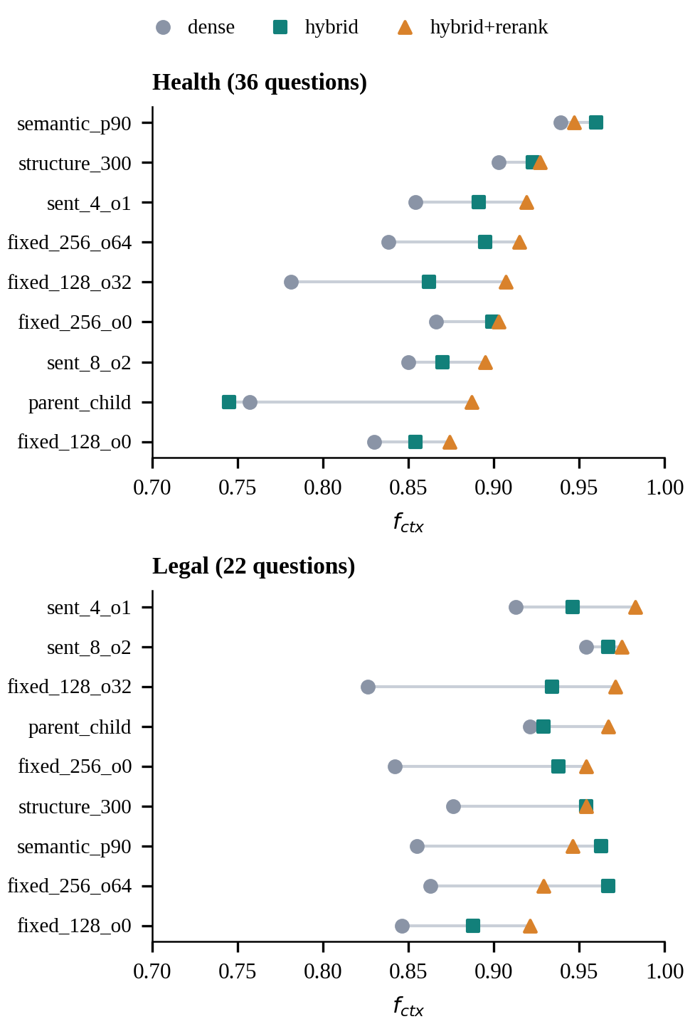
Fig. 4. Stage 3a f_{ctx} per chunker for dense (circle), hybrid (square) and hybrid + rerank (triangle) retrieval. Embedder: e5-small (health), bge-small (legal). Values were read from the notebook’s chart (±0.005).
TABLE VIII
Stage 3a: mean f_{ctx}, spread and time by retrieval mode
Domain | Mode | Mean | Spread | Time
Health | dense | 0.848 | ≈ 0.18 | 28 ms
Health | hybrid | 0.878 | ≈ 0.21 | 27 ms
Health | hybrid + rerank | 0.909 | ≈ 0.07 | 706 ms
Legal | dense | 0.876 | ≈ 0.13 | 26 ms
Legal | hybrid | 0.941 | ≈ 0.08 | 27 ms
Legal | hybrid + rerank | 0.954 | ≈ 0.06 | 990 ms

D. Answer Quality (Stage 3b)
Table IX reports the LLM-judged results for the two best pairs per domain on a 12-question subset. Groundedness is 1.000 in every configuration, as expected when the generator is told to answer only from the context. Correctness ranges from 0.833 to 1.000. One question moves correctness by 0.083, so differences of one or two questions cannot be interpreted. On health, adding the reranker raised correctness from 0.833 to 0.917 for both embedders (one question) although the f_{ctx} change was small. On legal, dense and hybrid retrieval answered all 12 questions correctly and the reranker lost one (0.917), even though it had the highest f_{ctx} (0.975). Higher f_{ctx} therefore does not map monotonically to higher correctness, and we draw no conclusions about mode effects on answers.
TABLE IX
Stage 3b: answer quality (12 questions, Gemini 3.5 Flash-Lite judge)
Pair | Mode | f_{ctx} | Ground. | Correct.
Health semantic + e5 | dense | 0.942 | 1.000 | 0.833
Health semantic + e5 | hybrid | 0.960 | 1.000 | 0.833
Health semantic + e5 | hyb.+rerank | 0.947 | 1.000 | 0.917
Health semantic + bge | dense | 0.918 | 1.000 | 0.833
Health semantic + bge | hybrid | 0.965 | 1.000 | 0.833
Health semantic + bge | hyb.+rerank | 0.947 | 1.000 | 0.917
Legal sent_8 + bge | dense | 0.951 | 1.000 | 1.000
Legal sent_8 + bge | hybrid | 0.965 | 1.000 | 1.000
Legal sent_8 + bge | hyb.+rerank | 0.975 | 1.000 | 0.917
Legal sent_8 + gte | dense | 0.935 | 1.000 | 1.000
Legal sent_8 + gte | hybrid | 0.975 | 1.000 | 1.000
Legal sent_8 + gte | hyb.+rerank | 0.975 | 1.000 | 0.917

E. Compression and Efficiency (Stage 4)
Table X and Fig. 5 evaluate compression for the best pair of each domain (semantic chunking with e5-small on health, eight-sentence groups with bge-small on legal). Truncating to 256 dimensions keeps 98.2% (health) and 95.0% (legal) of the full-vector f_{ctx} with a one-third smaller index; 128 dimensions keep 96.4% and 91.3%, and 64 dimensions 86.1% and 84.1%. Sign-bit binary quantization shrinks the index by a factor of 32 (0.029 to 0.001 MB on health) but keeps 78.5% (health) and 91.0% (legal) at 384 dimensions, and combining it with truncation degrades quality further (41.7% and 69.0% at 64 dimensions). The two domains disagree on how harmful binary codes are, and the corpora are so small that absolute index sizes (under 0.04 MB) make the storage saving irrelevant here.
The models were not trained for Matryoshka-style truncation and the binary codes use no calibration, so these are results for off-the-shelf small models and not a bound on what compression can achieve. H3 is partly supported: moderate truncation is cheap, whereas binary quantization of these models is not uniformly so. Median query latency stayed between 21 and 75 ms in every setting without a consistent trend, which suggests that query encoding on CPU, not vector search, dominates the cost on a corpus this size.
TABLE X
Stage 4: compression of the best pair (H = health, L = legal)
Dims | Type | H f_{ctx} | H rel. | L f_{ctx} | L rel. | MB (H / L)
384 | float32 | 0.942 | 100.0% | 0.951 | 100.0% | 0.029 / 0.034
384 | binary | 0.740 | 78.5% | 0.865 | 91.0% | 0.001 / 0.001
256 | float32 | 0.926 | 98.2% | 0.904 | 95.0% | 0.019 / 0.023
256 | binary | 0.632 | 67.0% | 0.781 | 82.1% | 0.001 / 0.001
128 | float32 | 0.908 | 96.4% | 0.868 | 91.3% | 0.010 / 0.011
128 | binary | 0.483 | 51.3% | 0.767 | 80.6% | <0.001 / <0.001
64 | float32 | 0.811 | 86.1% | 0.800 | 84.1% | 0.005 / 0.006
64 | binary | 0.393 | 41.7% | 0.657 | 69.0% | <0.001 / <0.001

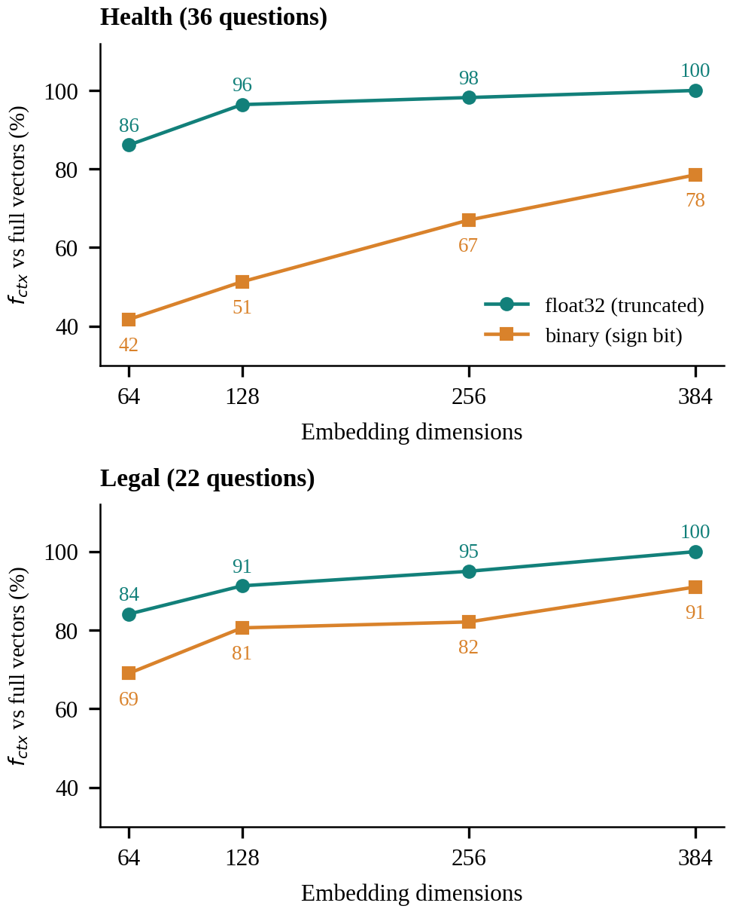
Fig. 5. Stage 4: f_{ctx} relative to full vectors against embedding dimensions.

VII. ITU-T F.748.52 Evaluation

A. The Standard and How the Study Maps to It
ITU-T Recommendation F.748.52 (03/2025) [30] defines requirements and evaluation methods for RAG systems: data handling, retrieval modes and quality, answer quality, optimization capabilities, application maturity, robustness, security, throughput and response time. We map every measurable clause to a stage of the study and review all 20 clauses for coverage (Table XIV). Eleven are implemented, five partly, two are out of scope for a research prototype and two are not implemented, so the study is aligned with the standard but not conformant.
The retrieval measures of clause 8.1.2 are the accuracy P_{A} (share of the five retrieved units that are relevant), the recall R_{A} (share of evidence spans found) and the mean average precision at n = 5 (MAP@5); the notebook reads “number of related documents” in the MAP equation as the number of gold evidence spans. Answer-level measures are the exact-match rate (clause 8.2.4), the Annex A five-level grades of relevance, faithfulness and truthfulness (clauses 8.2.1 to 8.2.3), negative rejection (P_{ERR}, P_{EAR} and P_{NRR}, clause 9.2.5) and information integration (P_{MIR}, clause 9.2.6). Throughput and response time are clauses 9.2.3 and 9.2.4.

B. Retrieval Measures
Table XI lists the three best configurations by MAP@5 in each domain. R_{A} exceeds 97% for all of them and MAP@5 lies between 0.915 and 0.966. P_{A} is low in absolute terms (28 to 46%) because most questions have one or two evidence spans while five units are retrieved, so it is useful for comparing configurations rather than as an absolute score. Differences between the top rows (0.01 to 0.02 in MAP@5) are within noise. On health the best MAP@5 is hybrid semantic chunking with e5-small (0.936); on legal it is four-sentence groups with bge-small and the reranker (0.966).
TABLE XI
F.748.52 retrieval measures: top three by MAP@5
Configuration | P_{A} (%) | R_{A} (%) | MAP@5
Health semantic_p90 + e5, hybrid | 28.3 | 98.6 | 0.936
Health semantic_p90 + e5, hyb.+rerank | 27.8 | 97.2 | 0.915
Health semantic_p90 + e5, dense | 28.3 | 98.6 | 0.911
Legal sent_4_o1 + bge, hyb.+rerank | 45.5 | 97.7 | 0.966
Legal sent_8_o2 + bge, hyb.+rerank | 39.1 | 97.7 | 0.962
Legal fixed_128_o32 + bge, hyb.+rerank | 46.4 | 97.7 | 0.958

C. Answer Measures
Table XII gives the answer-level measures for the Stage 3b configurations. Faithfulness is 5.00 in every configuration; relevance and truthfulness range from 4.33 to 5.00. P_{EAR} (answerable questions answered correctly) is 83 to 100% and P_{MIR} (multi-hop questions answered fully correctly) 71 to 100%, that is five to seven of the seven multi-hop questions in each subset. Exact match is low (8 to 25%), as expected for free-text answers compared with a short reference. The negative-rejection measures P_{ERR} and P_{NRR} cannot be computed on these domains because their gold sets contain no unanswerable questions. With 12 questions per configuration each question is worth 8.3 percentage points.
TABLE XII
F.748.52 answer measures (12 questions per setting)
Setting | P_{EAR} | P_{MIR} | EM | Rel. | Faith. | Truth.
Health semantic + e5, dense | 83.3 | 71.4 | 16.7 | 4.33 | 5.00 | 4.33
Health semantic + e5, hybrid | 83.3 | 71.4 | 16.7 | 4.33 | 5.00 | 4.33
Health semantic + e5, hyb.+rerank | 91.7 | 85.7 | 25.0 | 5.00 | 5.00 | 4.67
Health semantic + bge, dense | 83.3 | 71.4 | 16.7 | 4.33 | 5.00 | 4.33
Health semantic + bge, hybrid | 83.3 | 71.4 | 16.7 | 4.33 | 5.00 | 4.33
Health semantic + bge, hyb.+rerank | 91.7 | 85.7 | 25.0 | 5.00 | 5.00 | 4.67
Legal sent_8 + bge, dense | 100.0 | 100.0 | 25.0 | 5.00 | 5.00 | 5.00
Legal sent_8 + bge, hybrid | 100.0 | 100.0 | 16.7 | 5.00 | 5.00 | 5.00
Legal sent_8 + bge, hyb.+rerank | 91.7 | 85.7 | 8.3 | 4.67 | 5.00 | 4.67
Legal sent_8 + gte, dense | 100.0 | 100.0 | 16.7 | 5.00 | 5.00 | 5.00
Legal sent_8 + gte, hybrid | 100.0 | 100.0 | 8.3 | 5.00 | 5.00 | 5.00
Legal sent_8 + gte, hyb.+rerank | 91.7 | 85.7 | 8.3 | 4.67 | 5.00 | 4.67

D. Throughput and Response Time
Table XIII reports clauses 9.2.3 and 9.2.4. Dense and hybrid retrieval take 44 to 80 ms per query and sustain 13 to 19 queries per second on one thread; the cross-encoder reranker takes 1.2 s (health) and 3.4 s (legal) and sustains under one query per second. Throughput with four threads did not exceed single-thread throughput in these runs, which points to CPU contention; we did not investigate further. End-to-end response times (1.1 to 13.3 s) include the LLM call and are affected by provider rate limiting. These figures differ from the latencies in Section VI.C because they were measured with a separate procedure on a single configuration per domain.
TABLE XIII
F.748.52 throughput and response time
Domain | Mode | Retrieval (ms) | TPS, 1 thread | TPS, 4 threads | End-to-end (s)
Health | dense | 79.8 | 12.67 | 10.30 | 1.44
Health | hybrid | 44.0 | 18.55 | 5.93 | 1.24
Health | hyb.+rerank | 1243.9 | 0.68 | 0.56 | 6.65
Legal | dense | 62.7 | 15.40 | 10.82 | 1.36
Legal | hybrid | 60.3 | 16.59 | 10.79 | 1.13
Legal | hyb.+rerank | 3405.1 | 0.29 | 0.37 | 13.32

E. Human Review and Alignment
Annex A also asks for multiple reviewers. The notebook exports rating sheets and computes reviewer agreement and the agreement of the LLM judge with the human mean, but no completed rating sheets were available, so the human-versus-LLM agreement is not reported (Section X). Table XIV lists all 20 clauses with their status.

TABLE XIV
ITU-T F.748.52: clause-by-clause alignment
Clause | Requirement | Status | How this study covers it
7.1 | Data access | Partial | Text, HTML, PDF and markdown corpora; no images or video; not large-scale
7.2 | Data segmentation | Implemented | Fixed-length, sentence/punctuation, semantic, structure-aware and parent-child; configurable size and overlap. Recursive-character splitting not included
7.3 | Data indexing | Partial | Dense vector index (FAISS) and inverted-index scoring (BM25); no layer, list or graph indexes
7.4 | Data updates | Out of scope | Static corpus; embeddings are cached per text set, not updated incrementally or in real time
7.5 | Data storage | Partial | Index compression studied (dimension truncation, binary codes); no distributed storage, backup or partitioning
8.1.1 | Retrieval modes | Implemented | Semantic (dense), keyword (BM25), hybrid and combined retrieval with reranking; no MMR, iterative or cross-modal retrieval
8.1.2 | Retrieval quality | Implemented | P_{A}, R_{A} and MAP at n = 5 (eq. 1-4) plus span-based recall, precision and f_{ctx}
8.2.1 | Answer relevance (Table A.1) | Implemented | 5-level LLM grade; multi-reviewer averaging through human rating sheets
8.2.2 | Answer reliability / faithfulness (Table A.2) | Implemented | 5-level LLM grade against the retrieved context (clause text cites A.1; read as A.2)
8.2.3 | Answer truthfulness (Table A.3) | Implemented | 5-level LLM grade against the reference answer and context
8.2.4 | Answer correctness (eq. 5) | Implemented | Exact-match rate plus a judged correctness score (exact match is very strict for free-text answers)
8.2.5 | Context relevance (Table A.4) | Not implemented | Table A.4 grades coherence with preceding and following text; not meaningful for single-turn QA
8.3.1-8.3.5 | Optimization capabilities | Partial | Reranking, hybrid fusion, parent-child retrieval, constrained prompt template and context numbering; no query rewrite, HyDE, embedding fine-tuning, hallucination correction or feedback loop
9.1 | Application maturity | Partial | Modular components (loader, embedder, vector store, retriever, generator), configurable by script and by the Streamlit app; text only; no API or SDK
9.2.1 | Robustness (noise, counterfactual) | Not implemented | No noisy-document or counterfactual test sets
9.2.2 | Security | Out of scope | Research prototype; only public documents are sent to the LLM provider
9.2.3 | Throughput (TPS) | Implemented | Retrieval-level TPS with 1 and several threads (Section VII)
9.2.4 | Response time | Implemented | Retrieval response time and end-to-end non-streaming response time (Section VII)
9.2.5 | Negative rejection (eq. 11-13) | Implemented | P_{ERR}, P_{EAR}, P_{NRR} on the unanswerable and answerable questions of Stage 3b
9.2.6 | Information integration (eq. 14) | Implemented | P_{MIR} on the multi-hop questions of Stage 3b

VIII. Decision Matrix and Config Advisor

A. Decision Matrix
To turn the experiments into a recommendation we score every evaluated configuration as a weighted sum of min–max normalised f_{ctx}, normalised (log) median latency and normalised (log) index size, with weights (0.8, 0.1, 0.1) for accuracy, (0.4, 0.5, 0.1) for speed, (0.4, 0.1, 0.5) for low cost and (0.5, 0.25, 0.25) for balanced (Table XX). Table XV lists the winner per profile for each main domain. The two domains select different chunkers and embedders. On health documents, semantic chunking with e5-small wins the accuracy and balanced profiles with hybrid retrieval (f_{ctx} 0.960, 26.2 ms), the speed profile with dense retrieval (0.942) and the low-cost profile with 128-dimensional vectors (0.908). On legal documents, 256-word chunks with overlap, bge-small and hybrid retrieval win the accuracy, speed and balanced profiles (0.965), and the low-cost profile selects eight-sentence groups with binary codes (0.865). Reranked configurations do not appear among the winners because the score also penalises latency, and the reranker costs 27 to 36 times more per query. Latencies are measured on a CPU with 15 queries and are noisy, so the speed profile cannot reliably separate configurations. The decision matrix must therefore be recomputed for each corpus. The AI-governance pilot is omitted because its four questions leave most configurations tied at the ceiling.

TABLE XV
Decision matrix for the health and legal corpora
Domain | Profile | Chunker | Embedder | Mode | Dims | f_{ctx} | p50 ms | MB
Health | Accuracy | semantic_p90 | e5-small | hybrid | 384 | 0.960 | 26.2 | 0.03
Health | Speed | semantic_p90 | e5-small | dense | 384 | 0.942 | 21.8 | 0.03
Health | Low cost | semantic_p90 | e5-small | dense | 128 | 0.908 | 63.4 | 0.01
Health | Balanced | semantic_p90 | e5-small | hybrid | 384 | 0.960 | 26.2 | 0.03
Legal | Accuracy | fixed_256_o64 | bge-small | hybrid | 384 | 0.965 | 30.2 | 0.02
Legal | Speed | fixed_256_o64 | bge-small | hybrid | 384 | 0.965 | 30.2 | 0.02
Legal | Low cost | sent_8_o2 | bge-small | dense | 384 binary | 0.865 | 24.1 | <0.01
Legal | Balanced | fixed_256_o64 | bge-small | hybrid | 384 | 0.965 | 30.2 | 0.02

B. Config Advisor and Practical Guidelines
The Config Advisor is a Streamlit application (rag_studio.py) with three tabs. Results and Advisor shows the chunker-by-embedder heatmap for any metric with a plain-language reading, the effect of the retrieval mode, and a recommendation for a chosen priority (accuracy, balanced, speed or low storage) with the top ten alternatives. ITU-T F.748.52 shows the retrieval, answer and performance measures and the 20-clause alignment of Section VII. Ask your documents indexes a user-selected corpus with any of the nine chunkers and the embedders, retrieves in dense or hybrid mode and answers with numbered sources whose matching words are highlighted. It works with the eleven provider options of Section IV.B, or offline without a key.
From the evidence in this study we draw the following cautious guidelines: (i) use hybrid retrieval, which improved 17 of the 18 chunker-domain pairs; (ii) choose the chunker on your own documents, because the rankings of the two domains were unrelated; (iii) choose the embedder after the chunker, since their effects interact; (iv) prefer small units such as four-sentence groups when generation cost matters, since they cut the context 2.6 to 4.2 times with modest quality loss; (v) add a reranker only after checking that a gain of 0.01 to 0.03 in f_{ctx} is worth 27 to 36 times the latency; (vi) truncate to about 256 dimensions if storage matters, but test binary codes on your data first.

IX. Synthesis: Research Questions and Prior Work

A. Answers to the Research Questions
RQ1 (dependence of the best combination on the document and pipeline). Yes. The chunker rankings of the health and legal corpora are uncorrelated (Spearman −0.02), the best embedder differs (e5-small on health, bge-small on legal), the best embedder also changes with the chunker within a domain, and on legal documents the best chunker changes with the retrieval mode. RQ2 (does a stronger pipeline reduce sensitivity to chunking). Yes in the sense of spread: about 0.18, 0.21 and 0.07 on health and 0.13, 0.08 and 0.06 on legal for dense, hybrid and hybrid with reranking. Most of the quality gain comes from hybrid retrieval, and the reranker’s effect on individual chunkers is inconsistent. RQ3 (cost of compression). Truncation to 256 dimensions is nearly free (95.0 to 98.2% retained), 128 dimensions or fewer lose more, and sign-bit binary codes of these models retain 78.5 to 91.0% at full dimension. Table XVI summarises the hypotheses.
TABLE XVI
Summary of hypotheses
Hypothesis | Evidence in this study | Verdict
H1: structure-aware beats fixed-size and semantic chunking | structure_300 ranks 2nd (health) and 4th (legal); paired CIs include zero, except legal against sent_8_o2, where it is worse | Not supported
H2: a reranker narrows the gap between chunkers | Spread 0.18 → 0.21 → 0.07 (health) and 0.13 → 0.08 → 0.06 (legal); no CI for the spread | Supported (descriptive)
H3: truncated or binary embeddings lose little accuracy | 256-d keeps 95.0 to 98.2%; binary at 384-d keeps 78.5 to 91.0% | Partly supported

B. Relation to Prior Work
Semantic chunking was the best chunker on health documents (0.918) and only sixth on legal documents (0.854). This agrees with Qu et al. [7] in the sense that its gain is not consistent, and given its extra computation we would not adopt it by default. Yepes et al. [9] report gains from structure-aware chunking on financial reports; we did not observe clear gains on health or legal documents, but their domain and baselines differ and our intervals are wide (about ±0.05 to ±0.09), so the studies are inconclusive rather than in conflict. Our finding that hybrid retrieval gave the most reliable improvement is consistent with the recommendation of balanced component combinations in [25]. The benchmark-based reports on binary quantization [21] describe much of retrieval quality being retained, whereas we measured 78.5% on health and 91.0% on legal for small models with uncalibrated sign-bit codes; differences in model size, calibration and evaluation setting may explain this. Finally, [28] warns of judge biases, which is why we kept the judge out of the retrieval metrics.

C. Generalisability
Not every finding is equally likely to transfer. The result that the chunker ranking does not carry over between documents is the most general lesson of this study, but the particular winners (semantic chunking on health, eight-sentence groups on legal) are not: both corpora are tiny and the differences among the middle chunkers lie within noise. The benefit of hybrid retrieval, which appeared in 17 of 18 chunker-domain pairs, plausibly rests on the complementary strengths of lexical and semantic matching. The interaction between chunker and embedder is a reason to re-tune rather than a result to copy. The compression results are specific to small non-Matryoshka models. We therefore present the decision matrix as a worked procedure, backed by a reproducible notebook, to be re-run on a target corpus, and not as a universal recommendation.

X. Limitations and Future Work
Very small corpora. Each main corpus has two documents and about 2,300 to 2,500 words, so a chunker produces only 9 to 69 chunks. Retrieval is easier than on a realistic corpus, absolute f_{ctx} values are high, and the index sizes (under 0.04 MB) are not representative. Small question sets. The health and legal sets have 36 and 22 questions, answer metrics use 12, and one question is worth 8.3 points of correctness, so differences of a few hundredths are not meaningful. Unverified questions. All 58 questions were drafted by an LLM and filtered by exact evidence matching, but none was manually verified, and the drafting model is not recorded in the gold files. A question may be answerable from other passages, and absolute numbers may shift after review. No unanswerable questions. The main gold sets contain none, so P_{ERR} and P_{NRR} of ITU-T F.748.52 could not be measured.
Pilot and excluded corpora. The AI-governance pilot has four questions and saturates. The Python-documentation corpus was excluded: its gold questions refer to the argparse and re pages, but the documents loaded for that run were bisect and heapq, so all retrieval scores were exactly zero. The notebook’s coverage check flags this, and the corpus needs its document list corrected and a clean re-run. Provenance of results. Some saved outputs (the cross-domain table, part of Stage 3b and the tech_docs rows) came from earlier runs of the notebook and disagreed with the current Stage 1 numbers, so we used only values consistent with the current Stage 1 and Stage 2 results and excluded the stale rows. The per-chunker Stage 3a values were not exported as a table and are read from the notebook’s chart, which reproduces the labelled mode means to within 0.002; the spread statistics are therefore approximate. A clean re-run before final submission would remove this caveat.
Staged selection. Stage 2 only crossed the top three chunkers from a BGE-small ranking, and Stage 3a used a single embedder per domain. No tuning. Chunk sizes, k and fusion parameters were fixed. Judge. The judge is a single LLM family, which risks self-preference [28]; a second-provider check is implemented but has not been run, and no completed human rating sheets exist, so the human-versus-LLM agreement of Annex A is not reported. Latency. Measurements are CPU-bound with 15 queries, four-thread throughput was not higher than single-thread throughput, and end-to-end times depend on provider rate limits. Scoring. Min–max normalisation in the decision matrix includes deliberately degraded compressed configurations in its range, which compresses accuracy differences. Compression. Only one non-Matryoshka model per domain was compressed, with uncalibrated binary codes.
Responsible use. Only public documentation was sent to the LLM provider. The free tier of a hosted LLM service may retain prompts to improve its models, so private or confidential documents should not be used with it; local models or a paid tier with data controls are the safer choice for such corpora. All embeddings in this study were computed locally.
Table XVII lists the planned extensions.
TABLE XVII
Planned extensions
Planned work | Purpose | Expected output
Fix and re-run the Python-documentation corpus | Restore a corpus whose gold evidence is loaded; add a third domain | Valid three-domain comparison
Manual verification of questions | Remove ambiguous or multi-answer items | Verified benchmark, refreshed results
Larger corpora with unanswerable questions | Measure P_{ERR} and P_{NRR}; tighten intervals | Complete F.748.52 answer measures
Human rating sheets; second-provider judge | Check judge robustness and Annex A reviewer agreement | Reviewer and judge agreement
Larger reranker, more chunkers | Test late and contextual chunking | Extended Stage 3 comparison
Matryoshka and calibrated codes | Re-test H3 with suitable models | Fair compression results

XI. Conclusion
We compared nine chunking strategies, four embedding models and three retrieval pipelines on health and legal documents with a chunk-size-independent, span-based evaluation mapped to ITU-T F.748.52, and distilled the results into a decision matrix and an advisor tool. The main finding is that the best configuration depends on the document: the chunker rankings of the two domains were unrelated, semantic chunking led on health but not on legal, and the best embedder differed. Hybrid retrieval gave the largest consistent improvement, reranking narrowed the gap between chunkers at 27 to 36 times the latency, and 256-dimensional embeddings retained 95 to 98% of quality while sign-bit binary codes retained 78 to 91%. The practical message is that recommendations should be checked on one’s own documents. Because the evidence comes from two very small corpora and an unverified question set, these findings are preliminary and the planned extensions in Section X are needed before they can be generalised.
Appendix

A. Prompts (verbatim)
Question drafting, single-hop: You are building a retrieval test set. Read the PASSAGE and write ONE specific question that can be answered using only this passage. The question must be self-contained (never say 'the passage' or 'the text'). Also give the short answer and copy, EXACTLY and verbatim from the passage, the one or two consecutive sentences that contain the answer. Return ONLY JSON: {"question": "...", "answer": "...", "evidence": "..."} PASSAGE: <text>
Question drafting, multi-hop: You are building a retrieval test set. Write ONE self-contained question that can only be answered by combining information from BOTH passages below (never say 'passage'). Give the short answer, and copy EXACTLY and verbatim one or two consecutive sentences from each passage that are needed. Return ONLY JSON: {"question": "...", "answer": "...", "evidence_a": "...", "evidence_b": "..."} PASSAGE A: <text> PASSAGE B: <text>
Question drafting, unanswerable: Read the PASSAGE and write ONE plausible, self-contained question on the same topic that the passage does NOT answer (it must not be answerable from the passage). Never say 'the passage'. Return ONLY JSON: {"question": "..."} PASSAGE: <text>
Generation: Answer the question using ONLY the context below. If the context does not contain the answer, reply exactly: I don't know. Context: <numbered retrieved units> Question: <question> Answer:
Judge: You are a strict evaluator. Return ONLY JSON with keys groundedness, correctness, abstained, answer_relevance, faithfulness_level, truthfulness_level. groundedness: fraction (0 to 1) of the factual claims in ANSWER that are supported by CONTEXT (1.0 if the answer only says it does not know). correctness: 1 if ANSWER matches REFERENCE in substance, 0.5 if partially, else 0. If REFERENCE is UNANSWERABLE, correctness is 1 only if the ANSWER abstains, else 0. abstained: true if the ANSWER says it does not know. Then give three 5-level grades (integers 1 to 5), following the grading scales of ITU-T F.748.52, Annex A: answer_relevance: 1 = unrelated to the question; 2 = only touches the fringes; 3 = partly relevant but misses the core points; 4 = closely related and useful; 5 = answers the core points directly, accurately and usefully. faithfulness_level (match with CONTEXT): 1 = only keyword overlap, no real link to the context; 2 = refers to the context but much is fabricated; 3 = mostly consistent with a small amount of fabricated content; 4 = consistent but incomplete (omissions); 5 = consistent and complete. truthfulness_level (consistency with REFERENCE and CONTEXT): 1 = contradicts them or is false; 2 = partly consistent with significant errors or omissions; 3 = generally consistent with minor inaccuracies; 4 = highly consistent and reliable; 5 = fully consistent with no errors or omissions. If the ANSWER only abstains: answer_relevance = 5 if REFERENCE is UNANSWERABLE else 1; faithfulness_level = 5; truthfulness_level = 5 if REFERENCE is UNANSWERABLE else 1. CONTEXT: <context> QUESTION: <question> REFERENCE: <reference> ANSWER: <answer>

B. Fixed Settings and Bootstrap Intervals
TABLE XVIII
Fixed experiment settings
Parameter | Value
Units returned (k) | 5
Candidate pool / rerank pool | 30 / 20
RRF constant | 60
Relevance threshold | 30% of an evidence span, or half of the unit
Chunker for semantic splitting | all-MiniLM-L6-v2, buffer 1, 90th percentile
Reranker | cross-encoder/ms-marco-MiniLM-L-6-v2
Embedder in Stage 1 | BGE-small-en-v1.5
Gold questions obtained | 36 (health), 22 (legal)
LLM subset per configuration | 12 questions
Stage 3b answers and judge | Gemini 3.5 Flash-Lite, temperature 0
Latency queries | 15 (after one warm-up)
Bootstrap resamples | 2,000 (CI), 5,000 (paired)
Random seed | 42

TABLE XIX
Stage 1 f_{ctx} with 95% bootstrap intervals
Chunker | Health | Legal
fixed_128_o0 | 0.799 [0.735, 0.863] | 0.845 [0.767, 0.911]
fixed_128_o32 | 0.828 [0.764, 0.890] | 0.826 [0.748, 0.898]
fixed_256_o0 | 0.849 [0.791, 0.905] | 0.842 [0.775, 0.906]
fixed_256_o64 | 0.861 [0.806, 0.914] | 0.863 [0.778, 0.939]
sent_4_o1 | 0.851 [0.790, 0.910] | 0.910 [0.839, 0.968]
sent_8_o2 | 0.830 [0.760, 0.891] | 0.951 [0.913, 0.982]
semantic_p90 | 0.918 [0.873, 0.959] | 0.854 [0.791, 0.909]
structure_300 | 0.878 [0.828, 0.925] | 0.873 [0.809, 0.931]
parent_child | 0.742 [0.655, 0.825] | 0.921 [0.822, 0.979]

C. Scoring Profiles of the Decision Matrix
TABLE XX
Weights of f_{ctx}, latency and index size in each profile
Profile | Accuracy | Latency | Index size
Accuracy | 0.8 | 0.1 | 0.1
Speed | 0.4 | 0.5 | 0.1
Low cost | 0.4 | 0.1 | 0.5
Balanced | 0.5 | 0.25 | 0.25

D. Reproduction Steps
- Clone the repository and install the packages with pip install -r requirements.txt.
- Place documents in a folder per corpus (data/health, data/legal); the notebook downloads the pages listed for each corpus. Keep each corpus’s document list consistent with its gold file.
- Store the provider API key in a .env file that is not committed, and run the model picker to choose a model available to that key.
- Run the gold-set generator, open the CSV for each corpus, correct or delete weak questions and mark good ones as verified. Check that the output says “gold coverage OK” for every corpus before Stage 1.
- Run Stages 1 to 4 in order; each stage reads the previous stage’s ranking and appends rows to outputs/results.csv. If the corpus or the gold set changed, delete that file first so that no rows from an earlier state remain.
- Run the statistics, plotting, ITU-T F.748.52 and decision-matrix cells, then start the application with streamlit run rag_studio.py.

E. Abbreviations
RAG: retrieval-augmented generation. LLM: large language model. BM25: Okapi best-matching 25 ranking function. RRF: reciprocal rank fusion. FAISS: Facebook AI Similarity Search. CI: confidence interval. MRR: mean reciprocal rank. R, P: context recall and precision. f_{ctx}: harmonic mean of R and P. P_{A}, R_{A}: ITU-T accuracy and recall. MAP@5: mean average precision at five. P_{ERR}, P_{EAR}, P_{NRR}: negative-rejection measures. P_{MIR}: information-integration measure. EM: exact match. TPS: queries per second. ITU-T: International Telecommunication Union, Telecommunication Standardization Sector. Hit@5: some evidence span at least half covered in the top five units. Density: evidence characters divided by retrieved characters. p50, p95: median and 95th percentile latency.
Acknowledgment
The authors thank the course instructors for guidance during the reviews, and the open-source communities behind sentence-transformers, FAISS, rank_bm25, Streamlit and the documents used in this work.
Data and Code Availability
The experiment notebook, the gold question files, the results files, the decision matrix and the Config Advisor application are available at https://github.com/rahulsheno/Prompt_Engineering_Mini_Project. All embedding models and the reranker used are openly available; LLM outputs are cached so that reported numbers can be reproduced without new calls.
References
[1] P. Lewis et al., “Retrieval-augmented generation for knowledge-intensive NLP tasks,” in Proc. NeurIPS, 2020.
[2] V. Karpukhin et al., “Dense passage retrieval for open-domain question answering,” in Proc. EMNLP, 2020.
[3] Y. Gao et al., “Retrieval-augmented generation for large language models: A survey,” arXiv:2312.10997, 2023.
[4] S. Barnett et al., “Seven failure points when engineering a retrieval augmented generation system,” in Proc. IEEE/ACM CAIN, 2024, arXiv:2401.05856.
[5] N. F. Liu et al., “Lost in the middle: How language models use long contexts,” Trans. Assoc. Comput. Linguist., vol. 12, 2024.
[6] F. Cuconasu et al., “The power of noise: Redefining retrieval for RAG systems,” in Proc. ACM SIGIR, 2024.
[7] R. Qu, R. Tu, and F. Bao, “Is semantic chunking worth the computational cost?” in Findings of NAACL, 2025, arXiv:2410.13070.
[8] T. Chen et al., “Dense X retrieval: What retrieval granularity should we use?” in Proc. EMNLP, 2024, arXiv:2312.06648.
[9] A. J. Yepes et al., “Financial report chunking for effective retrieval augmented generation,” arXiv:2402.05131, 2024.
[10] P. Finardi et al., “The chronicles of RAG: The retriever, the chunk and the generator,” arXiv:2401.07883, 2024.
[11] M. Günther et al., “Late chunking: Contextual chunk embeddings using long-context embedding models,” arXiv:2409.04701, 2024.
[12] Anthropic, “Introducing Contextual Retrieval,” Anthropic blog, Sep. 2024.
[13] N. Reimers and I. Gurevych, “Sentence-BERT: Sentence embeddings using Siamese BERT-networks,” in Proc. EMNLP-IJCNLP, 2019.
[14] L. Wang et al., “Text embeddings by weakly-supervised contrastive pretraining,” arXiv:2212.03533, 2022.
[15] S. Xiao et al., “C-Pack: Packed resources for general Chinese embeddings,” in Proc. ACM SIGIR, 2024, arXiv:2309.07597.
[16] Z. Li et al., “Towards general text embeddings with multi-stage contrastive learning,” arXiv:2308.03281, 2023.
[17] Z. Nussbaum et al., “Nomic Embed: Training a reproducible long context text embedder,” arXiv:2402.01613, 2024.
[18] N. Muennighoff et al., “MTEB: Massive text embedding benchmark,” in Proc. EACL, 2023.
[19] N. Thakur et al., “BEIR: A heterogeneous benchmark for zero-shot evaluation of information retrieval models,” in Proc. NeurIPS Datasets and Benchmarks, 2021.
[20] A. Kusupati et al., “Matryoshka representation learning,” in Proc. NeurIPS, 2022.
[21] A. Shakir, T. Aarsen, and S. Lee, “Binary and scalar embedding quantization for significantly faster and cheaper retrieval,” Hugging Face blog, Mar. 2024.
[22] S. Robertson and H. Zaragoza, “The probabilistic relevance framework: BM25 and beyond,” Found. Trends Inf. Retr., vol. 3, no. 4, 2009.
[23] G. V. Cormack, C. L. A. Clarke, and S. Buettcher, “Reciprocal rank fusion outperforms Condorcet and individual rank learning methods,” in Proc. ACM SIGIR, 2009.
[24] R. Nogueira and K. Cho, “Passage re-ranking with BERT,” arXiv:1901.04085, 2019.
[25] X. Wang et al., “Searching for best practices in retrieval-augmented generation,” in Proc. EMNLP, 2024.
[26] J. Johnson, M. Douze, and H. Jégou, “Billion-scale similarity search with GPUs,” IEEE Trans. Big Data, vol. 7, no. 3, 2021.
[27] S. Es et al., “RAGAs: Automated evaluation of retrieval augmented generation,” in Proc. EACL (Demos), 2024.
[28] L. Zheng et al., “Judging LLM-as-a-judge with MT-Bench and Chatbot Arena,” in Proc. NeurIPS Datasets and Benchmarks, 2023.
[29] Python Software Foundation, “The Python Standard Library,” Python 3 documentation, docs.python.org/3/library/, accessed 2026.
[30] ITU-T Recommendation F.748.52, “Requirements and evaluation methods for retrieval augmented generation of large scale pre-trained models,” International Telecommunication Union, Mar. 2025. [Online]. Available: https://handle.itu.int/11.1002/1000/16242

