CREATE TABLE driver

(

dcode int ,

dname char(20),

dob date,

gender char(20),

CONSTRAINT PK_dcode primary key (dcode)

);

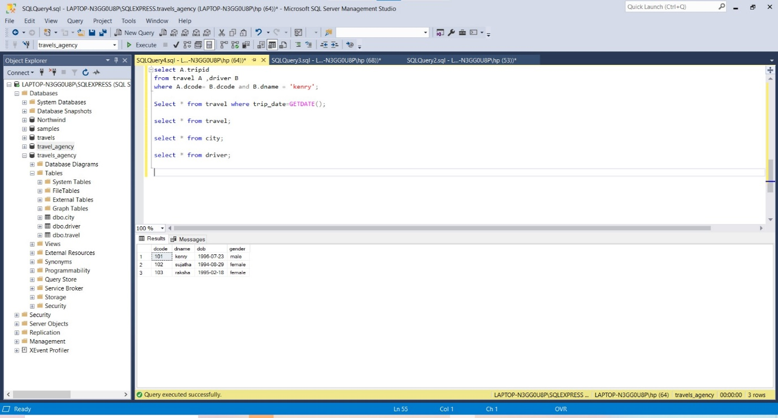

create table city

(

ccode int,

cname char(20)

constraint PK_ccode primary key (ccode)

);

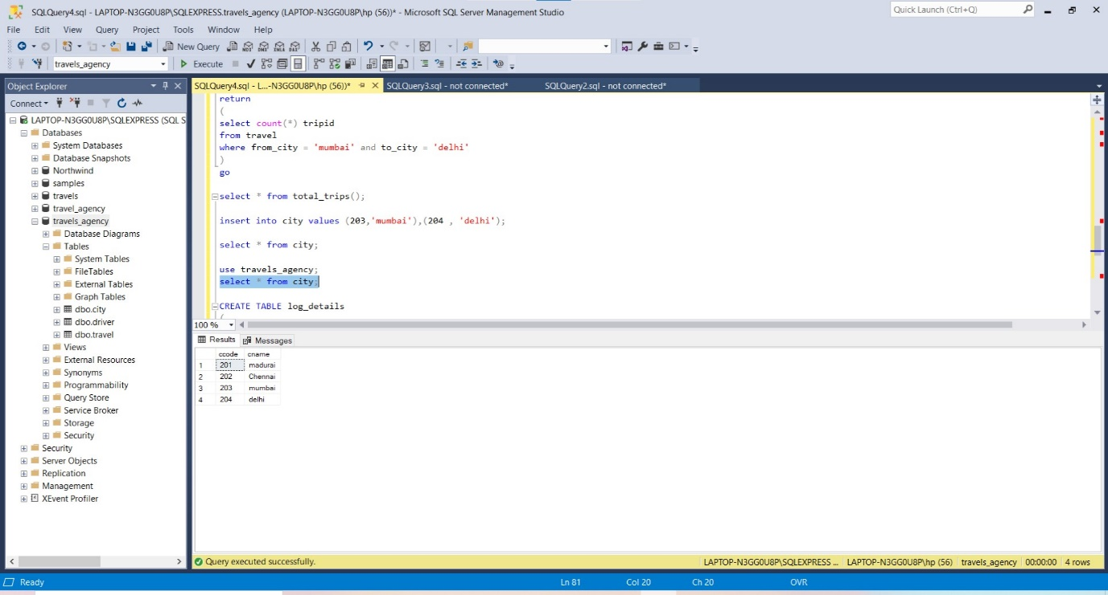

create table travel

(

tripid int,

dcode int,

trip_date date,

from_city char(20),

to_city char(20),

constraint PK_tripid primary key (tripid),

constraint FK_dcode foreign key (dcode) references driver(dcode)

);

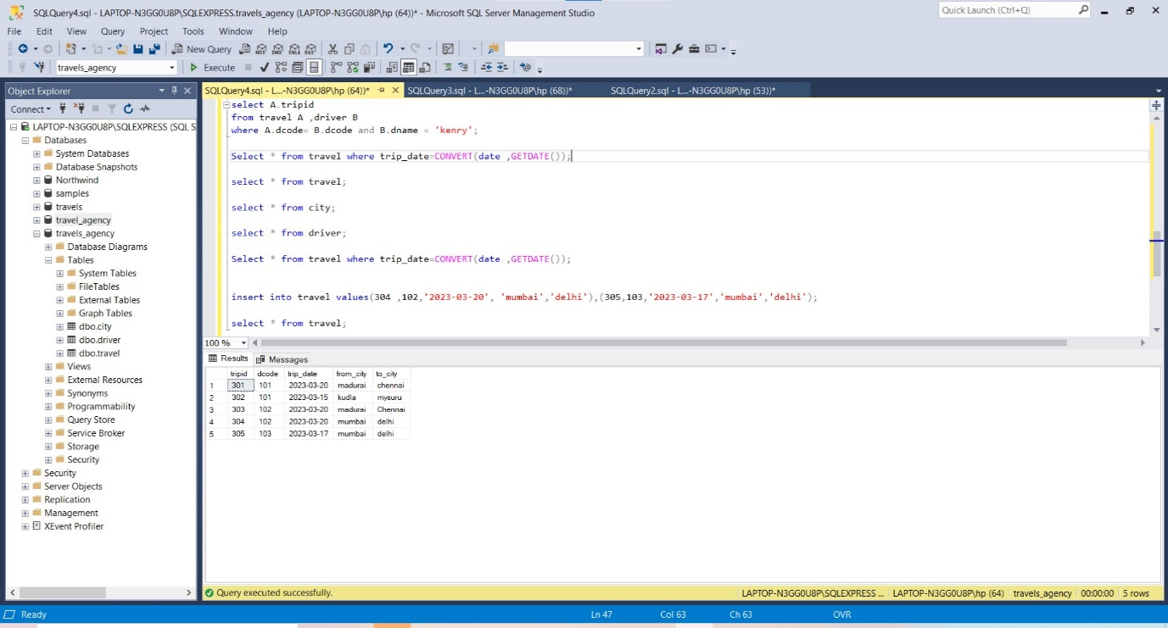

1)

Select * from driver where gender = 'female';

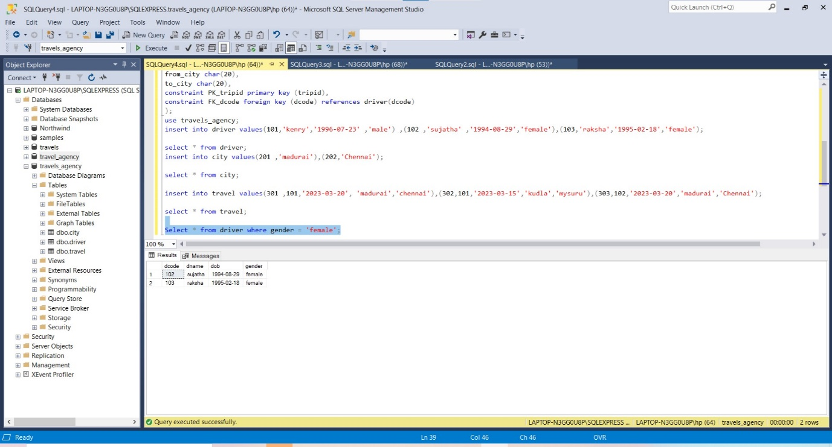

2)

Select * from travel where from_city = 'madurai' and to_city ='chennai' ;

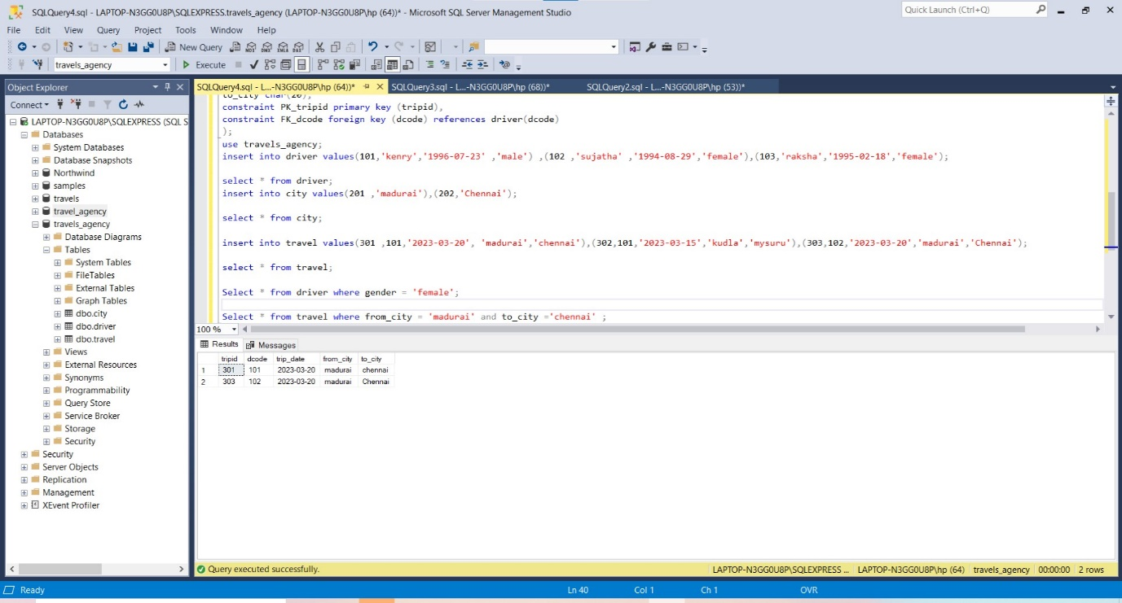

3)

select A.tripid

from travel A ,driver B

where A.dcode= B.dcode and B.dname = 'kenry';

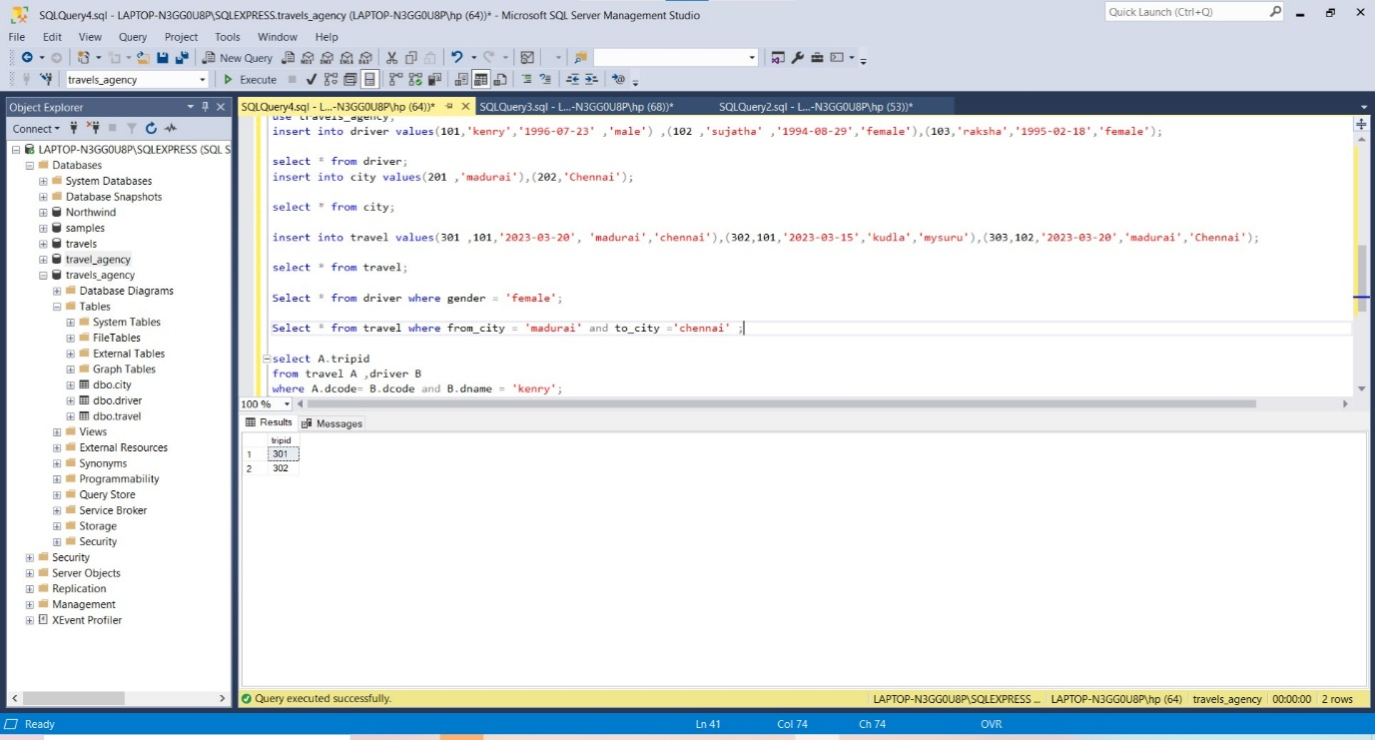

4)

Select * from travel where trip_date=CONVERT(date ,GETDATE());

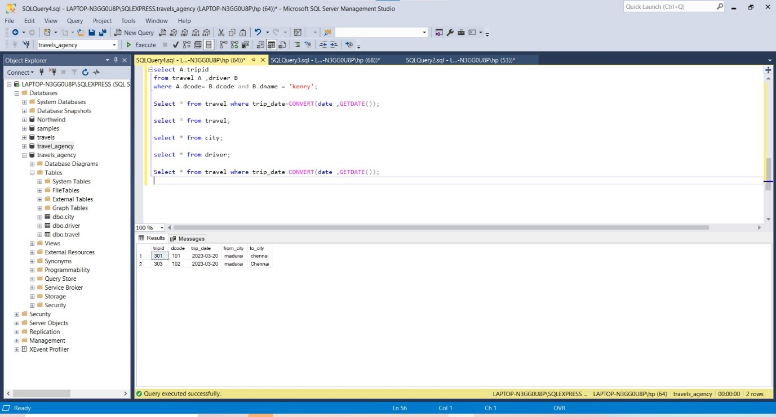

5)

create or alter function total_trips()

returns table

as

return

(

select count(*) tripid

from travel

where from_city = 'mumbai' and to_city = 'delhi'

)

go

select * from total_trips();

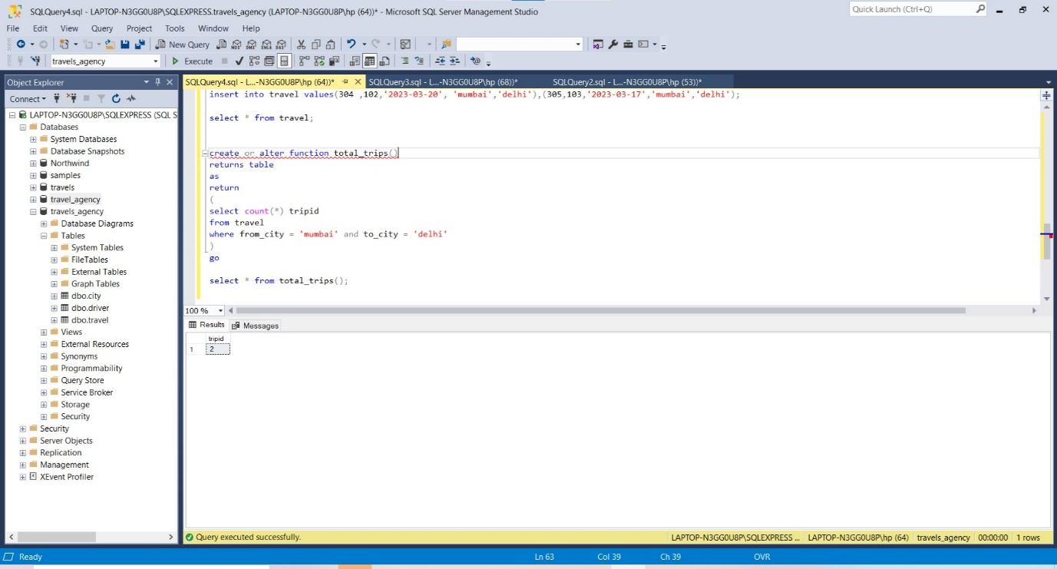

6)

create table triggertable (

LogID int IDENTITY(1,1) NOT NULL,

UpdatedDate Datetime NOT NULL,

Operation nvarchar(10) NOT NULL

)

go

create or alter trigger dbo.travels_agency

on dbo.travel

for insert

AS

INSERT INTO dbo.triggertable(UpdatedDate,Operation)select getdate(), 'INSERT' from inserted;

go

insert into travel values(307,101,'2023-03-20','kudla','goa');

go

select * from triggertable;