**Write queries for the following**

1. Create the Customer table with the following columns.

CustomerId Number(5)

Cust_Name varchar2(20)

Address1 Varchar2(30)

Address2 Varchar2(30)

**Create table Customer( CustomerId smallint(5),**

**Cust_Name varchar2(20),**

**Address1 varchar2(20),**

**Address2 varchar2(20));**

1. Modify the Customer table Cust_Name column of datatype with Varchar2(30), rename the column to CustomerName and it should not accept Nulls.

**Alter table Customers alter column Cust_name Varchar2(30) not null,**

**sp_rename ‘Cust_Name’ , ‘CustomerName’;**

1. Add the following Columns to the Customer table.

Gender Varchar2(1)

Age Number(3)

PhoneNo Number(10)

**Alter table Customers add column Gender varchar2(1),**

**Age small int(3),**

**Phone No Bigint(10);**

1. Add the below records to the Customer table:

(1000, ‘Allen’, ‘#115 Chicago’, ‘#115 Chicago’, ‘M’, ‘25, 7878776’)

1000, Allen, #115 Chicago, #115 Chicago, M, 25, 7878776

1001, George, #116 France, #116 France, M, 25, 434524

1002, Becker, #114 New York, #114 New York, M, 45, 431525

**Insert into Customers (CustomerId , CustomerName, Addresss1, Address2,Gender,**

**Age, Phone No) Values**

**(1000, ‘Allen’, ‘#115 Chicago’, ‘#115 Chicago’, ‘M’, 25, 7878776);**

**Insert into Customers (CustomerId , CustomerName, Addresss1, Address2,Gender,**

**Age, Phone No) Values**

**(1001, ‘George’, ‘#116 Chicago’, ‘#116 France’, ‘M’, 25, 434524);**

**Insert into Customers (CustomerId , CustomerName, Addresss1, Address2,Gender,**

**Age, Phone No) Values**

**(1002, ‘Becker’, ‘#114 New York’, ‘#114 New York’, ‘M’, 45, 431525);**

1. Add the Primary key constraint for Customerld with the name Custld_Prim.

**Alter table Customers add constraint pk_CustId_prim primary key(CustomerId);**

1. a) Disable the constraint on CustomerId, and insert the following data:

1002, Becker, #114 New York, #114 New york , M, 45, 431525

1003, Nanapatekar, #115 India, #115 India , M, 45, 431525

b) Drop the constraint Custld_Prim on CustomerId and insert the following Data.

**Alter table Customers drop constraint pk_custId_prim;**

**Insert into Customers values**

**(1002, ‘Becker’, ‘#114 New York’, ‘#114 New york’ , ‘M’, 45, 431525);**

**Insert into Customers values**

**(1002, ‘Nanapatekar’, ‘#115 India’, ‘#115 India’ , ‘M’, 45, 431525);**

1. Alter Customer table, drop constraint Custid_Prim.

1002, Becker, #114 New York, #114 New york , M, 45, 431525, 15000.50

1003, Nanapatekar, #115 India, #115 India , M, 45, 431525, 20000.50

1. Create Employee table with same structure as EMP table.

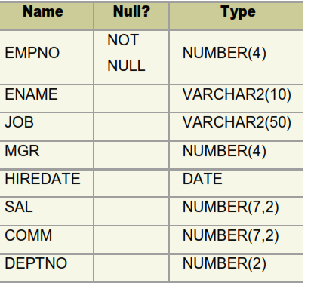

**Create table EMP (EMPNO Small int(4) Not Null,**

**ENAME varchar2(10),**

**JOB varchar2(50),**

**MGR small int(4),**

**HIREDATE date,**

**SAL decimal(7,2),**

**COMM decimal(7,2)**

**DEPTNO small int(2));**

1. Insert the following data in the above table
2. Write a query to populate Employee table using EMP table’s empno, ename, sal,, deptno columns.

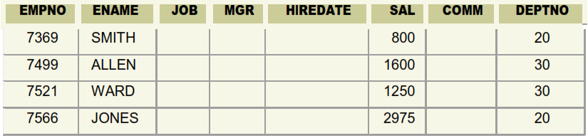

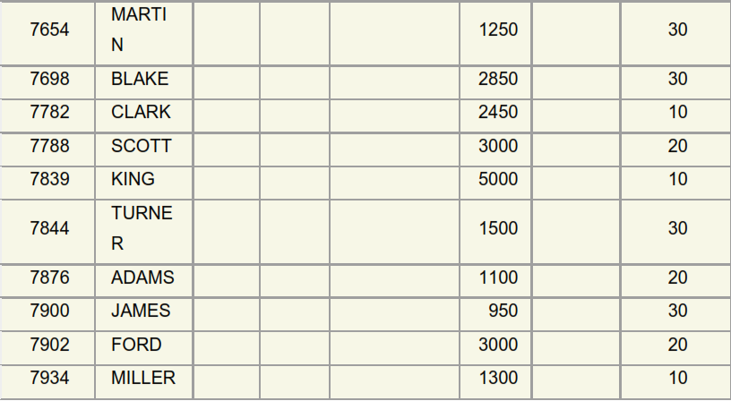

**Insert Employee (empno, ename, sal, deptno)**

**Select empno, ename, sal, deptno**

**From EMP;**

1. a. Write a query to change the job and deptno of employee whose empno is 7698 to the job and deptno of employee having empno 7788.

b. Write a query to change the deptno of employee with empno 7788 to that of employee having empno 7698.

A).

**Update Employee set job,deptno=**

**(select job,deptno from Employee where empno=7788) where empno =7698;**

B).

**update Employee set deptno =**

**(select deptno from Employee where empno = 7698)**

**where empno = 7788;**

1. Delete the details of department whose department name is ‘SALES’.

**Delete from department where department name=’SALES’;**

1. Insert the following rows to the Employee table

1000,Allen, Clerk,1001,12-jan-01, 3000, 2,10

1001,George, analyst, null, 08 Sep 92, 5000,0, 10

1002, Becker, Manager, 1000, 4 Nov 92, 2800,4, 20

1003, 'Bill', Clerk, 1002, 4 Nov 92,3000, 0, 20

**Insert into Employee values(1000,’Allen’, ‘Clerk’,1001,’12-jan-01’, 3000, 2,10);**

**Insert into Employee values(1001,’George’, ‘analyst’, null, ’08-Sep-92’, 5000,0, 10);**

**Insert into Employee values(1002, ‘Becker’, ‘Manager’, 1000, ‘4-Nov-92’, 2800,4, 20);**

**Insert into Employee values(1003, 'Bill', ‘Clerk’, 1002, ‘4-Nov-92’,3000, 0, 20);**

1. Create a Project Table with below structure

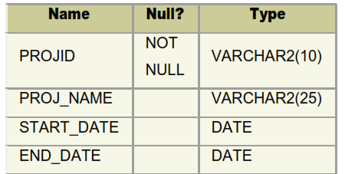

**Create table Project (PROJID varchar2(10) not null,**

**PROJ_NAME varchar2(25),**

**START_DATE date,**

**END_DATE date);**

1. Insert Records into Project Table as deemed necessary and relevant

**Insert into project(PROJID, PROJ_NAME, START_DATE, END_DATE)**

**Values(123, ‘abc’, ‘2022/01/23’, ‘2022/02/23’);**

**Insert into project(PROJID, PROJ_NAME, START_DATE, END_DATE)**

**Values(124, ‘pqr’, ‘2022/03/23’, ‘2022/04/23’);**

**Insert into project(PROJID, PROJ_NAME, START_DATE, END_DATE)**

**Values(124, ‘xyz’, ‘2022/06/23’, ‘2022/07/23’);**