Computer networks lab assignment

Rahul kumar sinha
serial no-- 2202

1.
#include <stdio.h>
#include <stdlib.h>
#include <sys/types.h>
#include <sys/socket.h>
#include <netinet/in.h>
#include <errno.h>
#include <string.h>
#include <arpa/inet.h>
#include <unistd.h>
void main()
{
int ssock,csock;
int a,b,c,fib1,fib2;
unsigned int len;
struct sockaddr_in server,client;
if((ssock=socket(AF_INET,SOCK_STREAM,0))==-1)
{
perror("socket: is not created");
exit(-1);
}
server.sin_family=AF_INET;
server.sin_port=htons(10000);
server.sin_addr.s_addr=INADDR_ANY;
bzero(&server.sin_zero,0);
len=sizeof(struct sockaddr_in);
if((bind(ssock,(struct sockaddr *)&server,len))==-1)
{ // binding port & IP
perror("bind: ");
exit(-1);
}
if((listen(ssock,5))==-1)
{ // listening for client
perror("listen: ");
exit(-1);
}
if((csock=accept(ssock,(struct sockaddr *)&client,&len))==-1)
{ // accepting connectn
perror("accept: ");
exit(-1);
}
while(1)
{
recv(csock,&a,sizeof(a),0);
fib1=0;
fib2=0;
for(b=0;b<a;b++)
{
c=fib1+fib2;
fib1=fib2;
fib2=c;
if(b==0)
fib2=1;
send(csock,&c,sizeof(c),0);
printf("Server: Sent Value is : %d\n",c);
}
}
close(ssock);
}

//CLIENT
#include <stdio.h>
#include <stdlib.h>
#include <sys/types.h>
#include <sys/socket.h>
#include <netinet/in.h>
#include <errno.h>
#include <string.h>
#include <arpa/inet.h>
#include <unistd.h>
void main()
{
int sock;
int a,b,c,i;
unsigned int len;
char ch[3]="no";
char ch1[3];
struct sockaddr_in client;
if( (sock=socket(AF_INET,SOCK_STREAM,0))==-1 )
{
// client socket is created..
perror("socket: ");
exit(-1);
}
client.sin_family=AF_INET;
client.sin_port=htons(10000);
client.sin_addr.s_addr=INADDR_ANY;
bzero(&client.sin_zero,0);
len=sizeof(struct sockaddr_in);
if( (connect(sock,(struct sockaddr *)&client,len))==-1)
{
//conneting to client
perror("connect: ");
exit(-1);
}
while(1)
{
printf("Servert:");
printf("Enter A Number :\n");
scanf("%d",&a);
send(sock,&a,sizeof(a),0);
printf("\nServer: ");
for(b=0;b<a;b++)
{
recv(sock,&c,sizeof(c),0);
printf("%d ",c);
}
printf("\nServer: Do you want to exit...press 'no' else press any key\n");
scanf("%s",ch1);
if((i=strcmp(ch,ch1))==0)
{
printf("\nServer: GOT it!\n");
close(sock);
exit(0);
}
}
}
OUTPUT-
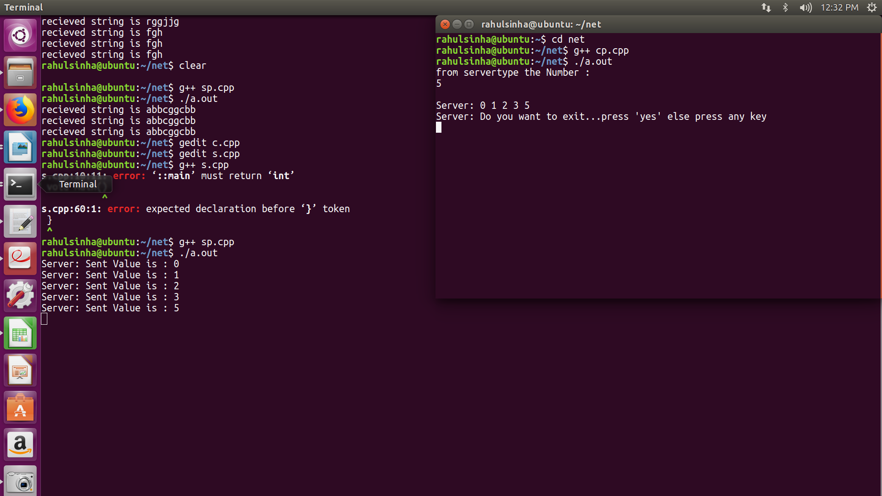

2.
//SERVER
#include <stdio.h>
#include <stdlib.h>
#include <sys/types.h>
#include <sys/socket.h>
#include <netinet/in.h>
#include <errno.h>
#include <string.h>
#include <arpa/inet.h>
#include <unistd.h>
void main()
{
int ssock,csock;
int a,b,c;
unsigned int len;
struct sockaddr_in server,client;
if((ssock=socket(AF_INET,SOCK_STREAM,0))==-1)
{
perror("socket: is not created");
exit(-1);
}
server.sin_family=AF_INET;
server.sin_port=htons(10000);
server.sin_addr.s_addr=INADDR_ANY;
bzero(&server.sin_zero,0);
len=sizeof(struct sockaddr_in);
if((bind(ssock,(struct sockaddr *)&server,len))==-1)
{ // binding port & IP
perror("bind: ");
exit(-1);
}
if((listen(ssock,5))==-1)
{ // listening for client
perror("listen: ");
exit(-1);
}
if((csock=accept(ssock,(struct sockaddr *)&client,&len))==-1)
{ // accepting connectn
perror("accept: ");
exit(-1);
}
while(1)
{
recv(csock,&a,sizeof(a),0);
c=1;
for(b=1;b<=a;b++)
c*=b;
send(csock,&c,sizeof(c),0);
// sending data to client...
printf("\nSent Factorial=: %d\n",c);
}
close(ssock);
}

//CLIENT
#include <stdio.h>
#include <stdlib.h>
#include <sys/types.h>
#include <sys/socket.h>
#include <netinet/in.h>
#include <errno.h>
#include <string.h>
#include <arpa/inet.h>
#include <unistd.h>
void main(){
int sock;
int a,b,c,i;
unsigned int len;
char ch[3]="ex";
char ch1[3];
struct sockaddr_in client;
if((sock=socket(AF_INET,SOCK_STREAM,0))==-1){
perror("socket: ");
exit(-1);
}
client.sin_family=AF_INET;
client.sin_port=htons(10000);
// initializing socket parameters
client.sin_addr.s_addr=INADDR_ANY;
//inet_addr("127.0.0.1");
bzero(&client.sin_zero,0);
len=sizeof(struct sockaddr_in);
if((connect(sock,(struct sockaddr *)&client,len))==-1)
{
perror("connect: ");
exit(-1);
}
while(1)
{
printf("Enter number to compute factorial:\n");
scanf("%d",&a);
send(sock,&a,sizeof(a),0);
recv(sock,&c,sizeof(c),0);
printf("Factorial is %d\n",c);
printf("\ndo you want to exit...press 'ex'\n");
scanf("%s",ch1);
if((i=strcmp(ch,ch1))==0){
close(sock);
exit(0);
}
}
}

OUTPUT-
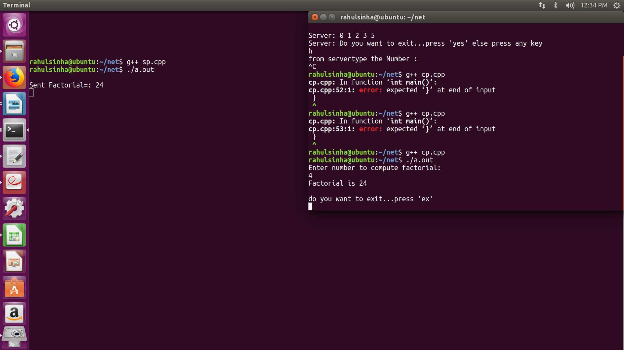

3.
//SERVER
Date of Submission-> 06-Aug-2018#include <stdio.h>
#include <stdlib.h>
#include <sys/types.h>
#include <sys/socket.h>
#include <netinet/in.h>
#include <errno.h>
#include <string.h>
#include <arpa/inet.h>
#include <unistd.h>
void main()
{
int ssock,csock;
int a,b,c,fib1,fib2;
unsigned int len;
char ch[1];
struct sockaddr_in server,client;
if((ssock=socket(AF_INET,SOCK_STREAM,0))==-1)
{
perror("socket: is not created");
exit(-1);
}
server.sin_family=AF_INET;
server.sin_port=htons(10000);
server.sin_addr.s_addr=INADDR_ANY;
bzero(&server.sin_zero,0);
len=sizeof(struct sockaddr_in);
if((bind(ssock,(struct sockaddr *)&server,len))==-1)
{
perror("bind: ");
exit(-1);
}
if((listen(ssock,5))==-1)
{
perror("listen: ");
exit(-1);
}
if((csock=accept(ssock,(struct sockaddr *)&client,&len))==-1)
{
perror("accept: ");
exit(-1);
}
while(1)
{
recv(csock,&a,sizeof(a),0);
printf("\nMarks Given by Client : %d ",a);
if( a>=85 && a<=100 )
c=65;
else if( a>=70 && a<=84 )
c=66;
else if( a>=60 && a<=69 )
c=67;
else if( a>=50 && a<=59 )
c=68;
else
Date of Submission-> 06-Aug-2018c=70;
send(csock,&c,sizeof(c),0);
ch[0]=c;
printf("\nGrade Sent to client %s ",ch);
}
close(ssock);
}
//CLIENT
#include <stdio.h>
#include <stdlib.h>
#include <sys/types.h>
#include <sys/socket.h>
#include <netinet/in.h>
#include <errno.h>
#include <string.h>
#include <arpa/inet.h>
#include <unistd.h>
void main()
{
int sock;
int a,b,c,i;
unsigned int len;
char ch[3]="no";
char ch1[3];
struct sockaddr_in client;
if( (sock=socket(AF_INET,SOCK_STREAM,0))==-1 )
{
perror("socket: ");
exit(-1);
}
client.sin_family=AF_INET;
client.sin_port=htons(10000);
client.sin_addr.s_addr=INADDR_ANY;
bzero(&client.sin_zero,0);
len=sizeof(struct sockaddr_in);
if( (connect(sock,(struct sockaddr *)&client,len))==-1)
{
perror("connect: ");
exit(-1);
Date of Submission-> 06-Aug-2018}
while(1)
{
printf("\nServer:");
printf(" Enter Marks - ");
scanf("%d",&a);
send(sock,&a,sizeof(a),0);
printf("\nServer: ");
recv(sock,&c,sizeof(c),0);
printf("Grade is %c \n",c);
printf("\nServer: Do you want to exit...press 'no' else press any key\n");
scanf("%s",ch1);
if((i=strcmp(ch,ch1))==0)
{
printf("\nServer: GOT it!\n");
close(sock);
exit(0);
}
}
}
OUTPUT-
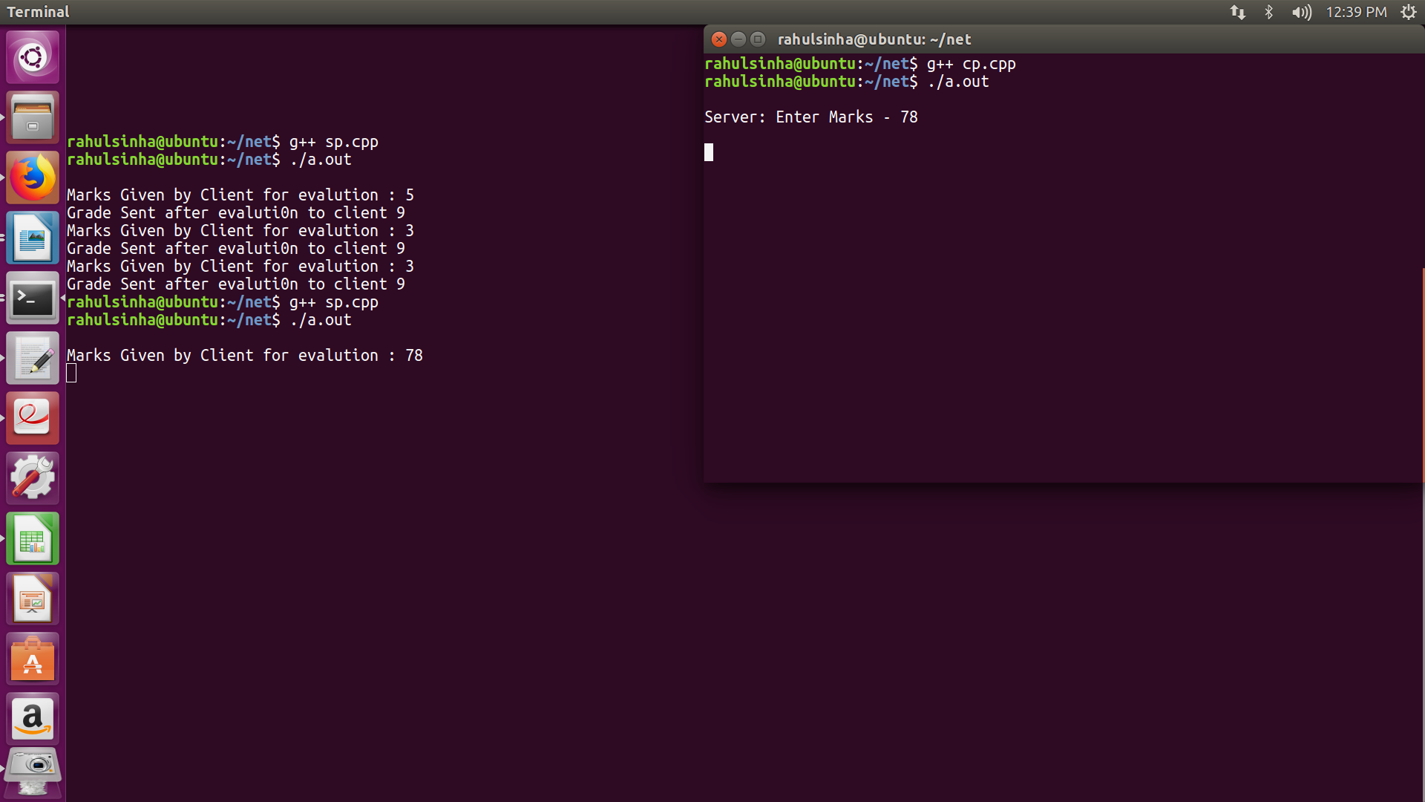

4.//SERVER
#include <stdio.h>
#include <stdlib.h>
#include <sys/types.h>
#include <sys/socket.h>
#include <netinet/in.h>
#include <errno.h>
#include <string.h>
#include <arpa/inet.h>
#include <unistd.h>
void main()
{
int ssock,csock;
int a,b,c;
unsigned int len;
// creating server and clinet socket discriptor
struct sockaddr_in server,client; // creating server & client socket object
char pass[9]="password";
int msg1=1;
int msg2=2;
char inp[100];
char hel[6]="Hello";
int var=0;
if((ssock=socket(AF_INET,SOCK_STREAM,0))==-1)
{
perror("socket: is not created");
exit(-1);
}
server.sin_family=AF_INET;
server.sin_port=htons(10000);
// initializing server socket parameters..
server.sin_addr.s_addr=INADDR_ANY;
bzero(&server.sin_zero,0);
len=sizeof(struct sockaddr_in);
if((bind(ssock,(struct sockaddr *)&server,len))==-1)
{ // binding port & IP
perror("bind: ");
exit(-1);
}
if((listen(ssock,5))==-1)
{ // listening for client
perror("listen: ");
exit(-1);
}
if((csock=accept(ssock,(struct sockaddr *)&client,&len))==-1)
{ // accepting connectn
perror("accept: ");
Date of Submission-> 06-Aug-2018exit(-1);
}
while(1)
{
recv(csock,inp,sizeof(inp),0);
if(strcmp(pass,inp)!=0){
printf("Authentication Failed\n");
send(csock,&msg2,sizeof(msg2),0);
}
else{
printf("Authentication Successfull\n");
send(csock,&msg1,sizeof(msg1),0);
var=1;
}
if(var==1){
recv(csock,inp,sizeof(inp),0);
printf("Client:%s\n",inp);
send(csock,hel,sizeof(hel),0);
printf("Server:%s\n",hel);
}
//sending data to client...
}
close(ssock);
}

//CLIENT
#include <stdio.h>
#include <stdlib.h>
#include <sys/types.h>
#include <sys/socket.h>
#include <netinet/in.h>
#include <errno.h>
#include <string.h>
#include <arpa/inet.h>
#include <unistd.h>
void main(){
int sock; // client socket discriptor
int a,b,c,i;
unsigned int len;
char ch[3]="ex";
char ch1[3];
char pass[100];
int msg1=1;
int msg2=1;
int inp1;
char inp2[100];
char inp3[100];
Date of Submission-> 06-Aug-2018struct sockaddr_in client;
if((sock=socket(AF_INET,SOCK_STREAM,0))==-1){ // client socket is created..
perror("socket: ");
exit(-1);
}
client.sin_family=AF_INET;
client.sin_port=htons(10000);
// initializing socket parameters
client.sin_addr.s_addr=INADDR_ANY;
bzero(&client.sin_zero,0);
len=sizeof(struct sockaddr_in);
if((connect(sock,(struct sockaddr *)&client,len))==-1){ //conneting to client
perror("connect: ");
exit(-1);
}
while(1){
printf("Enter Password:\n");
scanf("%s",pass);
send(sock,pass,sizeof(pass),0);
// sending data back to client...
recv(sock,&inp1,sizeof(c),0);
if(inp1==msg1){
printf("Send message:\n");
scanf("%s",inp2);
send(sock,inp2,sizeof(inp2),0);
printf("CLient:%s\n",inp2);
recv(sock,inp3,sizeof(inp3),0);
printf("Server:%s\n",inp3);
printf("Do you want to exit:Press ex\n");
scanf("%s",ch1);
}
else{
printf("Enter the correct Password:\n");
printf("Or do you want to exit,Press ex,else press any other char\n");
scanf("%s",ch1);
}
if((i=strcmp(ch,ch1))==0){
close(sock);
exit(0);
}
}
}
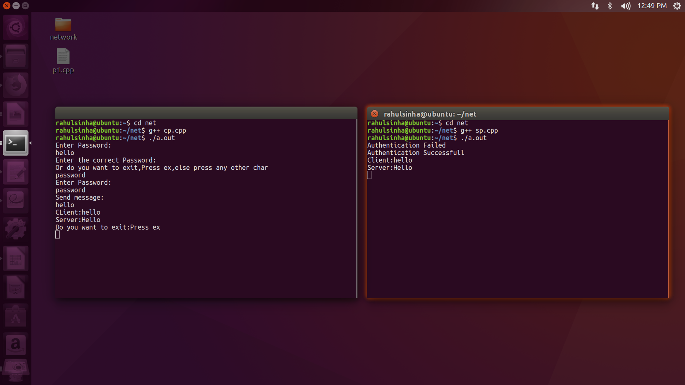
-

5.

//SERVER
#include <stdio.h>
#include <stdlib.h>
#include <sys/types.h>
#include <sys/socket.h>
#include <netinet/in.h>
#include <errno.h>
#include <string.h>
#include <arpa/inet.h>
#include <unistd.h>
void main()
{
int ssock,csock;
// creating server and clinet socket discriptor
int a,b,c;
unsigned int len;
char ch[1];
struct sockaddr_in server,client; // creating server & client socket object
if((ssock=socket(AF_INET,SOCK_STREAM,0))==-1)
{
perror("socket: is not created");
exit(-1);
}
server.sin_family=AF_INET;
server.sin_port=htons(10000);
// initializing server socket parameters..
server.sin_addr.s_addr=INADDR_ANY;
bzero(&server.sin_zero,0);
len=sizeof(struct sockaddr_in);
if((bind(ssock,(struct sockaddr *)&server,len))==-1)
{ // binding port & IP
perror("bind: ");
exit(-1);
}
if((listen(ssock,5))==-1)
{ // listening for client
perror("listen: ");
exit(-1);
}
if((csock=accept(ssock,(struct sockaddr *)&client,&len))==-1)
{ // accepting connectn
perror("accept: ");
exit(-1);
}
while(1)
{
recv(csock,&a,sizeof(a),0);
recv(csock,&b,sizeof(b),0);
printf("\nClient: Numbers are %d and %d.",a,b);
c=a+b;
send(csock,&c,sizeof(c),0);
printf("\nServer: Numbers are %d , ",c);
c=a-b;
send(csock,&c,sizeof(c),0);
printf("%d , ",c);
c=a*b;
send(csock,&c,sizeof(c),0);
printf("%d , ",c);
c=a/b;
send(csock,&c,sizeof(c),0);
printf("and %d",c);
}
close(ssock);
}

//CLIENT
#include <stdio.h>
#include <stdlib.h>
#include <sys/types.h>
#include <sys/socket.h>
#include <netinet/in.h>
#include <errno.h>
#include <string.h>
#include <arpa/inet.h>
#include <unistd.h>
void main()
{
int sock; // client socket discriptor
int a,b,c,i;
unsigned int len;
char ch[3]="yes";
char ch1[3];
struct sockaddr_in client;
if( (sock=socket(AF_INET,SOCK_STREAM,0))==-1 )
{
// client socket is created..
perror("socket: ");
exit(-1);
}
client.sin_family=AF_INET;
client.sin_port=htons(10000);
// initializing socket parameters
client.sin_addr.s_addr=INADDR_ANY; //inet_addr("127.0.0.1");
bzero(&client.sin_zero,0);
len=sizeof(struct sockaddr_in);
if( (connect(sock,(struct sockaddr *)&client,len))==-1)
{
//conneting to client
perror("connect: ");
exit(-1);
}
while(1)
{
printf("\nServer:");
printf(" Enter two Numbers -\n");
scanf("%d",&a);
scanf("%d",&b);
send(sock,&a,sizeof(a),0);
send(sock,&b,sizeof(b),0);
recv(sock,&c,sizeof(c),0);
printf("\nAddition is %d ",c);
recv(sock,&c,sizeof(c),0);
printf("\nSubtraction is %d ",c);
recv(sock,&c,sizeof(c),0);
printf("\nMultiplication is %d",c);
Date of Submission-> 06-Aug-2018recv(sock,&c,sizeof(c),0);
printf("\nDivision
nDivision is %d ",c);
printf("\nServer:
nServer: Do you want to exit...press 'yes' else press any key
key\n");
scanf("%s",ch1);
if((i=strcmp(ch,ch1))==0)
h,ch1))==0)
{
printf("\ \nServer: GOT it!\n");
close(sock);
exit(0);
}
}
}
OUTPUT-

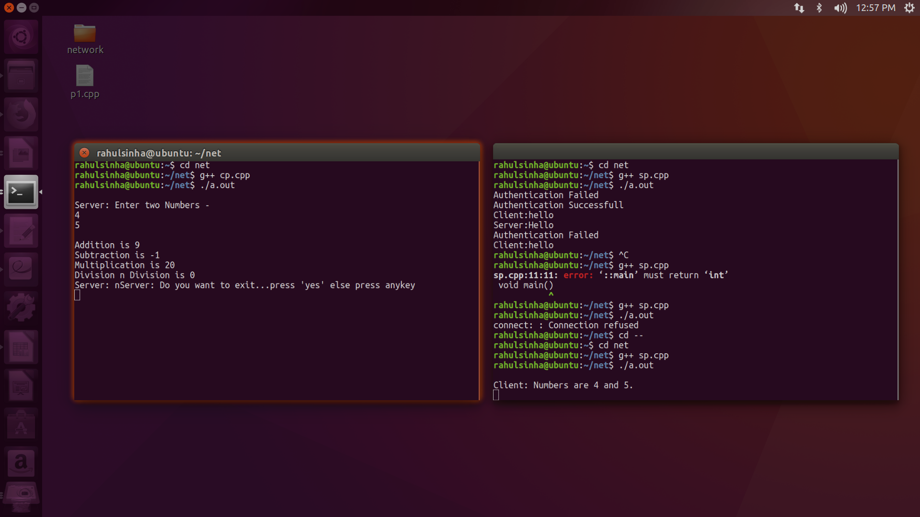

6.
//SERVER

#include <stdio.h>
#include <stdlib.h>
#include <sys/types.h>
#include <sys/socket.h>
#include <netinet/in.h>
#include <errno.h>
#include <string.h>
#include <arpa/inet.h>
#include <unistd.h>
void main()
{
int ssock,csock;
int a,b,c,n,i,j;
unsigned int len;
char arr[100];
// creating server and clinet socket discriptor
struct sockaddr_in server,client; // creating server & client socket object
if((ssock=socket(AF_INET,SOCK_STREAM,0))==-1)
{
perror("socket: is not created");
exit(-1);
}
server.sin_family=AF_INET;
server.sin_port=htons(10000);
// initializing server socket parameters..
server.sin_addr.s_addr=INADDR_ANY;
//inet_addr("127.0.0.1");
bzero(&server.sin_zero,0);
len=sizeof(struct sockaddr_in);
if((bind(ssock,(struct sockaddr *)&server,len))==-1)
{ // binding port & IP
perror("bind: ");
exit(-1);
}
if((listen(ssock,5))==-1)
{ // listening for client
perror("listen: ");
exit(-1);
}
if((csock=accept(ssock,(struct sockaddr *)&client,&len))==-1)
{ // accepting connectn
perror("accept: ");
exit(-1);
}
while(1)
{
recv(csock,&n,sizeof(n),0);
a=(2*n)-1;
for(i=0;i<n;i++){
a--;
for(j=0;j<2*n;j++)
arr[j]=' ';
Date of Submission-> 06-Aug-2018for(j=i;j<=a;j+=2)
arr[j]='*';
send(csock,arr,sizeof(arr),0);
}
printf("Pattern is sent\n");
}
close(ssock);
}
//CLIENT
#include <stdio.h>
#include <stdlib.h>
#include <sys/types.h>
#include <sys/socket.h>
#include <netinet/in.h>
#include <errno.h>
#include <string.h>
#include <arpa/inet.h>
#include <unistd.h>
void main(){
int sock; // client socket discriptor
int a,b,c,i,j,n;
unsigned int len;
char ch[3]="ex";
char ch1[3];
char arr[100];
struct sockaddr_in client;
if((sock=socket(AF_INET,SOCK_STREAM,0))==-1){ // client socket is created..
perror("socket: ");
exit(-1);
}
client.sin_family=AF_INET;
client.sin_port=htons(10000);
// initializing socket parameters
client.sin_addr.s_addr=INADDR_ANY;
//inet_addr("127.0.0.1");
bzero(&client.sin_zero,0);
len=sizeof(struct sockaddr_in);
if((connect(sock,(struct sockaddr *)&client,len))==-1){ //conneting to client
perror("connect: ");
exit(-1);
}
while(1){
printf("Enter the size of pattern:\n");
scanf("%d",&n);
send(sock,&n,sizeof(n),0);
for(i=0;i<n;i++){
Date of Submission-> 06-Aug-2018recv(sock,arr,sizeof(arr),0);
for(j=0;j<2*n;j++)
printf("%c",arr[j]);
printf("\n");
}
printf("\ndo you want to exit...press 'ex',else press any other character\n");
scanf("%s",ch1);
//printf("%s\n",ch1);
//printf("%s\n",ch);
if((i=strcmp(ch,ch1))==0){
close(sock);
exit(0);
}
}
}
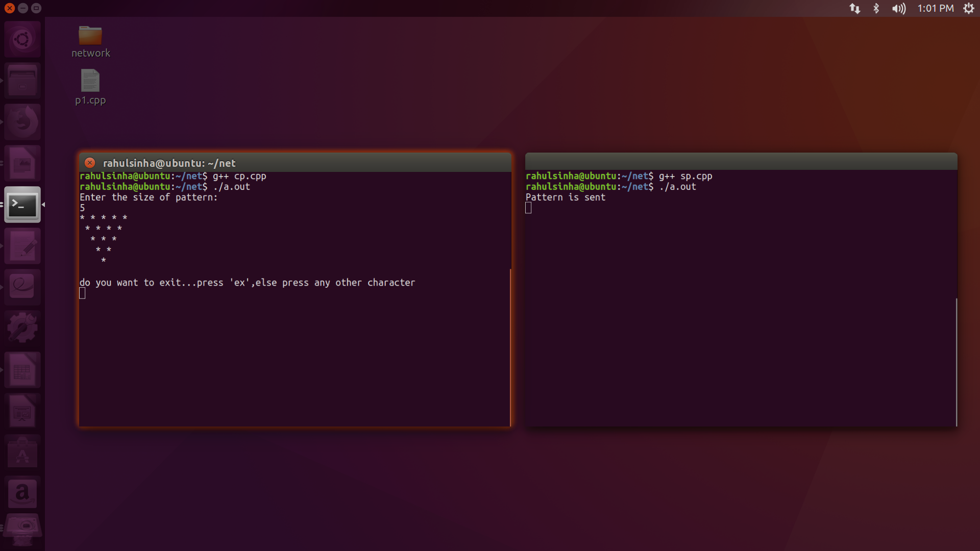

7.//SERVER
#include <stdio.h>
#include <stdlib.h>
#include <sys/types.h>
#include <sys/socket.h>
#include <netinet/in.h>
#include <errno.h>
#include <string.h>
#include <arpa/inet.h>
#include <unistd.h>
void main()
{
int ssock,csock;
// creating server and clinet socket discriptor
int a,b,c,n;
unsigned int len;
int f=4;
int count1=0;
struct sockaddr_in server,client; // creating server & client socket object
if((ssock=socket(AF_INET,SOCK_STREAM,0))==-1)
{
perror("socket: is not created");
exit(-1);
}
server.sin_family=AF_INET;
server.sin_port=htons(10000);
// initializing server socket parameters..
server.sin_addr.s_addr=INADDR_ANY;
//inet_addr("127.0.0.1");
bzero(&server.sin_zero,0);
len=sizeof(struct sockaddr_in);
if((bind(ssock,(struct sockaddr *)&server,len))==-1)
{ // binding port & IP
perror("bind: ");
exit(-1);
}
if((listen(ssock,5))==-1)
{ // listening for client
perror("listen: ");
exit(-1);
}
if((csock=accept(ssock,(struct sockaddr *)&client,&len))==-1)
{ // accepting connectn
perror("accept: ");
exit(-1);
}
a=3;
while(1)
{
recv(csock,&n,sizeof(n),0);
if(n==0)
c=3;
else{
c+=(f*count1);
count1++;
}
send(csock,&c,sizeof(c),0);
// sending data to client...
printf("\nSent number=: %d\n",c);
}
close(ssock);
}

//CLIENT
#include <stdio.h>
#include <stdlib.h>
#include <sys/types.h>
#include <sys/socket.h>
#include <netinet/in.h>
#include <errno.h>
#include <string.h>
#include <arpa/inet.h>
#include <unistd.h>
void main(){
int sock; // client socket discriptor
int a,b,c,i,n;
unsigned int len;
char ch[3]="ex";
char ch1[3];
struct sockaddr_in client;
if((sock=socket(AF_INET,SOCK_STREAM,0))==-1){ // client socket is created..
perror("socket: ");
exit(-1);
}
client.sin_family=AF_INET;
client.sin_port=htons(10000);
// initializing socket parameters
client.sin_addr.s_addr=INADDR_ANY;
//inet_addr("127.0.0.1");
bzero(&client.sin_zero,0);
len=sizeof(struct sockaddr_in);
if((connect(sock,(struct sockaddr *)&client,len))==-1){ //conneting to client
perror("connect: ");
exit(-1);
}
while(1){
printf("Enter Number:\n");
scanf("%d",&n);
send(sock,&n,sizeof(n),0);
recv(sock,&c,sizeof(c),0);
printf("Number sent is %d\n",c);
// receiving data from client
printf("\nDo you want to exit...press 'ex'\n");
scanf("%s",ch1);
//printf("%s\n",ch1);
//printf("%s\n",ch);
if((i=strcmp(ch,ch1))==0){
close(sock);
exit(0);
}
}
}
OUTPUT
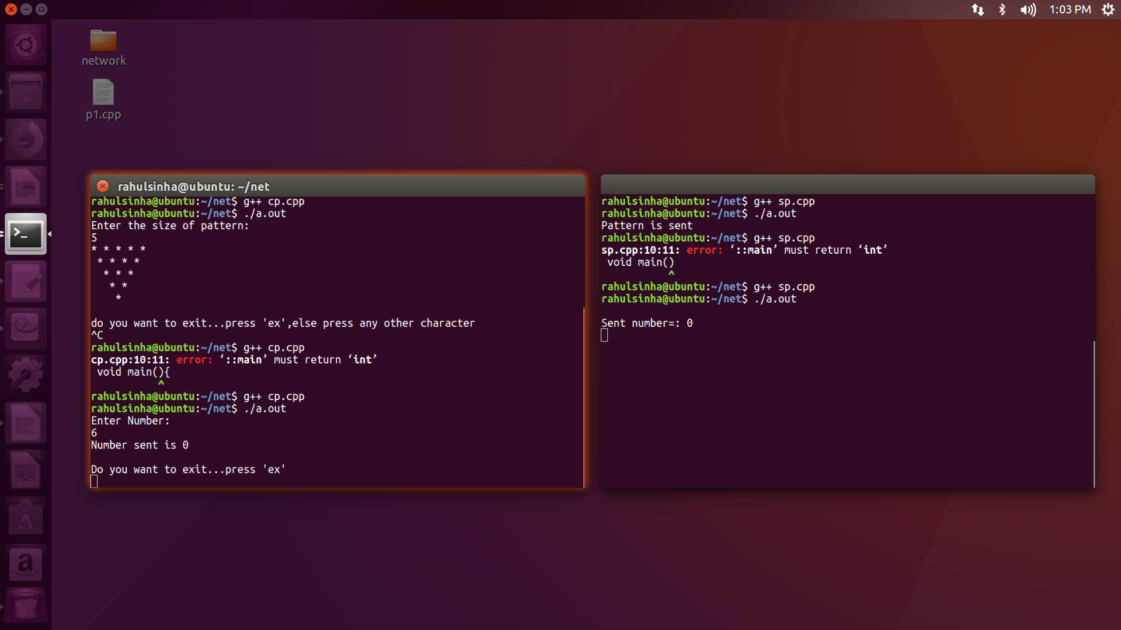

8.
//SERVER
#include <stdio.h>
#include <stdlib.h>
#include <sys/types.h>
#include <sys/socket.h>
#include <netinet/in.h>
#include <errno.h>
#include <string.h>
#include <arpa/inet.h>
#include <unistd.h>
struct Student
{
int name;
int age;
int std;
int section;
int pin;
};
void main()
{
struct Student data[10];
int i;
for(i=0;i<10;i++)
{
data[i].age=i+10;
data[i].std=i+1;
data[i].section=i;
data[i].name=i+2;
data[i].pin=i*i;
}
int ssock,csock;
// creating server and clinet socket discriptor
int a,b,c;
unsigned int len;
char ch[1];
struct sockaddr_in server,client; // creating server & client socket object
if((ssock=socket(AF_INET,SOCK_STREAM,0))==-1)
{
perror("socket: is not created");
exit(-1);
}
server.sin_family=AF_INET;
server.sin_port=htons(10000);
// initializing server socket parameters..
server.sin_addr.s_addr=INADDR_ANY;
//inet_addr("127.0.0.1");
bzero(&server.sin_zero,0);
len=sizeof(struct sockaddr_in);
if((bind(ssock,(struct sockaddr *)&server,len))==-1)
{ // binding port & IP
perror("bind: ");
exit(-1);
}
if((listen(ssock,5))==-1)
{ // listening for client
perror("listen: ");
exit(-1);
}
if((csock=accept(ssock,(struct sockaddr *)&client,&len))==-1)
{ // accepting connectn
perror("accept: ");
exit(-1);
}
while(1)
{
recv(csock,&a,sizeof(a),0);
printf("\nClient: Send Details for roll no. %d",a);
a--;
struct Student temp=data[a];
send(csock,&temp,sizeof(temp),0);
printf("\nRecord of Student With Roll No %d is sended.",a+1);
}
close(ssock);
}

//CLIENT
#include <stdio.h>
#include <stdlib.h>
#include <sys/types.h>
#include <sys/socket.h>
#include <netinet/in.h>
#include <errno.h>
#include <string.h>
#include <arpa/inet.h>
#include <unistd.h>
struct Student
{
int name;
int age;
int std;
int section;
int pin;
};
void main()
{
int sock; // client socket discriptor
int a,b,c,i;
unsigned int len;
char ch[3]="yes";
char ch1[3];
struct sockaddr_in client;
if( (sock=socket(AF_INET,SOCK_STREAM,0))==-1 )
{
// client socket is created..
perror("socket: ");
exit(-1);
}
client.sin_family=AF_INET;
client.sin_port=htons(10000);
// initializing socket parameters
client.sin_addr.s_addr=INADDR_ANY; //inet_addr("127.0.0.1");
bzero(&client.sin_zero,0);
len=sizeof(struct sockaddr_in);
if( (connect(sock,(struct sockaddr *)&client,len))==-1)
{
//conneting to client
perror("connect: ");
exit(-1);
}
while(1)
{
printf("\nServer:");
printf(" Enter Roll No. - ");
scanf("%d",&a);
send(sock,&a,sizeof(a),0);
struct Student temp;
recv(sock,&temp,sizeof(temp),0);
printf("\nName is -> %d",temp.name);
printf("\nAge is -> %d",temp.age);
printf("\nClass is -> %d",temp.std);
printf("\nSection is -> %d",temp.section);
printf("\nPinCode is -> %d",temp.pin);
printf("\nServer: Do you want to exit...press 'yes' else press any key\n");
scanf("%s",ch1);
if((i=strcmp(ch,ch1))==0)
{
printf("\nServer: GOT it!\n");
close(sock);
exit(0);
}
}
}
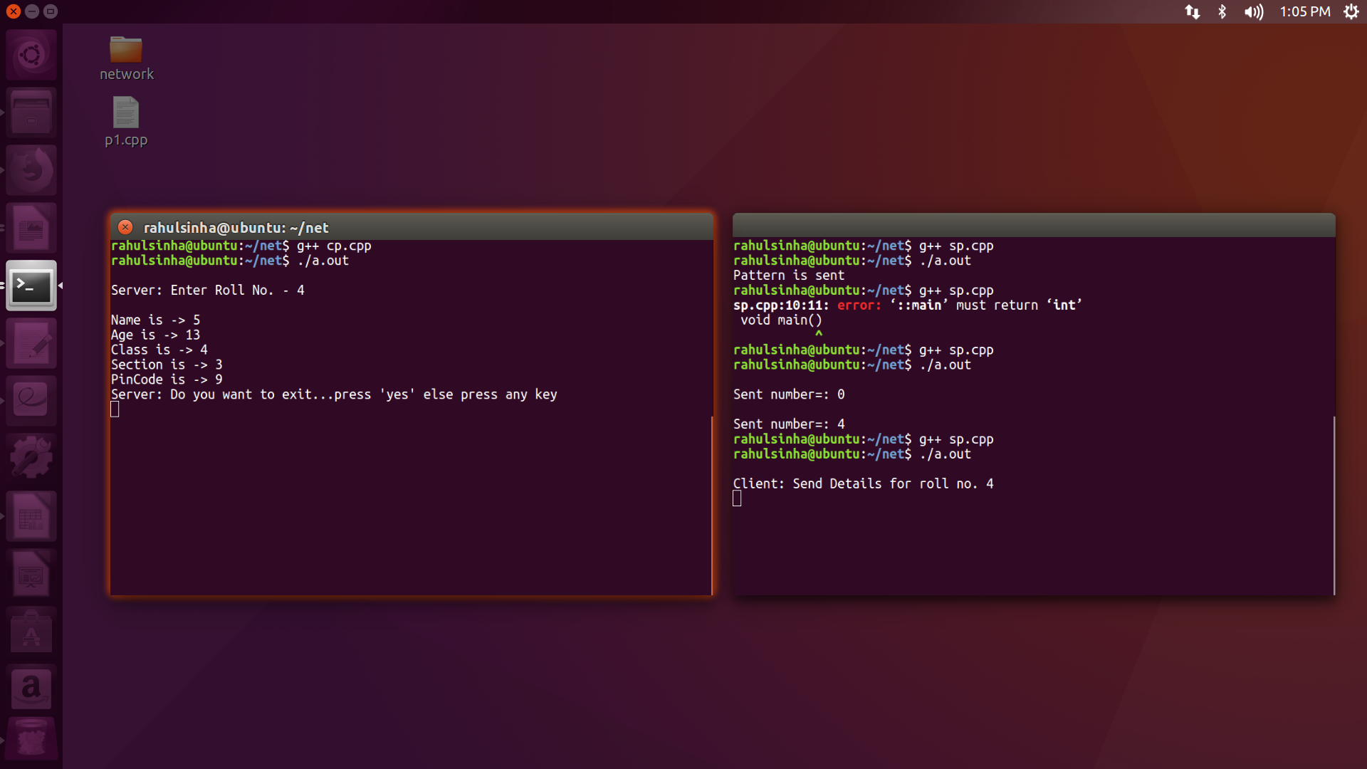

9.
//client
#include <stdio.h>
#include <stdlib.h>
#include <sys/types.h>
#include <sys/socket.h>
#include <netinet/in.h>
#include <errno.h>
#include <string.h>
#include <arpa/inet.h>
#include <unistd.h>
#include<bits/stdc++.h>
using namespace std;
int main()
{
char s[512],arr[26]={0};
int sock,dp[100];
int a,b,c,d,i,j;
unsigned int len;
char ch[4]="yes",ch2;
char ch1[4];
struct sockaddr_in client;
if( (sock=socket(AF_INET,SOCK_
{
// client socket is created..
perror("socket: ");
exit(-1);
}
client.sin_family=AF_INET;
client.sin_port=htons(10000);
client.sin_addr.s_addr=INADDR_
bzero(&client.sin_zero,0);
len=sizeof(struct sockaddr_in);
if( (connect(sock,(struct sockaddr *)&client,len))==-1)
{
//conneting to client
//Date of Submission-> 06-Aug-2018
perror("connect: ");
exit(-1);
}
while(1)
{
cout<<"type the word\n";
cin>>s;
send(sock,&s,sizeof(s),0);
// send(sock,&b,sizeof(b),0);
cout<<"maximum repeating character is\n";
recv(sock,&ch2,sizeof(ch2),0);
cout<<ch2<<"\n";
printf("\n-----------terminal exit chatting--------\n1.yes\n2.no\
scanf("%s",ch1);
if((j=strcmp(ch,ch1))==0)
{
printf("\nServer: GOT it!\n");
close(sock);
exit(0);
}
}
}

//server
#include <stdio.h>
#include <stdlib.h>
#include <sys/types.h>
#include <sys/socket.h>
#include <netinet/in.h>
#include <errno.h>
#include <string.h>
#include <arpa/inet.h>
#include <unistd.h>
#include<bits/stdc++.h>
using namespace std;
int main()
{
char s[512],ch2;
int ssock,csock,arr[26]={0},ma=-3;
int dp[100];
int a,b,c,j,d,fib1,fib2;
unsigned int len;
struct sockaddr_in server,client;
if((ssock=socket(AF_INET,SOCK_
{
perror("socket: is not created");
exit(-1);
}
server.sin_family=AF_INET;
server.sin_port=htons(10000);
server.sin_addr.s_addr=INADDR_
bzero(&server.sin_zero,0);
len=sizeof(struct sockaddr_in);
if((bind(ssock,(struct sockaddr *)&server,len))==-1)
{ // binding port & IP
perror("bind: ");
exit(-1);
}
if((listen(ssock,5))==-1)
{ // listening for client
perror("listen: ");
exit(-1);
}
if((csock=accept(ssock,(struct sockaddr *)&client,&len))==-1)
{ // accepting connectn
perror("accept: ");
exit(-1);
}
while(1)
{
recv(csock,&s,sizeof(s),0);
cout<<"recieved string is "<<s<<"\n";
int i=0;
while(s[i]!='\0')
{
//cout<<s[i]<<" ";
arr[s[i]-'a']++;
i++;
}
//cout<<"out of loop\n";
for(int i=0;i<26;i++)
{
if(arr[i]>ma)
{
ch2='a'+i;
ma=arr[i];
}
}
send(csock,&ch2,sizeof(ch2),0)
}
close(ssock);
}

output
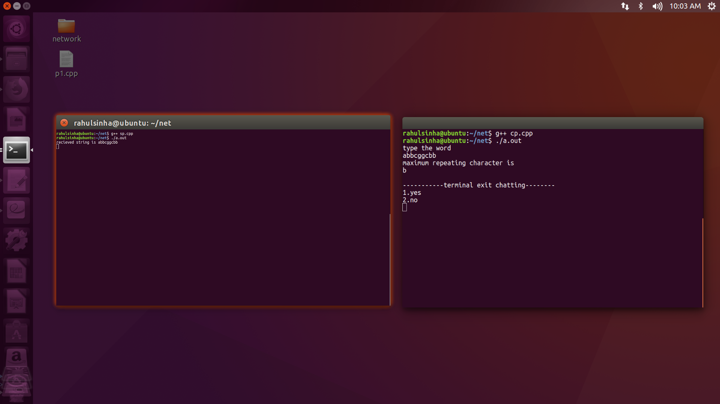

10.
//server

#include <stdio.h>
#include <stdlib.h>
#include <sys/types.h>
#include <sys/socket.h>
#include <netinet/in.h>
#include <errno.h>
#include <string.h>
#include <arpa/inet.h>
#include <unistd.h>
#include <string.h>
void main(){

int ssock,csock; // creating server and clinet socket discriptor
int n,c;int l,k;
unsigned int len;
struct student
{
int e_id;
int t_l;
int curr_bal;
int ex_l;
};

struct sockaddr_in server,client; // creating server & client socket object

if((ssock=socket(AF_INET,SOCK_STREAM,0))==-1){
perror("socket: is not created");
exit(-1);
}

server.sin_family=AF_INET;
server.sin_port=htons(10001); // initializing server socket parameters..
server.sin_addr.s_addr=INADDR_ANY;
//inet_addr("127.0.0.1");
bzero(&server.sin_zero,0); //appending 8 byte zeroes to 'struct sockaddr_in', to make it equal in size with 'struct sockaddr'..
len=sizeof(struct sockaddr_in);
if((bind(ssock,(struct sockaddr *)&server,len))==-1){ // binding port & IP
perror("bind: ");
exit(-1);
}
if((listen(ssock,5))==-1){ // listening for client
perror("listen: ");
exit(-1);
}
if((csock=accept(ssock,(struct sockaddr *)&client,&len))==-1){ // accepting connectn
perror("accept: ");
exit(-1);
}
struct student s[11];
s[0].e_id=1;
s[0].t_l=30;
s[0].curr_bal=13;
s[0].ex_l=2;
s[1].e_id=2;
s[1].t_l=30;
s[1].curr_bal=11;
s[1].ex_l=4;
s[2].e_id=3;
s[2].t_l=30;
s[2].curr_bal=9;
s[2].ex_l=0;
s[3].e_id=4;
s[3].t_l=30;
s[3].curr_bal=5;
s[3].ex_l=0;
s[4].e_id=5;
s[4].t_l=30;
s[4].curr_bal=29;
s[4].ex_l=10;
s[5].e_id=6;
s[5].t_l=30;
s[5].curr_bal=17;
s[5].ex_l=12;
s[6].e_id=7;
s[6].curr_bal=32;
s[6].t_l=40;
s[6].ex_l=0;
/*
s[7].r_no=8;
s[7].section=2;
s[7].ogpa=8.21;
s[7].branch='A';
s[7].name='K';
s[8].r_no=9;
s[8].section=2;
s[8].ogpa=3.14;
s[8].branch='E';
s[8].name='T';
s[9].r_no=10;
s[9].section=2;
s[9].ogpa=9.99;
s[9].branch='E';
s[9].name='Q';*/
while(1){
recv(csock,&n,sizeof(n),0);
recv(csock,&l,sizeof(l),0);
struct student a=s[n-1];
printf("Details\n");
printf("Total leaves %d\n",a.t_l);
printf("Current balance %d\n",a.curr_bal);
printf("Extra leaves %d\n",a.ex_l);
if(a.curr_bal+a.ex_l<l)
{
printf("Leave can't be sanctioned \n");
k=-1;
send(csock,&k,sizeof(k),0);
}
else
{
printf("Leave sanctioned\n");
k=0;
a.curr_bal=a.curr_bal-l;
k=a.curr_bal;
send(csock,&k,sizeof(k),0);
}
}
close(ssock);
}

//client
#include <stdio.h>
#include <stdlib.h>
#include <sys/types.h>
#include <sys/socket.h>
#include <netinet/in.h>
#include <errno.h>
#include <string.h>
#include <arpa/inet.h>
#include <unistd.h>
#include <string.h>

void main(){
int sock; // client socket discriptor
int n;int i=0;int c;
unsigned int len;
int l,k;
struct student
{
int e_id;
int t_l;
int curr_bal;
//int t_l;
int ex_l;
};

//char ch[3]="no";
//char ch1[3];

struct sockaddr_in client;
if((sock=socket(AF_INET,SOCK_STREAM,0))==-1){ // client socket is created..
perror("socket: ");
exit(-1);
}

client.sin_family=AF_INET;
client.sin_port=htons(10001); // initializing socket parameters
client.sin_addr.s_addr=INADDR_ANY;
//inet_addr("127.0.0.1");
bzero(&client.sin_zero,0); //appending 8 byte zeroes to 'struct sockaddr_in', to make it equal in size with 'struct sockaddr'..

len=sizeof(struct sockaddr_in);
if((connect(sock,(struct sockaddr *)&client,len))==-1){ //conneting to client
perror("connect: ");
exit(-1);
}
while(i!=1){
printf("enter employee id \n");
scanf("%d",&n);
printf("Enter the leave duration \n");
scanf("%d",&l);
send(sock,&n,sizeof(n),k);
send(sock,&l,sizeof(l),0);
recv(sock,&k,sizeof(k),0);
if(k==-1)
{
printf("Leave can't be sanctioned \n");
}
else
{
printf("Leave sanctioned \n");
printf("Remaining balance %d\n",k);
}
printf("To exit press 1 and to continue press 0\n");
scanf("%d",&c);
i=c;

}
// receiving data from client
//printf("\ndo you want to exit...press 'no'\n");

//scanf("%s",ch1);
//printf("%s\n",ch1);
//printf("%s\n",ch);

close(sock);
exit(0);
}

output
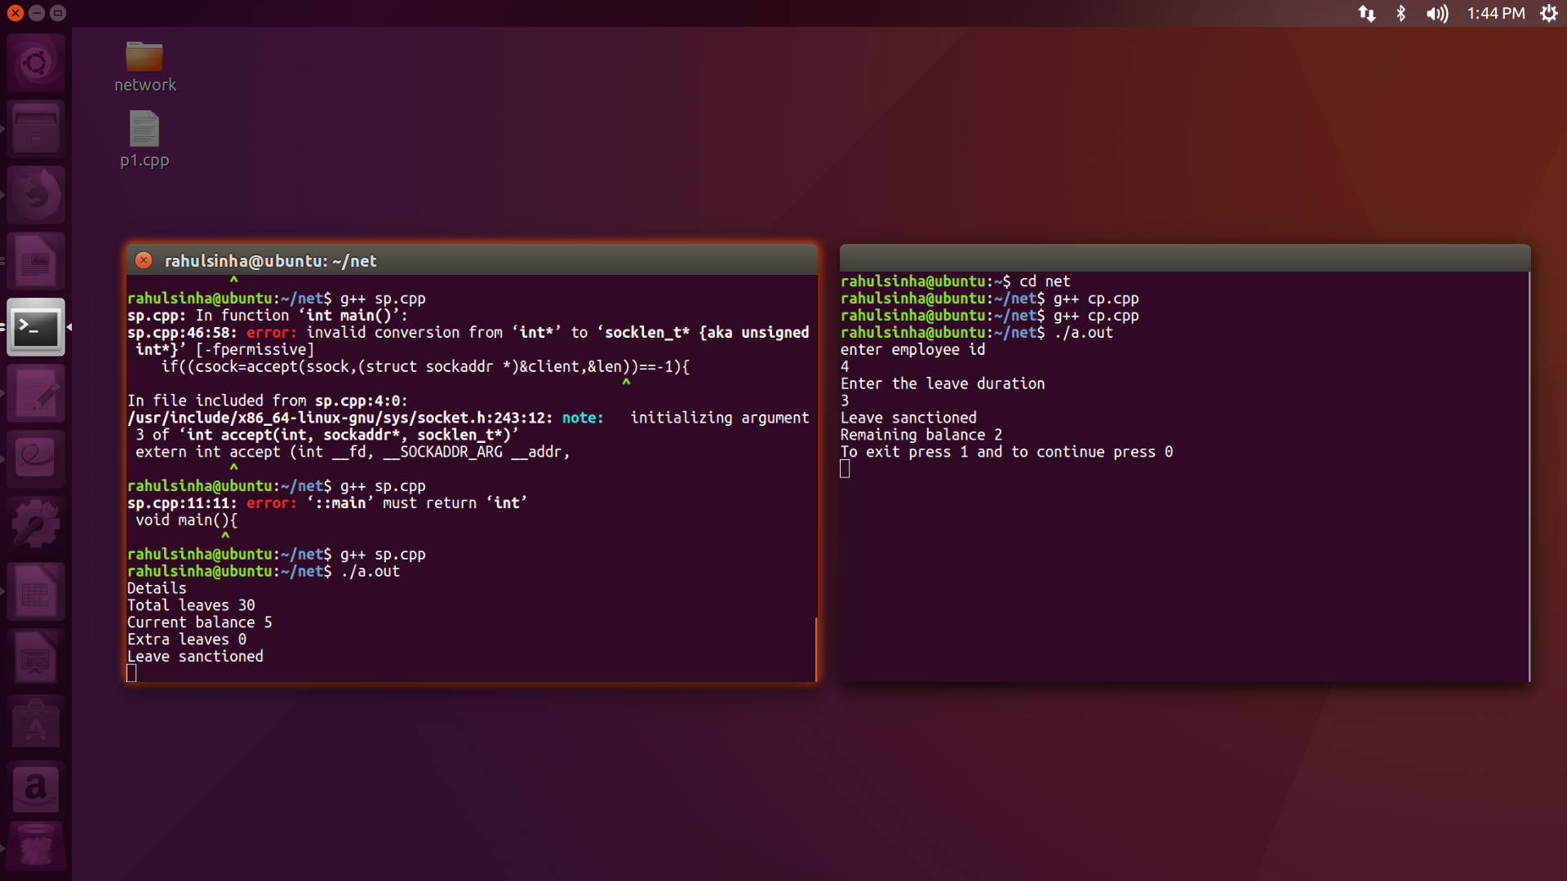

14.

//client
#include <stdio.h>
#include <stdlib.h>
#include <sys/types.h>
#include <sys/socket.h>
#include <netinet/in.h>
#include <errno.h>
#include <string.h>
#include <arpa/inet.h>
#include <unistd.h>

int main(){
int ssock,csock;
FILE *f;
int i=0,n,len;
char o[1000];
char c[1000];
char t[1000];
char nf[100]="No result";

struct sockaddr_in server,client;

if((ssock=socket(AF_INET,SOCK_STREAM,0))==-1){
perror("socket: is not created");
exit(-1);
}

server.sin_family=AF_INET;
server.sin_port=htons(10000);
server.sin_addr.s_addr=INADDR_ANY;

bzero(&server.sin_zero,0);

len=sizeof(struct sockaddr_in);

if((bind(ssock,(struct sockaddr *)&server,len))==-1){
perror("bind: ");
exit(-1);
}

if((listen(ssock,5))==-1){
perror("listen: ");
exit(-1);
}

if((csock=accept(ssock,(struct sockaddr *)&client,&len))==-1){
perror("accept: ");
exit(-1);
}

recv(csock,&o,sizeof(o),0);
f=fopen("Copy.txt","r");
while(fscanf(f,"%[^\n]\n",c)!=EOF){
fscanf(f,"%[^\n]\n",t);
if(strcmp(c,o)==0){
send(csock,&t,sizeof(t),0);
}
}
send(csock,&nf,sizeof(nf),0);
close(csock);
}

//server
#include <stdio.h>
#include <stdlib.h>
#include <sys/types.h>
#include <sys/socket.h>
#include <netinet/in.h>
#include <errno.h>
#include <string.h>
#include <arpa/inet.h>
#include <unistd.h>

int main(){
int ssock,csock;
FILE *f;
int i=0,n,len;
char o[1000];
char c[1000];
char t[1000];
char nf[100]="No result";

struct sockaddr_in server,client;

if((ssock=socket(AF_INET,SOCK_STREAM,0))==-1){
perror("socket: is not created");
exit(-1);
}

server.sin_family=AF_INET;
server.sin_port=htons(10000);
server.sin_addr.s_addr=INADDR_ANY;

bzero(&server.sin_zero,0);

len=sizeof(struct sockaddr_in);

if((bind(ssock,(struct sockaddr *)&server,len))==-1){
perror("bind: ");
exit(-1);
}

if((listen(ssock,5))==-1){
perror("listen: ");
exit(-1);
}

if((csock=accept(ssock,(struct sockaddr *)&client,&len))==-1){
perror("accept: ");
exit(-1);
}

recv(csock,&o,sizeof(o),0);
f=fopen("Copy.txt","r");
while(fscanf(f,"%[^\n]\n",c)!=EOF){
fscanf(f,"%[^\n]\n",t);
if(strcmp(c,o)==0){
send(csock,&t,sizeof(t),0);
}
}
send(csock,&nf,sizeof(nf),0);
close(csock);
}

output

15.
//client
#include <stdio.h>
#include <stdlib.h>
#include <sys/types.h>
#include <sys/socket.h>
#include <netinet/in.h>
#include <errno.h>
#include <string.h>
#include <arpa/inet.h>
#include <unistd.h>
#include <ctype.h>

int main(){
int sock; // client socket discriptor

unsigned int len;

struct sockaddr_in client;
if((sock=socket(AF_INET,SOCK_STREAM,0))==-1){ // client socket is created..
perror("socket: ");
exit(-1);
}

client.sin_family=AF_INET;
client.sin_port=htons(10000); // initializing socket parameters
client.sin_addr.s_addr=INADDR_ANY;
//inet_addr("127.0.0.1");
bzero(&client.sin_zero,0); //appending 8 byte zeroes to 'struct sockaddr_in', to make it equal in size with 'struct sockaddr'..

len=sizeof(struct sockaddr_in);
if((connect(sock,(struct sockaddr *)&client,len))==-1){ //conneting to client
perror("connect: ");
exit(-1);
}

char buffer[255];
FILE *fp;
fp=fopen("first.txt","r");
int wordCount = 0;
char c;

while((c=getc(fp))!=EOF)
{
fscanf(fp,"%s",buffer);
if(isspace(c)||c == '\t')
wordCount++;
}

write(sock,&wordCount,sizeof(int));
rewind(fp);

char ch;

while(ch!=EOF)
{
fscanf(fp,"%s",buffer);
write(sock,buffer,255);
ch = fgetc(fp);
}

printf("file has been successfully uploaded\n");

close(sock);
return 0;
}

//server
#include <stdio.h>
#include <stdlib.h>
#include <sys/types.h>
#include <sys/socket.h>
#include <netinet/in.h>
#include <errno.h>
#include <string.h>
#include <arpa/inet.h>
#include <unistd.h>

int main(){

int ssock,csock; // creating server and clinet socket discriptor

unsigned int len;

struct sockaddr_in server,client; // creating server & client socket object

if((ssock=socket(AF_INET,SOCK_STREAM,0))==-1){
perror("socket: is not created");
exit(-1);
}

server.sin_family=AF_INET;
server.sin_port=htons(10000); // initializing server socket parameters..
server.sin_addr.s_addr=INADDR_ANY;
//inet_addr("127.0.0.1");
bzero(&server.sin_zero,0); //appending 8 byte zeroes to 'struct sockaddr_in', to make it equal in size with 'struct sockaddr'..

len=sizeof(struct sockaddr_in);

if((bind(ssock,(struct sockaddr *)&server,len))==-1){ // binding port & IP
perror("bind: ");
exit(-1);
}

if((listen(ssock,5))==-1){ // listening for client
perror("listen: ");
exit(-1);
}

if((csock=accept(ssock,(struct sockaddr *)&client,&len))==-1){ // accepting connectn
perror("accept: ");
exit(-1);
}
char buffer[255];
FILE *fp;
int ch = 0;
fp = fopen("received.txt","a");
int words;

read(csock,&words,sizeof(int));

while(ch!=words)
{
read(csock,buffer,255);
fprintf(fp,"%s ",buffer);
ch++;
}

printf("The file has been received successfully and Saved\n");

close(ssock);
return 0;
}

output
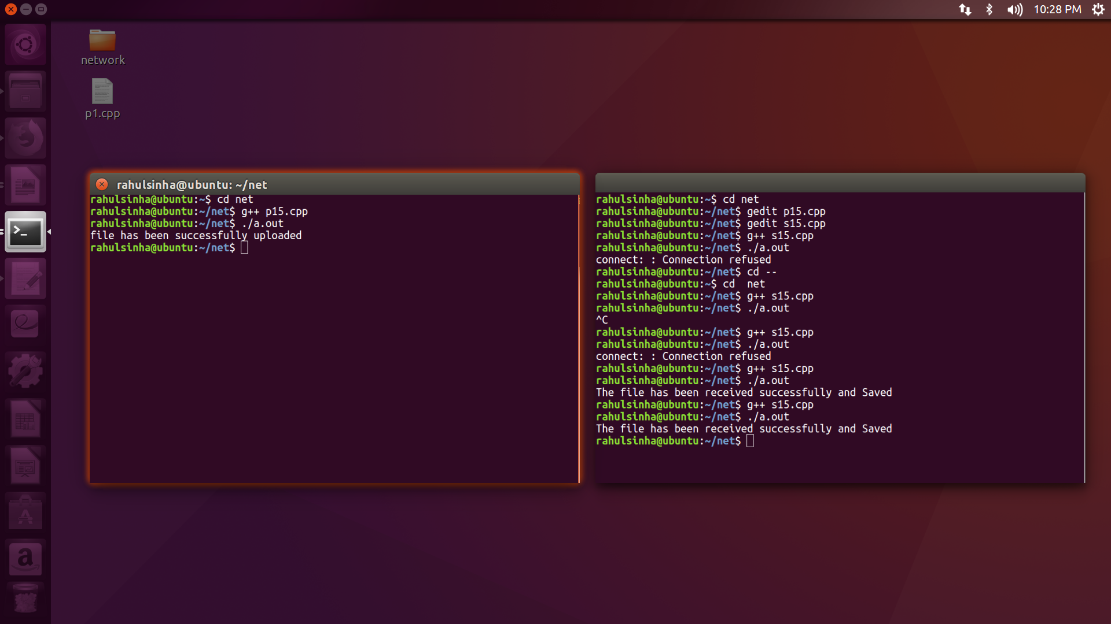

16.
//client
#include <stdio.h>
#include <stdlib.h>
#include <sys/types.h>
#include <sys/socket.h>
#include <netinet/in.h>
#include <errno.h>
#include <string.h>
#include <arpa/inet.h>
#include <unistd.h>

int main(){
int sock; // client socket discriptor
int a,b,i;
char pwd[20];
unsigned int len;
char ch[4]="yes";
char ch1[4];

struct sockaddr_in client;
if((sock=socket(AF_INET,SOCK_STREAM,0))==-1){ // client socket is created..
perror("socket: ");
exit(-1);
}

client.sin_family=AF_INET;
client.sin_port=htons(10010); // initializing socket parameters
client.sin_addr.s_addr=INADDR_ANY;
//inet_addr("127.0.0.1");
bzero(&client.sin_zero,0); //appending 8 byte zeroes to 'struct sockaddr_in', to make it equal in size with 'struct sockaddr'..

len=sizeof(struct sockaddr_in);
if((connect(sock,(struct sockaddr *)&client,len))==-1){ //connecting to client
perror("connect: ");
exit(-1);
}
printf("\nenter server password\n");
scanf("%s",pwd);

send(sock,&pwd,sizeof(pwd),0); // sending data back to client...
recv(sock,&b,sizeof(b),0);
if(b==0)
{
char say[3]="Hi";
send(sock,&say,sizeof(say),0);
char reply[6];
recv(sock,&reply,sizeof(reply),0);
printf("%s\n",reply);
}
//printf("%d\n",b); // receiving data from client

close(sock);

}

//server
#include <stdio.h>
#include <stdlib.h>
#include <sys/types.h>
#include <sys/socket.h>
#include <netinet/in.h>
#include <errno.h>
#include <string.h>
#include <arpa/inet.h>
#include <unistd.h>

int main(){

int ssock,csock; // creating server and clinet socket discriptor
int a,b,c;
char pwd[10]="client123";

unsigned int len;

struct sockaddr_in server,client; // creating server & client socket object

if((ssock=socket(AF_INET,SOCK_STREAM,0))==-1){
perror("socket: is not created");
exit(-1);
}

server.sin_family=AF_INET;
server.sin_port=htons(10010); // initializing server socket parameters..
server.sin_addr.s_addr=INADDR_ANY;
//inet_addr("127.0.0.1");
bzero(&server.sin_zero,0); //appending 8 byte zeroes to 'struct sockaddr_in', to make it equal in size with 'struct sockaddr'..

len=sizeof(struct sockaddr_in);

if((bind(ssock,(struct sockaddr *)&server,len))==-1){ // binding port & IP
perror("bind: ");
exit(-1);
}

if((listen(ssock,5))==-1){ // listening for client
perror("listen: ");
exit(-1);
}

if((csock=accept(ssock,(struct sockaddr *)&client,&len))==-1){ // accepting connectn
perror("accept: ");
exit(-1);
}
char ch[20];
recv(csock,&ch,sizeof(ch),0);
if((c=strcmp(pwd,ch))==0)
{
b=0;
send(csock,&b,sizeof(b),0);
char say[3];
recv(csock,&say,sizeof(say),0);
printf("%s\n",say);
char reply[6]="Hello";
send(csock,&reply,sizeof(reply),0);
//printf("\nserver replied Hello\n");
}
else
{
a = -1;
send(csock,&a,sizeof(a),0);
printf("\npassword not recongnised\n");
}

close(ssock);
return 0;
}

output
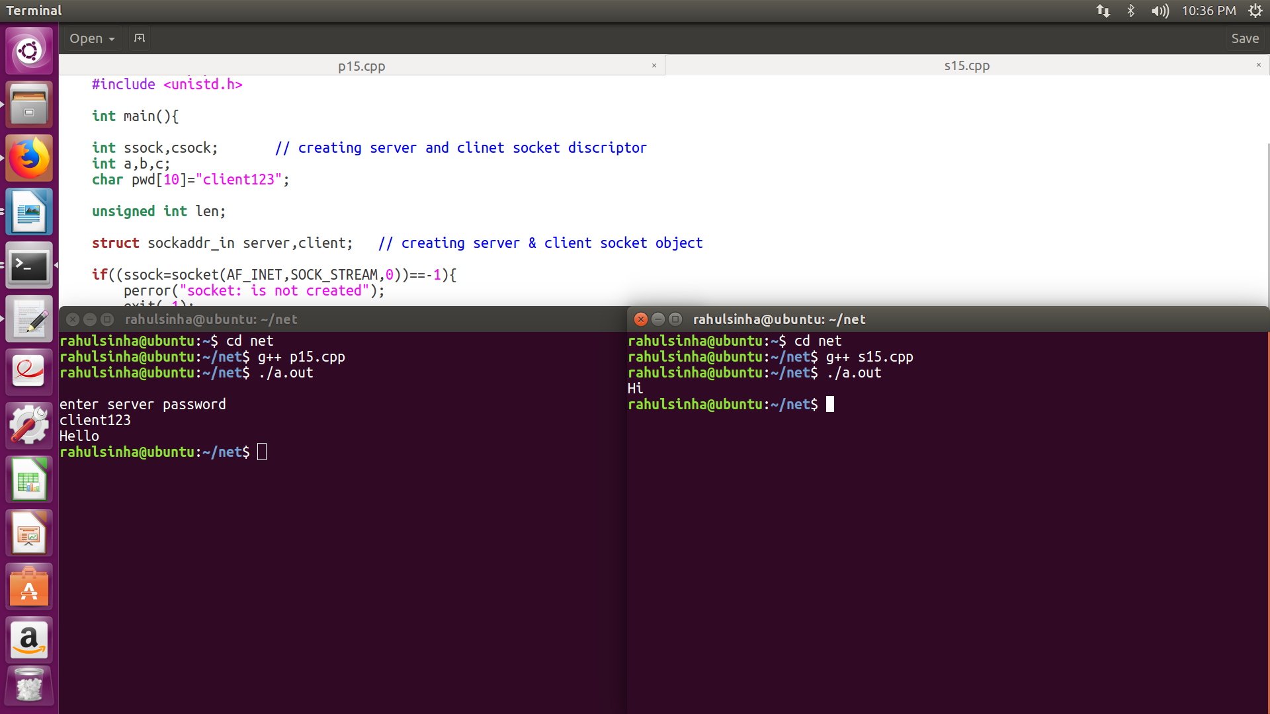

17.
//server
#include <stdio.h>
#include <stdlib.h>
#include <sys/types.h>
#include <sys/socket.h>
#include <netinet/in.h>
#include <errno.h>
#include <string.h>
#include <arpa/inet.h>
#include <unistd.h>

struct item{
char n[100];
int p;
int q;
};

void main(){
int ssock,csock;
FILE *f;
struct item a[2];
int i=0,n,len;
char o[100];
int d,t;

f=fopen("First.txt","r");
while(fscanf(f,"%s %d %d",a[i].n,&a[i].p,&a[i].q)!=EOF){
printf("%s %d %d\n",a[i].n,a[i].p,a[i].q);
i++;
}
n=i;

struct sockaddr_in server,client;

if((ssock=socket(AF_INET,SOCK_STREAM,0))==-1){
perror("socket: is not created");
exit(-1);
}

server.sin_family=AF_INET;
server.sin_port=htons(10000);
server.sin_addr.s_addr=INADDR_ANY;

bzero(&server.sin_zero,0);

len=sizeof(struct sockaddr_in);

if((bind(ssock,(struct sockaddr *)&server,len))==-1){
perror("bind: ");
exit(-1);
}

if((listen(ssock,5))==-1){
perror("listen: ");
exit(-1);
}

if((csock=accept(ssock,(struct sockaddr *)&client,&len))==-1){
perror("accept: ");
exit(-1);
}

while(1){
recv(csock,&o,sizeof(o),0);
recv(csock,&d,sizeof(d),0);
t=0;
for(i=0;i<n;i++){
if(strcmp(o,a[i].n)==0){
if(a[i].q>=d){
a[i].q-=d;
t=a[i].p*d;
}
}
}
send(csock,&t,sizeof(t),0);
}

}

//client
#include <stdio.h>
#include <stdlib.h>
#include <sys/types.h>
#include <sys/socket.h>
#include <netinet/in.h>
#include <errno.h>
#include <string.h>
#include <arpa/inet.h>
#include <unistd.h>
#include<string.h>

void main(){
int sock;
unsigned int len;
char s[100];
char t[100]="Done";
int i,n=0;

struct sockaddr_in client;
if((sock=socket(AF_INET,SOCK_STREAM,0))==-1){
perror("socket: ");
exit(-1);
}

client.sin_family=AF_INET;
client.sin_port=htons(10000);
client.sin_addr.s_addr=INADDR_ANY;

bzero(&client.sin_zero,0);

len=sizeof(struct sockaddr_in);
if((connect(sock,(struct sockaddr *)&client,len))==-1){
perror("connect: ");
exit(-1);
}

while(1){
printf("Enter order\n");
scanf("%s",s);
if(strcmp(s,t)==0)
break;
scanf("%d",&n);
send(sock,&s,sizeof(s),0);
send(sock,&n,sizeof(n),0);
recv(sock,&n,sizeof(n),0);
printf("Transction= %d\n",n);
}
close(sock);

}

