Redesign Project

1 April 2019

Rahul Sonti

**Motor Vehicle Death Rates (2012 & 2014) in the United States**

The visualization our group chose to redesign was an interactive graphic published by the Center for Disease Control and Prevention (CDC) through the data.gov public repository for federal government data. The visualization and data were published on 12 December 2014 by the CDC National Center for Injury Prevention and Control, Division of Unintentional Injury. The original sources of the data include the National Highway Traffic Safety Administration's (NHTSA) Fatality Analysis Reporting System (FARS) for 2012 and 2014. The data was provided in multiple formats, including csv, which we used for our analysis. The CDC’s purpose for publishing this chart was to help inform the public, public health experts, and policy makers on motor vehicle death rates across the United States in 2012 and 2014.

Our rationale for choosing this interactive chart is that we found selecting sets of bar charts to be uninformative for analyzing the dataset overall. While we were able to compare certain factors like age and gender, it wasn’t intuitive for determining any sort of geographic pattern or for investigating hunches about age groups that could be different from the norm. We also couldn’t easily see the changes between the two sets of data in 2012 versus 2014. We decided creating micromaps with the micromapST¹ library in R² would be the most effective way to solve these issues and re-visualize the dataset.

In order to improve all visualizations, two separate micromaps could be created using the micromapST¹ packages in R² to show any spatial relationships among states. The most pertinent message that could be highlighted from each dataset using the micromap is the spatial pattern of states with an increase or decrease in the death rate from 2012 to 2014. If there is a spatial pattern in the death rate, it could provide beneficial environmental information about possible reasons for the low or high death rate, which would ultimately further public safety and health. We were interested in comparing the results for all people, the results by gender, and the results by age (looking at older drivers ages 55 and up and younger drivers below 20). The first redesigned chart we wanted to make was a comparison of all age groups in 2012 and the changes in 2014 across the states. The standard data.gov view of the data is featured below (Fig.1):

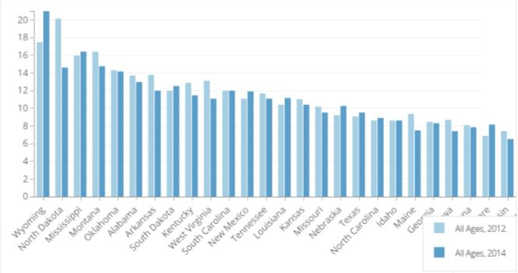

Fig. 1 Bar graph that illustrates motor vehicle death rates of all ages in 2012 and 2014 in each state,

source: CDC National Center for Injury Prevention and Control, Division of Unintentional Injury Prevention

We redesigned the visualization with a standard map, two bar charts representing 2012 and 2014 death rates, and an arrow representing the difference and ranked by largest positive change to largest negative change. This was accomplished by sub-setting a data frame with the states, 2012 death rates, 2014 death rates, a new field calculating the difference, and a column that was only zeroes (in order to construct the arrow chart).

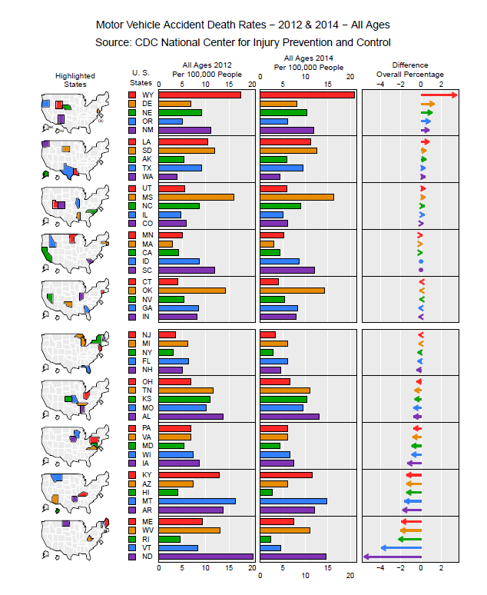

Fig.2 Linked micromap that visualizes the motor vehicle accidents death rates of all ages from 2012 and the overall difference between 2012 and 2014

The new chart (Fig.2) makes it much clearer which states have had net increases and decreases overall in motor vehicle death rates. We can see slight geographic connections: a handful of northwest states and southwest states are seeing an overall increase in death rates, while some northeast and mid-Atlantic states are seeing an overall decrease in death rates. There isn’t a clear trend though, especially as some states appear to be anomalies in their region. Population may also be skewing the results, since even though death rates are per 100,000 people, instances of motor vehicle death may weigh more heavily on states with lower populations. Finally, the District of Columbia is missing data altogether in the dataset, but we can accept this as an analysis of states only.

From the above micromap we can analyze that Wyoming has the highest increase rate from 2012 to 2014 and the state of North Dakota has the highest decrease rate from 2012 to 2014. The states of Idaho and South Carolina have no change in the death rate from 2012 to 2014.

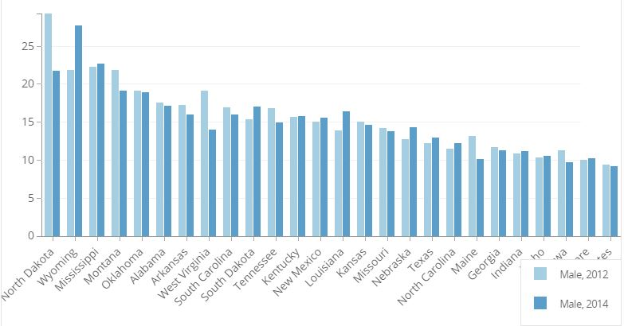

Fig. 3 Bar graph that illustrates motor vehicle death rates of males in 2012 and 2014 in each state,

source: CDC National Center for Injury Prevention and Control, Division of Unintentional Injury Prevention

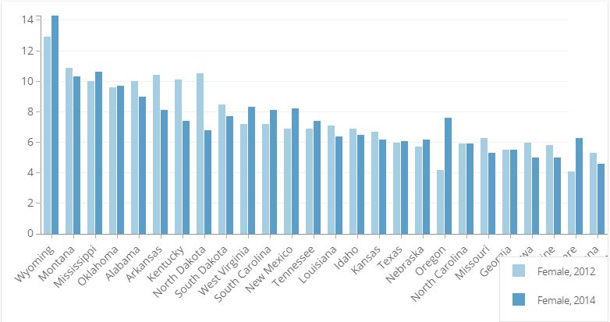

Fig. 4 Bar graph that illustrates motor vehicle death rates of females in 2012 and 2014 in each state,

source: CDC National Center for Injury Prevention and Control, Division of Unintentional Injury Prevention

The bar graph (Fig. 3) visualizes the motor vehicle death rates of males of all ages in the United States. The second bar graph (Fig. 4) visualizes the motor vehicle death rates of females of all ages in the United States. From these bar graphs, the only factors that can be compared are the male or female death rates in 2012 and 2014 for each individual state. Both original visualizations do not allow you to compare the 2012 and 2014 death rates for each state against the other states easily. Additionally, neither bar graph allows you to see if there is any sort of spatial relationship between death rates in 2012, 2014 or any change in the death rate from 2012 to 2014.

For the visualization to look better, we cleaned the dataset by removing the District of Columbia, Vermont, and Rhode Island from the dataframe due to a lack of information for either 2012, 2014 or both. For the original female death rate dataset, the states of Rhode Island, Hawaii, the District of Columbia, Vermont, and Alaska were removed due to lack of data for 2012, 2014, or both. To enhance the messaging, a column was added to the male and female dataset that contained the amount of change, positive or negative, in the death rate from 2012 to 2014. That column was then used to create an arrow glyph in each micromap, with the entire micromap being sorted by the rate of change column in descending order. By doing this, the first thing that the reader sees is the five states with the highest increase in male or female death rates and the five states with the strongest negative change in male or female death rates. Furthermore, the addition of a two tailed micromap allows for the reader to easily pick out where their state is and if their state is below or above the median. Below is the redesigned visualization for motor vehicle death rates in males of all ages in 2012 and 2014 (Fig. 5) and the redesigned visualization for motor vehicle death rates of females of all ages in 2012 and 2014 (Fig.6).

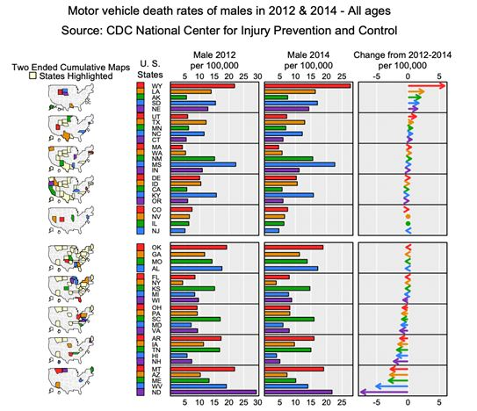

Fig.5 Linked micromap that visualization motor vehicle death rates of males, all ages, in 2012, 2014 and the rate of change between the two years.

From the above chart (Fig.5) we can see that in the central region there is an increase in the male death rate from 2012 to 2014 and in the Eastern region and Southern region the death rate is on a decline, there is a slight increase in the Western region and Northern region. In the states of Nevada and Illinois there is no or negligible change in the death rate from 2012 to 2014.

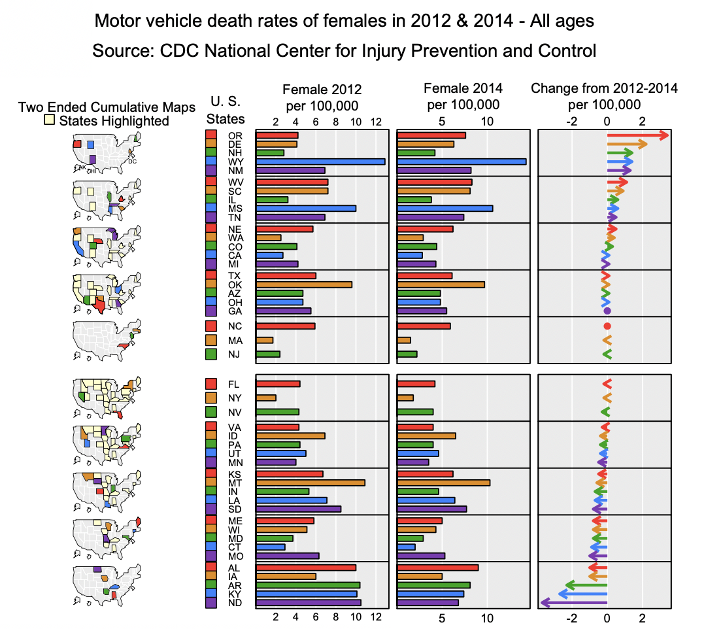

Fig. 6 Linked micromap that visualization motor vehicle death rates of females, all ages, in 2012, 2014 and the rate of change between the two years.

From the above chart (Fig.6) we can analyze that in Western region the change in female death rate is increasing and in the Southeast and Midwest region the female death rate is decreasing.

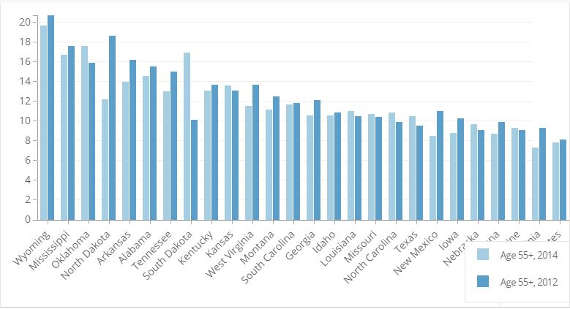

Fig.7 Bar graph that illustrates motor vehicle death rates of age 55+ in 2012 and 2014 in each state,

source: CDC National Center for Injury Prevention and Control, Division of Unintentional Injury Prevention

The above bar chart (Fig.7) is the standard chart from the website that illustrates the deaths of age 55+ in 2012 and 2014. However, if we want to compare the change, which is not present, or to compare one state to other state or to rank the highest to lowest is not possible. To do this, we developed a micromap that aligns the data from highest to lowest with reference to change in the death rate from 2012 to 2014. To achieve this, we did not consider the states of Alaska, Vermont, Delaware, Rhode Island, New Hampshire, Hawaii, and District of Columbia as the data for 2012 or 2014 or both in few cases was not available.

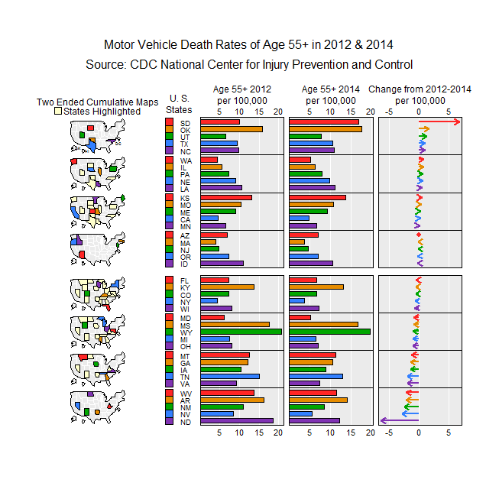

Fig. 8 Linked micromap that visualization motor vehicle death rates of ages 55+ in 2012, 2014 and the rate of change between the two years.

From above chart (Fig.8) we can clearly see which states have the highest change in the death rate from 2012 to 2014. The state of South Dakota has the highest increase rate and the state of North Dakota has the highest decrease in the death rate from 2012 to 2014. We can also analyze that in the death rate is on rise in Central and Western regions, and in the Eastern regions and few parts of central-north are on a decline. The state of Arizona has no change from 2012 to 2014 in the death rates of ages 55+.

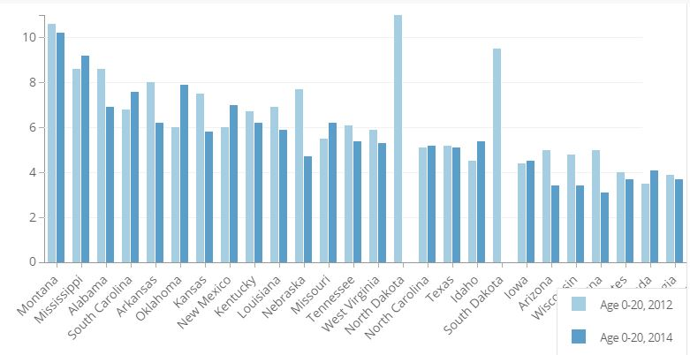

Fig.9 Bar graph that illustrates motor vehicle death rates of age 0-20 in 2012 and 2014 in each state,

source: CDC National Center for Injury Prevention and Control, Division of Unintentional Injury Prevention

The above bar chart (Fig.9) is the chart available from the CDC website which gives us the visualization for the data of death rates of ages 0-20 from 2012 and 2014. But from this chart we cannot analyze which state suffered from highest growth or the highest decrease in the death rates from 2012 to 2014. For which we used a micromap, but as the data of 2012 or 2014 or both in few cases was missing for some of the states we did not consider those states for the analysis. The states that were not considered for the analysis are District of Columbia, South Dakota, Maine, Alaska, Vermont, North Dakota, Delaware, New Hampshire, Wyoming, Rhode Island, Hawaii and Connecticut.

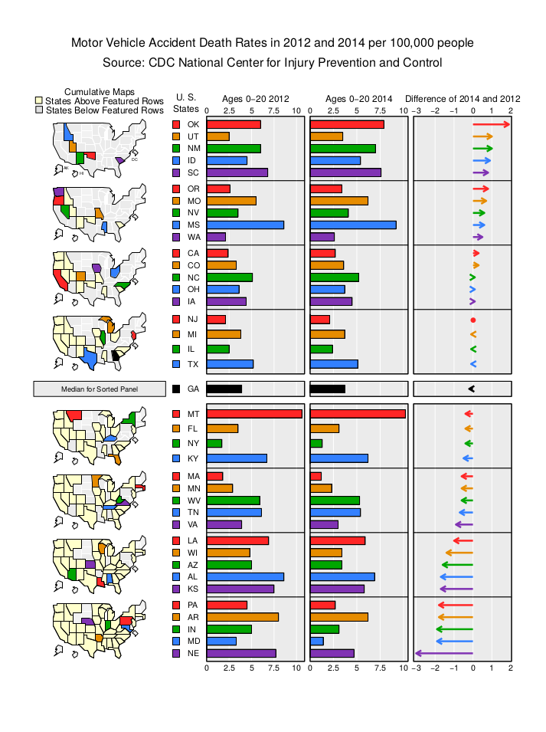

Fig.10 Linked micromap that visualization motor vehicle death rates of ages 0-20 in 2012, 2014 and the rate of change between the two years.

From the above chart (Fig.10) we can analyze that the state of Oklahoma has the highest increase in the death rates of age 0-20 from 2012 to 2014, the state of Nebraska has the highest amount of decline from 2012 to 2014 and New Jersey has no change from 2012-2014 in the death rates. We can also see that there is an increase in the death rates in both Western regions and Southern regions, and as we go towards the Eastern and Northern regions, the death rate decreased from 2012 to 2014.

The use of micromaps to redesign the default visualizations provided by the data source has given us new insights about motor vehicle death rates by geography and demographics. We can observe the approximate geographic regions changes are occurring. We can see that some groups, like drivers ages 0-20 and women of all ages, have only net changes of 2-3 percentage points, while other groups, like men all ages and drivers ages 55+, experience larger net changes between years of up to 5 percentage points. We can also instantly scale the results to each other and see the how men and women stack up and how younger and older drivers compare. Net changes, the max values for a demographic in a given year, and the grouping of states was information that we could not easily understand from the original visualization.

**References**

1. Daniel B. Carr and Linda Williams Pickle (2010). Visualizing Data Patterns with Micromaps.

2. R Core Team (2018). R: A language and environment for statistical computing. R Foundation for Statistical Computing. Vienna, Austria. URL [https://www.R-project.org/](https://www.r-project.org/)

3. CDC NCIPC Division of Unintentional Injury Prevention (2014). Motor Vehicle Occupant Death Rate, by Age and Gender, 2012 & 2014, All States. <https://data.cdc.gov/Motor-Vehicle/Motor-Vehicle-Occupant-Death-Rate-by-Age-and-Gende/rqg5-mkef>