Nama : Rahul Bin Subagio

Nim : 123180033

Plug : N

SELECT * FROM pasien WHERE alamat LIKE '%og%';

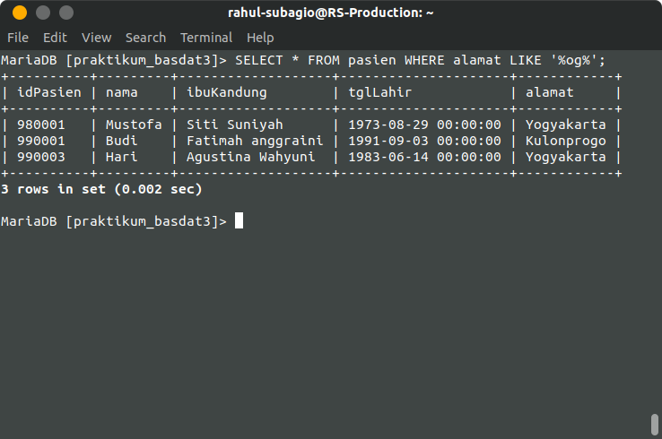

SELECT * FROM dokter ORDER BY taripkonsul;

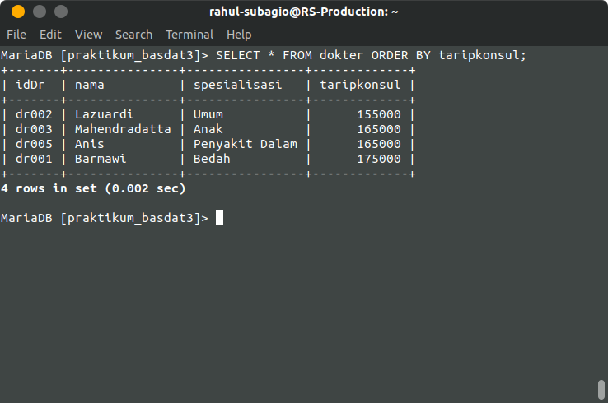

SELECT p.nama, r.NamaRuang FROM pasien p

-> JOIN ranap rp ON p.idPasien = rp.idPasien

-> JOIN ruang r ON r.idRuang = rp.idRuang

-> WHERE p.nama = 'Mustofa';

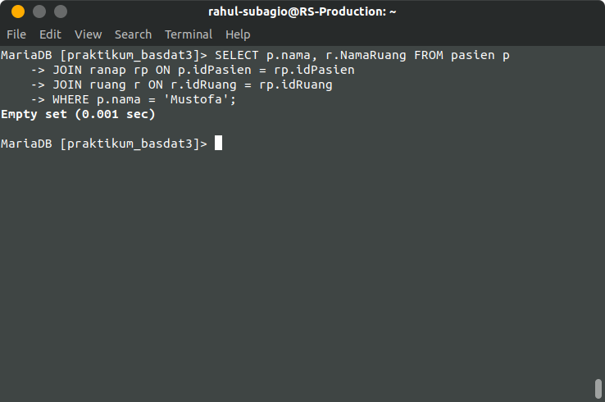

SELECT p.nama, d.nama, r.NamaRuang FROM pasien p

-> JOIN ranap rp ON p.idPasien = rp.idPasien

-> JOI= N dokter d ON d.idDr = rp.idDr

-> JOIN ruang r ON r.idRuang = rp.idRuang

-> WHERE d.spesialisasi 'Anak';

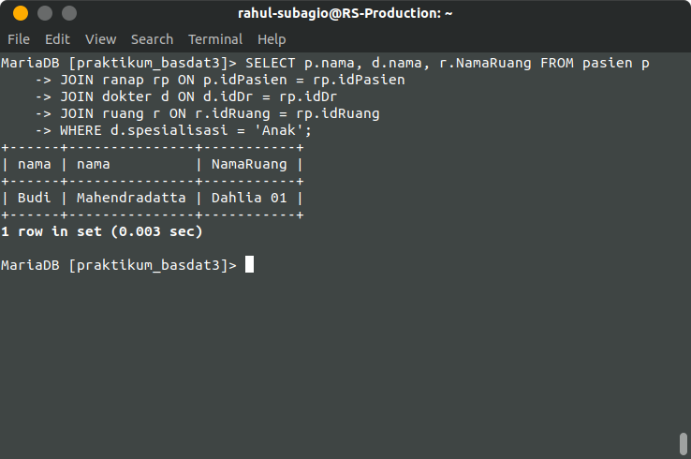

1. S

SELECT nama FROM dokter WHERE idDr = 'dr005';

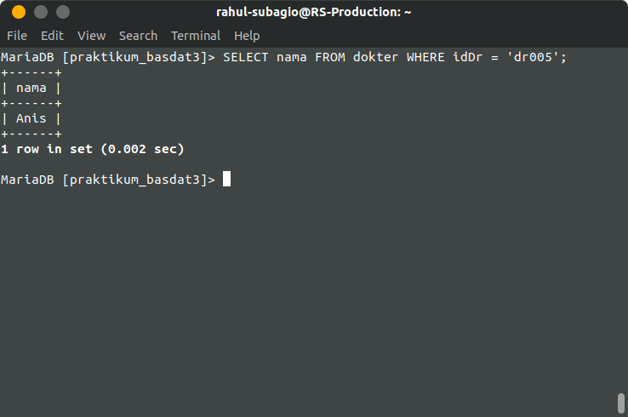

UPDATE pasien SET alamat = 'bandung' WHERE nama = 'Mustofa';

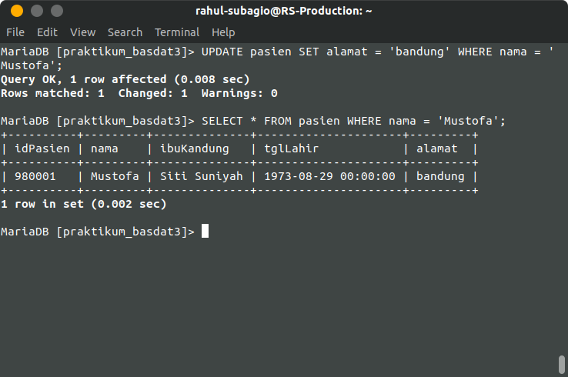

DELETE FROM pasien WHERE nama = 'Nurul';

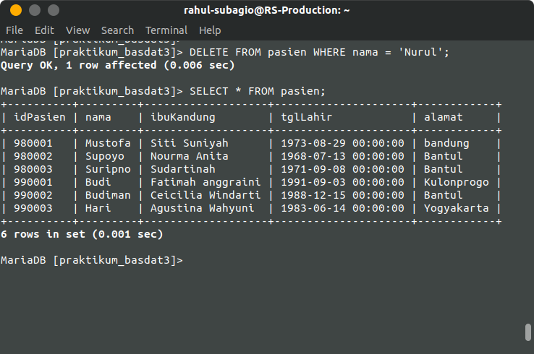

SELECT p.nama, d.nama, r.NamaRuang, rp.wktMasuk, rp.wktKeluar FROM pasien p

-> JOIN ranap rp ON p.idPasien = rp.idPasien

-> JOIN dokter d ON rp.idDr = d.idDr

-> JOIN ruang r ON rp.idRuang = r.idRuang;

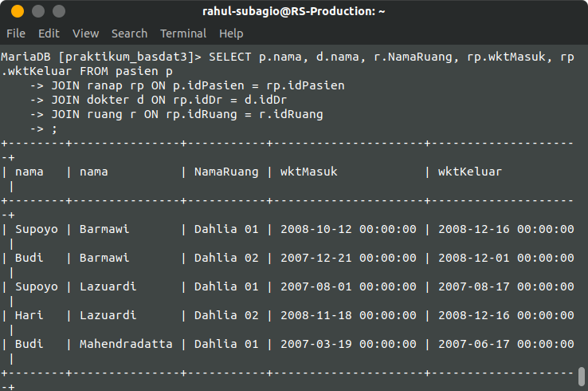

MariaDB [praktikum_basdat3]>DELETE FROM ruang WHERE idRuang = 'ke001';

MariaDB [praktikum_basdat3]> DELETE FROM ruang WHERE idRuang = 'ke002';

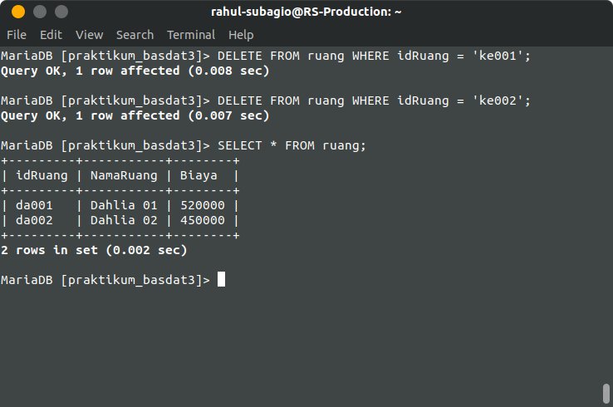

INSERT INTO ruang VALUES

-> ('VP001', 'VVIP', 250000);

