Part1

1.[SELECT](http://localhost/phpmyadmin/url.php?url=http://dev.mysql.com/doc/refman/5.5/en/select.html) OrderNumber, (QuotedPrice*QuantityOrdered) AS Revenue

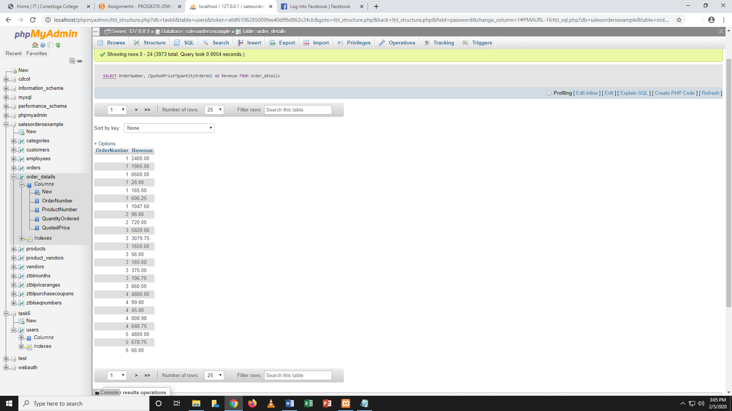FROM order_details;

2.[SELECT](http://localhost/phpmyadmin/url.php?url=http://dev.mysql.com/doc/refman/5.5/en/select.html) EmpFirstName, TIMESTAMPDIFF([year](http://localhost/phpmyadmin/url.php?url=http://dev.mysql.com/doc/refman/5.5/en/date-and-time-types.html), EmpBirthDate,[CURRENT_DATE](http://localhost/phpmyadmin/url.php?url=http://dev.mysql.com/doc/refman/5.5/en/date-and-time-functions.html#function_current_date)()) AS Age FROM `employees` ORDER By Age ASC;

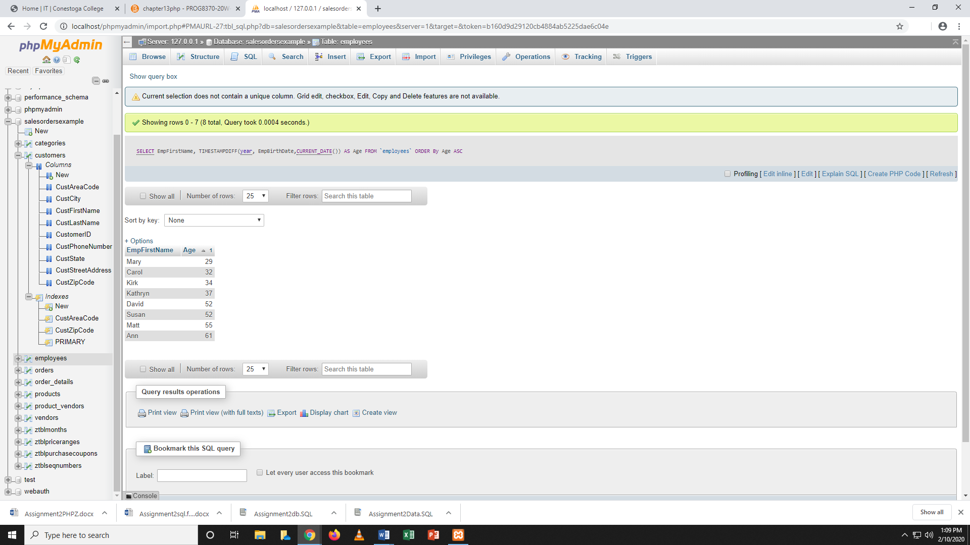

Part 2

1.[SELECT](http://localhost/phpmyadmin/url.php?url=http://dev.mysql.com/doc/refman/5.5/en/select.html) * FROM `employees` WHERE EmpFirstName [LIKE](http://localhost/phpmyadmin/url.php?url=http://dev.mysql.com/doc/refman/5.5/en/string-comparison-functions.html#operator_like) '%r%' [AND](http://localhost/phpmyadmin/url.php?url=http://dev.mysql.com/doc/refman/5.5/en/logical-operators.html#operator_and) EmpLastName [NOT](http://localhost/phpmyadmin/url.php?url=http://dev.mysql.com/doc/refman/5.5/en/logical-operators.html#operator_not) [LIKE](http://localhost/phpmyadmin/url.php?url=http://dev.mysql.com/doc/refman/5.5/en/string-comparison-functions.html#operator_like) '%q%';

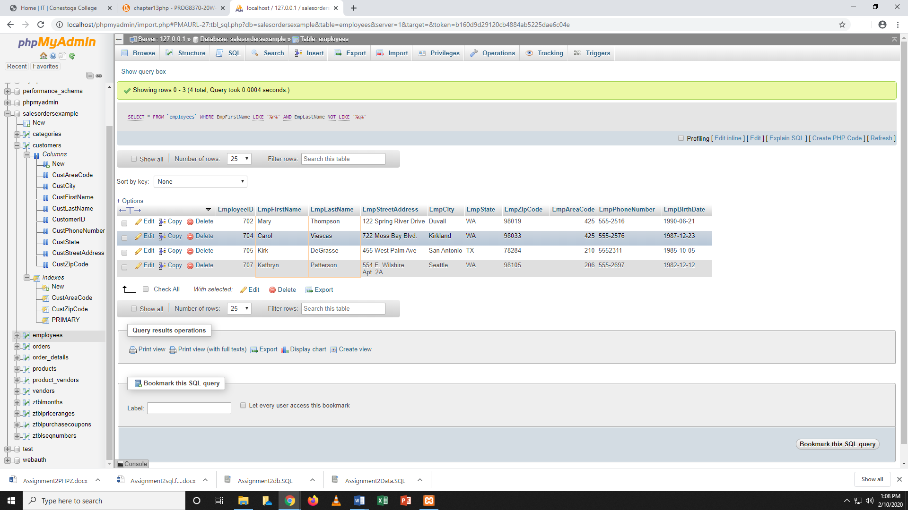

Part3.

1.

It should have primary key and phone number should not be null as well as products should b in normalised form.

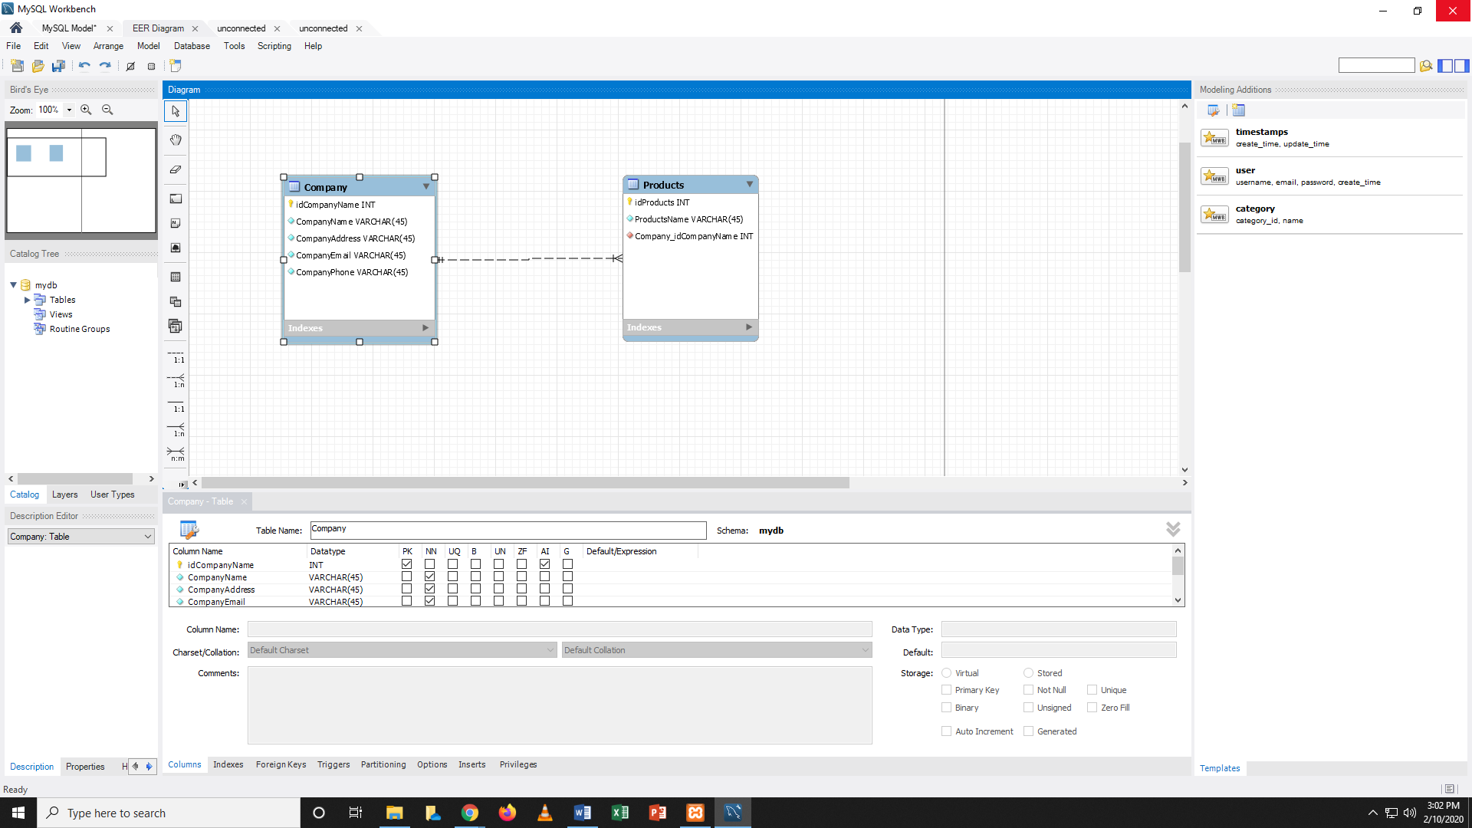

Part4.

1. [SELECT](http://localhost/phpmyadmin/url.php?url=http://dev.mysql.com/doc/refman/5.5/en/select.html) DISTINCT c.CustFirstName, c.CustPhoneNumber FROM `customers` as c join orders as o ON c.customerId= o.CustomerID JOIN order_details as od ON o.OrderNumber= od.OrderNumber JOIN products as p ON od.ProductNumber=p.ProductNumber WHERE p.ProductName [LIKE](http://localhost/phpmyadmin/url.php?url=http://dev.mysql.com/doc/refman/5.5/en/string-comparison-functions.html#operator_like) '%helmet%'

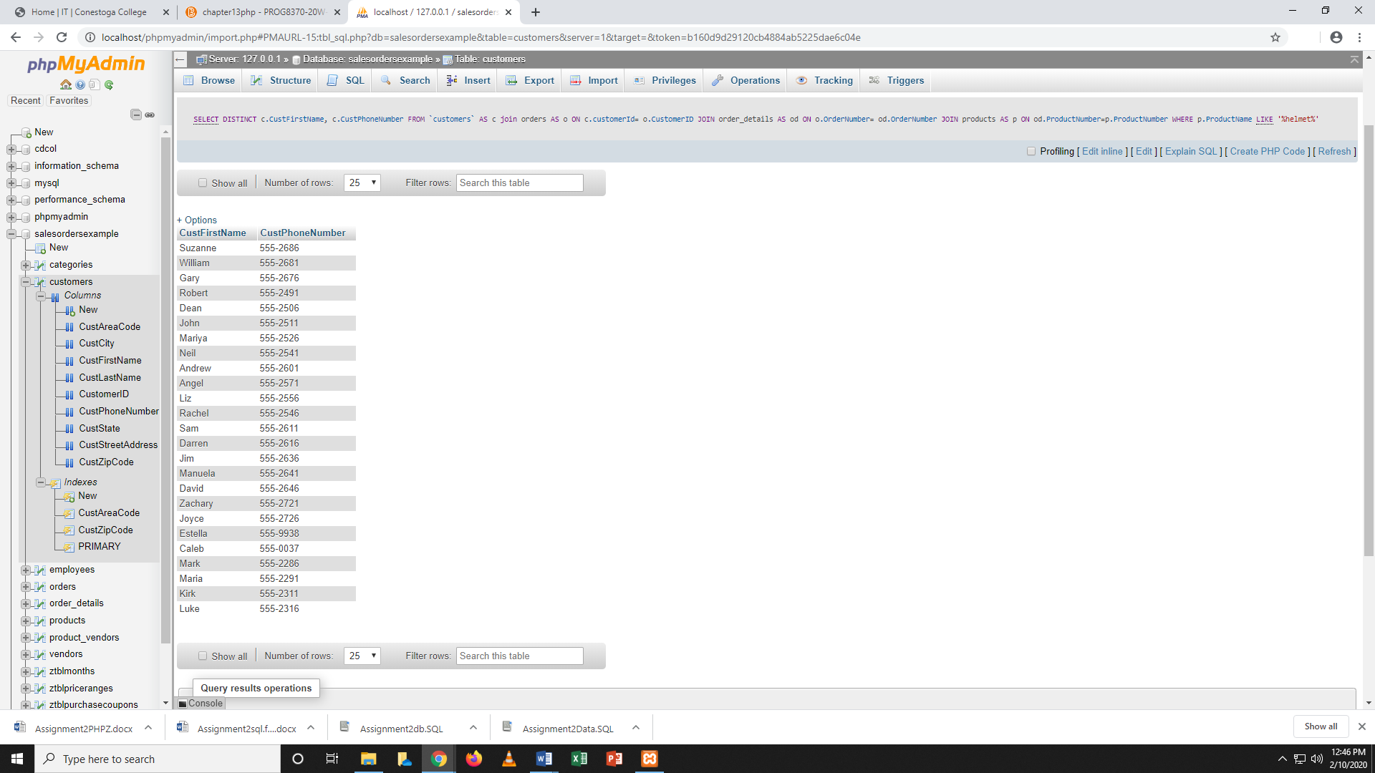

2.[SELECT](http://localhost/phpmyadmin/url.php?url=http://dev.mysql.com/doc/refman/5.5/en/select.html) c.CustFirstName, e.EmpFirstName FROM customers c INNER JOIN employees e ON c.CustFirstName=e.EmpFirstName;

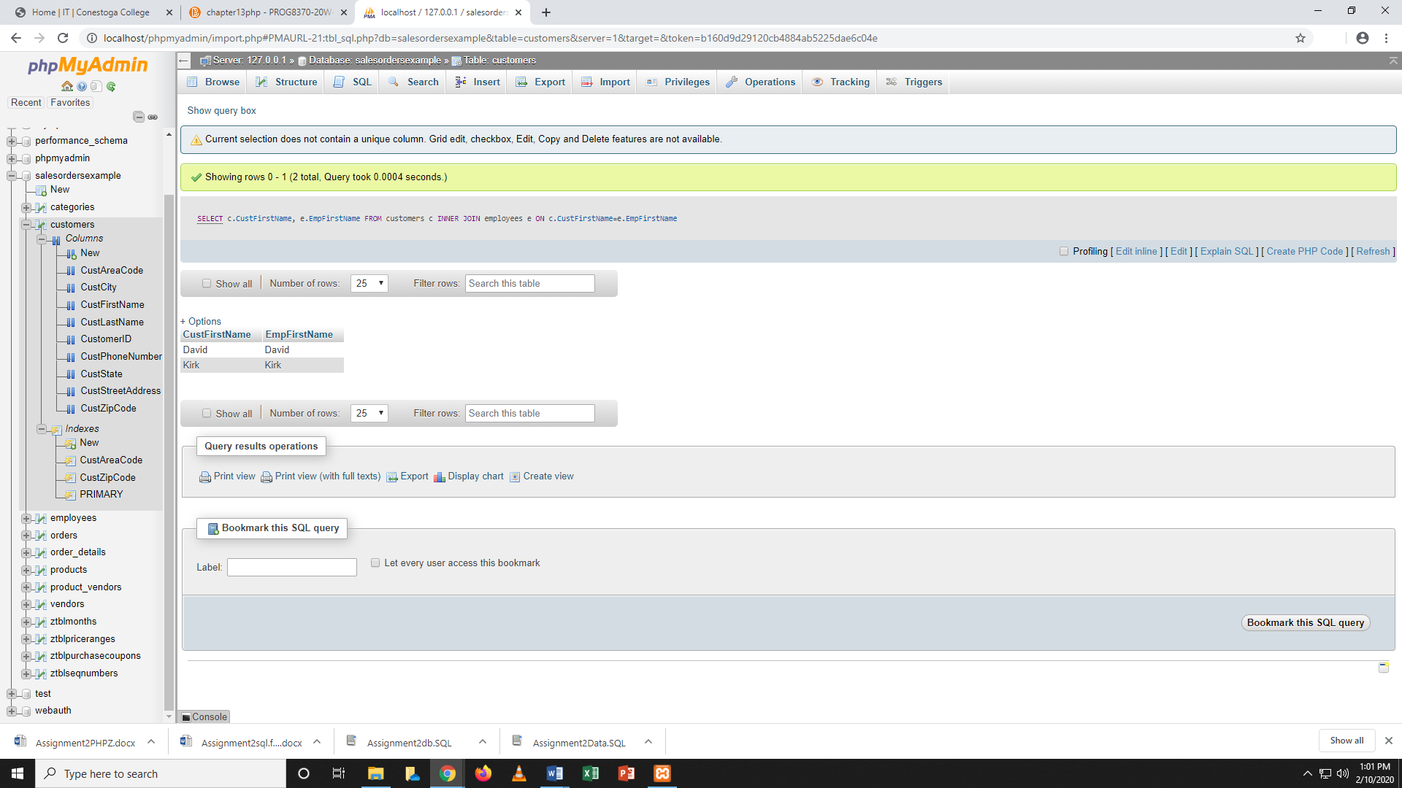

Part5.

1.[SELECT](http://localhost/phpmyadmin/url.php?url=http://dev.mysql.com/doc/refman/5.5/en/select.html) [SUM](http://localhost/phpmyadmin/url.php?url=http://dev.mysql.com/doc/refman/5.5/en/group-by-functions.html#function_sum)(QuantityOrdered*QuotedPrice*2) AS total FROM order_details as od JOIN orders o ON od.OrderNumber=o.OrderNumber JOIN customers as c ON o.CustomerID=c.CustomerID WHERE c.CustState='OR';

