URL SHORTENER API
API Documentation

1) API : User Registration
HTTP Method | POST
Endpoint | /api/auth/register
Authentication | Not required
Purpose | Creates a new user account and returns a JWT token after successful registration.

Request Body:
{
"email": "user@example.com",
"password": "Password123!"
}

Response Body
{
"token": "<JWT_TOKEN>"
}
Swagger Screenshot:
i). Request Body Screenshot:
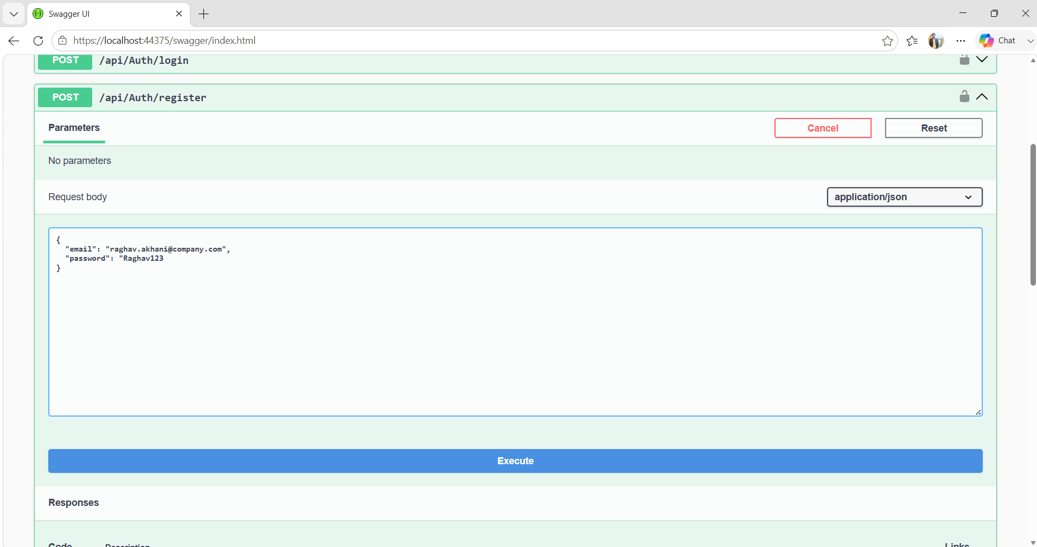
ii). Response Body Screenshot:
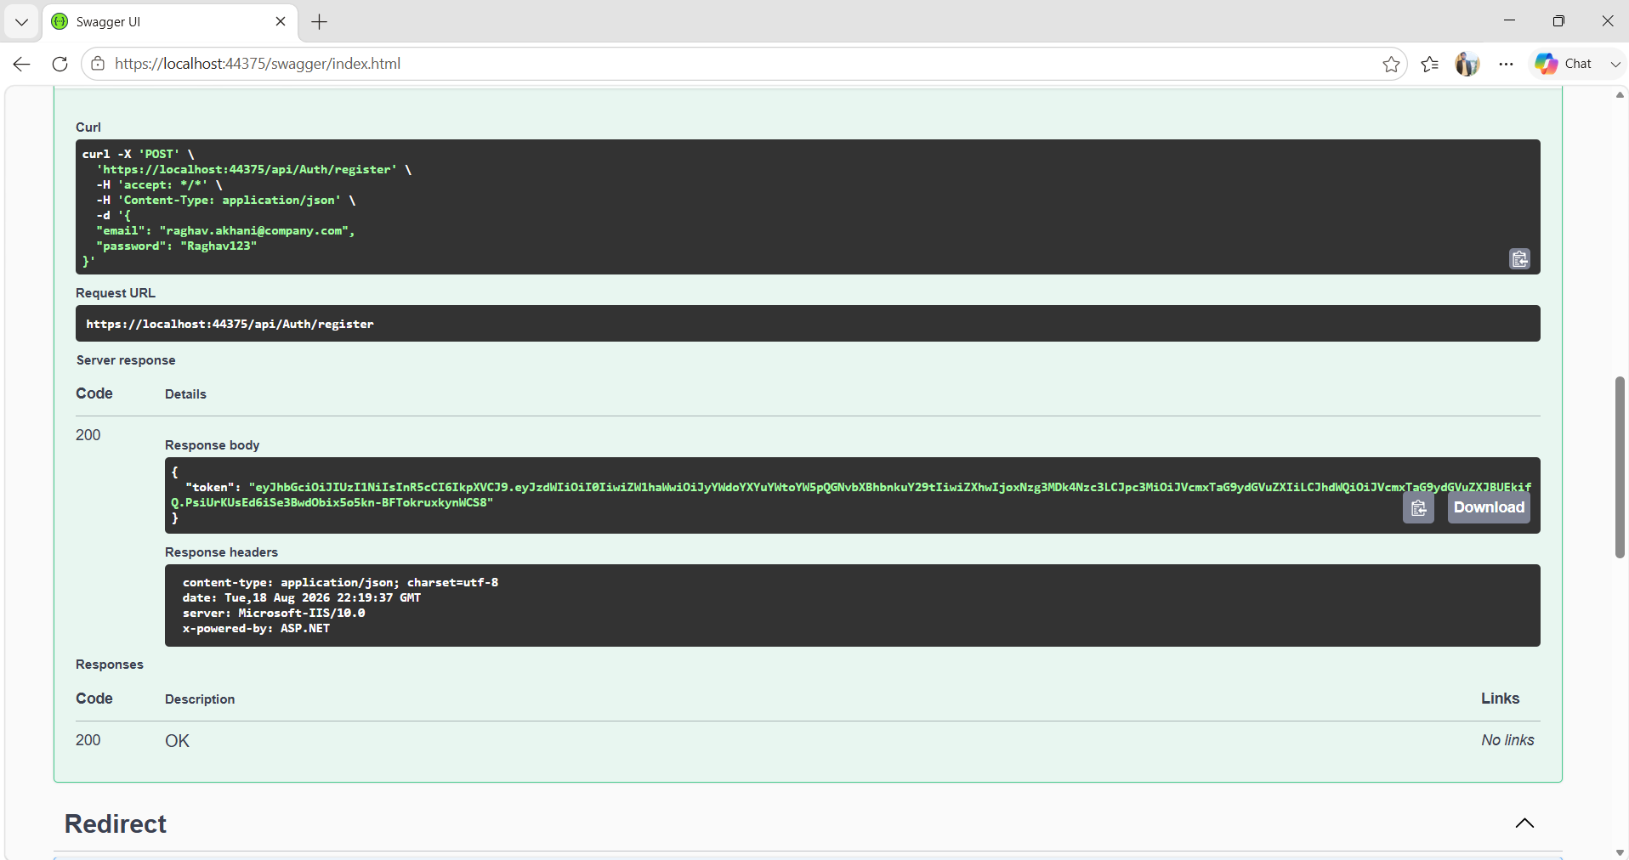
2) API : User Login
HTTP Method | POST
Endpoint | /api/auth/login
Purpose | Authenticates an existing  user and returns a JWT token.

Request Body
{
"email": "user@example.com",
"password": "Password123!"
}

Response Body
{
"token": "<JWT_TOKEN>"
}
Swagger Screenshot:
i). Request Body Screenshot:
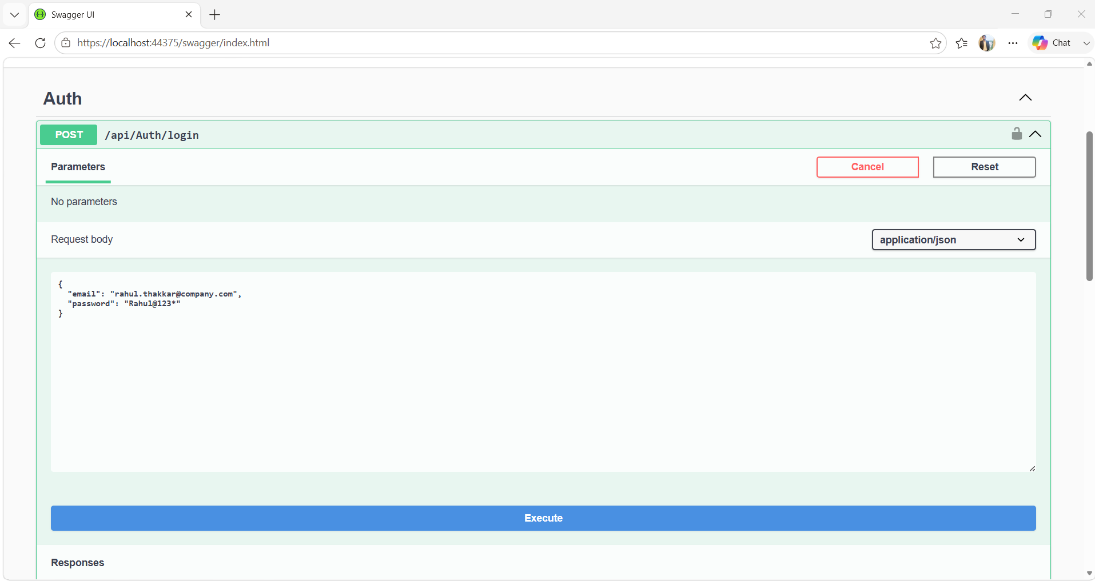
ii). Response Body Screenshot:
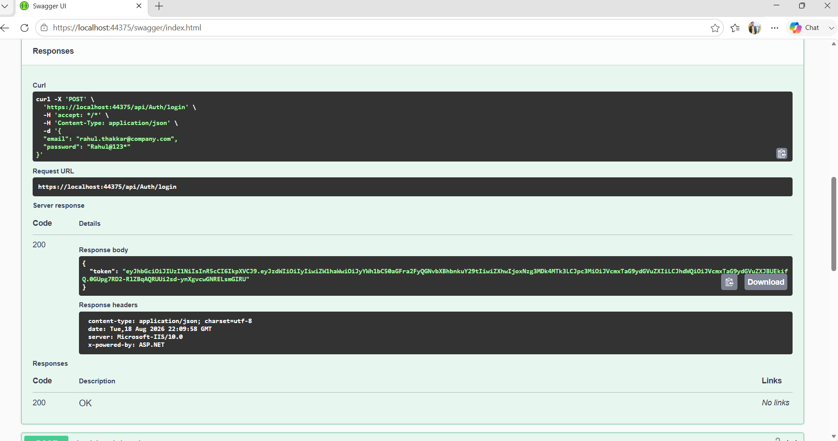

3) API : Create Short URL
HTTP Method | POST
Endpoint | /api/urls
Purpose | Creates a short URL for an authenticated user and generates a unique short code.

Request Body
{
"url": "https://example.com",
"expiresAt": "2026-12-22T23:17:237Z"
}

Response Body
{
"id": 4,
"originalUrl": "https://example.com",
"shortCode": "O5w8EM",
"createdAt": "2026-08-18T23:19:21.463549Z",
"expiresAt": "2026-08-22T23:17:30.237Z",
"isActive": true,
"clickCount": 0
}

Swagger Screenshot:
i). Request Body Screenshot:
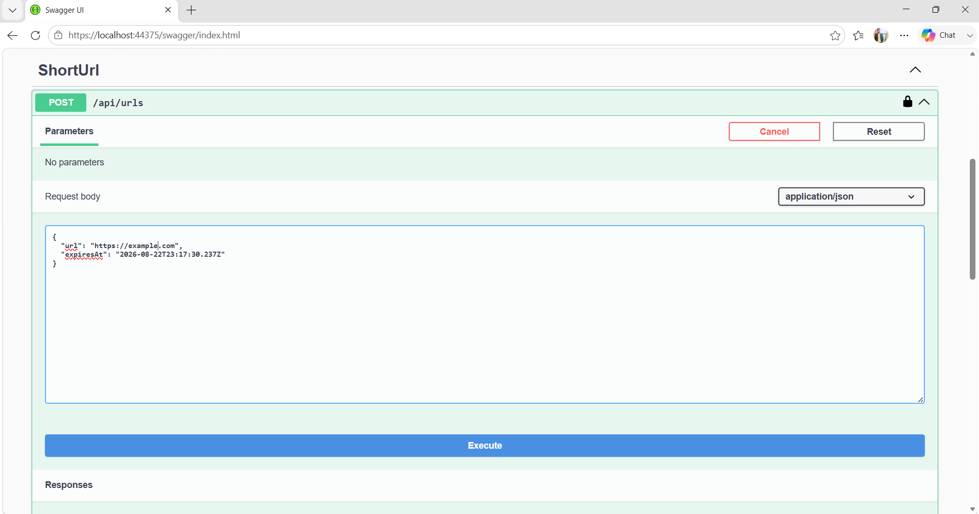
ii). Response Body Screenshot:
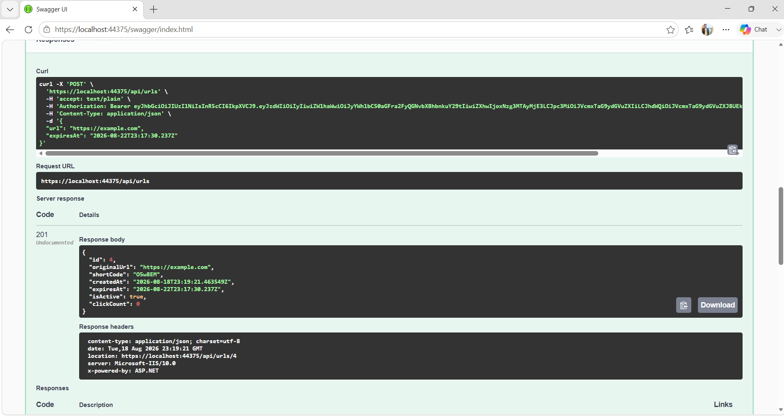

4) API : Get All Short URLs

HTTP Method | GET
Endpoint | /api/urls
Purpose | Returns the authenticated user's short URLs with the implemented pagination, searching, and status-filtering functionality.

Request Body Parameters:

Parameter | Value
page | 1
pageSize | 10
search | example
status | active

Response Body
{
"items": [
{
"id": 4,
"originalUrl": "https://example.com",
"shortCode": "O5w8EM",
"createdAt": "2026-08-18T23:19:21.463549",
"expiresAt": "2026-08-22T23:17:30.237",
"isActive": true
}
],
"totalCount": 1,
"page": 1,
"pageSize": 10,
"totalPages": 1
}

Swagger Screenshots:
i). Request Body Screenshot
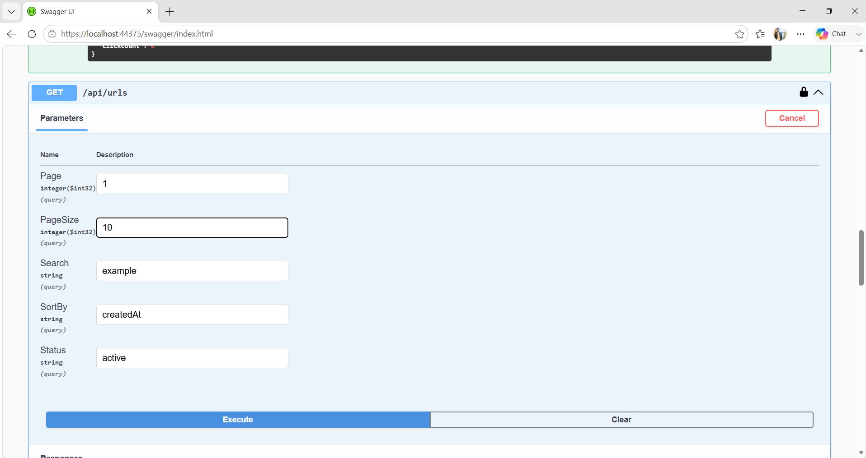
ii). Response Body Screenshot
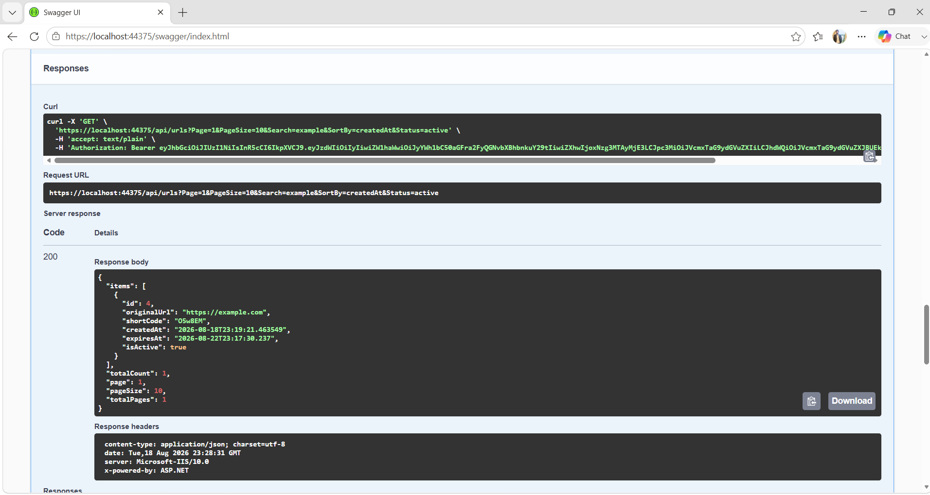

5) API : Get Short URL Details
HTTP Method | GET
Endpoint | /api/urls/{id}
Purpose | Returns details for a specific short URL belonging to the authenticated user.

Request Body Query Parameters:
Parameter | Value
id | 4

Response Body
{
"id": 4,
"originalUrl": "https://example.com",
"shortCode": "O5w8EM",
"createdAt": "2026-08-18T23:19:21.463549",
"expiresAt": "2026-08-22T23:17:30.237",
"isActive": true,
"clickCount": 0
}

Swagger Screenshot
i). Request Body Screenshot
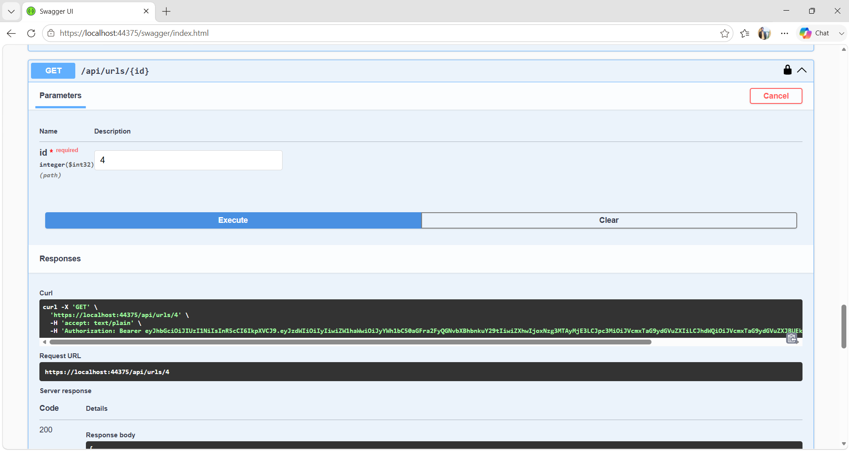
ii). Response Body Screenshot
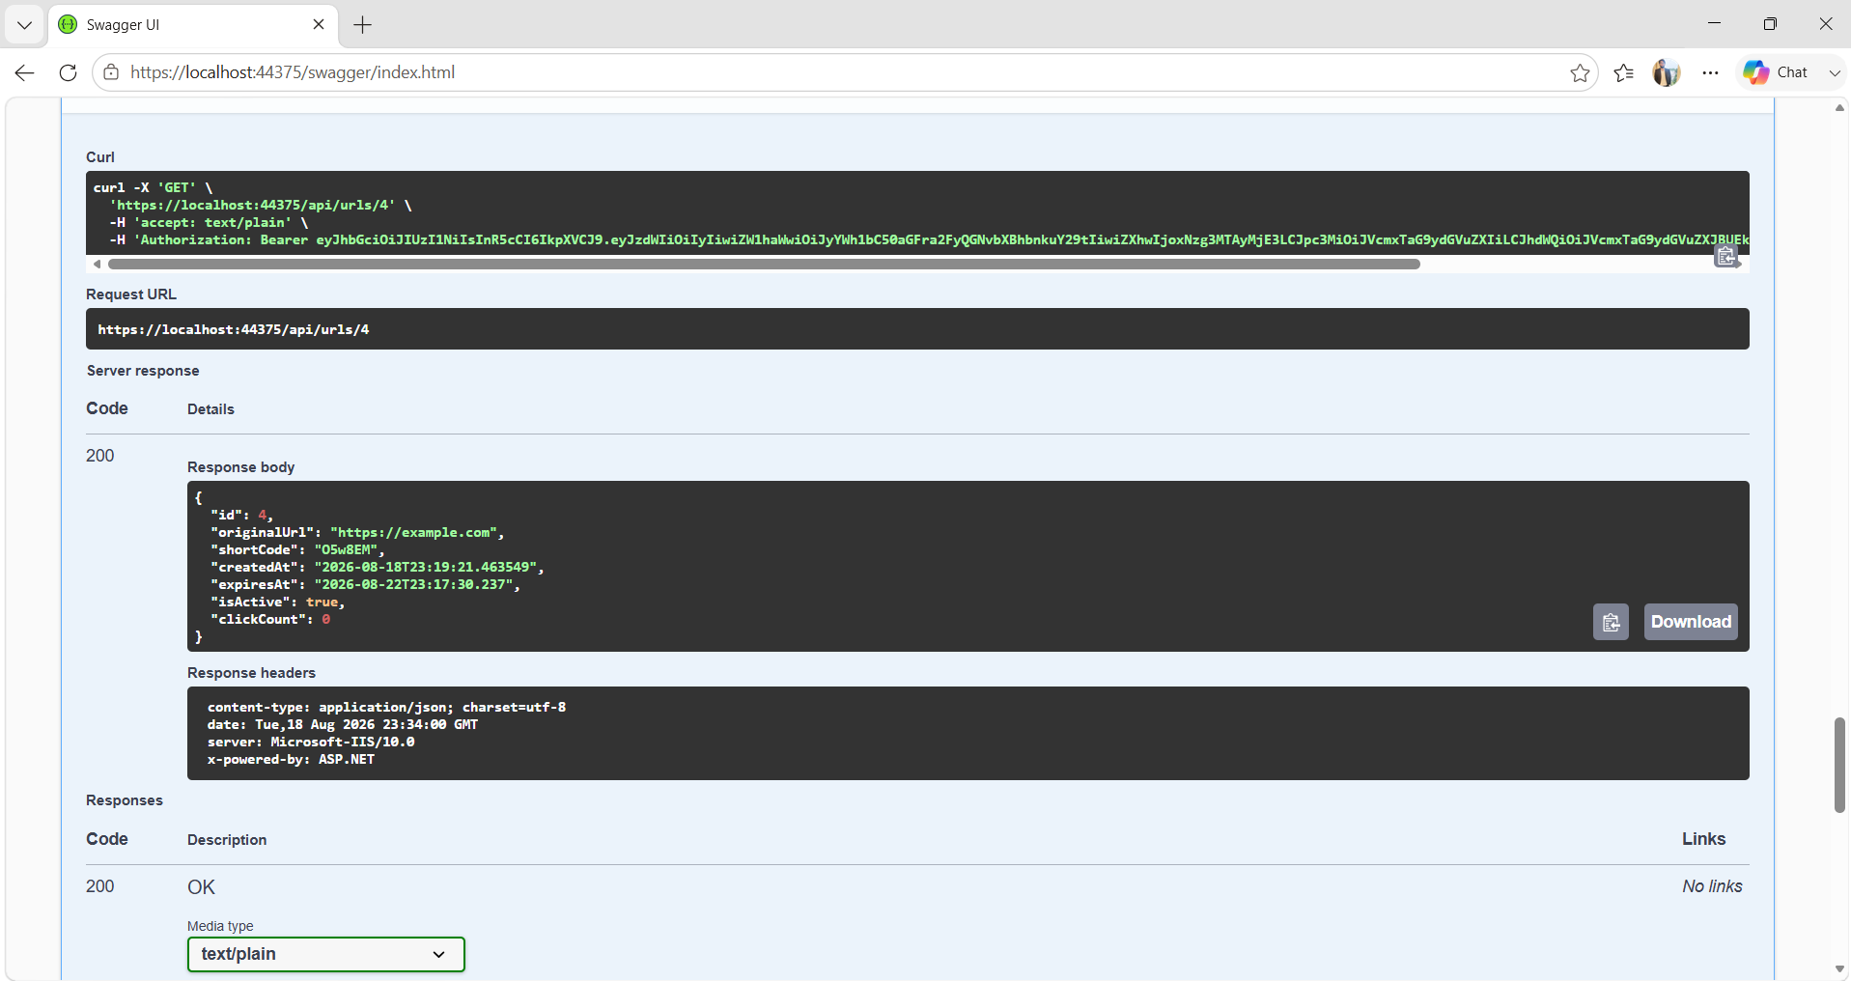

6) API : Disable/Delete Short URL
HTTP Method | DELETE
Endpoint | /api/urls/{id}
Purpose | Disables a short URL while preserving its database record and click history.

Request Body Query Parameters:

Parameter | Value
id | 4

Response Body
date: Tue,18 Aug 2026 23:54:15 GMT
server: Microsoft-IIS/10.0
x-powered-by: ASP.NET

Swagger Screenshot
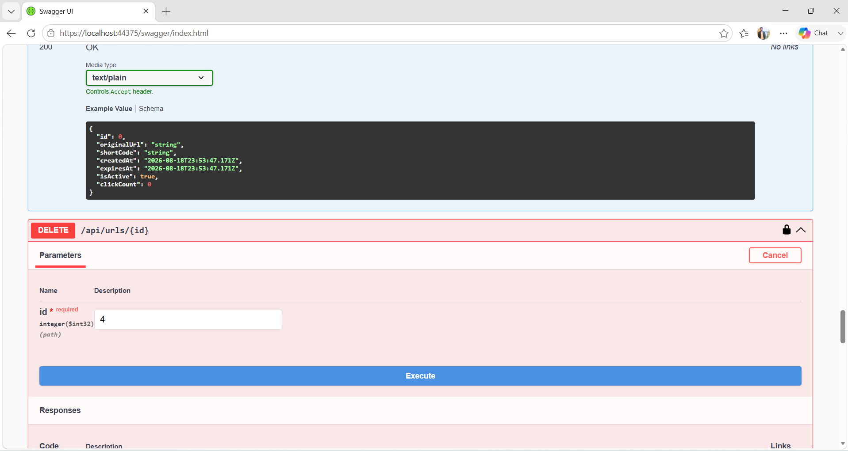

7) API : Redirect to Original URL
HTTP Method | GET
Endpoint | /{code}
Purpose | Resolves a short code and redirects the client to the original URL. The implemented redirect uses HTTP 302 Found.

Request Body Query Parameters
Parameter | Value
code | O5w8EM

Response Body
HTTP/1.1 302 Found
Location: https://example.com

Swagger Screenshot
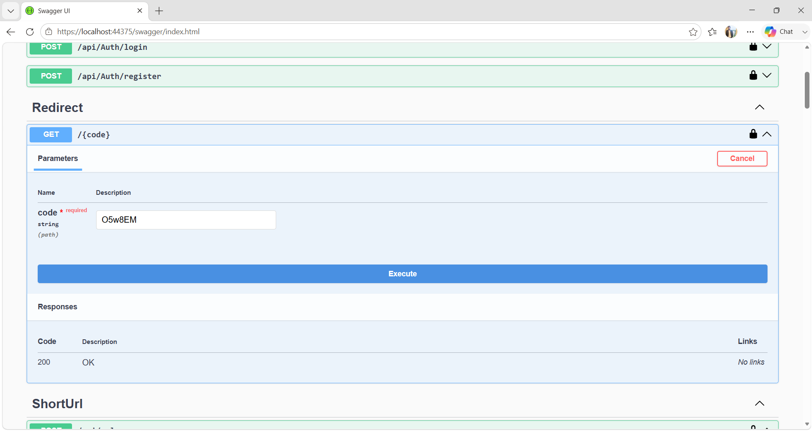

8) API : Get URL Statistics
HTTP Method | GET
Endpoint | /api/urls/{id}/statistics
Purpose | Returns statistics for a specific short URL using recorded Click records.

Request Body Query Parameters
Parameter | Value
id | 4

Response Body
{
"totalClicks": 1,
"clicksToday": 1,
"clicksLast7Days": 1,
"createdAt": "2026-08-18T23:19:21.463549"
}
Swagger Screenshot:
i). Request Body Screenshot
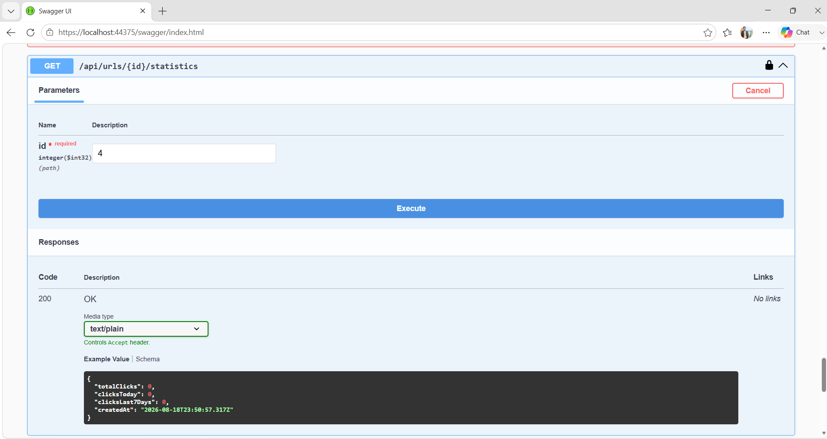
ii). Response Body Screenshot
