ORBIS UI AUTOMATION
Software Architecture Document
Framework Design · arc42-aligned · C4 views

Field | Value
Document type | Architecture / Framework Design (not test catalog)
Audience | Architecture · Leadership · QA · JIRA attachment
Scope | Framework only — structure, strategy, concepts, decisions
Method | arc42 sections + C4-style context/container diagrams
Date | 2026-07-23
Repo | orbis-UI-automation
Primary entrypoint | run_suite.py

This document describes how the Orbis UI automation framework is designed — goals, constraints, context, solution strategy, building blocks, runtime behavior, deployment, cross-cutting concepts (including non-determinism and golden sets), architecture decisions, risks, and glossary.

Contents
1. Introduction & Goals
2. Architecture Constraints
3. Context & Scope
4. Solution Strategy
5. Building Block View
6. Runtime View
7. Deployment View
8. Cross-cutting Concepts
8.1 Auth & session model
8.2 Non-deterministic answer judgment
8.3 Golden set approach
8.4 Reporting & evidence
9. Architecture Decisions (ADRs)
10. Quality Requirements
11. Risks & Technical Debt
12. Glossary
Appendix A — Suite catalog & CLI
Appendix B — Current golden inventory

1. Introduction & Goals

1.1 Purpose
Orbis UI Automation is a Python + Playwright framework that executes real-browser regression against the Orbis agent chat product. It loads questions from Excel, drives the UI (select agent → ask → capture answer/sources/routing evidence), judges answer quality with layers designed for non-deterministic generative outputs, and produces auditable artifacts.
This is not a generic web UI toolkit. It is an Orbis-specialized quality architecture for agentic answers under LOCAL and Citrix operating constraints.

1.2 Stakeholders & expectations
Stakeholder | Expectation from this architecture
Leadership | Clear capability, evidence trail, known boundaries (esp. MFA)
Architects | Layered design, decisions with consequences, quality attributes
QA engineers | Understand how a run works end-to-end without tribal knowledge
Ops / Citrix users | Practical auth + viewport constraints that actually run

1.3 Top quality goals
# | Quality goal | Why it matters
QG-1 | Diagnosable failures | Separate UI / route / meaning / fact failures via buckets
QG-2 | Resilient to wording variance | Agent paraphrase must not become false FAIL
QG-3 | Practical auth on LOCAL/Citrix | Daily MFA once; reuse storage_state same day
QG-4 | Auditable evidence | JSON/TXT/HTML + drift dashboards for review & JIRA
QG-5 | Maintainable layers | Pages don’t validate; validators don’t drive UI

2. Architecture Constraints
Type | Constraint
Technical | Orbis answers are generative / non-deterministic (wording & order vary)
Technical | Microsoft SSO + MFA (+ Outlook confirm) required to access Orbis
Technical | Citrix: fixed viewport; browser maximize breaks chat layout
Technical | Azure OpenAI available for LLM judgment; embeddings for semantic score
Organizational | Test intent lives in Excel; framework must stay data-driven
Organizational | Full unattended service-account login ruled out while MFA remains
Process | Framework must produce attachable evidence for leadership / JIRA

3. Context & Scope

3.1 System context (C4 Level 1)
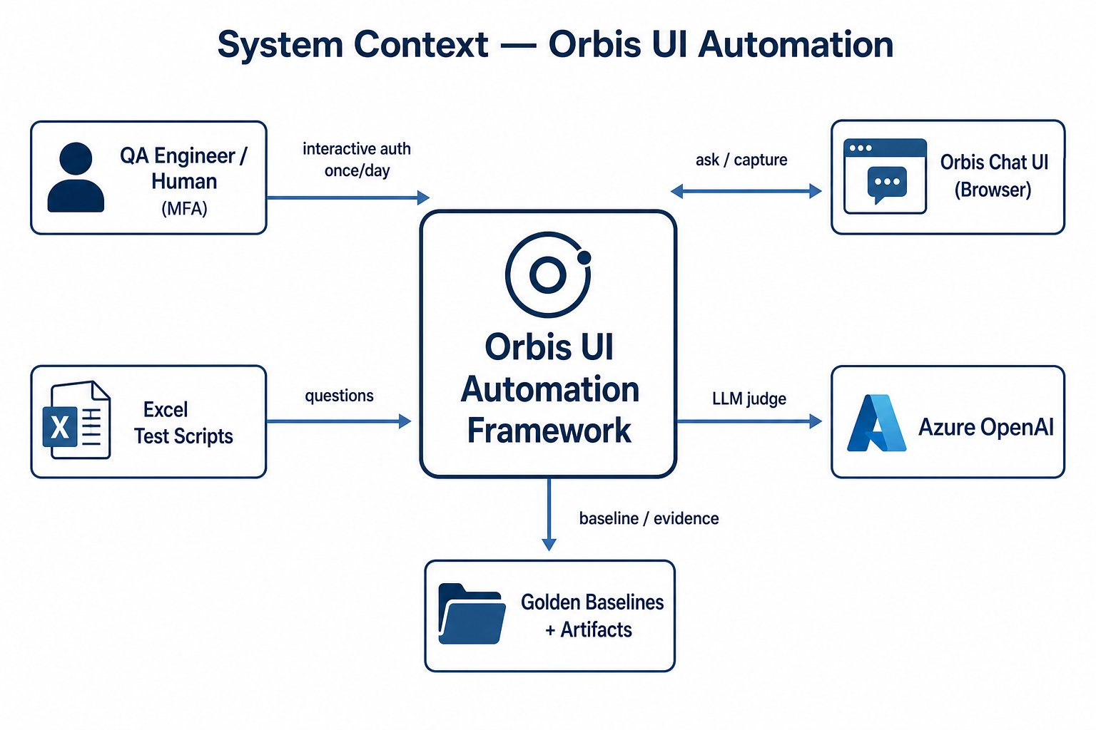
Figure 1 — System context: framework and its external actors/systems

3.2 In scope
- Browser UI automation for Orbis chat/agents (Edge/Chrome via Playwright)
- Excel-driven suites and composable JSON suite definitions
- Multi-layer validation (UI → Route → Semantic → LLM → Final)
- Golden baseline / drift mode
- Auth age-check + interactive MFA refresh
- Artifact reporting (JSON, TXT, HTML, drift/trend dashboards)

3.3 Out of scope
- Business meaning / SME ownership of each Excel scenario
- Fully unattended MFA/Outlook login
- Allure / pytest-marker-driven discovery as the primary runner
- Parallel worker farm (not part of current architecture)

4. Solution Strategy
Cornerstone decisions that shape the entire framework. Details appear in later sections.
Decision | Approach | Quality goal served
Runner | Custom CLI (run_suite.py), not pytest discovery | QG-5 controllable orchestration
Decomposition | Strict layers: Config / Core / Locators / Pages / Flows / Validators / Utils | QG-1, QG-5
Non-determinism | Layered judgment + PASS/FAIL/REVIEW bands + optional retry | QG-2
Baseline stability | Golden templates (3 variants) as primary judge when enabled | QG-2, QG-4
Auth | Playwright storage_state + daily freshness gate | QG-3
Evidence | Custom dated artifacts (not Allure) | QG-4
Environments | Env-parameterized (ORBIS_ENV, browser, thresholds, Azure) | QG-3, CI-ready knobs

5. Building Block View

5.1 Layered structure (C4 container/component)
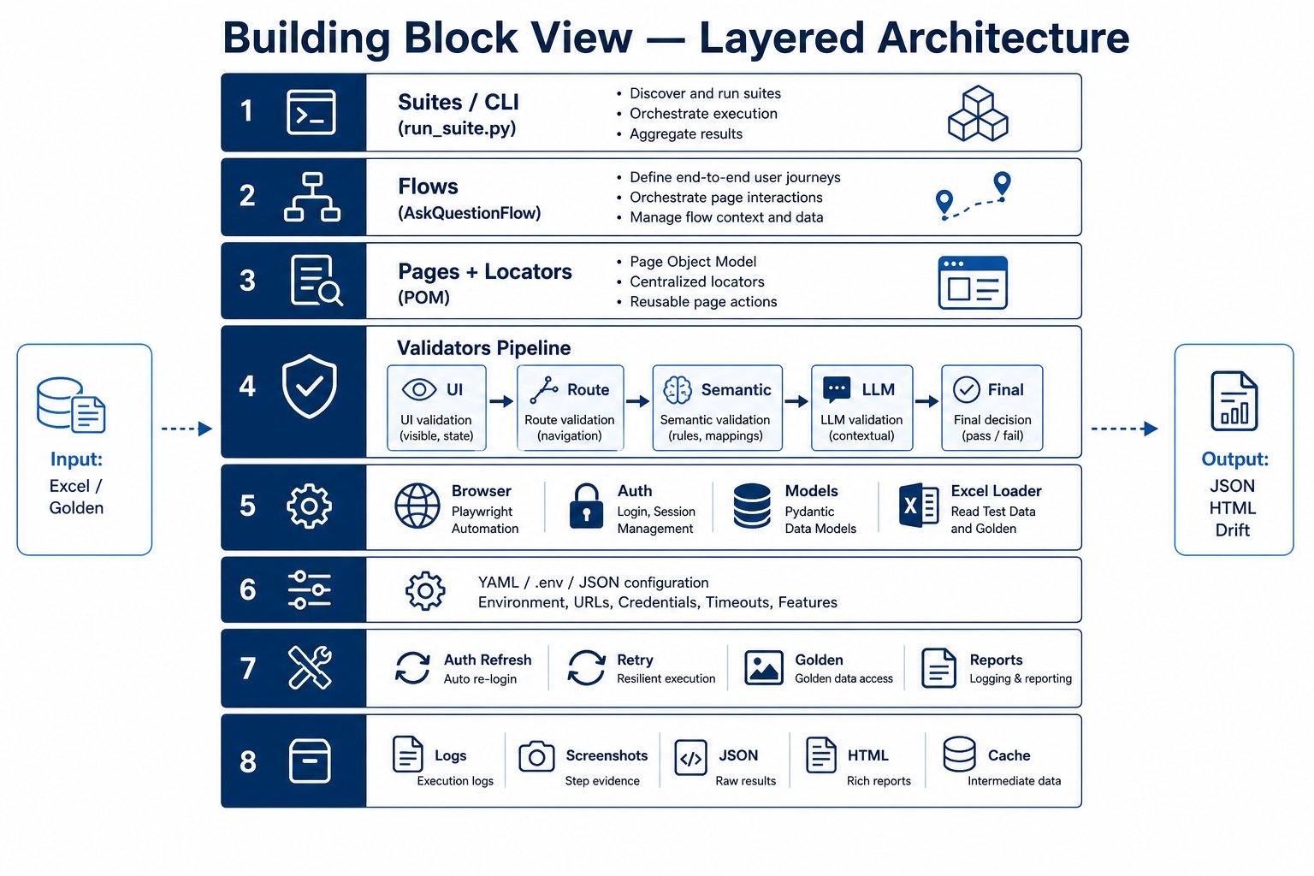
Figure 2 — Building block view: layered framework structure

5.2 Layer contracts (hard rules)
Building block | Responsibility | Must not
suites/ + run_suite.py | Compose & orchestrate jobs | Embed page selectors / meaning asserts
flows/ | One ask journey end-to-end | Load Excel / final PASS/FAIL / reports
pages/ + locators/ | UI actions & selectors | Validate meaning / write reports
validators/ | Judge TestResult layers | Drive Playwright UI
core/ | Browser, auth, models, Excel load | Business assertions
config/ | Env, thresholds, agent mapping | Playwright logic
utils/ | Auth refresh, retry, golden, writers | Own page business flows
golden/ | Baseline templates + manifests | Execution logic
artifacts/ | Runtime evidence output | Source of truth for code

5.3 Key abstractions
- TestCase — Excel input (id, question, expected, flags)
- TestResult — execution evidence + all validation fields (stream ≠ final answer)
- AskQuestionFlow — UI journey producer of TestResult
- ValidationPipeline — ordered post-UI judgment
- FinalResultDecider — combines layers into PASS/FAIL/REVIEW/ERROR

6. Runtime View

6.1 Suite lifecycle
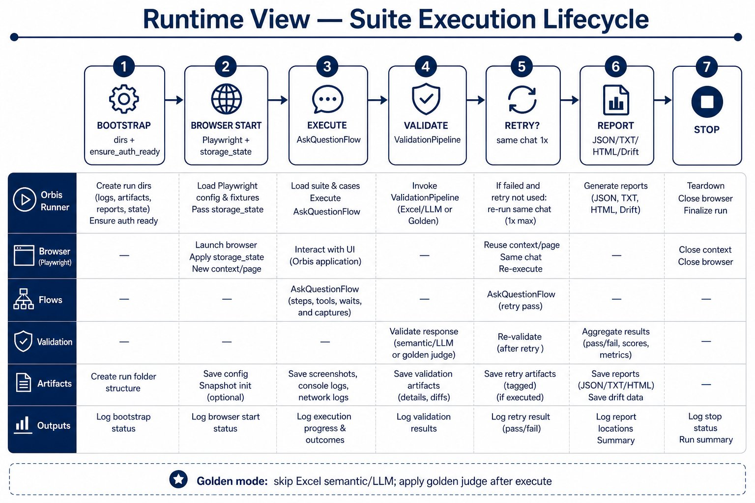
Figure 3 — Runtime view: suite execution lifecycle

6.2 Per-question scenario
- Prepare/reuse chat session; select UI agent when required.
- Ask question; wait out streaming phrases; capture stream separately from final answer.
- Capture sources and internal-agent routing evidence (ticker / Reasoning / Thought Process).
- Run ValidationPipeline (or UI+route only in golden-primary path, then golden judge).
- Eligible FAIL/ERROR may get one same-session retry (route failures skipped).
- Write suite_results.json, suite_summary.json, RUN_SUMMARY.txt (+ ANSWER_REVIEW.html if golden).

6.3 Session behavior
- One Playwright context per job.
- Reuse chat across scripts while UI agent unchanged; New Chat when agent changes.
- Rename chat at end for auditability.

7. Deployment View
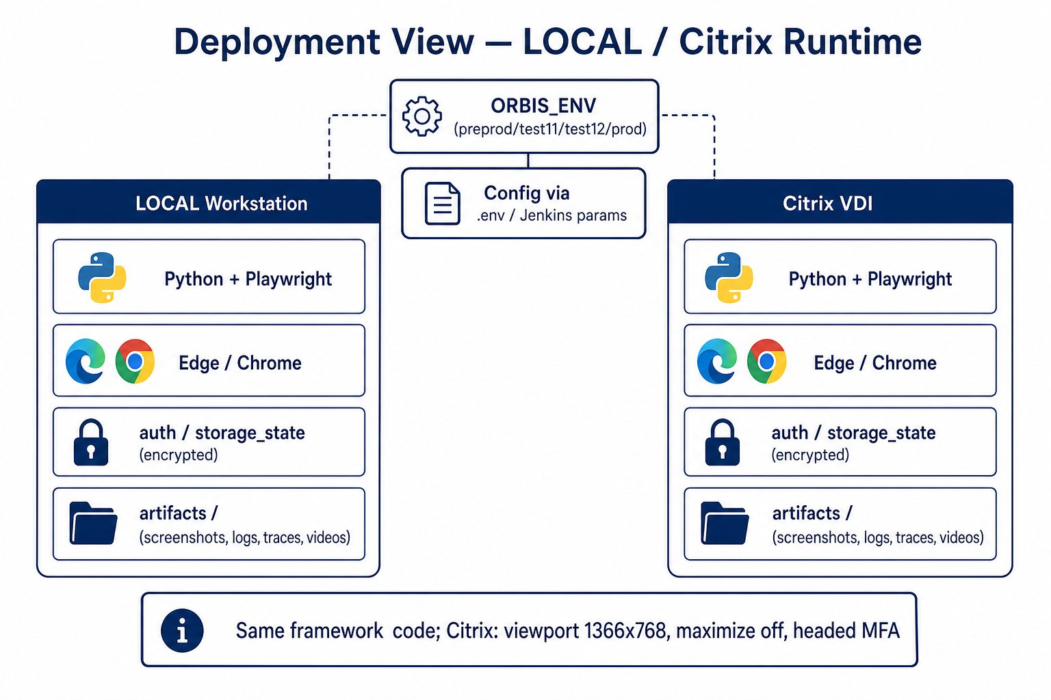
Figure 4 — Deployment view: LOCAL and Citrix share one codebase
Concern | LOCAL / Citrix behavior
Codebase | Same framework; no Citrix fork
Browser | Edge default (Chrome optional); headed for MFA
Viewport | 1366×768; maximize disabled (Citrix chat layout)
Auth file | auth/auth_state_<ORBIS_ENV>.json
Config | .env + env vars (ORBIS_ENV, thresholds, Azure, evidence toggles)
CI readiness | Parameterized CLI + archiveable artifacts; Jenkinsfile not required for architecture

8. Cross-cutting Concepts

8.1 Auth & session model
Operating model (locked for LOCAL/Citrix):
- Before every suite: ensure_auth_ready() checks auth file mtime for today’s local date.
- Missing / stale / --force-auth-refresh → headed browser → human completes MFA/Outlook once → save storage_state.
- Fresh today → reuse without MFA.
- Flags: --skip-auth-refresh, --force-auth-refresh.
- Unattended service-account auto-login is an explicit non-goal while MFA remains.

8.2 Non-deterministic answer judgment
Classic exact-string asserts fail on Orbis for the wrong reason (wording drift). The architecture uses defense-in-depth judgment instead of binary string equality.
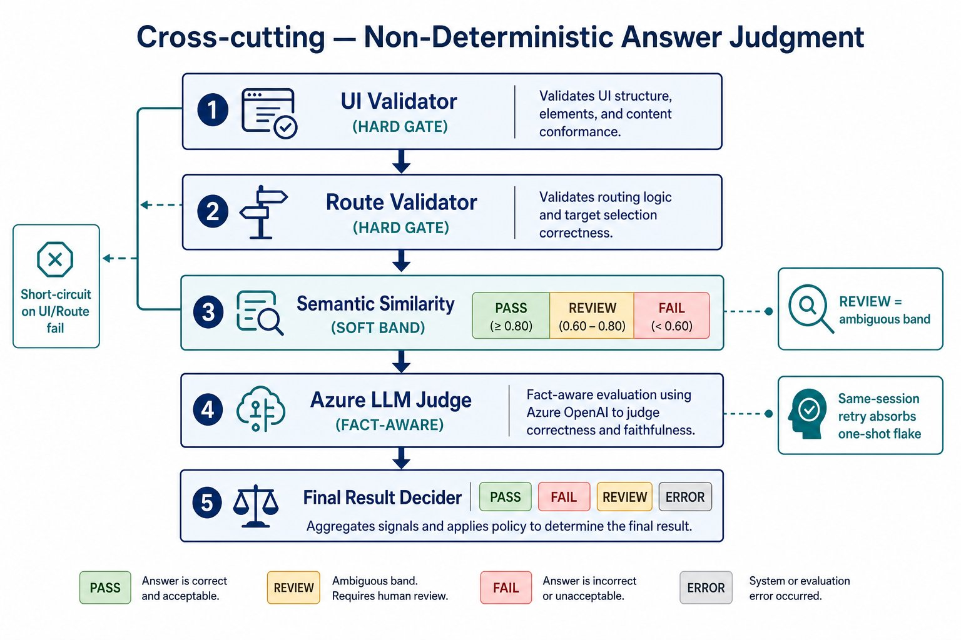
Figure 5 — Cross-cutting: non-deterministic validation pipeline
Layer | Nature | Protects against
UIValidator | Hard / mostly deterministic | No answer, UI errors, empty/short response
RouteValidator | Hard when mapped | Wrong internal specialist agent
SemanticValidator | Soft similarity bands | Paraphrase vs expected/golden
LLMJudge (Azure) | Soft / fact-aware | Missing critical facts despite similar wording
FinalResultDecider | Rule combine | Consistent PASS/FAIL/REVIEW/ERROR + buckets
Same-session retry | Flake absorber (1×) | One-shot agent failures (not route fails)

Outcome model (not binary):
Status | Meaning
PASS | Hard gates OK and quality layers meet pass band
FAIL | Hard fail or quality clearly below fail band
REVIEW | Ambiguous band — human/SME attention required
ERROR | Execution/framework error path
NOT_RUN | Layer skipped (missing expected, or short-circuited)

Default threshold bands (env-overridable):
Signal | PASS if ≥ | REVIEW band lower bound
Semantic cosine (all-MiniLM-L6-v2) | 0.75 | 0.65
LLM confidence (Azure, temperature 0) | 0.75 | 0.60

Short-circuit: UI fail/error skips later layers; route fail skips semantic/LLM. This preserves signal quality and Azure cost.

8.3 Golden set approach
Golden mode is a first-class stability architecture for non-deterministic answers over time. It replaces Excel expected_answer as the PASS/FAIL baseline while Excel still supplies questions.
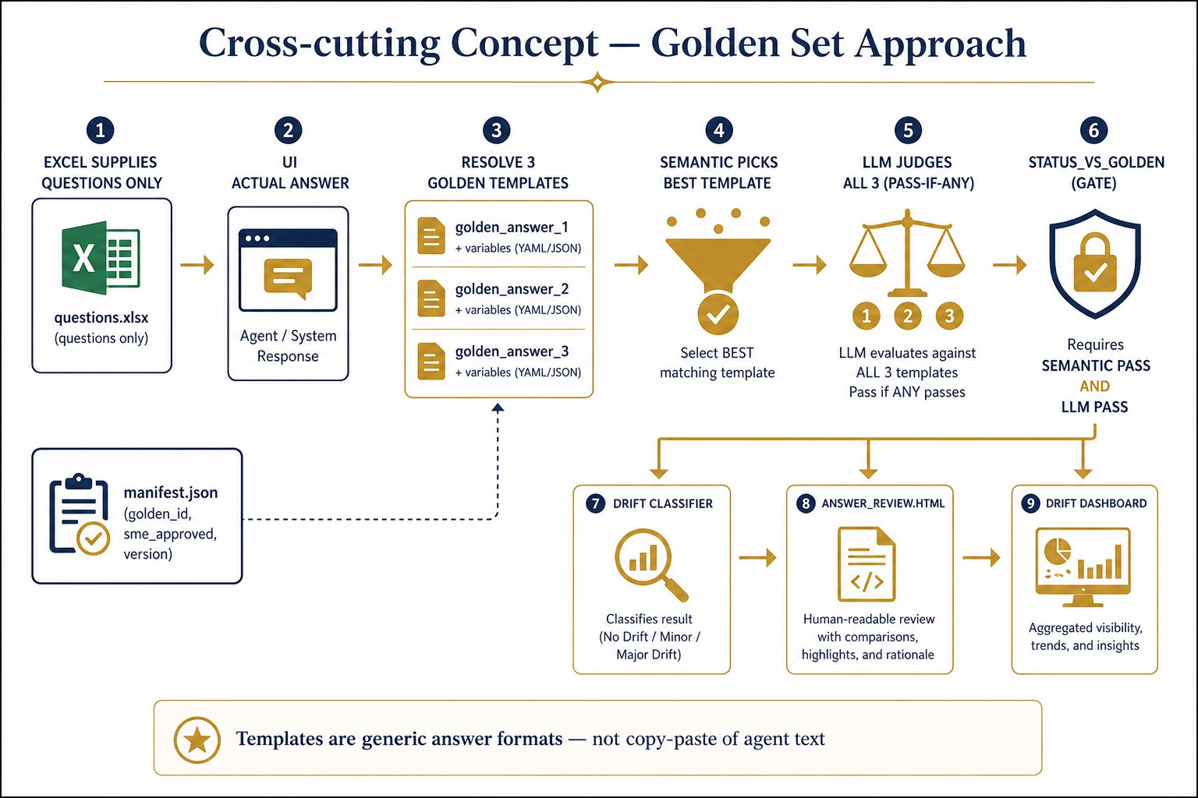
Figure 6 — Cross-cutting: golden set approach

8.3.1 Design principles
- Templates are generic answer formats derived from agent style — not copy-paste of a single agent response.
- Each question has up to three variants (golden_answer_1/2/3) with {variable} placeholders.
- Variables (sponsor, counts, links, key_facts, etc.) are resolved at compare time.
- Excel expected_answer is audit-only in golden mode (not PASS/FAIL source).
- Manifest tracks golden_id, version, sme_approved, scope, bootstrap source run.

8.3.2 Storage & resolution
Path pattern: golden/<business>/<sheet>/golden_v1.json (+ sibling manifest.json)
- R1_* / R3_* sheets → client_contract
- Handler / Process_Agent / System_Agent / … → orbis_core
- Explicit --golden-path overrides resolution

8.3.3 Judgment algorithm
- Resolve all three templates with variables.
- Semantic: score actual vs each template; pick best template for drift baseline.
- LLM: evaluate actual vs all three resolved templates; PASS if any variant PASSes (pass-if-any).
- status_vs_golden = PASS only if semantic PASS AND (LLM PASS or LLM not run).
- Otherwise FAIL; classify rich drift types for triage.

8.3.4 Drift typology (examples)
Drift type | Intent
stable / wording_drift / moderate_drift / significant_drift | Similarity-band change without typed fact flip
not_available_to_available / available_to_not_available | Availability language flipped
link_added / link_removed / link_changed | Document link set changed
count_changed / number_changed | Numeric/count facts changed
fact_added / fact_removed / fact_drift / contradiction | Fact-level change or conflict

8.3.5 Runtime integration
- CLI: --use-golden (implies golden-primary by default); optional --golden-path, --golden-primary.
- When --use-golden: pipeline skips Excel semantic/LLM; UI+route still run; golden applied after asks.
- Golden retry: one same-session re-ask for status_vs_golden FAIL/ERROR (route bucket still skipped).
- Artifacts: ANSWER_REVIEW.html, RUN_SUMMARY golden block, drift dashboards, stability history.

8.4 Reporting & evidence
Custom writers under utils/ (not Allure). Typical run folder:
artifacts/results/<date>/<Business>/<Sheet>/<HHMM>/ → suite_results.json, suite_summary.json, RUN_SUMMARY.txt, optional ANSWER_REVIEW.html
- Multi-script jobs also write job_summary.json under Suite/job_*_AllScripts/
- Drift / suite dashboards under artifacts/drift and artifacts/suite
- Optional screenshots / Playwright traces / videos via config toggles; retention cleanup by days

9. Architecture Decisions (ADRs)

ADR-001: Custom CLI runner instead of pytest discovery
Context
Need multi-script suite composition, shared browser session, phased execute/validate/retry/report, and golden post-processing.
Decision
Use run_suite.py + suites/*.json as the primary execution architecture.
Consequences
Clear job control and session reuse; pytest remains unused by project code (deps may exist for ecosystem).

ADR-002: Layered execute ≠ validate ≠ report
Context
Mixed UI asserts hide whether Orbis UI broke or answer quality drifted.
Decision
Pages/flows only capture; validators only judge; utils write evidence.
Consequences
failure_bucket triage; higher maintainability; slightly more indirection.

ADR-003: PASS / FAIL / REVIEW outcome model
Context
Generative answers create an ambiguous middle band that binary status corrupts.
Decision
Introduce REVIEW with configurable semantic/LLM bands.
Consequences
Fewer false greens/reds; requires human process for REVIEW queue.

ADR-004: Golden-primary PASS/FAIL when --use-golden
Context
Excel expected text ages poorly and was never designed as long-term baseline.
Decision
Questions from Excel; judgment vs golden_v1 templates; Excel expected audit-only.
Consequences
Stable drift tracking; requires golden authoring/SME approval discipline (sme_approved flag).

ADR-005: Daily interactive MFA auth via storage_state
Context
MFA + Outlook block unattended login; Citrix/LOCAL must still run suites same day repeatedly.
Decision
ensure_auth_ready() age-check; human once per day; reuse storage_state thereafter.
Consequences
Practical operability; not fully unattended overnight without human auth refresh.

ADR-006: Same-session single auto-retry (skip route)
Context
Agent one-shot flakes are common; routing defects should remain visible.
Decision
Retry FAIL/ERROR once in same chat; never auto-retry ROUTE_VALIDATION.
Consequences
Absorbs flake without hiding systematic route bugs; attempt evidence retained.

10. Quality Requirements
ID | Scenario | Expected architecture behavior
QR-1 | Answer paraphrased but facts intact | Semantic/LLM PASS (or golden PASS); not exact-string FAIL
QR-2 | Answer mid-confidence | REVIEW — not silent PASS
QR-3 | UI returns empty / access denied | UI FAIL/ERROR; later layers skipped; bucket set
QR-4 | Wrong internal agent when mapped | Route FAIL; no semantic/LLM; no auto-retry
QR-5 | One-shot agent flake then success | Attempt 2 PASS; flipped_to_pass visible in summary
QR-6 | Auth older than today | Interactive refresh before suite starts
QR-7 | Golden wording drift only | High similarity → stable/wording_drift; not false crisis
QR-8 | Golden fact flip (count/link/availability) | Typed drift label + FAIL vs golden for triage

11. Risks & Technical Debt
Item | Risk / debt | Mitigation / note
MFA human gate | Cannot be fully lights-out overnight | By design; daily auth model
No Jenkinsfile in repo | CI packaging not codified | Env knobs + CLI already CI-shaped
reports/ stubs | Package name empty; writers live in utils/ | Cosmetic debt
Soft route when no agents captured | May hide missing telemetry | Noted on result; answer quality still judged
Relaxed route maps for some agents | Until product rules confirmed | Config-driven; tighten via agent_mapping
No parallelism | Long nightly wall-clock | Accepted current scope

12. Glossary
Term | Definition
UI agent | Agent selected in Orbis UI dropdown
Internal agent | Specialist inferred from Thought Process / Reasoning / ticker
storage_state | Playwright saved SSO session for reuse
TestResult | Per-question evidence + validation fields
REVIEW | Ambiguous quality band requiring human attention
failure_bucket | Triage category for non-PASS outcomes
Golden | Versioned baseline templates used for stability/drift
status_vs_golden | PASS/FAIL vs resolved golden baseline
Drift | Meaningful change vs golden beyond mere wording
Same-session retry | One re-ask in the same chat without new login

Appendix A — Suite catalog & CLI
Suite | Intent
handler | Default Orbis Core Handler
orbis_core | Handler + specialty sheets + procurement under Orbis UI
client_contract | Client Contract Excel set
iod | IOD smoke
procurement | Procurement Excel under Procurement UI agent
all | Nightly-style composition of the above

Example commands:
- python run_suite.py --suite handler
- python run_suite.py --suite client_contract --use-golden
- python run_suite.py --suite all
- python run_suite.py --force-auth-refresh
- python run_suite.py --suite handler --skip-auto-retry

Appendix B — Current golden inventory
Present under golden/ at time of writing (framework asset map, not business content):
Business | Sheet / agent golden sets
client_contract | R1_Non_stats, R1_Stats, R3_Main_requirements, R3_Edge_Cases
orbis_core | Handler, Process_Agent, System_Agent, Service_Agent, Web_Agent, Project_agent_Automated_script, Procurement_Agent

Each set: golden_v1.json entries + manifest.json metadata (golden_id, version, sme_approved, purpose, optional bootstrap source run).

End of Architecture Document — Framework design only. Business Excel scenarios remain under input/test_scripts/.

