Orbis API Automation Tool
Old State to New State
Author: Rahul Thakur | Current-state implementation focus | Future roadmap intentionally excluded
Executive message: The inherited testing utility has been transformed into an operational automation capability with source control, configuration management, Docker deployment, Jenkins CI/CD, nightly execution, reporting dashboards and evidence generation.
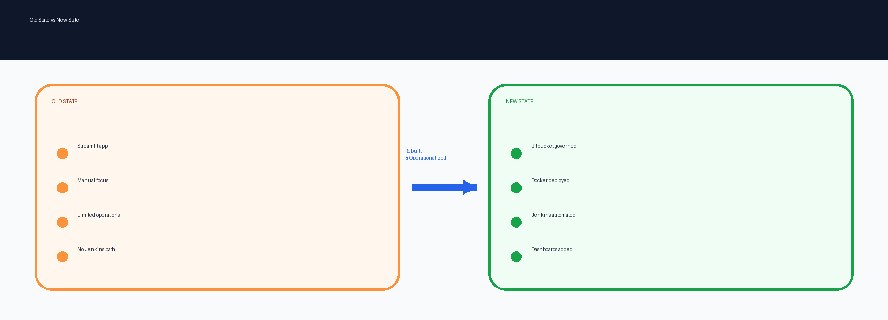
Figure 1. Old state vs new state summary.

1. Executive Overview
Theme | Summary
Old state | The inherited tool was a Streamlit-based testing application with expected-vs-actual evaluation logic embedded in app.py and runtime configuration visible in the old package.
New state | The current Orbis API Automation Tool is backed by Bitbucket repository governance, branch workflow, Docker deployment, configuration-driven runtime settings and server deployment on eu-icnllmt-a007:8522.
Operationalization | Jenkins now builds and deploys the Dockerized application, stores runtime environment configuration as a Jenkins credential, performs health checks, and supports nightly automation for single scripts or suite files.
Business value | The work moved the solution from a tester-run utility to a repeatable automation platform with deployment governance, nightly execution capability, dashboards and evidence generation.

2. Old State Received from Development Team
The old package was a working Streamlit application named “VA Automated Testing Tool”. It included Python-based API testing, data handling, Azure OpenAI-based evaluation and report/export-related libraries. The inherited state had usable functional value, but it was not yet operationalized for long-term automation ownership, repeatable deployment, CI/CD and management reporting.
Old State Area | Description
Application form | Single Streamlit application primarily driven by app.py.
Evaluation model | LLM-as-judge expected-vs-actual evaluation with PASS/FAIL, confidence and reason.
Runtime style | Configuration and secrets were visible in the old package; secret values are intentionally excluded here.
Operational gap | No management-ready automated deployment, Jenkins, nightly execution or dashboard operating model was evident from the old package.
Ownership risk | The handover required stabilization, structure, deployment documentation, operational commands and secure runtime configuration practices.

3. New State Delivered
Implemented Capability | Management Meaning
Repository and branch workflow | Bitbucket repository established for orbis-api-automation-tool with main branch governance and user-branch workflow.
Configuration model | Runtime configuration externalized through environment files/variables and config.py endpoint/environment mapping.
Expanded endpoint support | Current configuration supports Swarm, Deepagent, Auto, IOD variants, Client variants, RAFT, QC Assistant and Procurement Agent mappings.
Local and server setup | Local run, dependency installation, JFrog/PyPI usage, server folder and deployment path are documented for repeatable onboarding.
Docker deployment | Docker image/container deployment validated on server eu-icnllmt-a007 using port 8522, with health check and lifecycle commands.
Jenkins deployment | Jenkins deployment job performs checkout, file validation, Docker build, credential binding, redeploy and health check.
Nightly automation | Separate Jenkins nightly job supports single-script or suite-file execution and archives Excel/HTML evidence.
Dashboard reporting | Suite dashboard, business-agent dashboard, pass/fail trend, slowest questions, failed details and internal-agent summaries are built into the current reporting layer.
Failure analysis | Failure buckets classify access denied, wrong answer, low AI score, no response, API error, missing expected data and other cases.
Operational controls | Jenkins credential handling, health checks, Docker cleanup and disk-space recovery practices are documented.

4. Current-State Architecture
The diagram below has been simplified and enlarged for readability. It shows implemented current-state flow only: test inputs, execution, API layer, outputs, Bitbucket, Jenkins, Docker and server deployment.
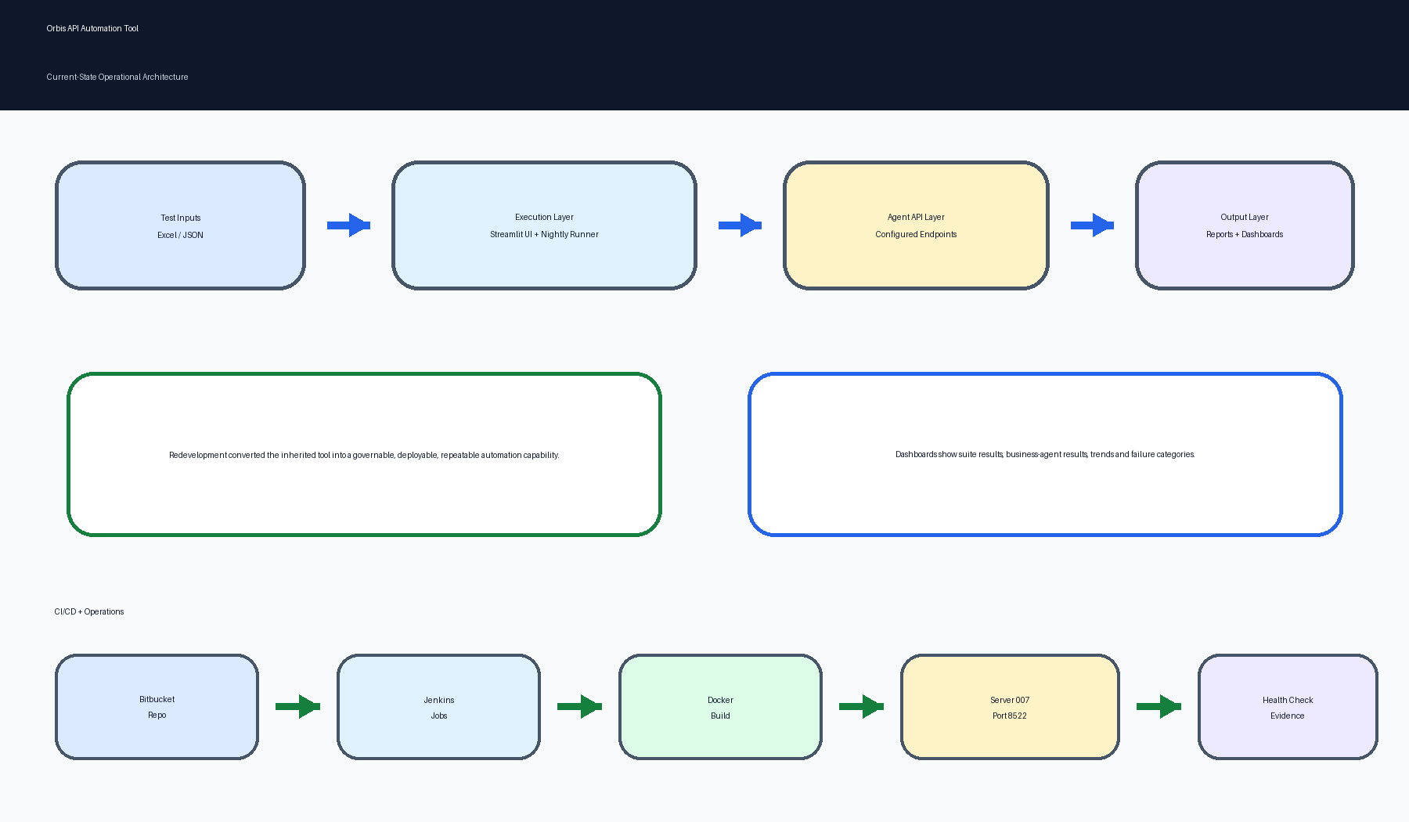
Figure 2. Current-state operational architecture.

5. Before vs After Impact
Area | Old State | New State Delivered
Source Control | No governed team-owned repository story for management. | Bitbucket repository, main branch and user-branch workflow.
Configuration | Runtime values coupled closely to application package. | Environment-driven runtime config and endpoint mapping.
Execution Model | Interactive Streamlit-focused execution. | UI execution plus Jenkins nightly single-script and suite execution.
Deployment | Manual/local focus. | Docker deployment on eu-icnllmt-a007 with health checks.
CI/CD | No confirmed Jenkins pipeline in old state. | Jenkins deploy job and nightly automation job.
Reporting | Row-level result focus. | Suite dashboard, business-agent dashboard, failure buckets and trend view.
Operational Support | Knowledge concentrated in code/package. | Setup guide, command reference and Jenkins runbook support operations.

6. Implementation Summary
The key story is that the tool was not only changed technically; it was made governable, deployable, repeatable and reviewable.
- Established repository governance and branch workflow for Orbis API Automation Tool.
- Documented local setup, dependency installation, Bitbucket workflow and development onboarding path.
- Validated Docker application deployment on server 007 using port 8522.
- Implemented Jenkins deployment with Bitbucket checkout, Docker build, credential binding, redeploy and health check.
- Implemented Jenkins-managed runtime environment file approach instead of committing secrets.
- Created nightly automation capability with single-script and suite execution support.
- Expanded configuration-driven environment and endpoint support, including Procurement Agent and multiple agent variants.
- Built dashboard and failure analytics layer for suite-level and business-agent reporting.
- Documented operational commands for health check, logs, restart, rebuild and cleanup.

7. Coverage Check
This version covers the major implemented/current-state areas evidenced from the actual tool package and related implementation documents: old testing tool baseline, current Orbis tool package, repository and branch workflow, local setup, runtime configuration, endpoint mappings, Docker deployment, server 007 hosting, Jenkins deployment, Jenkins nightly execution, report archival, dashboards, failure buckets, health checks, credential handling and operational runbook coverage. It does not attempt to document every line of source code, because this document is intended for management review rather than developer handover.

8. Security and Operational Controls
Control Area | Delivered / Documented Control
Secrets handling | Secret values are intentionally omitted from this document and should remain in Jenkins credentials or approved stores.
Jenkins credential model | Runtime environment file, Bitbucket, JFrog/PyPI and Docker registry credentials are handled as Jenkins credentials.
Health checks | Deployment includes health check validation against the Streamlit health endpoint.
Operational resilience | Documented Docker cleanup and disk-space recovery steps support stable Jenkins/Docker operation.

9. Scope Note
This document deliberately excludes future-phase roadmap items and focuses only on the old state, delivered current state, implementation work and operational value for management review.

