**Algorithms : Lab 6**

**Date : 8th Feb, 2017**

|  |  |
| --- | --- |
| Name | SNU ID |
| Sonali Shankar | 1410110425 |
| Rahul Thapar | 1410110321 |

**Problem Statement :**

Suppose you were to drive from point A to point B. Your gas tank with a capacity C, when full, holds enough gas to travel m miles. You have a precise map that gives distances between gas stations along the route. Let d1 < d2 < …. < dn be the locations of all the gas stations along the route where di is the distance from point A to the gas station. You can assume that the distance between neighboring gas stations is at most m miles.

In the case that the rate at which you can fill your tank at a gas station is r (in liters/minute), so if you stop to fill your tank from 2 liters to 8 liters, you would have to stop for 6/r minutes. Give the most efficient greedy solution, where you need to minimize the total time you stop for gas filling?

**Screenshot :**

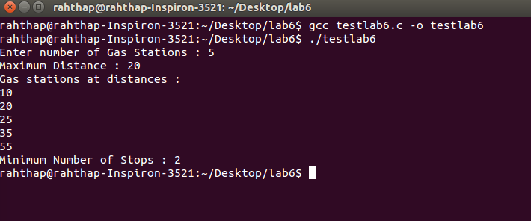

**Algorithm :**

1. Distance is calculated between the consecutive gas stations.
2. If this distance >= m (max distance), then refill the tank and count (stop) +=1
3. If the distance < m, then array is traversed and count remains same.
4. CODE given below:

**INPUTS :**

N = number of gas stations

M = Max distance

D = Distance of gas stations from starting point A.

**OUTPUT:**

Minimum number of stops in order to reach from point A to point B.

**CODE:**

