**LAB 8**

Fractional Knapsack Problem

Name : Rahul Thapar

ID : 1410110321

Date : 22 Feb, 2017

**SCREENSHOT :**

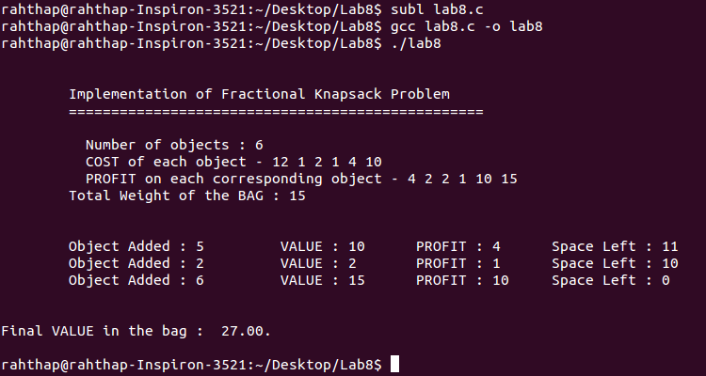

**CODE**:

/*

@author : Rahul Thapar

ID : 1410110321

Problem : Implement Fractional Knapsack Problem

Algorithm

__________

1. Calculate DENSITY(PROFIT) : value per weight for each item

2. Sort the items as per the value density in descending order

3. Take as much item as possible not already taken in the knapsack

*/

#include <stdio.h>

int n;

int cost[50];

int value[50];

int W;

int q;

void knapsack_fill() {

int current_weight;

float total_value;

int i, maximum_i;

int used[10];

for (i = 0; i < n; ++i)

used[i] = 0;

current_weight = W;

while (current_weight > 0) { // While the bag is NOT full : add

// Find the suitable object to ADD

maximum_i = -1;

for (i = 0; i < n; ++i)

if ((used[i] == 0) &&((maximum_i == -1) || ((float)value[i]/cost[i] > (float)value[maximum_i]/cost[maximum_i])))

maximum_i = i;

used[maximum_i] = 1; // Maximum value used

current_weight -= cost[maximum_i];

total_value += value[maximum_i];

if (current_weight >= 0)

printf("\tObject Added : %d\t VALUE : %d\t PROFIT : %d\t Space Left : %d\n", maximum_i + 1, value[maximum_i], cost[maximum_i], current_weight);

else {

printf("\tObject Added : %d\t VALUE : %d\t PROFIT : %d\t Space Left : %d\n", (int)((1 + (float)current_weight/cost[maximum_i]) * 100), value[maximum_i], cost[maximum_i], maximum_i + 1);

total_value -= value[maximum_i];

total_value += (1 + (float)current_weight/cost[maximum_i]) * value[maximum_i];

}

}

printf("\n\n");

printf("Final VALUE in the bag : %.2f.\n\n", total_value);

}

int main(){

printf("\n\n");

printf("\tImplementation of Fractional Knapsack Problem\n");

printf("\t=================================================\n\n");

printf("\t Number of objects : ");

scanf("%d",&n);

printf("\t COST of each object - ");

for(q=0;q<n;q++){

scanf("%d",&cost[q]);

}

printf("\t PROFIT on each corresponding object - ");

for(q=0;q<n;q++){

scanf("%d",&value[q]);

}

printf("\tTotal Weight of the BAG : ");

scanf("%d",&W);

printf("\n\n");

knapsack_fill();

return 0;

}