**Version Control Tool ( GIT )**

**GIT :-** Git is a distributed version control tool used for source code management.

* Git is used to track changes in the source code
* Allows multiple developers to work together
* Supports non-linear development because of thousands of parallel branches
* Has the ability to handle large projects efficiently

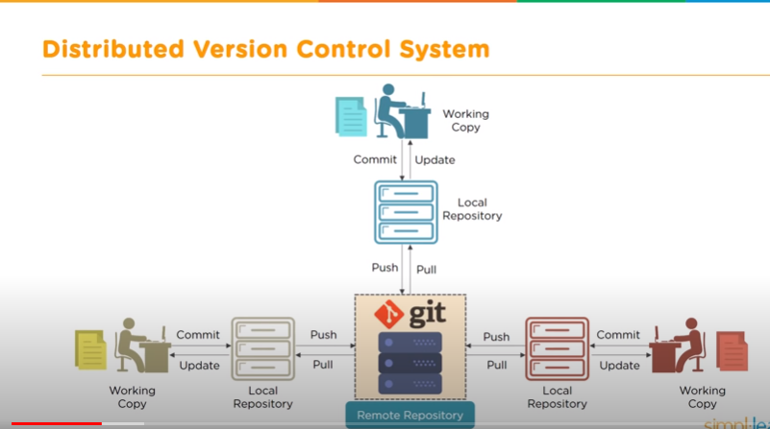

**Git :-**

* Git is a software tool
* It is installed on the local system
* It is used to manage different versions of the source code
* It provides a command line to interact with the files

**GitHub :-**

* GitHub is a service
* It is hosted on the Web
* It is used to have a copy of the local repository code
* It provides a graphical interface to store the files

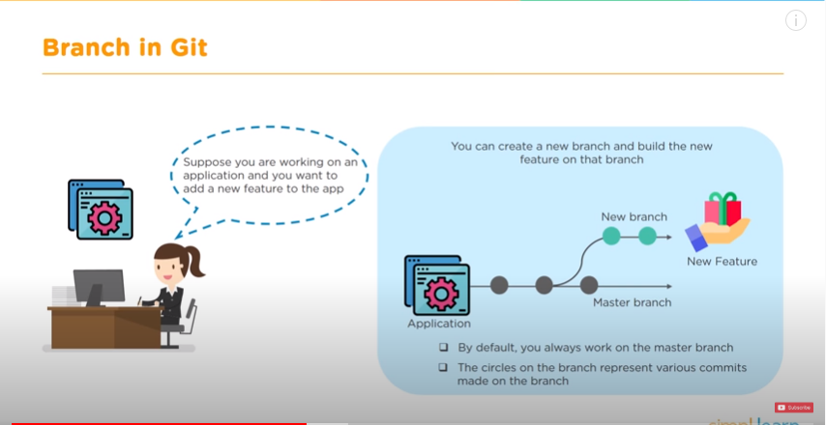

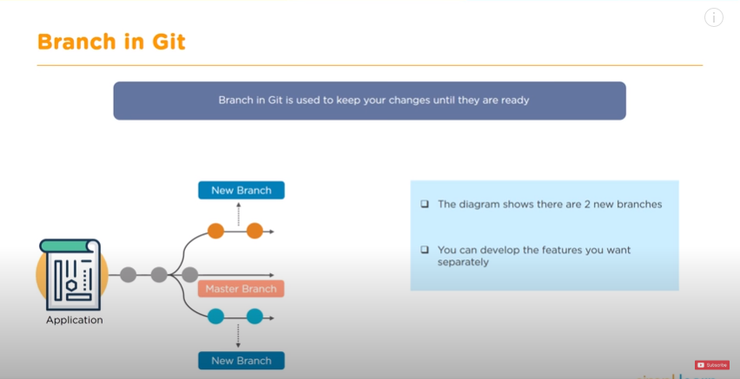

**Git Architecture**

**git add --** Working directory – Working directory is the folder where your currently working

**git commit --** Staging area – You add your files to the staging area before making a commit

**Local repository –** After making all the changes, you commit those file to the local repository

**git push --** Remote repository – you can push the committed files to the remote repository

**Git pull –** git pull fetches all the changes from a remote repository to a local repository

**Git checkout –** You can create new branches and switch to them as and when required

**Git merge –** After you are done with the changes, you can merge the new branches to the master branch

**Popular Git commands**

**git init --** Initialize a local git repository

**git add / git add . –** Add one or more files to staging area

**git commit –m “commit message” --** Commit changes to head but not to the remote repository

**git status ---** Check the status of your current repository and list the files you have changed

**git log ---** Provides a list of all the commits made on your branch

**git diff –** View the changes you have made to the file

**git clone --** Creates a git repository copy from a remote source

**git branch <branch name > --** Create a new branch

**git checkout <branch name > ---** Switch from one branch to another

**git merge <branch name > ---** Merge a branch into the active branch