**Domain Migration: DAIICT to DAU**

**-------------------------------------------------------------------------------------------------------------------**

**I) How to Login with Your New Email ID (say, abc@dau.ac.in)?**

After the migration, you will no longer be able to log in with your old email address ([abc@daiict.ac.in](mailto:abc@daiict.ac.in)).

To access your account, you need to log in using your new email address ([abc@dau.ac.in](mailto:abc@dau.ac.in)).

Steps to follow:

1. **Open Gmail:** Go to [gmail.com](https://www.gmail.com) using your web browser.
2. **Sign in with New Email Account:**
   * If you're not signed in yet, click on the **Sign in** button on the top-right corner of the page.
   * Enter your new email ID: [abc@dau.ac.in](mailto:abc@dau.ac.in)

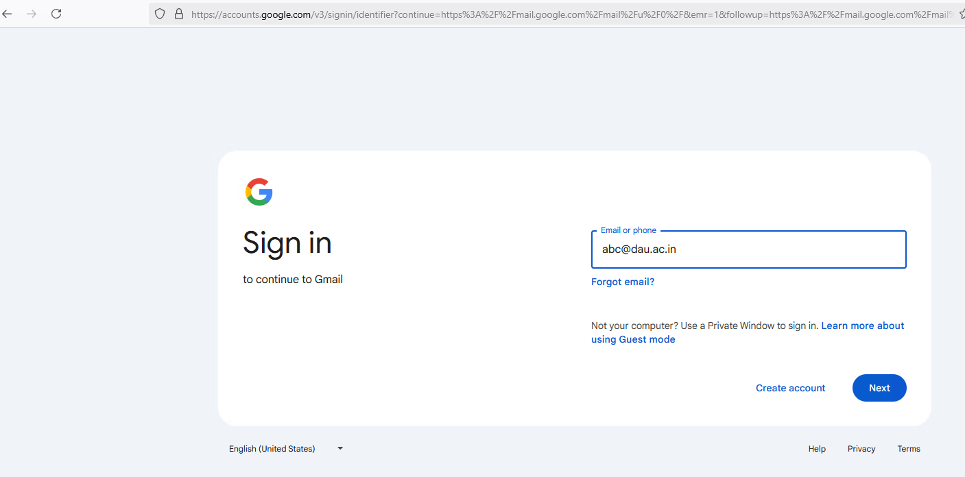

1. **Enter Your Old Password:**
   * When prompted for your password, enter the same password that you were using with your old email ID ([abc@daiict.ac.in](mailto:abc@daiict.ac.in)).
2. **Complete Sign-In:** After entering the correct password, click on the **Next** button to complete the login process.

You should now be logged into your new email account at **abc@dau.ac.in**.

**II) How to add a signature in Google Workspace (G-Suite)?**

1. Open Gmail Account
2. At the top right, click Settings and then See all settings.

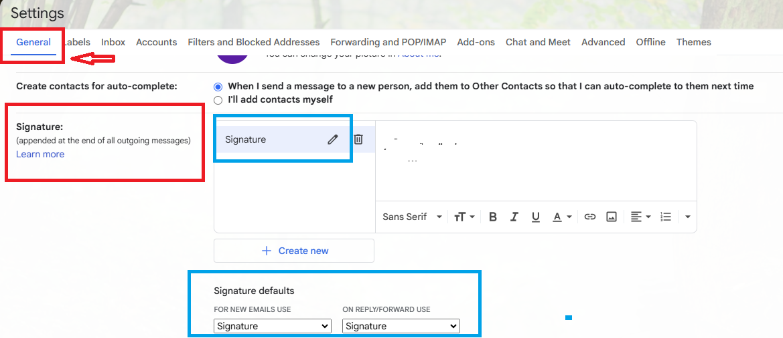

1. In the "Signature" section, click Create new and add your signature text in the box.

If you want, you can format your message by adding an image or changing the text style.

Note: Your image also counts toward the character limit. If you get an error, try to resize the image.

1. Signature defaults: select signature for new email use & on reply/ forward use
2. At the bottom of the page, click Save Changes.