tree_model.R

rahul

Wed Apr 1 12:33:19 2015

EnsurePackage<-function(x)  
{ # EnsurePackage(x) - Installs and loads a package  
 # if necessary  
 x <- as.character(x)  
 if (!require(x, character.only=TRUE))  
 {  
 install.packages(pkgs=x,  
 repos="http://cran.r-project.org")  
 }  
 require(x, character.only=TRUE)  
   
}  
  
#Installs and loads all packages necessary  
#  
Prepare.models<-function(){  
   
 EnsurePackage("ISLR")  
 EnsurePackage("MASS")  
 EnsurePackage("mosaic")  
 EnsurePackage("mosaicData")  
 EnsurePackage("rpart")  
 EnsurePackage("tidyr")  
}  
  
Prepare.models()

## Loading required package: ISLR  
## Loading required package: MASS  
## Loading required package: mosaic  
## Loading required package: car  
## Loading required package: dplyr  
##   
## Attaching package: 'dplyr'  
##   
## The following object is masked from 'package:MASS':  
##   
## select  
##   
## The following object is masked from 'package:stats':  
##   
## filter  
##   
## The following objects are masked from 'package:base':  
##   
## intersect, setdiff, setequal, union  
##   
## Loading required package: lattice  
## Loading required package: ggplot2  
##   
## Attaching package: 'mosaic'  
##   
## The following objects are masked from 'package:dplyr':  
##   
## count, do, tally  
##   
## The following object is masked from 'package:car':  
##   
## logit  
##   
## The following objects are masked from 'package:stats':  
##   
## binom.test, cor, cov, D, fivenum, IQR, median, prop.test,  
## quantile, sd, t.test, var  
##   
## The following objects are masked from 'package:base':  
##   
## max, mean, min, prod, range, sample, sum  
##   
## Loading required package: mosaicData  
## Loading required package: rpart  
## Loading required package: tidyr

library(ElemStatLearn)  
data(spam)  
# Exploratory Analysis  
?spam  
ncol(spam)

## [1] 58

head(spam)

## A.1 A.2 A.3 A.4 A.5 A.6 A.7 A.8 A.9 A.10 A.11 A.12 A.13 A.14  
## 1 0.00 0.64 0.64 0 0.32 0.00 0.00 0.00 0.00 0.00 0.00 0.64 0.00 0.00  
## 2 0.21 0.28 0.50 0 0.14 0.28 0.21 0.07 0.00 0.94 0.21 0.79 0.65 0.21  
## 3 0.06 0.00 0.71 0 1.23 0.19 0.19 0.12 0.64 0.25 0.38 0.45 0.12 0.00  
## 4 0.00 0.00 0.00 0 0.63 0.00 0.31 0.63 0.31 0.63 0.31 0.31 0.31 0.00  
## 5 0.00 0.00 0.00 0 0.63 0.00 0.31 0.63 0.31 0.63 0.31 0.31 0.31 0.00  
## 6 0.00 0.00 0.00 0 1.85 0.00 0.00 1.85 0.00 0.00 0.00 0.00 0.00 0.00  
## A.15 A.16 A.17 A.18 A.19 A.20 A.21 A.22 A.23 A.24 A.25 A.26 A.27 A.28  
## 1 0.00 0.32 0.00 1.29 1.93 0.00 0.96 0 0.00 0.00 0 0 0 0  
## 2 0.14 0.14 0.07 0.28 3.47 0.00 1.59 0 0.43 0.43 0 0 0 0  
## 3 1.75 0.06 0.06 1.03 1.36 0.32 0.51 0 1.16 0.06 0 0 0 0  
## 4 0.00 0.31 0.00 0.00 3.18 0.00 0.31 0 0.00 0.00 0 0 0 0  
## 5 0.00 0.31 0.00 0.00 3.18 0.00 0.31 0 0.00 0.00 0 0 0 0  
## 6 0.00 0.00 0.00 0.00 0.00 0.00 0.00 0 0.00 0.00 0 0 0 0  
## A.29 A.30 A.31 A.32 A.33 A.34 A.35 A.36 A.37 A.38 A.39 A.40 A.41 A.42  
## 1 0 0 0 0 0 0 0 0 0.00 0 0 0.00 0 0  
## 2 0 0 0 0 0 0 0 0 0.07 0 0 0.00 0 0  
## 3 0 0 0 0 0 0 0 0 0.00 0 0 0.06 0 0  
## 4 0 0 0 0 0 0 0 0 0.00 0 0 0.00 0 0  
## 5 0 0 0 0 0 0 0 0 0.00 0 0 0.00 0 0  
## 6 0 0 0 0 0 0 0 0 0.00 0 0 0.00 0 0  
## A.43 A.44 A.45 A.46 A.47 A.48 A.49 A.50 A.51 A.52 A.53 A.54 A.55  
## 1 0.00 0 0.00 0.00 0 0 0.00 0.000 0 0.778 0.000 0.000 3.756  
## 2 0.00 0 0.00 0.00 0 0 0.00 0.132 0 0.372 0.180 0.048 5.114  
## 3 0.12 0 0.06 0.06 0 0 0.01 0.143 0 0.276 0.184 0.010 9.821  
## 4 0.00 0 0.00 0.00 0 0 0.00 0.137 0 0.137 0.000 0.000 3.537  
## 5 0.00 0 0.00 0.00 0 0 0.00 0.135 0 0.135 0.000 0.000 3.537  
## 6 0.00 0 0.00 0.00 0 0 0.00 0.223 0 0.000 0.000 0.000 3.000  
## A.56 A.57 spam  
## 1 61 278 spam  
## 2 101 1028 spam  
## 3 485 2259 spam  
## 4 40 191 spam  
## 5 40 191 spam  
## 6 15 54 spam

table(spam[58])

##   
## email spam   
## 2788 1813

summary(spam[58]  
 )

## spam   
## email:2788   
## spam :1813

# description of the dataset  
  
# This is a quantitative collection of 4601 observations of emails which contain spam emails and non spam emails. A total of 2788 non spam emails and 1813 spam emails. Each row is description of an email, with precentages of key words in the email as attributes among other things. The total number of attributes of 'spam' dataset is 58 among this the first 57 are numerical vectors while the last column contains a factor label, that describes if the mail is a spam or not.   
  
#The first 48 columns contain continuous real attributes,[0,100], which describes the percentage of words in the email that match a WORD in the email. What the word is can be given as the name of the attribute. A standard format is to use word\_freq\_WORD. The next 6 attributes are also real and continous,[0,100], that gives percentage of number of characters in the email that match a particular CHAR. The next 3 attributes are continuous real variables, [1,...], which describe average length of uninterupted sequence of capital letters, length of the longest uninterrupted sequence of capital letters, total number of capital letters in the e-mail.   
  
#There are no null values in this dataset.  
  
# plot of spam/non-spam  
count.table <- as.data.frame(table(spam[58]))  
?plot  
  
plot(spam$spam)

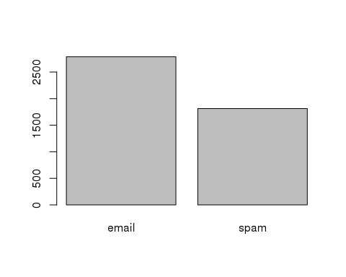

# splitting data into training and testing  
  
set.seed(123)  
?sample

## Help on topic 'sample' was found in the following packages:  
##   
## Package Library  
## base /usr/lib64/R/library  
## dplyr /usr/lib64/R/library  
## mosaic /usr/lib64/R/library  
##   
##   
## Using the first match ...

ind.spam <- sample(2, nrow(spam), replace = TRUE, prob = c(0.7, 0.3))  
spam.train <- spam[ind.spam ==1,]  
spam.test <- spam[ind.spam ==2,]  
  
  
# creating a model using rpart  
spam.model.rpart <- rpart(spam ~ ., method = "class", data = spam.train, cp = 0.001)  
  
plotcp(spam.model.rpart)

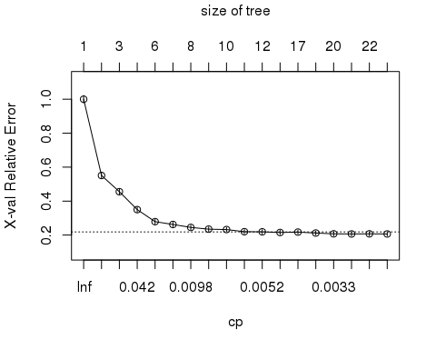

printcp(spam.model.rpart)

##   
## Classification tree:  
## rpart(formula = spam ~ ., data = spam.train, method = "class",   
## cp = 0.001)  
##   
## Variables actually used in tree construction:  
## [1] A.16 A.17 A.19 A.24 A.25 A.27 A.42 A.45 A.46 A.5 A.52 A.53 A.55 A.56  
## [15] A.57 A.7 A.8   
##   
## Root node error: 1269/3229 = 0.393  
##   
## n= 3229   
##   
## CP nsplit rel error xerror xstd  
## 1 0.4751773 0 1.00000 1.00000 0.021871  
## 2 0.1536643 1 0.52482 0.55083 0.018442  
## 3 0.0425532 2 0.37116 0.45548 0.017166  
## 4 0.0409771 3 0.32861 0.34988 0.015421  
## 5 0.0141844 5 0.24665 0.27896 0.013990  
## 6 0.0102443 6 0.23247 0.26241 0.013618  
## 7 0.0094563 7 0.22222 0.24507 0.013211  
## 8 0.0078802 8 0.21277 0.23483 0.012960  
## 9 0.0063042 9 0.20489 0.23247 0.012902  
## 10 0.0055162 10 0.19858 0.21986 0.012581  
## 11 0.0049908 11 0.19307 0.21907 0.012561  
## 12 0.0047281 14 0.17809 0.21513 0.012458  
## 13 0.0039401 16 0.16864 0.21749 0.012520  
## 14 0.0035461 17 0.16470 0.21198 0.012374  
## 15 0.0031521 19 0.15760 0.20725 0.012248  
## 16 0.0023641 20 0.15445 0.20646 0.012227  
## 17 0.0015760 21 0.15209 0.20725 0.012248  
## 18 0.0010000 27 0.14263 0.20646 0.012227

# minimum xerror from cptable = 0.21671, correponding cp = 0.0015760  
  
# pruning the tree with the correponding cp  
spam.model.pruned <- prune(spam.model.rpart, cp = 0.00157)  
plot(spam.model.pruned, uniform = TRUE, main = "Classification Tree Model using rpart")  
text(spam.model.pruned, all = TRUE, cex = 0.65)

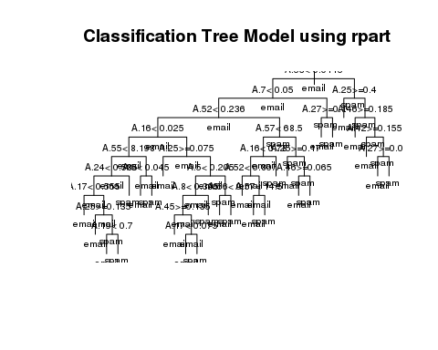

print(spam.model.pruned)

## n= 3229   
##   
## node), split, n, loss, yval, (yprob)  
## * denotes terminal node  
##   
## 1) root 3229 1269 email (0.60699907 0.39300093)   
## 2) A.53< 0.0445 2398 552 email (0.76980817 0.23019183)   
## 4) A.7< 0.05 2173 342 email (0.84261390 0.15738610)   
## 8) A.52< 0.236 1794 151 email (0.91583055 0.08416945)   
## 16) A.16< 0.025 1605 93 email (0.94205607 0.05794393)   
## 32) A.55< 8.198 1581 81 email (0.94876660 0.05123340)   
## 64) A.24< 0.585 1566 73 email (0.95338442 0.04661558)   
## 128) A.17< 0.555 1516 61 email (0.95976253 0.04023747) *  
## 129) A.17>=0.555 50 12 email (0.76000000 0.24000000)   
## 258) A.25>=0.135 28 0 email (1.00000000 0.00000000) *  
## 259) A.25< 0.135 22 10 spam (0.45454545 0.54545455)   
## 518) A.19< 0.7 7 1 email (0.85714286 0.14285714) *  
## 519) A.19>=0.7 15 4 spam (0.26666667 0.73333333) *  
## 65) A.24>=0.585 15 7 spam (0.46666667 0.53333333) *  
## 33) A.55>=8.198 24 12 email (0.50000000 0.50000000)   
## 66) A.5< 0.045 15 3 email (0.80000000 0.20000000) *  
## 67) A.5>=0.045 9 0 spam (0.00000000 1.00000000) *  
## 17) A.16>=0.025 189 58 email (0.69312169 0.30687831)   
## 34) A.25>=0.075 53 1 email (0.98113208 0.01886792) *  
## 35) A.25< 0.075 136 57 email (0.58088235 0.41911765)   
## 70) A.5< 0.205 91 25 email (0.72527473 0.27472527)   
## 140) A.8< 0.395 84 19 email (0.77380952 0.22619048)   
## 280) A.45>=0.135 30 0 email (1.00000000 0.00000000) *  
## 281) A.45< 0.135 54 19 email (0.64814815 0.35185185)   
## 562) A.17< 0.075 42 11 email (0.73809524 0.26190476) *  
## 563) A.17>=0.075 12 4 spam (0.33333333 0.66666667) *  
## 141) A.8>=0.395 7 1 spam (0.14285714 0.85714286) *  
## 71) A.5>=0.205 45 13 spam (0.28888889 0.71111111)   
## 142) A.56< 9 14 5 email (0.64285714 0.35714286) *  
## 143) A.56>=9 31 4 spam (0.12903226 0.87096774) *  
## 9) A.52>=0.236 379 188 spam (0.49604222 0.50395778)   
## 18) A.57< 68.5 197 48 email (0.75634518 0.24365482)   
## 36) A.16< 0.78 179 33 email (0.81564246 0.18435754)   
## 72) A.52< 0.807 130 10 email (0.92307692 0.07692308) *  
## 73) A.52>=0.807 49 23 email (0.53061224 0.46938776)   
## 146) A.57< 14.5 23 4 email (0.82608696 0.17391304) *  
## 147) A.57>=14.5 26 7 spam (0.26923077 0.73076923) *  
## 37) A.16>=0.78 18 3 spam (0.16666667 0.83333333) *  
## 19) A.57>=68.5 182 39 spam (0.21428571 0.78571429)   
## 38) A.25>=0.17 20 1 email (0.95000000 0.05000000) *  
## 39) A.25< 0.17 162 20 spam (0.12345679 0.87654321)   
## 78) A.46>=0.065 8 0 email (1.00000000 0.00000000) *  
## 79) A.46< 0.065 154 12 spam (0.07792208 0.92207792) *  
## 5) A.7>=0.05 225 15 spam (0.06666667 0.93333333)   
## 10) A.27>=0.14 7 0 email (1.00000000 0.00000000) *  
## 11) A.27< 0.14 218 8 spam (0.03669725 0.96330275) *  
## 3) A.53>=0.0445 831 114 spam (0.13718412 0.86281588)   
## 6) A.25>=0.4 62 4 email (0.93548387 0.06451613) *  
## 7) A.25< 0.4 769 56 spam (0.07282185 0.92717815)   
## 14) A.46>=0.185 21 4 email (0.80952381 0.19047619) *  
## 15) A.46< 0.185 748 39 spam (0.05213904 0.94786096)   
## 30) A.42>=0.155 12 1 email (0.91666667 0.08333333) *  
## 31) A.42< 0.155 736 28 spam (0.03804348 0.96195652)   
## 62) A.27>=0.08 7 2 email (0.71428571 0.28571429) *  
## 63) A.27< 0.08 729 23 spam (0.03155007 0.96844993) *

# prediction  
spam.predict.rpart <-predict(spam.model.pruned, newdata=spam.test, type = 'class')  
table(spam.predict.rpart, spam.test$spam)

##   
## spam.predict.rpart email spam  
## email 772 73  
## spam 56 471

mean(spam.predict.rpart == spam.test$spam) # classification mean

## [1] 0.9059767

rpart.error <- mean(spam.predict.rpart != spam.test$spam) # miss classification mean - testing error -rpart  
  
rpart.error

## [1] 0.09402332