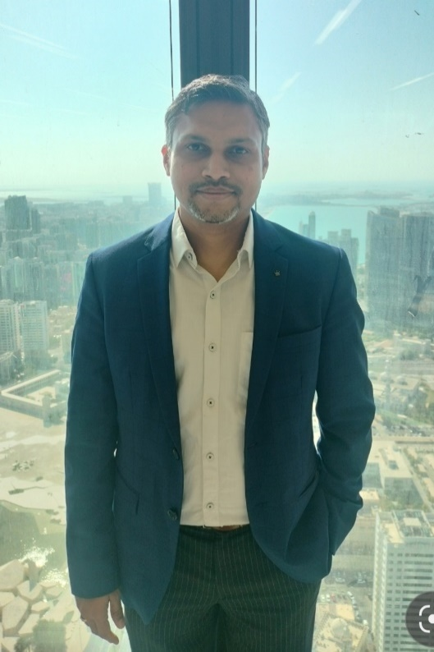
Rahul Kumar Verma
Digital Twin Architect | Simulation & AI Engineer | Python Developer
Bangalore, Karnataka, India | +91-6380112978 | rahulshverma@gmail.com
LinkedIn | GitHub:

Professional Summary
- 15+ years of experience in Mechanical Engineering, CFD, FEA, Digital Twin and AI-enabled engineering solutions.
- Developed Hybrid Digital Twin solutions for rotating and static equipment in Oil & Gas, Energy and Industrial sectors.
- Expertise in Physics-based Modelling, Predictive Analytics, RUL estimation and Condition Monitoring.
- Strong Python developer with experience building engineering applications using Streamlit, Flask, Plotly and cloud deployment.
- Built engineering simulation platforms, digital twins and investment analytics applications.
- Multiple patents, international publications and production-scale engineering solutions.

Core Expertise
Digital Twin • CFD • FEA • Predictive Analytics • Python • Machine Learning • Streamlit • Flask • Cloud (AWS/GCP) • Simulation Automation • Rotating Equipment • Thermal Systems • Asset Health • RUL • Industrial AI

Technical Skills
Engineering | CFD, FEA, Thermal, Heat Transfer, System Simulation, Digital Twin
Programming | Python, C++, MATLAB, VBA, SQL
Application Development | Streamlit, Flask, Plotly, HTML/CSS, Bootstrap, REST APIs, Git
AI / Data | Pandas, NumPy, Scikit-learn, XGBoost, Time Series
Cloud | AWS, Google Cloud Platform

Career Highlights
- Improved oil production by 18% using Hybrid Digital Twin for Sulfate Reduction Plant.
- Published Digital Twin solution at ADIPEC 2025.
- Developed digital twins for compressors, pumps, generators and heat exchangers.
- Led SOFC simulation platform from research to product.
- Developed engineering automation tools using Python.
- Designed high-power density motors up to 1000 kW.
- Built cloud-hosted engineering and investment analytics applications.

Professional Experience
Bosch | Digital Twin Architect | 2024-Present
- Developed Hybrid Digital Twin solutions for rotating and static equipment.
- Built physics + AI models for predictive maintenance and RUL.
- Integrated engineering models with historian and analytics platforms.
- Developed Python-based engineering applications and dashboards.
Bosch | Simulation Specialist | 2015-2024
- Led CFD, thermal and multiphysics simulation projects.
- Developed simulation automation frameworks using Python.
- Delivered SOFC system modelling and optimization.
CRI Pumps | Senior Engineer | 2013-2015
- Thermal CFD of motors and pumps.
- Validated simulations with experiments.
- Optimized premium efficiency motors.
Jyoti Ltd | Engineer | 2010-2013
- Designed thermal solutions for TEFC motors and generators.
- Optimized cooling systems using CFD.
- Developed high power-density motor designs.

Selected Projects
- Hybrid Digital Twin for Sulfate Reduction Plant
- Compressor, Pump & Heat Exchanger Digital Twins
- SOFC Thermal Simulation Platform
- High Power Density Motor Development
- Wind Generator Cooling Design

Software & App Development
- Cooler Digital Twin with transient simulation engine and calibration.
- Mechanical Seal Digital Twin with health and RUL prediction.
- Asset Health Monitoring dashboards.
- Engineering simulation automation platform.
- Cloud driven portfolio and Analytics Dashboard
- Cloud deployment on Google Cloud Platform using Flask/Streamlit.

Patents & Publications
- Multiple patents (Germany & India)
- ADIPEC 2025 publication
- Physics-powered AI publications for predictive maintenance

Education
M.Tech, Thermal & Fluid Engineering
Indian Institute of Technology Bombay

