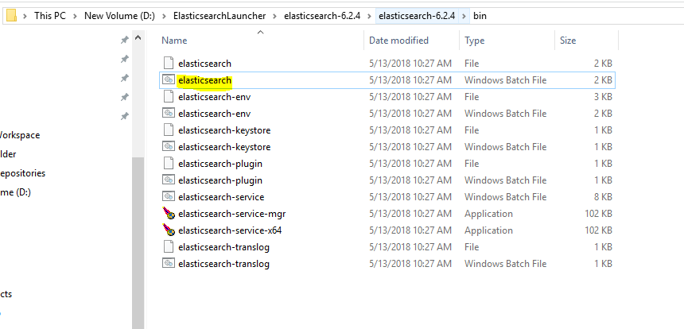

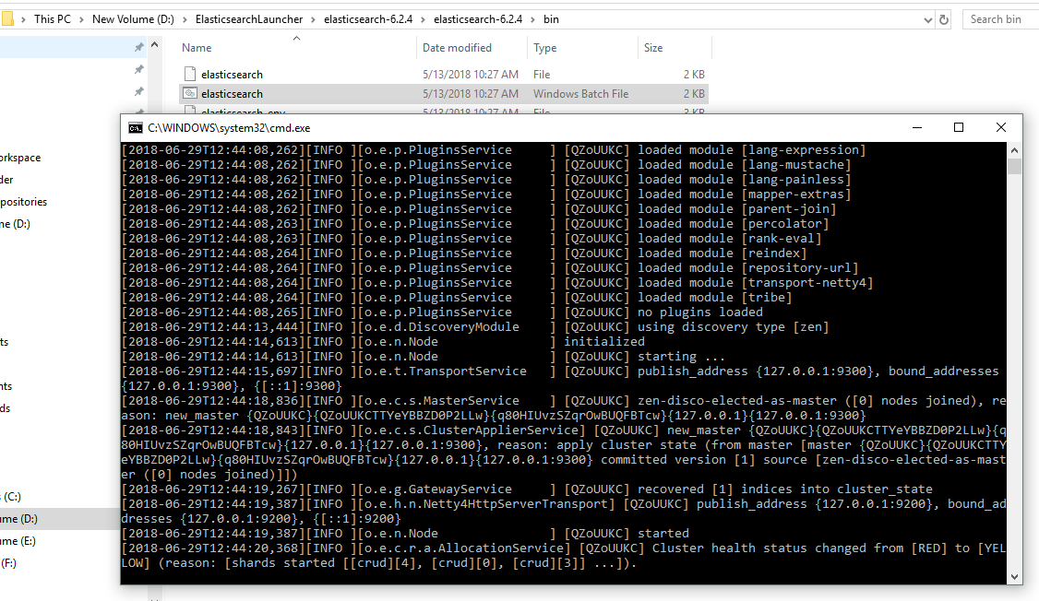

Seeing the logs closely, we can see this –

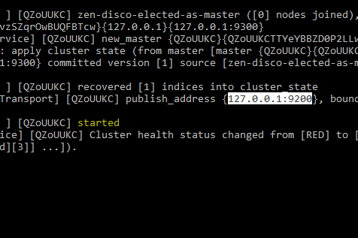

Now, executing the same on browser-

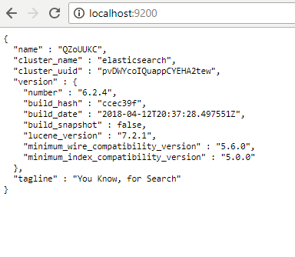

Now launch, POSTMAN-

What you verified on browser, let’s see the same on POSTMAN:

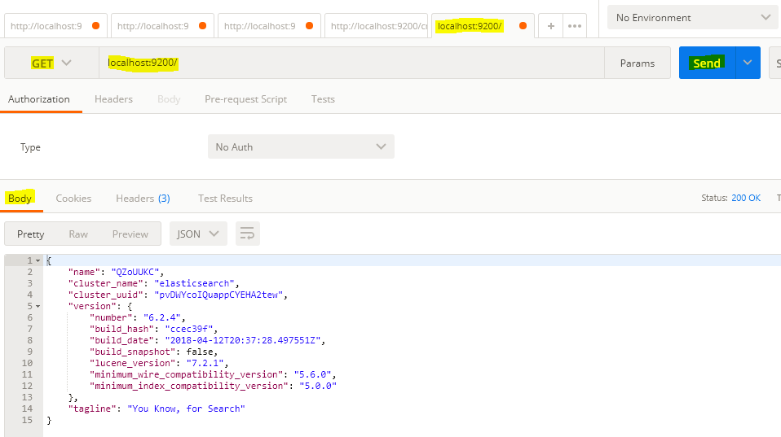

Let’s insert something:



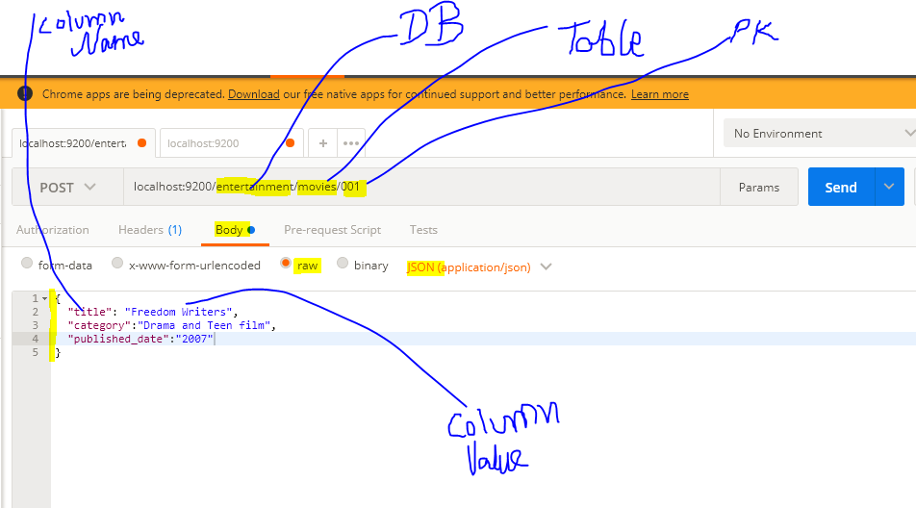

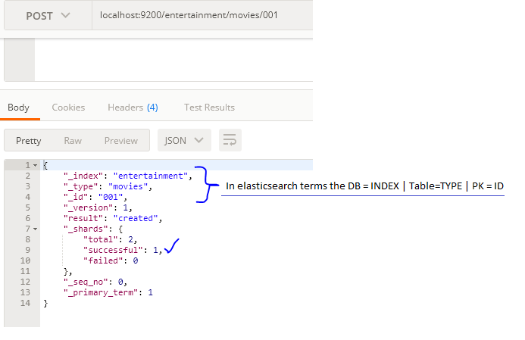

Making one more entry - 002:

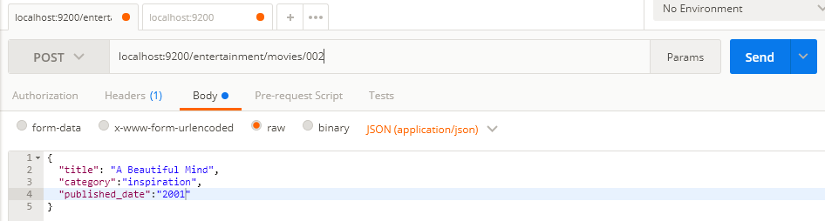

New record inserted ☺

Now if we make any change in the request body keeping the primary key ’untouched’, then the record gets updated – sounds logical !!

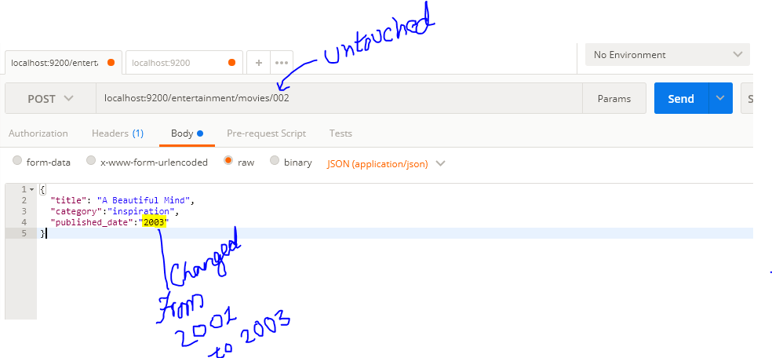

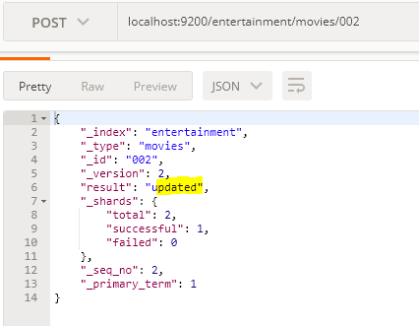

Now let’s search –

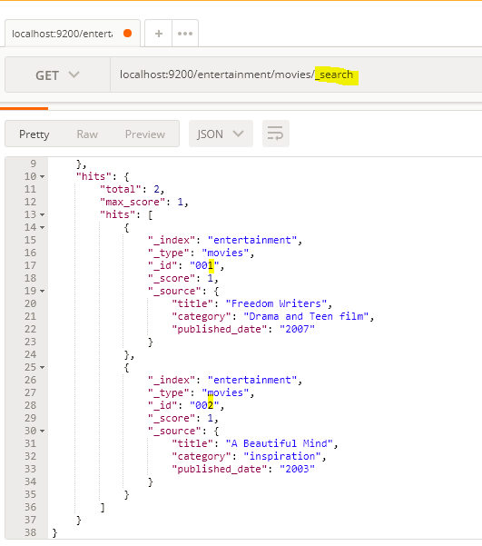

Now let’s search something specific –

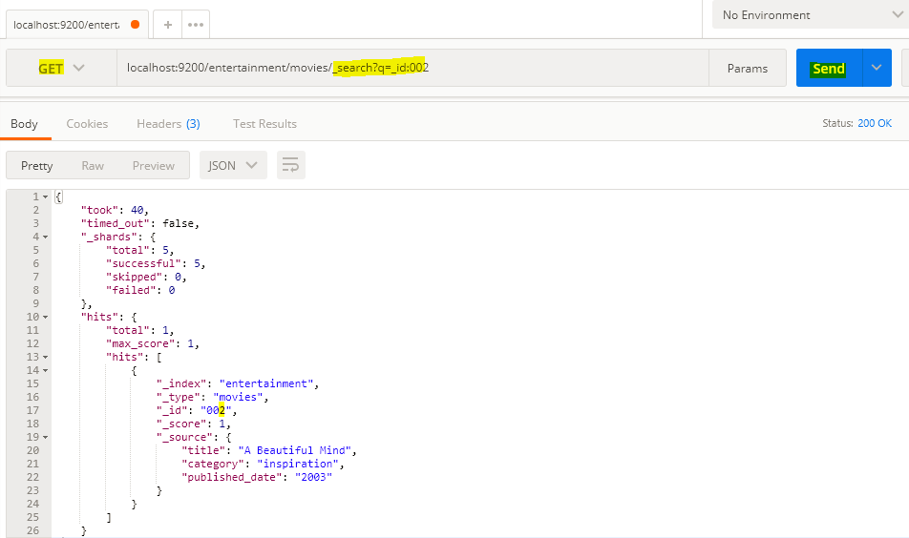

OR

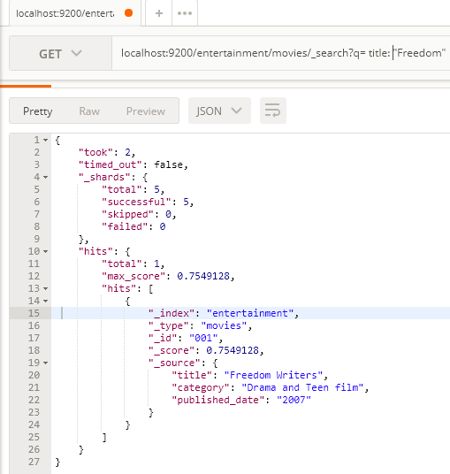

OR (USING LIKE)

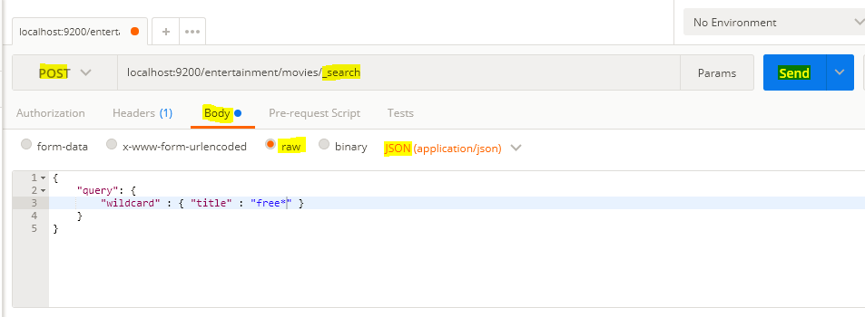

Response-

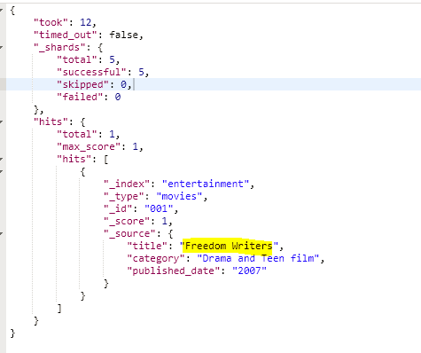

OR COMPLEX CONDITIONS-

<https://www.elastic.co/guide/en/elasticsearch/guide/current/combining-filters.html>

Now if you want to delete any record -

