WAY#1

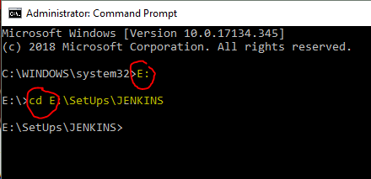

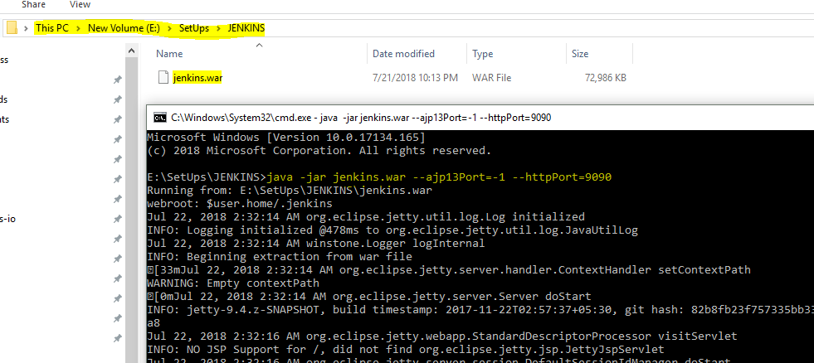
java -jar jenkins.war --ajp13Port=-1 --httpPort=9090
Now on Web Browser: localhost:9090
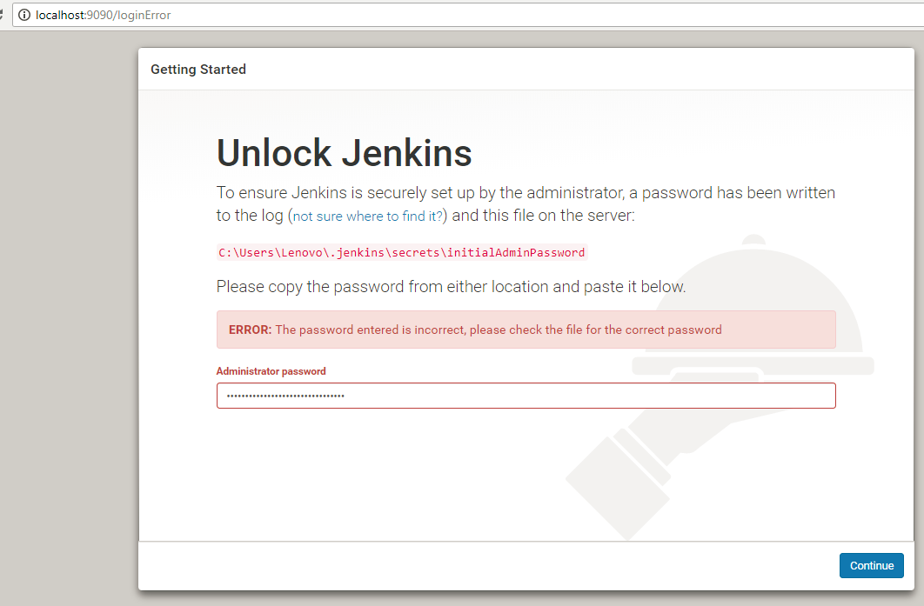
For Adminstrative Password look here: 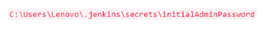

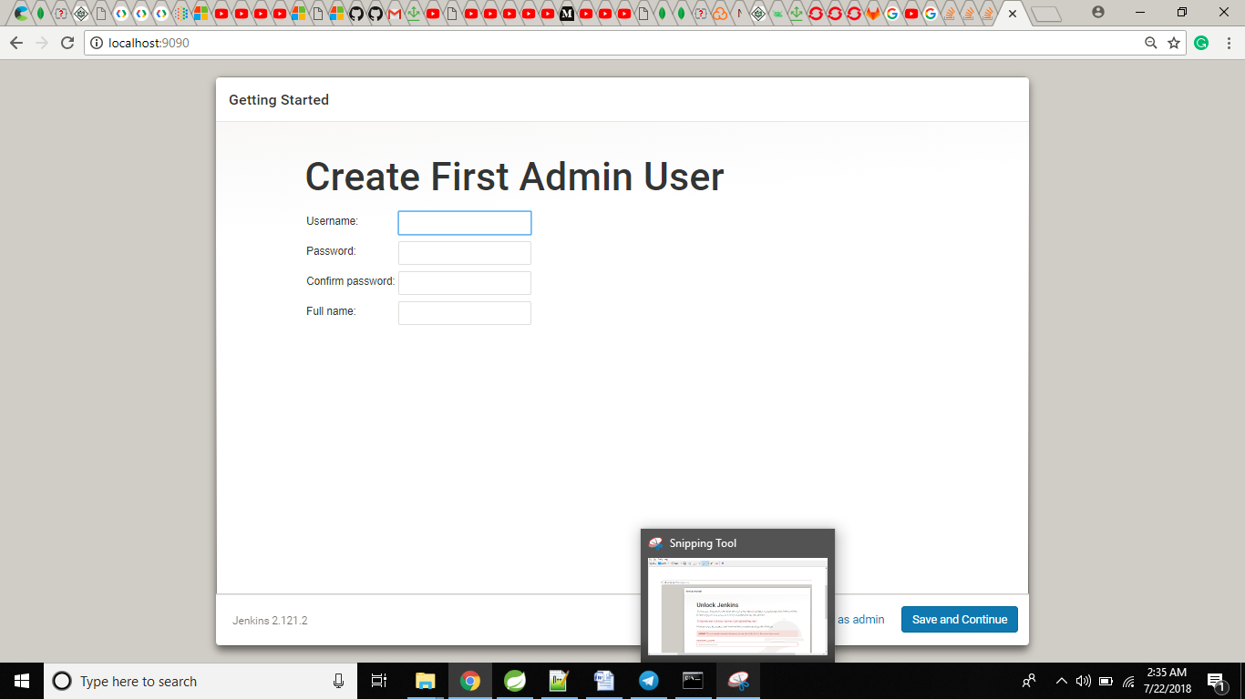

rahulvaish
rahulvaish
rahulvaish
rahul Vaish
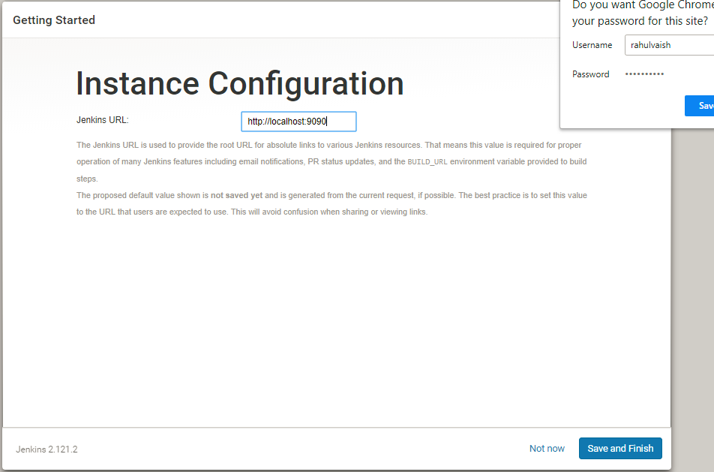

My Experience: After Save and Finish, on trying localhost:9090, I had to make twice attempts to restart the Jenkins server and refresh the Jenkins home page.
