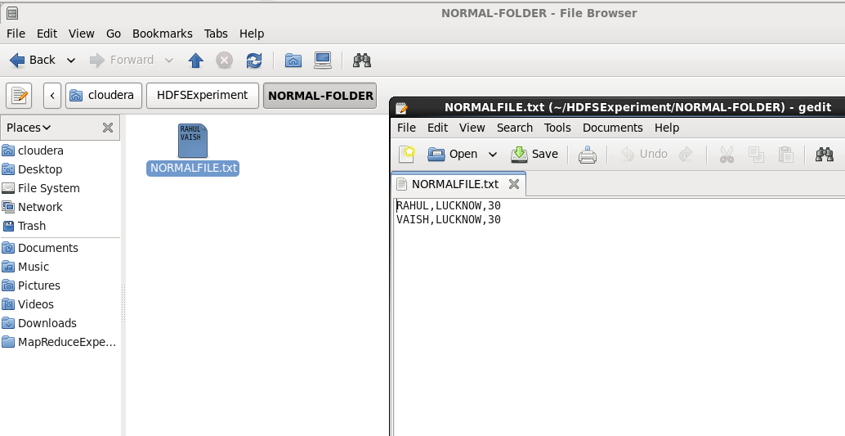
There is a simple file with data inside it. Now moving this file in HDFS:
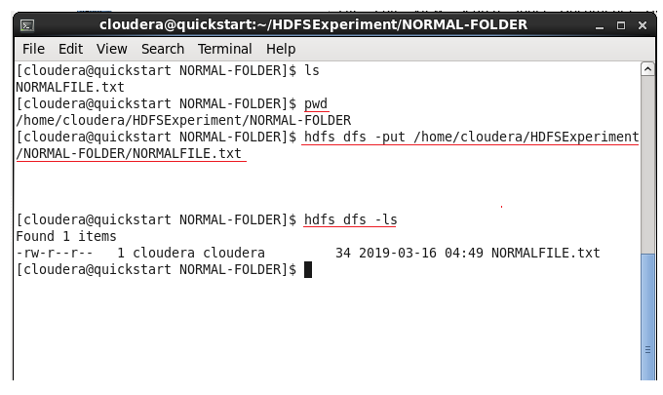
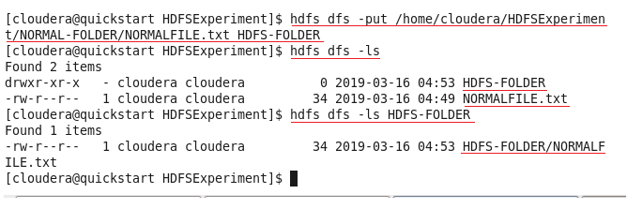

Similarly we can use –rm , –rmdir , -cat …etc
To view theses HDFS, you can see:
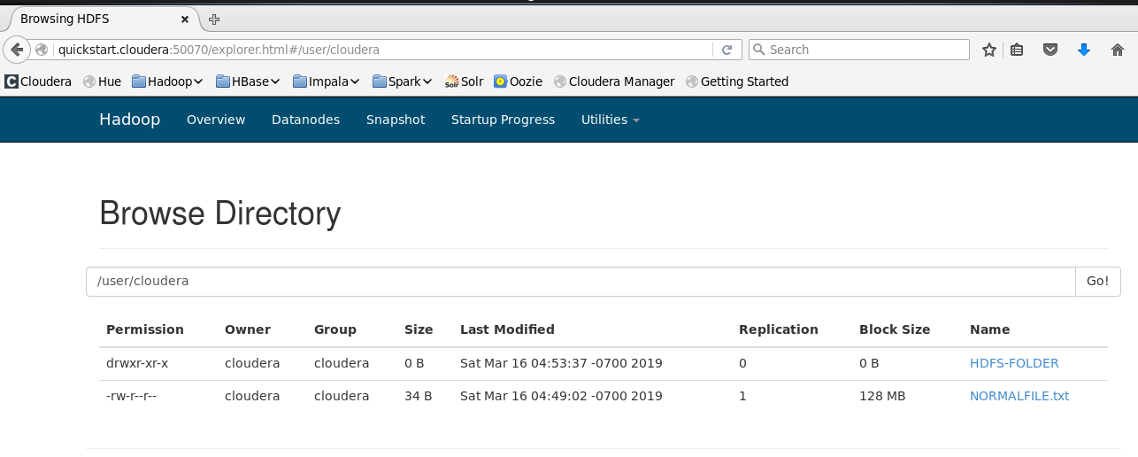
Inside HDFS-FOLDER
